**Application: Sechia**

*Furniture Web Shop*

*By:Mehdija Sekic*

Introduction

*This document serves as an introduction to how this application works. As the application is hosted locally, you can explore its functionalities without the need to install additional dependencies or manage product databases.*

*Sechia is designed to provide customers with a fast and easy shopping experience from the comfort of their homes, featuring a user-friendly interface that enhances the overall experience. For sellers, it offers a streamlined process for managing products and analyzing orders. Whether you're a newcomer or a seasoned user, our locally hosted setup ensures easy access and seamless exploration of the application's capabilities.*

*For the backend, it's used .NET 6 to make our application strong and well-connected to the frontend. We handle data management with SQL Server Management Studio, ensuring everything runs smoothly and securely. Frontend is developed with Angular.*

*The application is designed for the Bosnia marketplace.*

Functionalities and UI for Users

Welcome screen:

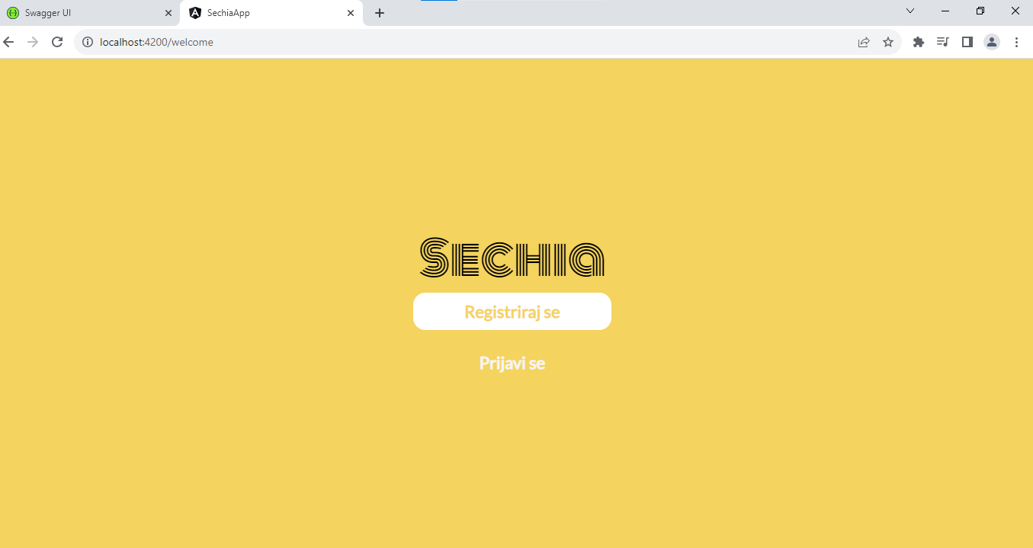

Registration screen:

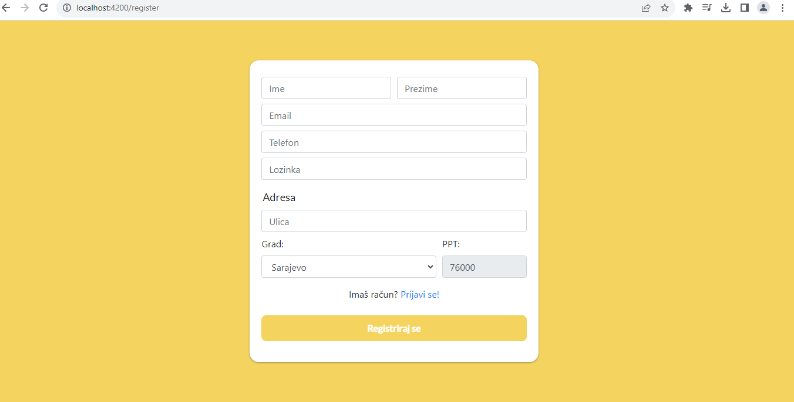

Login screen:

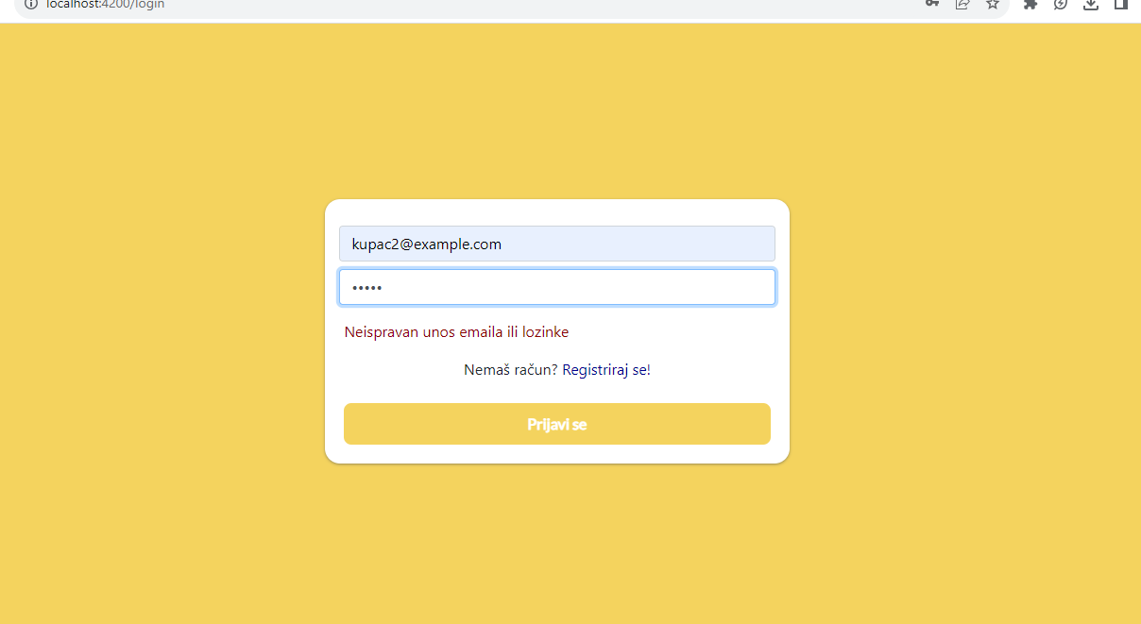

The following picture shows the home screen. The element in the middle is a repeating video, and by clicking on the search engine symbol we go to the search screen. Application features number animations that incrementally increase until they reach predefined values

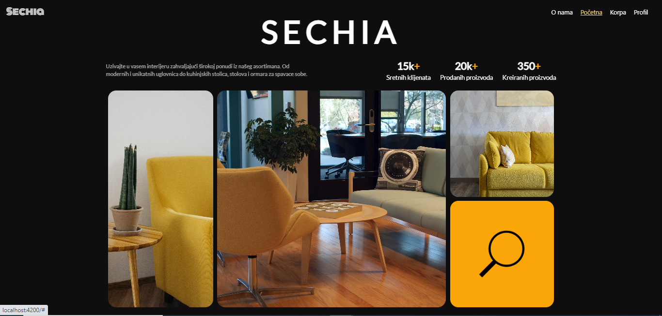

Products screen:

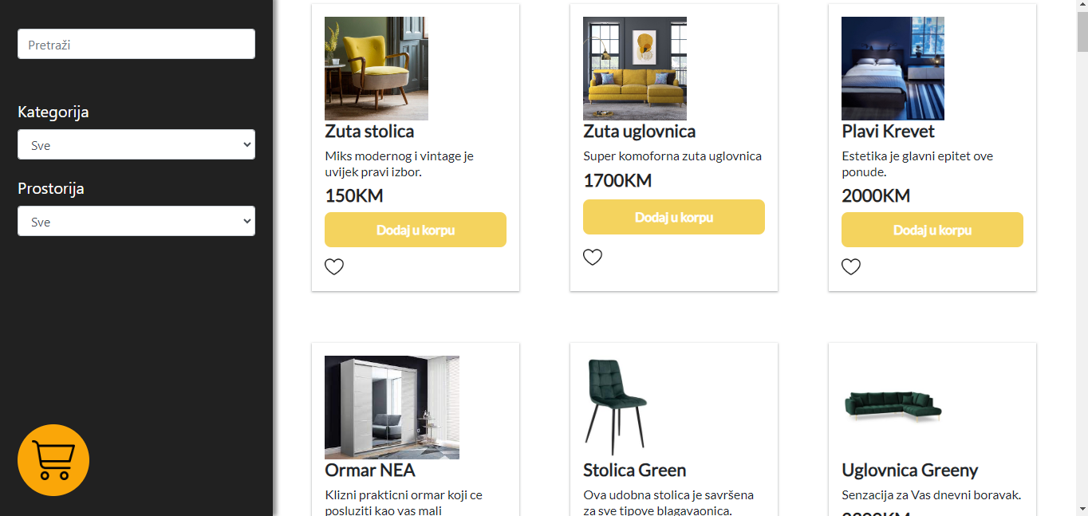

Here we can buy products by cliking on button “Dodaj u korpu” (*engl. Add to cart*), see our products by clicking on the cart button, filtering products by category or room. Categories, rooms, products are from the backend. Everything is connected to the backend.

When we click on a certain product it shows us detailed information about the product.

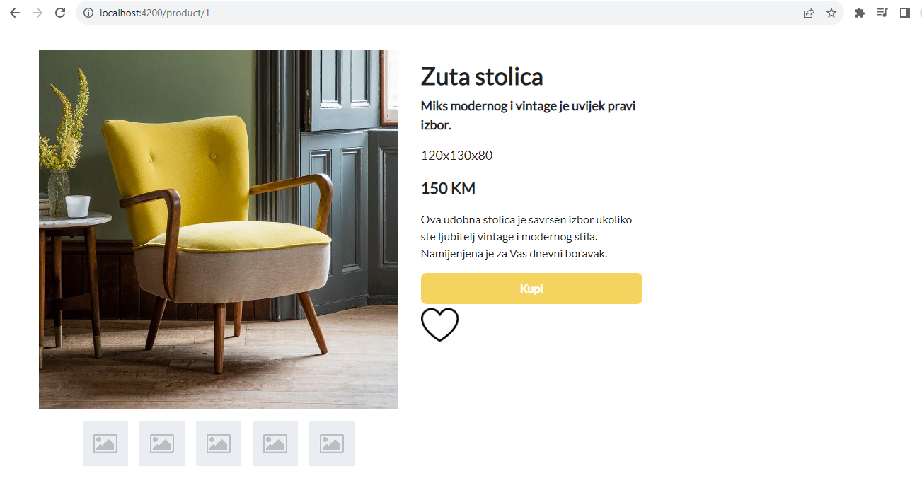

Filtering

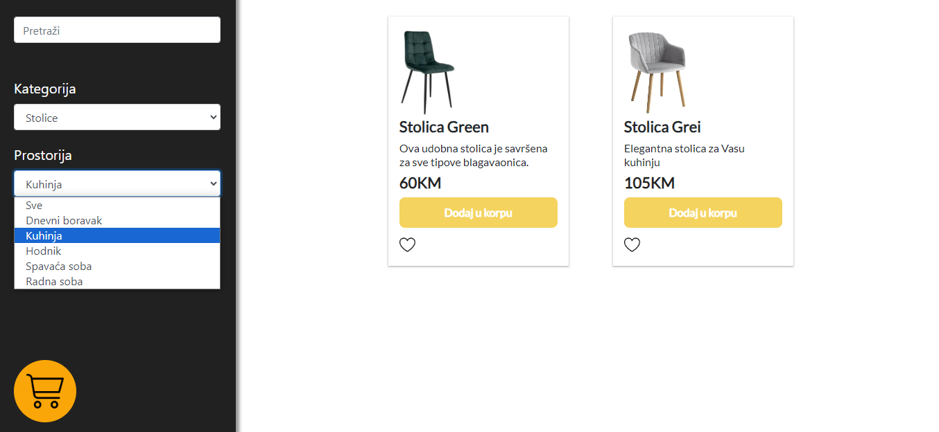

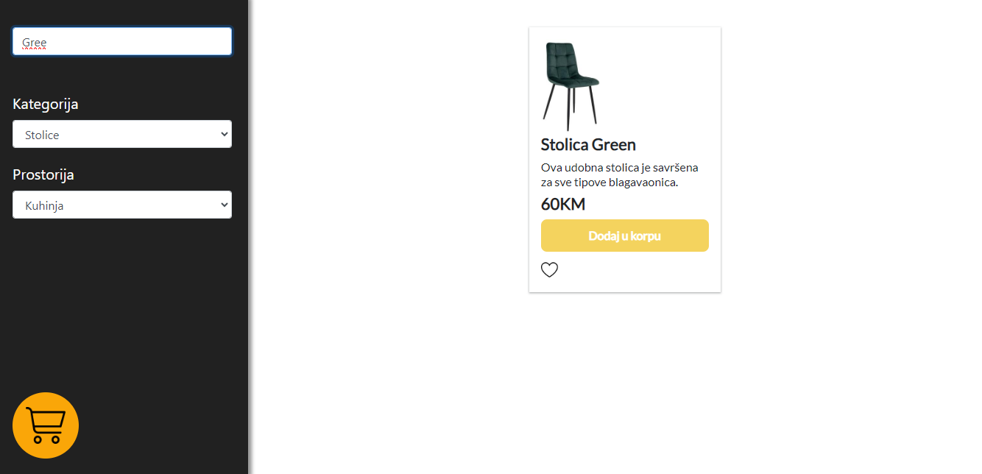

Shopping

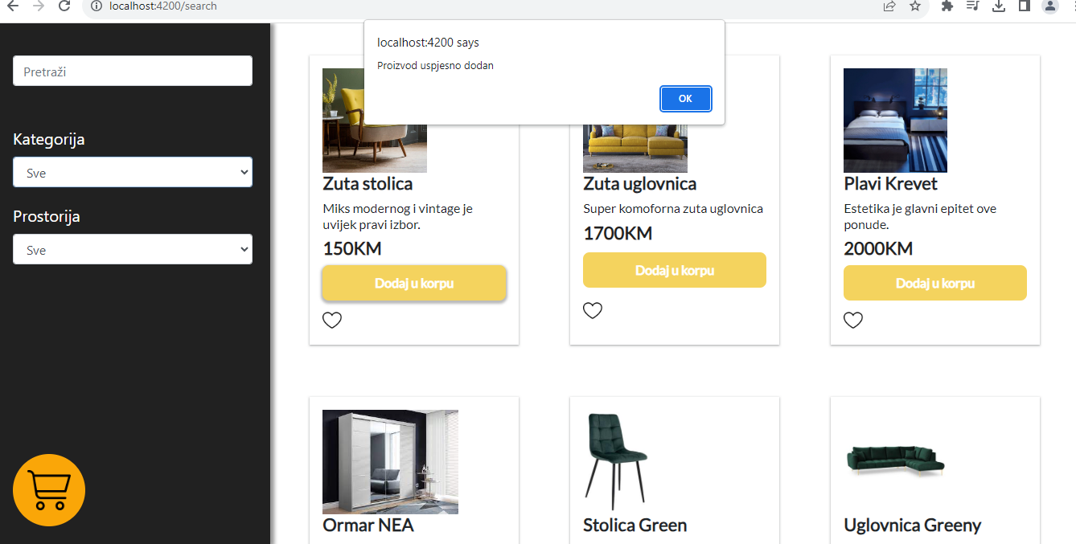

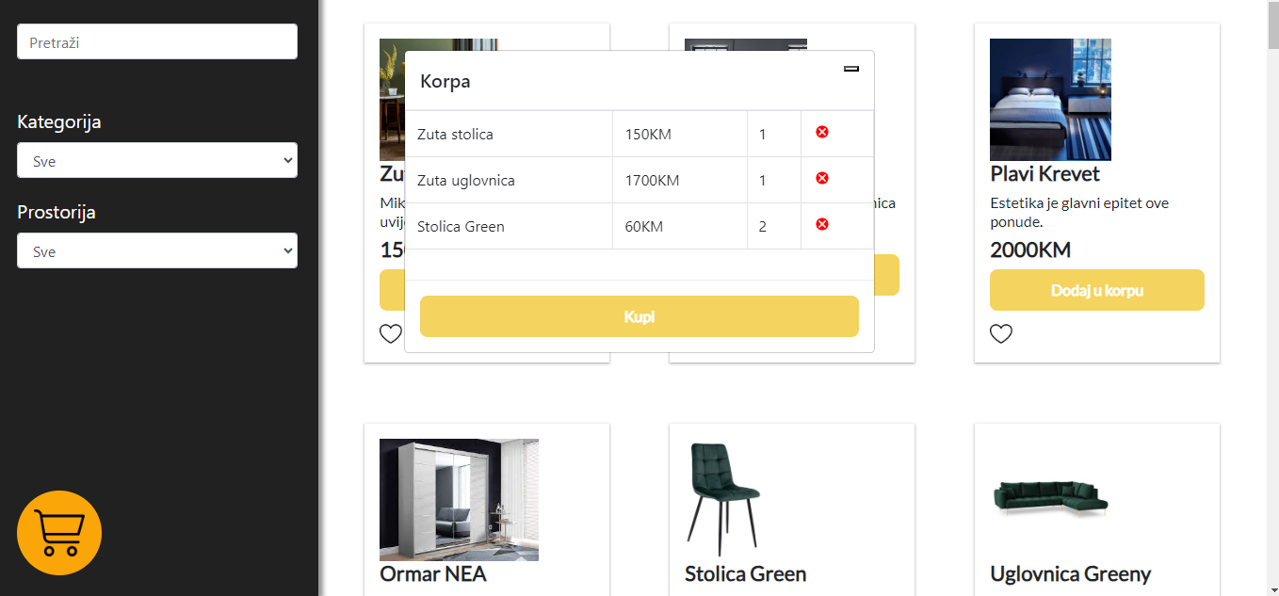

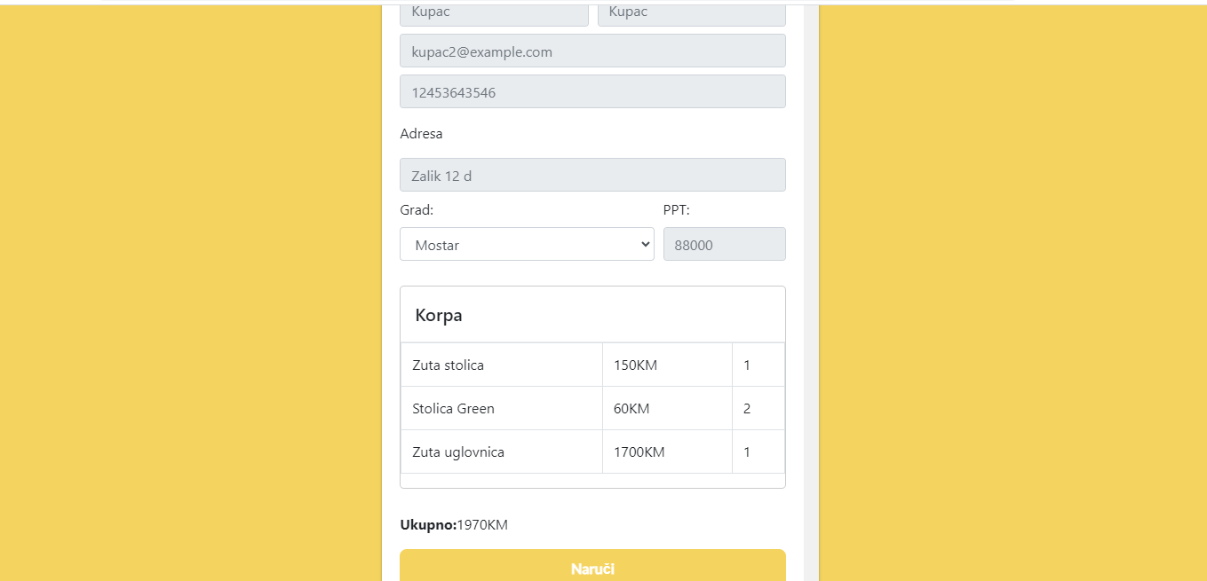

When we click on the button “Naruci” (*engl. Order*) the order is ready and sent to the sellers.

Admin and seller panel

We have the same panel layout for both sellers and admins, with the only difference being that the admin panel includes additional functionalities for managing sellers, such as seller registration and deletion.

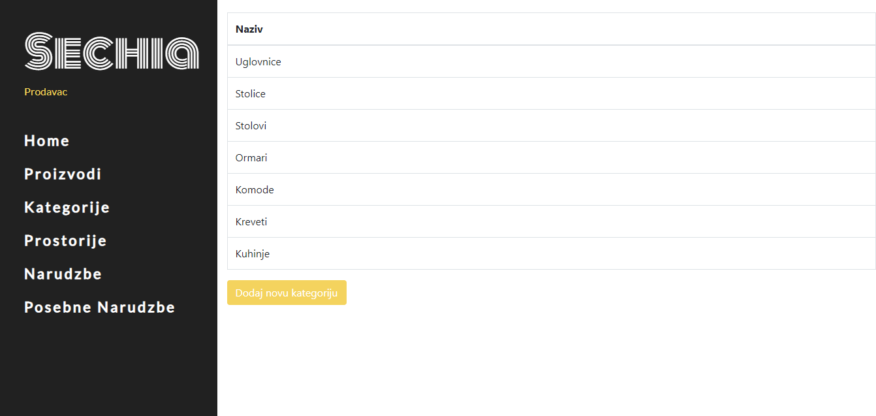

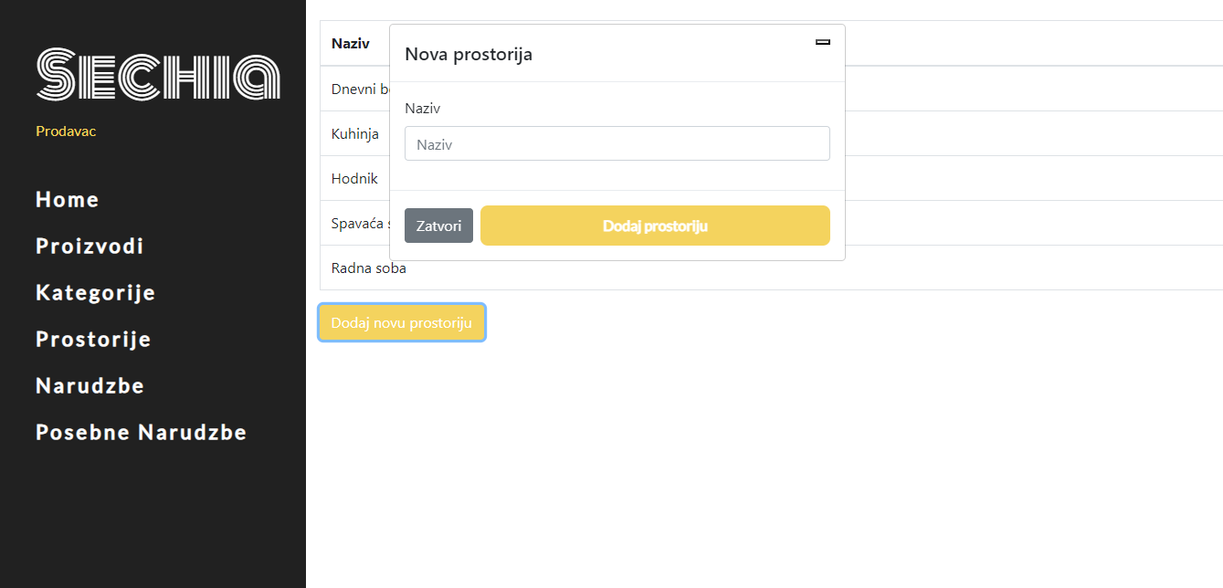

We have options for viewing products, rooms, and categories, as well as adding new ones.

These same options are available on the admin panel as well.

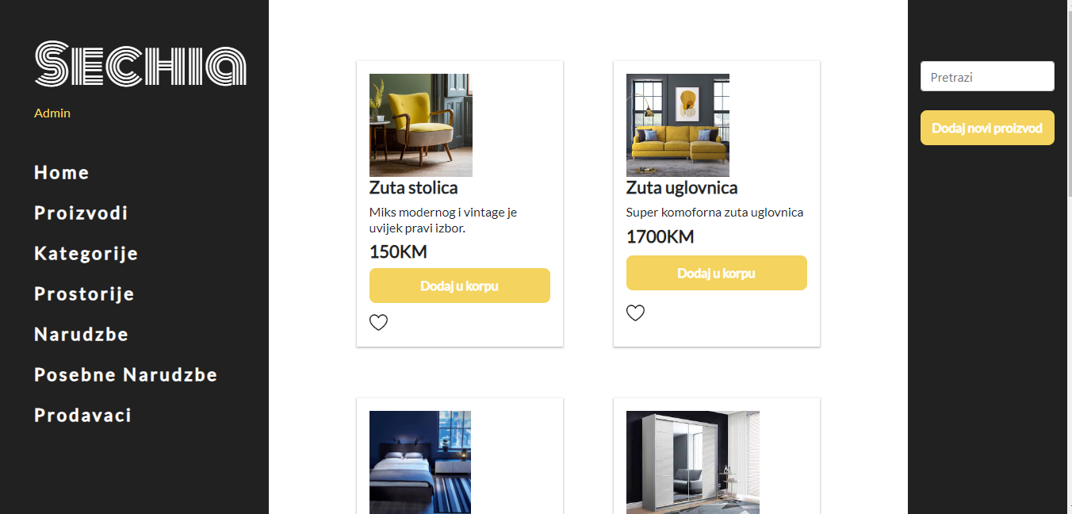

When we click on the button “Dodaj novi proizvod” (*engl. Add new product*) the seller/admin can add new product.

New product screen:

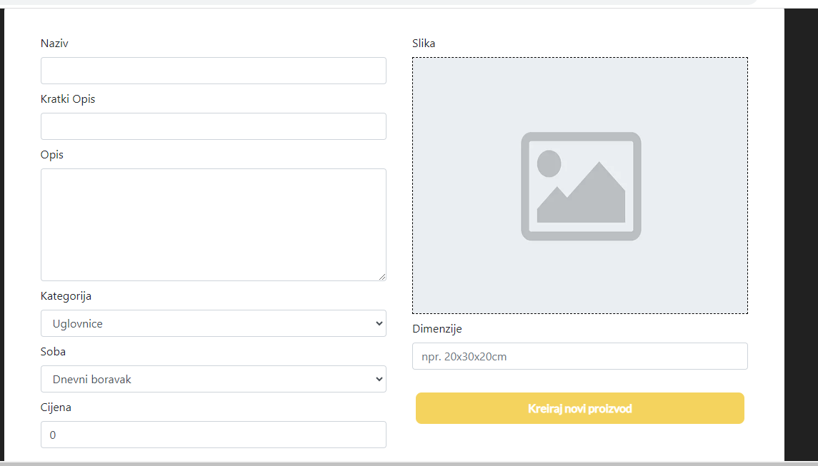

Admin panel

We have functionalities for viewing, deleting, and adding new sellers

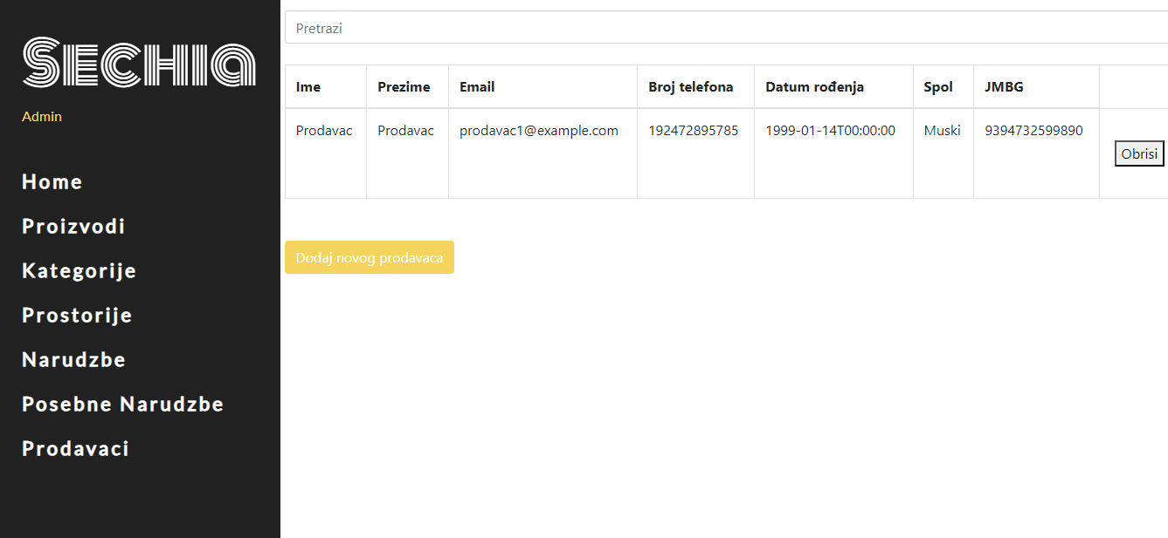

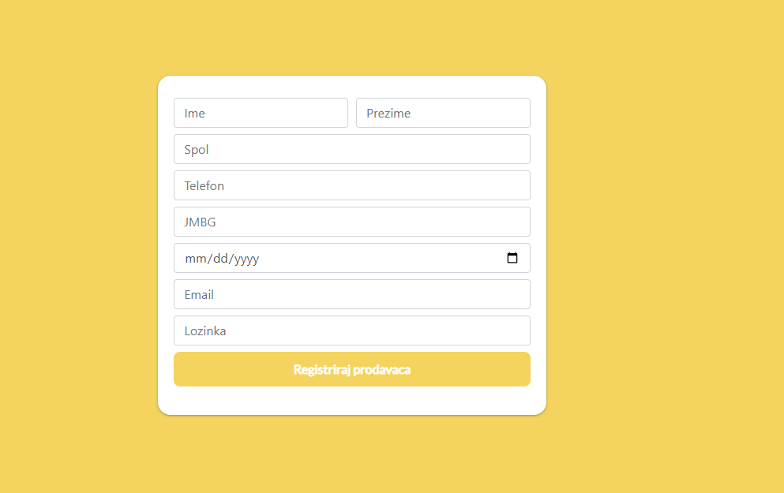

Backend

The backend code adheres to SOLID principles and implements features such as token-based logic, repository pattern, dependency injection, view models, and auto-mapper for enhanced functionality and maintainability.

Repository pattern

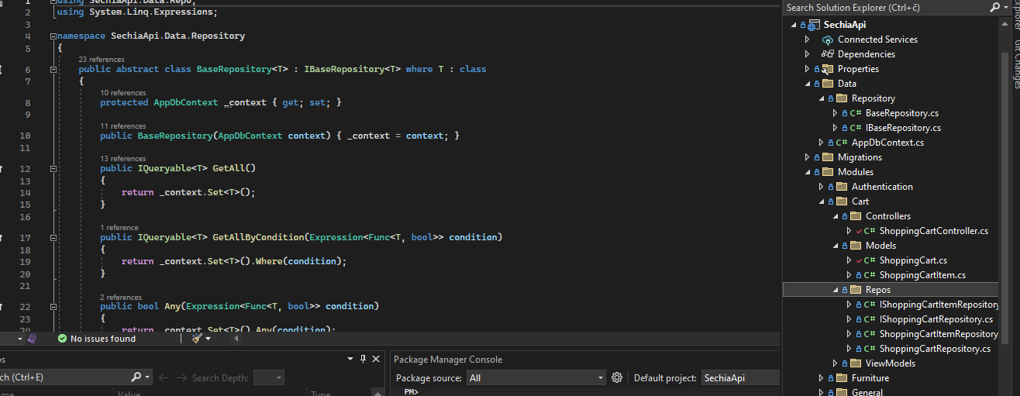

Tokens

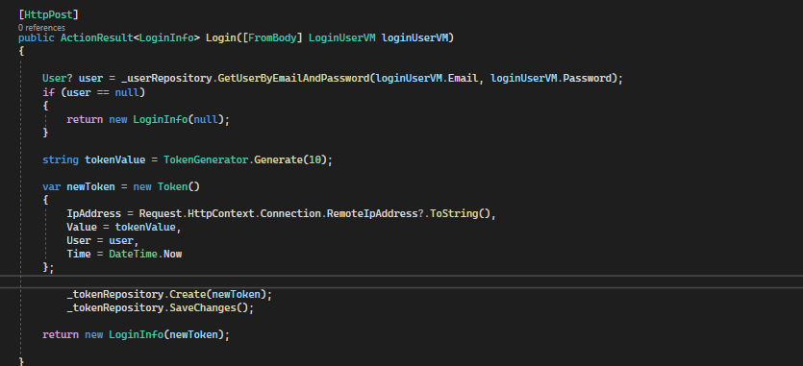

Picture upload

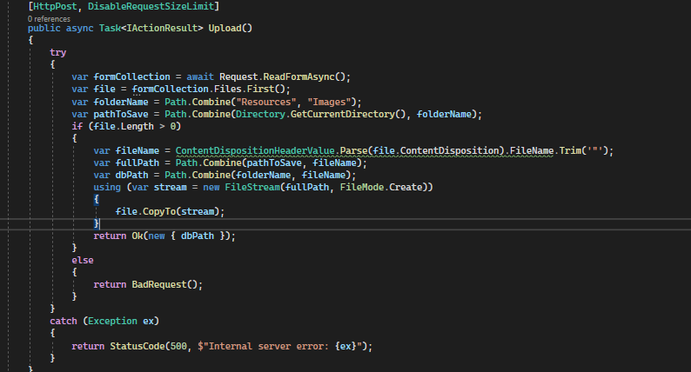

Code organization

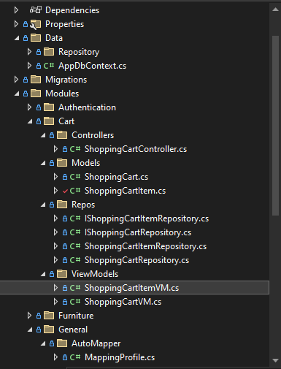

Mapper

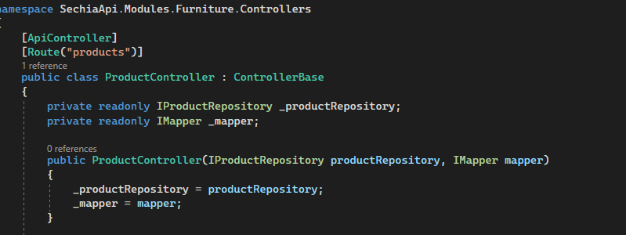

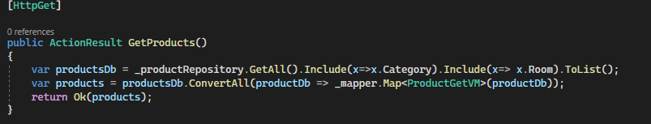

Virtual models:

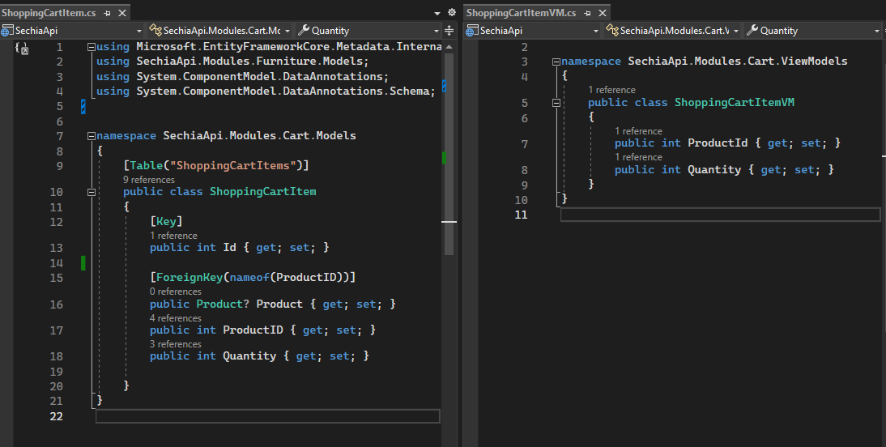

Improvements

It's my first web application where I've worked on both the backend and frontend, starting from scratch by drafting the project's vision, designing use cases and class diagram. There are better ways to handle some aspects, but it has been a great learning experience.