1. **:**
   * 1. =1

|  |  |
| --- | --- |
|  |  |
| 2 | 6 |
| 4 | 3 |
| 5 | 6 |
| 7 | 3 |
| 8 | 2 |
| 3,6,9 | It’s always 9 for $y≥2$ |

$\left\lceil \frac{n}{m}\right\rceil =\left\lfloor \frac{n+m-1}{m}\right\rfloor =\left\lfloor \frac{n-1}{m}\right\rfloor +1$

$\left\lfloor \frac{n}{m}\right\rfloor =\left\lceil \frac{n+m-1}{m}\right\rceil =\left\lceil \frac{n-1}{m}\right\rceil +1$

$\sum_{k=1}^{n-1}{\left\lfloor \frac{kn}{m}\right\rfloor =\frac{\left(m-1\right)\left(n-1\right)+\gcd\left(m,n\right)-1}{2}}$

$2^{n}=\sum_{k=0}^{n}{\left({n \atop k}\right)}$

$As \left({n \atop k}\right) is symmetic,for 0≤k≤n. Thus 2^{n-1}=\sum_{k=0}^{\frac{n}{2}}{\left({n \atop k}\right)}$

1. If the vertices of a triangle be (x1,y1), (x2,y2) and (x3,y3), then the centroid of the triangle is $(\frac{x1+ x2+ x3}{3},\frac{y1+ y2+ y3}{3})$
$Sum of all possible product of subsets of a given set \left\{a,b,c,…,d\right\} answer:\left(1+a\right)×\left(1+b\right)×\left(1+c\right)×…×\left(1+d\right)-1$

2. Minimum increment/decrement to make all array elements equal make all elements equal = **median**.
3. Bitwise and arithmetic

|  |  |
| --- | --- |
| $$arithmetic$$ | $$bitwise$$ |
| A+B | A^B+2*(A&B) |
| A-B | A^(~B+1)+2*(A&(~B+1))  or  (A^B)-2*((~A)&B) |
| A&(B|C) | (A&B)|(A&C) |
| A&(B^C) | (A&B)^(A&C) |
| A|(B&C) | (A|B)&(A|C) |
| A^1 | ~A |

1. In any sequence of **n2+1** terms, there will be an increasing or decreasing subsequence of **n+1** terms.
2. An **Odd number** has only *odd divisors*.
3. If a is any integer and n is divisible by d, then an−1 is divisible by ad−1.
4. If D is the divisor of n, then n−D must also be divisible by D; $a=0 (mod d) then a-d=0 (mod d)$
5. Fibonacci properties
6. 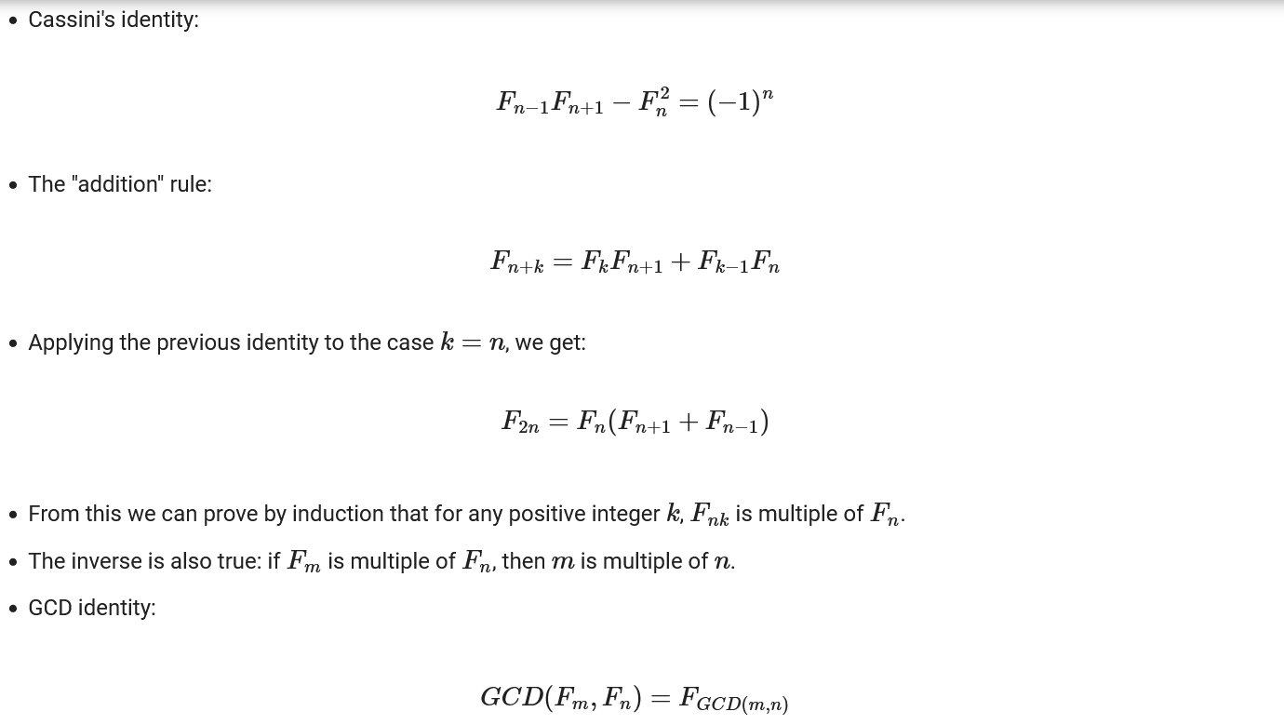Fibonacci sequence has **p2-1** modulo property.
7. [Sieve of Eratosthenes](https://cp-algorithms.com/algebra/sieve-of-eratosthenes.html) and Asymptotic analysis:

two known facts:

* The number of prime numbers less than or equal to n is approximately $\frac{n}{\ln{n}}$
* The k-th prime number approximately equals $k\ln{k}$

1. a = b (mod p) means a=np+b
$phi\left(p^{k}\right)=p^{k}-p^{k-1}$

$phi\left(ab\right)=phi\left(a\right)phi\left(b\right)\frac{d}{phi(d)};d=gcd⁡(a,b)$

2. $x^{n}=x^{φ\left(m\right)+[n mod φ\left(m\right)]} mod m$;where n>= log2m
3. ab mod ac = a (b mod c)
$ac = bc \left(mod m\right), then a = b mod\frac{m}{g\left(c,m\right)}$

$if p is prime, then {(x+y)}^{p} = x^{p}+y^{p} (mod p).$

4. m*d (mod n) = 0 then the smallest number m ,is equal to lcm(n,d)
5. The number of vertices with odd degree is even
6. Problem in prefix function : why to go l=lps[l-1] again and again
7. Minimum number of edge add to make bridge =0 , for tree ans= $\frac{no of child+1}{2}$
8. Maximum xor value in range [l,r] is = (1<<msb(l^r))-1;
9. [ternary balance](https://puzzling.stackexchange.com/questions/116976/why-are-all-numbers-from-1-to-2n-covered-by-weights-with-powers-of-3?noredirect=1&lq=1)

# Problem List

|  |  |  |
| --- | --- | --- |
| problems need to do again | |  |
|  |  |  |
| **Problem Name** | **Rating** | **Category** |
| [B. Catching Cheaters](https://codeforces.com/problemset/problem/1446/B) | 1800 | DP |
| [Palindrome Free Strings](https://codingcompetitions.withgoogle.com/kickstart/round/00000000008cb33e/00000000009e762e) | kickstart | DP |
| [Longest Increasing Subsequence Arrays](https://www.hackerrank.com/contests/world-codesprint-5/challenges/longest-increasing-subsequence-arrays) | medium | combinatorics |
| https://www.codechef.com/LTIME24/problems/NWAYS/ | medium | combinatorics |
| https://atcoder.jp/contests/abc247/tasks/abc247_e | medium | Sliding window |
| https://toph.co/p/switchblade-of-thanos | Medium | DP |
| https://blog.birost.com/a?ID=00500-89641bff-fec3-4cdc-ab6c-55df6d4c448f | medium | combinaorics |
| https://www.spoj.com/problems/WATER/ | easy | bfs |
| https://acm.timus.ru/problem.aspx?space=1&num=2034 | hard | bfs |
| [ADV04F1 - Four Chips (Hard)](https://www.spoj.com/problems/ADV04F1/) | Medium | bfs |
| [INVESORT - Inversion Sort](https://www.spoj.com/problems/INVESORT/) | Hard(unsolved) | bfs |
| [E. Shortest Path](https://codeforces.com/contest/59/problem/E) | easy | bfs |
| [MULTII - Yet Another Multiple Problem](https://www.spoj.com/problems/MULTII/) | Medium | Bfs |
| [RIOI_2_3 - Path of the righteous man](https://www.spoj.com/problems/RIOI_2_3/) | medium | dfs |
| [Gen string](https://codeforces.com/contest/710/problem/E) | Mid | dp |
| https://www.geeksforgeeks.org/maximise-sum-of-product-of-pairs-by-choosing-subsequence-of-same-length-from-given-arrays/ | Easy | dp |
| https://atcoder.jp/contests/m-solutions2020/tasks/m_solutions2020_c | Easy | maths |
| https://codeforces.com/contest/700/problem/C | mid | Graph(first make a graph which contains path from s-d, then for all I in the path from s-d remove it and apply bridge ) |
| https://codeforces.com/contest/732/problem/F | mid | Graph+implementation |
| https://codeforces.com/contest/126/problem/B | mid | Prefix function |
| https://codeforces.com/contest/349/problem/B | Mid | greedy |
| https://codeforces.com/contest/1333/problem/C | Mid | **Implementation\*\*\*** |
| https://codeforces.com/contest/1336/problem/B | mid | **greedy** |
| https://codeforces.com/problemset/problem/1325/D | mid | **xor** |
| https://toph.co/p/m-sequence | Mid | **Ss er implementation** |
|  |  |  |
|  |  |  |

|  |  |
| --- | --- |
| **Word** | **Meaning** |
| scattered | বিক্ষিপ্ত |
| ladder | মই |
| Potion | তরল ঔষধ বা বিষ |
| Merely | নিছক,কেবল |
| Reminiscent | স্মরণ করিয়ে দেয় |
| Ambush | ঘাপটি/ ত্তৎ পাতা |
| perish | প্রাণ হারান |
| casualty | আহত |
| prey | শিকার |
|  |  |