Implementation of different types of LAN topology with IP addressing using PT

Objectives:
- Design the following topology in Packet Tracer.
- Subnet each of the network with the IP and complete the following table.
- Assign the appropriate IP into each of the network.
- Add one more PC to each of router and assign IP.
- Test connectivity between PC in a router.
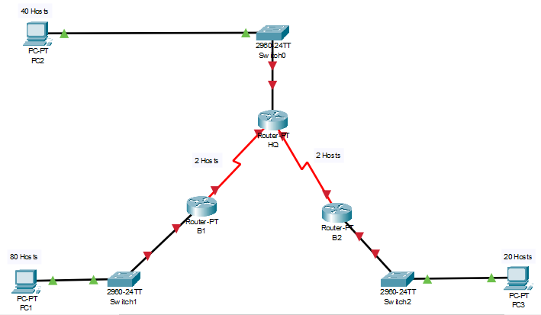
Address Space
192.168.1.0 / 24
First subnet (80 hosts)
192.168.1.0 /24
Required hosts 80= 2⁷ =128 hosts
Subnet mask= 11111111. 11111111.11111111. 10000000 =255.255.255.128
N.A= 192.168.1.0 /25 ------- B.A= 192.168.1.127 /25

Second subnet (40 hosts)
192.168.1.128 /26
Required hosts 40= 2⁶ =64 hosts
Subnet mask= 11111111. 11111111.11111111. 11000000 =255.255.255.192
N.A= 192.168.1.128 /26 -------- B.A= 192.168.1.191 /26
3rd subnet (20 hosts)
192.168.1.192 /27
Required hosts 20= 2⁵ =32 hosts
Subnet mask= 11111111. 11111111.11111111. 11100000 =255.255.255.224
N.A= 192.168.1.192 /27 ----------- B.A= 192.168.1.223 /27
4th subnet (2 hosts)
192.168.1.224 /30
Required hosts 20= 2² =4 hosts
Subnet mask= 11111111. 11111111.11111111. 11111100 =255.255.255.252
N.A= 192.168.1.224 /30 ----------- B.A= 192.168.1.227/30

5th subnet (2 hosts)
192.168.1.228 /30
Required hosts 20= 2² =4 hosts
Subnet mask= 11111111. 11111111.11111111. 11111100 =255.255.255.252
N.A= 192.168.1.228 /30 ----------- B.A= 192.168.1.231/30

Subnet Table
Subnet | Assignable Adress Range | Subnet Mask | Subnet Address | Broadcast Address
First subnet (80 hosts) | 192.168.1.1 /25 -192.168.1.126 /25 | 255.255.255.128 | 192.168.1.0 /25 | 192.168.1.127 /25
Second subnet (40 hosts) | 192.168.1.129 /26 -  192.168.1.190 /26 | 255.255.255.192 | 192.168.1.128 /26 | 192.168.1.191 /26
3rd subnet (20 hosts) | 192.168.1.193 /27-  192.168.1.222 /27 | 255.255.255.224 | 192.168.1.192 /27 | 192.168.1.223 /27
4th subnet  (2 hosts) | 192.168.1.225 /30-  192.168.1.226/30 | 255.255.255.252 | 192.168.1.224 /30 | 192.168.1.227/30
5th subnet  (2 hosts) | 192.168.1.229/30-  192.168.1.230/30 | 255.255.255.252 | 192.168.1.228 /30 | 192.168.1.231 /30

Addressing table
Device | Interface | IP address | Subnet mask | Default Gateway
HQ | Fast ethernet 0/0 | 192.168.1.190 /26 | 255.255.255.192 | N/A
HQ | Serial 2/0 | 192.168.1.225 /30 | 255.255.255.252 | N/A
HQ | Serial 3/0 | 192.168.1.229/30 | 255.255.255.252 | N/A
B1 | Fast ethernet 0/0 | 192.168.1.126 /25 | 255.255.255.128
B1 | Serial 2/0 | 192.168.1.226/30 | 255.255.255.252
B2 | Fast ethernet 0/0 | 192.168.1.222 /27 | 255.255.255.224
B2 | Serial 3/0 | 192.168.1.230/30 | 255.255.255.252
PC1 | N/A | 192.168.1.1 /25 | 255.255.255.128 | 192.168.1.126 /25
PC2 | N/A | 192.168.1.129 /26 | 255.255.255.192 | 192.168.1.190 /26
PC3 | N/A | 192.168.1.193/27 | 255.255.255.224 | 192.168.1.222 /27

Static Routing Table for Router
Router | Unknown Network Address | Mask Address | Next Hop
HQ | 192.168.1.0 /25 | 255.255.255.128 | 192.168.1.226/30
HQ | 192.168.1.192/27 | 255.255.255.224 | 192.168.1.230/30
B1 | 192.168.1.128 /26 | 255.255.255.192 | 192.168.1.225 /30
B1 | 192.168.1.192 /27 | 255.255.255.224 | 192.168.1.225 /30
B1 | 192.168.1.228 /30 | 255.255.255.252 | 192.168.1.225 /30
B2 | 192.168.1.128 /26 | 255.255.255.192 | 192.168.1.229/30
B2 | 192.168.1.0 /25 | 255.255.255.128 | 192.168.1.229/30
B2 | 192.168.1.224 /30 | 255.255.255.252 | 192.168.1.229/30

