Implementation of different types of LAN topology with IP addressing using PT

Objectives:
- Design the following topology in Packet Tracer.
- Subnet each of the network with the IP and complete the following table.
- Assign the appropriate IP into each of the network.
- Add one more PC to each of router and assign IP.
- Test connectivity between PC in a router.
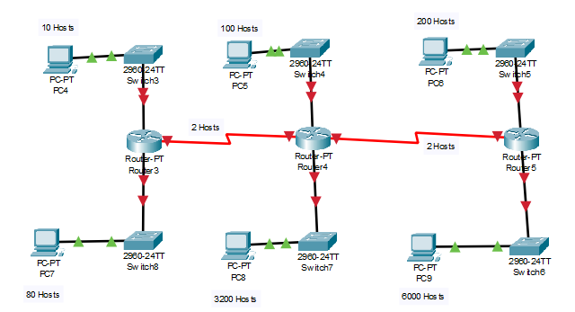
Address Space
192.168.1.0 / 20
First subnet (6000 hosts)
Required hosts = 6000 ≈ 8192 = 2^13 ,Prefix portion = 32 -13 = 19
Subnet mask = 11111111. 11111111.11100000. 00000000 =255.255.224.0
N.A= 192.168.1.0 /19
B.A= 192.168.000000001.00000000
192.168.00011111.11111111
192.168.31.255 /19

Second subnet (3200 hosts)
Required hosts 3200 ≈ 4096 = 2^12 ,Prefix portion = 32 -12 = 20
Subnet mask = 11111111. 11111111.11110000. 00000000 =255.255.240.0
N.A = 192.168.32.0 /20
B.A= 192.168.00100000.00000000
192.168.00101111.11111111
192.168.47.255/20
3rd subnet (300 hosts)
Required hosts 300 ≈ 512 = 2^9 ,Prefix portion = 32 -9 = 23
Subnet mask = 11111111. 11111111.11111110. 00000000 =255.255.254.0
N.A = 192.168.48.0 /23
B.A= 192.168.00110000.00000000
192.168.00110001.11111111
192.168.49.255/23
4th subnet (100 hosts)
Required hosts 100 ≈ 128 = 2^7 ,Prefix portion = 32 -7 = 25
Subnet mask = 11111111. 11111111.11111111. 10000000 =255.255.255.128
N.A = 192.168.50.0 /25
B.A= 192.168.00110010.00000000
192.168.00110010.01111111
192.168.50.127/25

5th subnet (80 hosts)
Required hosts 80 ≈ 128 = 2^7 ,Prefix portion = 32 -7 = 25
Subnet mask = 11111111. 11111111.11111111. 10000000 =255.255.255.128
N.A= 192.168.50.128 /25 ----------- B.A= 192.168.50.255/25

6th subnet (2 hosts)
Required hosts 2 ≈ 4 = 2^2 hosts ,Prefix portion = 32 -2 = 30
Subnet mask= 11111111. 11111111.11111111. 11111100 =255.255.255.252
N.A= 192.168.51.0 /30 ----------- B.A= 192.168.51.3/30

7th subnet (2 hosts)
Required hosts 2 ≈ 4 = 2^2 hosts ,Prefix portion = 32 -2 = 30
Subnet mask= 11111111. 11111111.11111111. 11111100 =255.255.255.252
N.A= 192.168.51.4 /30 ----------- B.A= 192.168.51.7/30

Subnet Table
Subnet | Assignable Adress Range | Subnet Mask | Subnet Address | Broadcast Address
First subnet (6000 hosts) | 192.168.1.1 /19 -192.168.31.254 /19 | 255.255.224.0 | 192.168.1.0 /19 | 192.168.31.255 /19
Second subnet (3200 hosts) | 192.168.32.1 /20-  192.168.47.254/20 | 255.255.240.0 | 192.168.32.0 /20 | 192.168.47.255/20
3rd subnet (300 hosts) | 192.168.48.1 /23 -  192.168.49.254 /23 | 255.255.254.0 | 192.168.48.0 /23 | 192.168.49.255/23
4th subnet  (100 hosts) | 192.168.50.1 /25 -  192.168.50.126/25 | 255.255.255.128 | 192.168.50.0 /25 | 192.168.50.127/25
5th subnet  (80 hosts) | 192.168.50.129 /25-  192.168.50.254/25 | 255.255.255.128 | 192.168.50.128 /25 | 192.168.50.255/25
6th subnet (2 hosts) | 192.168.51.1 /30 –  192.168.51.2/30 | 255.255.255.252 | 192.168.51.0 /30 | 192.168.51.3/30
7th subnet (2 hosts) | 192.168.51.5 /30 –  192.168.51.6/30 | 255.255.255.252 | 192.168.51.4 /30 | 192.168.51.7/30

Addressing table
Device | Interface | IP address | Subnet mask | Default Gateway
R3 | Fast ethernet 0/0 |  |  | N/A
R3 | Serial 2/0 |  |  | N/A
R3 | Serial 3/0 |  |  | N/A
R4 | Fast ethernet 0/0
R4 | Serial 2/0
R5 | Fast ethernet 0/0
R5 | Serial 3/0
PC4 | N/A
PC5 | N/A
PC6 | N/A
PC7 | N/A
PC8 | N/A
PC9 | N/A

