Student Task Manager System

Project Report

--------------------------------------------------

Course: CSE-3532 — Tools and Technologies for Internet Programming
Semester: Spring 2026 | 5th Semester | Section 5CM
Institution: International Islamic University Chittagong (IIUC)

Submitted by:
Mehedi Hasan Howlader (C241086)
Mohammad Sadman Tahiat (C241100)
Minhaj Hasan Rohan (C241101)

Submitted To: Ahasanul Kalam Akib
Adjunct Lecturer, Department of CSE, IIUC

Abstract
This project presents a Student Task Manager System, a full-stack web application built with the MERN Stack (MongoDB, Express.js, React.js, Node.js) to help university students manage their academic tasks efficiently. The system provides a centralized dashboard where students can create, edit, delete, and track tasks with deadlines, priority levels, and status indicators. It features secure authentication via email/password and Google OAuth (Firebase), interactive analytics with Chart.js visualizations, a responsive dark/light theme UI, and smart filtering, search, and sorting capabilities. The application addresses the real problem that 67% of university students struggle to organize academic tasks, leading to missed deadlines and lower academic performance. The system was developed as a semester project for the course CSE-3532 at International Islamic University Chittagong (IIUC).

1. Introduction
University students face increasingly demanding academic workloads. Managing multiple courses, assignments, lab reports, presentations, and personal responsibilities simultaneously is a significant challenge. Traditional methods such as scattered paper notes, generic reminder apps, or relying on memory do not provide structured priority assignment, deadline tracking, or centralized progress visualization.
The Student Task Manager System is a purpose-built web application designed to solve these challenges. It provides a centralized, intuitive, and modern dashboard where students can manage all their academic tasks from a single interface accessible on any device. The application uses the MERN stack along with Tailwind CSS for styling, Chart.js for analytics, and Firebase for Google authentication.

2. Problem Definition

2.1 Problem Statement
University students struggle to organize their academic tasks effectively. Existing solutions are either too generic (like to-do apps not designed for academic contexts) or too fragmented (using different tools for different purposes). There is a lack of a centralized, student-specific task management tool that combines task creation, deadline tracking, priority management, progress visualization, and analytics in one place.

2.2 Why This Project?
67% of university students struggle with task organization, leading to missed deadlines.
Traditional methods (paper notes, memory, generic apps) lack structured priority and deadline tracking.
No single tool is designed specifically for the academic workflow of university students.
Students need a responsive, accessible tool that works on any device (mobile, tablet, desktop).

3. Objectives
- Develop a full-stack MERN web application for student task management.
- Implement secure user authentication with email/password and Google OAuth via Firebase.
- Provide full CRUD (Create, Read, Update, Delete) operations on academic tasks.
- Enable task attributes: title, description, deadline, priority (Low/Medium/High), and status (Pending/In Progress/Completed).
- Build a productivity dashboard with summary statistics and interactive charts (Chart.js).
- Implement smart search, filtering, and sorting for efficient task retrieval.
- Design a responsive, accessible UI with dark/light theme support using Tailwind CSS.
- Ensure the application works seamlessly across mobile, tablet, and desktop devices.

4. System Analysis

4.1 Functional Requirements
ID | Requirement | Description
FR-01 | User Registration | Users can create an account with name, email, and password
FR-02 | User Login | Email/password login and Google OAuth (Firebase)
FR-03 | Task Creation | Create tasks with title, description, deadline, priority, status
FR-04 | Task Listing | View all tasks in grid/list layout for authenticated users
FR-05 | Task Editing | Edit any field of an existing task
FR-06 | Task Deletion | Permanently delete a task with confirmation dialog
FR-07 | Status Management | Cycle status: Pending → In Progress → Completed
FR-08 | Search Tasks | Real-time text search by task title
FR-09 | Filter Tasks | Filter by status and priority level
FR-10 | Sort Tasks | Sort by deadline (asc/desc) or creation date
FR-11 | Analytics Dashboard | Summary cards + Doughnut/Bar charts (Chart.js)
FR-12 | Theme Switcher | Dark/Light toggle with localStorage persistence
FR-13 | Protected Routes | Unauthenticated users redirected to Login page
FR-14 | User Profile | Display logged-in user name on dashboard
FR-15 | Logout | Clear stored tokens and user data on logout

4.2 Non-Functional Requirements
ID | Requirement | Description
NFR-01 | Performance | API responses within 500ms under normal load
NFR-02 | Security | bcryptjs hashing (12 rounds), JWT stateless auth
NFR-03 | Responsiveness | Mobile (320px+), tablet (768px+), desktop (1024px+)
NFR-04 | Usability | Intuitive UI with minimal onboarding, consistent design
NFR-05 | Compatibility | Modern browsers (Chrome, Firefox, Safari, Edge)
NFR-06 | Scalability | MongoDB Atlas + stateless backend for horizontal scaling
NFR-07 | Maintainability | Modular code with separation of concerns
NFR-08 | Availability | 99% availability target during development lifecycle
NFR-09 | Accessibility | Semantic HTML, ARIA labels, keyboard navigation

5. System Design

5.1 ER Diagram (Entity Relationship Diagram)
User (1) — (N) Task
User Entity: _id (PK), name, email (unique, lowercase), password (bcrypt-hashed), createdAt, updatedAt
Task Entity: _id (PK), user (FK → User._id), title, description, deadline, priority (Low/Medium/High), status (Pending/In Progress/Completed), createdAt, updatedAt
Relationship: One User has Many Tasks (1:N). Each Task belongs to exactly one User. All task queries are filtered by user._id using JWT authentication.

5.2 Data Flow Diagram (DFD)

Level 0 (Context Diagram)
Actor: Student (Browser)
Student → Student Task Manager System (Frontend React + Backend Express + MongoDB + Firebase Auth)
External Entities: MongoDB Atlas (database), Firebase Authentication (Google OAuth)

Level 1 (Detailed Processes)
Process 1.0 — Authentication: Student → Register/Login → Backend → MongoDB (User) / Firebase Auth → JWT returned → localStorage
Process 2.0 — Task Management: Student → CRUD Operations → Backend → MongoDB (Task, filtered by user._id) → JSON response → UI Render
Process 3.0 — Analytics: Student → Stats Request → Backend → Aggregates Task data by status/priority → Stats JSON → Chart.js Charts
Process 4.0 — Theme & UI: Student toggles theme → Context API → CSS variables change → localStorage persistence

6. Technology Used

Frontend
Technology | Version | Purpose
React | ^18.3.1 | UI component library
Vite | ^8.0.16 | Build tool and dev server
Tailwind CSS | ^3.4.13 | Utility-first CSS framework
React Router DOM | ^6.26.2 | Client-side routing
Axios | ^1.7.7 | HTTP client for API calls
Chart.js | ^4.4.4 | Data visualization library
React ChartJS 2 | ^5.2.0 | React wrapper for Chart.js
Firebase | ^12.15.0 | Google Authentication

Backend
Technology | Version | Purpose
Node.js | Runtime | JavaScript server runtime
Express.js | ^4.21.0 | Web framework for REST API
MongoDB | Cloud/Local | NoSQL document database
Mongoose | ^8.6.0 | ODM for MongoDB
bcryptjs | ^2.4.3 | Password hashing
jsonwebtoken | ^9.0.2 | JWT token generation/verification
CORS | ^2.8.5 | Cross-origin resource sharing
dotenv | ^16.4.5 | Environment variable management
Nodemon | ^3.1.4 | Auto-restart dev server

Dev Tools
- Git/GitHub — Version control and collaboration
- VS Code — Code editor
- Postman/cURL — API testing
- MongoDB Atlas — Cloud database hosting
- Chrome DevTools — Debugging and responsive testing

7. Database Design

7.1 User Collection
Sample document:
{"_id": "ObjectId", "name": "string", "email": "string (unique)", "password": "string (bcrypt)", "createdAt": "Date", "updatedAt": "Date"}

7.2 Task Collection
Sample document:
{"_id": "ObjectId", "user": "ObjectId (ref: User)", "title": "string", "description": "string", "deadline": "Date", "priority": "enum", "status": "enum", "createdAt": "Date", "updatedAt": "Date"}

7.3 Database Connection
The backend connects to MongoDB using Mongoose with two modes:
Production: MongoDB Atlas cloud cluster (connection string stored in .env)
Development: Falls back to mongodb-memory-server if local MongoDB is unavailable (data resets on server restart)
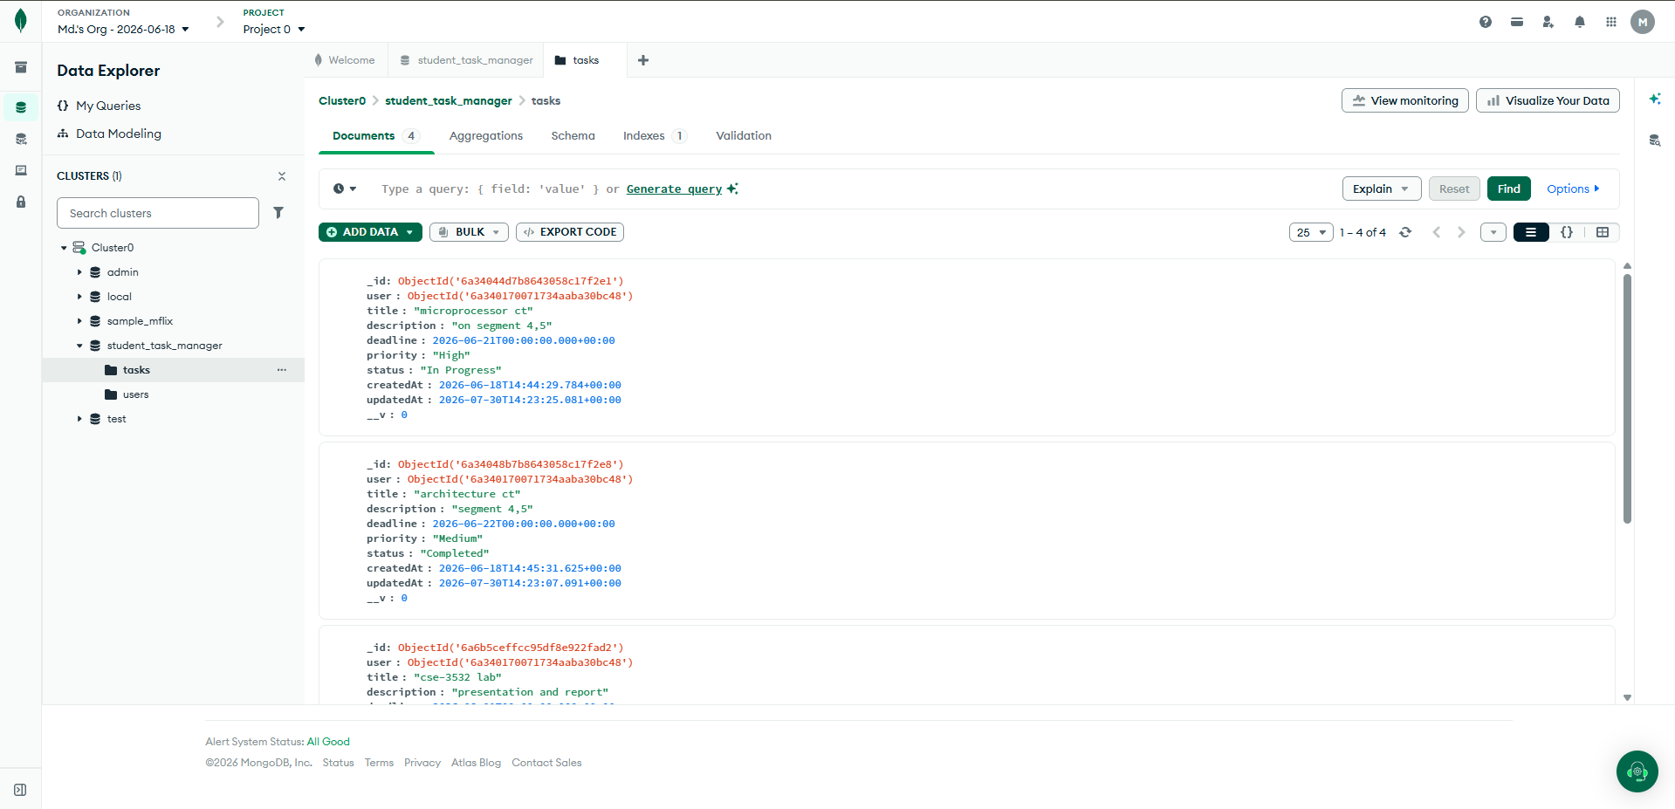
Figure: MongoDB Atlas Cluster — student_task_manager database
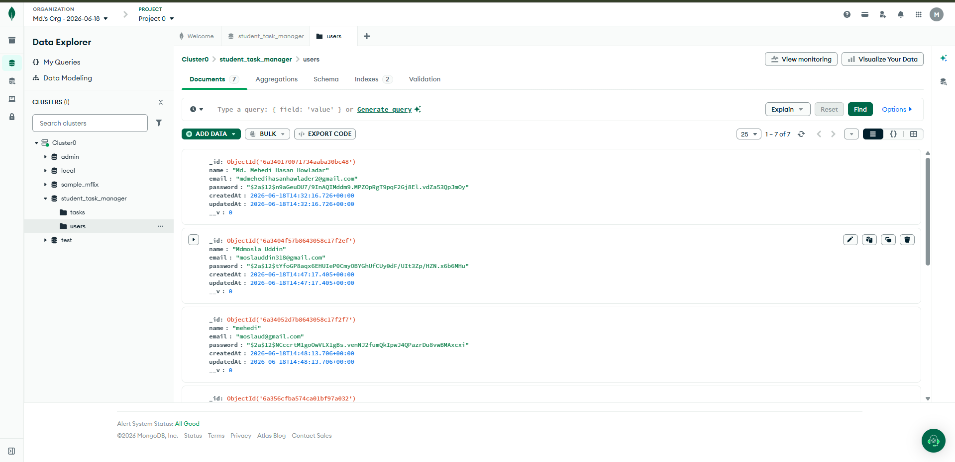
Figure: MongoDB Atlas — users collection

8. Screenshots of Project Pages

8.1 Landing Page
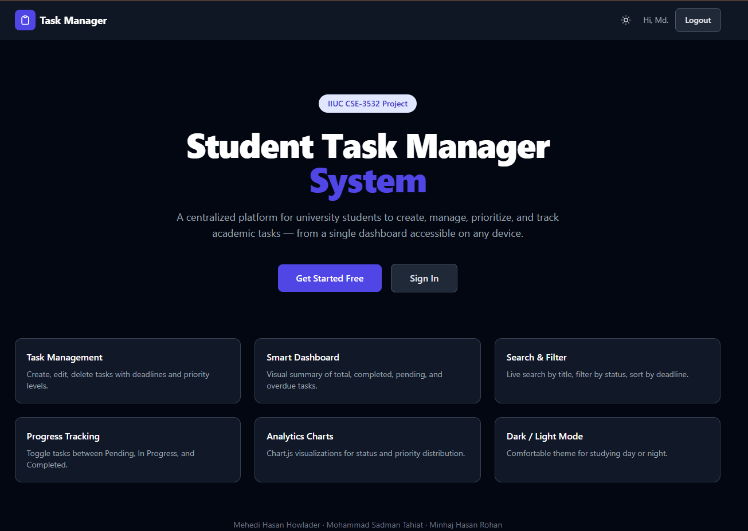
Figure: Landing page with hero section and feature cards overview.

8.2 Dashboard (Home Page)
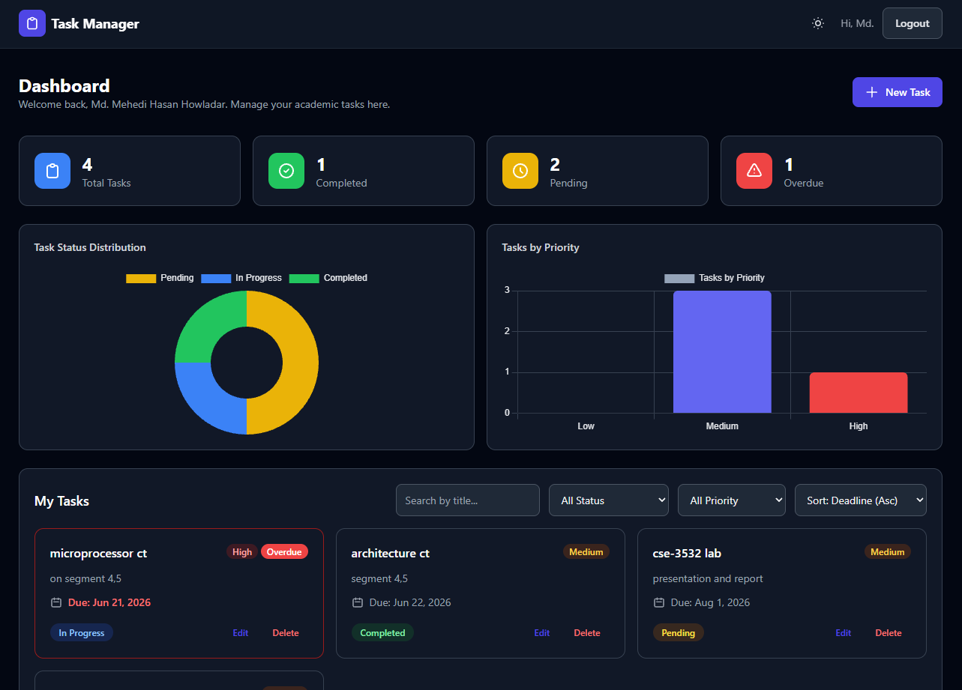
Figure: Dashboard with summary cards, charts, search, filters, and task list.

8.3 Dashboard (Light Theme)
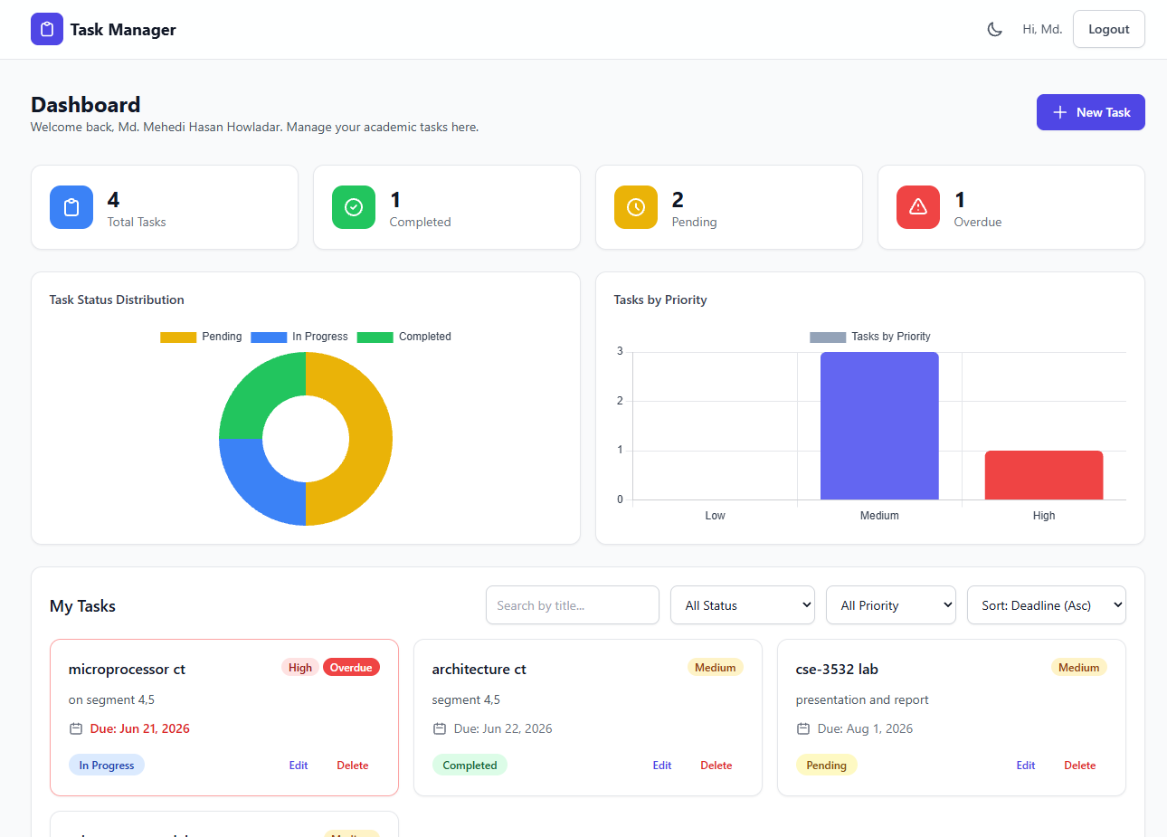
Figure: Dashboard in light theme mode.

8.4 Registration Page
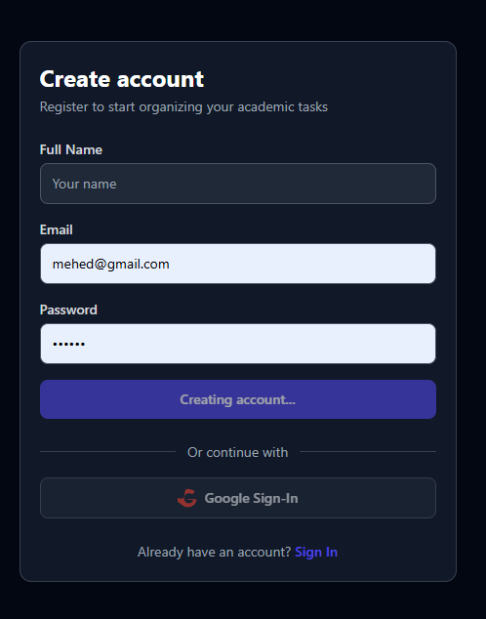
Figure: User registration page with name, email, and password fields.

8.5 Login Page
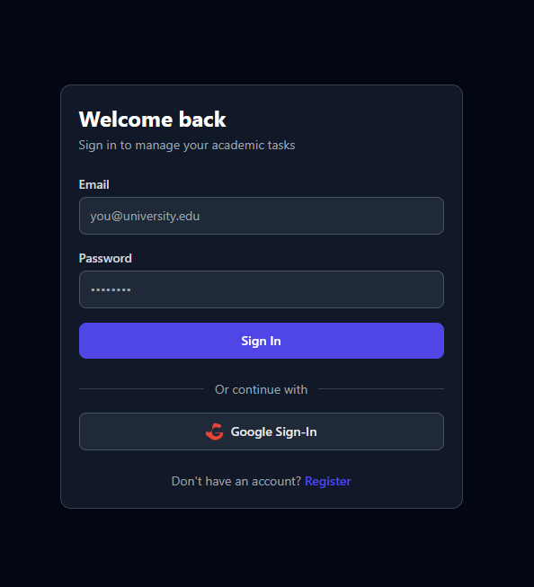
Figure: Login page with email/password form and Google Sign-In option.

8.6 Firebase Authentication (Google Sign-In)
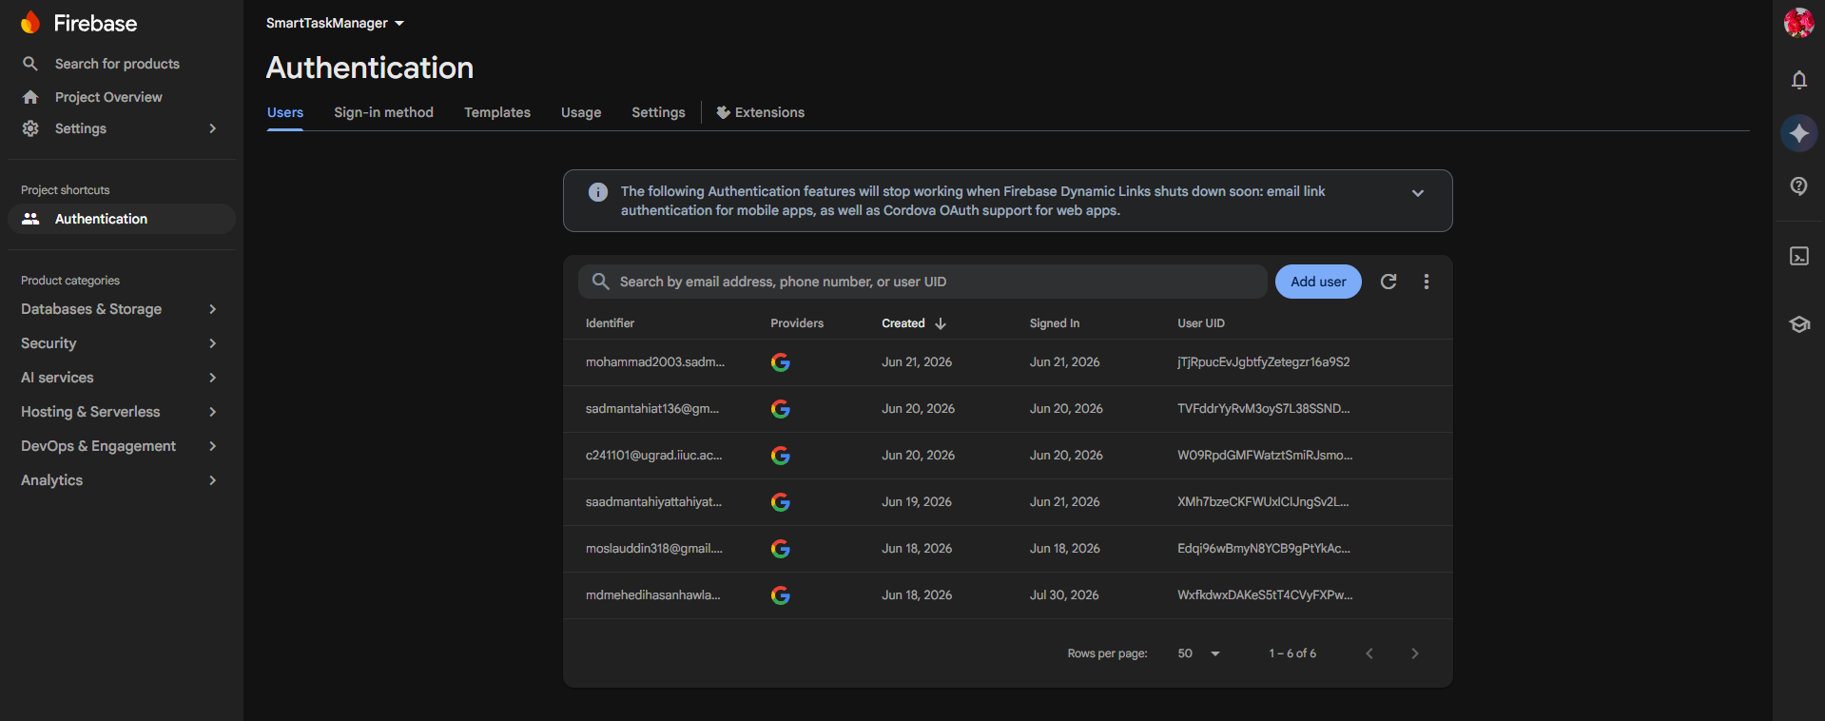
Figure: Google sign-in via Firebase Authentication.

8.7 Create Task
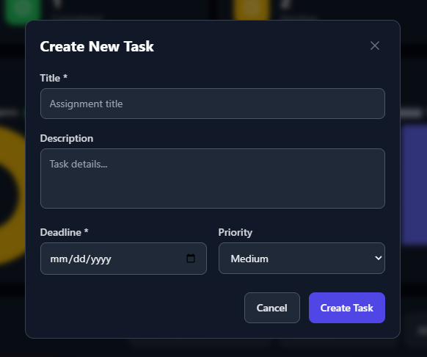
Figure: Creating a new task via the modal form with title, description, deadline, and priority.

8.8 Edit Task
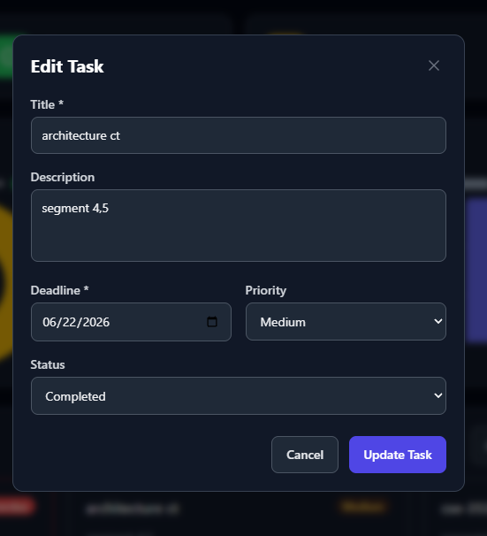
Figure: Editing an existing task.

9. Limitations
- No real-time notifications — the system does not send email or browser push notifications for approaching deadlines or task updates.
- No calendar view — tasks are listed in a grid; there is no calendar-based visualization of task timelines.
- No file attachments — users cannot upload documents, images, or notes within task cards.
- Single user scope — the application is designed for individual use; no collaboration or shared task features for group projects.
- No offline support — the application requires an active internet connection.
- No email verification — user registration does not require email verification, which could allow fake accounts.
- Limited analytics — the dashboard shows basic counts and distribution charts; advanced insights (trends over time) are not available.
- MongoDB Memory Server data loss — when using the in-memory fallback, all data is lost when the server stops.
- No API rate limiting — the API does not implement rate limiting, a potential security concern in production.
- No explicit input sanitization — additional XSS and injection protection beyond Mongoose schema validation is not implemented.

10. Future Scope
Smart Deadline Alerts: Integrate email notifications (nodemailer) and browser push notifications (Service Workers) for upcoming deadlines.
Calendar View: Build an interactive monthly/weekly calendar component showing task density, deadlines, and timelines.
Collaboration Boards: Add shared task boards for group projects, enabling team members to delegate and track subtasks.
AI Priority Assistant: Integrate a rule-based or ML model to analyze deadlines, descriptions, and history for priority suggestions.
Document Attachments: Allow uploads of lecture slides, notes, PDFs, screenshots inside task cards using GridFS or Firebase Storage.
React Native Mobile App: Develop a mobile companion with offline-first synchronization using AsyncStorage and background sync.
Localization / i18n: Implement multi-language support starting with Bengali translation for IIUC's Bengali-medium students.
Admin Panel: Create an instructor dashboard for course-level task completion statistics and oversight.
API Security Hardening: Implement express-rate-limit, Helmet.js, and Joi-based input validation for production readiness.
Email Verification & Password Reset: Add email verification on registration and a password reset flow using nodemailer or SendGrid.

11. Conclusion
The Student Task Manager System is a fully functional, full-stack MERN web application that successfully addresses the real challenge of academic task management for university students. By integrating secure authentication (email/password and Google OAuth), complete CRUD task management, interactive analytics with Chart.js, a responsive dark/light theme UI, and smart search/filter/sort capabilities, the system provides a cohesive and modern task management experience.
The project demonstrates the practical application of modern web development technologies: React for the frontend, Node.js and Express for the backend, MongoDB with Mongoose for data persistence, Tailwind CSS for responsive styling, Firebase for Google authentication, and Chart.js for data visualization. It follows best practices in code organization, modular architecture, and security (bcrypt password hashing, JWT authentication, protected routes).
While there are limitations — such as the lack of real-time notifications, calendar view, and collaboration features — the current scope delivers a solid foundation that can be extended with the future enhancements outlined in this report. The project successfully fulfills the requirements for the CSE-3532 course and serves as a learning reference for full-stack web development using the MERN stack.

