**CURRICULUM VITAE**

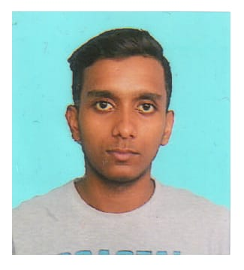**NAME:** MD. RAJIBUL ISLAM

**VILL:** TUBGRAM

**P.O:** KALIGRAM

**P.S**: KALIGRAM

**DIST:** BARDDHAMAN

**PIN:** 713102

**STATE:** WEST BENGAL

**MOBILE NO:** 9732472860

**WHATSAPP NO**: 9732472860

**EMAIL:** rajibul9786@gmail.com

**ABOUT MY FAMILY**

My Name Is Md.Rajibul Islam from Tubgram, Kaligram, Barddhaman.

My Father Mr.Asraf Mia is a Business Man & My Mother Mrs.Sahanara Bibi is a Home maker. I have two elder sisters & I am the younger one in my family.

**CAREER OBJECTIVE:**

To obtain a challenging position in the professional organization, where I can enhance my analytical and effective work capabilities, skills, and strengths in conjunction with the company’s goal and objectives.

**EDUCATIONAL QUALIFIACATION:**

Secondary Examination from WBBSE in the year 2017

Higher Secondary Examination from WBBHSE in the year 2019

**PROFESSIONAL QUALIFICATION:**

Recently I have Joined Diploma in Event Management. That I am pursuing from NIEM, situated in Kolkata.

**SKILLS & STRENGTHS:**

I firmly believe in people being the most important asset of an organization. Excellent interpersonal & communication skills, ability to create synergy within teams, computer proficiency and good human relation skills are some of my strengths. My ability to achieve targets and deliver results under pressurized environment helps me to perform beyond expectations.

**Extra Curricular Activities:**

Knowledge of computer applications

**Interests/Community Activities:**

Gardening

**Linguistic Abilities:**

English, Hindi, Bengali

**DECLARATION:**

I hereby declare that above information’s are correct and true to the best of my Knowledge and belief.

**Date:**

**Place:** Tubgram,Kaligram **S i g n a t u r e:**