A.HEMANTH

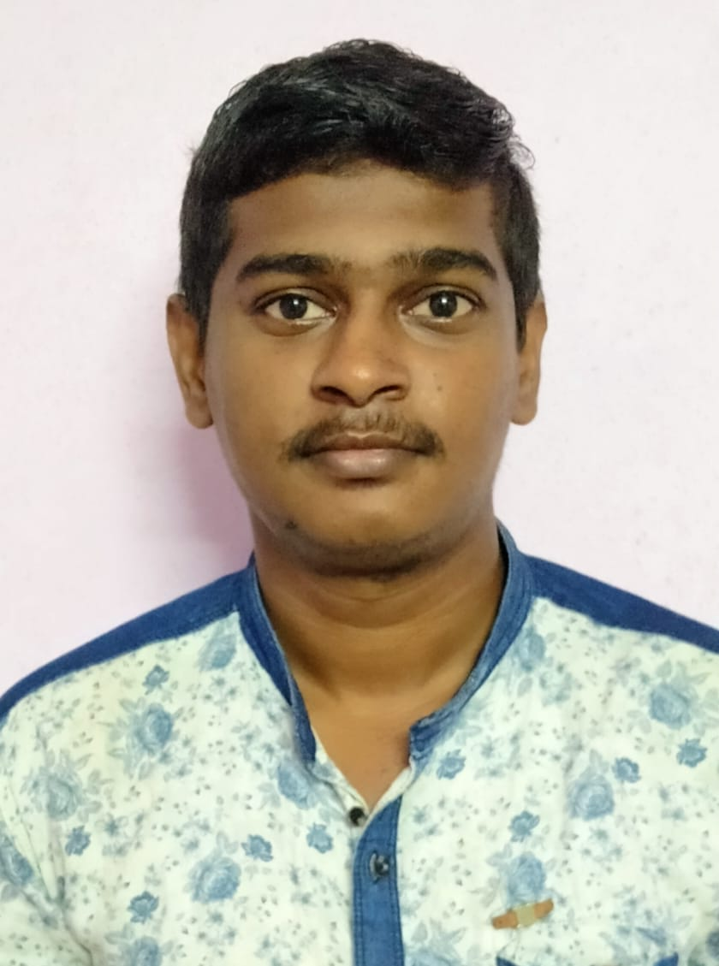

# S/O A.SRINIVASA RAO

# D NO :15-107

# Podili MANDAL,PRAKASAM

# DISTRICT - ,AP-523240

PHONE : 9618223233 [E-mail:adkhemanth8888@gmail.com](mailto:sokejaswanth5866@gmail.com)

# CAREER OBJECTIVE:

Seeking a challenging position in a reputed organization where I can learn new skills, expand

my knowledge of

networking, and leverage my learnings.

# ACADAMIC PROFILE:

|  |  |  |  |  |  |
| --- | --- | --- | --- | --- | --- |
| S.NO | Name of the Course | Institution | Board/University | Year | Marks |
| 1. | B.Tech[CSE] | Audisankara College of Engineering  and Technology | JNTUA,  Anantapur. | May,2023/Pursuing | 8.0% |
| 2. | Intermediate [PUC I&II] | Sri Chaitanya Junior College | Board of Intermediate Education. | April,2019 | 8.2% |
| 3. | SSC [10th] | NARAYANA  E.M  SCHOOL | Board of Secondary School Education. | May,2017 | 8.4% |

# INTERESTS:

Music & Surfing Internet

# PERSONAL PROFILE:

Name : A.HEMANTH

Father’s Name :A. SRINIVASA RAO

Date of Birth : 22/09/2001.

Nationality : Indian.

Marital Status : Unmarried.

Hobies : Travelling,Playing Cricket. Permanent Address : H.No: 15- 107

PODILI (village), PODILI[mandal], PRAKASAM[district]

AP- 523240

Languages Known : English, Telugu ,HINDI

# DECLARATION:

I hear by declared that the information furnished above is true to the best of my knowledge and belief.

Place:

Date: Signature