# *BIO DATA*

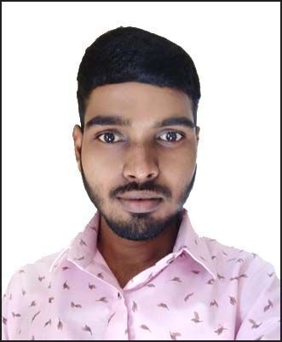

# Mangaldip Das

# Permanent Address:

**Vill – Darabastibala, P.O.- Bala,**

**P.S.- Chandrakona ,Dist:- Paschim Medinipur**,

**State-West Bengal, Pin-721201**

# Personal Profile

# Father’s Name : Lt. Gour Das

**Mother Name : Lt. Bhagyabati Das Date of Birth** : **10/06/1997** **Contact No. : 9800709690 Aadhar Number : 399275623626 Pan Number : CJSPD9775Q Voter Card Number : WUQ2122935 Sex : Male Cast : SC Marital Status : Unmarried Nationality : Indian Religion : Hinduism Languages known : Bengali, Hindi & English. E – Mail : dasmangal2016@gmail.com**

# Educational Qualification:

|  |  |  |  |  |
| --- | --- | --- | --- | --- |
| **Name Of Examination** | **Year** | **Board/Institute Name** | **Total Marks** | **% of Marks** |
| **Madhyamik** | **2013** | **W.B.B.S.E** | **365** | **52.14%** |
| **H.S** | **2015** | **W.B.C.H.S.E** | **324** | **64.80%** |
| **Graduate** | **2020** | **N.S.O.U** | **1046** | **67.48%** |

**Extra Qualification :- Diploma in Computer 1 Year.**

**:- Certificate Examination For Business Correspondents/Facilitators(BCA)**

**:­- Certificate Examination For Aadhaar Supervisor/Operator.**

**:- Certificate Examination For Debt Recovery Agent.(DRA).**

**Work Experience :- Business Correspondent Agent at CANARA BANK. (18 Nov 2019 to Still Now)**

**Declaration:**

**I hereby declare that the above-mentioned information are correct up to my knowledge and I bear the responsibility for the correctness of the above-mentioned particulars.**

**Date :- ………………………...**

**_______________________________**

**Place :- ………….................... ( Mangaldip Das)**