|  |
| --- |
|  |
| Liquidity and Market Dynamics in Bangladesh:  An Empirical Study of the Call Money Rate’s Influence on Equity Performance |
|  |

**Liquidity and Market Dynamics in Bangladesh:  
An Empirical Study of the Call Money Rate’s Influence on Equity Performance**

Internship report submitted to the IBA Career Centre, Institute of Business Administration to fulfill the degree of **Master of Business Administration**

**Submitted by:**Mehedi Hasan Ahmed  
Roll: ZR 201-64-007  
Batch: MBA 64D

**Supervised by:**Homayara Latifa Ahmed  
Associate Professor  
Institute of Business Administration, University of Dhaka

22 May, 2025

**Tanisha Bukth**  
Assistant Professor & Coordinator, IBA Career Center  
Institute of Business Administration  
University of Dhaka

**Subject: Submission of Internship Report**

Dear Madam,

With due respect, I am pleased to formally submit my internship report titled **“Liquidity and Market Dynamics in Bangladesh: An Empirical Study of the Call Money Rate’s Influence on Equity Performance.”** This report encapsulates the analytical work I have conducted during my internship at LR Global Asset Management Company Limited. The study draws from secondary data and time-series econometric techniques to investigate how short-term liquidity, measured by the call money rate, impacts the capital market performance in Bangladesh.

I have made sincere efforts to ensure that the report is thorough, academically rigorous, and aligned with the guidelines provided by the Institute. I believe the report fulfills the learning objectives of the MBA internship program and offers practical insights relevant to both academia and industry.

This report has been prepared under the direct supervision of **Homayara Latifa Ahmed**, Associate Professor, IBA. Please note that this report is submitted solely for academic purposes, and no part of it will be reproduced, disclosed, or used for any other intent without prior authorization.

Thank you for your kind consideration.

Sincerely,  
**Mehedi Hasan Ahmed**  
Roll No: ZR 201-64-007  
Batch: MBA 64D  
Institute of Business Administration  
University of Dhaka

Acknowledgement

I would like to express my deepest gratitude to everyone who has supported and guided me throughout the course of my internship and the preparation of this report.

Firstly, I would like to thank **LR Global Bangladesh Limited** for providing me with the opportunity to conduct my internship within such a dynamic and intellectually stimulating environment. The experience has significantly enriched my understanding of financial markets and investment research in the context of Bangladesh.

I am especially thankful to **Ms. Mst. Sharmin Sultana Sumi**, Investment Advisor at LR Global Bangladesh, and **Mr. Md. Sivlee Rahman**, Senior Research Analyst – Global Market, for their valuable direction, constructive feedback, and generous support in granting access to essential data sources and analytical resources. Their guidance has played a critical role in shaping the empirical foundation of this report.

I would also like to extend my sincere appreciation to my academic supervisor, **Homayara Latifa Ahmed**, Associate Professor, Institute of Business Administration, University of Dhaka, for her continuous support, insightful feedback, and encouragement throughout the development of this report.

Finally, I am grateful to the IBA Career Center for coordinating the internship process and ensuring a structured academic experience.

Table of Contents

Executive Summary viii

Chapter 1 Introduction 1

1.1. Background of the Study 1

1.2. Problem Statement 1

1.3. Research Questions 1

1.4. Research Objectives 2

1.5. Significance of the Study 2

Chapter 2 Literature Review 3

2.1. Macroeconomic and Institutional Influences on Capital Markets 3

2.2. Direct Impact of Call Money Rate on Market Capitalization 3

2.3. Lead-Lag Dynamics: Global Perspective from the U.S. Market 3

2.4. Real-World Relevance: Insights from India’s Money Market 4

2.5. Summary 4

Chapter 3 Theoretical Framework and Hypotheses 5

3.1. Theoretical Framework 5

3.1.1. Liquidity Preference Theory 5

3.1.2. Efficient Market Hypothesis (EMH) 5

3.1.3. Monetary Transmission Mechanism 5

3.1.4. Relationship Between Short-Term Interest Rates and Capital Markets 6

3.2. Hypotheses Development 6

Chapter 4 Methodology 7

4.1. Research Design 7

4.2. Variable Definitions 7

4.3. Hypothesis Testing Approach 7

4.4. Econometric Models 8

4.5. Analytical Tools and Techniques 8

4.6. Justification of Methodology 9

4.7. Regression Implementation Details 9

4.8. Data Preparation and Cleaning 9

4.9. Stationarity Check 10

Chapter 5 Exploratory Data Analysis (EDA) 11

5.1. Descriptive Statistics 11

5.2. Trend Visualization 12

5.3. Sector Comparison 14

Chapter 6 Regression Results and Discussion 16

6.1. Impact of Call Money Rate on Market Performance (H1) 16

6.2. Sectoral Sensitivity to Liquidity Changes (H2) 16

6.3. Investor Behavior (H3) 16

6.4. Summary Table: Regression Results 17

6.5. Interpretation 17

Chapter 7 Summary of Findings 18

7.1. Investor Behavior (H3) 18

7.2. Overall Market Performance (H1) 18

7.3 Sectoral Sensitivity (H2) 18

7.4. Overall Reflection 19

Chapter 8 Conclusion and Policy Implications 20

8.1. Conclusion 20

8.2. Policy Implications 20

Chapter 9 Limitations and Future Scope 22

9.1. Limitations 22

9.2. Future Scope 22

References 24

Appendix 25

Appendix A: Summary of Full Dataset 25

Appendix B: ADF Test Results 26

Appendix C: Correlation Matrix 27

Appendix D: Sector Indices Over Time 28

Appendix E: Full Regression Results 29

List of Tables and Figures

List of Tables

Table 4.1 Variable Definitions 7

Table 5.1 Descriptive Statistics 11

Table 5.2 Correlation between Sectors and Call Money Rate (%) 14

Table 6.1 Summary Table: Regression Results 17

List of Figures

Figure 5.1 DSEX Index vs Call Money Rate (2009–2025) 13

Figure 5.2 Trading Volume vs Call Money Rate (2009–2025) 13

Figure 5.3 Top 5 Liquidity-Sensitive Sectors vs Call Money Rate (2009–2025) 15

List of Acronyms

|  |  |
| --- | --- |
| Acronym | Full Form |
| DSE | Dhaka Stock Exchange |
| DSEX | Dhaka Stock Exchange Broad Index |
| NBFI | Non-Bank Financial Institution |
| ADF | Augmented Dickey-Fuller Test |
| OLS | Ordinary Least Squares |
| EDA | Exploratory Data Analysis |

# Executive Summary

This report examines the impact of short-term liquidity using the call money rate, on the performance of Bangladesh’s capital market over the period from January 2009 to February 2025. As liquidity is a core component of monetary policy and a key indicator of market functioning, understanding its relationship with equity market performance is essential for policymakers, investors, and regulatory bodies. The study investigates how fluctuations in the call money rate affect the overall market index (DSEX), sectoral indices, and investor behavior, which is replaced by trading volume as a proxy.

The analysis is based on monthly time-series data sourced from the Bangladesh Bank and Dhaka Stock Exchange. Conventional econometric methods followed by the Augmented Dickey-Fuller test examined the variables stationarity; non-stationary series were differenced further. Using ordinary least squares (OLS) regression, one found the link between the call money rate and market performance across different industries. First hypotheses are validated and trends graphically checked using exploratory data analysis as well.

The results suggest a statistically significant negative correlation between the DSE index and the call money rate, therefore implying that tighter liquidity conditions link general market performance to downturns. Sectors including Fuel, Real Estate, Tannery, and Pharmaceuticals exhibit sector-wise increasing sensitivity to changes in the call money rate, therefore reflecting their reliance on capital or investor mood. Conversely, sectors such as Textile and NBFI show a positive connection reflecting distinct structural dynamics or investment flows. The first visual trends showed a negative link between liquidity and trading volume, but the regression analysis failed to find statistical significance suggesting that other unobserved or lagged variables might affect investor behavior.

These insights highlight the significant contribution monetary policy makes to define the behavior of capital markets. Though global liquidity tightening influences the market overall, the degree and direction of that influence differ greatly among sectors. This calls for more tailored policy issues, particularly with relation to liquidity management in an emerging market such as Bangladesh. The work provides a basis for next research to analyze more complex models integrating extra macroeconomic elements, non-linear impacts, and investor-level behavior, thus better guiding policy and investment choices.

# Introduction

## Background of the Study

The call money market is a vital component of the short-term financial system, where funds are borrowed and lent for one day without collateral. Managing liquidity among banks and financial institutions depends on this market to a major extent. A key indicator of liquidity situation in the economy, the call money rate is the interest rate at which these temporary funds are moved. Often acting as a signal for the direction of central bank policy, changes in this rate reflect the dynamics of supply and demand for money in the banking system.

In many countries, especially underdeveloped ones like Bangladesh, the call money rate has far-reaching effects outside the interbank market. Capital markets could react to changes in the call money rate if they are sensitive to changes in liquidity and interest rates. Higher rates could mean that there is less money available, which would make buyers less willing to take risks and affect how well the stock market does. A low call money rate, on the other hand, could mean that there is a lot of cash on hand, which would encourage stockholders to spend. As financial markets become more linked, it is important for both market participants and lawmakers to understand this link.

## Problem Statement

There is a lot of research on how broad monetary policy tools, like central bank policy rates, affect capital markets. However, there isn't as much research on how short-term interbank funding conditions, like the call money rate, directly affect capital markets in Bangladesh. In a developing country with an emerging financial system, sudden shortages of cash can put too much stress on capital markets, which can change how investors feel and the prices of assets.

There isn't a lot of systematic empirical study that looks at how changes in the call money rate affect the performance of the stock market, especially at the sector level. This study looks at the changing connection between short-term liquidity (shown by the call money rate) and the Bangladeshi stock market to fill that gap. It also wants to find out if some areas are more affected by liquidity shocks than others. This will help us understand how the market really works.

## Research Questions

1. Does the call money rate significantly affect the performance of the stock market in Bangladesh?
2. Are specific sectors of the capital market more sensitive to changes in the call money rate?
3. How do investors react to shifts in short-term liquidity conditions?

## Research Objectives

* To analyze the relationship between call money rate fluctuations and overall market performance, particularly the DSEX index.
* To investigate the sensitivity of various industry sectors to changes in the call money rate.
* To explore investor behavior and capital flow dynamics in response to short-term liquidity shifts.

## Significance of the Study

This research offers valuable insights for multiple stakeholders in the financial ecosystem. The regulators and policymakers can enhance the effectiveness of monetary policy transmission by understanding how the call money rate impacts market performance. According to the results, investors and financial analysts can use them to make better portfolio allocation decisions by finding areas that are more or less vulnerable to liquidity shocks. Moreover, this study contributes to the academic literature on financial intermediation and market efficiency in emerging economies, highlighting the nuanced interactions between short-term money markets and long-term capital markets.

# Literature Review

The relationship between short-term liquidity indicators, particularly the call money rate, and capital market performance has garnered significant academic and policy interest. This section reviews both local and international literature addressing the influence of macroeconomic and institutional factors—especially the call money rate—on stock market performance.

## 2.1. Macroeconomic and Institutional Influences on Capital Markets

Islam et al. (2017) used data from 1995 to 2015 to examine the macroeconomic and institutional determinants of the Dhaka Stock Exchange’s (DSE) performance. They applied ordinary least squares (OLS) regression on two sets of variables: internal (market capitalization, turnover, total issued capital) and external (GDP, CPI, inflation, and FDI inflows). The results indicated that both macroeconomic and institutional factors significantly influenced market performance, with **GDP and CPI showing particularly strong explanatory power**. Although the **call money rate was not directly included**, the role of inflation and other liquidity-related variables provided a foundational understanding of how short-term economic stressors might affect capital markets.

## 2.2. Direct Impact of Call Money Rate on Market Capitalization

A more targeted investigation was conducted by Hasan and Chokroborty (2024), who empirically evaluated the **impact of foreign exchange reserves, inflation, and call money rates on market capitalization** in Bangladesh from 2010 to 2022. Using monthly data and log-linear regression models, their findings revealed a **statistically significant negative relationship between the call money rate and market capitalization**, implying that rising borrowing costs in the short-term money market exert downward pressure on stock prices. In contrast, inflation and foreign exchange reserves had **positive and significant impacts**. This study provides **strong empirical evidence supporting the hypothesis that liquidity tightness, reflected through the call money rate, adversely affects the capital market**.

## 2.3. Lead-Lag Dynamics: Global Perspective from the U.S. Market

Guo et al. (2011) provided a global perspective by exploring the **temporal relationship between the U.S. stock market and short-term interest rates**, including the Federal Funds Rate (FFR). The study used the **Thermal Optimal Path (TOP) method** and found that the **S&P 500 index leads changes in the FFR and Treasury yields** which is contrary to conventional theories where interest rates are presumed to lead stock markets This implies that while the stock market itself can affect central bank conduct, investors might **react in expectation of changes in monetary policy**. These results provide a methodological and theoretical framework for investigating **bidirectional or reverse causality between capital market fluctuations** and liquidity indicators such as the call money rate for the present research.

## 2.4. Real-World Relevance: Insights from India’s Money Market

A Recent Reuters (2025) analysis indicates modern policy issues with liquidity in India's call money industry. Officials of central banks warned that **declining money market liquidity—shown in volatile call money rates—may cause disturbance** of more general financial market stability. This underscores **the practical significance of monitoring short-term borrowing costs** and their ripple effects across financial instruments, including equities. These real-world dynamics confirm the need to research the **call money rate as a substitute for liquidity stress** and its ability to affect investor attitude and market activity.

## 2.5. Summary

The reviewed literature collectively supports the core hypothesis of this study is that changes in the call money rate, as a reflection of short-term liquidity conditions, have a measurable impact on capital market performance. Some studies talk about this directly (Hasan & Chokroborty, 2024), while others give a bigger picture of the economy (Islam et al., 2017), methodological insights (Guo et al., 2011), or policy ideas from the real world (Reuters, 2025). This review gives a strong theoretical and empirical basis for looking at how investors in Bangladesh's capital market react to changes in the call money rate and how sensitive different sectors are to those changes.

# Theoretical Framework and Hypotheses

## Theoretical Framework

This study is underpinned by a combination of financial and economic theories that explain how short-term interest rates such as the call money rate may influence capital market dynamics. The key theoretical pillars of this research are:

### Liquidity Preference Theory

Proposed by John Maynard Keynes, the Liquidity Preference Theory posits that interest rates are the price for parting with liquidity. Investors require higher interest rates to compensate for the risk and inconvenience of lending money instead of holding it. In the context of capital markets, when short-term rates rise—such as the call money rate—investors may prefer the relative safety and returns of money markets over riskier equity investments. This behavior can reduce demand for equities, depressing stock prices.

Higher call money rates, therefore, signal tighter liquidity conditions and increase the opportunity cost of holding equities, leading to a potential decline in stock market activity and valuations (Keynes, 1936).

### Efficient Market Hypothesis (EMH)

The EMH, particularly in its semi-strong form, suggests that stock prices incorporate all publicly available information, including interest rates. However, unexpected fluctuations in the call money rate—especially during liquidity shocks—can result in rapid adjustments in asset prices. The EMH supports the idea that markets respond almost immediately to new information related to monetary policy signals and liquidity conditions.

Thus, movements in the call money rate serve as both a monetary signal and a liquidity indicator, potentially triggering immediate market reactions.

### Monetary Transmission Mechanism

The monetary transmission mechanism explains how changes in interest rates affect economic activities and asset prices. When central banks adopt a tighter monetary stance, reflected through increases in the call money rate, it raises borrowing costs, reduces investment, and ultimately lowers corporate profitability expectations. These effects transmit into the capital market through a drop in stock prices and investment sentiment.

In emerging markets like Bangladesh, where monetary tools are more liquidity-sensitive than rate-sensitive, the call money rate plays a direct role in transmitting monetary shocks to the stock market (Mishkin, 1996).

### Relationship Between Short-Term Interest Rates and Capital Markets

Existing literature, both theoretical and empirical, supports a generally **inverse relationship** between short-term interest rates and stock market performance. As rates rise, the present value of future earnings diminishes due to higher discounting, and safe assets become more attractive than equities. Moreover, sectors such as financials and real estate tend to be more sensitive to interest rate changes than others like consumer staples.

This interest rate–equity market dynamic offers a critical foundation for assessing sectoral sensitivity to changes in the call money rate.

## Hypotheses Development

Based on the theoretical framework and prior empirical findings, the study proposes the following hypotheses:

#### **H1:**

There is a negative relationship between the monthly average call money rate and the DSEX index performance in Bangladesh.

#### **H2:**

Different industry sectors exhibit varying levels of sensitivity to changes in the call money rate, with interest rate-sensitive sectors showing a stronger inverse relationship.

#### **H3:**

Investor behavior, measured by trading volume or volatility, changes significantly in response to abrupt movements in the call money rate, reflecting liquidity-based sentiment shifts.

# Methodology

## 4.1. Research Design

This study adopts a **quantitative, time-series-based empirical approach** to examine the impact of short-term liquidity (proxied by the call money rate) on capital market performance in Bangladesh. The analysis covers monthly data from **January 2009 to February 2025**, enabling investigation over multiple market cycles and monetary policy phases.

The research follows a **deductive reasoning structure**, starting from theoretical hypotheses derived from macro-financial literature and testing them through statistical methods using real-world data.

## 4.2. Variable Definitions

Table . Variable Definitions

|  |  |  |
| --- | --- | --- |
| **Variable Type** | **Variable** | **Description** |
| Dependent Variable | DSE | Normalized DSEX index, rebased to 1000 by LRG team |
| Dependent Variable | Sector Indices | 19 sector indices (Bank, Cement, Food, etc.) rebased to 1000 |
| Dependent Variable | Total Volume | Monthly trading volume (proxy for investor behavior) |
| Independent Variable | Call Money Rate (%) | Monthly weighted average, from Bangladesh Bank |

## 4.3. Hypothesis Testing Approach

The study tests the following hypotheses:

* **H1**: Call money rate has a significant negative effect on the DSE index.
* **H2**: Different industry sectors exhibit different sensitivities to changes in the call money rate.
* **H3**: Investor behavior, proxied by trading volume, responds to liquidity fluctuations.

## 4.4. Econometric Models

#### **Model 1: Impact on Market Performance (DSE)**

This model captures the direct impact of short-term borrowing costs on the normalized broad market index.

#### **Model 2: Sectoral Sensitivity**

For each sector *i*:

This model is run individually across the 19 sector indices to identify sectors most sensitive to liquidity changes.

#### **Model 3: Investor Behavior**

Here, the trading volume captures elasticity in market participation with respect to liquidity pressure.

## 4.5. Analytical Tools and Techniques

* **Descriptive Statistics**: To understand distribution, spread, and basic behavior.
* **Pearson Correlation**: To identify linear relationships between variables.
* **Ordinary Least Squares (OLS) Regression**: To test the significance and direction of relationships.
* **Dual-Axis Plotting**: For visual alignment of market response with liquidity trends.

The analysis is conducted using **Python (Pandas, Statsmodels, Seaborn)** due to its flexibility and reproducibility in handling financial time series data.

## 4.6. Justification of Methodology

OLS regression is appropriate as the first approach due to the linear nature of the relationship being tested, and the large time span improves the robustness of coefficient estimates. Moreover, analyzing each sector separately allows for **cross-sectoral comparison**, directly addressing Hypothesis 2. By applying these models to monthly data, the research captures medium-term reactions while filtering out excessive daily noise.

## 4.7. Regression Implementation Details

Prior to regression estimation, all-time series variables were tested for stationarity using the **Augmented Dickey-Fuller (ADF) test**. Variables found to be non-stationary (e.g., DSE, total volume, most sector indices) were transformed using **first differences** to ensure robustness and avoid spurious regression. Only variables that were stationary in level form (e.g., Fuel, Textile, NBFI, Engineering, and Call Money Rate) were retained in their original form.

The regression models were estimated using **Ordinary Least Squares (OLS)** via the statsmodels package in Python. Each regression included a constant term, and results were assessed based on **coefficient sign**, **statistical significance (p-value)**, and **R-squared** values. Separate models were run for each sector and for the overall DSE index to allow for individualized sector sensitivity interpretation.

## 4.8. Data Preparation and Cleaning

**Data Preparation**

The dataset (Appendix A) used in this study was carefully constructed by collecting and integrating data from multiple sources, with the goal of capturing both capital market dynamics and short-term liquidity conditions in Bangladesh. The key variables include sectoral index values, a normalized market-wide index (DSE), total trading volume, and the call money rate.

**Market Index and Sectoral Data**

The stock market-related data, including sectoral indices and trading volume, was collected from internal resources compiled by the LRG research team. These datasets include daily index values for 19 distinct sectors (e.g., Bank, Cement, Engineering, Pharmaceuticals, etc.) as well as the DSEX index, which represents the broader market performance. Notably, the DSEX index provided was **normalized and rebased to 1000**, consistent with how the sector indices were treated. This normalized version, referred to as “DSE” in the dataset, ensures comparability across sectors and time. The normalization was handled internally by the LRG team, using standard financial base-year re-indexing methods.

All data were compiled into a single CSV file and read into a pandas Data Frame in Python. The date column was converted into datetime format and set as the index to facilitate time-series analysis. Since the original data was in daily frequency, it was resampled into monthly frequency for consistency with the call money rate data.

**For monthly aggregation:**

The last trading day of each month was used to represent the monthly value of each index. The total trading volume was aggregated using a sum to capture total investor activity for the month.

**Call Money Rate Data**

The monthly weighted average call money rate was sourced from the official website of Bangladesh Bank, available in Excel format. The dates were standardized to match the stock market dataset in YYYY-MM format, and the column was renamed for clarity. This dataset was then merged with the previously prepared market index data using a left join on the monthly date column.

**Final Dataset Structure**

After merging, all rows containing missing values were dropped to ensure a clean and consistent dataset. The final Data Frame spans 193 monthly observations from January 2009 to February 2025, and includes:

* DSE index: normalized DSEX index (rebased to 1000)
* 19 sectoral indices: including Bank, Cement, Fuel, Pharmaceuticals, etc.
* Total trading volume: monthly sum of shares traded
* Call money rate (%): monthly weighted average (liquidity indicator)

This dataset serves as the empirical foundation for the exploratory, regression, and sectoral sensitivity analyses in the following sections of the study.

## 4.9. Stationarity Check

The Augmented Dickey-Fuller (ADF) test was applied to all series. Only a few variables (Engineering, NBFI, Fuel, Textile, and Call Money Rate) were stationary in level form. All others (including DSE, total volume, and most sectors) required first differencing to ensure stationarity. This step ensures valid regression results by avoiding spurious correlations.

# Exploratory Data Analysis (EDA)

## 5.1. Descriptive Statistics

Table . Descriptive Statistics

|  |  |  |  |  |  |  |  |  |
| --- | --- | --- | --- | --- | --- | --- | --- | --- |
| Sector/Metric | Count | Mean | Std Dev | Min | 25% | 50% | 75% | Max |
| DSE | 193.0 | 2883.31 | 854.26 | 1032.77 | 2248.63 | 2784.52 | 3515.92 | 4647.83 |
| Bank | 193.0 | 2123.77 | 715.03 | 663.22 | 1433.85 | 2148.55 | 2896.76 | 3634.17 |
| Cement | 193.0 | 2376.52 | 722.28 | 914.33 | 1773.18 | 2485.60 | 2926.99 | 4147.09 |
| Ceramics | 193.0 | 965.71 | 266.32 | 532.33 | 745.77 | 928.56 | 1196.14 | 1700.92 |
| Engineering | 193.0 | 2445.75 | 545.67 | 1046.51 | 2077.10 | 2442.66 | 2773.67 | 4334.92 |
| NBFI | 193.0 | 2145.40 | 834.41 | 880.69 | 1553.09 | 2034.90 | 2418.87 | 5918.47 |
| Food | 193.0 | 13899.44 | 7573.61 | 1086.75 | 4723.33 | 15891.90 | 19047.40 | 26697.10 |
| Fuel | 193.0 | 2185.38 | 417.76 | 993.20 | 1922.43 | 2192.52 | 2436.27 | 3188.76 |
| Insurance | 193.0 | 2639.20 | 1101.43 | 998.56 | 1901.23 | 2218.69 | 3411.95 | 5494.77 |
| IT | 193.0 | 1491.04 | 470.22 | 758.87 | 1160.87 | 1344.16 | 1652.33 | 2695.23 |
| Jute | 193.0 | 4302.83 | 3319.38 | 743.11 | 1741.18 | 2886.36 | 5704.23 | 15524.60 |
| Miscellaneous | 193.0 | 2076.18 | 1271.38 | 789.26 | 1029.37 | 1280.50 | 3440.39 | 4551.75 |
| Mutual Fund | 193.0 | 505.97 | 164.67 | 232.41 | 354.50 | 494.52 | 643.18 | 950.08 |
| Paper | 193.0 | 484.42 | 285.88 | 135.78 | 297.95 | 399.09 | 611.48 | 1303.97 |
| Pharmaceuticals | 193.0 | 3157.99 | 1467.53 | 1016.42 | 1660.22 | 3059.12 | 4337.05 | 5861.10 |
| Service & Real Estate | 193.0 | 2449.67 | 864.71 | 967.39 | 1782.77 | 2251.58 | 3008.72 | 4421.40 |
| Tannery | 193.0 | 2678.89 | 1053.68 | 940.24 | 1872.18 | 2712.10 | 3040.98 | 6156.37 |
| Textile | 193.0 | 2085.36 | 646.37 | 1050.80 | 1696.51 | 2021.21 | 2322.72 | 5413.57 |
| Travel & Leisure | 193.0 | 920.80 | 432.60 | 408.94 | 574.81 | 776.17 | 1116.82 | 2459.07 |
| Telecommunication | 193.0 | 2917.80 | 1311.49 | 882.63 | 1559.91 | 2884.00 | 4263.56 | 5347.00 |
| Total Volume | 193.0 | 3,032,099,000 | 2,404,394,000 | 43,956,976 | 1,442,649,000 | 2,342,839,000 | 3,520,136,000 | 14,660,170,000 |
| Call Money Rate (%) | 193.0 | 6.25 | 3.80 | 0.72 | 3.74 | 5.49 | 8.03 | 33.54 |

Table 5.1 presents the descriptive statistics for the DSEX index, 19 sectoral indices, total trading volume, and the call money rate based on 193 monthly observations from January 2009 to February 2025. The DSEX index, representing overall capital market performance, has a mean of 2,883 points, with values ranging from 1,033 to 4,648. This reflects considerable variability in the market over the study period, also evident in its standard deviation of 854, indicating periods of high volatility. Among sectors, Food recorded the highest average index value (13,899) and also the widest dispersion (standard deviation ≈ 7,574), suggesting large-scale valuation shifts in that sector. On the opposite end, Paper and Mutual Fund sectors showed relatively low average index values, 484 and 506 respectively, with narrower variability.

The call money rate, the primary independent variable in this study, has a mean of 6.25%, a standard deviation of 3.80, and ranges between 0.72% and 33.54%. This wide range indicates multiple liquidity regimes—including severe squeezes and easy money phases—during the observation period. These fluctuations are essential to capture potential responses in market indices. The total trading volume, used as a proxy for investor activity, averaged around 3.03 billion shares per month, ranging from 43 million to over 14.66 billion, confirming periods of both stagnation and extreme market participation. Such dynamics support the relevance of Hypothesis 3, which investigates how short-term liquidity affects investor behavior.

Sectoral indices such as Insurance, Telecommunication, Tannery, and Textile also showed significant dispersion, indicating varying degrees of market sensitivity. These disparities suggest that certain sectors may be more exposed to liquidity changes, supporting the rationale for testing Hypothesis 2. Overall, the descriptive statistics confirm the presence of sufficient variation in both dependent and independent variables, justifying further econometric analysis.

## 5.2. Trend Visualization

Figure 5.1 illustrates the co-movement of the DSEX Index (left y-axis, blue line) and the call money rate (right y-axis, red line) over the period from January 2009 to February 2025. The graph utilizes a dual-axis format to accommodate the differing scales of the two variables, allowing a clearer comparative visualization. The DSEX index shows multiple cyclical trends throughout the sample period. Notably, the index surged between 2009 and 2010, reaching a significant peak in early 2011, followed by a sharp correction. Interestingly, this peak coincides with a sudden and extreme spike in the call money rate, which touched over 30%, suggesting a possible liquidity shock that may have contributed to the market downturn.

In subsequent years, the call money rate stabilized at relatively lower levels, especially between 2015 and 2020, during which the DSEX index exhibited a more gradual upward trend. However, from 2021 onward, the DSEX experienced strong growth followed by volatility, while the call money rate began climbing again after years of relative stability. This inverse pattern—where periods of high call money rates often align with or precede corrections in the DSEX index—supports the theoretical expectation that tighter liquidity conditions may exert downward pressure on stock prices. It sets the stage for a more formal regression analysis to empirically test the direction and significance of this relationship.

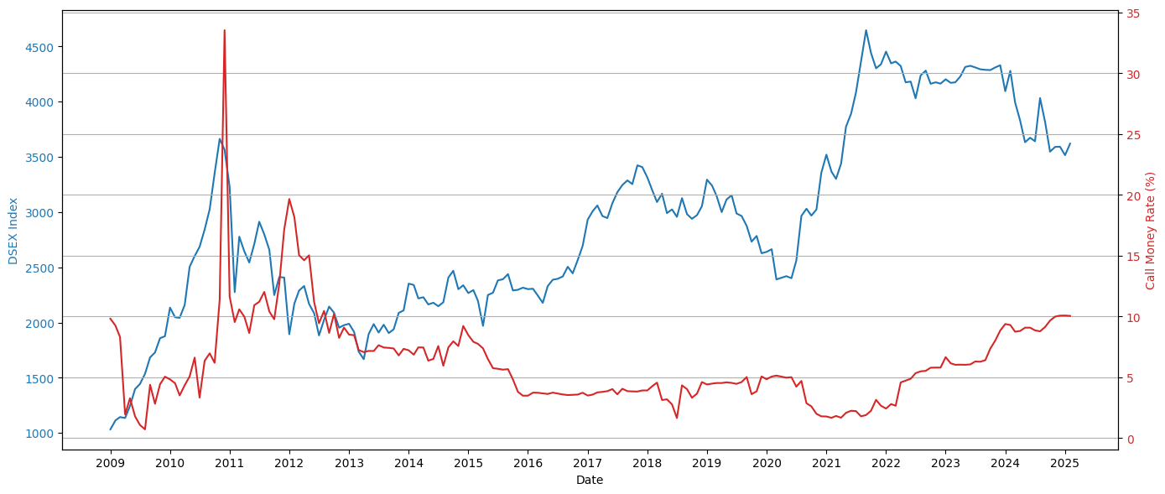

Figure . DSEX Index vs Call Money Rate (2009–2025)

Figure 5.2 shows the movement of total monthly trading volume alongside the call money rate. A preliminary visual inspection suggests periods of inverse movement, where spikes in the call money rate correspond to reduced trading activity, indicating possible investor caution under tight liquidity conditions. This supports the investigation under Hypothesis H3.

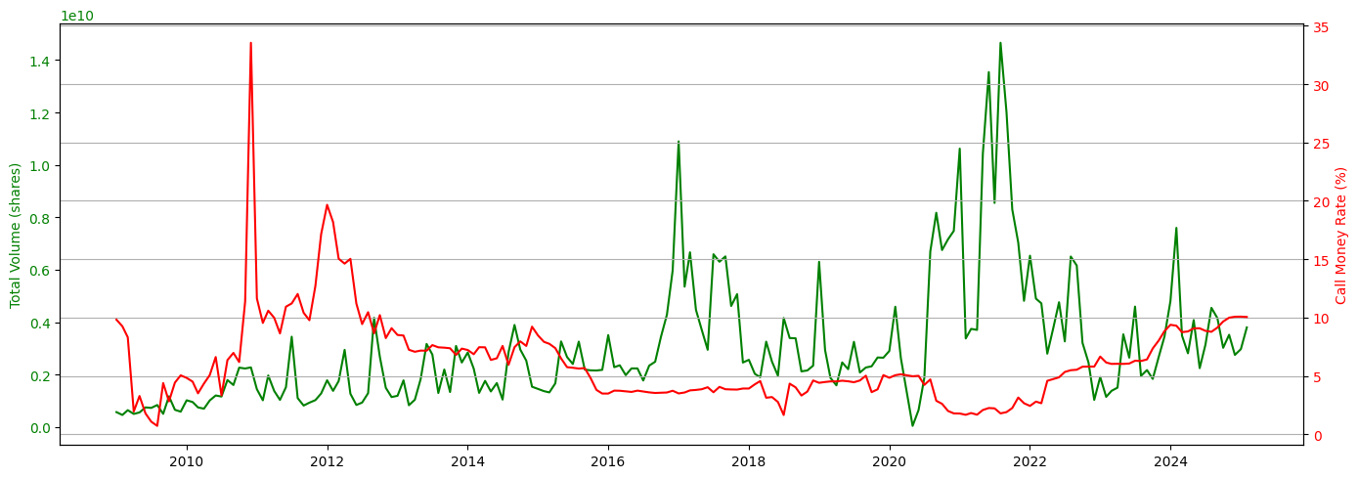

Figure . Trading Volume vs Call Money Rate (2009–2025)

## 5.3. Sector Comparison

Table . Correlation between Sectors and Call Money Rate (%)

|  |  |
| --- | --- |
| Sector | Correlation |
| Food | -0.390931 |
| Telecommunication | -0.389184 |
| Pharmaceuticals | -0.338814 |
| Fuel | -0.313968 |
| Mutual Fund | -0.275975 |
| Tannery | -0.254355 |
| Cement | -0.177111 |
| Jute | -0.153091 |
| Service & Real Estate | -0.144401 |
| IT | -0.122726 |
| Ceramics | -0.065379 |
| Bank | 0.010812 |
| Insurance | 0.026850 |
| Engineering | 0.035456 |
| Miscellaneous | 0.129501 |
| NBFI | 0.255777 |
| Paper | 0.376560 |
| Textile | 0.475744 |
| Travel & Leisure | 0.586170 |

Table 5.2 and Figure (Appendix C) present the correlation matrix between the DSEX index, sectoral indices, total trading volume, and the call money rate for the period January 2009 to February 2025. The goal of this analysis is to understand the strength and direction of linear relationships between liquidity conditions (proxied by the call money rate) and capital market variables. The DSEX index shows a mildly negative correlation with the call money rate (-0.11), suggesting that market-wide performance tends to decline during tight liquidity periods, although the relationship is not particularly strong. In contrast, sectoral indices exhibit varying levels of sensitivity, both in magnitude and direction. Notably, the following sectors display the strongest negative correlation with the call money rate:

* Food: -0.39
* Telecommunication: -0.39
* Pharmaceuticals: -0.34
* Fuel: -0.31
* Mutual Fund: -0.28

These findings support the idea that certain sectors are more liquidity-sensitive, likely due to their capital-intensive nature or high dependence on investor sentiment. Conversely, a few sectors such as Textile (0.48) and Travel & Leisure (0.59) exhibit positive correlations, which may imply either delayed market response or structural resilience to liquidity changes. Furthermore, total trading volume is negatively correlated with the call money rate (-0.32), reinforcing the interpretation that liquidity tightening discourages market participation. This correlation structure validates Hypothesis 2 and partially supports Hypothesis 3, motivating the next phase of regression analysis to establish causality and statistical significance.

Figure 5.3 presents the five sectors most negatively correlated with the call money rate: Food, Telecommunication, Pharmaceuticals, Fuel, and Mutual Funds. These sectors exhibited substantial downward movement during periods of rising short-term borrowing costs, as indicated by the red dashed line representing the call money rate (right axis). The Food sector, in particular, showed the strongest negative correlation (-0.39), suggesting that tight liquidity conditions may significantly influence investor sentiment or financial performance in this segment. Similarly, Telecommunications and Pharmaceuticals demonstrated moderate sensitivity. This dual-axis visualization offers early evidence supporting Hypothesis 2, indicating that capital market responses to monetary tightening are not uniform and that sector-level heterogeneity is a crucial dimension to investigate further through econometric analysis.

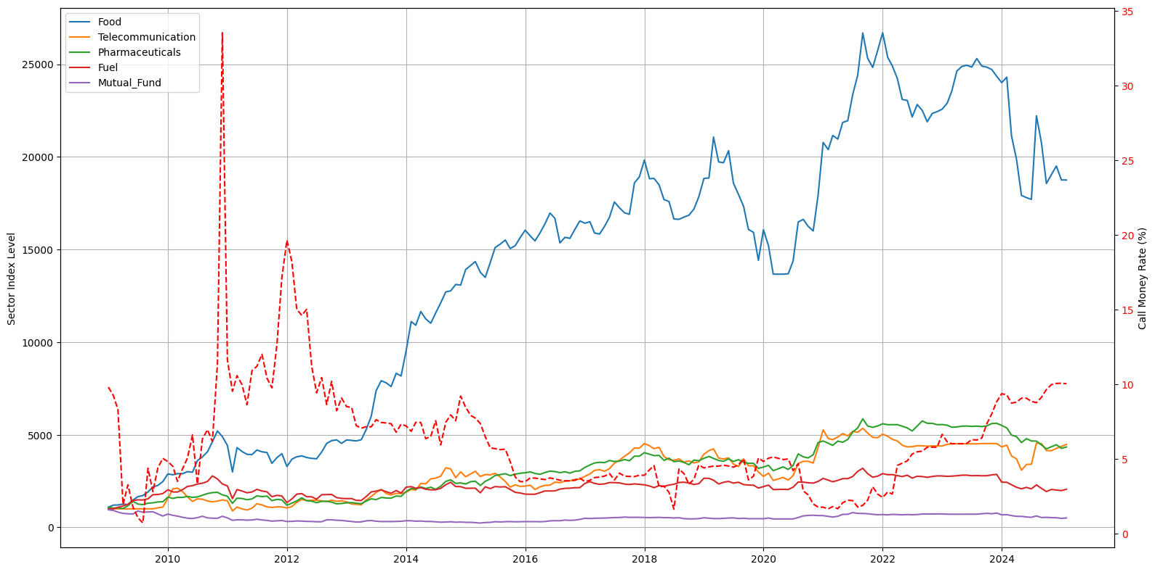

Figure . Top 5 Liquidity-Sensitive Sectors vs Call Money Rate (2009–2025)

The figure (Appendix D) displays the performance of 19 sector indices rebased to 1000, as constructed by the LRG research team, over the period 2009–2025. The chart provides a high-level overview of relative index movements across sectors. While certain sectors—such as Food, Jute, and Tannery—show exceptional long-term growth, others exhibit more moderate behavior. However, due to the high number of lines and some overlaps, the chart becomes visually dense.

# Regression Results and Discussion

## 6.1. Impact of Call Money Rate on Market Performance (H1)

The regression model estimating the effect of the call money rate on the overall market (proxied by the normalized DSEX index) yields a β coefficient of -7.83 with a p-value of 0.0122, indicating a statistically significant inverse relationship. This result supports Hypothesis 1, suggesting that increases in the call money rate—representing tighter liquidity—lead to declines in the stock market index. The R-squared value is 0.0326, implying that changes in liquidity explain about 3.3% of the variation in monthly DSE movements, which is reasonable for a single-variable macro-financial model.

## 6.2. Sectoral Sensitivity to Liquidity Changes (H2)

Table 6.1 summarizes the regression results for 19 sector indices and their relationship with the call money rate. Sectors demonstrated varying levels of sensitivity:

* The **Textile** sector showed the strongest positive relationship (β = +80.98, p < 0.001), implying that it tends to perform better during periods of higher call money rates. This could suggest delayed market reaction, reliance on different financing structures, or defensive investment flows.
* In contrast, **Fuel** (-34.54, p < 0.001) and **Miscellaneous** (-13.71, p = 0.0006) sectors were negatively and significantly affected, indicating high sensitivity to liquidity tightening. Other negatively impacted sectors include:
  + **Service & Real Estate** (-14.41, p = 0.0075)
  + **Tannery** (-10.46, p = 0.0089)
  + **Pharmaceuticals** (-7.01, p = 0.0160)
  + **IT** (-6.34, p = 0.0200)

These results validate **Hypothesis 2**, confirming that the impact of liquidity conditions is not uniform across industries. Sectors with capital-intensive operations or speculative investor interest are more exposed to monetary shocks.

## 6.3. Investor Behavior (H3)

The relationship between the call money rate and total trading volume was found to be statistically insignificant (β = -5.13 million, p = 0.8726). This suggests that changes in short-term interest rates do not have an immediate or linear impact on overall investor participation in the market. Thus, Hypothesis 3 is not supported by the regression results. Possible explanations include offsetting investor sentiment factors, market frictions, or institutional buffering mechanisms.

## 6.4. Summary Table: Regression Results

Table . Summary Table: Regression Results

|  |  |  |  |  |
| --- | --- | --- | --- | --- |
| Sector/Variable | β (Beta) | p-value | R² | Significance |
| Textile | +80.98 | 0.0000 | 0.2263 | Significant Positive |
| Fuel | -34.54 | 0.0000 | 0.0986 | Significant Negative |
| NBFI | +56.21 | 0.0003 | 0.0654 | Significant Positive |
| Miscellaneous | -13.71 | 0.0006 | 0.0605 | Significant Negative |
| Service & Real Estate | -14.41 | 0.0075 | 0.0371 | Significant Negative |
| Tannery | -10.46 | 0.0089 | 0.0354 | Significant Negative |
| DSE (Market) | -7.83 | 0.0122 | 0.0326 | Significant Negative |
| Pharmaceuticals | -7.01 | 0.0160 | 0.0301 | Significant Negative |
| IT | -6.34 | 0.0200 | 0.0281 | Significant Negative |
| Bank, Food, Cement, etc. | Various | > 0.05 | Low | Not Significant |
| Total Volume | -5.13M | 0.8726 | 0.0001 | Not Significant |

## 6.5. Interpretation

The results confirm that market-wide performance (DSE) and several sectors are **negatively affected** by liquidity tightening (higher call money rates), consistent with **liquidity preference theory** and the **monetary transmission mechanism**. Sectors like **Fuel**, **Real Estate**, and **Tannery** are highly liquidity-sensitive, likely due to capital needs or speculative investment behavior. The **positive and significant impact** on **Textile** and **NBFI** may point to industry-specific dynamics that warrant further qualitative exploration.

# Summary of Findings

## 7.1. Investor Behavior (H3)

**EDA Observation:** Visual inspection of the line chart comparing total trading volume and call money rate (Figure X) suggested a potential inverse relationship. Periods of elevated call money rates appeared to coincide with reduced trading volume, implying reduced investor activity during liquidity tightening. This pattern provided preliminary support for Hypothesis 3.

**Regression Result:** The regression analysis, however, revealed a statistically insignificant relationship between changes in the call money rate and trading volume (β = -5.13 million, p = 0.8726). The R² value was negligible, indicating that liquidity does not significantly explain fluctuations in monthly trading volume.

**Interpretation:** Although the EDA implied investor sensitivity to liquidity shocks, this was not confirmed statistically. The apparent pattern may be due to other unobserved factors or may reflect non-linear or lagged responses not captured in the current model. Hypothesis 3 is not supported by the regression evidence.

## 7.2. Overall Market Performance (H1)

**EDA Observation:** Line plots of the DSE index and call money rate indicated periods of co-movement, particularly where spikes in the call money rate were followed by corrections in the DSE index.

**Regression Result:** The regression model showed a significant negative relationship (β = -7.83, p = 0.0122) between the call money rate and changes in the DSE index. This suggests that higher borrowing costs and tighter liquidity are associated with market-wide downturns. The result directly supports Hypothesis 1.

**Interpretation**: Both visual and statistical analyses align, confirming that short-term liquidity tightening negatively impacts the capital market at the index level in Bangladesh.

## 7.3 Sectoral Sensitivity (H2)

**EDA Observation:** Pearson correlation results showed moderate to strong negative correlations between the call money rate and several sector indices, especially **Food**, **Telecommunication**, **Fuel**, and **Mutual Fund**, suggesting that some industries might be more exposed to liquidity shocks.

**Regression Result**: The regression models revealed sectoral heterogeneity in sensitivity:

* Sectors like Fuel, Miscellaneous, Tannery, Service Real Estate, and Pharmaceuticals showed significant negative β coefficients (p < 0.05), validating their sensitivity to liquidity.
* Interestingly, Textile and NBFI showed significant positive relationships with the call money rate, suggesting resilience or contrarian movement.
* Several sectors (e.g., Bank, Food, Cement, Mutual Fund) showed no statistically significant response.

**Interpretation:** These findings partially confirm Hypothesis 2, highlighting that not all sectors are equally affected by liquidity changes. Capital-intensive or speculative sectors tend to respond negatively, while others may be influenced more by structural or sector-specific dynamics.

## 7.4. Overall Reflection

The analysis confirms that:

* The call money rate has a statistically and economically meaningful impact on the overall market index.
* Some industry sectors are highly sensitive, while others are insulated or reactive in unexpected ways.
* Investor behavior, measured through trading volume, appears visually linked to liquidity, but is not statistically significant in this model.

This integrated view reinforces the importance of combining visual diagnostics and formal modeling to develop a robust understanding of financial market dynamics.

# Conclusion and Policy Implications

## 8.1. Conclusion

This study empirically examined the influence of short-term liquidity, represented by the call money rate, on the performance of Bangladesh's capital market from January 2009 to February 2025. The research used time-series econometric models to look at the impact on the broad market index (DSEX), sectoral indices, and behavior of investors as shown by trading volume.

The results show that there is a statistically significant negative link between the call money rate and the DSE index. This means that higher call money rates, which indicate less available cash, hurt the performance of the market as a whole. When looking at different sectors, we saw that some were more sensitive to changes in liquidity than others. For example, the textile, fuel, and non-bank financial institutions (NBFIs) sectors were more sensitive. On the other hand, there was no statistically significant link between the call money rate and trade volume. This suggests that changes in short-term liquidity may not directly affect the number of investors who participate.

These results show how important monetary policy is in shaping the way the Bangladeshi capital market works. The different sectoral sensitivities show that policymakers need to think about policies that take into account how they will affect different companies in different ways.

## 8.2. Policy Implications

The study's outcomes have several policy implications for financial regulators, policymakers, and market participants:

1. **Monetary Policy Calibration**: Given the significant impact of call money rates on market indices, the Bangladesh Bank should consider the broader capital market implications when formulating monetary policies. A balanced approach that mitigates inflation without unduly constraining market liquidity is essential.
2. **Sector-Specific Strategies**: The different sensitivities in different sectors imply that a one-size-fits-all solution could not be able to solve problems. Targeted support or legislative changes for particularly sensitive industries, such NBFIs and Fuel, could help to improve market stability in times of liquidity constraint.
3. **Enhancing Market Liquidity**: Initiatives to deepen the capital market, such adding new financial instruments and supporting more general investor involvement, should be given top priority in order to offset the negative consequences of liquidity restrictions.
4. **Investor Education and Protection**: Educating investors about the implications of monetary policy changes can help in managing expectations and reducing market volatility. Strengthening investor protection mechanisms will also bolster confidence during periods of economic adjustment.
5. **Data Transparency and Timeliness**: Improving the availability and timeliness of financial data, including call money rates and sectoral performance metrics, will aid in more responsive and informed decision-making by all stakeholders.

In sum, the interaction between capital market performance and short-term liquidity situations in Bangladesh is multifarious and complicated. To create a strong and inclusive financial ecosystem, policymakers have to take a comprehensive and flexible attitude, considering both macroeconomic goals and sector-specific dynamics.

# Limitations and Future Scope

## 9.1. Limitations

While the study provides meaningful insights into the relationship between short-term liquidity (call money rate) and capital market performance in Bangladesh, several limitations should be acknowledged:

1. **Univariate Regression Models:** The econometric models focused on the call money rate as the sole independent variable. In reality, capital markets are influenced by multiple macroeconomic and geopolitical factors such as interest rates, inflation, GDP growth, political events, and foreign investment inflows. Omitting these may result in omitted variable bias.
2. **Linear Relationship Assumption:** Ordinary Least Squares (OLS) regression assumes linearity between variables. However, market responses to liquidity conditions may be non-linear or subject to threshold effects that the model does not capture.
3. **Stationarity Treatment by Differencing:** While differencing helps achieve stationarity, it may remove long-term trend information. This limits the interpretation of long-run relationships between variables.
4. **Sector Index Construction:** The sector indices were already rebased by the LRG research team. While useful for comparison, rebasing may mask absolute performance or valuation metrics critical to investors or regulators.
5. **Trading Volume Proxy for Investor Behavior:** Trading volume was used as a proxy for investor sentiment. However, volume may be influenced by structural factors like institutional rebalancing or regulatory changes, which are not modeled.
6. **Data Constraints:** The study used monthly data, which smooths out high-frequency volatility but may also mask short-term shocks or lagged effects. Additionally, limited access to granular investor-level or intra-sector data constrained deeper behavioral analysis.

## 9.2. Future Scope

Future research can extend the current work in the following directions:

1. **Multivariate Modeling:** Incorporate other macroeconomic indicators such as inflation, interest rates, exchange rates, and global market indices to build a more comprehensive model of capital market behavior.
2. **Dynamic or Non-linear Models:** Explore advanced time-series models such as Vector Auto Regression (VAR), Threshold Regression, or Machine Learning-based forecasting to capture complex interactions between liquidity and the market.
3. **Lagged Effects and Causality Testing:** Test for lagged impacts of liquidity shocks using Granger causality or impulse response functions to determine directionality and delay in market response.
4. **Investor Type Differentiation:** Analyze trading behavior across investor types (institutional vs. retail) if data permits, as their sensitivity to liquidity condition may differ significantly.
5. **Policy Event Analysis:** Investigate how specific monetary policy announcements or regulatory changes influence the relationship between liquidity and market outcomes.
6. **Cross-Market Comparison:** Compare Bangladesh’s market dynamics with other emerging economies in South Asia to assess whether observed liquidity sensitivities are unique or part of a regional pattern.

# References

Ahmed, M. H. (2025). DSE_CMR_project [Jupyter notebook]. GitHub. <https://github.com/Mehedi24434/DSE_CMR_project/blob/main/working_notebook.ipynb>

Bangladesh Bank. (n.d.). Monthly average call money market rates. <https://www.bb.org.bd/en/index.php/publication/publictn/3/10>

Dhaka Stock Exchange. (n.d.). Recent market information. <https://www.dsebd.org/recent_market_information_more.php>

Fama, E. F. (1970). Efficient capital markets: A review of theory and empirical work. Journal of Finance, 25(2), 383–417. <https://doi.org/10.2307/2325486>

Gurley, J. G., & Shaw, E. S. (1960). Money in a theory of finance. Brookings Institution.

Hasan, M. R., & Sultana, S. (2017). Macroeconomic and institutional determinants of capital market performance in Bangladesh: A case of Dhaka Stock Exchange. IOSR Journal of Business and Management (IOSR-JBM), 19(10), 1–12. <https://www.iosrjournals.org/iosr-jbm/papers/Vol19-issue10/Version-4/A1910040112.pdf>

Islam, M. M., & Noman, S. M. (2019). Impact of foreign exchange reserve, inflation and call money rate on market capitalization of Dhaka Stock Exchange. The Cost and Management, 47(3), 19–25. <https://www.icmab.org.bd/wp-content/uploads/2020/12/04.Impact-of-Foreign-Exchange.pdf>

Keynes, J. M. (1936). The general theory of employment, interest, and money. Macmillan.

LR Global Bangladesh. (2025). Sectoral index and trading volume datasets [Internal data archive].

Mishkin, F. S. (1996). The channels of monetary transmission: Lessons for monetary policy (NBER Working Paper No. 5464). National Bureau of Economic Research. <https://doi.org/10.3386/w5464>

Rapach, D. E., Strauss, J. K., & Zhou, G. (2016). The U.S. stock market leads the federal funds rate and Treasury bond yields. Journal of Financial Economics, 121(3), 569–591. <https://doi.org/10.1016/j.jfineco.2016.06.011>

# Appendix

*Supporting Materials and Supplementary Results*

## Appendix A: Summary of Full Dataset

| **Date** | **DSE** | **Bank** | **Cement** | **...** | **Telecommunication** | **Total Volume** | **Call Money Rate (%)** |
| --- | --- | --- | --- | --- | --- | --- | --- |
| 2009-01-01 | 1032.77 | 868.63 | 1006.07 | ... | 1000.00 | 569,083,533 | 9.82 |
| 2009-02-01 | 1114.10 | 798.45 | 1015.33 | ... | 1000.00 | 460,763,854 | 9.25 |
| 2009-03-01 | 1144.00 | 663.22 | 914.33 | ... | 1000.00 | 643,641,302 | 8.31 |
| 2009-04-01 | 1135.64 | 858.42 | 915.12 | ... | 1000.00 | 500,314,714 | 1.95 |
| 2009-05-01 | 1245.34 | 850.36 | 949.60 | ... | 1000.00 | 557,243,295 | 3.28 |
| 2009-06-01 | 1398.13 | 1079.18 | 1137.05 | ... | 1000.00 | 749,497,009 | 1.79 |
| 2009-07-01 | 1443.77 | 1012.97 | 1101.87 | ... | 1000.00 | 729,662,040 | 1.08 |
| 2009-08-01 | 1535.89 | 980.62 | 1097.16 | ... | 1000.00 | 839,900,266 | 0.72 |
| 2009-09-01 | 1684.49 | 980.48 | 1141.63 | ... | 1000.00 | 503,183,057 | 4.39 |
| 2009-10-01 | 1728.88 | 1028.99 | 1165.78 | ... | 1000.00 | 1,171,265,505 | 2.82 |
| 2009-11-01 | 1858.51 | 1315.17 | 1314.82 | ... | 1052.02 | 657,109,039 | 4.43 |
| 2009-12-01 | 1876.22 | 1353.71 | 1360.75 | ... | 1095.85 | 586,419,798 | 5.05 |
| 2010-01-01 | 2135.30 | 1498.89 | 1546.24 | ... | 1559.91 | 1,020,694,538 | 4.83 |
| 2010-02-01 | 2048.02 | 1419.85 | 1328.18 | ... | 2076.56 | 953,635,699 | 4.51 |
| 2010-03-01 | 2042.80 | 1394.86 | 1365.90 | ... | 2116.89 | 747,994,344 | 3.51 |
| ... | ... | ... | ... | ... | ... | ... | ... |
| 2024-05-01 | 3633.16 | 2975.70 | 2609.72 | ... | 3083.36 | 4,081,024,704 | 9.08 |
| 2024-06-01 | 3673.75 | 2953.13 | 2812.71 | ... | 3392.49 | 2,245,993,807 | 9.08 |
| 2024-07-01 | 3641.96 | 3061.09 | 2691.66 | ... | 3408.07 | 3,142,553,042 | 8.86 |
| 2024-08-01 | 4032.89 | 3614.93 | 3090.76 | ... | 4552.89 | 4,547,417,619 | 8.78 |
| 2024-09-01 | 3814.79 | 3634.17 | 2804.60 | ... | 4519.09 | 4,156,803,781 | 9.14 |
| 2024-10-01 | 3547.65 | 3360.60 | 2479.59 | ... | 4145.42 | 3,022,667,212 | 9.66 |
| 2024-11-01 | 3590.72 | 3277.73 | 2488.30 | ... | 4138.47 | 3,520,135,847 | 9.99 |
| 2024-12-01 | 3592.34 | 3245.21 | 2428.95 | ... | 4263.56 | 2,751,191,096 | 10.07 |
| 2025-01-01 | 3515.92 | 3213.24 | 2259.71 | ... | 4370.12 | 2,970,669,926 | 10.08 |
| 2025-02-01 | 3620.60 | 3310.18 | 2305.57 | ... | 4473.94 | 3,801,682,638 | 10.05 |

## Appendix B: ADF Test Results

|  |  |  |
| --- | --- | --- |
| Variable | ADF Statistic | p-value |
| DSE | -2.0941 | 0.2469 |
| Bank | -1.4239 | 0.5708 |
| Cement | -2.4752 | 0.1216 |
| Ceramics | -2.6381 | 0.0854 |
| Engineering | -3.3989 | 0.0110 |
| NBFI | -3.4029 | 0.0109 |
| Food | -1.5739 | 0.4967 |
| Fuel | -3.2280 | 0.0184 |
| Insurance | -1.8918 | 0.3359 |
| IT | -1.7411 | 0.4101 |
| Jute | -1.0049 | 0.7515 |
| Miscellaneous | -1.6175 | 0.4740 |
| Mutual Fund | -2.7921 | 0.0594 |
| Paper | -1.6663 | 0.4486 |
| Pharmaceuticals | -1.1944 | 0.6760 |
| Service & Real Estate | -2.5655 | 0.1003 |
| Tannery | -2.2013 | 0.2058 |
| Textile | -3.0053 | 0.0344 |
| Travel & Leisure | -2.6504 | 0.0830 |
| Telecommunication | -1.3647 | 0.5991 |
| Total Volume | -2.7117 | 0.0720 |
| Call Money Rate (%) | -2.9082 | 0.0444 |

## Appendix C: Correlation Matrix

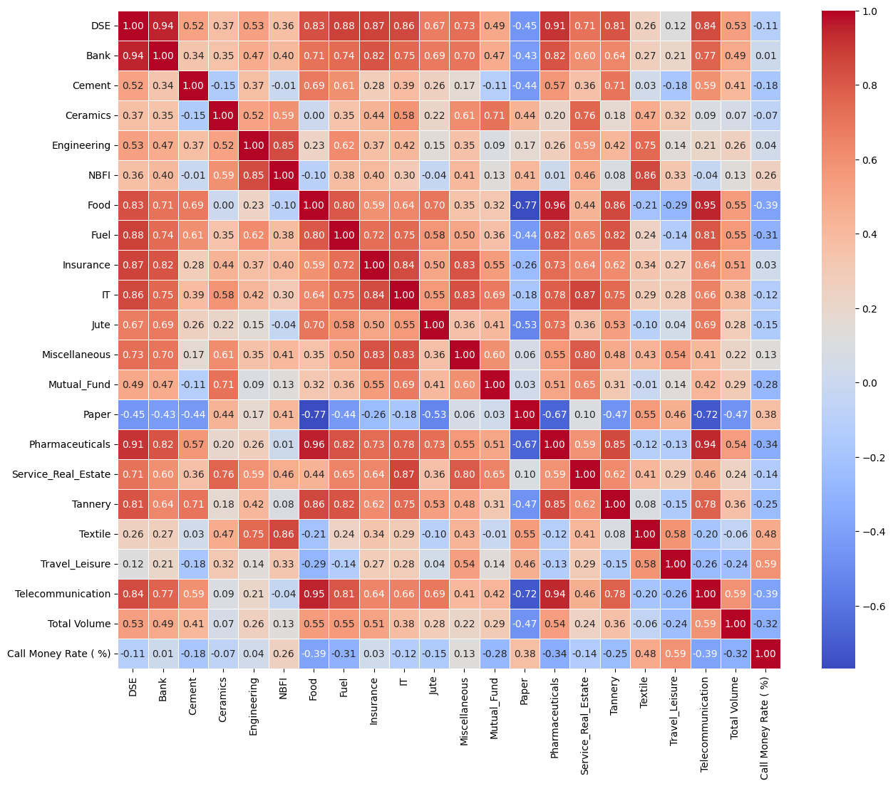

|  |
| --- |
| Appendix D: Sector Indices Over Time |

|  |
| --- |
|  |

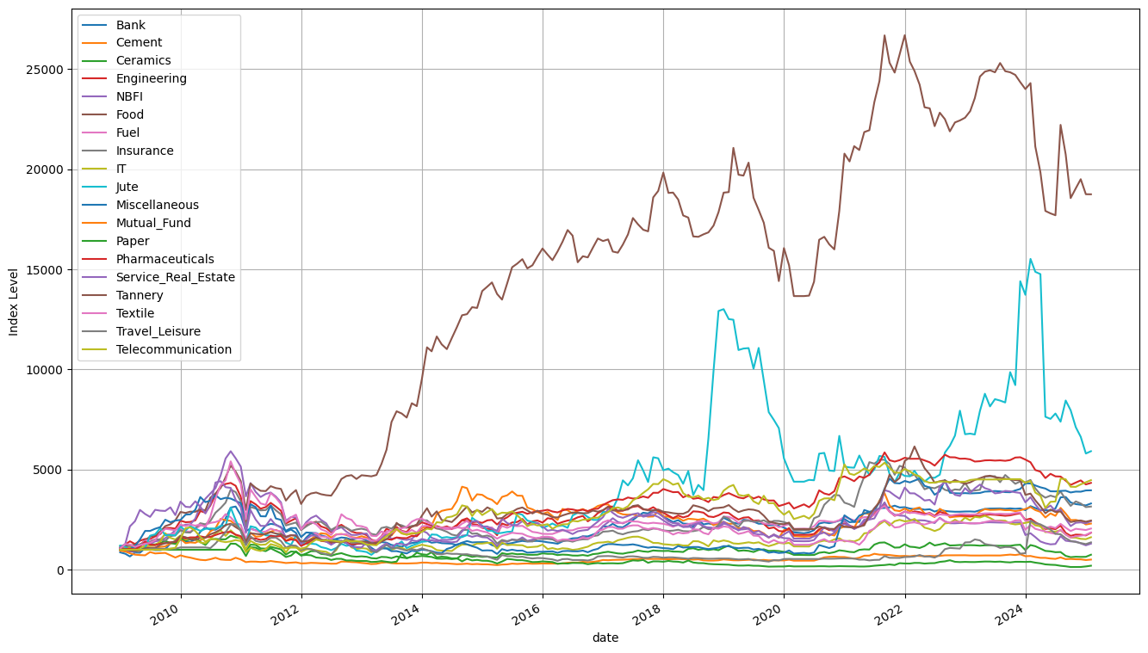

## Appendix E: Full Regression Results

|  |  |  |  |
| --- | --- | --- | --- |
| **Variable** | **Beta** | **p-value** | **R-squared** |
| Textile | 8.098270e+01 | 0.0000 | 0.2263 |
| Fuel | -3.454200e+01 | 0.0000 | 0.0986 |
| NBFI | 5.620610e+01 | 0.0003 | 0.0654 |
| Miscellaneous | -1.371330e+01 | 0.0006 | 0.0605 |
| Service Real Estate | -1.440810e+01 | 0.0075 | 0.0371 |
| Tannery | -1.045770e+01 | 0.0089 | 0.0354 |
| DSE | -7.829600e+00 | 0.0122 | 0.0326 |
| Pharmaceuticals | -7.010200e+00 | 0.0160 | 0.0301 |
| IT | -6.342900e+00 | 0.0200 | 0.0281 |
| Ceramics | -3.608100e+00 | 0.0595 | 0.0186 |
| Insurance | -8.804100e+00 | 0.0631 | 0.0181 |
| Bank | -4.465700e+00 | 0.1257 | 0.0123 |
| **Variable** | **Beta** | **p-value** | **R-squared** |
| Food | -2.128580e+01 | 0.1847 | 0.0092 |
| Cement | -4.185400e+00 | 0.2938 | 0.0058 |
| Jute | -1.644710e+01 | 0.3473 | 0.0047 |
| Paper | -1.077900e+00 | 0.4942 | 0.0025 |
| Engineering | 5.095300e+00 | 0.6245 | 0.0013 |
| Travel Leisure | -1.213500e+00 | 0.7079 | 0.0007 |
| Telecommunication | -1.470500e+00 | 0.7374 | 0.0006 |
| Mutual Fund | -1.411000e-01 | 0.8492 | 0.0002 |
| Total Volume | -5.131691e+06 | 0.8726 | 0.0001 |