Implementing OLAP Operations in Oracle

1. Creating Table:
CREATE TABLE sales (
item_name varchar2(5) NOT NULL,
color varchar2(6) NOT NULL,
cloths_size varchar2(6) NOT NULL,
quantity NUMBER(5) NOT NULL
);

2. Inserting Data:

INSERT ALL
INTO sales VALUES ('skirt', 'dark', 'small', 2)
INTO sales VALUES ('skirt', 'dark', 'medium', 5)
INTO sales VALUES ('skirt', 'dark', 'large', 1)
INTO sales VALUES ('skirt', 'pastel', 'small', 11)
INTO sales VALUES ('skirt', 'pastel', 'medium', 9)
INTO sales VALUES ('skirt', 'pastel', 'large', 15)
INTO sales VALUES ('skirt', 'white', 'small', 2)
INTO sales VALUES ('skirt', 'white', 'medium', 5)
INTO sales VALUES ('skirt', 'white', 'large', 3)

INTO sales VALUES ('dress', 'dark', 'small', 2)
INTO sales VALUES ('dress', 'dark', 'medium', 6)
INTO sales VALUES ('dress', 'dark', 'large', 12)
INTO sales VALUES ('dress', 'pastel', 'small', 4)
INTO sales VALUES ('dress', 'pastel', 'medium', 3)
INTO sales VALUES ('dress', 'pastel', 'large', 3)
INTO sales VALUES ('dress', 'white', 'small', 2)
INTO sales VALUES ('dress', 'white', 'medium', 3)
INTO sales VALUES ('dress', 'white', 'large', 0)

INTO sales VALUES ('shirt', 'dark', 'small', 2)
INTO sales VALUES ('shirt', 'dark', 'medium', 6)
INTO sales VALUES ('shirt', 'dark', 'large', 6)
INTO sales VALUES ('shirt', 'pastel', 'small', 4)
INTO sales VALUES ('shirt', 'pastel', 'medium', 1)
INTO sales VALUES ('shirt', 'pastel', 'large', 2)
INTO sales VALUES ('shirt', 'white', 'small', 17)
INTO sales VALUES ('shirt', 'white', 'medium', 1)
INTO sales VALUES ('shirt', 'white', 'large', 10)

INTO sales VALUES ('pants', 'dark', 'small', 14)
INTO sales VALUES ('pants', 'dark', 'medium', 6)
INTO sales VALUES ('pants', 'dark', 'large', 0)
INTO sales VALUES ('pants', 'pastel', 'small', 1)
INTO sales VALUES ('pants', 'pastel', 'medium', 0)
INTO sales VALUES ('pants', 'pastel', 'large', 1)
INTO sales VALUES ('pants', 'white', 'small', 3)
INTO sales VALUES ('pants', 'white', 'medium', 0)
INTO sales VALUES ('pants', 'white', 'large', 2)
SELECT * FROM dual;

ROLLUP
In addition to the regular aggregation results we expect from the GROUP BY clause, the ROLLUP extension produces group subtotals from right to left and a grand total. If "n" is the number of columns listed in the ROLLUP, there will be n+1 levels of subtotals.

Ref: http://oracle-base.com/articles/misc/rollup-cube-grouping-functions-and-grouping-sets.php

Only group by

SELECT item_name, cloths_size, color, SUM(quantity) AS sales_quantity
FROM sales
GROUP BY item_name, cloths_size, color

Rollup

SELECT item_name, cloths_size, color, SUM(quantity) AS sales_quantity
FROM sales
GROUP BY rollup(item_name, cloths_size, color)
ORDER BY item_name, cloths_size, color;

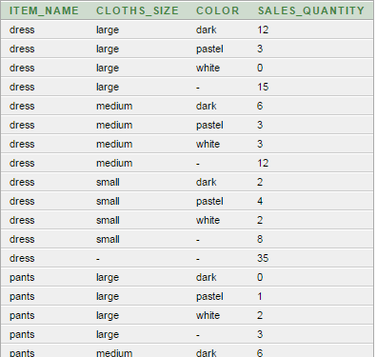
SELECT color, item_name, cloths_size, SUM(quantity) AS sales_quantity
FROM sales
GROUP BY rollup(color, item_name, cloths_size)
ORDER BY color, item_name, cloths_size;

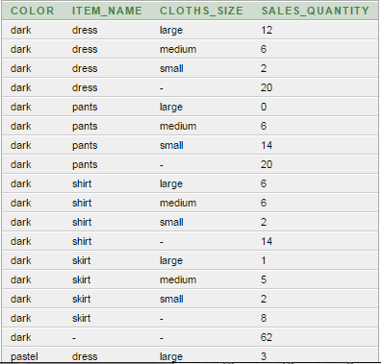

SELECT item_name, cloths_size, color, SUM(quantity) AS sales_quantity
FROM sales
GROUP BY rollup(item_name), rollup(cloths_size, color)
ORDER BY item_name, cloths_size, color;

CUBE
In addition to the subtotals generated by the ROLLUP extension, the CUBE extension will generate subtotals for all combinations of the dimensions specified. If "n" is the number of columns listed in the CUBE, there will be 2^{n} subtotal combinations.
SELECT item_name, cloths_size, color, SUM(quantity) AS sales_quantity
FROM sales
GROUP BY cube(item_name, cloths_size, color)
ORDER BY item_name, cloths_size, color;
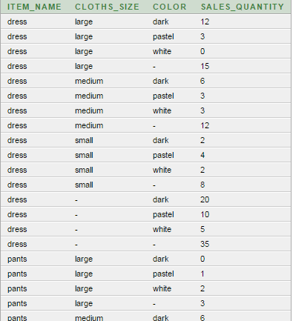

SELECT decode(grouping(item_name),1, 'all', item_name) as item_name,
decode(grouping(cloths_size),1, 'all', cloths_size) as cloths_size,
decode(grouping(color),1, 'all', color) as color,
SUM(quantity) AS sales_quantity
FROM sales
GROUP BY cube(item_name, cloths_size, color)
ORDER BY item_name, cloths_size, color;

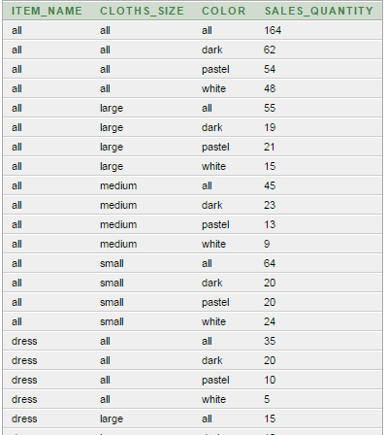
select case when grouping(item_name) = 1 then 'all’
else item_name end as item_name,
case when grouping(color) = 1 then 'all’
else color end as color,
'all' as clothes_size, sum(quantity) as quantity
from sales
group by cube(item_name, color);

ITEM_NAME | COLOR | CLOTHES_SIZE | QUANTITY
all | all | all | 164
all | dark | all | 62
all | white | all | 48
all | pastel | all | 54
dress | all | all | 35
dress | dark | all | 20
dress | white | all | 5
dress | pastel | all | 10
pants | all | all | 27
pants | dark | all | 20
pants | white | all | 5
pants | pastel | all | 2
shirt | all | all | 49
shirt | dark | all | 14
shirt | white | all | 28
shirt | pastel | all | 7
skirt | all | all | 53
skirt | dark | all | 8
skirt | white | all | 10
skirt | pastel | all | 35

GROUPING Functions

GROUPING
It can be quite easy to visually identify subtotals generated by rollups and cubes, but to do it programatically you really need something more accurate than the presence of null values in the grouping columns. This is where the GROUPING function comes in. It accepts a single column as a parameter and returns "1" if the column contains a null value generated as part of a subtotal by a ROLLUP or CUBE operation or "0" for any other value, including stored null values.
The following query is a repeat of a previous cube, but the GROUPING function has been added for each of the dimensions in the cube.
SELECT item_name, cloths_size, color, SUM(quantity) AS sales_quantity,
GROUPING(item_name) AS item_name_flag,
GROUPING(cloths_size) AS cloths_size_flag,
GROUPING(color) AS color_flag
FROM sales
GROUP BY CUBE (item_name, cloths_size, color)
ORDER BY item_name, cloths_size, color;

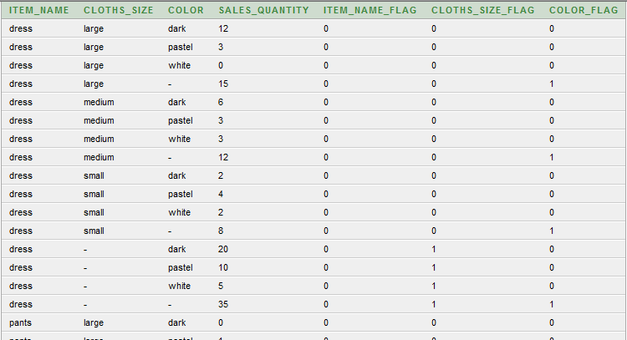

SELECT item_name, cloths_size, color, SUM(quantity) AS sales_quantity,
GROUPING(item_name) AS f1g,
GROUPING(cloths_size) AS f2g,
GROUPING(color) AS f3g
FROM sales
GROUP BY CUBE (item_name, cloths_size, color)
having (GROUPING(color) = '1' and GROUPING(cloths_size) = '1') or (GROUPING(item_name) = '1' and GROUPING(cloths_size) = '1')
ORDER BY item_name, cloths_size, color;

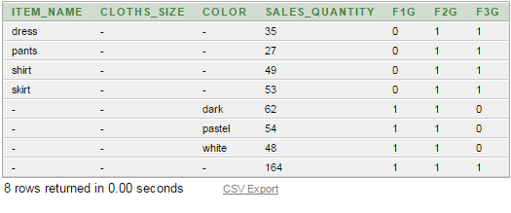

PIVOT operation: The PIVOT operator takes data in separate rows, aggregates it and converts it into columns. To see the PIVOT operator in action we need to create a test table.
Ref: http://oracle-base.com/articles/11g/pivot-and-unpivot-operators-11gr1.php
PIVOT operation using DECODE function in Oracle 10g. (In 11g direct PIVOT operation exist)
SELECT item_name, cloths_size,
SUM(DECODE(color, 'dark', quantity, 0)) AS dark_sum_quantity,
SUM(DECODE(color, 'pastel', quantity, 0)) AS pastel_sum_quantity,
SUM(DECODE(color, 'white', quantity, 0)) AS white_sum_quantity
FROM sales
GROUP BY item_name, cloths_size
ORDER BY item_name, cloths_size;
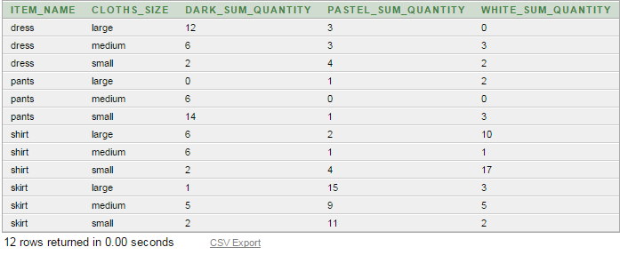
SELECT item_name,
SUM(DECODE(color, 'dark', quantity, 0)) AS dark_sum_quantity,
SUM(DECODE(color, 'pastel', quantity, 0)) AS pastel_sum_quantity,
SUM(DECODE(color, 'white', quantity, 0)) AS white_sum_quantity
FROM sales
GROUP BY item_name
ORDER BY item_name;

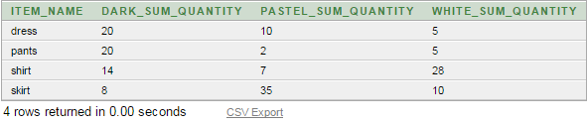
SELECT cloths_size,
SUM(DECODE(color, 'dark', quantity, 0)) AS dark_sum_quantity,
SUM(DECODE(color, 'pastel', quantity, 0)) AS pastel_sum_quantity,
SUM(DECODE(color, 'white', quantity, 0)) AS white_sum_quantity
FROM sales
GROUP BY cloths_size
ORDER BY cloths_size;
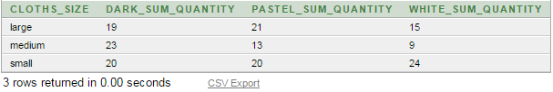

SELECT item_name, color,
SUM(DECODE(cloths_size, 'small', quantity, 0)) AS small_sum_quantity,
SUM(DECODE(cloths_size, 'medium', quantity, 0)) AS medium_sum_quantity,
SUM(DECODE(cloths_size, 'large', quantity, 0)) AS large_sum_quantity
FROM sales
GROUP BY item_name, color
ORDER BY item_name, color;
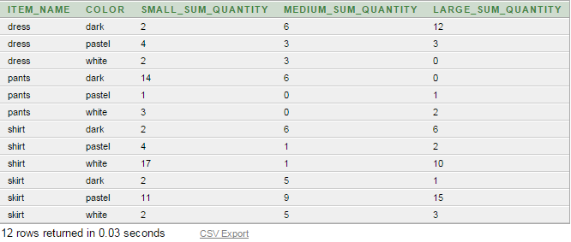

PIVOT operation without DECODE function

select *
from sales
pivot (sum(quantity)
for color in ('dark','pastel','white'))
order by item_name;

ITEM_NAME | CLOTHS_SIZE | 'dark' | 'pastel' | 'white'
dress | Large | 12 | 3 | 0
dress | Medium | 6 | 3 | 3
dress | Small | 2 | 4 | 2
pants | Large | 0 | 1 | 2
pants | Medium | 6 | 0 | 0
pants | Small | 14 | 1 | 3
shirt | Large | 6 | 2 | 10
shirt | Medium | 6 | 1 | 1
shirt | Small | 2 | 4 | 17
skirt | Large | 1 | 15 | 3
skirt | Medium | 5 | 9 | 5
skirt | Small | 2 | 11 | 2

Try this: https://stackoverflow.com/questions/53739424/oracle-sql-crosstab-with-sum

Creating Table ItemCategory:
CREATE TABLE itemcategory (
item_name varchar2(5) NOT NULL,
category varchar2(12) NOT NULL
);
INSERT ALL
INTO itemcategory VALUES ('dress', 'womenwear')
INTO itemcategory VALUES ('skirt', 'womenwear')
INTO itemcategory VALUES ('shirt', 'menwear')
INTO itemcategory VALUES ('pants', 'menwear')
SELECT * FROM dual;

select category, sales.item_name, sum(quantity)
from sales, itemcategory
where sales.item_name = itemcategory.item_name
group by rollup(category, sales.item_name)

CATEGORY | ITEM_NAME | SUM(QUANTITY)
menwear | pants | 27
menwear | shirt | 49
menwear | - | 76
womenwear | dress | 35
womenwear | skirt | 53
womenwear | - | 88
- | - | 164

select item_name, color, cloths_size, sum(quantity)
from sales
group by rollup(item_name), rollup(color), rollup(cloths_size)

generates the groupings
{item_name, ()} X {color, ()} X {cloths_size, ()}
= { (item_name, color), (item_name), (color),() } X {cloths_size, ()}
= { (item_name, color, cloths_size), (item_name, cloths_size), (color, cloths_size),(cloths_size), (item_name, color), (item_name), (color),() }
UNPIVOT Operation: The UNPIVOT operator converts column-based data into separate rows. To see the UNPIVOT operator in action we need to create a test table.
1. Creating Table:
CREATE TABLE unpivot_test (
id NUMBER,
customer_id NUMBER,
product_code_a NUMBER,
product_code_b NUMBER,
product_code_c NUMBER,
product_code_d NUMBER
);
2. Inserting Data:
INSERT INTO unpivot_test VALUES (1, 101, 10, 20, 30, NULL);
INSERT INTO unpivot_test VALUES (2, 102, 40, NULL, 50, NULL);
INSERT INTO unpivot_test VALUES (3, 103, 60, 70, 80, 90);
INSERT INTO unpivot_test VALUES (4, 104, 100, NULL, NULL, NULL);
COMMIT;
3. Prior to 11g, we can get the same result using the DECODE function and a pivot table with the correct number of rows. In the following example we use the CONNECT BY clause in a query from dual to generate the correct number of rows for the unpivot operation.

SELECT id,
customer_id,
DECODE(unpivot_row, 1, 'A',
2, 'B',
3, 'C',
4, 'D',
'N/A') AS product_code,
DECODE(unpivot_row, 1, product_code_a,
2, product_code_b,
3, product_code_c,
4, product_code_d,
'N/A') AS quantity
FROM unpivot_test,
(SELECT level AS unpivot_row FROM dual CONNECT BY level <= 4)
ORDER BY 1,2,3;
