

**Agent Based Model of COVID-19 Transmission Based on Using Mask in a Super Shop**

This report has been prepared and submitted for the partial fulfillment of the requirement for the ‘Modeling and Simulation’ course

Report on Agent Based Model of COVID-19 Transmission Based on Using Mask in a Super Shop

|  |  |
| --- | --- |
| **Name** | **ID** |
| Bishal Saha | 1520563042 |
| Md Amjad Hossen | 1632698042 |
| Md. Mehedi Hasan | 1721448042 |
| Wasimul Islam | 1721694042 |

**SUBMITTED TO  
DR. SIFAT MOMEN**Associate Professor,  
Department of Electrical & Computer EngineeringNorth South University **SUBMITTED BY**

Course: CSE 422  
Section: 1  
Fall 2020  
17 January, 2021

**Acknowledgement**

Firstly, we ‘d like to remember the Almighty Allah for allowing us to finish this report on time and efficaciously. We might want to offer our obligation of thanks to our respectable faculty Dr. Sifat Momen, Associate Professor, Department of Electrical & Computer Engineering, North South University, for his steady motivation, valuable analysis, liberal direction, and profound interest in this project. Without his legitimate rule, the project probably won't be conceivable appropriately to finish in due time. We 'd additionally like to thank such countless astonishing analysts everywhere on the world who are right now dealing with this very issue. For this exploration we couldn't do any hands-on work. So, the total of our work relied upon these astonishing investigates, diaries, periodicals and examination papers that were distributed by such countless astonishing specialists. Referencing every one of them here is practically incomprehensible. We have recognized them through innumerable references in everywhere on our fundamental assortment of report. At last, we might want to thank our dear sir Dr. Sifat Momen by and by for giving us the occasion to do this examination which advanced we all with our newly discovered information.

**Abstract**

The rapid spread of the corona virus disease (COVID-19) has become a global threat affecting almost all countries in the world. As countries reach the infection peak, it is planned to return to a new normal under different coexistence conditions in order to reduce the economic effects produced by the total or partial closure of companies, universities, shops, etc. Under such circumstances, the use of mathematical models to evaluate the transmission risk of COVID-19 in various facilities represents an important tool in assisting authorities to make informed decisions. So we had planned a model named agent based model of COVID-19 transmission based on using mask in a super shop, where we mainly show that when we don’t use any mask then this virus how transmitted so easily one to another. Different from classical mathematical models, agent-based approaches model individuals with distinct characteristics and provide more realistic results. In this paper, an agent-based model to evaluate the COVID-19 transmission risks in facilities is presented. The proposed scheme has been designed to simulate the spatiotemporal transmission process. In the model, simulated agents make decisions depending on the programmed rules. Such rules correspond to spatial patterns and infection conditions under which agents interact to characterize the transmission process. Also, this model also includes an individual profile for each agent, which defines its main social characteristics and health conditions used during its interactions. In general, this profile partially determines the behavior of the agent during its interactions with other individuals. Several hypothetical scenarios have been considered to show the performance of the proposed model. Experimental results have demonstrated that the simulations provide useful information to produce strategies for reducing the transmission risks of COVID-19 within the facilities.

**Table of Contents**

**Chapter 01: Introduction 01**

1.0 Introduction **02**

1.2 Statement of the Problem **03**

1.3 Agent Based Modeling **04**

**Chapter 2: Literature Review 05**

2.0 Literature Review **06**

2.1 Virus **06**

2.2 COVID-19 Mask Use Transmission **07**

2.3 The Limitations of their Study **08**

**Chapter 3: Proposed Model 09**

3.0 Proposed Model **10**

3.1 Model Description **10**

3.2 Parameters of this Model **10**

**Chapter 4: Experimental Results 14**

4.0 Experimental Results **15**

4.1 Analysis **19**

**Chapter 5: Conclusion 20**

5.0 Conclusion **21**

**List of Figures**

**Figure: 1.0.1 Coronavirus 03**

**Figure3.2.1: Tools to Control parameters 12**

**Figure 3.2.2: Graph tools 12**

**Figure 3.2.3: Model World/ Closed Environment (Super Shop layout) 12**

**Figure 3.2.4: Agent- Shape in the Model 13**

**Figure 4.0.1: Model at 10% infected 15**

**Figure 4.0.2: Model at 52% infected 16**

**Figure4.0.3: Model at 100% infected 17**

**Figure4.0.5: Graph at 100% infected 18**

**Chapter 1: Introduction**

**1.0. Introduction**

On January 30, 2020, the World Health Organization declared the coronavirus disease 2019 (COVID-19) outbreak as a Public Health Emergency of International Concern. COVID-19 is considered a very infectious disease transmitted from one host to another through different modes of transmission, such as airborne droplets disseminated by sneezing or coughing, direct physical contact, etc. In its transmission, an agent or set of agents like in our model based on mask protection are introduced into a population of susceptible elements.

COVID-19 is considered a very infectious disease (Gang,2020) transmitted from one host to another through different modes of transmission, such as airborne droplets disseminated by sneezing or coughing, direct physical contact, etc. In its transmission, an agent or set of agents are introduced into a population of susceptible elements. Then, the infection is transferred to other agents through its forms of transportation, consequently spreading in the population. An infected element can persist without typical symptoms at the early phase of the infection (Noelle,2020); only later, the patient can develop clinical symptoms and be diagnosed as a disease case. When the number of cases increases above the normal average of events within a brief period, a disease outbreak happens. Several mathematical tools are used to characterize, predict, or analyze the transmission process of an infectious disease (Michael Y,2018). Traditional explorative methods use experimental and statistical data for obtaining information on the disease transmission process. However, such approaches are not appropriate (Marcello,2020) for several reasons:

a) For human infectious diseases, large-scale tests may be impractical or unethical, and

b) Available data sets pertinent to the disease include only partial information not accurate enough for reliable statistical studies.

Mathematical modeling is recognized as an important tool for emulating the transmission of infectious diseases computationally. Mathematical models have been widely used for evaluating the effectiveness of control strategies and for reducing their associated risks (Oliver M,2018) Through mathematical modeling, it is possible to obtain critical information about the mechanisms of transmission and spread. It helps to highlight important factors in the disease transmission process. From its results, it is also possible to suggest preventive measures or effective control strategies. Another important function of mathematical models is hypothesis testing (Yan,2020) Under this role, it is possible to test different scenarios considering distinct hypothetical conditions that are impossible to analyze in the real circumstances. Compared to experimental methods, the modeling schemes have the convenience of saving time and economic resources. In the last decades, the design of mathematical models for disease transmission has attracted the attention of the scientific community. Some examples include the classical Susceptible-Infect- Susceptible (SIS) epidemic model established by Kermack and (McKendrick  Kermack W ,1997)the Susceptible-Infect-Recovered (SIR) epidemic model proposed by (Bailey  Kermack W,1975) McKendrick A. Contributions to the mathematical theory of epidemics (Part I) Proc. R. Soc. 1927;115:700–721 the Susceptible-Infect-Vaccination-Susceptible (SIVS) epidemic system introduced by Arion et al. (Arino J,2003) and the stochastic Susceptible-Infect-Quarantine-Susceptible (SIQS) epidemic model studied by Zhang et al. (Zhang X,2014) All these models are proper for explaining the global behavior of an epidemic on larger scales considering general variables. They are not able to provide accurate predictions at a finer resolution. There exist many scenarios in which it is important to analyze the transmission dynamics in a more microscopic way, especially in small populations or in facilities where the infection process can be identified by the interactions among their members ( Qi H., Zhang,2018)

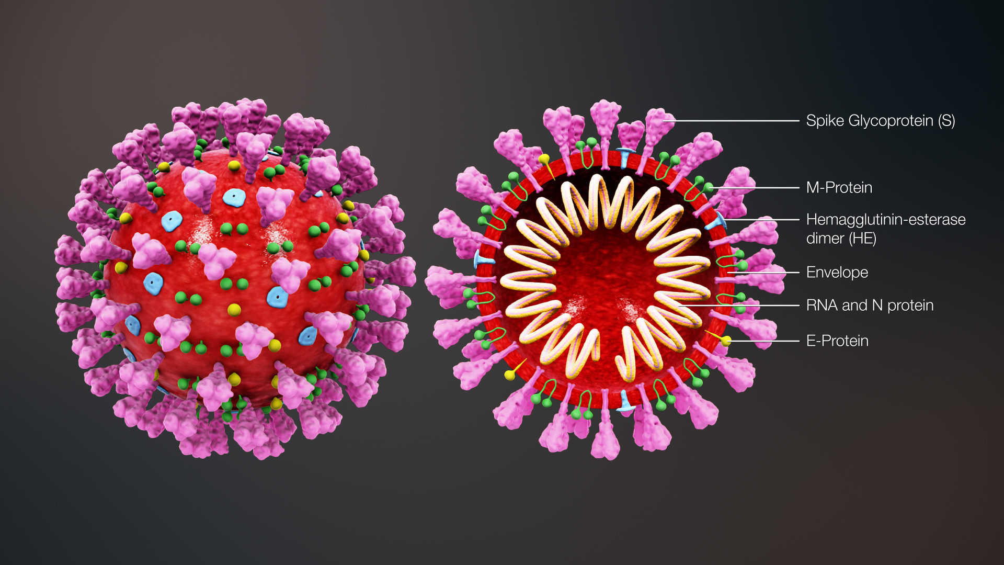

Figure: 1.0.1 Coronavirus

**1.2. Statement of the Problem**

Our proposed model consists the problem of Covid-19 transmission in a super shop which is a closed environment that makes the risk higher because people stay in a close proximity for a long time. During the rapid rise in COVID-19 illnesses and deaths globally, and notwithstanding recommended precautions, questions are voiced about routes of transmission for this pandemic disease. Inhaling small airborne droplets is probable as a third route of infection, in addition to more widely recognized transmission via larger respiratory droplets and direct contact with infected people or contaminated surfaces. While uncertainties remain regarding the relative contributions of the different transmission pathways, we argue that existing evidence is sufficiently strong to warrant engineering controls targeting airborne transmission as part of an overall strategy to limit infection risk indoors. Appropriate building engineering controls include sufficient and effective ventilation, possibly enhanced by particle filtration and air disinfection, avoiding air recirculation and avoiding overcrowding. Often, such measures can be easily implemented and without much cost, but if only they are recognized as significant in contributing to infection control goals. We believe that the use of engineering controls in public buildings, including hospitals, shops, offices, schools, kindergartens, libraries, restaurants, cruise ships, elevators, conference rooms or public transport, in parallel with effective application of other controls (including isolation and quarantine, social distancing and hand hygiene), would be an additional important measure globally to reduce the likelihood of transmission and thereby protect healthcare workers, patients and the general public. We want to simulate this problem in NetLogo which is an agent-based modeling software.

**1.3. Agent Based Modeling**

Agent-based modeling corresponds to a new scheme for simulating systems with interacting autonomous elements. Agents are artificial individuals programmed to perform pre-defined operations (V., Son,2010) While they operate based on their own behavior, collaborate, or compete with each other agents. The complexity of the actions conducted by an agent is quite simple. They range from elementary decisions (yes or no) to stochastic behaviors.

Agents interact in an environment (virtual map) in the form of a lattice or a multi-dimensional space. Agents can move freely within the environment. With this characteristic, it is possible to visualize the agent behaviors as a physical system, such as simulations of evacuations, traffic, biological systems, infections, etc.

Agent-based models are simple. They do not use sophisticated architectures or difficult behavioral rules. In spite of these simple behaviors, they are capable of generating several complex global patterns (behaviors) as a consequence of the modeling characteristics produced by the interactions of a set of simple agents. Global behavioral patterns refer to consistent microscopic regularities, such as coherent temporal, spatial and behavioral structures, or identifiable distributions.

A general agent-based modeling scheme consists of the following steps. First, a set of A agents {a1,…,aA} are initialized. Under this stage, agents are configurated in a determined position or in a specific state. Then, each agent ai (i∈1,…,A) is selected randomly or considering a particular order. For this agent ai, a set of rules are applied in order to change its position, state or relationship with other agents. These rules consider a relation of conditions imposed by other agents (specific agents) or local influences (neighbor agents). This process is repeated until a determined stop criterion has been reached.

Under the agent-based methodology, several interesting basic global patterns have been proposed to simulate complex phenomena such as diffusion, concentration and insolating, fire spreading, segregation and others. These behavioral patterns have been analyzed in terms of the simple rules that provoke them. In order to illustrate this methodology, two simple examples are considered: Fire spreading and segregation.

**Chapter 2: Literature Review**

**2.0. Literature Review**

In this chapter we will discuss aboutsome similar models that we are proposing. We also discuss about how is our proposed model different from them. Here is two similar models that we have found:

1. Virus by Uri Wilensky,1998
2. COVID-19 Mask Use Transmission by Soutrik Banarjee,2020

In this chapter we will talk discuss about these model and state how is our model different from them.

**2.1. Virus**

This model simulates the transmission and perpetuation of a virus in a human population. Ecological biologists have suggested a number of factors which may influence the survival of a directly transmitted virus within a population.(Yorke)

The model is initialized with 150 people, of which 10 are infected. People move randomly about the world in one of three states: healthy but susceptible to infection (green), sick and infectious (red), and healthy and immune (gray). People may die of infection or old age. When the population dips below the environment's "carrying capacity" (set at 300 in this model) healthy people may produce healthy (but susceptible) offspring.

Some of these factors are summarized below with an explanation of how each one is treated in this model.

The density of the population: Population density affects how often infected, immune and susceptible individuals come into contact with each other. You can change the size of the initial population through the NUMBER-PEOPLE slider.

Population turnover: As individuals die, some who die will be infected, some will be susceptible and some will be immune. All the new individuals who are born, replacing those who die, will be susceptible. People may die from the virus, the chances of which are determined by the slider CHANCE-RECOVER, or they may die of old age.

In this model, people die of old age at the age of 50 years. Reproduction rate is constant in this model. Each turn, if the carrying capacity hasn't been reached, every healthy individual has a 1% chance to reproduce.

Degree of immunity: If a person has been infected and recovered, how immune are they to the virus? We often assume that immunity lasts a lifetime and is assured, but in some cases, immunity wears off in time and immunity might not be absolutely secure. In this model, immunity is secure, but it only lasts for a year.

Infectiousness (or transmissibility): How easily does the virus spread? Some viruses with which we are familiar spread very easily. Some viruses spread from the smallest contact every time. Others (the HIV virus, which is responsible for AIDS, for example) require significant contact, perhaps many times, before the virus is transmitted. In this model, infectiousness is determined by the INFECTIOUSNESS slider.

Duration of infectiousness: How long is a person infected before they either recover or die? This length of time is essentially the virus's window of opportunity for transmission to new hosts. In this model, duration of infectiousness is determined by the DURATION slider.

Hard-coded parameters: Four important parameters of this model are set as constants in the code (See setup-constants procedure). They can be exposed as sliders if desired. The turtles’ lifespan is set to 50 years, the carrying capacity of the world is set to 300, the duration of immunity is set to 52 weeks, and the birth-rate is set to a 1 in 100 chance of reproducing per tick when the number of people is less than the carrying capacity.

**2.2.** **COVID-19 Mask Use Transmission**

This model simulates the spread of the SARS-CoV-2, via human-to-human transmission, in a small isolated population. It illustrates the utility of masks in the population. It is not intended to measure the recovery rate from Coronavirus, as seen in SIRD / SEIRD models.

As it is understood that COVID-19 is spread from human to human through forceful expulsion by coughing of virus-laden aerosols by an infected individual. The aerosols can directly enter the susceptible individual if within 2 meters of distance from the infected or the aerosols that can keep the virus alive on objects that a susceptible individual may touch and later the virus can enter her/his body through nose, mouth and eyes among the major portals of entry, or through gestures as hugging, handshaking, close proximity, health-care delivery, etc. that can transmit the virus from the infected to the susceptible. COVID-19 can remain alive for different lengths of time periods on different materials, but this model does not try to highlight this property of the virus. Neither this model tries to capture the transmission of COVID-19 by indirect method by contact exposure of contaminated surfaces by the susceptible and then entry of virus into the individual. Rather the goal of this model is to examine the infection rate among susceptible individuals, which will potentially change with time, by the use or not of masks that is putatively thought to influence the spread of the disease in the community and closed-space arenas like hospitals, public transport and places of public gatherings like markets.

The model examines the emergent effects of four scenarios of mask use. The user controls the amount of time two (or more) individuals will stay in close proximity as that can influence the spread.

**2.3.** **The Limitations of their Study**

Both of the study presents virus transmission which is kind of similar to our but focuses on different fields. Where Virus focuses on virus infections, agents age, and immunity. And COVID-19 Mask Use Transmission focuses on how Corona Virus spread.

But none of them contains

1. A close environment
2. Practical behavior area
3. Mask to mask transmission
4. Mask to no mask transmission
5. No mask to no mask transmission

These problems are discussed in our model. In a way, we have extended both of this models’ limitations.

**Chapter 3: Proposed Model**

**3.0. Proposed Model**

Ourproposed model is Agent Based Model of COVID-19 Transmission Based on Using Mask in a Super Shop. This model uses closeup to represent two people engaged close proximity like hugging, handshaking, trade, buying, interacting with shopkeeper etc. in a super shop. If an individual stays 1 hour in close proximity, that assumes 1/24 probability of disease transmission to someone theoretically lives 24 hours in close proximity. In the same way, someone staying 2 hours in close proximity will have 1/12 probability of disease transmission and so on. This is irrespective of mask use, which is in influencer of the transmission rate among agents. The presence of the mask in the population is represented by symbols of the agents. Two colors are used to denote if the agent is infecting or susceptible: green individuals are uninfected, and red individuals are infected. In reality, after some time, it happens that infected individuals will be removed from the population at-risk by either death or recovery. But our model will not explore that feature currently.

**3.1. Model Description**

The probability of a person being infected depends on several factors that range from his health condition to his discipline in following the prevention measurements. In our approach, the probability of infection is modeled through the use of a probability term close -proximity which can be changeable in slider. This term is different for each individual and summarizes all possible factors that affect positively or negatively to his infection. The infection maintains a high relationship with the contact and mobility rate among the people in the facility. In the proposed scheme, the contact and mobility rate among elements is modeled with a probability factor average random proximity tendency. This parameter involves several factors that determine the movement of an individual within the facility, such as mask, no mask, infected, not infected customer etc. This parameter can be the same for groups of individuals, such as customers with the same area, shopkeepers with the same schedule, etc. However, elements difficult to describe, such as personal intentions, going of different areas or others, modify this parameter, making it unique for each individual.

**3.2. Parameters of this Model**

The SETUP button creates individuals with particular behavioral tendencies according to the values of the interface’s sliders (described below). Once the simulation has been setup, you are now ready to run it, by pushing the GO button. GO starts the simulation and runs it continuously until GO is pushed again. During a simulation initiated by GO, adjustments in sliders can affect the behavioral tendencies of the population. A monitor shows the % of the population that is infected by COVID-19. In this model, each time-step is considered one day; the number of days that have passed is shown in the toolbar.

Here is a summary of the sliders in the model. They are explained in more detail below:

* INITIAL-PEOPLE: How many people simulation begins with (100–500).
* AVERAGE-HOURS-PROXIMITY: How many hours proximity typically lasts (0–12).
* AVERAGE-PROXIMITY-TENDENCY: General chance a member of population to use a mask (0–10).

The total number of individuals in the simulation is controlled by the slider INITIAL-PEOPLE (initialized to vary between 100–500), which must be set before SETUP is pushed. During the model’s setup procedures, all individuals are given a RANDOM-NEAR tendency around AVERAGE-PROXIMITY-TENDENCY. These tendencies are generally assigned in a normal distribution, so that, for instance, if a tendency slider is set at 8, the most common value for that tendency in the population will be 8. Less frequently, individuals will have values 7 or 9 for that tendency, and even less frequently will individuals have values 6 or 10 (and so on). Decreasing this to low values like 1 or 2 will result in a condition akin to flattening the curve by a stricter lockdown situation or imposing restrictions on individual movements. In a complete lockdown scenario, the infections will not increase.

The slider AVERAGE-HOURS-PROXIMITY (0–12) determines how long individuals are likely to stay in close-up situation (hours). Again, the tendencies of both individuals to stay in a close distance are considered; the proximity duration only lasts as long as is allowed by the tendency of the neighbor with a shorter commitment tendency.

INITIAL-NUMBER-MASKS (0–75) assigns masked individuals at the beginning of the simulation. It is kept from no use to 1/4th of the default population size of 300 in the current model.

INITIAL-INFECTED-PROP (0–1) is the proportion of initially infected population, which is @33%.

TRANSMIT-PROB-MASK-MASK, TRANSMIT-PROB-NOMASK-MASK, TRANSMIT-PROB-MASK-NOMASK, TRANSMIT-PROB-NOMASK-NOMASK represents the different transmission probabilities (0–1) between the partner and the agent, respectively

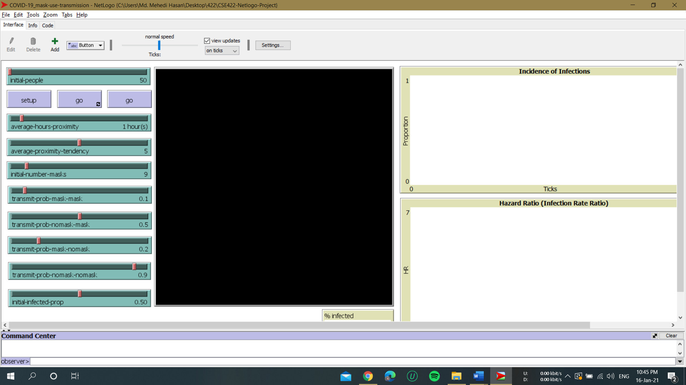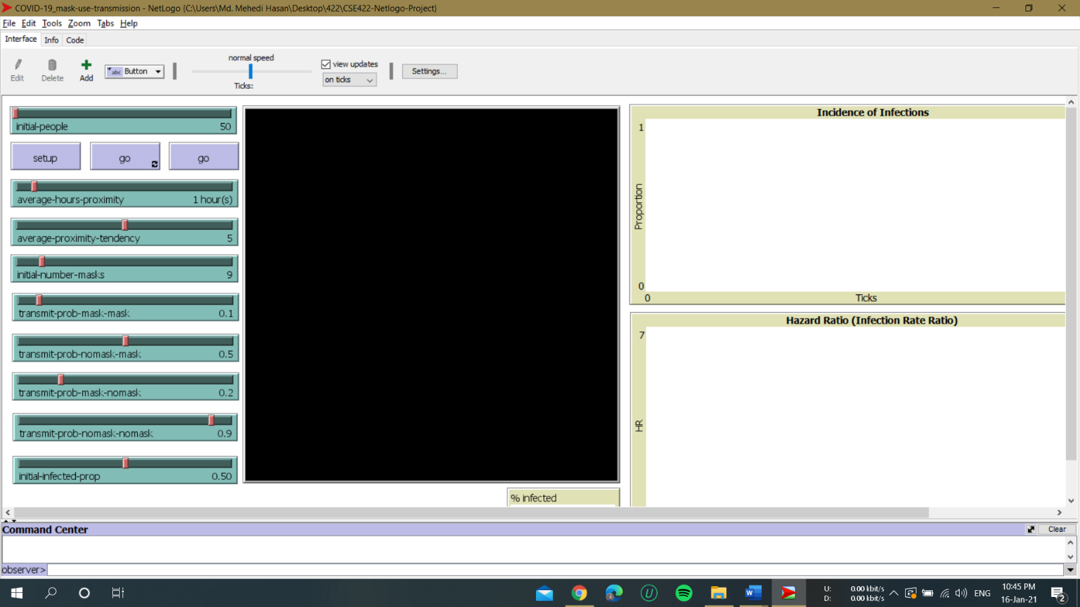

**Figure3.2.1: Tools to Control parameters Figure 3.2.2: Graph tools**

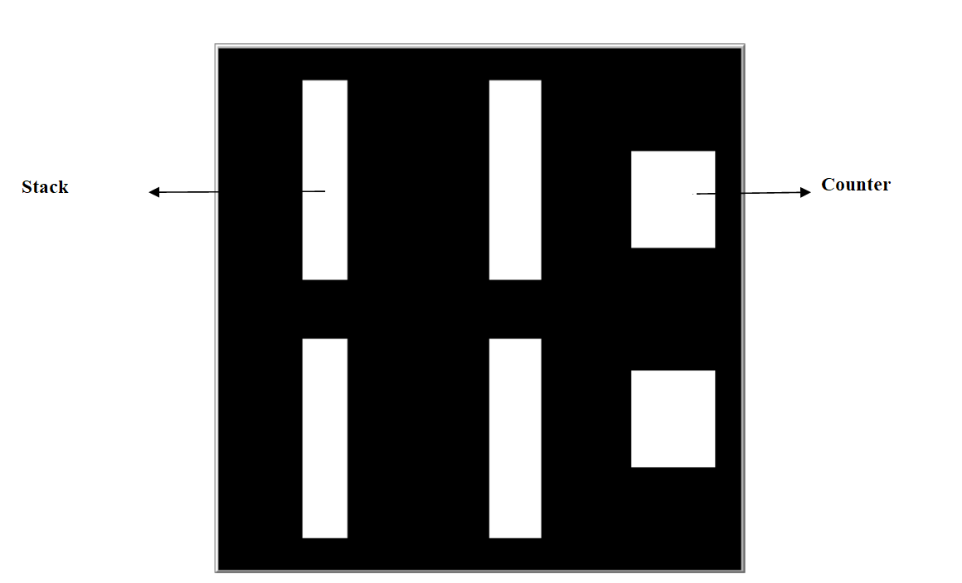

**Figure 3.2.3: Model World/ Closed Environment (Super Shop layout)**

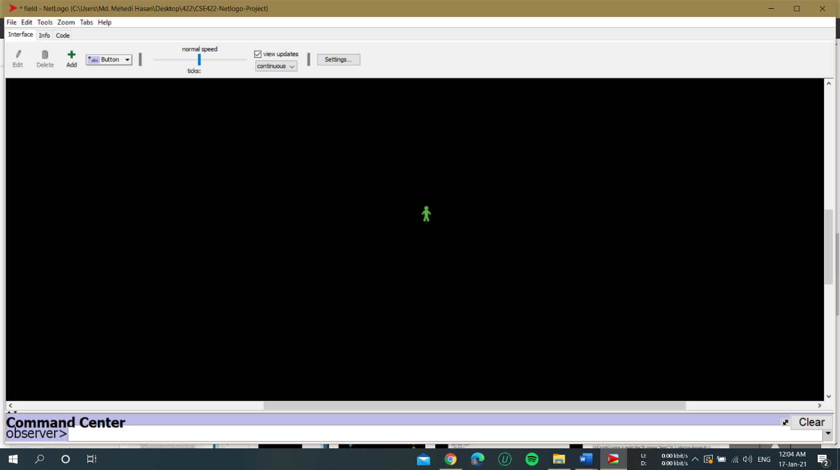 **-** No Mask non-infected agent

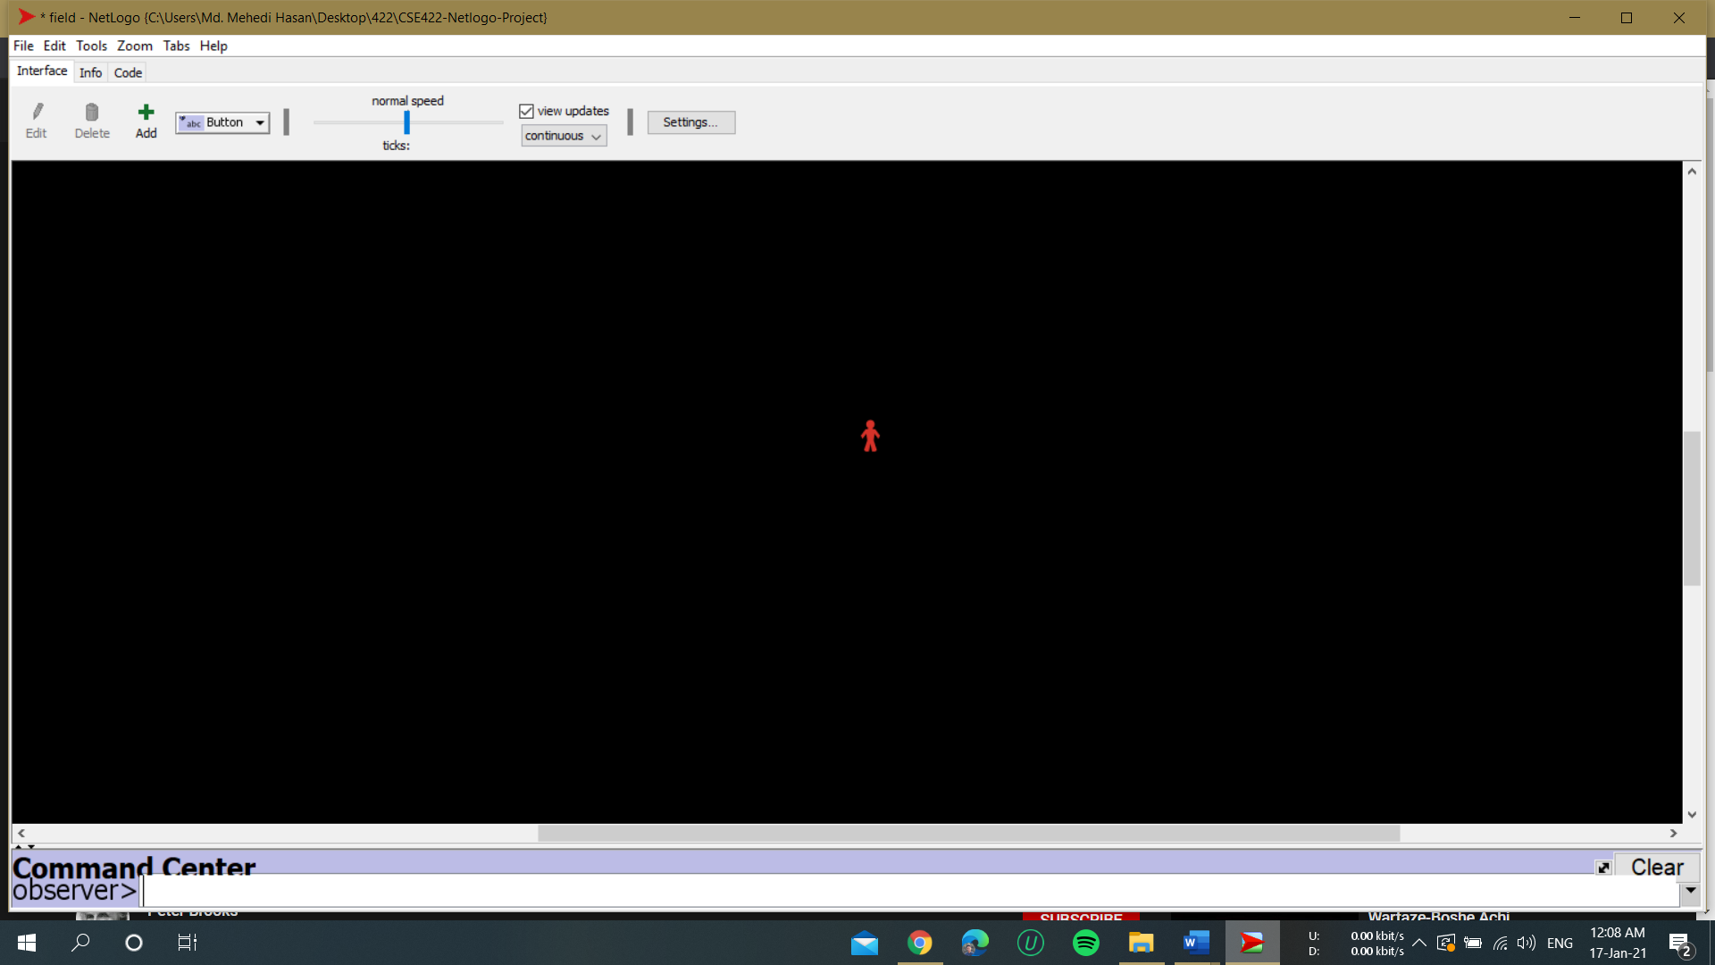 **-** No Mask infected agent

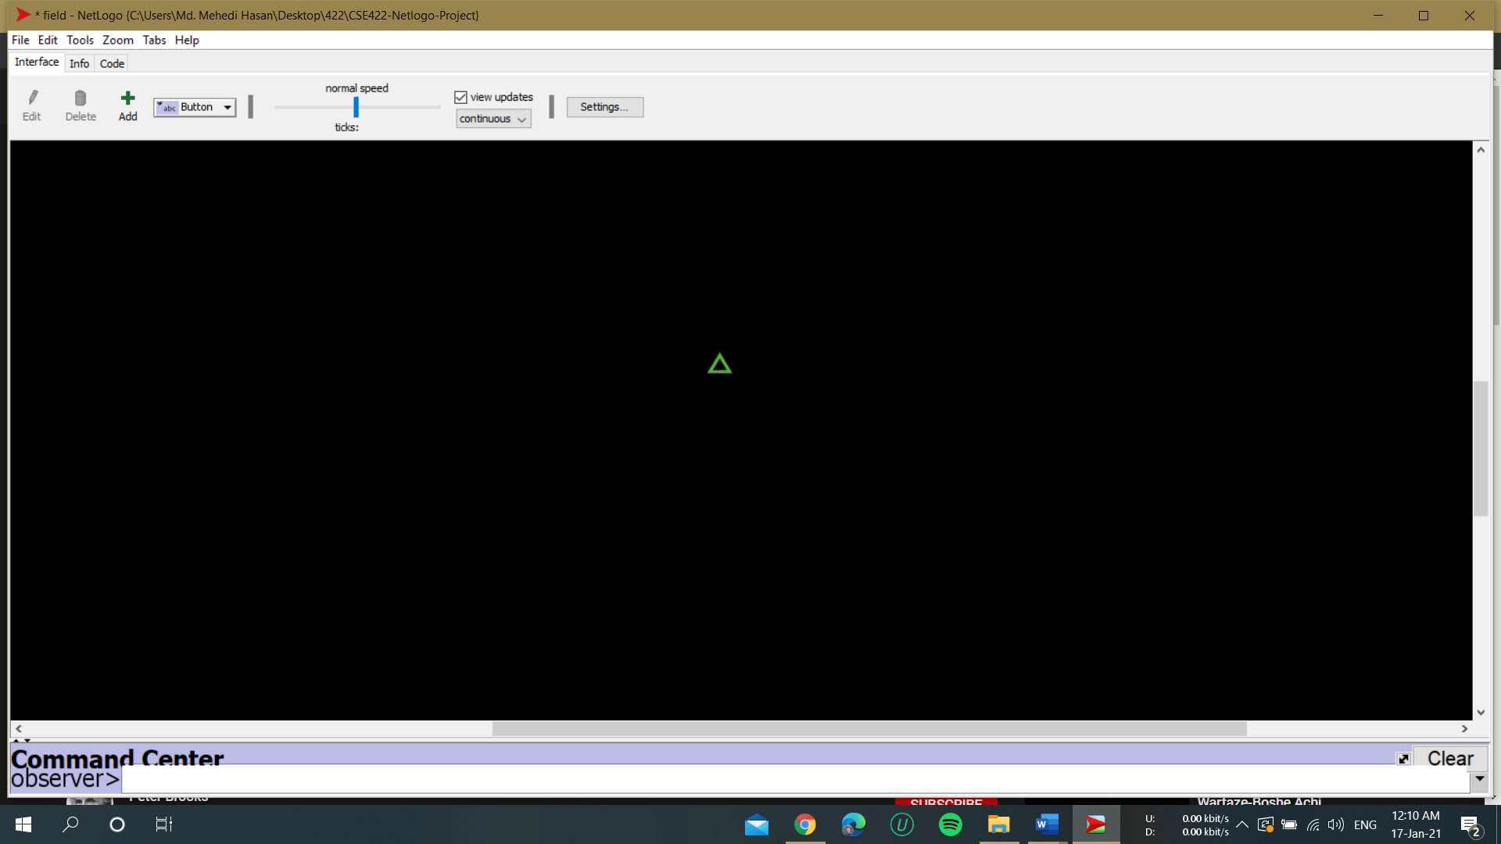 **-** Masked non-infected agent

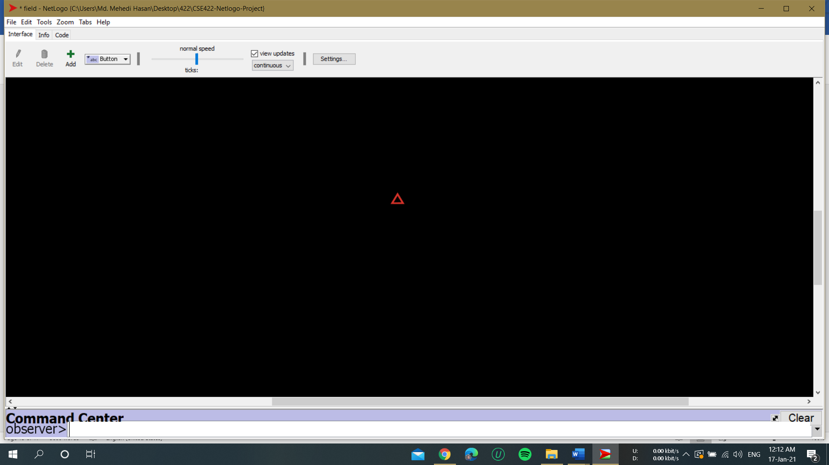 **-** Masked infected agent

**Figure 3.2.4: Agent- Shape in the Model**

**Chapter 4: Experimental Results**

**4.0. Experimental Results**

In this chapter we will run our model and showcase our result. Our model is a close environment model for Covid-19 Transmission based on Mask use in Super Shop. For showcasing result, we will simulate with 180 agents (150 non masked agents, 30 masked) until the infected rate is 100%.

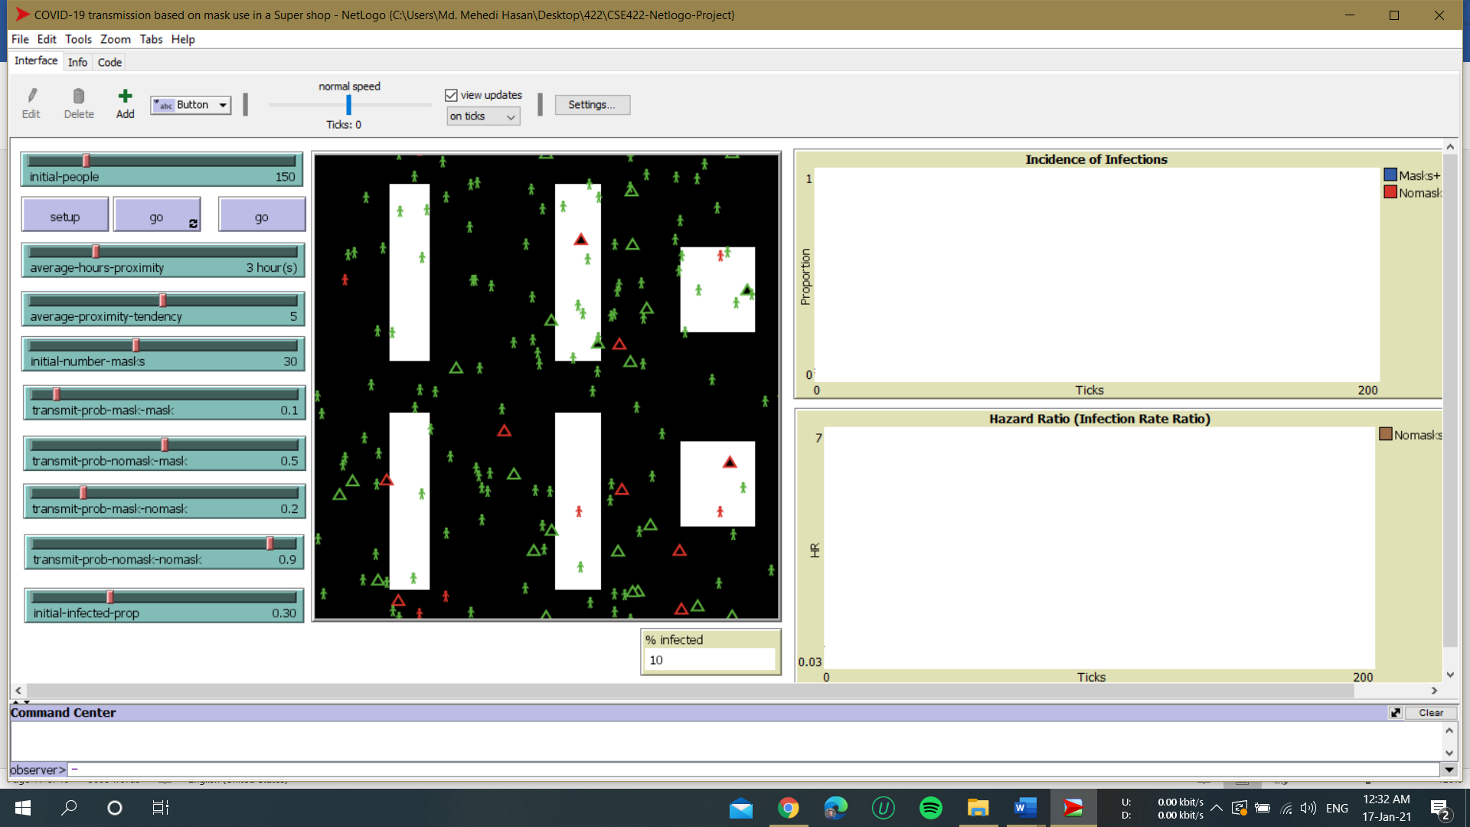

**Figure 4.0.1: Model at 10% infected**

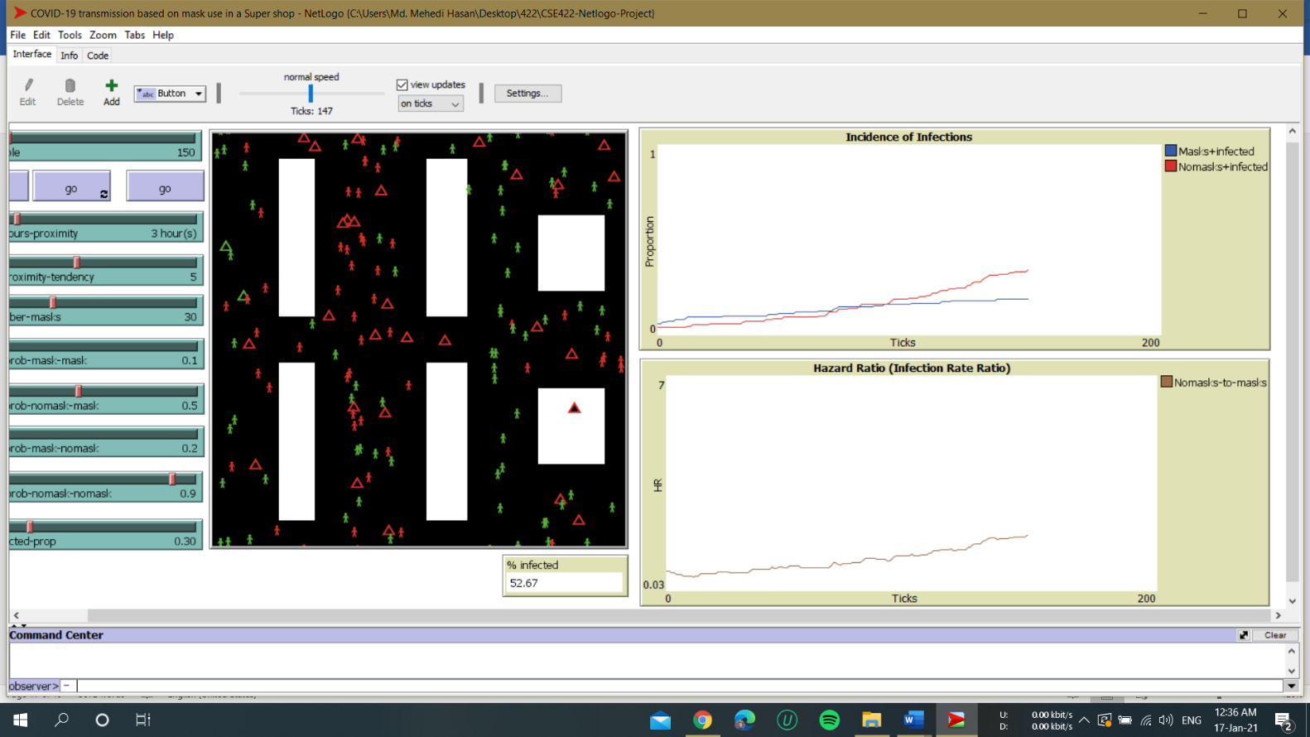

**Figure 4.0.2: Model at 52% infected**

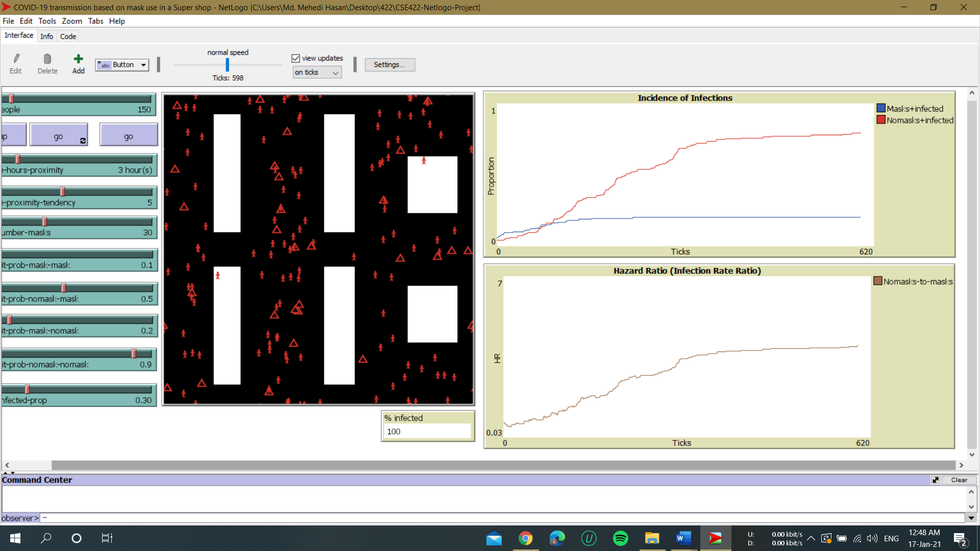

**Figure4.0.3: Model at 100% infected**

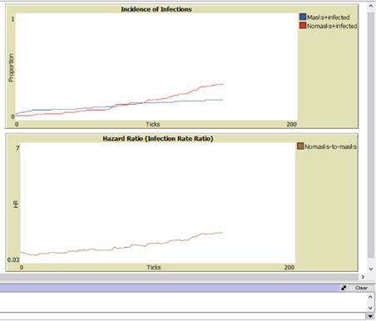

**Figure4.0.4: Graph at 52% infected**



**Figure4.0.5: Graph at 100% infected**

**4.1. Analysis**

From the report of WHO we know that 97% chance to get infected when no mask-no mask people interact, for no mask-mask interaction the infection rate is 50-70%, for mask-no mask interaction the infection rate is 20-30%, for mask-to-mask interaction the infection rate is 10% (Economictimes,2020)

In this model, we can see that happening. From the graph, we can see the rate of infection is much higher for non-mask user people in the super shop. As, time passes, non-masked people get infected in much higher rate then the masked people which represents the real-world data. So, we can see that our model is working.

The model assumes that individuals who are infected / tested positive do not necessarily use mask. This portrayal of human behavior is clearly not entirely realistic, but it does create interesting emergent behavior that has genuine relevance to certain public health debate. However, an interesting extension of the model would be to change individuals’ reactions to knowledge of Coronavirus tested status.

The model does not assume that mask use is always 100% effective even if both individuals in proximity have mask. In fact, responsible mask use is actually slightly less than ideal protection from the transmission of Coronavirus, which is thought to be the best using PPE or complete locked down scenario. A line code is added to the INFECT procedure to check for a slight random chance that a particular episode of mask-use is not effective.

Finally, certain significant changes can easily be made in the model by simply changing the value of certain global variables in the procedure SETUP-GLOBALS.

**Chapter 5: Conclusion**

**5.0. Conclusion**

COVID-19 has become a global threat affecting almost all countries in the world. The public health consequences of acquiring COVID-19 have led many governments to impose a set of control measures. Inside facilities, there is a higher probability of infection. Within these spaces, there is maintained a high contact rate between people sharing the same common surfaces of interaction. However, rarely are their specific countermeasures related to these facilities or conducted studies that analyze possible coexistent strategies. In this paper, an agent-based model to evaluate the COVID-19 transmission risks in Super Shop has been presented. In the model, the behavior of each individual is characterized by a set of simple rules that considers its basic interactions inside the facility. In its iterations, each agent maintains different mobility requirements and contagion susceptibility. From these models, several possible scenarios can be tested to obtain the coexistence conditions that need to be imposed among the members or the habits that have to be avoided for reducing the transmission risks. The model is flexible and allows testing several hypotheses. Under this role, it is possible to test different scenarios considering distinct hypothetical conditions that are impossible to analyze under real circumstances. Compared to experimental methods, the use of this agent-based model has the convenience of saving time and economic resources. In the paper, several experiments with the model are described and discussed. The experiments have as objectives to show the characteristics of the model and the results that it can provide.

**Reference**

 Arino J., McCluskey C.C., wan den Driessche P. Global results for an epidemic model with vaccination that exhibits backward bifurcation. SIAM J. Appl. Math. 2003;64:260–276.

Breslin Noelle, Baptiste Caitlin, Gyamfi-Bannerman Cynthia, Miller Russell, Goffman Dena. COVID-19 infection among asymptomatic and symptomatic pregnant women: two weeks of confirmed presentations to an affiliated pair of New York City hospitals. Am. J. Obstet. Gynecol. MFM. 2020 doi: 10.1016/j.ajogmf.2020.100118. In press. [PMC free article] [PubMed] [CrossRef] [Google Scholar]

Bailey N. The mathematical theory of infectious diseases and its applications. Griffin. 1975;28:479–480.

Chan, V., Son, Y., Macal, C., Agent-based simulation tutorial - simulation of emergent behavior and differences between agent-based simulation and discrete-event simulation, Proceedings of the 2010 Winter Simulation Conference B. Johansson, S. Jain, J. Montoya-Torres, J. Hugan, and E. Yücesan, eds.

Economictimes.indiatimes., 2020 Masks, explained: What percentage of the virus can be blocked, and what it means for the infected and uninfected?< https://economictimes.indiatimes.com/magazines/panache/mask-explained-what-percentage-of-the-virus-can-be-blocked-and-what-it-means-for-the-infected-and-uninfected/articleshow/79282831.cms>

Kermack W., McKendrick A. Contributions to the mathematical theory of epidemics (Part I) Proc. R. Soc. 1927;115:700–721

Li Gang, Hu Rui, Gu Xuefang. A close-up on COVID-19 and cardiovascular diseases. Nutr. Metabol. Cardiovasc. Dis. 2020 doi: 10.1016/j.numecd.2020.04.001. [PMC free article] [PubMed] [CrossRef] [Google Scholar]

Li Michael Y. Springer Verlag; 2018. An Introduction to Mathematical Modeling of Infectious Diseases. [Google Scholar]

Li Yan, Zhang Qimin. The balanced implicit method of preserving positivity for the stochastic SIQS epidemic model. Physica A. 2020;538:122972.

Marinia Marcello, Brunner Cyril, Chokani Ndaona, Abhari RezaS. Enhancing response preparedness to influenza epidemics: agentbased study of 2050 influenza season in Switzerland. Simulat. Model. Pract. Theor. 2020;103:102091

Oliver M., Cliff Nathan Harding, Mahendra Piraveenan E. Yagmur Erten, Manoj Gambhir, Mikhail Prokopenko, Investigating spatiotemporal dynamics and synchrony of influenza epidemics in Australia: an agent-based modelling approach. Simulat. Model. Pract. Theor. 2018;87:412–431

Qi H., Zhang S., Meng X., Dong H. Periodic solution and ergodic stationary distribution of two stochastic SIQS epidemic systems. Physica A. 2018;508(223–241)

(Yorke, et al. "Seasonality and the requirements for perpetuation and eradication of viruses in populations." Journal of Epidemiology, volume 109, pages 103-123)

Zhang X., Xiang H., Meng X. Dynamics of the deterministic and stochastic SIQS epidemic model wiht non-linear incidence. Appl. Math. Comput. 2014;243:546–558.