

# **Contact:**

+8801784094462

md.mehedi4462@gmail.com

linkedin.com/md-mehedi62

Rangpur Sadar, Bangladesh

# **Skill Highlights:**

* Excellent Communication and Organizing Skill
* English Teaching
* Leadership & Teamwork
* Event Management
* Critical Problem Solving
* Content Making & Writing
* MS PowerPoint & MS Excel
* MS Word & Internet

# **Language Proficiency:**

Bangla – C2

English – B1

Hindi – B1

# **Personal Interests:**

* Strength Training
* Journey
* Teaching

# **Experience & Extracurricular Activities:**

* Campus Ambassador of "Smartifier Academy"
* Affiliate Co-ordinator at "10 Minute School"
* English instructor at "Advance Cadet Coaching"
* English instructor at "Nefron Coaching Centre"
* Former Ambassador of "Bohubrihi Online Courses"
* Former Campus Director of "CKH Network"

# **Educational Qualification:**

**Graduation-Bachelor of Arts**

Institute : Begum Rokeya University, Rangpur

Department : English

Year : 2nd year, 1st Semester

SGPA : 3.00

**HSC**

Institute : New Govt. Degree College, Rajshahi

Group : Humanities

GPA : 4.83 (out of 5.00)

**SSC**

Institute : Gaopara Senbhag High School

Group : Science

GPA : 4.67 (out of 5.00)

# **Achievement:**

* Best organizing and participation performance certificate from "CKH Network: Next Gen Leaders Summit-2020"
* Certification for Excellency in Volunteerism from "TalkDigital"
* 10+ Online Courses Certificates.

**Profile & Objective:**

To work in the creative department of different local or international organizations of Bangladesh and grow rapidly with increasing responsibilities.

organizationsofBangladeshandgrowrapidlywithincreasing

responsibilities.

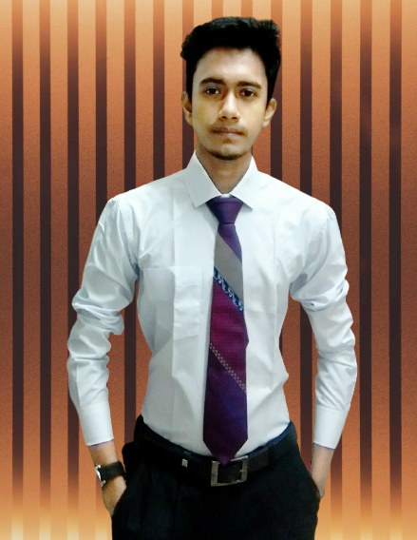

**Md. Mehedi Hasan**