YAML_LAB

What is YAML
YAML (Yet Another Markup Language/YAML Ain't Markup Language) is a human-readable, lightweight data serialization format commonly used in DevOps for configuration files, Infrastructure as Code (IaC), and CI/CD pipelines. It enables automation in tools like Kubernetes, Docker, and Ansible, using indentation-based key-value pairs.

YAML VS JSON

YAML | JSON
Comments are denoted with a hash/number sign. | Comments are not allowed.
Hierarchy is denoted by using double space characters. Tab characters are not allowed. | Objects and Arrays are denoted in braces and brackets.
String quotes are optional but it supports single and double quotes. | Strings must be in double quotes.
Root node can be any of the valid data types. | Root node must either be an array or an object.

INDENTATION RULES IN YAML
- Spaces Only: Tab characters are forbidden in YAML for indentation because different systems treat them differently, which can lead to portability issues
- Hierarchy via Indentation: Increased indentation signifies a nested, child element, while items at the same indentation level are considered siblings.
- Consistency is Key: While you can choose any number of spaces per indentation level (the convention is 2 or 4), you must use that same number consistently throughout the entire document.
- Indentation Amount: The YAML specification doesn't mandate a specific number of spaces, only that nested blocks must be indented more than their parent.
- Sequence Indentation: Items in a sequence (list) are denoted by a hyphen (-) followed by a space.

KEY VALUE PAIRS IN YAML
key-value pairs (also known as mappings or dictionaries) are the basic building blocks for representing data. They associate a key with a value using a colon (:) separator, and structure is defined by indentation
fruit: Apple

# Nested key-value pairs using indentation
person:
name: Reetesh Kumar # String value
age: 25 # Number value
isStudent: true # Boolean value
address: # A nested dictionary (map)
street: "458 Walkman Dr."
city: "Royal Oak"

LISTS
Lists can also contain complex objects, such as mappings (key-value pairs), which is common in configuration files like Kubernetes manifests or Ansible playbooks.
- Block Style (Recommended for Readability)
Each item in a block-style list is on its own line, preceded by a hyphen (-) and a space, and must maintain the same level of indentation.
yaml
fruits:
- apple
- banana
- orange

- Flow Style (JSON Equivalent)
Flow style allows you to define a list on a single line using square brackets [] and commas , , similar to JSON syntax.
yaml
fruits: ["apple", "banana", "orange"]

- Lists of Mappings (Dictionaries/Objects)
Lists can also contain complex objects, such as mappings (key-value pairs), which is common in configuration files like Kubernetes manifests or Ansible playbooks.
yaml
people:
- name: John Smith
age: 30
email: john@example.com
- name: Jane Doe
age: 25
email: jane@example.com

- Nested Lists
Lists can be nested within other lists using consistent indentation
yaml
groceries:
- fruits:
- apple
- banana
- vegetables:
- carrot
- broccoli

- Lists can also contain complex objects, such as mappings (key-value pairs), which is common in configuration files like Kubernetes manifests or Ansible playbooks.
Indentation Matters: Child elements are indented relative to their parent.
- Mappings (Dictionaries): Key-value pairs where the value can be another nested structure, defined by key: value.
- Sequences (Lists): Ordered lists marked by a hyphen and space (- ).
- No Tabs: Only spaces are allowed for indentation, typically 2 or 4 per level.
- Comments: Use # to add comments.

CREATE A BASIC YAML FILE

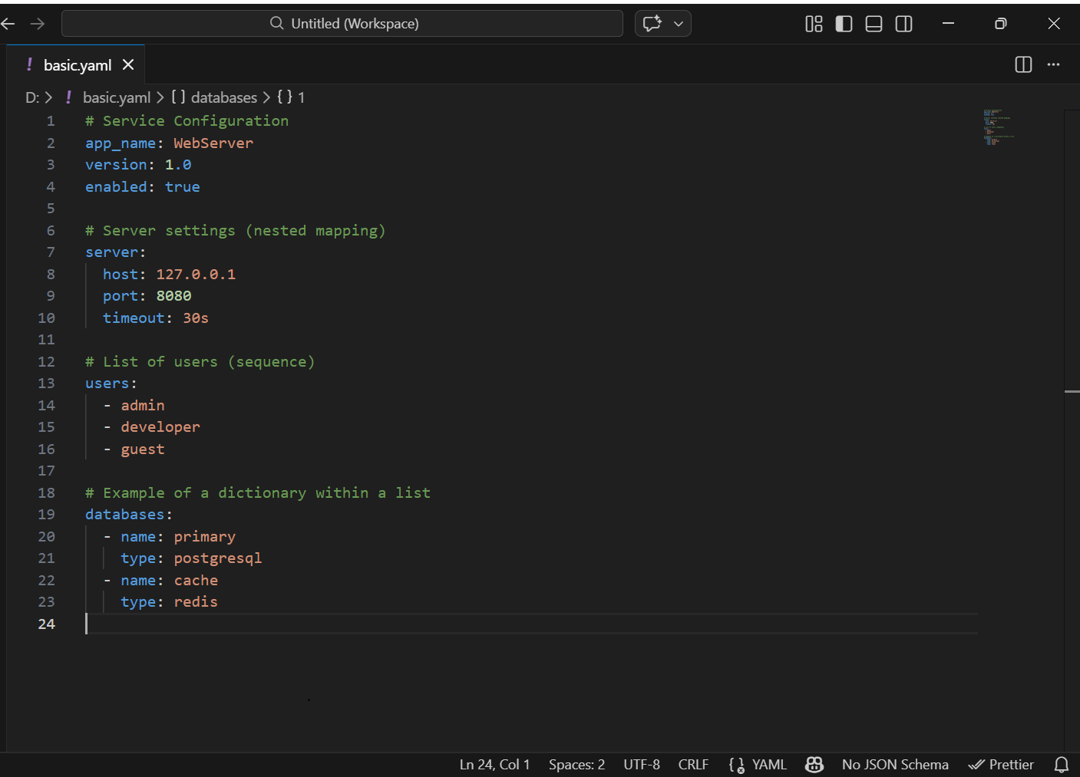

CONVERT JSON INTO YAML
Json file created
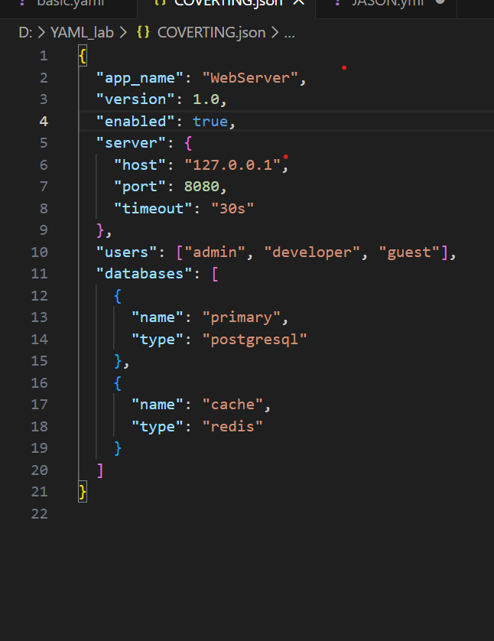

Converting JSON to YAML
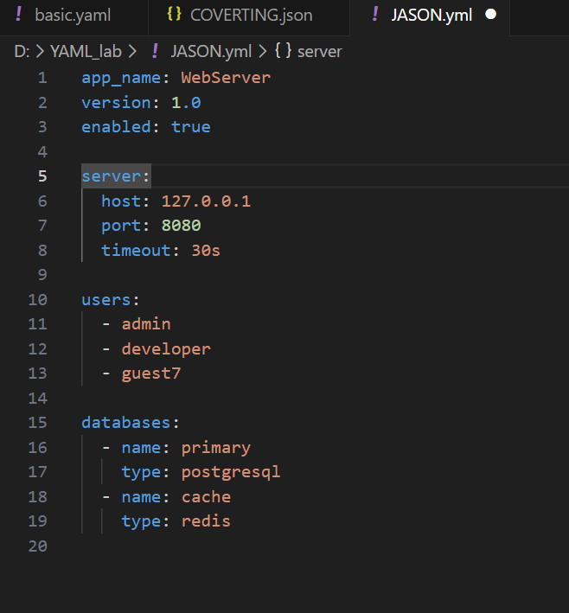

LAB 2

MULTILINES IN YAML
There are two types of formats that YAML supports for scalar strings. (Scalars are what YAML calls basic values like numbers or strings, as opposed to complex types like arrays or objects.)
- Flow scalar formats are designed for robust simplicity but do have a limited escaping and line-break support. They are designed to ignore indentations.
- Block scalar formats provide more control over how they are interpreted by increasing sensitivity rules regarding indentations and escaping. These are designed to answer for cases whenever scalar flow formats become cumbersome or insufficient.

YAML
example: 'A simple string.'
Result
A simple string.

Block Scalars
A block scalar header has three parts:
Block Style Indicator: The block style indicates how newlines inside the block should behave. If you would like them to be kept as newlines, use the literal style, indicated by a pipe (|). If instead you want them to be replaced by spaces, use the folded style, indicated by a right angle bracket (>)
.Block Chomping Indicator: The chomping indicator controls what should happen with newlines at the end of the string. The default, clip, puts a single newline at the end of the string. To remove all newlines, strip them by putting a minus sign (-) after the style indicator. Both clip and strip ignore how many newlines are actually at the end of the block; to keep them all put a plus sign (+) after the style indicator.
Indentation Indicator: Ordinarily, the number of spaces you're using to indent a block will be automatically guessed from its first line. You may need a block indentation indicator if the first line of the block starts with extra spaces. In this case, simply put the number of spaces used for indentation (between 1 and 9) at the end of the header.
Bottom of Form
YAML
example: >
Several lines of text,
with some "quotes" of various 'types',
and also a blank line:
and some text with
extra indentation
on the next line,
plus another line at the end.

Result
Several lines of text, with some "quotes" of various 'types', and also a blank line:and some text with extra indentationon the next line, plus another line at the end.

ANCHOR & ALIASES

YAML anchors (&) and aliases (*) are used to reuse a block of configuration or data within a single YAML file, following the "Don't Repeat Yourself" (DRY) principle. This improves maintainability and readability by defining common elements once
- Anchor (&): Marks a specific data node (scalar, sequence, or mapping) with a unique name using the &anchor_name syntax. This is like defining a variable or a template.

- Alias (*): References a previously defined anchor elsewhere in the document using the *anchor_name syntax. When the YAML is parsed, the alias is replaced by the content of the anchored node.

- Merge Key (<<:): A special key, used with an alias (<<: *anchor_name), that allows merging the contents of an aliased mapping (dictionary) into the current mapping.

ENVIRONMENT VARIABLE

YAML is a data format and does not natively support referencing environment variables. The ability to use environment variables within a YAML file is provided by the specific application, programming language library, or CI/CD tool that reads and processes the file.
Example: Kubernetes
In Kubernetes, you define environment variables within the Deployment or Pod specification. The application running inside the container then accesses these variables via the operating system's standard mechanism (e.g., $VAR_NAME in Linux)

Example: CI/CD Pipelines (Azure DevOps)
In a CI/CD pipeline like Azure Pipelines, variables defined at the pipeline level can be accessed in scripts.

COMMENTS AND FORMATTING
Comments:
In a YAML file, comments are created using the # (hash) symbol. Everything following the # on the same line is treated as a comment and is ignored by the YAML parser.

YAML supports two types of comments:
Full-line comments: These comments occupy an entire line and are typically used to describe a section of code or provide general information about the file.

- yaml
- # This is a full-line comment
- key: value

Inline comments: These comments are placed on the same line as a code statement to provide brief, specific explanations about the line they accompany.
yaml
key: value # This is an inline comment

Formatting:
YAML is a human-readable data serialization format that relies heavily on whitespace and indentation to define structure. It is used for configuration files in many applications like Kubernetes and Ansible
- Scalars (Strings, Numbers, Booleans):
  - Strings are often unquoted. Quotes are necessary if a string contains special characters, reserved words (like true or null), or needs specific escape sequences (double quotes allow C-style escapes like \n).
  - Numbers (integers and floats) and Booleans (true or false, case sensitive in YAML 1.1) are automatically detected.
- Multi-line Strings:
  - The literal style (pipe character |) preserves all newlines and indentation.
  - The folded style (greater-than character >) folds newlines into single spaces, useful for long text that should be read as a single line.
- Flow Style: YAML supports an inline "flow style" using square brackets [] for lists and curly braces {} for key-value maps, similar to JSON syntax. This is more compact but less human-readable than the standard block style.

CREATE REUSABLE YAML CONFIGIRATION USING ANCHOR
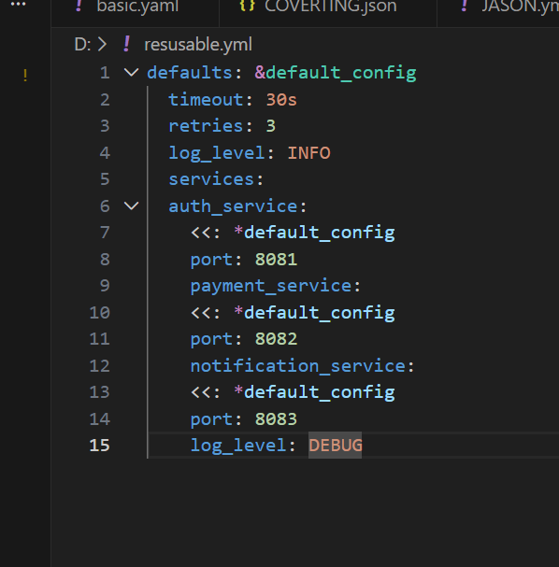

- Anchors work only within the same YAML file
- Supported by most tools (Docker Compose, CI/CD, Kubernetes configs)
- YAML does not execute — tools read it

