

**University of Asia Paciﬁc**

Dept. of Computer Science & Engineering

Course Title : Database System Lab

Course Code : CSE 212

Section: D (1)

Project Title : Online Job Portal

:

Submitted by:

Faiza Haque Shoily

ID: 22201183

Meher Afroz

ID : 22201176

Jannatul Maowa Meghla

ID : 22201194

Submitted to:

Alif Ruslan

Lecturer,

Department of Computer Science and Engineering,

University of Asia Pacific

**Contents**

**Topic Pages**

Description 3

Entities 3

Relationship Sets 4

Attributes 4 - 5

ER Diagram 6

Schema Diagram 7

Queries 8 - 16

CEP Mapping 17 - 19

**Online - Job Portal**

**Project Description -**

As more companies are recruiting students for jobs virtually, there is a need for an online Job Portal to connect both job seekers and companies for the recruitment process. The Job Portal would help boost a person’s job seeking efforts and company’s hiring process.

**Entities -**

1. **Jobseeker -** The table is structured to store essential personal details of job seekers, including identification, contact information , and credentials.
2. **Profile -** The table is used to store additional details about the job seeker's educational background, and it is linked to the jobseeker table by the jobseeker_id.
3. **Company -** The table's primary purpose is to store basic details about each company, with the company_id serving as a unique identifier. The name and location columns store the company's name and physical location, respectively.
4. **Job -** The table stores job-specific details and links each job listing to a company through the company_id foreign key. This relationship ensures that each job listing is associated with the relevant company.
5. **Interview -** The table's primary purpose is to store interview details, including the interview identifier, date, time, and the associated job and job seeker. The Interview_no and date and job_id together form the composite primary key, ensuring that each interview is uniquely identified by its number and date. The table also establishes relationships with the Job and jobseeker tables through foreign keys.
6. **Result -** The table tracks the results of interviews, associating each result with a specific job and job seeker. It links to the Job and jobseeker tables through foreign keys, allowing the status of an interview to be recorded and tracked for each job seeker and job.
7. **Apply -** The Apply table is designed to store information about job applications made by job seekers**.**

**Relationship Sets -**

1. **Profile - Jobseeker**

* One-to-One (1:1).

1. **Jobseeker - Interview**

* One-to-Many (1:M).

1. **Jobseeker - Job**

* Many-to-Many (M:N).

1. **Jobseeker - Result**

* One-to-Many (1:M).

1. **Job – Interview**

* One-to-Many (1:M).

1. **Job – Result**

* One-to-Many (1:M).

1. **Job – Company**

* One-to-Many (M:1).

**Attributes:**

|  |  |  |
| --- | --- | --- |
| **Entities**  Attributes | **Data_Type** | **Key/Non-key** |
| **Jobseeker**  jobseeker_id  first_name  last_name phone_number  address  email | INT  VARCHAR2(20)  VARCHAR2(20)  NUMBER  VARCHAR2(20)  VARCHAR2(30) | PRIMARY KEY  Non_key attribute  Non_key attribute  Non_key attribute  Non_key attribute  Non_key attribute |
| **Profile**  profile_id  jobseeker_id  college  department  education | INT  INT  VARCHAR2(20)  VARCHAR2(10)  VARCHAR2(30) | PRIMARY KEY  FOREIGN KEY  Non_key attribute  Non_key attribute  Non_key attribute |
|  |  |  |
| **Company**  company_id  name  location | varchar (20)  varchar (20)  varchar (20) | PRIMARY KEY  Non_key attribute  Non_key attribute |
| **Job**  job_id  job_title  job_type  job_description  job_salary  company_id | varchar (20)  varchar (40)  varchar (20)  varchar (20)  varchar (30)  varchar (20) | PRIMARY KEY  Non_key attribute  Non_key attribute  Non_key attribute  Non_key attribute  FOREIGN KEY |
| **Interview**  Interview_no  date  time  job_id  jobseeker_id | VARCHAR(50)  varchar(20)  VARCHAR(50),  VARCHAR(20)  INT | PRIMARY KEY  PRIMARY KEY  Non_key attribute  PRIMARY KEY, FOREIGN KEY  FOREIGN KEY |
| **Apply**  job_id  jobseeker_id | VARCHAR2(50)  INT | PRIMARY KEY, FOREIGN KEY  PRIMARY KEY, FOREIGN KEY |
| **Result**  result_id  job_id  jobseeker_id  status | INT  VARCHAR(50)  INT  VARCHAR(20) | PRIMARY KEY  FOREIGN KEY  FOREIGN KEY  Non_key attribute |

**ER Diagram –**

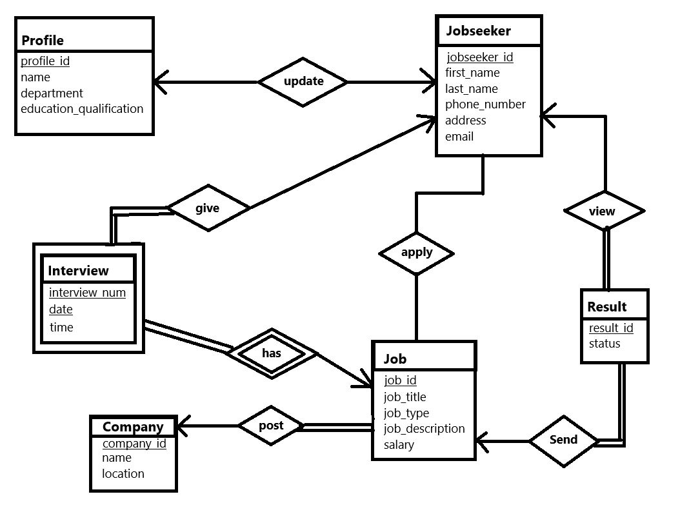

**Relational Schema -**

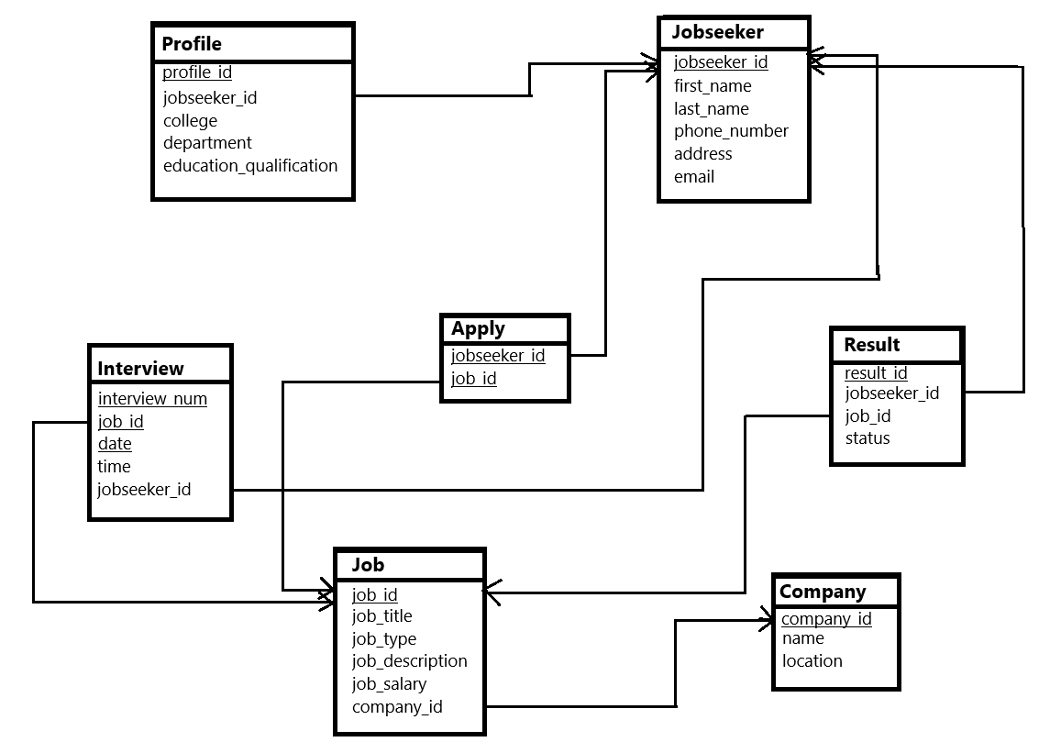

**Queries -**

1. . Find company based on a specific location:

* select * from company where location = 'Dhaka';

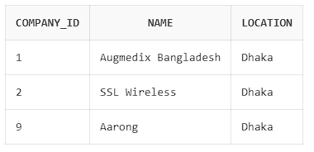

1. . Get the Number of Interviews Scheduled for a Job:

* select count(*) as interview_count

from Interview

where job_id = 'J001';

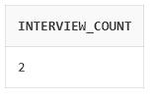

3. Remove password from jobseeker:

* alter table jobseeker drop column password;

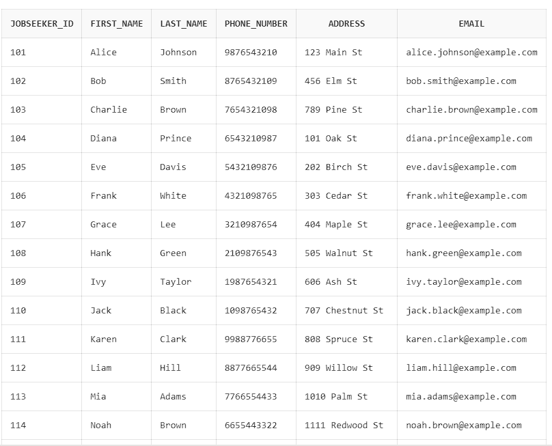

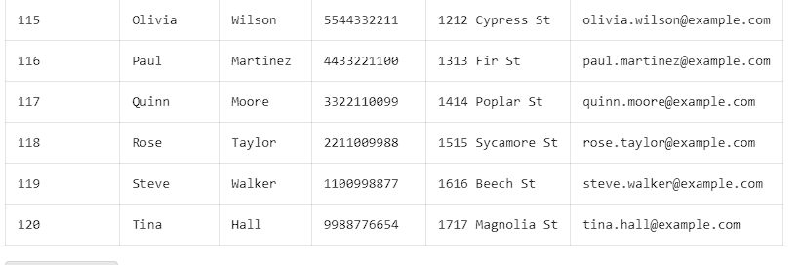

4. job_title ordered alphabetically in ascending order:

* select job_title from Job

order by job_title asc;

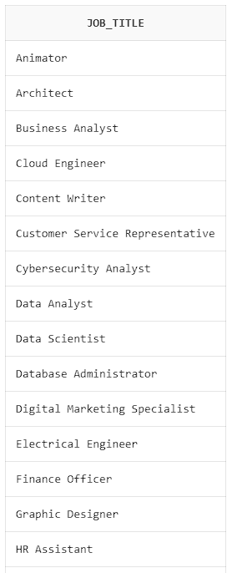

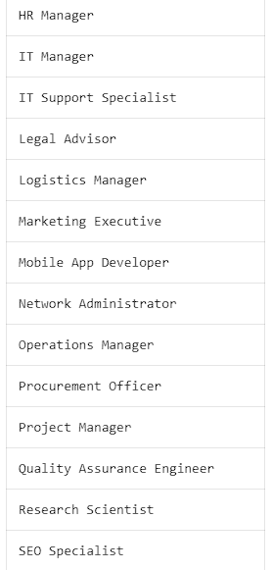

5. Find the jobseekers who are PhD holders:

* select * from profile where education = 'PhD';

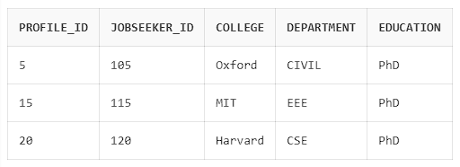

6. Find profile id’s who are from Stanford and Harvard University:

* select profile_id, jobseeker_id

from profile

where college = 'Stanford' or college = 'Harvard';

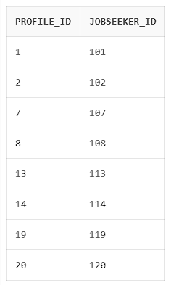

7. Find profiles who are from CSE and CIVIL department:

* select * from profile

where department in ('CSE', 'CIVIL');

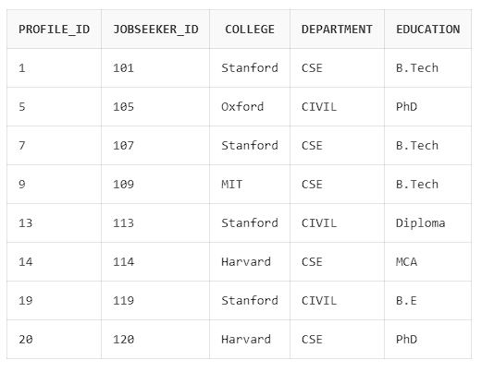

8. Find how many Full-Time, Half-Time,Contract job is available:

* select count (job_type) , job_type from job group by job_type;

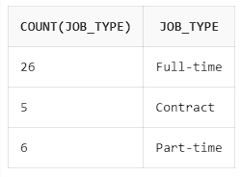

9. Find Full Time jobs with salary greater than 50000 :

* select * from job where job_type = 'Full-time' and job_salary > 50000;

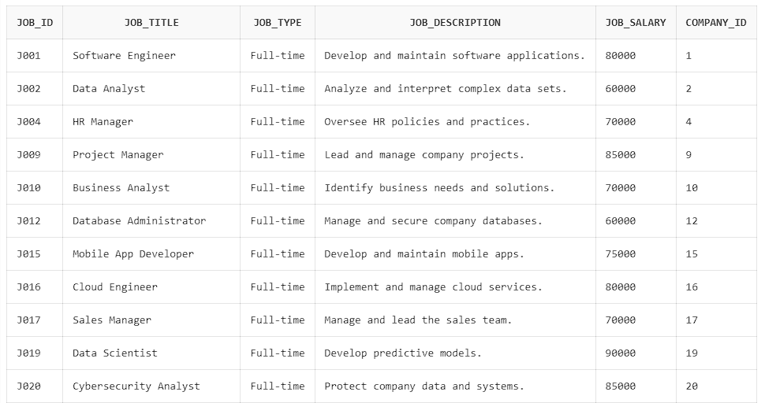

10. Find how many candidates are accepted and their jobseeker id’s for a job :

* select count (jobseeker_id) as selected , jobseeker_id as Accepted_Candidate from result

where status = 'Accepted' group by jobseeker_id;

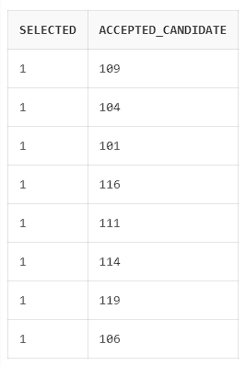

11. Find Job Seekers Who Have Applied for a Specific Job

* select jobseeker_id from Apply

where job_id = 'J001';

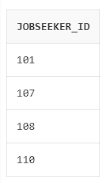

12. List All Companies with Their Number of Job Listings

* select company_id, count(*) as num_jobs from Job

group by company_id ;

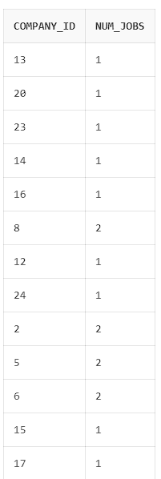

13. Count the Number of Applications for Each Job

* select j.job_title, count(a.jobseeker_id) as num_applications

from Job j

join Apply a on j.job_id = a.job_id

group by j.job_title;

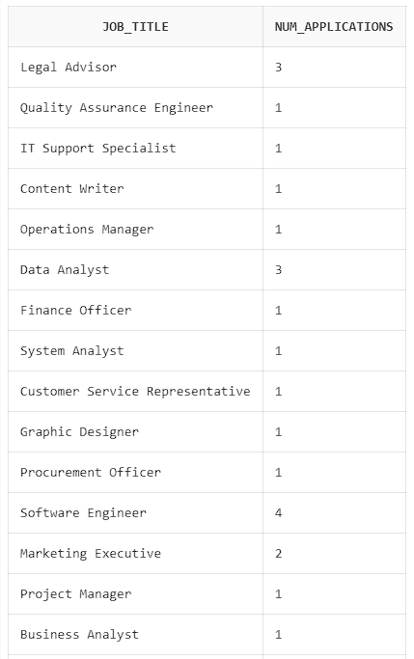

14. Find All Companies Hiring for a Specific Job Title

* select c.company_id, j.job_title

from Company c

join Job j on c.company_id = j.company_id

where j.job_title = 'Software Engineer';

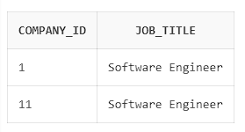

15. Find Job Titles That Have More Than 1 Applications

* select j.job_title, count(a.jobseeker_id) as num_applications

from Job j join Apply a

on j.job_id = a.job_id

group by j.job_title having count(a.jobseeker_id) > 1;

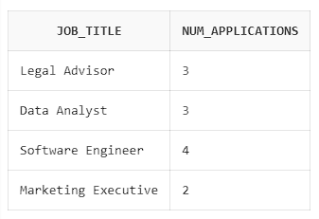

**CEP Mapping –**

How Knowledge Prole (Ks) are addressed through our project:

|  |  |  |
| --- | --- | --- |
| **Ks** | **Attribute** | **How Ks are addressed through the project** |
| K3 | Engineering Fundamentals | The project required understanding of database fundamentals for designing the database model, and defining relationships between entities. |
| K5 | Engineering design | We utilized ER Diagram and Schema Diagram to visualize the structure of the database |
| K6 | Engineering practice | Used Oracle Live sql and MySQL on an online compiler website to test, debug, and execute SQL queries |
| K7 | Comprehension | Defines the essential aspects of how the system handles, stores, processes, and shares data across multiple entities. It outlines the flow of knowledge from raw data inputs to meaningful outputs that can be accessed by users (job seekers, companies) and the system. |

How Complex Engineering Problems (Ps) are addressed through our project and mapping among Ps, COs, POs:

|  |  |  |  |  |
| --- | --- | --- | --- | --- |
| **Ps** | **Attribute** | **How Ps are addressed through the project** | **COs** | **POs** |
| P1 | Depth of knowledge required | Cannot be resolved without in-depth knowledge of engineering at the level of one or more Database fundamentals (K3), ER diagram & Schema diagram (K5), use of SQL server to implement SQL (K6) and lastly the impact on society (K7). | CO1  CO2  CO3  CO4  CO5 | PO1  PO3  PO5  PO6  PO7  PO8 |
| P3 | Depth of analysis required | Demands a thorough examination of the database schema, relationships between entities, business logic, query requirements, and managing multiple jobseekers’ and companies’ data. | CO3  CO4  CO5 | PO6  PO7  PO8 |
| P6 | Extent of stakeholder | The system supports diverse stakeholders, including donors, volunteers and administrative staff, each with unique roles and requirements. | CO6 | PO6  PO8 |
| P7 | Interdependence | refers to the interrelationships between the different components and entities within the database and how each part of the system interacts with others to function as a cohesive unit. | CO7  CO8 | PO11 PO12 |

How Complex Engineering Activities (As) are addressed through our project and mapping among As, COs, POs:

|  |  |  |  |  |
| --- | --- | --- | --- | --- |
| **As** | **Attribute** | **How As are addressed through the project** | **COS** | **POS** |
| A1 | Range of resources | The Online Job Portal utilizes various resources, including technology (database management systems), information( Job Title, Companies, Job salaries) equipment (computers), human resources | CO8  CO9 | PO11 |
| A4 | Consequences for society and environment | Online job portal brings significant benefits to society by making job opportunities more accessible, efficient, and diverse | CO6 | PO6 PO12 |
| A5 | Familiarity | Online job portal database refers to how easily various stakeholders (job seekers, employers, recruiters, and system administrators) can interact with the database system, understand its structure, and use it effectively. | CO9 | PO11  PO12 |