MILESTONE – 1

- ERD (Entity-Relationship Diagram):

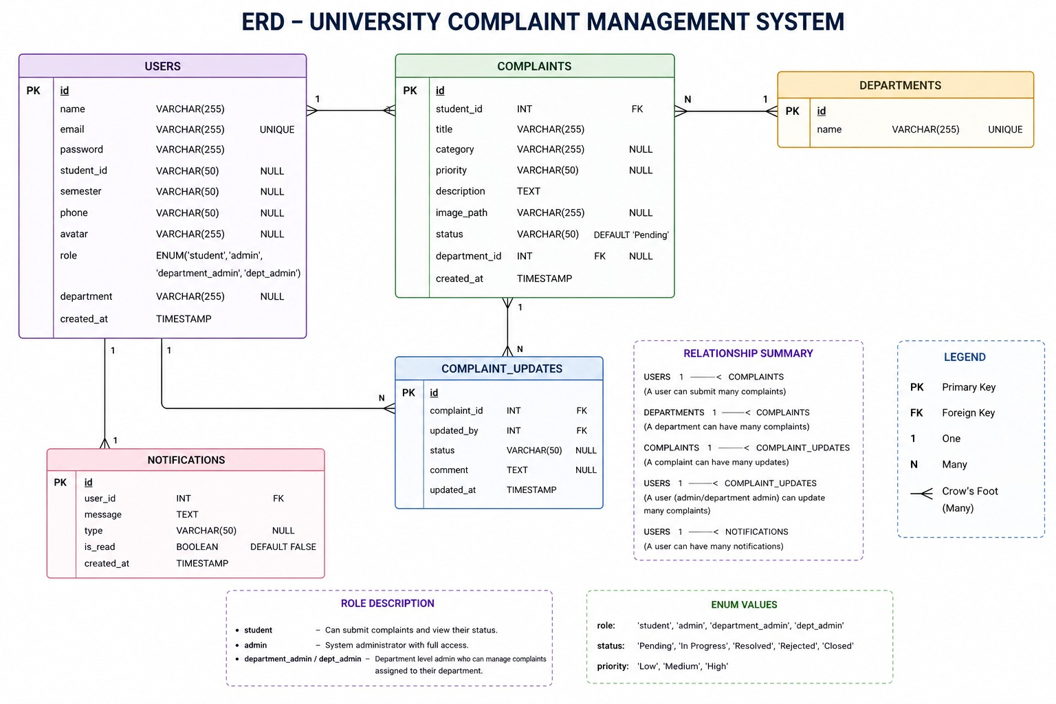

- Relational Database Schema Description

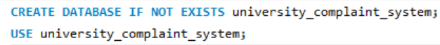
- Tables Creation:

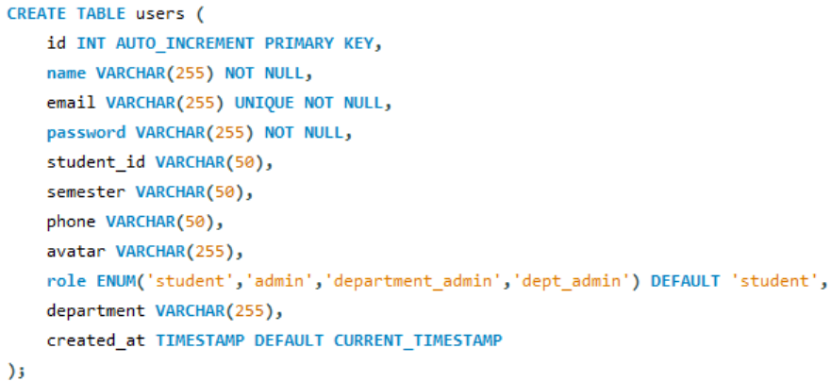

Users: Stores all users of the system (students, admins, department admins).
It keeps their personal info like name, email, password, role, and department.
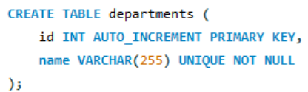

Departments: Stores the list of university departments (like IT, CS, Business).
Used to organize complaints based on departments.
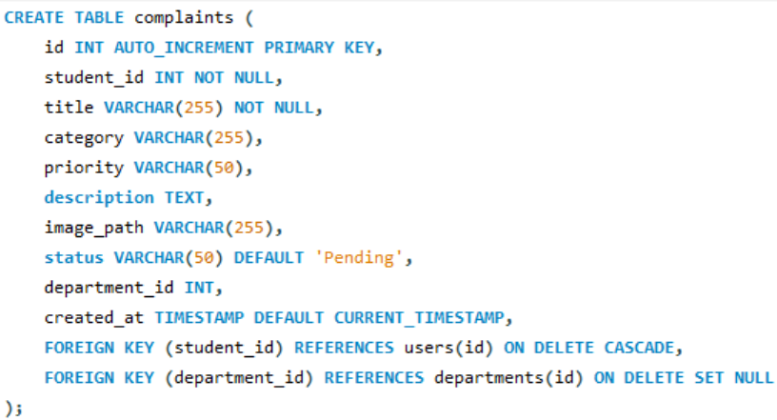

Complaints: Stores all complaints submitted by students.
It includes complaint details like title, description, priority, status, and linked department.
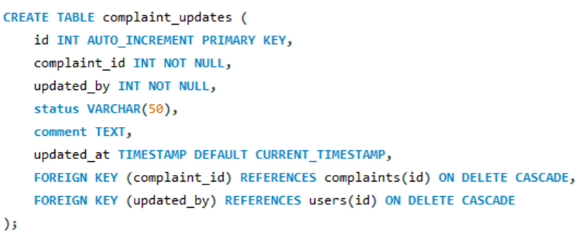
complaint_updates: Stores updates made on complaints (like status changes or comments) Helps track progress and actions taken on each complaint.
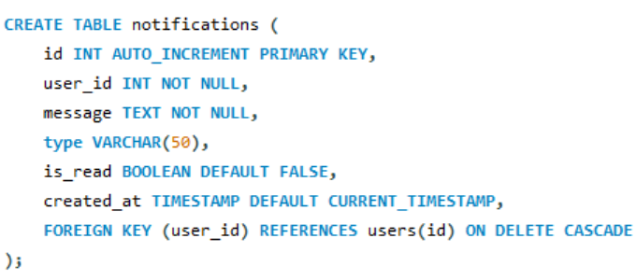

Notifications: Stores messages/alerts sent to users.
Used to notify users about updates, status changes, or important information.

