MILESTONE – 2
- Updated ERD (Entity-Relationship Diagram):
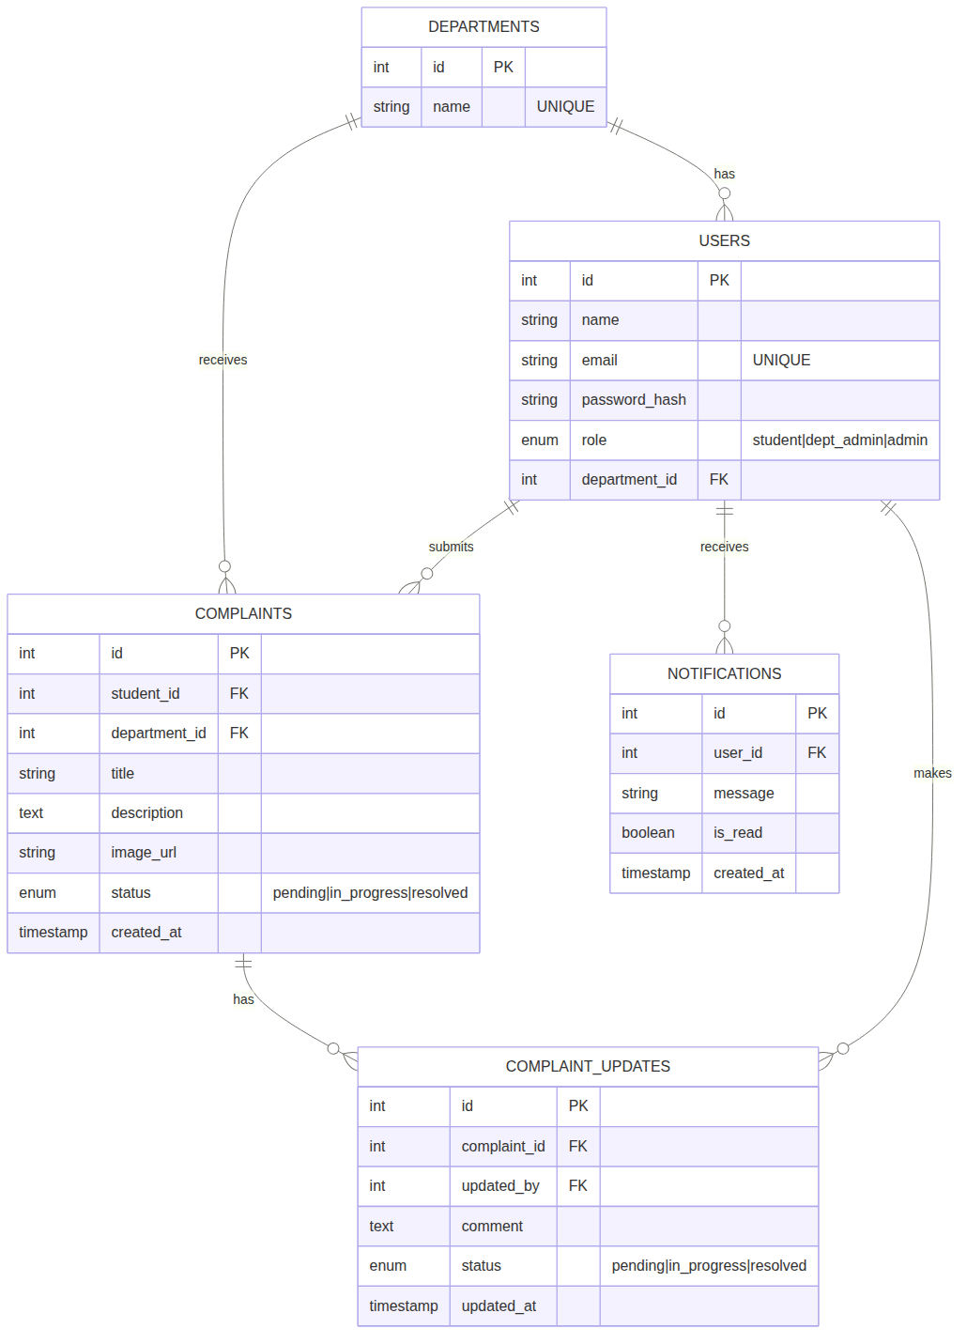
The ERD above has been updated to reflect all normalization changes.

- Normalization & Duplicates Removal:

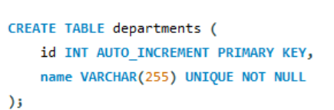

Table: departments

Normalization:
- 1NF: Satisfied. It uses a simple structure with atomic values for ID and Name.
- 2NF: Satisfied. All non-key data (the department name) is fully functionally dependent on the primary key id.
- 3NF: Satisfied. There are no transitive dependencies; the name of the department depends on nothing other than its own ID.
- Change & Why: No change needed. The table is already a "lookup" table, which is the standard way to store unique category names efficiently.
Duplicate Removal:
- Duplicates Found: None.
- Action Taken: Added UNIQUE constraint to the name column.
- Why: This prevents the database from accidentally having two departments with the exact same name (e.g., two "Computer Science" entries), which is the most basic form of duplicate prevention.
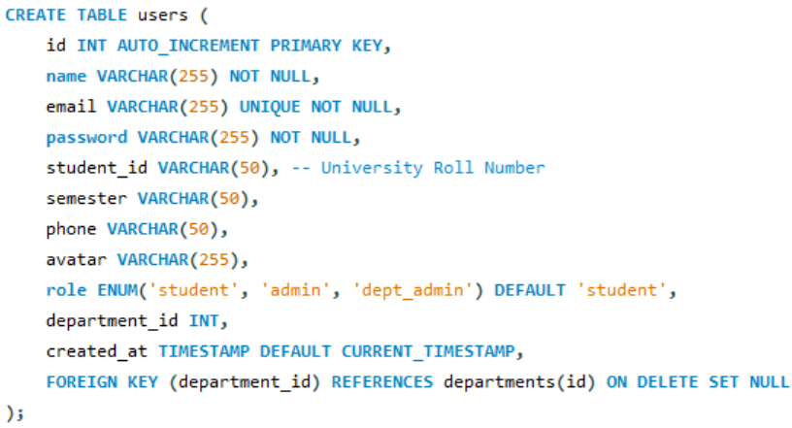

Table: users

Normalization:
- 1NF: Satisfied. Every column contains atomic values (no lists or comma-separated values) and there are no repeating groups.
- 2NF: Satisfied. The table has a primary key (id), and all attributes like name and email depend on the whole key.
- 3NF: Issue Identified. The department column was a transitive dependency because it relied on the department's identity, which should be managed separately.
- Change & Why: Replaced department (text) with department_id (foreign key). This ensures that if a department name changes, it only needs to be updated in one table, preventing data inconsistency.
Duplicate Removal:
- Duplicates Found: Yes. 1. Redundant strings in the department column. 2. Overlapping roles in the role ENUM.
- Action Taken: 1. Replaced the department VARCHAR with department_id linked to the departments table. 2. Removed the redundant 'department_admin' string from the ENUM, leaving only 'dept_admin'.
- Why: Instead of storing the text "Business Administration" for every student, we store a single integer. Consolidating the roles ensures the system doesn't have two different labels for the same user type.

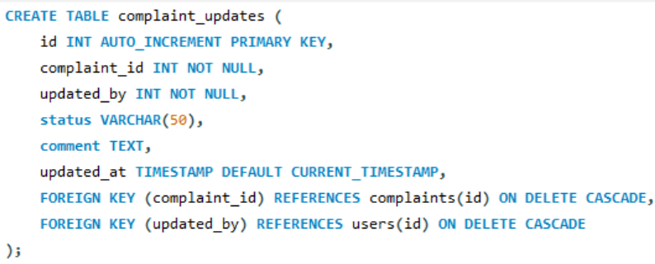

Table: complaint_updates

Normalization:
- 1NF: Satisfied. All columns (status, comment, timestamp) contain single, discrete values.
- 2NF: Satisfied. Every entry is a unique log of an update, and all details are tied to that specific update id.
- 3NF: Satisfied. There are no hidden dependencies; the comment and status in this table refer strictly to the update event itself.
- Change & Why: No change needed. The table correctly links to the complaints and users tables via IDs, which is the correct relational approach for an audit trail.
Duplicate Removal:
- Duplicates Found: None.
- Action Taken: Maintained strict relational mapping using IDs.
- Why: This table only stores the change (comment and status). It does not duplicate the complaint title, description, or the user's name, ensuring the "audit trail" is lightweight and doesn't repeat data already found in the complaints or users tables.
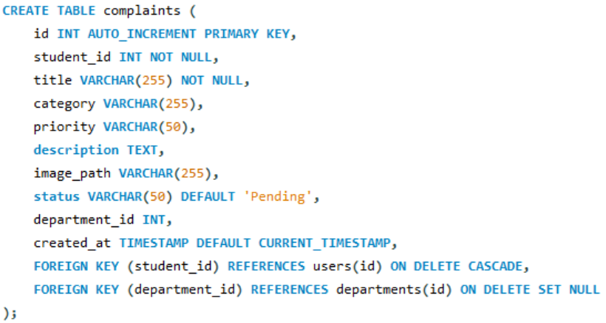

Table: complaints

Normalization:
- 1NF: Satisfied. Each complaint record contains unique, atomic information such as title and description.
- 2NF: Satisfied. Every attribute in the table describes the specific complaint identified by the id.
- 3NF: Satisfied. All fields relate directly to the complaint; student and department info is handled via foreign keys.
- Change & Why: No change needed. By using student_id and department_id as foreign keys, the table avoids storing redundant user or department details, keeping the data normalized.
Duplicate Removal:
- Duplicates Found: Yes (Potential).
- Action Taken: Linked both student_id and department_id as Foreign Keys.
- Why: By referencing IDs instead of names, we ensure that student and department details are stored in one place only (their respective tables). This prevents "data sprawl" where user info is copied into every complaint they file.

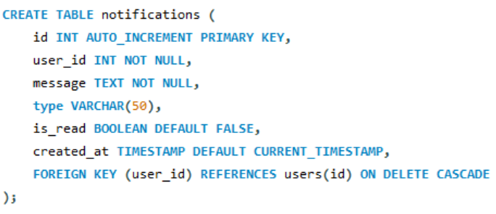

Table: notifications

Normalization:
- 1NF: Satisfied. Values like message and is_read are atomic.
- 2NF: Satisfied. The notification details are fully dependent on the primary key id.
- 3NF: Satisfied. Information doesn't "jump" through other non-key columns; the message belongs to the notification, and the notification belongs to the user.
- Change & Why: No change needed. The structure is a direct, flat relationship between a user and an alert, which is already optimized for 3NF.
Duplicate Removal:
- Duplicates Found: None.
- Action Taken: Standardized the relationship to a simple user_id reference.
- Why: By only storing a message and a user reference, we avoid repeating user metadata (like email or phone) inside the notification logs. Each piece of information exists in only one table.

