MILESTONE – 3
- Dataset:
- Approach: Synthetic Data Generation
This project uses a University Complaint Management System that does not rely on a real-world dataset. Synthetic data was generated using pure Python (no external dependencies) to produce realistic, structured records that properly populate all five core tables. The data was designed to reflect real university complaint scenarios — realistic student names, university-style email addresses, meaningful complaint titles, and role-appropriate user accounts.
Data Generation Summary

Table | Rows Generated | Method | Notes
departments | 10 | Python (hardcoded) | Real university department names
users | 100 | Python (randomised) | 1 admin, 10 dept_admins, 89 students
complaints | 100 | Python (randomised) | Mixed statuses, dated 2024–2025
complaint_updates | 100 | Python (randomised) | All non-pending complaints have updates
notifications | 100 | Python (randomised) | Linked to real users and complaint titles

Data Quality Measures
Referential integrity: All foreign keys were validated programmatically before export. Every student_id in complaints points to a valid user, every department_id points to a valid department, every complaint_id in complaint_updates points to a real complaint, and every user_id in notifications points to a real user. Zero orphaned references.
No duplicate rows: Each table uses a unique integer primary key (id). Email addresses in the users table are guaranteed unique — a set-based deduplication check was applied during generation.
Consistent data types: All id columns are integers. Timestamps follow the format YYYY-MM-DD HH:MM:SS throughout. The role column in users is restricted to three values: student, dept_admin, admin. The status column in complaints and complaint_updates is restricted to: Pending, In Progress, Resolved. Boolean is_read in notifications is stored as 0 or 1.
Null handling: The department_id column in users is intentionally NULL for the admin role, since the system administrator does not belong to a specific department. The image_url column in complaints is empty for approximately 50% of rows, correctly reflecting that image upload is optional. All other required fields are populated.
Realistic content: Complaint titles and descriptions are drawn from realistic university scenarios (e.g., "WiFi connectivity issues in lab", "Exam timetable clash", "Attendance marked incorrectly"). User names use common Pakistani university student name patterns. Emails follow institutional formats (student.university.edu, university.edu). Timestamps are distributed across Jan 2024 – Apr 2025, with complaint update timestamps always falling after their parent complaint's created_at timestamp.

- Dataflow:
- Table Dependency Order
The tables must be populated and queried in this order because each table depends on the one above it:

Order | Table | Depends On | Role in System
1 | departments | None (root table) | Lookup table — defines valid departments
2 | users | departments | All actors: students, dept admins, admin
3 | complaints | users, departments | Core entity — the complaint record
4 | complaint_updates | complaints, users | Audit trail of status changes
5 | notifications | users, complaints | Alerts delivered to users

Data Entry Points
Entry Point 1 — User Registration / Account Creation
Data enters the system when the admin creates user accounts. The following fields are written to the users table:
- Input fields: name, email, password (hashed), role, department_id
- Table written: users
- Dependency: department_id must already exist in the departments table before a user record can be created.
- Validation: Email must be unique. Role must be one of: student, dept_admin, admin. department_id is required for students and dept_admins, NULL for admin.
Entry Point 2 — Complaint Submission (Student)
Data enters the system when a logged-in student fills and submits the complaint form:
- Input fields: title, description, department_id, image_url (optional)
- Table written: complaints — a new row is inserted with status set to "pending" and created_at set to the current timestamp.
- Dependency: student_id is taken from the logged-in user's session (must exist in users). department_id must exist in departments.
- Trigger: On successful insert, the system automatically inserts a row into notifications for the dept_admin of the target department, alerting them that a new complaint has been received.
Data Movement Through the System
Flow 1 — User Login
When a user submits their login credentials:
- The email and password are received by the system.
- The system queries the users table: SELECT id, role, department_id WHERE email = ? AND password_hash = ?
- The role field determines which dashboard the user is redirected to: student → Student Dashboard, dept_admin → Department Admin Dashboard, admin → Admin Dashboard.
- Output: Authenticated session with role and department context. No data is written.
Flow 2 — Complaint Submission
When a student submits a complaint:
- Form data (title, description, department_id, optional image) is received.
- A new row is inserted into complaints with student_id (from session), department_id, title, description, image_url, status = "pending", created_at = NOW().
- The system identifies the dept_admin for the target department by querying users WHERE role = "dept_admin" AND department_id = ?
- A new row is inserted into notifications for that dept_admin: user_id = dept_admin.id, message = "New complaint received: {title}", is_read = 0.
- Output: New complaint record visible on student's dashboard. Notification appears in dept_admin's notification panel.
Flow 3 — Complaint Status Update (Dept Admin)
When a dept_admin reviews a complaint and changes its status:
- Admin selects a complaint and submits a status change and optional comment.
- The complaints table is updated: SET status = ? WHERE id = ?
- A new row is inserted into complaint_updates: complaint_id, updated_by (dept_admin's user id), comment, new status, updated_at = NOW().
- A new row is inserted into notifications for the student who submitted the complaint: user_id = complaint.student_id, message = "Your complaint status has been updated to {status}."
- Output: Updated status visible on student's dashboard. Full update history available in complaint_updates. Student receives notification.
Flow 4 — Notification Delivery
Notifications are not submitted by users — they are generated automatically by the system in Flows 2 and 3 above:
- On complaint submission → notification to dept_admin.
- On status update → notification to the student who filed the complaint.
- The notifications table is queried on dashboard load: SELECT * FROM notifications WHERE user_id = ? ORDER BY created_at DESC. Unread count (is_read = 0) is shown as a badge.
- When a user opens their notifications, is_read is set to 1: UPDATE notifications SET is_read = 1 WHERE user_id = ?
- Output: Real-time alert count on dashboard. Full notification history per user.

Data Outputs Summary

Output | Source Tables | Consumer
Student dashboard — complaint list + statuses | complaints | Student
Dept admin dashboard — incoming complaints | complaints, users | Dept Admin
Complaint detail view — full history | complaints, complaint_updates, users | Dept Admin / Student
Notification panel — alerts + unread count | notifications | All users
Admin dashboard — all users and departments | users, departments | Admin

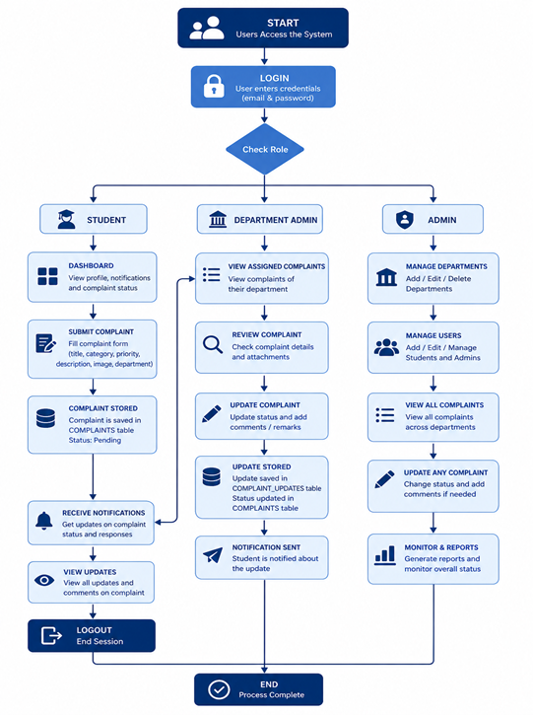
- CSV Files:
All five tables have been exported as clean CSV files. These files will be used in Milestone 5 to load data directly into the database. Each file uses the table name as its filename and includes a header row with column names matching the schema exactly.

File | Table | Rows | Columns
departments.csv | departments | 10 | id, name
users.csv | users | 100 | id, name, email, password_hash, role, department_id
complaints.csv | complaints | 100 | id, student_id, department_id, title, description, image_url, status, created_at
complaint_updates.csv | complaint_updates | 100 | id, complaint_id, updated_by, comment, status, updated_at
notifications.csv | notifications | 100 | id, user_id, message, is_read, created_at

