MILESTONE-4
- Database Setup:
All CREATE TABLE statements have been written based on the finalized normalized schema from Milestone 2. Each table includes a primary key, foreign key references, NOT NULL constraints, and UNIQUE or CHECK constraints where applicable. Indexes have been added on all foreign key columns and any columns expected to be queried frequently.

Table: departments

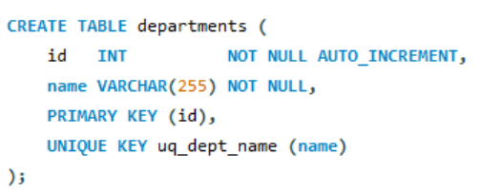

Table: users

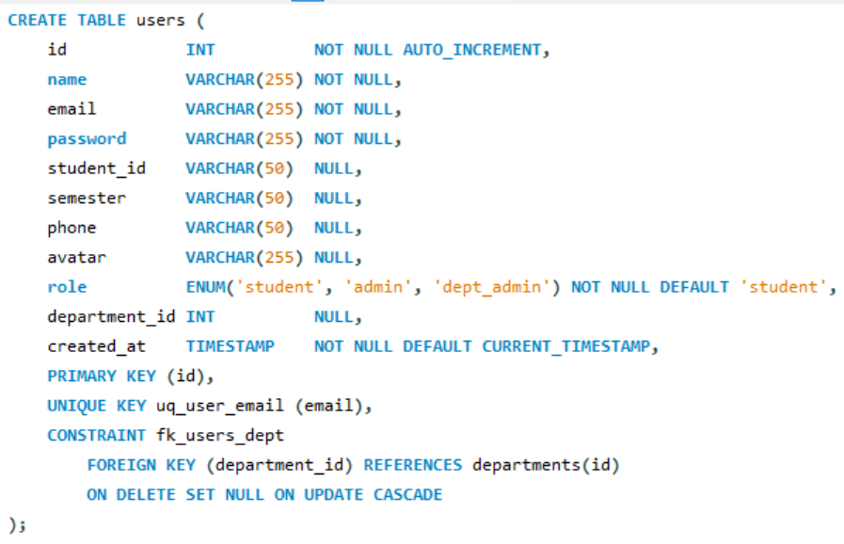

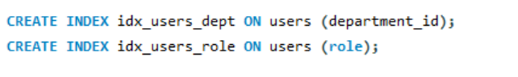

Table: complaints

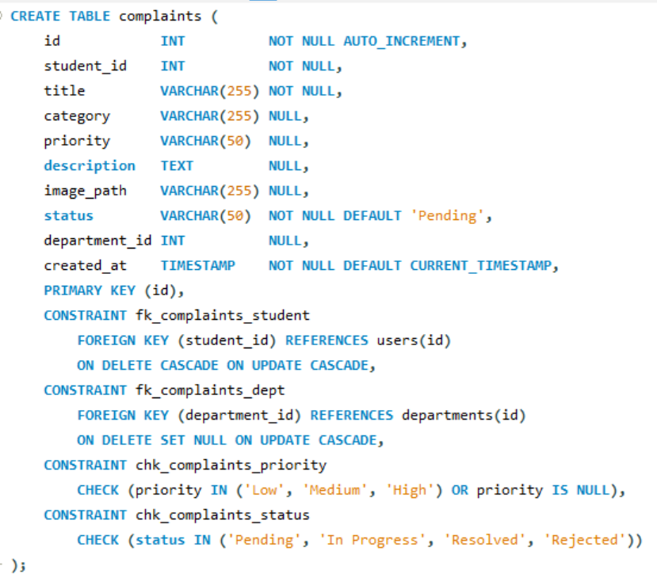

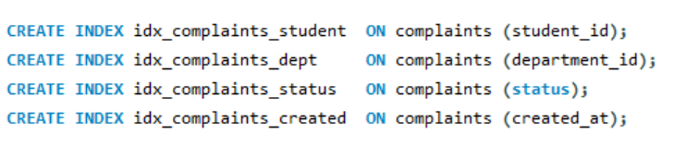

Table: complaint_updates

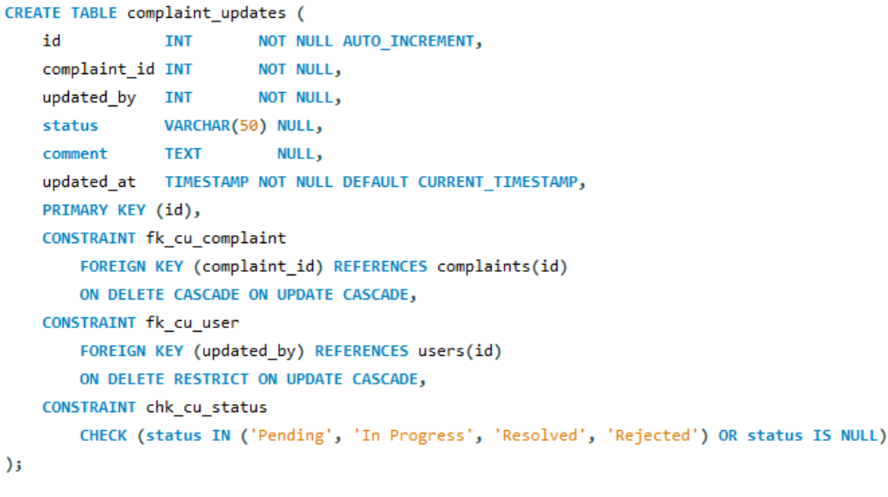

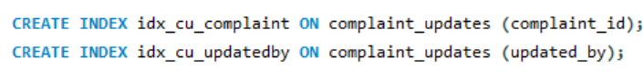

Table: notifications

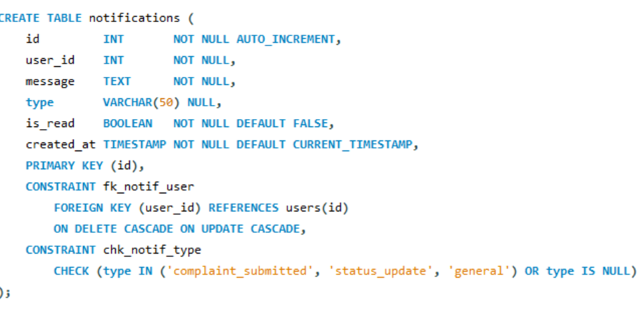

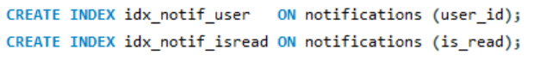

EER Diagram Verification:
After running all DDL scripts in MySQL Workbench, the EER Diagram was opened and verified. The following was confirmed:
- All five tables are present: departments, users, complaints, complaint_updates, notifications.
- All foreign key relationships are visible as connecting lines with correct cardinality (1-to-many in all cases).
- The structure of the EER diagram matches the updated ERD from Milestone 2 exactly.
- No validation errors were reported by MySQL Workbench.

