MILESTONE-5
- Data Population:

Table: departments

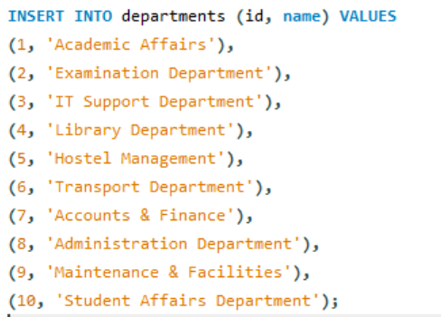

Table: users

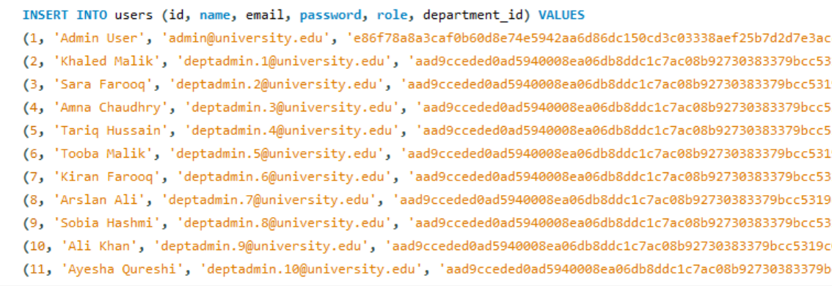

Table: complaints

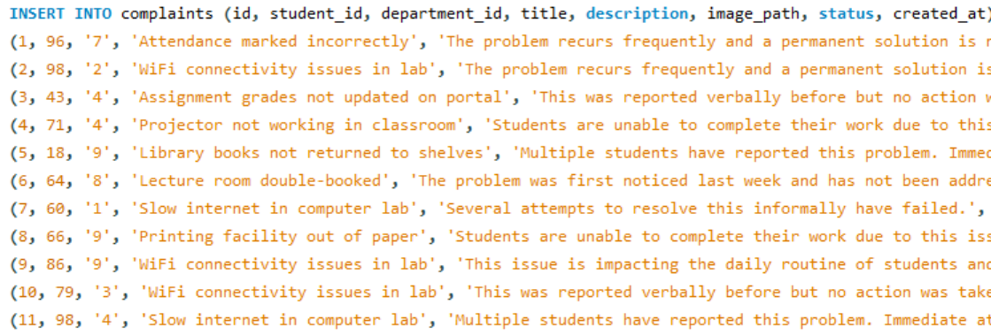

Table: complaint_updates

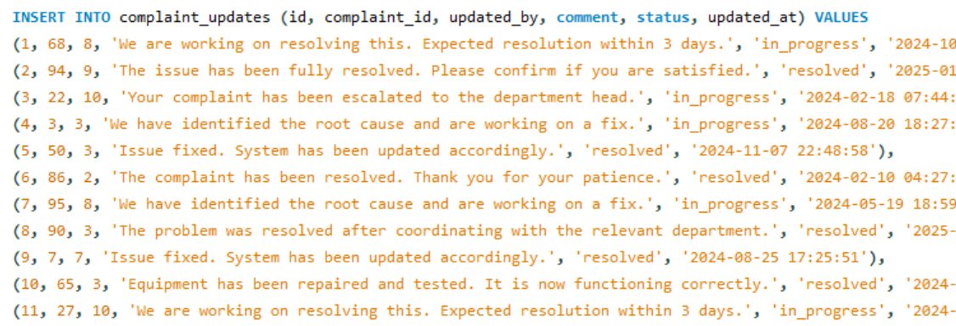

Table: notifications

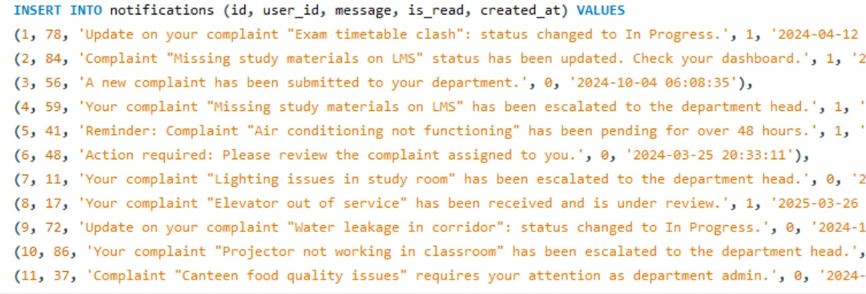

UPDATE and DELETE Demonstrations:

UPDATE Operation:
Scenario: A dept_admin has reviewed complaint ID 5 and its status needs to be changed from 'pending' to 'In Progress'.
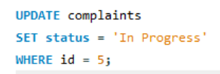

DELETE Operation
Scenario: A test/spam complaint (ID 99) needs to be removed from the system.


Validation Queries:

COUNT(*) — Row Count Verification:

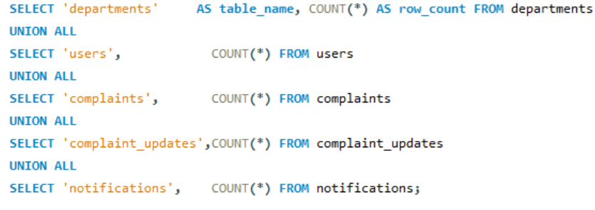

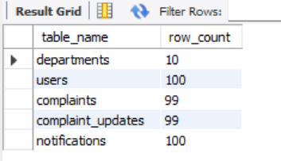

NULL Check — Key Columns:

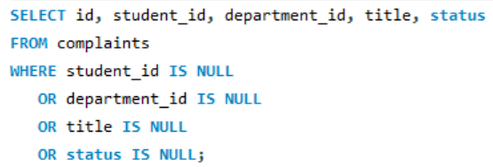

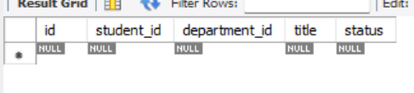

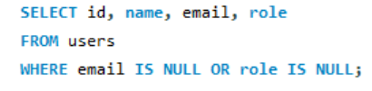

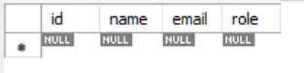

0 rows returned for both queries.

JOIN-Based Foreign Key Integrity Check:

-- Verify every complaint links to a valid student and department

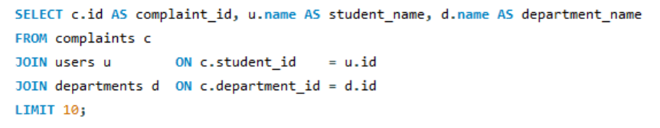

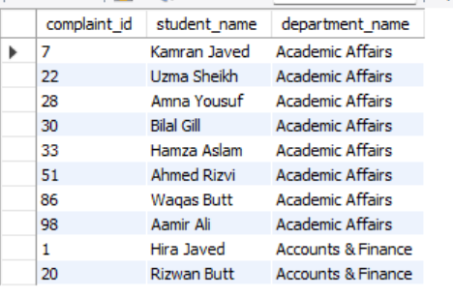

-- Verify every complaint_update links to a valid complaint and user

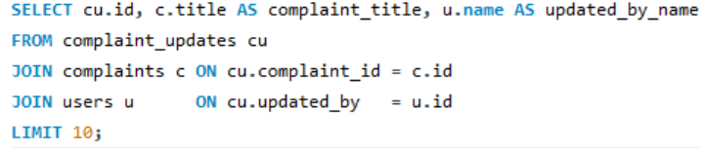

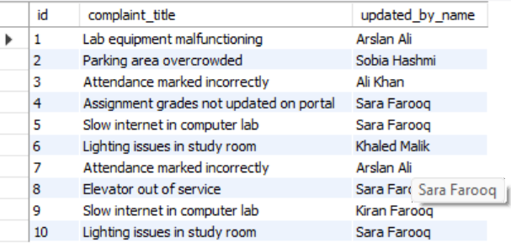

-- Verify every notification links to a valid user

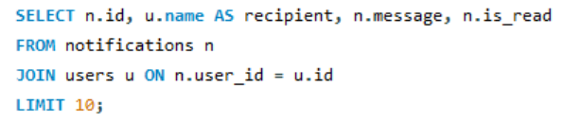

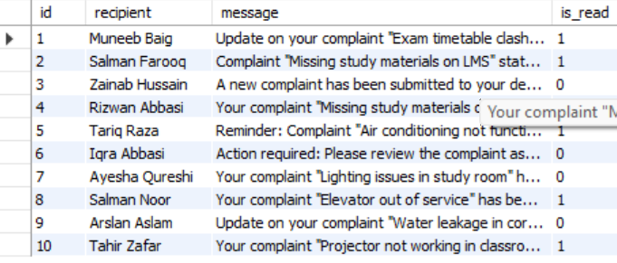

All three queries return rows with no NULLs in the joined columns, confirming that every foreign key value in the loaded data points to a valid parent record.

