AI ASSISTED CODING
ASSIGNMENT – Disaster Management
Hallticket No: 2303A51902
Batch – 09
App.py:
#Create app.py for a Smart Disaster Relief Management System. The app should include routes for dashboard (index), add camp, register victim, distribute resources, and view records. Use Jinja templates to render dynamic data such as total camps, total victims, and emergency status. Handle form submissions using POST methods, manage emergency mode state, and store data using a simple database.
# Use file handling to read/write camp and victim data, and implement smart resource distribution logic based on victim health conditions and camp capacities.
from flask import Flask, render_template, request, redirect
import os
import random

app = Flask(__name__)

# Initializing required data files if they don't exist.
# safe startup without FileNotFoundError.
def initialize_files():
files = ["camps.txt", "victims.txt", "distribution.txt"]
for file in files:
if not os.path.exists(file):
open(file, "w").close()

initialize_files()
# a global emergency mode toggle system that can dynamically switch disaster response logic.
EMERGENCY_MODE = False

@app.route("/toggle_emergency")
def toggle_emergency():
global EMERGENCY_MODE
EMERGENCY_MODE = not EMERGENCY_MODE
return redirect("/")
# Designing home dashboard route that displays total camps, total victims and emergency status.
@app.route("/")
def home():
with open("camps.txt", "r") as f:
camps = f.readlines()

with open("victims.txt", "r") as f:
victims = f.readlines()

return render_template(
"home.html",
total_camps=len(camps),
total_victims=len(victims),
emergency=EMERGENCY_MODE
)

# Creating a route to add new disaster relief camps with capacity and resource tracking.
@app.route("/add_camp", methods=["GET", "POST"])
def add_camp():
if request.method == "POST":
camp_id = request.form["camp_id"]
location = request.form["location"]
max_capacity = request.form["max_capacity"]
food = request.form["food"]
medical = request.form["medical"]
volunteers = request.form["volunteers"]

# AI suggestion:
# Store occupancy as 0 initially
with open("camps.txt", "a") as f:
f.write(f"{camp_id},{location},{max_capacity},{food},{medical},{volunteers},0\n")

return redirect("/")

return render_template("add_camp.html")

# Registering a victim and automatically assign them to the most suitable available camp.
# Prioritize medical-heavy camps in emergency mode
@app.route("/register_victim", methods=["GET", "POST"])
def register_victim():
message = ""

if request.method == "POST":
name = request.form["name"]
age = request.form["age"]
health_condition = request.form["health_condition"]
# Generate unique 4-digit victim ID
while True:
victim_id = str(random.randint(1000, 9999))
with open("victims.txt", "r") as f:
existing_ids = [line.split(",")[0] for line in f.readlines()]
if victim_id not in existing_ids:
break

with open("camps.txt", "r") as f:
camps = f.readlines()

available_camps = []

for camp in camps:
data = camp.strip().split(",")
camp_id, location, max_capacity, food, medical, volunteers, occupancy = data

if int(occupancy) < int(max_capacity):
available_camps.append(data)

if not available_camps:
message = "All Camps Are Full!"
return render_template("register_victim.html", message=message)

# Emergency mode prioritizes highest medical stock
if EMERGENCY_MODE and health_condition == "critical":
selected_camp = max(available_camps, key=lambda x: int(x[4]))
else:
# Otherwise choose lowest occupancy
selected_camp = min(available_camps, key=lambda x: int(x[6]))

selected_camp_id = selected_camp[0]

# Update occupancy
updated_camps = []
for camp in camps:
data = camp.strip().split(",")
if data[0] == selected_camp_id:
data[6] = str(int(data[6]) + 1)
updated_camps.append(",".join(data) + "\n")

with open("camps.txt", "w") as f:
f.writelines(updated_camps)

# Store victim data
with open("victims.txt", "a") as f:
f.write(f"{victim_id},{name},{age},{health_condition},{selected_camp_id}\n")

message = f"Victim Registered! ID: {victim_id} | Assigned Camp: {selected_camp_id}"

return render_template("register_victim.html", message=message)
# Implementing smart resource distribution logic.
# Critical victims receive medical kits, others receive food packets.
@app.route("/distribute", methods=["GET", "POST"])
def distribute():
message = ""

if request.method == "POST":
victim_id_input = request.form["victim_id"]

with open("victims.txt", "r") as f:
victims = f.readlines()

with open("camps.txt", "r") as f:
camps = f.readlines()

victim_data = None

for victim in victims:
v = victim.strip().split(",")
if v[0] == victim_id_input:
victim_data = v
break

if not victim_data:
message = "Victim Not Found!"
return render_template("distribute.html", message=message)

victim_id, name, age, health_condition, assigned_camp = victim_data

updated_camps = []
resource = ""

for camp in camps:
c = camp.strip().split(",")
camp_id, location, max_capacity, food, medical, volunteers, occupancy = c

food = int(food)
medical = int(medical)

if camp_id == assigned_camp:

if health_condition == "critical":
if medical <= 0:
message = "No Medical Kits Available!"
return render_template("distribute.html", message=message)
medical -= 1
resource = "Medical Kit"
else:
if food <= 0:
message = "No Food Packets Available!"
return render_template("distribute.html", message=message)
food -= 1
resource = "Food Packet"

updated_line = f"{camp_id},{location},{max_capacity},{food},{medical},{volunteers},{occupancy}\n"
updated_camps.append(updated_line)
else:
updated_camps.append(camp)

with open("camps.txt", "w") as f:
f.writelines(updated_camps)
# Log distribution history for audit tracking
with open("distribution.txt", "a") as f:
f.write(f"{victim_id},{name},{resource},{assigned_camp}\n")

message = f"{resource} distributed successfully to {name}!"

return render_template("distribute.html", message=message)

#Creating admin view page that displays camps, victims and distribution history.
@app.route("/view")
def view():
with open("camps.txt", "r") as f:
camps = f.readlines()

with open("victims.txt", "r") as f:
victims = f.readlines()

with open("distribution.txt", "r") as f:
distributions = f.readlines()

return render_template(
"view.html",
camps=camps,
victims=victims,
distributions=distributions
)
# Run Flask application in debug mode for development testing.
if __name__ == "__main__":
app.run(debug=True)
Output:
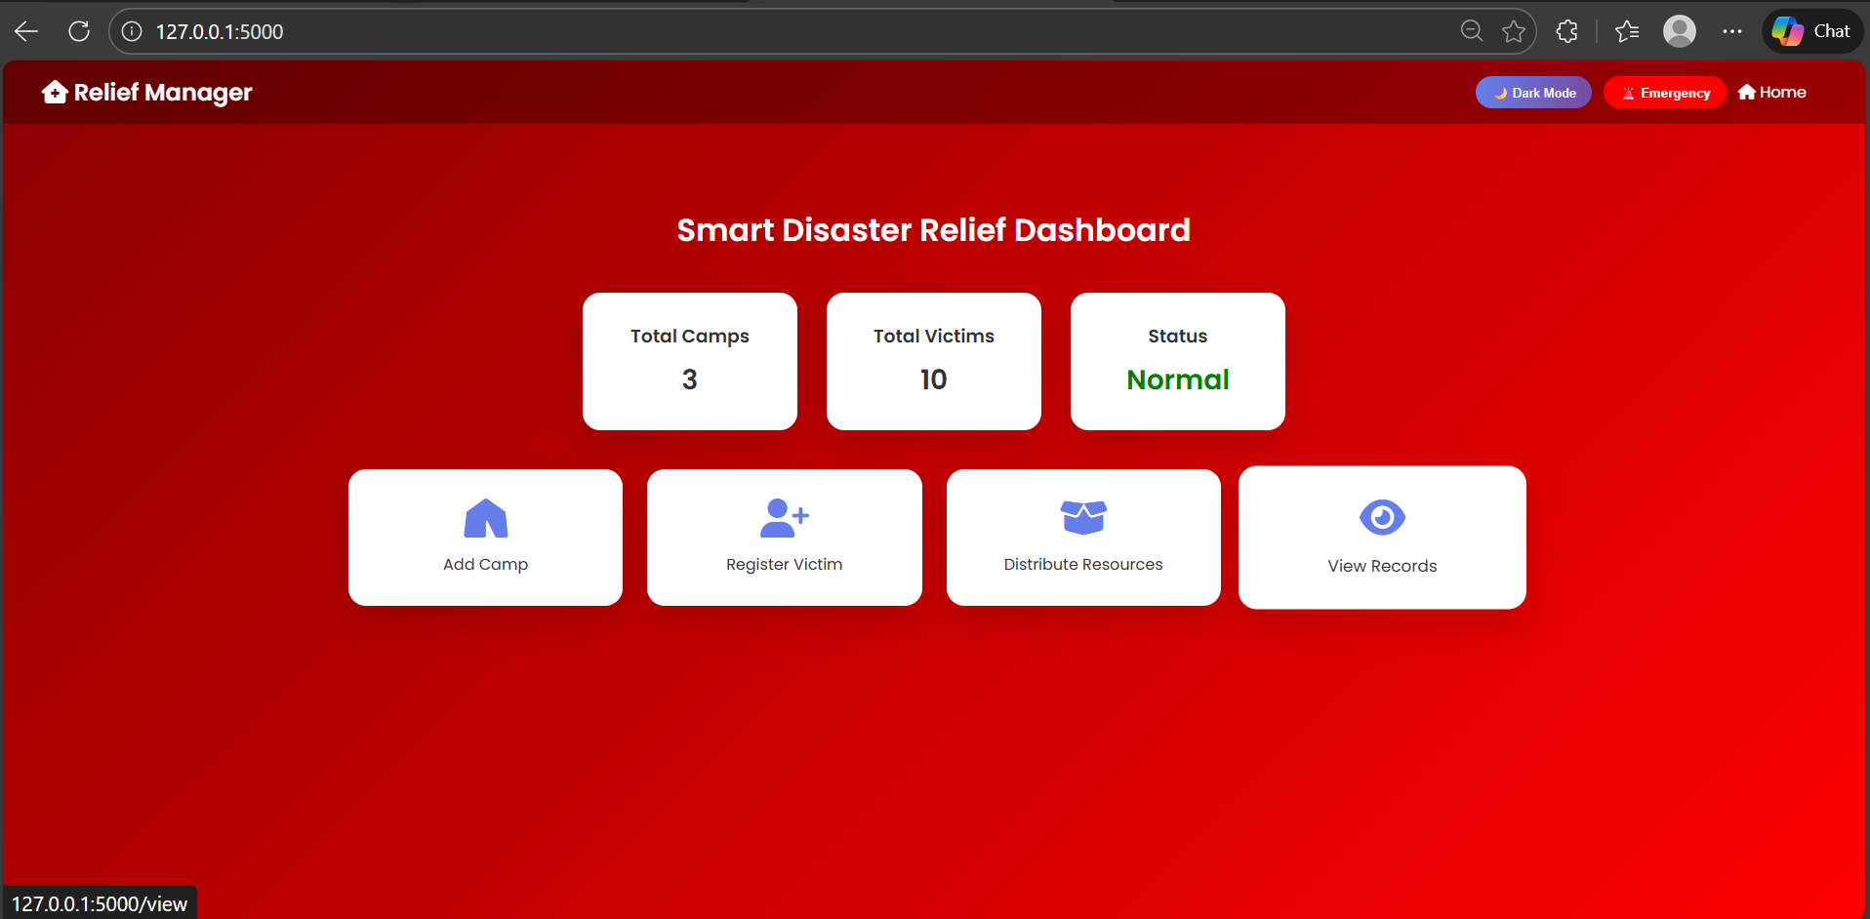
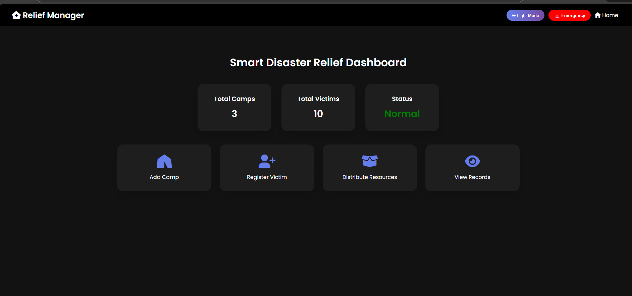
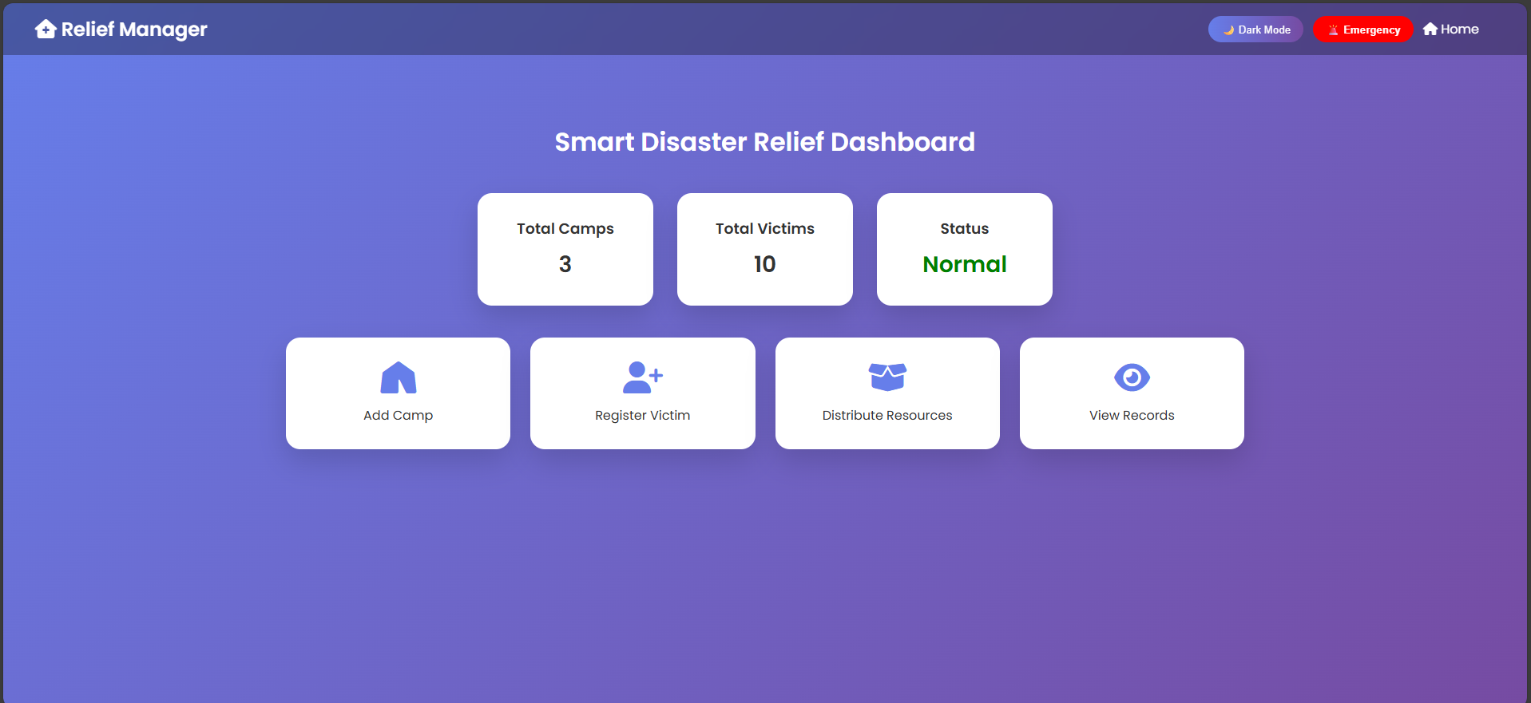
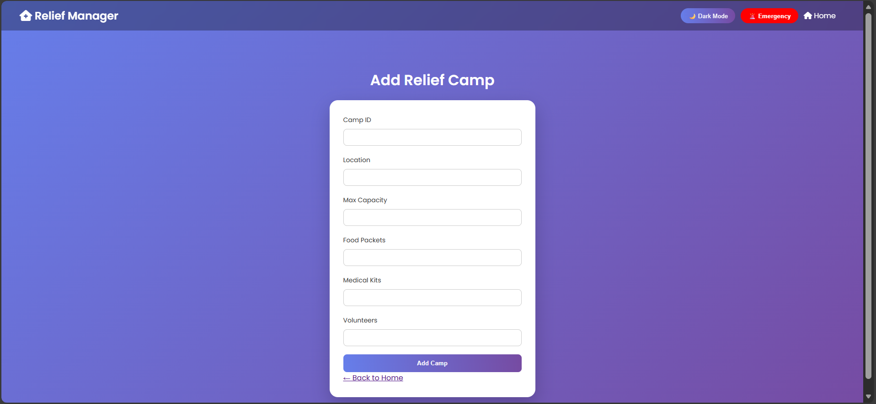
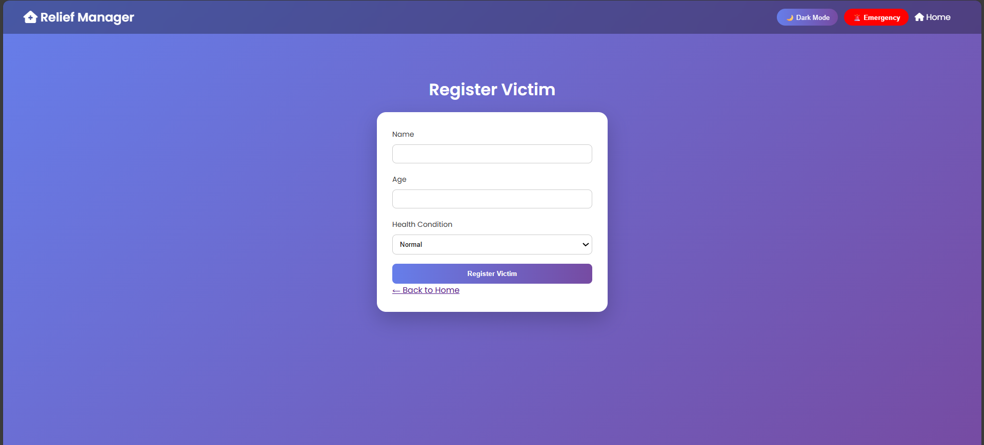
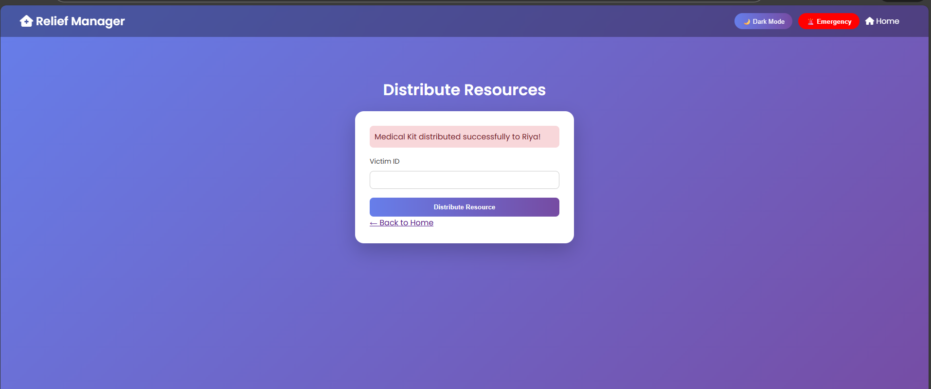
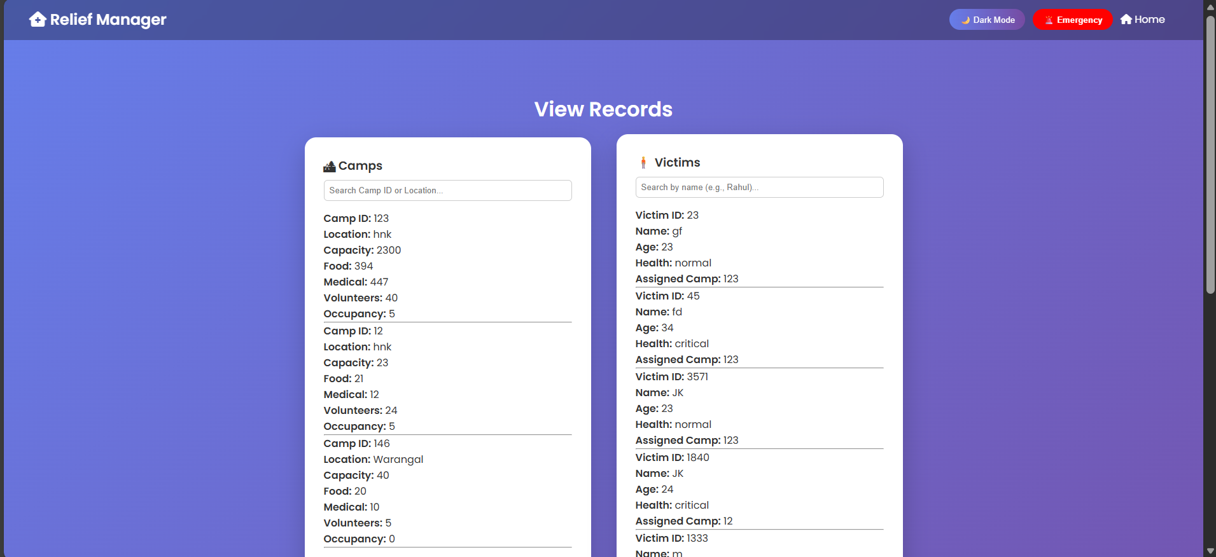
The project is designed to manage disaster relief operations by handling camp details, victim registration, and resource distribution in a systematic way. It allows administrators to add new camps with information such as capacity, available food packets, medical kits, volunteers, and current occupancy. Victims can be registered and assigned to camps after checking capacity constraints to prevent overcrowding. The system also prioritizes critical victims during resource distribution by allocating medical kits first, while normal cases receive food packets. All data is stored using file handling in text files, ensuring persistent record management. The menu-driven interface enables smooth navigation and repeated operations, making the system practical for real-world disaster management scenarios.

