AI ASSISTED CODING
ASSIGNMENT – 1.4
Hallticket No: 2303A51902
Batch – 09
Task-01:
Prompt:
# Write a Python program to check whether a number is prime.
# Take user input and do not use any user-defined functions.
Code:
num = int(input("Enter a number: "))
if num > 1:
for i in range(2, int(num**0.5) + 1):
if (num % i) == 0:
print(f"{num} is not a prime number.")
break
else:
print(f"{num} is a prime number.")
else:
print(f"{num} is not a prime number.")
Output:
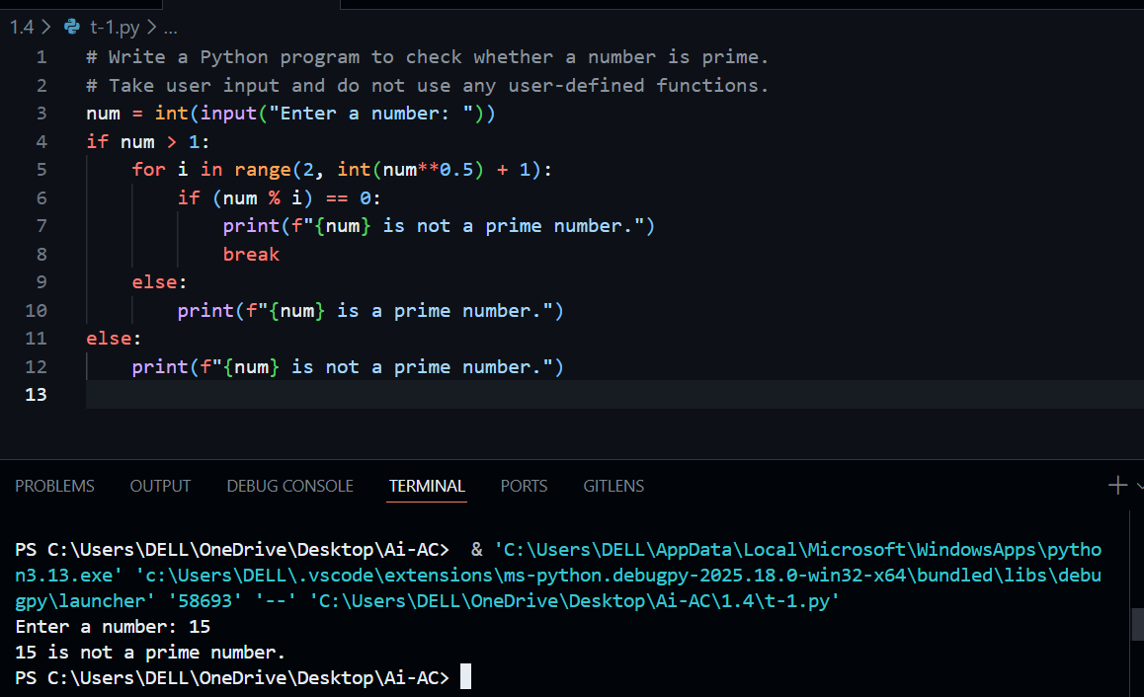
Explanation:
This program checks whether a number is prime by trying to divide it with numbers starting from 2 up to the square root of the number.
If any number divides it exactly, it is not prime.
If no divisor is found, the number is prime.
Task-02:
Prompt:
#Optimize the above code of prime numbers to improve efficiency and readability
# do not use any user-defined functions
Code:
num = int(input("Enter a number: "))
if num <= 1:
print(f"{num} is not a prime number.")
else:
is_prime = True
for i in range(2, int(num**0.5) + 1):
if (num % i) == 0:
is_prime = False
break
if is_prime:
print(f"{num} is a prime number.")
else:
print(f"{num} is not a prime number.")
Ouput:
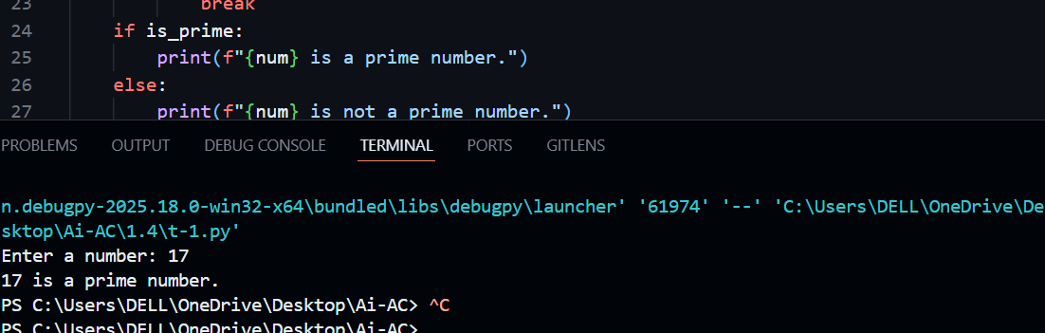
Explanation:
This optimized version avoids unnecessary checks by stopping the loop as soon as a divisor is found.The use of a Boolean variable makes the code easier to read and understand.
Checking only till √n improves efficiency for large numbers.
Task-03:
Prompt:
# Write a Python function to check whether a number is prime.
# The function should return True or False.
Code:
def is_prime(number):
if number <= 1:
return False
for i in range(2, int(number**0.5) + 1):
if number % i == 0:
return False
return True
# Example usage:
user_input = int(input("Enter a number: "))
result = is_prime(user_input)
if result:
print(f"{user_input} is a prime number.")
else:
print(f"{user_input} is not a prime number.")
# The function improves code readability and allows for reuse.
# The time complexity remains O(√n), which is efficient for this problem.
# The use of a function allows for easier testing of the primality logic.
Output:
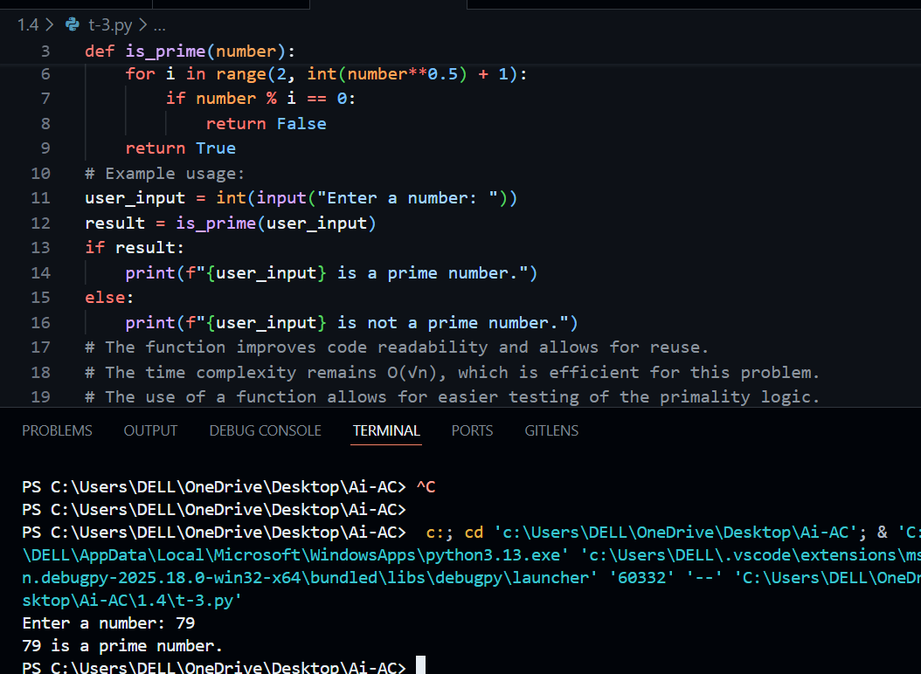
Explanation:
The prime-checking logic is placed inside a function so it can be reused easily.
The function returns True if the number is prime and False otherwise.This makes the program more modular, readable, and easy to debug.
Task-04:
Prompt:
#Compare two Python programs:1. A prime number checking program written without using functions 2. A prime number checking program written using a user-defined function.
# Analyze and explain the differences between the two programs based on:
# - Code clarity and readability
# - Reusability of logic
# - Ease of debugging and maintenance
# - Suitability for large-scale or real-world applications
# Present the comparison in a clear table or short analytical explanation.
Output:
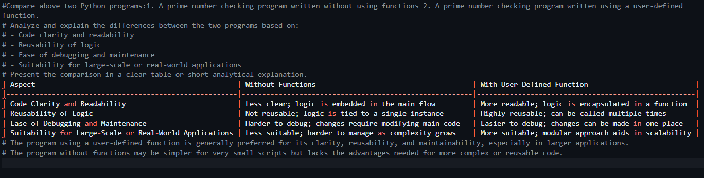
Explanation:
Programs without functions are simple but hard to reuse and maintain.
Function-based programs are clearer, reusable, and easier to debug.For large-scale or real-world applications, function-based code is more suitable.
Task-05:
Prompt 1: Basic Divisibility Check (Naive Approach)
# Write a Python program to check whether a number is prime.
# Use a basic divisibility approach by checking all numbers from 2 to n-1.
# The program should take user input and print whether the number is prime or not.
Code:
num = int(input("Enter a number: "))
if num > 1:
for i in range(2, int(num**0.5) + 1):
if (num % i) == 0:
print(f"{num} is not a prime number.")
break
else:
print(f"{num} is a prime number.")
else:
print(f"{num} is not a prime number.")
# The program checks for primality by testing divisibility from 2 up to the square root of the number.
# This approach is efficient for small to moderately large numbers.
# The time complexity is O(√n), which is efficient for this problem.
# The program handles edge cases such as numbers less than or equal to 1 correctly.
# The program could be further optimized or structured using functions for better readability and reusability.
Output:
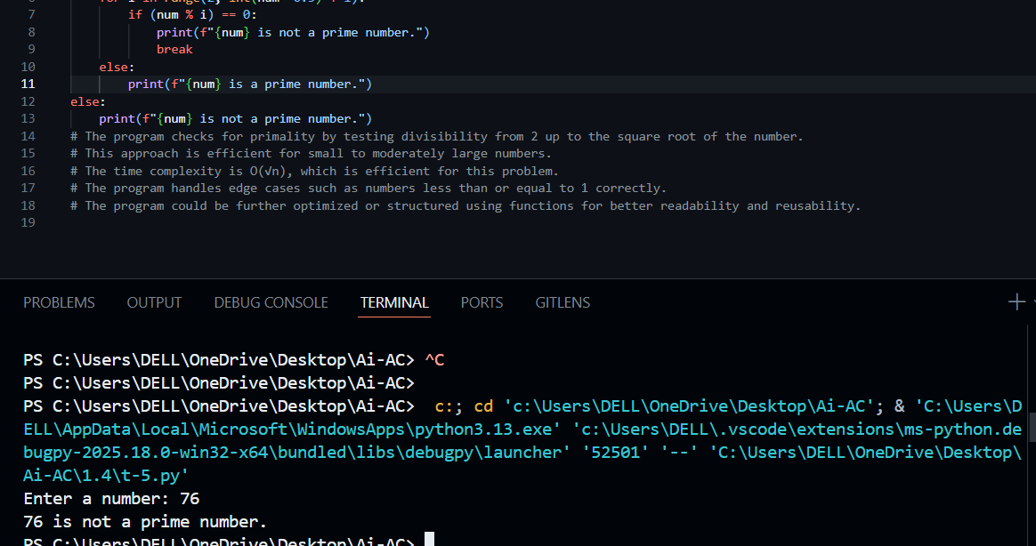
Prompt-1 Explanation:
The program checks if a number is divisible by other numbers to decide if it is prime.It stops checking once a divisor is found.This approach is easy to understand but slower for large inputs.
Prompt 2: Optimized Prime Check (Square Root Approach)
# Write a Python program to check whether a number is prime.
# Optimize the logic by checking divisibility only up to the square root of the number.
# The program should take user input and print whether the number is prime or not.
Code:
import math
def is_prime(n):
if n <= 1:
return False
for i in range(2, int(math.sqrt(n)) + 1):
if n % i == 0:
return False
return True
num = int(input("Enter a number: "))
if is_prime(num):
print(f"{num} is a prime number.")
else:
print(f"{num} is not a prime number.")
Ouput:
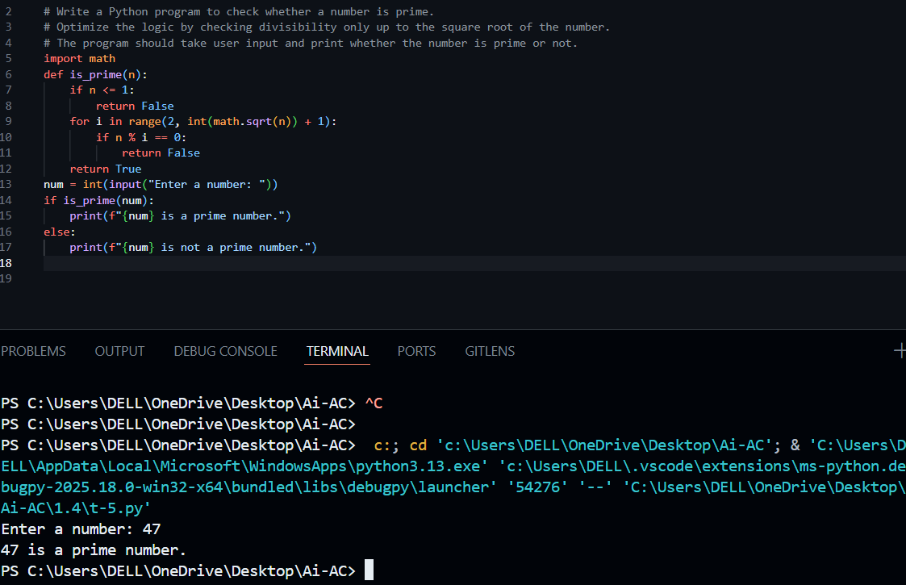
Prompt-2 explanation:
This program checks divisibility only up to the square root of the number.This reduces the number of iterations and improves performance.It is faster and more suitable for large input values.

