AI ASSISTED CODING
ASSIGNMENT – 10.3
Hallticket No: 2303A51902
Batch – 09
Task-01:
Prompt:
#check Python function of factorial:
#def factorial(n):
#result = 1
#for i in range(1, n):
# result = result * i
#return result
#Identify the logical bug in the code and why?
#Provide a corrected version.Mention any edge cases such as negative numbers or zero.
Code:
#The logical bug in the code is that the loop runs from 1 to n-1, which means it does not include n in the multiplication. This will result in an incorrect factorial value for any n greater than 1.
#Here is the corrected version of the factorial function:
def factorial(n):
if n < 0:
raise ValueError("Factorial is not defined for negative numbers.")
elif n == 0:
return 1
else:
result = 1
for i in range(1, n + 1):
result *= i
return result
n = int(input("Enter a non-negative integer: "))
try:
print(f"The factorial of {n} is {factorial(n)}.")
except ValueError as e:
print(e)
#In this corrected version, we also handle edge cases:
#If n is negative, we raise a ValueError since factorial is not defined for negative numbers.
# If n is zero, we return 1, as the factorial of zero is defined to be 1.
# For positive integers, we calculate the factorial by multiplying all integers from 1 to n inclusive.
Output:
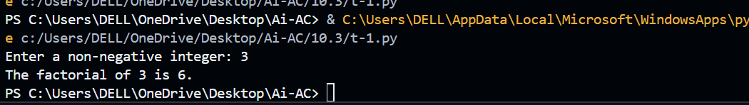
Explanation:
The bug in the original factorial function occurs because the loop uses range(1, n), which stops at n-1. This means the value n is not included in the multiplication, leading to an incorrect factorial result. The corrected version uses range(1, n+1) so that all numbers from 1 to n are multiplied. It also handles edge cases: if the input is negative, it raises an error, and if n = 0, it correctly returns 1.
Task-02:
Prompt:
#chcek the below Python function and parameter naming, and lack of documentation.
#def calc(a, b, c):
# if c == "add":
#return a + b
#elif c == "sub":
# return a - b
# elif c == "mul":
# return a * b
#elif c == "div":

#Rewrite the function with:Descriptive function and parameter names;A proper docstring (description, parameters, return value, examples);Exception handling for division by zero
Code:
def calculate(num1, num2, operation):
"""
Perform a basic arithmetic operation on two numbers.

Parameters:
num1 (float): The first number.
num2 (float): The second number.
operation (str): The operation to perform. Can be "add", "subtract", "multiply", or "divide".

Returns:
float: The result of the arithmetic operation.

Raises:
ValueError: If the operation is not one of the specified options.
ZeroDivisionError: If division by zero is attempted.

Examples:
>>> calculate(10, 5, "add")
15
>>> calculate(10, 5, "subtract")
5
>>> calculate(10, 5, "multiply")
50
>>> calculate(10, 5, "divide")
2.0
"""

if operation == "add":
return num1 + num2
elif operation == "subtract":
return num1 - num2
elif operation == "multiply":
return num1 * num2
elif operation == "divide":
if num2 == 0:
raise ZeroDivisionError("Cannot divide by zero.")
return num1 / num2
else:
raise ValueError("Invalid operation. Please choose 'add', 'subtract', 'multiply', or 'divide'.")
# Get user input
try:
number1 = float(input("Enter the first number: "))
number2 = float(input("Enter the second number: "))
op = input("Enter the operation (add, subtract, multiply, divide): ").strip().lower()

result = calculate(number1, number2, op)
print(f"The result of {op}ing {number1} and {number2} is: {result}")
except ValueError as ve:
print(ve)
except ZeroDivisionError as zde:
print(zde)
Output:
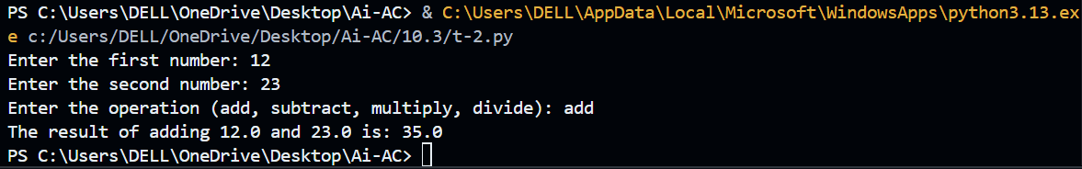
Explanation:
The original function had poor variable names (a, b, c) and no documentation, making it difficult to understand. The improved version uses clear parameter names (num1, num2, operation) and includes a detailed docstring explaining the function, parameters, return values, and examples. It also adds exception handling to prevent division by zero and handles invalid operations.
Task-03:
Prompt:
#def Checkprime(n):
#for i in range(2, n):
#if n % i == 0:
#return False
#check ths code for PEP8 Violations and improve it.
#list all PEP8 Violations.Refactor code to follow PEP8 naming coventions,spacing and indentation .ensure functionality remians same.add improvements if necessary
Code:
def check_prime(n):
"""
Check if a number is prime.

Parameters:
n (int): The number to check.

Returns:
bool: True if the number is prime, False otherwise.
"""
if n <= 1:
return False
for i in range(2, n):
if n % i == 0:
return False
return True
# Example usage:
print(check_prime(7)) # Output: True
Output:
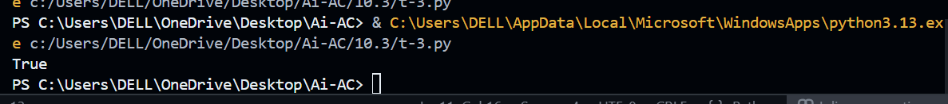
Explanation:
The original code violated several PEP8 coding standards, such as incorrect function naming (Checkprime instead of check_prime) and improper indentation. The refactored version follows Python naming conventions, uses proper indentation, and includes a docstring explaining the function. It also improves functionality by handling cases where the number is less than or equal to 1, which are not prime numbers.
Task-04:
Prompt:
#Act as a senior code reviewer and improve this function with better naming, type hints, input validation, and configurable multiplier.
Code:
def process_data(data: list, multiplier: int = 2) -> list:
"""
Process a list of numbers by multiplying even numbers with a specified multiplier.

Parameters:
data (list): A list of numbers to process.
multiplier (int): The value to multiply even numbers by. Default is 2.

Returns:
list: A list of processed numbers where even numbers are multiplied by the multiplier.

Raises:
ValueError: If the input data is not a list or if the multiplier is not an integer.
"""

if not isinstance(data, list):
raise ValueError("Input data must be a list.")

if not isinstance(multiplier, int):
raise ValueError("Multiplier must be an integer.")

return [x * multiplier for x in data if isinstance(x, (int, float)) and x % 2 == 0]
# Example usage:
print(process_data([1, 2, 3, 4, 5], multiplier=3)) # Output: [6, 12]
Output:
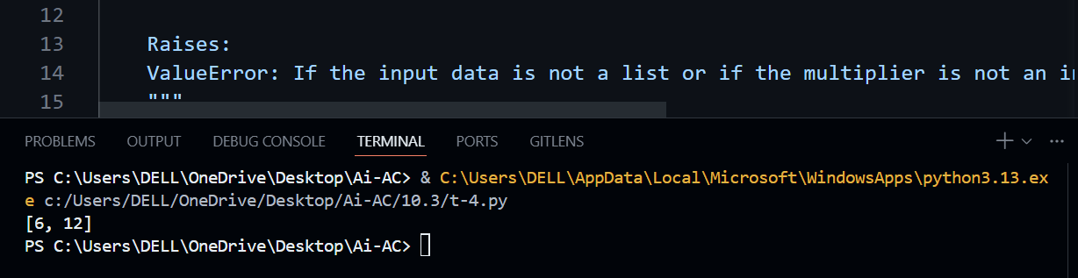
Explanation:
The original function name and purpose were unclear. The improved version renames the function to process_data, adds type hints for better understanding, and includes input validation to ensure the input is a list and the multiplier is an integer. A configurable multiplier is added so users can change the multiplication factor. The function now clearly processes a list and multiplies only even numbers by the specified multiplier.
Task-05:
Prompt:
# Analyze the time complexity of this Python function and provide a faster optimized implementation.
Code:
#The time complexity of the provided `sum_of_squares` function is O(n), where n is the number of elements in the input list `numbers`. This is because the function iterates through each element in the list once to calculate the sum of squares.
#A faster optimized implementation can be achieved using a generator expression, which can be more memory efficient and slightly faster due to reduced overhead. Here is the optimized version:
def sum_of_squares(numbers):
return sum(num ** 2 for num in numbers)
# This implementation still has a time complexity of O(n) but is more concise and can be
#more efficient in terms of memory usage, especially for large lists, as it does not create an intermediate list of squares.
# Example usage:
print(sum_of_squares([1, 2, 3, 4])) # Output: 30
Output:
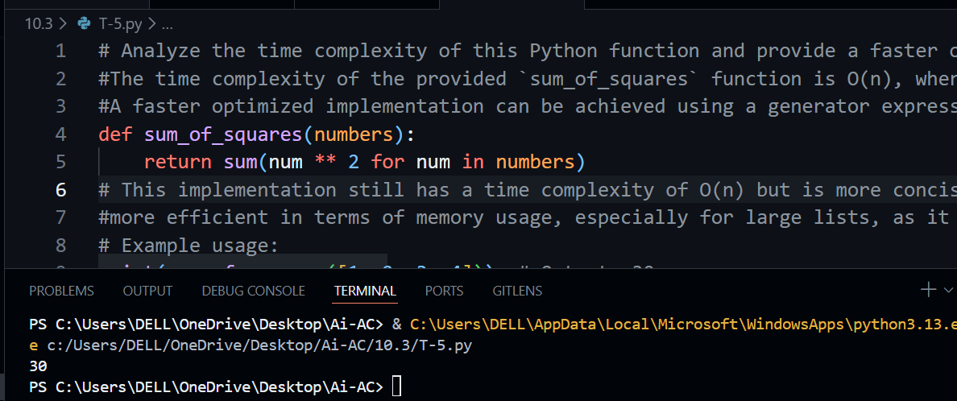
Explanation:
The original function calculates the sum of squares using a loop, which has a time complexity of O(n) because it processes each element once. The optimized version uses Python’s built-in sum() function with a generator expression. This approach is shorter, cleaner, and more memory-efficient.

