AI ASSISTED CODING
ASSIGNMENT - 3.3
Hallticket No: 2303A51902
Batch – 09
Task - 01:
Prompt:
#Write a simple Python program for an electricity billing system.It should take user input for previous meter reading, current meter reading, and type of customer (domestic or commercial) and Calculate the units consumed by subtracting the previous reading from the current reading.Display the total units consumed.Do not use classes or separate functions.Write all the logic inside the main program only.
Code:
# Get user input for previous and current meter readings
previous_reading = float(input("Enter previous meter reading: "))
current_reading = float(input("Enter current meter reading: "))
# Get user input for type of customer
customer_type = input("Enter type of customer (domestic/commercial): ").strip().lower()
# Calculate units consumed
units_consumed = current_reading - previous_reading
# Display the total units consumed
print(f"Total units consumed: {units_consumed} units")
# Calculate the bill based on customer type and units consumed
if customer_type == "domestic":
if units_consumed <= 100:
bill_amount = units_consumed * 1.5
elif units_consumed <= 300:
bill_amount = (100 * 1.5) + (units_consumed - 100) * 2.5
else:
bill_amount = (100 * 1.5) + (200 * 2.5) + (units_consumed - 300) * 4.0
elif customer_type == "commercial":
if units_consumed <= 100:
bill_amount = units_consumed * 2.0
elif units_consumed <= 300:
bill_amount = (100 * 2.0) + (units_consumed - 100) * 4.0
else:
bill_amount = (100 * 2.0) + (200 * 4.0) + (units_consumed - 300) * 6.0
else:
print("Invalid customer type. Please enter 'domestic' or 'commercial'.")
bill_amount = 0
# Display the total bill amount
if bill_amount > 0:
print(f"Total bill amount for {customer_type} customer: ${bill_amount:.2f}")
Output:
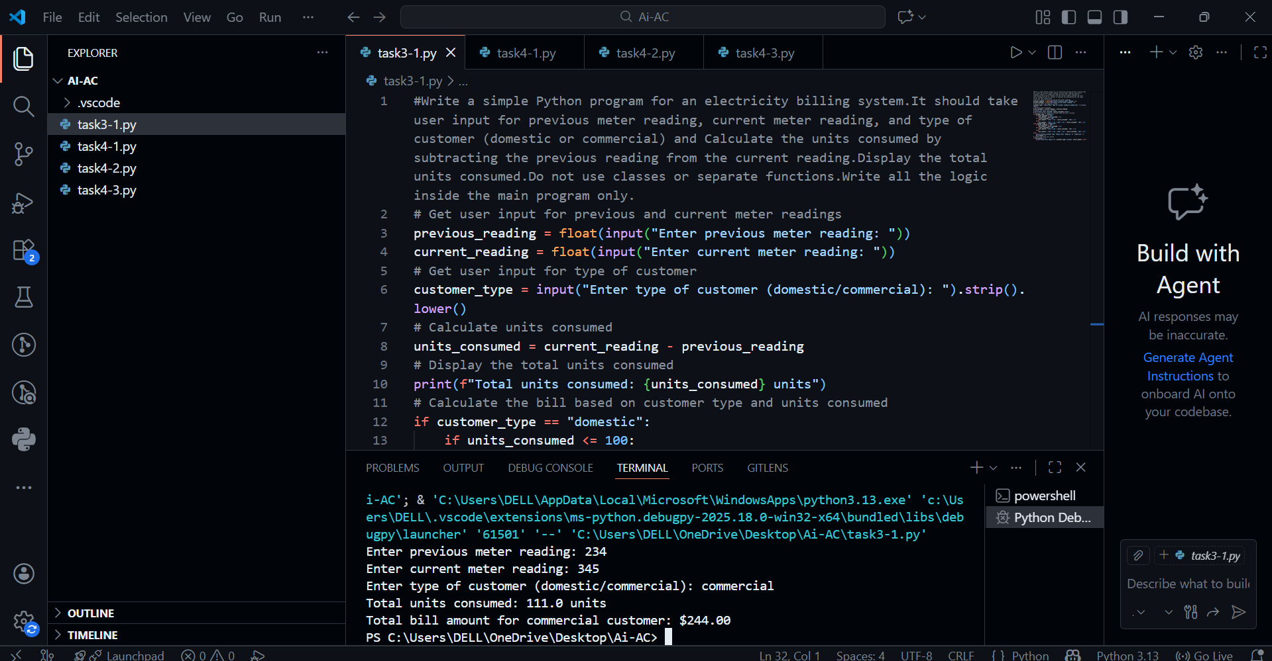
Explanation:
This program calculates electricity usage and bill amount using simple input and conditions.
It takes the previous and current meter readings to find total units consumed.
Based on the customer type (domestic or commercial), it applies different rates and displays the final bill amount.
Task-02:
Prompt:
#Extend the previous code to calculate Energy Charges (EC).Update the program to use conditional statements for different customer types: domestic, commercial, and industrial.Improve the readability of the code by simplifying the energy charge calculation logic and optimizing the conditional statements.
Code:
# Get user input for previous and current meter readings
previous_reading = float(input("Enter previous meter reading: "))
current_reading = float(input("Enter current meter reading: "))
# Get user input for type of customer
customer_type = input("Enter type of customer (domestic/commercial/industrial): ").strip().lower()
# Calculate units consumed
units_consumed = current_reading - previous_reading
# Display the total units consumed
print(f"Total units consumed: {units_consumed} units")
# Calculate the bill based on customer type and units consumed
if customer_type == "domestic":
if units_consumed <= 100:
bill_amount = units_consumed * 1.5
elif units_consumed <= 300:
bill_amount = (100 * 1.5) + (units_consumed - 100) * 2.5
else:
bill_amount = (100 * 1.5) + (200 * 2.5) + (units_consumed - 300) * 4.0
elif customer_type == "commercial":
if units_consumed <= 100:
bill_amount = units_consumed * 2.0
elif units_consumed <= 300:
bill_amount = (100 * 2.0) + (units_consumed - 100) * 4.0
else:
bill_amount = (100 * 2.0) + (200 * 4.0) + (units_consumed - 300) * 6.0
elif customer_type == "industrial":
if units_consumed <= 100:
bill_amount = units_consumed * 2.5
elif units_consumed <= 300:
bill_amount = (100 * 2.5) + (units_consumed - 100) * 5.0
else:
bill_amount = (100 * 2.5) + (200 * 5.0) + (units_consumed - 300) * 7.5
else:
print("Invalid customer type. Please enter 'domestic', 'commercial', or 'industrial'.")
bill_amount = 0
# Display the total bill amount
if bill_amount > 0:
print(f"Total bill amount for {customer_type} customer: ${bill_amount:.2f}")
Output:
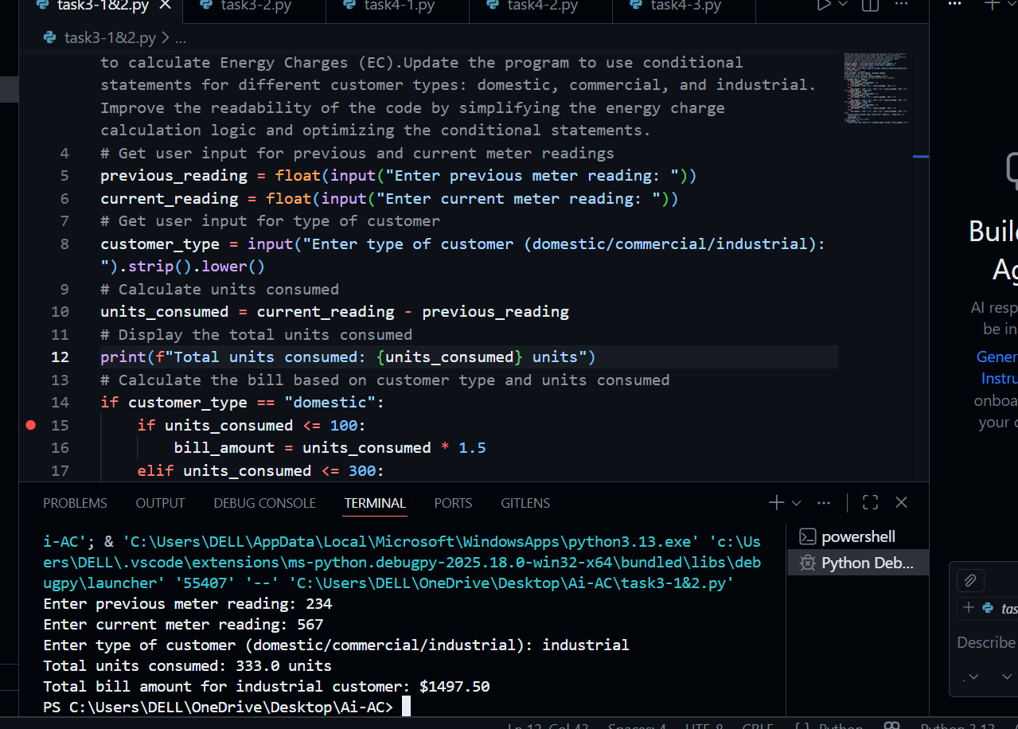
Explanation:
This task extends the previous program by adding Energy Charges (EC) and a new industrial customer type.
It uses conditional statements to apply different unit rates for domestic, commercial, and industrial users.
The code is structured clearly so the billing logic is easy to read and understand.
Task – 03:
Prompt:
#Generate a Python program for an electricity billing system using a modular design.Use user-defined functions to calculate Energy Charges (EC) and Fixed Charges (FC).Each function should take the required inputs and return the calculated value.Include meaningful comments Ensure the program reusable for multiple consumers,include test cases with their outputs to demonstrate correct working.
Code:
# Function to calculate Energy Charges (EC)
def calculate_energy_charges(units_consumed, customer_type):
if customer_type == "domestic":
if units_consumed <= 100:
return units_consumed * 1.5
elif units_consumed <= 300:
return (100 * 1.5) + (units_consumed - 100) * 2.5
else:
return (100 * 1.5) + (200 * 2.5) + (units_consumed - 300) * 4.0
elif customer_type == "commercial":
if units_consumed <= 100:
return units_consumed * 2.0
elif units_consumed <= 300:
return (100 * 2.0) + (units_consumed - 100) * 4.0
else:
return (100 * 2.0) + (200 * 4.0) + (units_consumed - 300) * 6.0
elif customer_type == "industrial":
if units_consumed <= 100:
return units_consumed * 2.5
elif units_consumed <= 300:
return (100 * 2.5) + (units_consumed - 100) * 5.0
else:
return (100 * 2.5) + (200 * 5.0) + (units_consumed - 300) * 7.0
else:
return None
# Function to calculate Fixed Charges (FC)
def calculate_fixed_charges(customer_type):
if customer_type == "domestic":
return 50.0
elif customer_type == "commercial":
return 100.0
elif customer_type == "industrial":
return 150.0
else:
return None
# Main program
def main():
# Get user input for previous and current meter readings
previous_reading = float(input("Enter previous meter reading: "))
current_reading = float(input("Enter current meter reading: "))
# Get user input for type of customer
customer_type = input("Enter type of customer (domestic/commercial/industrial): ").strip().lower()
# Calculate units consumed
units_consumed = current_reading - previous_reading
# Display the total units consumed
print(f"Total units consumed: {units_consumed} units")
# Calculate Energy Charges (EC)
energy_charges = calculate_energy_charges(units_consumed, customer_type)
# Calculate Fixed Charges (FC)
fixed_charges = calculate_fixed_charges(customer_type)
# Check for valid customer type
if energy_charges is None or fixed_charges is None:
print("Invalid customer type. Please enter 'domestic', 'commercial', or 'industrial'.")
return
# Calculate total bill amount
total_bill_amount = energy_charges + fixed_charges
# Display the total bill amount
print(f"Total bill amount for {customer_type} customer: ${total_bill_amount:.2f}")
# Run the main program
if __name__ == "__main__":
main()
Output:
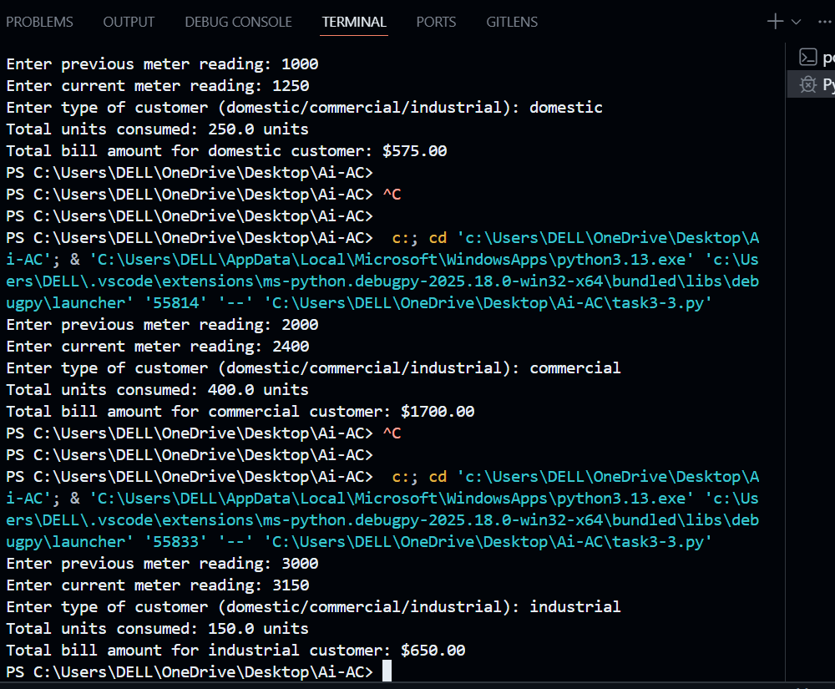
Explanation:
The electricity billing system is redesigned using user-defined functions.
Separate functions calculate Energy Charges (EC) and Fixed Charges (FC), making the code reusable and modular.
This approach improves readability, reduces repetition, and allows the program to handle multiple consumers easily.
Task -04:
Prompt:
#Update the electricity billing program to add extra charges.Calculate Fixed Charges (FC), Customer Charges (CC), and Electricity Duty (ED), where ED is a percentage of the Energy Charges (EC).Display each charge clearly and show a neat bill summary and include sample inputs and outputs.
Code:
# Function to calculate Energy Charges (EC)
def calculate_energy_charges(units_consumed, customer_type):
if customer_type == "domestic":
if units_consumed <= 100:
return units_consumed * 1.5
elif units_consumed <= 300:
return (100 * 1.5) + (units_consumed - 100) * 2.5
else:
return (100 * 1.5) + (200 * 2.5) + (units_consumed - 300) * 4.0
elif customer_type == "commercial":
if units_consumed <= 100:
return units_consumed * 2.0
elif units_consumed <= 300:
return (100 * 2.0) + (units_consumed - 100) * 4.0
else:
return (100 * 2.0) + (200 * 4.0) + (units_consumed - 300) * 6.0
elif customer_type == "industrial":
if units_consumed <= 100:
return units_consumed * 2.5
elif units_consumed <= 300:
return (100 * 2.5) + (units_consumed - 100) * 5.0
else:
return (100 * 2.5) + (200 * 5.0) + (units_consumed - 300) * 7.0
else:
return None
# Function to calculate Fixed Charges (FC)
def calculate_fixed_charges(customer_type):
if customer_type == "domestic":
return 50.0
elif customer_type == "commercial":
return 100.0
elif customer_type == "industrial":
return 150.0
else:
return None
# Function to calculate Customer Charges (CC)
def calculate_customer_charges(customer_type):
if customer_type == "domestic":
return 20.0
elif customer_type == "commercial":
return 40.0
elif customer_type == "industrial":
return 60.0
else:
return None
# Function to calculate Electricity Duty (ED)
def calculate_electricity_duty(energy_charges):
# Electricity Duty is 5% of Energy Charges
return energy_charges * 0.05
# Main program
def main():
# Get user input for previous and current meter readings
previous_reading = float(input("Enter previous meter reading: "))
current_reading = float(input("Enter current meter reading: "))
# Get user input for type of customer
customer_type = input("Enter type of customer (domestic/commercial/industrial): ").strip().lower()
# Calculate units consumed
units_consumed = current_reading - previous_reading
# Display the total units consumed
print(f"Total units consumed: {units_consumed} units")
# Calculate Energy Charges (EC)
energy_charges = calculate_energy_charges(units_consumed, customer_type)
# Calculate Fixed Charges (FC)
fixed_charges = calculate_fixed_charges(customer_type)
# Calculate Customer Charges (CC)
customer_charges = calculate_customer_charges(customer_type)
# Calculate Electricity Duty (ED)
electricity_duty = calculate_electricity_duty(energy_charges)
# Check for valid customer type
if (energy_charges is None or fixed_charges is None or
customer_charges is None):
print("Invalid customer type. Please enter 'domestic', 'commercial', or 'industrial'.")
return
# Calculate total bill amount
total_bill_amount = (energy_charges + fixed_charges +
customer_charges + electricity_duty)
# Display the bill summary
print("\n--- Electricity Bill Summary ---")
print(f"Customer Type : {customer_type.capitalize()}")
print(f"Units Consumed : {units_consumed} units")
print(f"Energy Charges (EC) : ${energy_charges:.2f}")
print(f"Fixed Charges (FC) : ${fixed_charges:.2f}")
print(f"Customer Charges(CC): ${customer_charges:.2f}")
print(f"Electricity Duty(ED): ${electricity_duty:.2f}")
print(f"Total Bill Amount : ${total_bill_amount:.2f}")
# Run the main program
if __name__ == "__main__":
main()
Output:
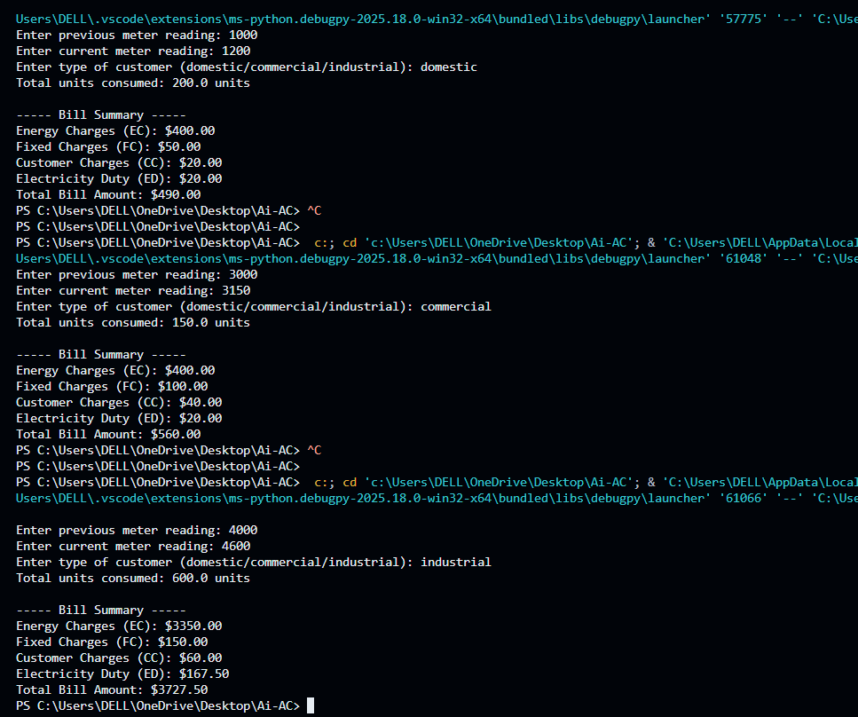
Explanation:
This task adds more billing components to generate a detailed electricity bill. Calculates Energy Charges (EC),Fixed Charges (FC), Customer Charges (CC), and Electricity Duty (ED).
All charges are displayed clearly in a neat bill summary, making the final output easy to understand.
Task -05:
Prompt:
#Create a Python program to generate the final electricity bill.Calculate the total bill as the sum of Energy Charges, Fixed Charges, Customer Charges, and Electricity Duty.Show each charge clearly and print the final bill amount.
Code:
# Function to calculate Energy Charges (EC)
def calculate_energy_charges(units_consumed, customer_type):
if customer_type == "domestic":
if units_consumed <= 100:
return units_consumed * 0.5
elif units_consumed <= 300:
return (100 * 0.5) + ((units_consumed - 100) * 0.75)
else:
return (100 * 0.5) + (200 * 0.75) + ((units_consumed - 300) * 1.0)
elif customer_type == "commercial":
if units_consumed <= 200:
return units_consumed * 0.75
elif units_consumed <= 500:
return (200 * 0.75) + ((units_consumed - 200) * 1.0)
else:
return (200 * 0.75) + (300 * 1.0) + ((units_consumed - 500) * 1.25)
elif customer_type == "industrial":
if units_consumed <= 500:
return units_consumed * 1.0
else:
return (500 * 1.0) + ((units_consumed - 500) * 1.5)
else:
return None
print(f"Fixed Charges (FC): ${fixed_charges:.2f}")
print(f"Customer Charges (CC): ${customer_charges:.2f}")
print(f"Electricity Duty (ED): ${electricity_duty:.2f}")
print(f"Total Bill Amount: ${total_bill_amount:.2f}")
# Function to calculate Energy Charges (EC)
def calculate_energy_charges(units_consumed, customer_type):
if customer_type == "domestic":
if units_consumed <= 100:
return units_consumed * 2.5
elif units_consumed <= 300:
return (100 * 2.5) + (units_consumed - 100) * 5.0
else:
return (100 * 2.5) + (200 * 5.0) + (units_consumed - 300) * 7.0
elif customer_type == "commercial":
if units_consumed <= 200:
return units_consumed * 5.0
elif units_consumed <= 500:
return (200 * 5.0) + (units_consumed - 200) * 7.5
else:
return (200 * 5.0) + (300 * 7.5) + (units_consumed - 500) * 10.0
elif customer_type == "industrial":
if units_consumed <= 500:
return units_consumed * 7.0
else:
return (500 * 7.0) + (units_consumed - 500) * 10.0
else:
return None
# Function to calculate Fixed Charges (FC)
def calculate_fixed_charges(customer_type):
if customer_type == "domestic":
return 75.0
elif customer_type == "commercial":
return 150.0
elif customer_type == "industrial":
return 200.0
else:
return None
# Function to calculate Customer Charges (CC)
def calculate_customer_charges(customer_type):
if customer_type == "domestic":
return 30.0
elif customer_type == "commercial":
return 60.0
elif customer_type == "industrial":
return 90.0
else:
return None
# Function to calculate Electricity Duty (ED)
def calculate_electricity_duty(energy_charges):
# Electricity Duty is 8% of Energy Charges
return energy_charges * 0.08

# Main program
def main():
# Get user input for previous and current meter readings
previous_reading = float(input("Enter previous meter reading: "))
current_reading = float(input("Enter current meter reading: "))
# Get user input for type of customer
customer_type = input("Enter type of customer (domestic/commercial/industrial): ").strip().lower()
# Calculate units consumed
units_consumed = current_reading - previous_reading
# Display the total units consumed
print(f"Total units consumed: {units_consumed} units")
# Calculate Energy Charges (EC)
energy_charges = calculate_energy_charges(units_consumed, customer_type)
# Calculate Fixed Charges (FC)
fixed_charges = calculate_fixed_charges(customer_type)
# Calculate Customer Charges (CC)
customer_charges = calculate_customer_charges(customer_type)
# Calculate Electricity Duty (ED)
electricity_duty = calculate_electricity_duty(energy_charges)
# Calculate Total Bill Amount
total_bill_amount = (energy_charges + fixed_charges + customer_charges + electricity_duty)
# Display the breakdown of charges
print("\nElectricity Bill Breakdown:")
print(f"Energy Charges (EC): ${energy_charges:.2f}")
print(f"Fixed Charges (FC): ${fixed_charges:.2f}")
print(f"Customer Charges (CC): ${customer_charges:.2f}")
print(f"Electricity Duty (ED): ${electricity_duty:.2f}")
print(f"Total Bill Amount: ${total_bill_amount:.2f}")
# Check for valid customer type
if (energy_charges is None or fixed_charges is None or
customer_charges is None):
print("Invalid customer type. Please enter 'domestic', 'commercial', or 'industrial'.")
return
# Calculate total bill amount
total_bill_amount = (energy_charges + fixed_charges +
customer_charges + electricity_duty)
# Display the bill summary
print("\n----- Bill Summary -----")
print(f"Energy Charges (EC): ${energy_charges:.2f}")
print(f"Fixed Charges (FC): ${fixed_charges:.2f}")
print(f"Customer Charges (CC): ${customer_charges:.2f}")
print(f"Electricity Duty (ED): ${electricity_duty:.2f}")
print(f"Total Bill Amount: ${total_bill_amount:.2f}")
return
if __name__ == "__main__":
main()
Output:
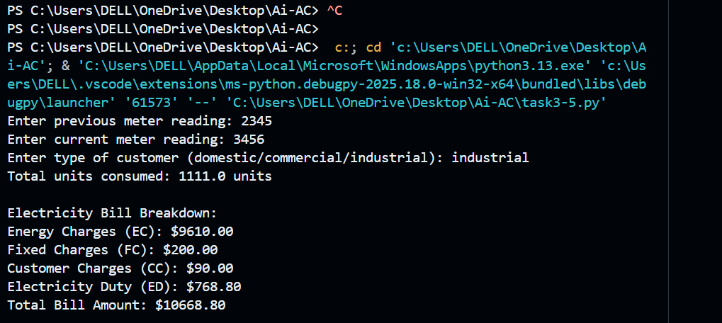
Explanation:
Generates a complete electricity bill with a full breakdown of charges.
It calculates Energy Charges, Fixed Charges, Customer Charges, and Electricity Duty, then adds them to get the total bill.Each charge is printed clearly, followed by the final bill amount, giving a professional and complete billing output.

