AI ASSISTED CODING
ASSIGNMENT - 4.3
Hallticket No: 2303A51902
Batch – 09
Task - 01:
Prompt:
#Write a Python function that takes year as an integer input.The function should check whether the given year is a leap year or not using the correct rules and returns result whether the year is a leap year or not.
Code:
def is_leap_year(year):
# A year is a leap year if it is divisible by 4
# but not divisible by 100, unless it is also divisible by 400.
if (year % 4 == 0 and year % 100 != 0) or (year % 400 == 0):
return f"{year} is a leap year."
else:
return f"{year} is not a leap year."
year = int(input("Enter a year: "))
result = is_leap_year(year)
print(result)
Output:
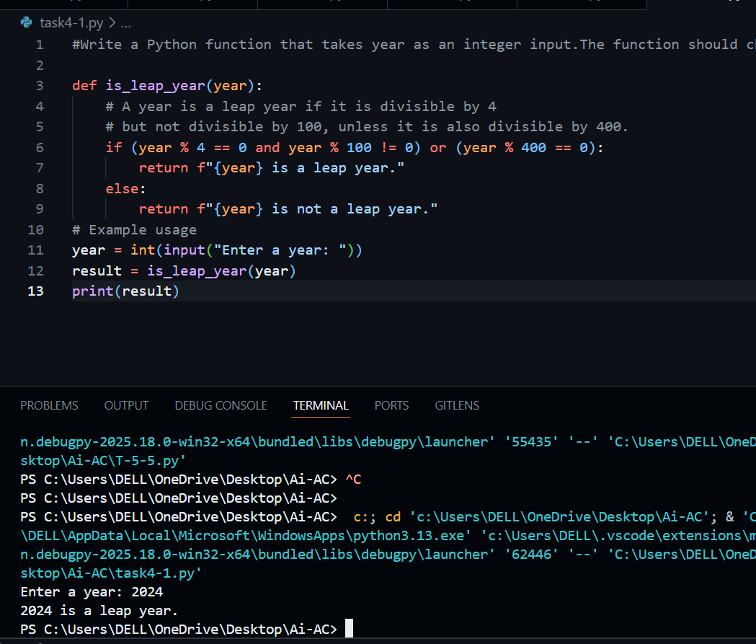
Explanation:
This program checks whether a given year is a leap year using standard rules. A year is a leap year if it is divisible by 4 but not by 100, unless it is also divisible by 400. The function takes a year as input, applies these conditions, and returns the result.
Task - 02:
Prompt:
#Python function that converts a value from centimeters to inches using the correct mathematical formula.For example, if the input is 10 centimeters, the output should be 3.94 inches.
#should accept a numeric value in centimeters and return the converted value in inches.
Code:
def cm_to_inches(cm):
"""
Converts centimeters to inches.

Parameters:
cm (float): The value in centimeters to be converted.

Returns:
float: The converted value in inches.
"""
inches = cm / 2.54 # Correct conversion factor
return round(inches, 2) # Rounded to 2 decimal places
# Example usage
if __name__ == "__main__":
cm_value = float(input("Enter value in centimeters: "))
inches_value = cm_to_inches(cm_value)
print(f"{cm_value} centimeters is equal to {inches_value} inches.")
Output:
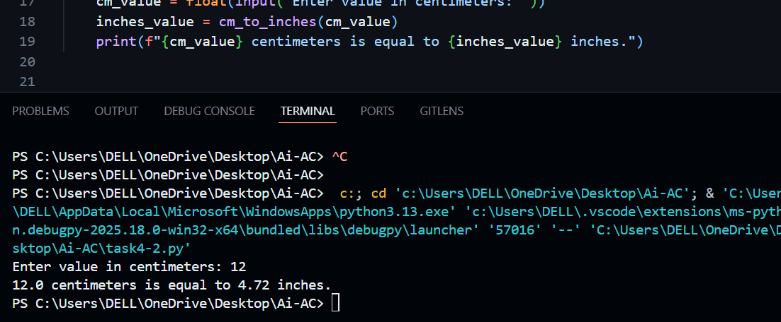
Explanation:
This function converts centimeters to inches using the correct formula (cm ÷ 2.54). The result is rounded to two decimal places for accuracy. The example helps guide the AI to produce the correct logic and output format.
Task -03:
Prompt:
#generate Python function that takes a full name as input and formats it in the form “Last, First”.
#Examples:Input: "John Smith" → Output: "Smith, John" ; Input: "Alice Brown" → Output: "Brown, Alice"
#The function should return the formatted name.
Code:
def format_name(full_name):
"""
Formats a full name in the form "Last, First".
Parameters:
full_name (str): The full name to be formatted.
Returns:
str: The formatted name in "Last, First" format.
"""
# Split the full name into parts
name_parts = full_name.split()
# Check if there are at least two parts (first and last name)
if len(name_parts) < 2:
raise ValueError("Full name must include at least a first and last name.")
# Extract first and last names
first_name = name_parts[0]
last_name = name_parts[-1]
# Format the name
formatted_name = f"{last_name}, {first_name}"
return formatted_name
# Example usage
if __name__ == "__main__":
full_name = input("Enter full name (First Last): ")
try:
formatted = format_name(full_name)
print("Formatted Name:", formatted)
except ValueError as e:
print("Error:", e)
Output:
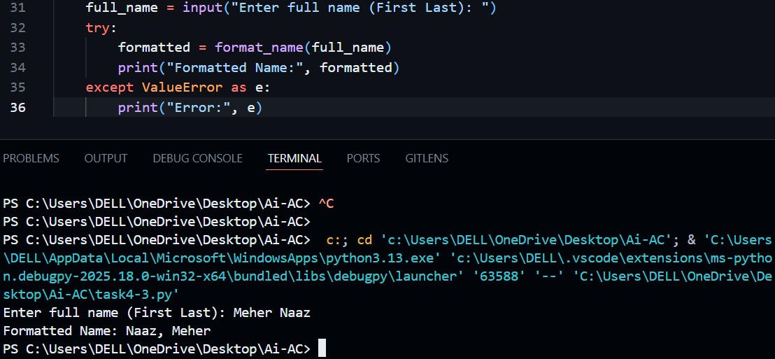
Explanation:
The function takes a full name as input and rearranges it into the format “Last, First”. It splits the name into parts, extracts the first and last names, and formats them properly. Examples ensure the output strictly follows the required pattern.
Task-04:
Zero-shot Prompt:
#Generate Python function that counts the number of vowels in a given string and returns the count.
Code:
def count_vowels(input_string):
"""
Counts the number of vowels in the given string.

Parameters:
input_string (str): The string to be analyzed.

Returns:
int: The number of vowels in the string.
"""
vowels = "aeiouAEIOU"
count = sum(1 for char in input_string if char in vowels)
return count
# Example usage
if __name__ == "__main__":
test_string = input("Enter a string: ")
vowel_count = count_vowels(test_string)
print("Number of vowels in the string:", vowel_count)
Output:
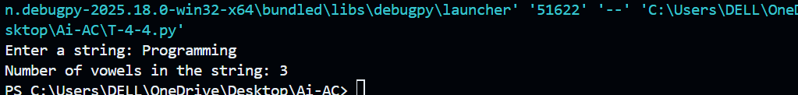
Few-shot Prompt:
#Write a Python function that counts vowels in a string.
#Examples: Input: "hello" → Output: 2 ; Input: "AI Coding" → Output: 4
Code:
def count_vowels(input_string):
"""
Counts the number of vowels in a given string.

Parameters:
input_string (str): The string to count vowels in.

Returns:
int: The number of vowels in the string.
"""
vowels = "aeiouAEIOU"
count = sum(1 for char in input_string if char in vowels)
return count
# Example usage
if __name__ == "__main__":
test_string = input("Enter a string: ")
vowel_count = count_vowels(test_string)
print("Number of vowels in the string:", vowel_count)
Output:
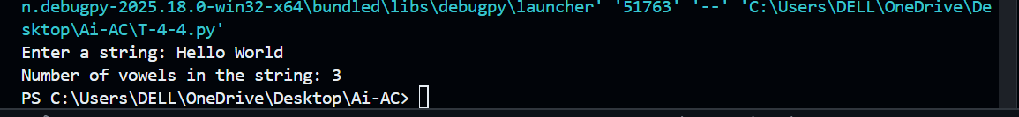
Explanation:
Both functions count vowels in a given string accurately. The zero-shot version works well with just instructions, while the few-shot version benefits from examples that guide the expected output. Few-shot prompting generally improves clarity and confidence in results.
Task-05:
Prompt:
#Write a Python function that reads a .txt file, counts the number of lines in the file, and returns the line count.
#Examples:
#File content:
#Hello World
#Python Programming
#AI Assisted Coding
#Output: 3
#File content:
#Line one
#Line two
#Output: 2
Code:
def count_lines_in_file(file_path):
"""
Counts the number of lines in a .txt file.
Parameters:
file_path (str): The path to the .txt file.
Returns:
int: The number of lines in the file.
"""
try:
with open(file_path, 'r') as file:
lines = file.readlines()
line_count = len(lines)
return line_count
except FileNotFoundError:
raise FileNotFoundError(f"The file at {file_path} was not found.")
except Exception as e:
raise e
# Example usage
if __name__ == "__main__":
file_path = input("Enter the path to the .txt file: ")
try:
count = count_lines_in_file(file_path)
print("Number of lines in the file:", count)
except Exception as e:
print("Error:", e)
Output:
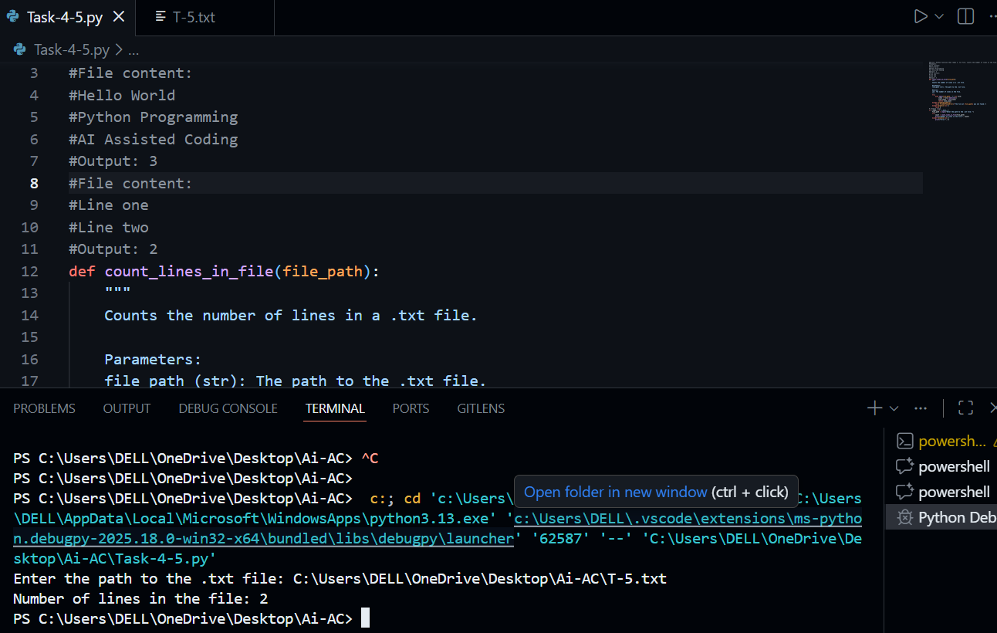

.txt file:
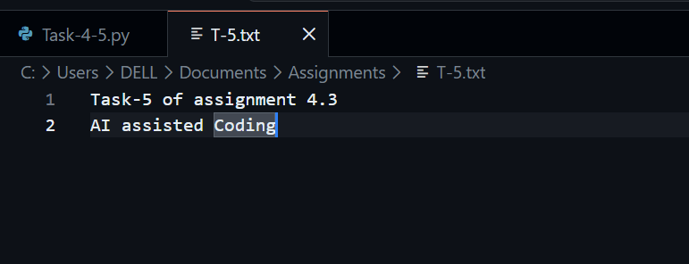
Explanation:
This function reads a .txt file and counts the number of lines in it. It uses file handling concepts like open() and readlines(). Example inputs help the AI understand how line counting works and ensure correct results. Error handling is added to manage missing files safely.

