AI ASSISTED CODING
ASSIGNMENT – 6.3
Hallticket No: 2303A51902
Batch – 09
Task-01:
Prompt:
# Create a Python Student class with name, roll_number, and branch.Use __init__ and a display_details() method.Create an object and print the details.
Code:
class Student:
def __init__(self, name, roll_number, branch):
self.name = name
self.roll_number = roll_number
self.branch = branch

def display_details(self):
print(f"Name: {self.name}")
print(f"Roll Number: {self.roll_number}")
print(f"Branch: {self.branch}")
# Create an object of the Student class
student1 = Student("Alice", "101", "Computer Science")
# Print the details of the student
student1.display_details()

Output:
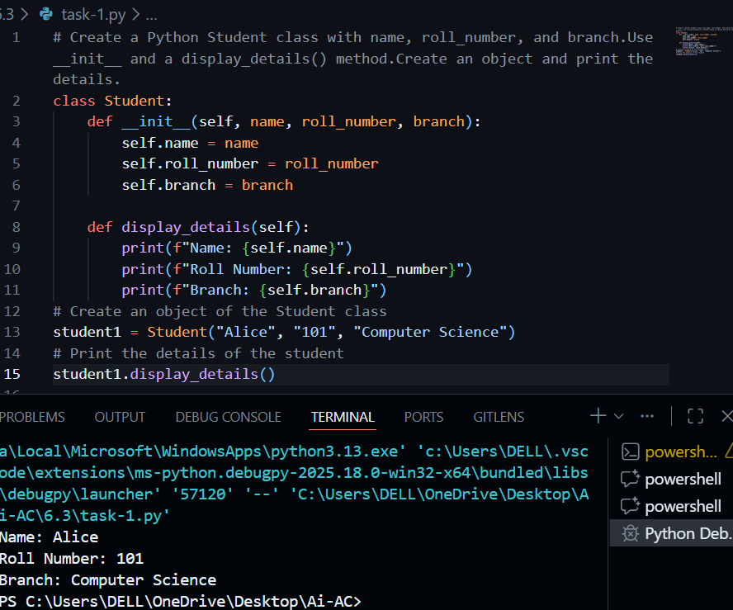
Explanation:
This program defines a Student class with name, roll number, and branch. The __init__ method initializes the values, and display_details() prints them clearly. An object is created and its details are displayed.
Task-02:
For loop Prompt:
# Write a Python function that prints the first 10 multiples of a given number using a for loop.The number should be taken as user input.
Code:
def print_multiples(n):
print(f"First 10 multiples of {n}:")
for i in range(1, 11):
print(n * i)
number = int(input("Enter a number: "))
print_multiples(number)
# The function print_multiples takes an integer n as input and prints the first 10 multiples of that number.
# The for loop iterates from 1 to 10, multiplying n by the loop variable i and printing the result.
# The program prompts the user to enter a number, which is then passed to the print_multiples function to display the multiples.
Output:
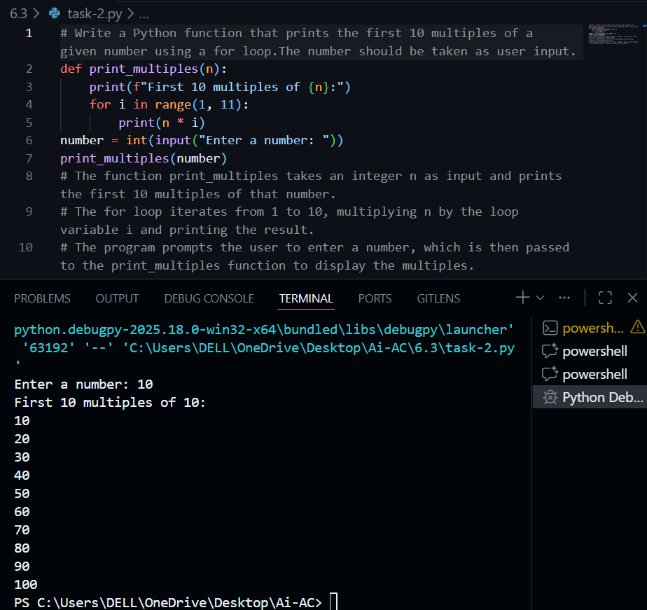
Explanation:
The function uses a for loop from 1 to 10 to print the first 10 multiples of a given number. The number is taken as user input and passed to the function.
While loop prompt:
# Write the same program to print the first 10 multiples of a given number,but use a while loop instead of a for loop.
Code:
def print_multiples_while(n):
print(f"First 10 multiples of {n} using while loop:")
i = 1
while i <= 10:
print(n * i)
i += 1
number = int(input("Enter a number: "))
print_multiples_while(number)
# The function print_multiples_while takes an integer n as input and prints the first 10 multiples of that number using a while loop.
# The while loop continues as long as i is less than or equal to 10, multiplying n by i and printing the result, then incrementing i by 1.
# The program prompts the user to enter a number, which is then passed to the print_multiples_while function to display the multiples.
Output:
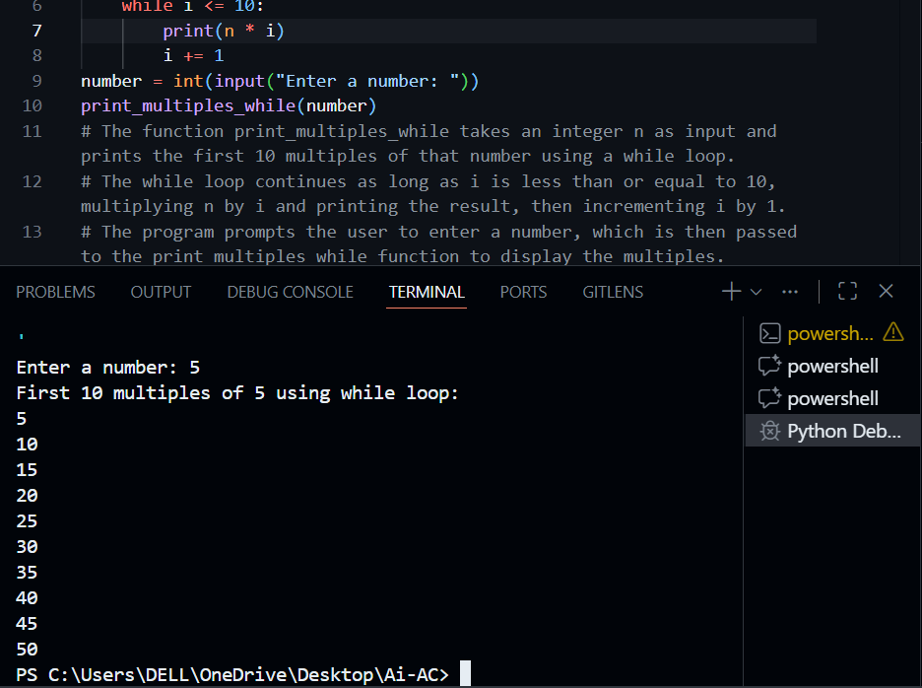
Explanation:
This version does the same task using a while loop. A counter starts at 1 and runs until 10, printing multiples at each step.

Task-03:
Prompt: (Using if-elif-else)
# Write a Python function that classifies a person's age into: child, teenager, adult, or senior using if-elif-else conditions.
# Take age as user input and print the category.
Code:
def classify_age(age):
if age < 13:
category = "child"
elif 13 <= age < 20:
category = "teenager"
elif 20 <= age < 65:
category = "adult"
else:
category = "senior"
print(f"A person aged {age} is classified as a {category}.")
age = int(input("Enter your age: "))
classify_age(age)
# The function classify_age takes an integer age as input and classifies it into one of four categories: child, teenager, adult, or senior.
# It uses if-elif-else conditions to determine the appropriate category based on the age provided.
# The program prompts the user to enter their age, which is then passed to the classify_age function to display the classification.
Output:
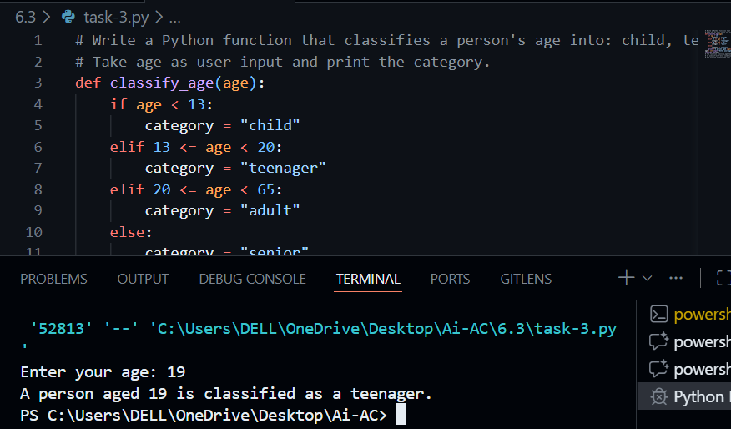
Explanation:
The function classifies age into child, teenager, adult, or senior using clear conditional ranges. User input is taken and the category is printed.
Prompt: (Alternative logic)
# Rewrite the age classification program using simplified conditions alternative logic without changing its functionality.
Code:
def classify_age_simplified(age):
if age < 13:
category = "child"
elif age < 20:
category = "teenager"
elif age < 65:
category = "adult"
else:
category = "senior"
print(f"A person aged {age} is classified as a {category}.")
age = int(input("Enter your age: "))
classify_age_simplified(age)
# The function classify_age_simplified takes an integer age as input and classifies it into one of four categories: child, teenager, adult, or senior.
# It uses simplified if-elif-else conditions to determine the appropriate category based on the age provided.
# The program prompts the user to enter their age, which is then passed to the classify_age_simplified function to display the classification.
# Both functions perform the same task of age classification, but the second function uses a more concise approach to the conditional checks.
Output:
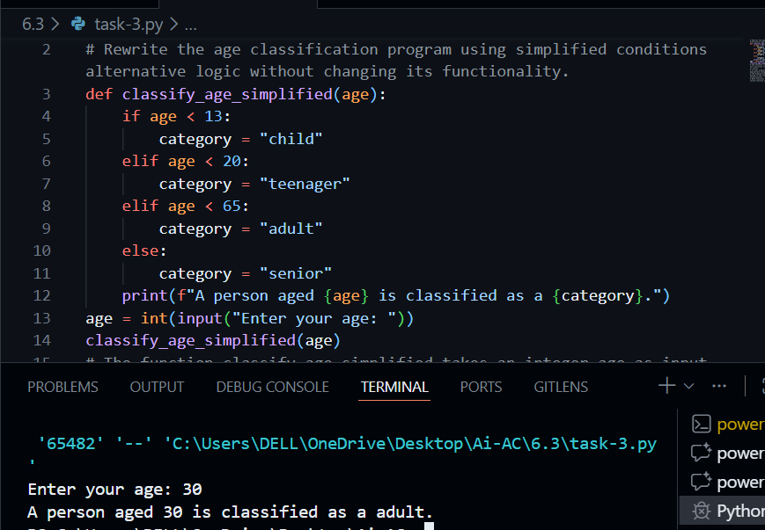
Explanation:
This version simplifies the conditions by removing repeated comparisons. It is more readable and easier to maintain while giving the same result.
Task-04:
Prompt:
# Write a Python function sum_to_n() that calculates the sum of the first n natural numbers
# using a for loop. Take n as user input.
Code:
def sum_to_n(n):
total = 0
for i in range(1, n + 1):
total += i
print(f"The sum of the first {n} natural numbers is: {total}")
number = int(input("Enter a natural number n: "))
sum_to_n(number)
# The function sum_to_n takes an integer n as input and calculates the sum of the first n natural numbers.
# It uses a for loop to iterate from 1 to n, adding each number to the total sum.
# The program prompts the user to enter a natural number n, which is then passed to the sum_to_n function to display the sum.
Output:
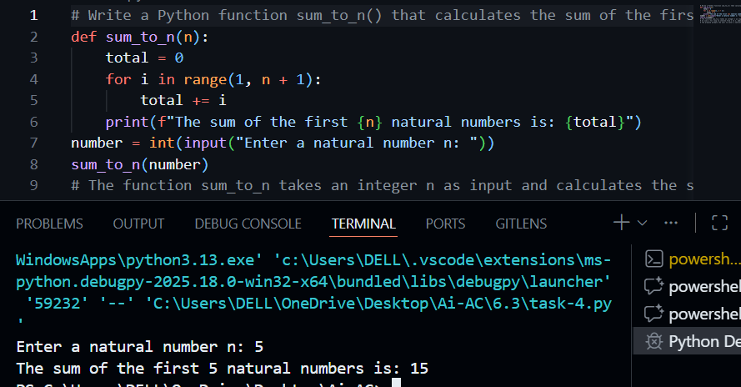
Explanation:
The function adds numbers from 1 to n using a loop and prints the total sum. This approach is simple and easy to understand.
Alternative prompt:
# Rewrite the sum_to_n() function using while loop or a mathematical formula.Explain which approach is more efficient.
Code:
def sum_to_n_formula(n):
total = n * (n + 1) // 2
print(f"The sum of the first {n} natural numbers using formula is: {total}")
number = int(input("Enter a natural number n: "))
sum_to_n_formula(number)
# The function sum_to_n_formula takes an integer n as input and calculates the sum of the first n natural numbers using the mathematical formula n(n + 1)/2.
# This approach is more efficient than using a loop because it computes the sum in constant time O(1), regardless of the size of n.
# The program prompts the user to enter a natural number n, which is then passed to the sum_to_n_formula function to display the sum.
# Using the mathematical formula is more efficient than using a loop, especially for large values of n, as it avoids the overhead of iteration.
Ouptut:
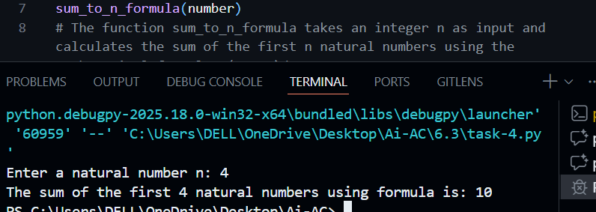
Explanation:
This version uses the mathematical formula n(n+1)/2 to calculate the sum instantly. It is more efficient because it runs in constant time O(1).
Task-05:
Prompt:
# Create a Python class BankAccount with account_holder and balance.Add deposit(), withdraw(), and check_balance() methods.
# Create an object and show deposit and withdrawal.Add simple comments to explain the code.
Code:
class BankAccount:
def __init__(self, account_holder, initial_balance=0):
"""Initialize the bank account with account holder's name and initial balance."""
self.account_holder = account_holder
self.balance = initial_balance

def deposit(self, amount):
"""Deposit a specified amount into the account."""
if amount > 0:
self.balance += amount
print(f"Deposited: ${amount:.2f}. New balance: ${self.balance:.2f}")
else:
print("Deposit amount must be positive.")

def withdraw(self, amount):
"""Withdraw a specified amount from the account if sufficient funds are available."""
if amount > 0:
if amount <= self.balance:
self.balance -= amount
print(f"Withdrew: ${amount:.2f}. New balance: ${self.balance:.2f}")
else:
print("Insufficient funds for this withdrawal.")
else:
print("Withdrawal amount must be positive.")

def check_balance(self):
"""Check and print the current balance of the account."""
print(f"Current balance: ${self.balance:.2f}")

# Create a BankAccount object for 'John Doe' with an initial balance of $1000
account = BankAccount("John Doe", 1000)
# Show the initial balance
account.check_balance()
# Deposit $500 into the account
account.deposit(500)
# Withdraw $200 from the account
account.withdraw(200)
# Check the final balance after deposit and withdrawal
account.check_balance()
# The BankAccount class represents a simple bank account with methods to deposit, withdraw, and check the balance.
# An object of BankAccount is created for a user named 'John Doe' with an initial balance of $1000.
# The program demonstrates depositing $500, withdrawing $200, and checking the balance at each step
# to show the changes in the account balance.
# Each method includes basic validation to ensure that deposit and withdrawal amounts are positive
# and that there are sufficient funds for withdrawals.
# This implementation provides a clear and straightforward way to manage a bank account using object-oriented programming principles.
Output:
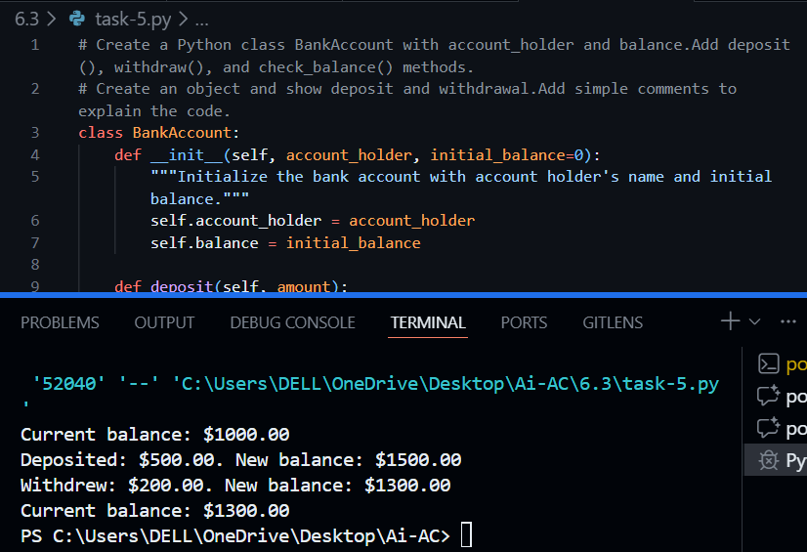
Explanation:
This program creates a BankAccount class with account holder name and balance. deposit() adds money , withdraw() removes money with balance check, check_balance() shows current balanceThe object demonstrates deposit and withdrawal operations with proper validation and clear output.

