AI ASSISTED CODING
ASSIGNMENT – 6.4
Hallticket No: 2303A51902
Batch – 09
Task-01:
Prompt:
class Student:
def __init__(self, name, roll_number, marks):
self.name = name
self.roll_number = roll_number
self.marks = marks
#Write a method to display student details clearly and a method that compares the student's marks with the class average and returns a message using if-else
Code:
class Student:
def __init__(self, name, roll_number, marks):
self.name = name
self.roll_number = roll_number
self.marks = marks
#Write a method to display student details clearly and a method that compares the student's marks with the class average and returns a message using if-else
def display_details(self):
"""Display the student's details."""
print(f"Name: {self.name}")
print(f"Roll Number: {self.roll_number}")
print(f"Marks: {self.marks}")
def compare_with_average(self, class_average):
"""Compare the student's marks with the class average and return a message."""
if self.marks > class_average:
return f"{self.name} has above average marks."
elif self.marks < class_average:
return f"{self.name} has below average marks."
else:
return f"{self.name} has average marks."
# Create a Student object
student = Student("Alice", 101, 85)
# Display student details
student.display_details()
# Compare student's marks with class average
class_average = 75
comparison_result = student.compare_with_average(class_average)
print(comparison_result)
# The Student class represents a student with attributes for name, roll number, and marks.
# It includes methods to display the student's details and to compare the student's marks with the class average.
# An object of Student is created for a student named 'Alice' with roll number 101 and marks 85.
# The program demonstrates displaying the student's details and comparing the marks with a class average of 75.
# The compare_with_average method uses if-else statements to determine whether the student's marks are above, below, or equal to the class average,
# and returns an appropriate message.
# Each method includes clear output to provide information about the student's performance.
# This implementation provides a straightforward way to manage and evaluate student information using object-oriented programming principles.
Output:
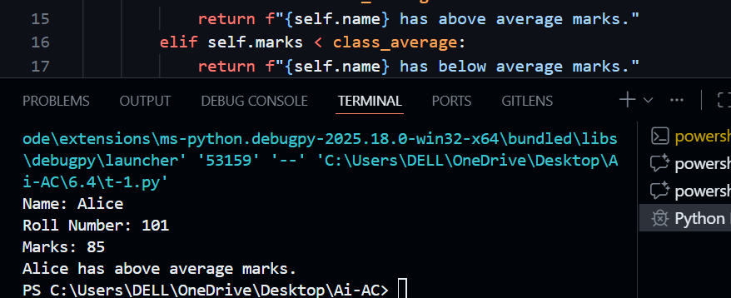
Explanation:
This program defines a Student class with attributes for name, roll number, and marks.
The display_details() method prints the student’s information.
The compare_with_average() method compares the student’s marks with the class average using conditional statements and returns a suitable message.
An object is created and both methods are demonstrated.
Task-02:
Prompt :
sensor_readings = [12, 7, 9, 16, 5, 20]
for reading in sensor_readings:
# Check if the reading is even. If even, calculate its square
# Print the reading and its square in a readable format
Code:
sensor_readings = [12, 7, 9, 16, 5, 20]
for reading in sensor_readings:
# Check if the reading is even. If even, calculate its square
# Print the reading and its square in a readable format
if reading % 2 == 0:
square = reading ** 2
print(f"Reading: {reading}, Square: {square}")
else:
print(f"Reading: {reading} is odd, skipping.")
# The code iterates through a list of sensor readings and checks if each reading is even.
# If a reading is even, it calculates the square of that reading and prints both the reading and its square.
# If a reading is odd, it prints a message indicating that the reading is odd and skips the calculation.
# This implementation demonstrates the use of a for loop to process a list of values, conditional statements to check for even numbers,
# and formatted string literals to display the output in a clear and readable format.
Output:
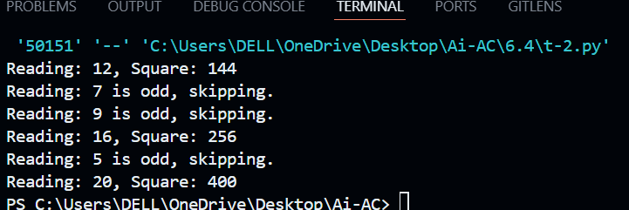
Explanation:
The program iterates through a list of sensor readings using a for loop.
It checks whether each reading is even using the modulus operator.
If the reading is even, its square is calculated and printed.
Odd readings are skipped with a message.
Task-03:
Prompt:
class BankAccount:
def __init__(self, account_holder, balance):
self.account_holder = account_holder
self.balance = balance
# Define 2 methods one to deposit money into the account other to withdraw money
# Prevent withdrawal if balance is insufficient and take user input
Code:
class BankAccount:
def __init__(self, account_holder, balance):
self.account_holder = account_holder
self.balance = balance
# Define 2 methods one to deposit money into the account other to withdraw money
# Prevent withdrawal if balance is insufficient and take user input
def deposit(self, amount):
"""Deposit a specified amount into the account."""
if amount > 0:
self.balance += amount
print(f"Deposited: ${amount:.2f}. New balance: ${self.balance:.2f}")
else:
print("Deposit amount must be positive.")
def withdraw(self, amount):
"""Withdraw a specified amount from the account if sufficient funds are available."""
if amount > 0:
if amount <= self.balance:
self.balance -= amount
print(f"Withdrew: ${amount:.2f}. New balance: ${self.balance:.2f}")
else:
print("Insufficient funds for this withdrawal.")
else:
print("Withdrawal amount must be positive.")
# Create a BankAccount object
account = BankAccount("Jane Smith", 500)
# Take user input for deposit and withdrawal amounts
deposit_amount = float(input("Enter amount to deposit: "))
account.deposit(deposit_amount)
withdraw_amount = float(input("Enter amount to withdraw: "))
account.withdraw(withdraw_amount)
# The BankAccount class represents a simple bank account with methods to deposit and withdraw money.
# An object of BankAccount is created for a user named 'Jane Smith' with an initial balance of $500.
# The program takes user input for deposit and withdrawal amounts and performs the respective operations.
# Each method includes basic validation to ensure that deposit and withdrawal amounts are positive
# and that there are sufficient funds for withdrawals.
# This implementation provides a clear and straightforward way to manage a bank account using object-oriented programming principles.
Output:
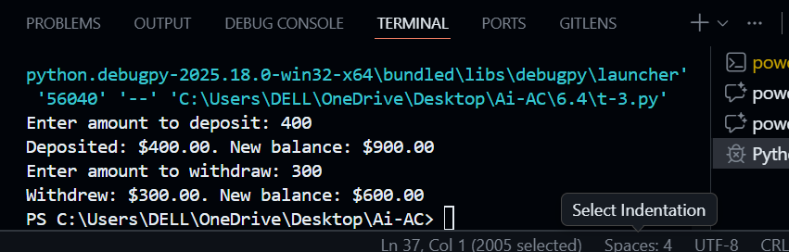
Explanation:
This program defines a BankAccount class with account holder name and balance.
The deposit() method adds money after validating the amount.
The withdraw() method checks if sufficient balance is available before withdrawal.
User input is taken to perform deposit and withdrawal operations.
Task-04:
Prompt:
students = [
{"name": "Asha", "score": 82},
{"name": "Rahul", "score": 68},
{"name": "Neha", "score": 90}
]
index = 0
#Use a while loop to iterate through the list and Print names of students who scored more than 75
Code:
students = [
{"name": "Asha", "score": 82},
{"name": "Rahul", "score": 68},
{"name": "Neha", "score": 90}
]
index = 0
#Use a while loop to iterate through the list and Print names of students who scored more than 75
while index < len(students):
student = students[index]
if student["score"] > 75:
print(f"Student: {student['name']}, Score: {student['score']}")
index += 1
# The code defines a list of dictionaries, each representing a student with their name and score.
# It uses a while loop to iterate through the list and checks if each student's score is greater than 75.
# If the condition is met, it prints the student's name and score in a readable format.
# This implementation demonstrates the use of a while loop to process a list of values,
# conditional statements to filter based on a score threshold,
# and formatted string literals to display the output clearly.
Output:
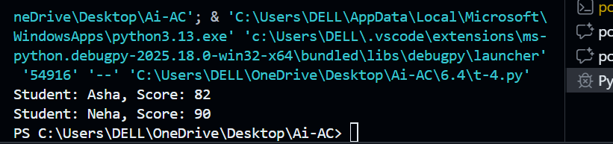
Explanation:
The program stores student details in a list of dictionaries.
A while loop is used to iterate through the list.
Students with scores greater than 75 are identified and their names are printed.
This demonstrates looping and condition checking.
Task-05:
Prompt:
class ShoppingCart:
def __init__(self):
self.items = []
#Write 3 methods to add items (name, price, quantity),to remove items from the cart,to calculate total bill using a loop
# also Apply discount if total exceeds a certain amount.Use dynamic input for item details
Code:
class ShoppingCart:
def __init__(self):
self.items = []
#Write 3 methods to add items (name, price, quantity),to remove items from the cart,to calculate total bill using a loop
# also Apply discount if total exceeds a certain amount.Use dynamic input for item details
def add_item(self, name, price, quantity):
"""Add an item to the shopping cart."""
self.items.append({"name": name, "price": price, "quantity": quantity})
print(f"Added {quantity} of {name} at ${price:.2f} each to the cart.")
def remove_item(self, name):
"""Remove an item from the shopping cart by name."""
for item in self.items:
if item["name"] == name:
self.items.remove(item)
print(f"Removed {name} from the cart.")
return
print(f"Item {name} not found in the cart.")
def calculate_total(self):
"""Calculate the total bill, applying a discount if applicable."""
total = 0
for item in self.items:
total += item["price"] * item["quantity"]
# Apply a 10% discount if total exceeds $100
if total > 100:
discount = total * 0.10
total -= discount
print(f"Applied a discount of ${discount:.2f}.")
print(f"Total bill: ${total:.2f}")
return total
# Create a ShoppingCart object
cart = ShoppingCart()
# Take dynamic input for item details
while True:
action = input("Enter 'add' to add item, 'remove' to remove item, 'total' to calculate total, or 'exit' to quit: ").strip().lower()
if action == 'add':
name = input("Enter item name: ")
price = float(input("Enter item price: "))
quantity = int(input("Enter item quantity: "))
cart.add_item(name, price, quantity)
elif action == 'remove':
name = input("Enter item name to remove: ")
cart.remove_item(name)
elif action == 'total':
cart.calculate_total()
elif action == 'exit':
break
else:
print("Invalid action. Please try again.")
# The ShoppingCart class represents a simple shopping cart with methods to add items, remove items, and calculate the total bill.
# An object of ShoppingCart is created, and the program takes dynamic input from the user to manage the cart.
# The add_item method allows adding items with their name, price, and quantity.
# The remove_item method allows removing items by name.
# The calculate_total method computes the total bill and applies a 10% discount if the total exceeds $100.
# The program runs in a loop, allowing the user to perform multiple actions until they choose to
Output:
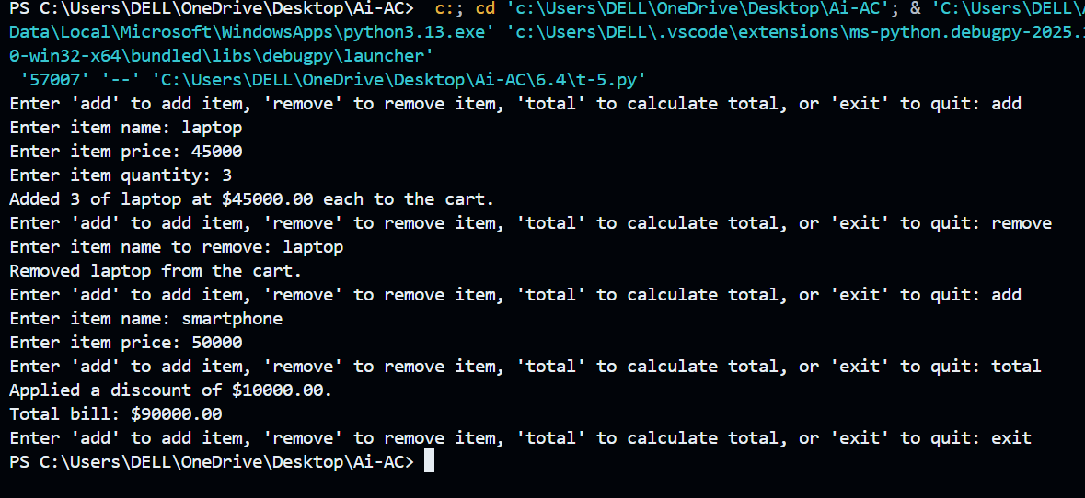
Explanation:
The ShoppingCart class manages items using a list.Items can be added or removed using methods.
The total bill is calculated using a loop, and a discount is applied if the total exceeds a certain amount.User input allows dynamic interaction with the cart.

