AI ASSISTED CODING
ASSIGNMENT – 8.3
Hallticket No: 2303A51902
Batch – 09
Task-01:
Prompt:
#write a python program for email input validation in user registration use proper test cases and rules
Code:
email = input("Enter your email address: ")
# email validation function
def validate_email(email):
if "@" not in email:
return False
local_part, domain_part = email.split("@", 1)
if not local_part or not domain_part:
return False
if "." not in domain_part:
return False
return True
# validate the email and print the result
if validate_email(email):
print("Email address is valid.")
else:
print("Email address is invalid.")
print(f"Please enter proper email format as listed below")
# test cases
test_emails = ["user@example.com","invalid.email","@example.com","user@","user..name@example.com"]
for test_email in test_emails:
result = validate_email(test_email)
print(f"{test_email}")
Output:
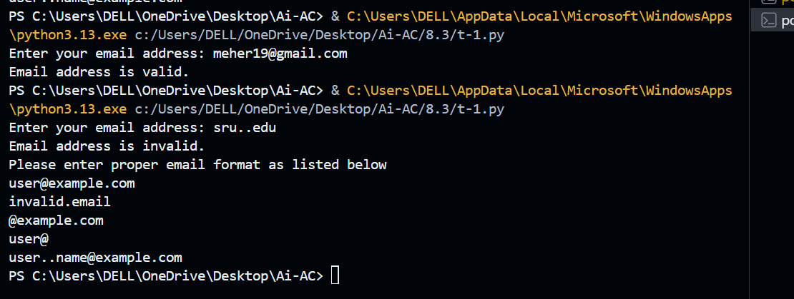
Task-02:
Prompt:
#Write a Python program to implement a function that assigns letter grades based on the given score.
#The program should include test cases for valid scores (90, 80, 70, 60) and invalid inputs (-5, 105, "eighty").
#90–100 → A,80–89 → B,70–79 → C,60–69 → D,Below 60 → F and take score as user input
Code:
# Function to assign grades based on score
def assign_grade(score):
if score < 0 or score > 100:
return "Invalid input: Score must be between 0 and 100."
if score >= 90:
return "A"
elif score >= 80:
return "B"
elif score >= 70:
return "C"
elif score >= 60:
return "D"
else:
return "F"
# Take score as user input and validate it
user_input = input("Enter the score: ")
try:
score = float(user_input) # Convert input to a number
result = assign_grade(score)
except ValueError:
result = "Invalid input: Score must be a number."
print(f"Score: {user_input} → Grade: {result}")
# Test cases
test_scores = [90, 80, 70, 60, -5, 105, "eighty"]
for test_score in test_scores:
try:
score = float(test_score) # Convert test score to a number
result = assign_grade(score)
except ValueError:
result = "Invalid input: Score must be a number."
print(f"Score: {test_score} → Grade: {result}")
Output:
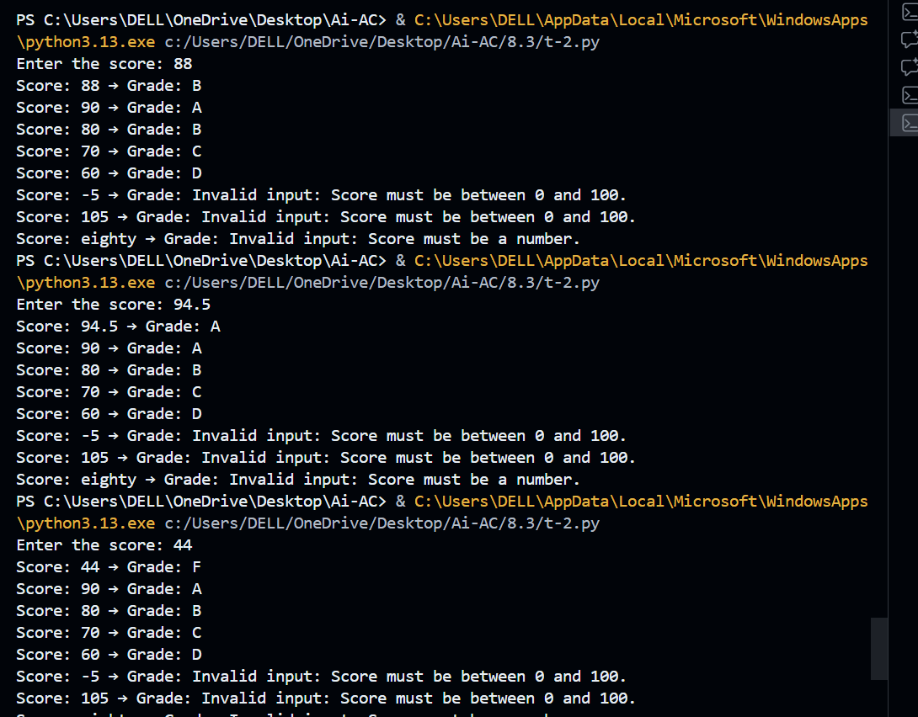
Task-03:
Prompt:
#Write a Python program that checks if a given sentence is a palindrome. The program should ignore case, spaces, and punctuation. Include test cases for both palindromic and non-palindromic sentences
Code:
import string
def is_palindrome(sentence):
# Remove spaces, punctuation, and convert to lowercase
cleaned_sentence = ''.join(char for char in sentence if char.isalnum()).lower()
# Check if the cleaned sentence is equal to its reverse
return cleaned_sentence == cleaned_sentence[::-1]
# Take user input
user_input = input("Enter a sentence: ")
# Check if the input sentence is a palindrome and print the result
if is_palindrome(user_input):
print("The sentence is a palindrome.")
else:
print("The sentence is not a palindrome.")
# Test cases
test_sentences = ["Madam, in Eden, I'm Adam", "Hello, World!", "A man, a plan, a canal, Panama", "Not a palindrome", "Was it a car or a cat I saw?"]
for test_sentence in test_sentences:
result = is_palindrome(test_sentence)
print(f"'{test_sentence}' → Palindrome: {result}")
Output:
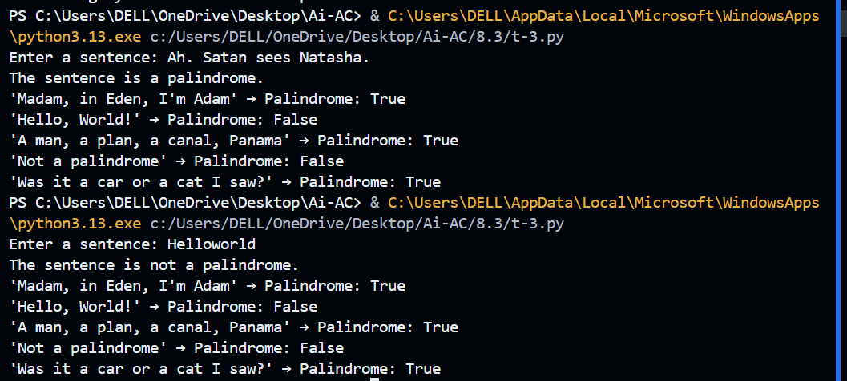
Task-04:
Prompt:
#Create a simple ShoppingCart class in Python with methods:add_item(name, price),remove_item(name),total_cost()
#items should be added and removed correctly, total cost is calculated accurately, and empty cart cases are handled. Also include basic test cases to verify functionality.
Code:
class ShoppingCart:
def __init__(self):
self.items = {}
def add_item(self, name, price):
if name in self.items:
self.items[name] += price
else:
self.items[name] = price
def remove_item(self, name):
if name in self.items:
del self.items[name]
else:
print(f"Item '{name}' not found in the cart.")
def total_cost(self):
return sum(self.items.values())
# Test cases
cart = ShoppingCart()
cart.add_item("Apple", 1.00)
cart.add_item("Banana", 0.50)
print("Total cost after adding items:", cart.total_cost()) # Expected: 1.50
cart.remove_item("Apple")
print("Total cost after removing Apple:", cart.total_cost()) # Expected: 0.50
cart.remove_item("Orange") # Expected: Item 'Orange' not found in the cart.
cart.add_item("Grapes", 2.00)
print("Total cost after adding Grapes:", cart.total_cost()) # Expected: 2.50
cart.remove_item("Banana")
print("Total cost after removing Banana:", cart.total_cost()) # Expected: 2.00
cart.remove_item("Grapes")
print("Total cost after removing Grapes:", cart.total_cost()) # Expected: 0.00
Output:
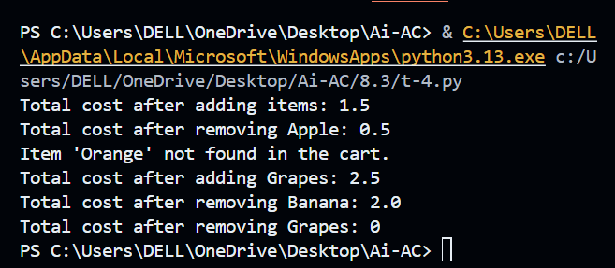
Task-05:
Prompt:
#Write a Python function that converts a date from "YYYY-MM-DD" to "DD-MM-YYYY".
#Include test cases and ensure all valid inputs are converted correctly. take user input
Code:
def convert_date(date_str):
try:
year, month, day = date_str.split('-')
year = int(year)
month = int(month)
day = int(day)
if month < 1 or month > 12:
return "Invalid month. Please enter a month between 1 and 12."
if day < 1 or day > 31:
return "Invalid day. Please enter a day between 1 and 31."

return f"{day:02d}-{month:02d}-{year}"
except ValueError:
return "Invalid date format. Please use 'YYYY-MM-DD'."
# Test cases
#print(convert_date("2024-06-15")) # Expected: "15-06
#print(convert_date("1990-01-01")) # Expected: "01-01-199
#print(convert_date("2024/06/15")) # Expected: "Invalid date format. Please use 'YYYY-MM-DD'."
#print(convert_date("2024-13-15")) # Expected: "Invalid month. Please enter a month between 1 and 12."
#print(convert_date("2024-06-32")) # Expected: "Invalid day.Please enter a day between 1 and 31."
user_date = input("Enter a date in 'YYYY-MM-DD' format: ")
print("Converted date:", convert_date(user_date))
Output:
