INTERNSHIP REPORT
ON
MEHER.DEV — WEB DEVELOPER INTERN PORTFOLIO
Submitted to
School of Computer Science and Engineering
IILM University, Greater Noida, U.P.
In partial fulfillment of the requirement of degree of
B.Tech CSE

BY
NAME OF STUDENT: MEHER PRATEEK
ROLL NUMBER: 25SCS1003002642
BATCH: 2025-29
Internship Role: Web Developer Intern
Organization: Codec Technologies Pvt. Ltd.
Internship Duration: 13/06/2026 to 16/07/2026

CANDIDATE'S DECLARATION
I, MEHER PRATEEK, do hereby declare that the internship report titled "Meher.dev — Web Developer Intern Portfolio" has been completed by me to fulfil the requirement for the award of the degree of Bachelor of Technology in CSE. The report presents the work and learning undertaken during my internship as a Web Developer Intern at Codec Technologies Pvt. Ltd. I have quoted references wherever required and have not knowingly taken material from any other source without acknowledgement. I affirm that this report is my own work and has not been submitted to any other institute for any degree or diploma requirement. I shall be solely responsible for any copyright violation in this regard.
Signature

MEHER PRATEEK
Roll No.: 25SCS1003002642

ACKNOWLEDGEMENT
I am using this opportunity to express my gratitude to everyone who supported me throughout the Internship Program. I am thankful for their guidance, constructive feedback and encouragement during the completion of the internship and the associated project work.
I sincerely thank Codec Technologies Pvt. Ltd. for providing me the opportunity to undertake a Web Developer Internship and for allowing me to gain practical exposure to web development concepts and project implementation. The internship helped me understand how a personal website moves from planning and visual design to implementation, testing and deployment.
I am also grateful to the faculty and the School of Computer Science and Engineering, IILM University, Greater Noida, for their academic support and guidance. I express my gratitude to my parents for their blessings and continuous encouragement.
Signature

MEHER PRATEEK
Roll No.: 25SCS1003002642

INTERNSHIP COMPLETION CERTIFICATE
Copy of the certificate issued by the organization
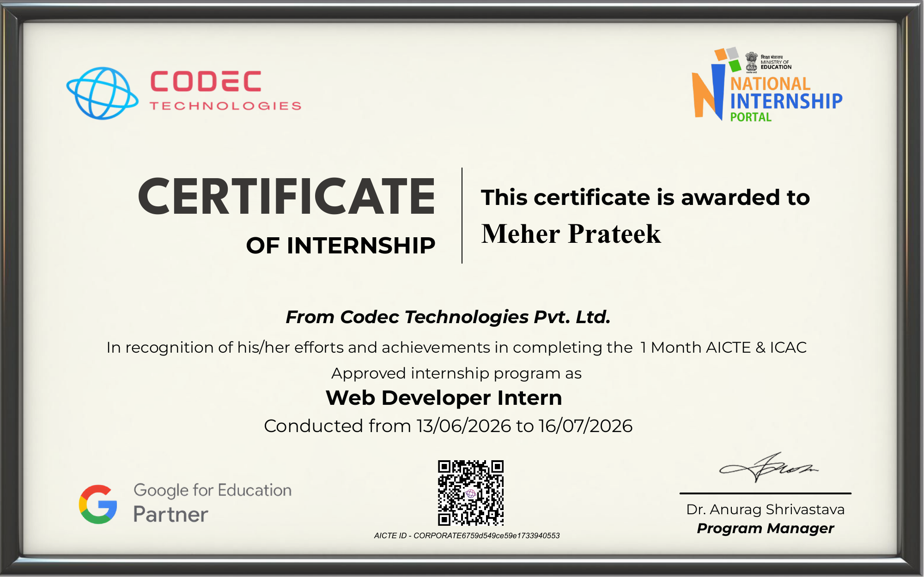

TABLE OF CONTENTS
Chapter No. | Chapter Name | Page No.
1. | Candidate's Declaration | i
2. | Acknowledgement | ii
3. | Internship Completion Certificate | —
4. | Project Description | 2
4.1 | Introduction | 2
4.2 | Organization Profile | 3
4.3 | Problem Statement | 3
4.4 | Project Objectives | 5
4.5 | Scope of the Project | 5
4.6 | Technologies and Tools Used | 7
4.7 | System Architecture | 8
4.8 | Methodology | 10
4.9 | Expected Outcomes | 12
4.10 | Certificates of Completion and Other Communication Proof | 13
5. | Bibliography / References | 15

4. PROJECT DESCRIPTION

4.1 Introduction
Meher.dev is a browser-based personal portfolio website developed as the project component of the internship. The site brings together an intern's profile, skills, internship projects and reflections into a single place, styled with a distinctive code-editor / GitHub-dark visual identity. The project was implemented as a lightweight client-side web application using HTML, CSS and vanilla JavaScript, without a separate backend or build system.
The primary design objective was to create an interface that reflects the everyday world of a web developer while remaining simple to navigate. The homepage introduces the intern and links to dedicated sections for About, Skills, Projects, Learnings and Contact. Navigation is styled to resemble open editor tabs (home.tsx, about.md, skills.json, and so on), and internship projects are presented as repository-style cards.
The project also emphasizes responsive interface design and accessibility-conscious interaction. Semantic HTML, visible focus states, keyboard-friendly controls and reduced-motion support are included in the implementation. Scroll-triggered reveal animations, an active navigation-tab indicator and a mobile hamburger menu are used to make the site feel polished across devices.
Project Snapshot
Item | Details
Project Title | Meher.dev — Web Developer Intern Portfolio
Project Type | Client-side web application
Role | Web Developer Intern
Primary Technologies | HTML5, CSS3, JavaScript
Visual Identity | Code-editor / GitHub-dark theme
Deployment | GitHub Pages

4.2 Organization Profile
According to the internship offer letter, Codec Technologies is described as a global platform dedicated to empowering learners and connecting diverse talent to create meaningful career opportunities worldwide. The offer letter states that the organization delivers dedicated IT and business consultancy services across 27+ countries, with a focus on global innovation and strategic growth. The internship was offered in a hybrid, Pan-India mode and the candidate was assigned the designation of Web Developer Intern.
The offer letter specifies the internship duration as 13/06/2026 to 16/07/2026 and states that interns were expected to complete assigned projects and training tasks through the organization's platform and email. The internship therefore provided a context for applying web-development concepts in a structured project environment.

4.3 Problem Statement
Many student portfolios rely on generic templates that do not reflect the person who built them, and often fail to clearly communicate what was actually learned and produced during an internship. The problem addressed by this project is to design a single, simple personal website where an intern's profile, skills, projects and takeaways can be presented clearly, without requiring a complex setup or external backend.
The website should provide an understandable homepage, present skills grouped by category, showcase internship projects with real details, record key learnings in a structured way, and offer a way for visitors to make contact. The solution should remain responsive and usable across common desktop and mobile screen sizes.
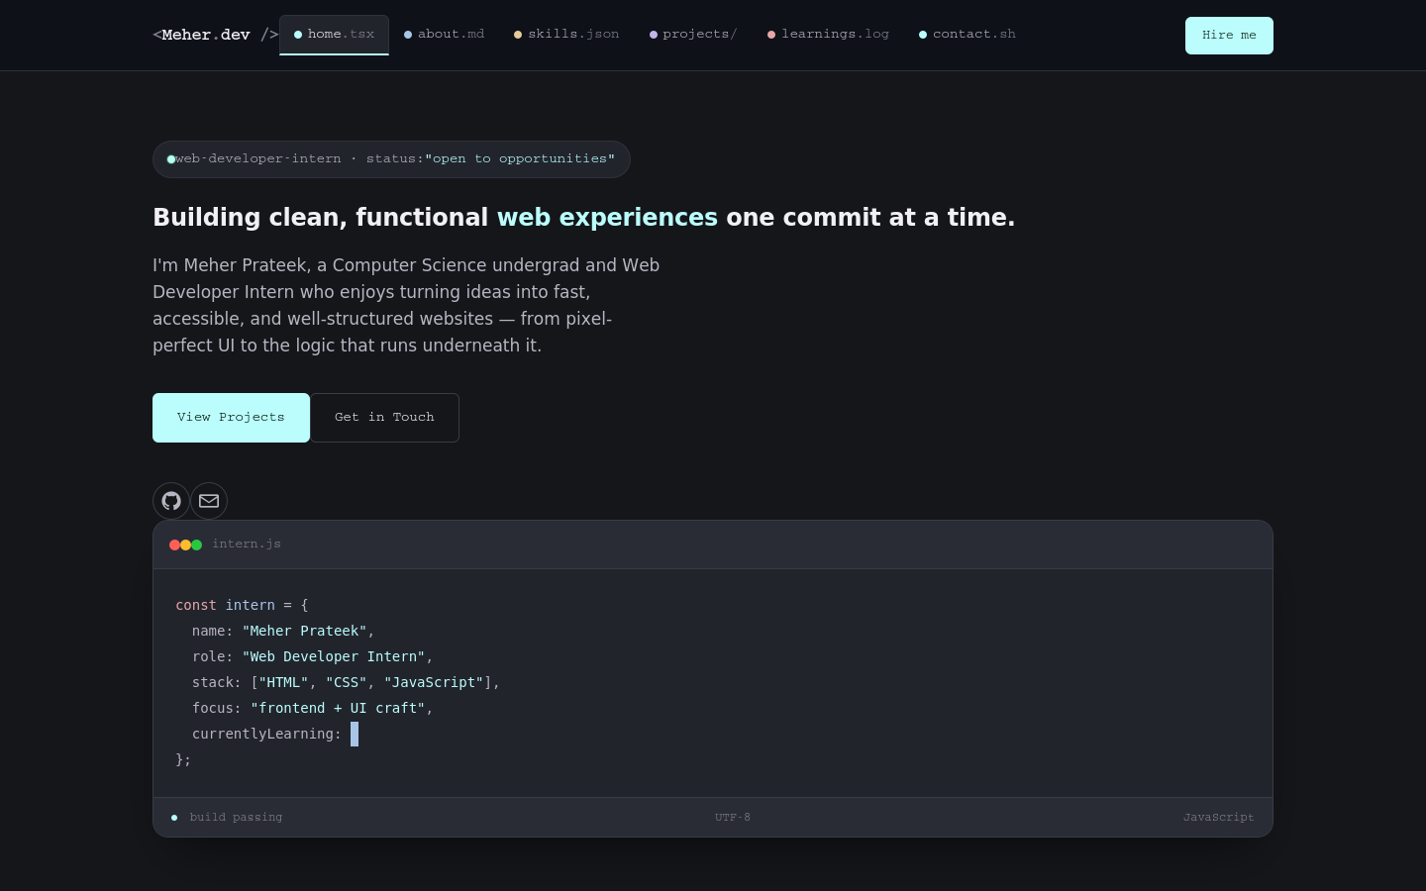
Figure 4.2 Meher.dev homepage hero

4.4 Project Objectives
- Design a distinctive, code-editor-inspired visual identity instead of a generic portfolio template.
- Present skills, internship projects and learnings in dedicated, well-structured sections.
- Build fully responsive layouts with a working mobile navigation menu.
- Implement smooth scrolling, scroll-triggered reveal animations and an active navigation-tab indicator.
- Provide a front-end-validated contact form along with direct contact links.
- Apply basic accessibility practices such as semantic markup, visible focus states and reduced-motion support.
- Deploy the completed static website using GitHub Pages and maintain its source code in a GitHub repository.

4.5 Scope of the Project
The current scope covers a front-end personal portfolio that runs entirely in the browser. It includes a hero/home section, an about section, a categorized skills section, an internship-projects section, a “What I Learned” section presented as a commit log, a contact section and a footer. The site does not persist any data beyond the current page view.
The project does not include backend email delivery, a content-management system, user accounts, or database-backed project data. These areas can be considered future extensions if the site is developed further. Keeping the current implementation client-side makes the project lightweight and suitable for static deployment.
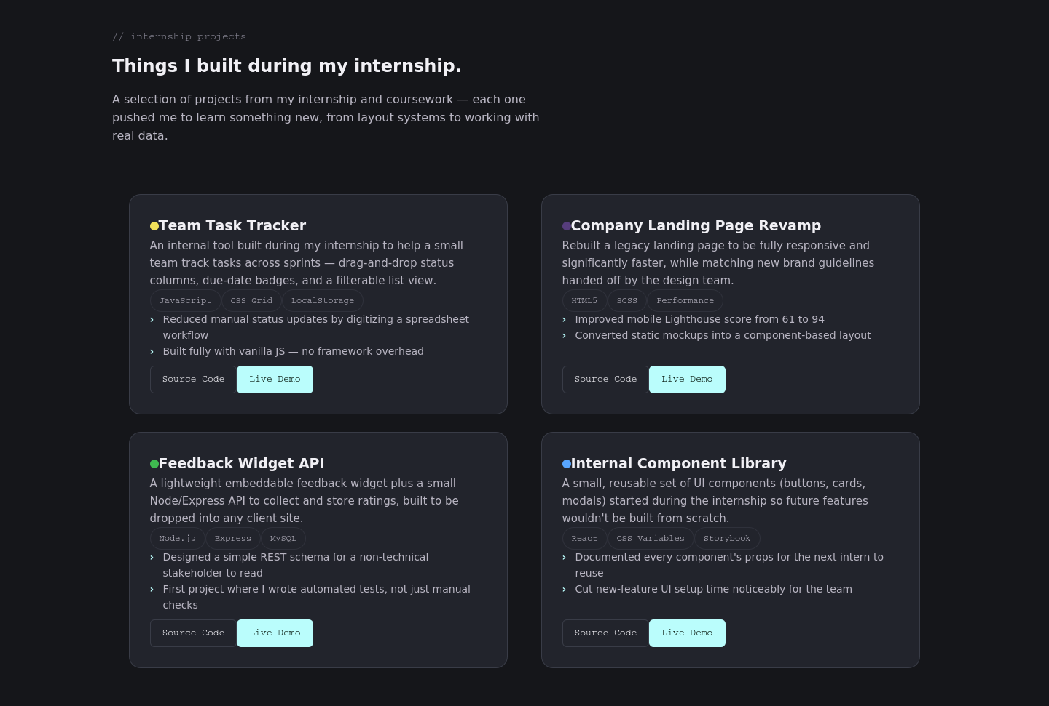
Figure 4.3 Meher.dev internship-projects section

4.6 Technologies and Tools Used
Technology / Tool | Purpose | Application in Project
HTML5 | Structure and semantics | Defines the site shell, navigation tabs, sections and content.
CSS3 | Presentation and responsive design | Controls the GitHub-dark design system, layout, cards, buttons and responsive behavior.
JavaScript (Vanilla) | Application logic | Handles scroll reveal, the typing effect, mobile menu, active-tab highlighting and form validation.
Visual Studio Code | Development environment | Used to create, edit, organize and test the project files.
Live Server | Local testing | Used to serve the static site locally during development.
Git & GitHub | Version control and hosting | Repository management and source-code hosting.
GitHub Pages | Deployment | Publishes the static website as a public site.
Google Fonts | Typography | Provides the Space Grotesk, Inter and JetBrains Mono type families used across the design.
The project deliberately avoids frameworks and a build step. This keeps the implementation easy to inspect and demonstrates understanding of core front-end technologies.
Repository and deployment
The project source is maintained in the internship GitHub repository. The site is deployed through GitHub Pages from the main branch and the root directory. This makes the final project accessible through a public browser URL while preserving the source files and documentation in the same repository.
GitHub Repository: https://github.com/MeherPrateek31/2025-29_Meher_Prateek_25SCS1003002642_3rd_Semester_2CSE14

4.7 System Architecture
Meher.dev follows a simple client-side architecture. The browser loads the HTML document, applies the CSS presentation layer and executes the JavaScript application logic. User interactions are handled through JavaScript event listeners. There is no application state persisted beyond the current page.
The architecture is intentionally lightweight. There is no application server or database in the current version. This reduces deployment complexity and allows the site to be hosted as a static page. The same architecture also makes the project suitable for demonstrating the fundamentals of front-end web development.
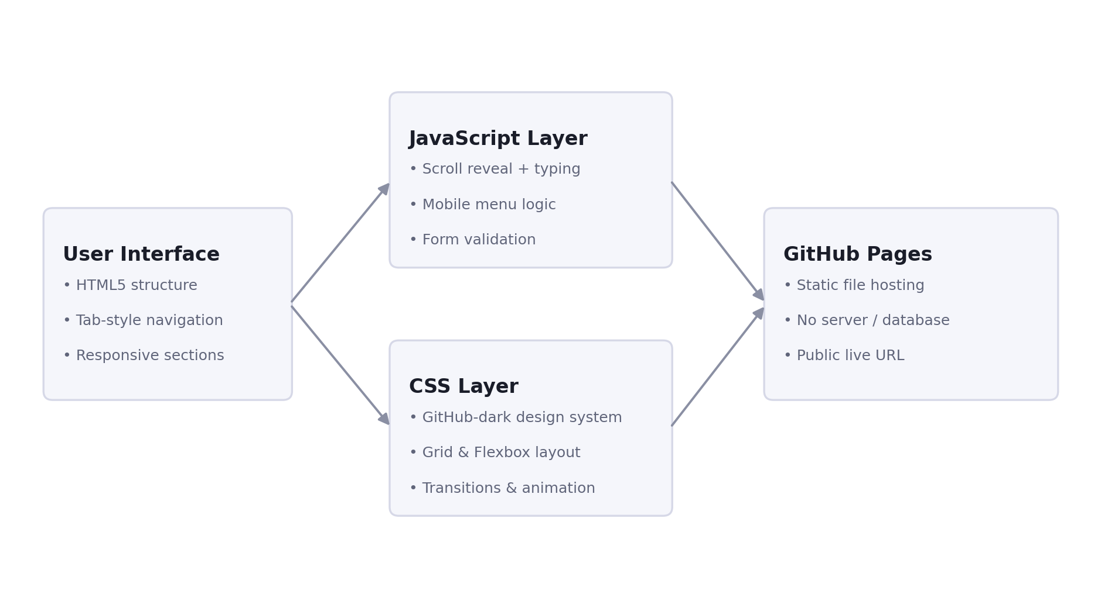
Figure 4.4 System Architecture of Meher.dev
Major modules
- Navigation Module — controls tab-style section links, the mobile hamburger menu and the active-tab indicator.
- Hero Module — introduces the intern with a typing-effect code-editor mockup.
- About Module — presents the intern's profile, background and quick facts.
- Skills Module — groups technical skills into categorized chip lists.
- Projects Module — displays internship projects as repository-style cards with tags and links.
- Learnings Module — presents internship takeaways as a commit-log-styled timeline.
- Contact Module — provides a front-end-validated contact form and direct contact links.

4.8 Methodology
Stage | Description
Requirement Identification | The project requirements were translated into a small set of content modules: hero, about, skills, projects, learnings and contact. The objective was to keep the site useful without adding unnecessary backend complexity.
Interface Planning | A code-editor-inspired layout was selected with tab-style navigation and repository-style cards. Sections were used to make important information visually scannable.
HTML Structure | The site was organized with semantic HTML elements for navigation, sections, forms and content. Accessibility attributes and labels were included where appropriate.
CSS Implementation | CSS custom properties were used for design tokens such as colors, spacing, borders and typography, matching a GitHub-dark visual identity. Media queries provide responsive behavior across breakpoints.
JavaScript Implementation | Vanilla JavaScript manages scroll-triggered reveal animations, a typing effect, mobile menu behavior, active-tab highlighting and contact-form validation. The code is organized into logical sections for each behavior.
Testing | The site was run locally using a browser-based development server. Each section was tested through normal user interactions, including navigating between tabs, opening the mobile menu and submitting the contact form.
Deployment | The completed files were uploaded to the GitHub internship repository and configured for GitHub Pages. The public deployment was then checked in the browser.
Figure 4.5 Development workflow
Requirements → UI Planning → HTML/CSS → JavaScript Logic → Testing → GitHub Deployment

4.9 Expected Outcomes
The expected outcome of the internship project is a functional, responsive and well-organized personal portfolio website that demonstrates practical front-end web-development skills. The completed implementation meets the core objective of presenting an intern's profile, skills, projects and learnings in a single, coherent site.
- A fully responsive, single-page portfolio site reflecting the internship experience.
- Working mobile navigation and smooth-scroll section links with an active-tab indicator.
- Categorized skills and internship-project sections with real project write-ups.
- A commit-log-styled “What I Learned” timeline documenting internship takeaways.
- A front-end-validated contact form along with direct contact links.
- Public deployment through GitHub Pages, making the project accessible for demonstration.
- Documented source code and README content maintained in the GitHub repository.
Learning outcomes
Through the implementation, practical understanding was developed in semantic HTML, responsive CSS layout using Grid and Flexbox, JavaScript event handling and DOM manipulation, IntersectionObserver-based scroll animation, basic accessibility considerations, local testing and static web deployment. The project also provided experience in organizing a personal narrative into a small set of reusable content modules and documenting the work for portfolio and academic purposes.
Limitations and future enhancement
Because the current version is intentionally client-side, the contact form does not deliver messages to an inbox and no project data is stored beyond the page itself. Future versions could add a backend or third-party service for form submissions, a small content-management system for updating project content without editing code, and analytics to understand visitor engagement. These enhancements are outside the present project scope.

4.10 Certificates of Completion and Other Communication Proof
The internship completion certificate issued by Codec Technologies Pvt. Ltd. is attached immediately after the Acknowledgement section as required by the report format. The certificate identifies MEHER PRATEEK as a Web Developer Intern and records the internship period from 13/06/2026 to 16/07/2026.

Figure 4.6 Internship Completion Certificate issued by Codec Technologies Pvt. Ltd.
The internship offer letter is also included as supporting communication proof. It states the designation as Web Developer Intern, the Pan-India hybrid mode, the internship duration and the assigned-project/training expectations.
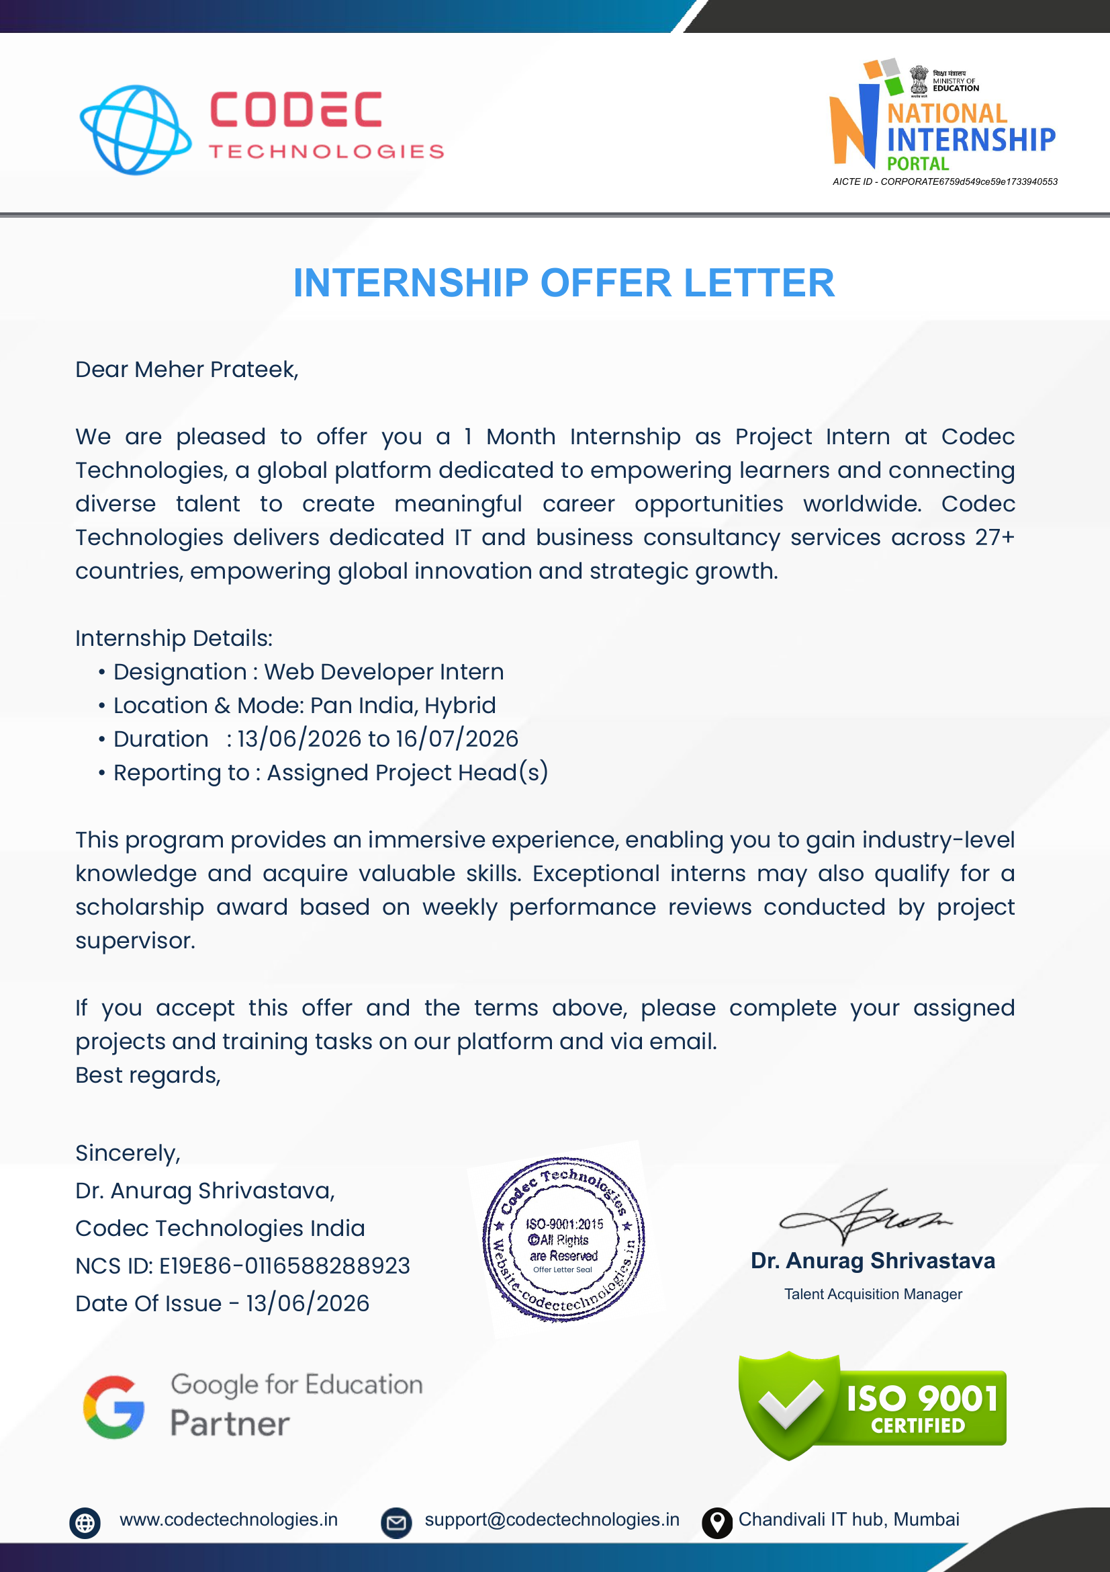
Figure 4.7 Internship Offer Letter from Codec Technologies

5. BIBLIOGRAPHY / REFERENCES
Codec Technologies Pvt. Ltd. (2026). Internship Offer Letter issued to Meher Prateek, dated 13/06/2026.
Codec Technologies Pvt. Ltd. (2026). Internship Completion Certificate for the Web Developer Intern program, covering 13/06/2026 to 16/07/2026.
Mozilla Developer Network (MDN). HTML, CSS and JavaScript documentation used as general technical references.
GitHub Documentation. GitHub Pages documentation for publishing static websites.
W3C Web Accessibility Initiative (WAI). General accessibility guidance for web content and user interface development.
Project Repository: https://github.com/MeherPrateek31/2025-29_Meher_Prateek_25SCS1003002642_3rd_Semester_2CSE14
Live Project: Meher.dev — GitHub Pages

