Resources for SEA region

Virtual network

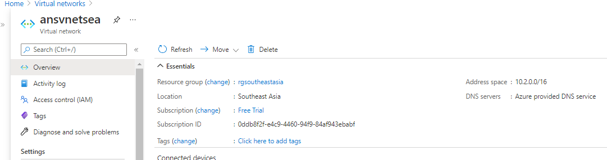

Subnets

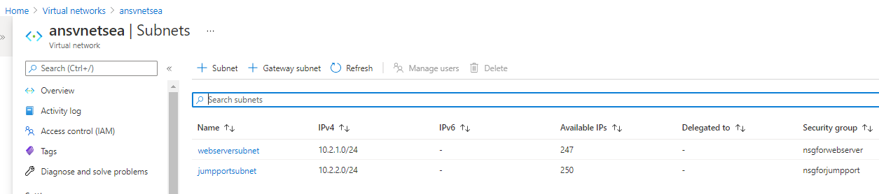

Load balancer and its configuration

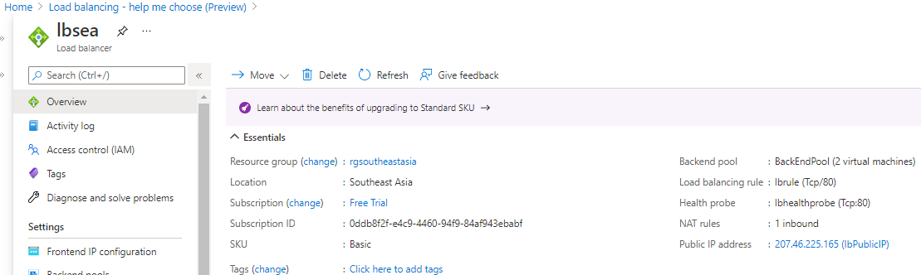

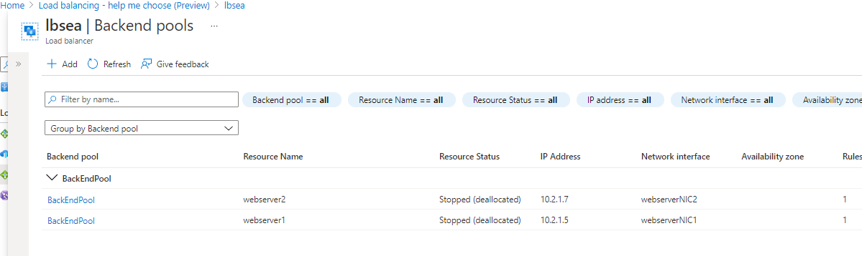

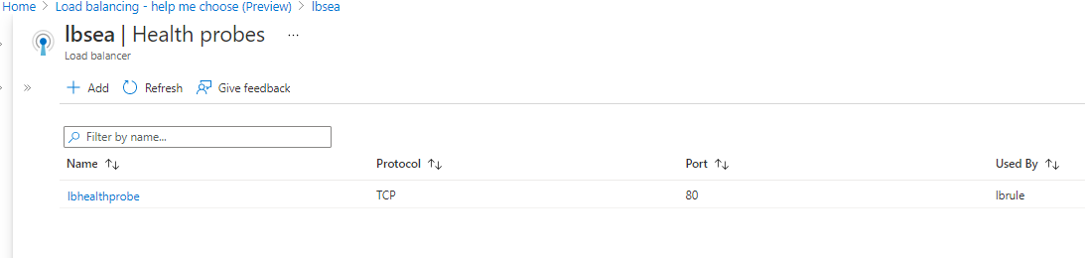

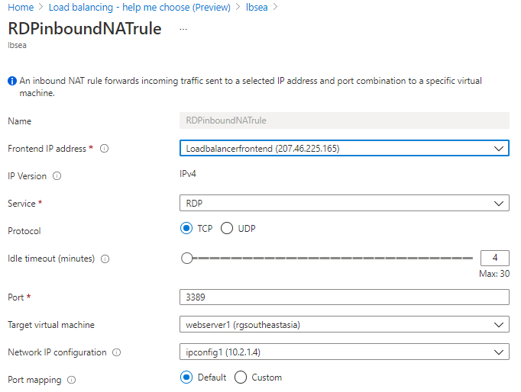

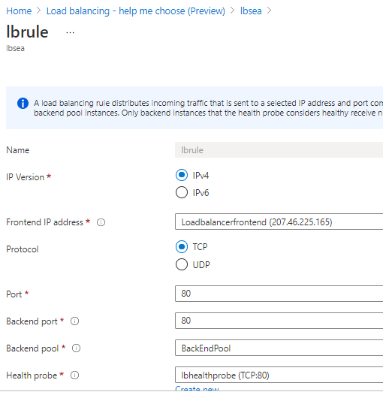

Availability set

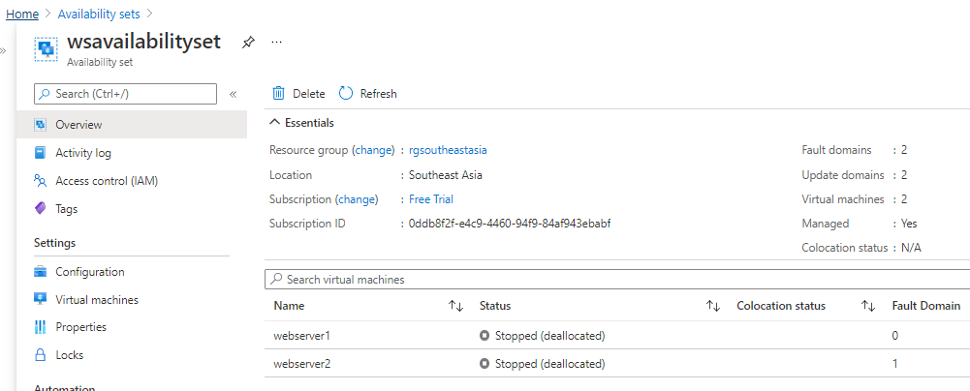

NIC for webservers and jumpport

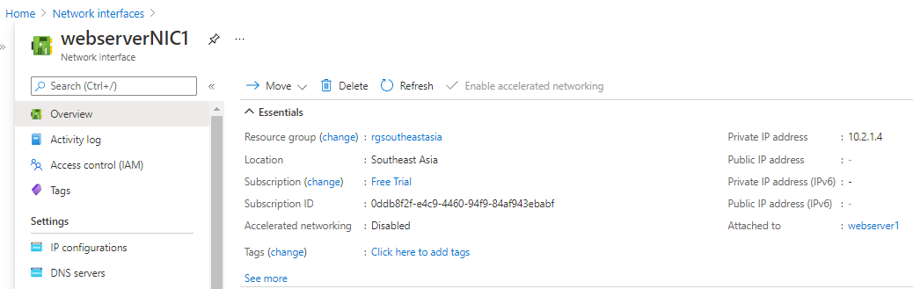

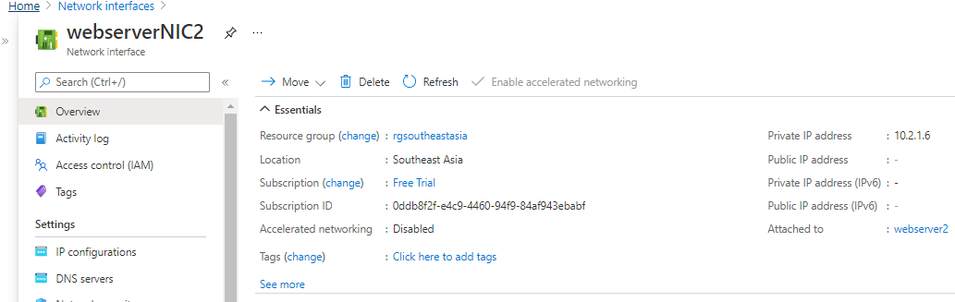

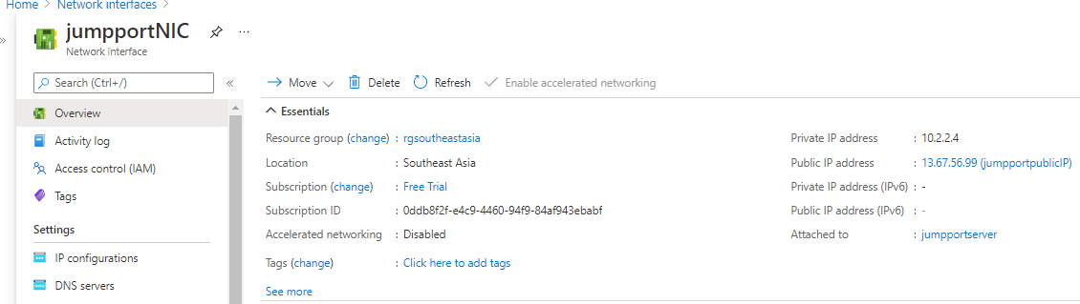

Webservers and jumpport

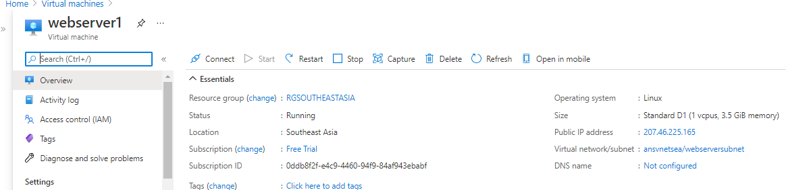

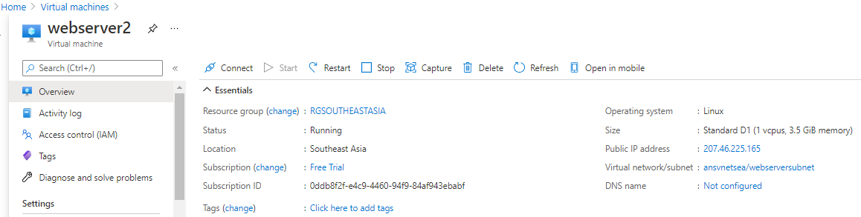

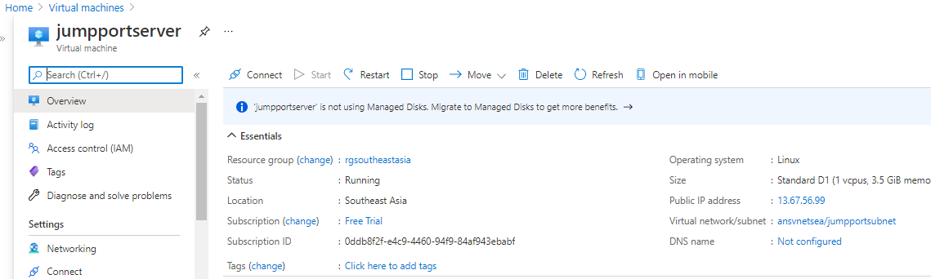

TOPOLOGY FOR SEA REGION

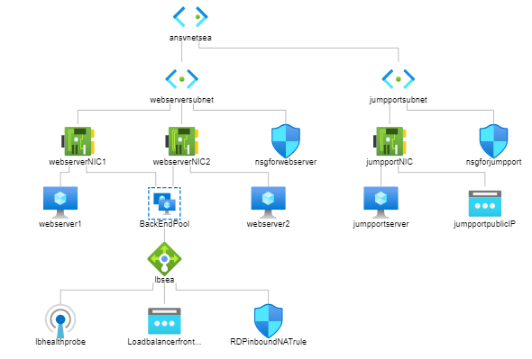

Resources for SEA region

Virtual network

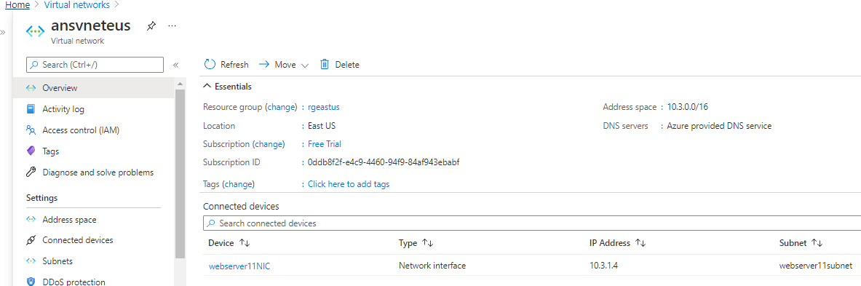

NIC for webserver11

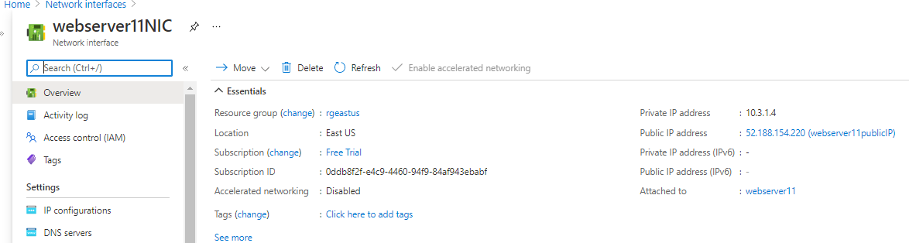

VM for webserver11

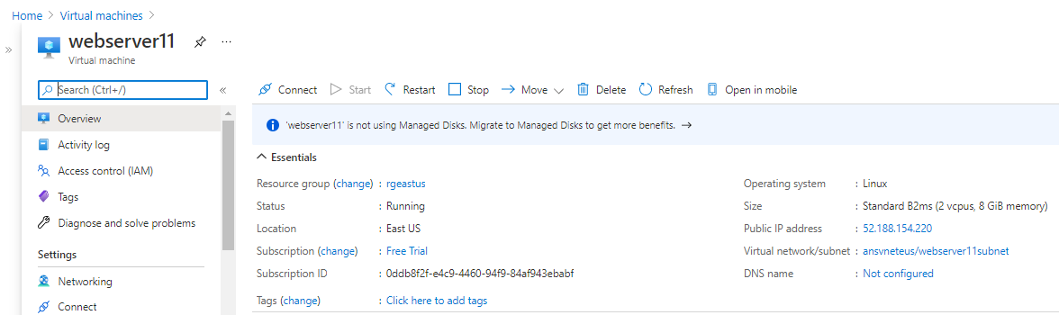

TOPOLOGY FOR EUS REGION

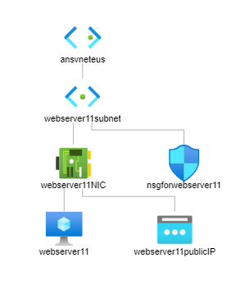

Storage account for SEA region

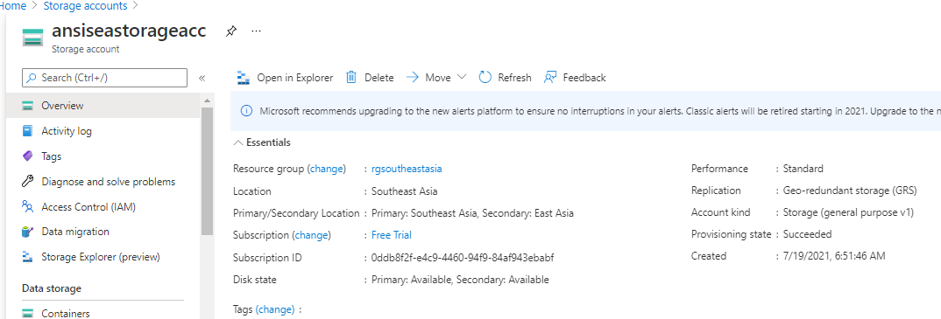

Storage account for EUS region

