A Load balancer showing the details of the back end pool, load balancing rule and NAT rule

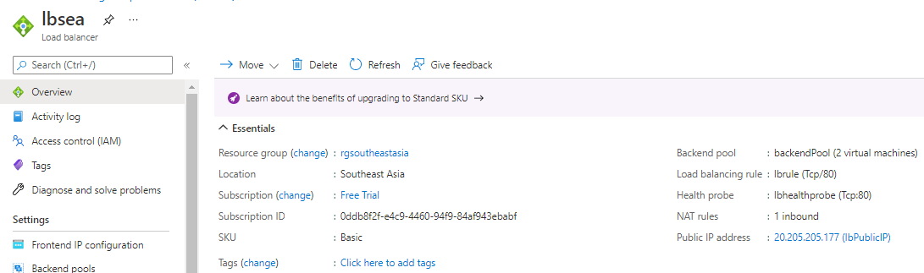

Webserver1, indicating the mapping of the load balancer IP

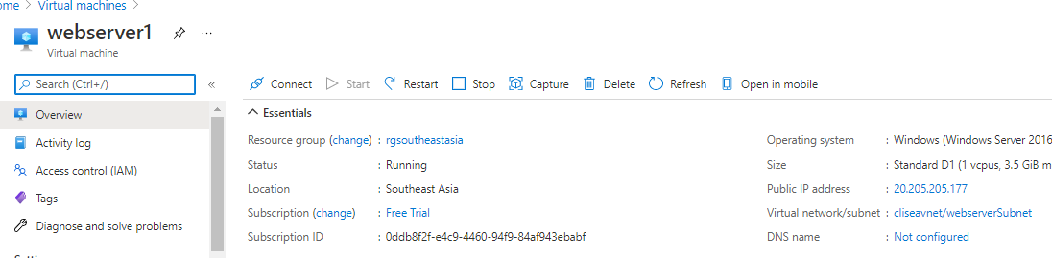

Webserver2, indicating the mapping of the load balancer IP

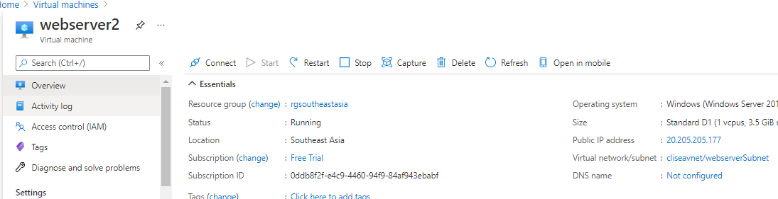

NSG rule applied for webservers

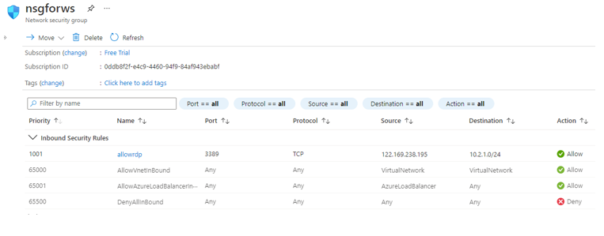

NSG rule applied for jump port server

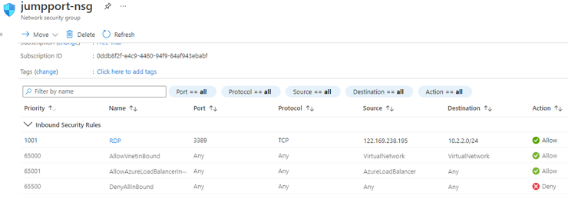

NSG rule applied for webserver11

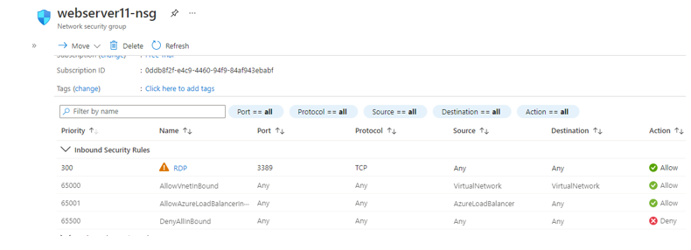

CLIUser1 having Virtual Machine Contributor role at subscription level

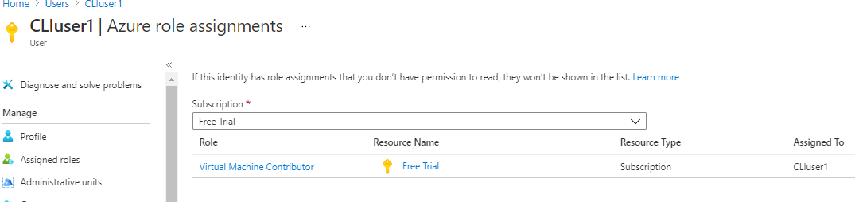

CLIUser2 having backup contributor role at resource group level

