Creating resources in SEA region

Creating a virtual network

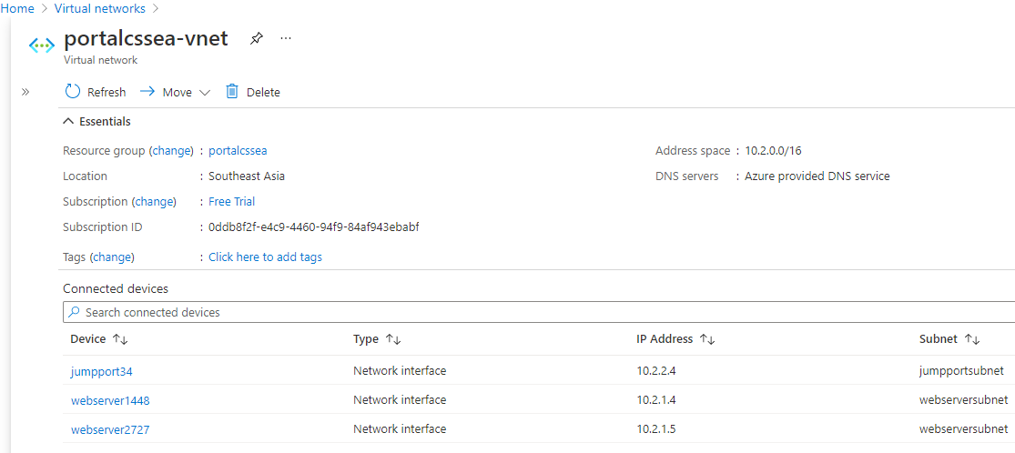

Creating subnets inside virtual network

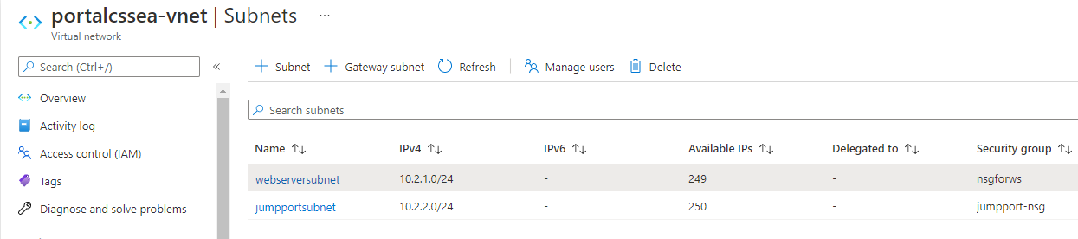

Creating an NSG for webservers

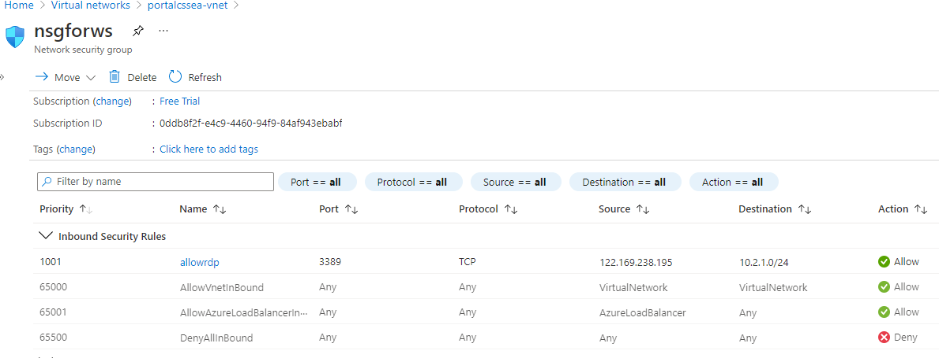

Creating an NSG for jump port

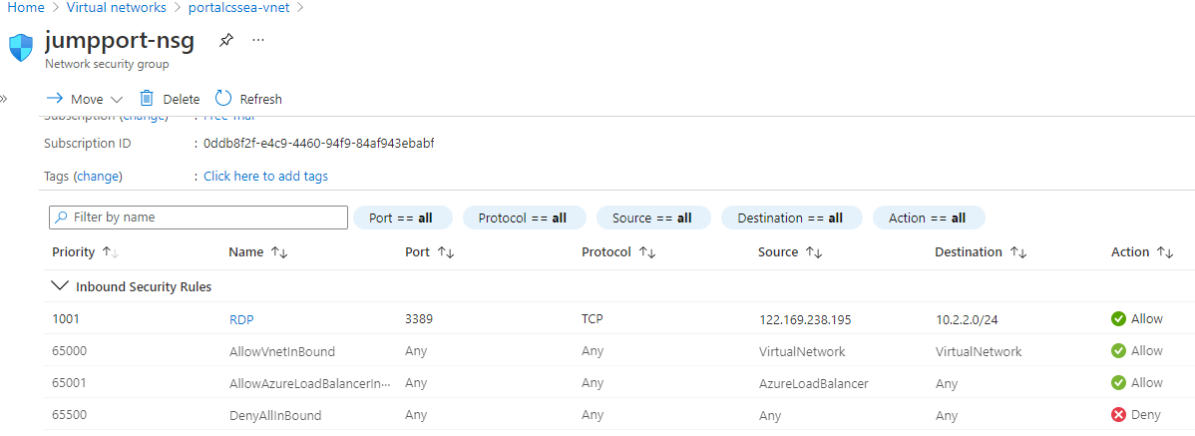

Creating an availability set which is used against web servers

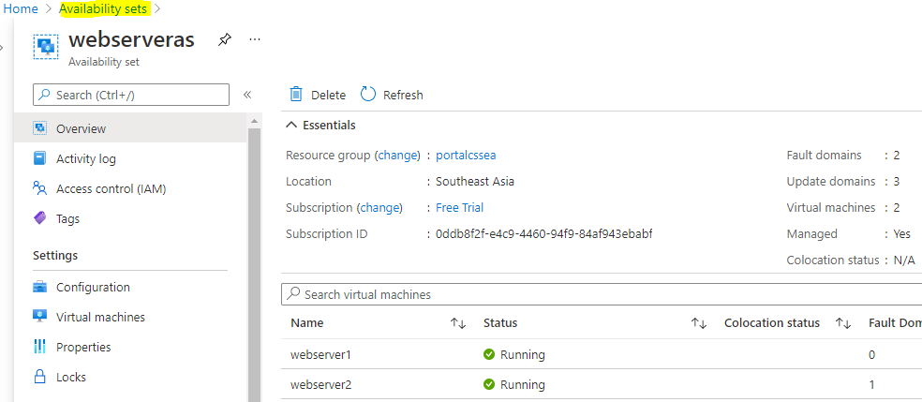

Creating webserver1

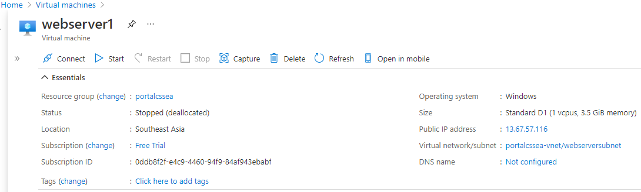

Creating webserver2

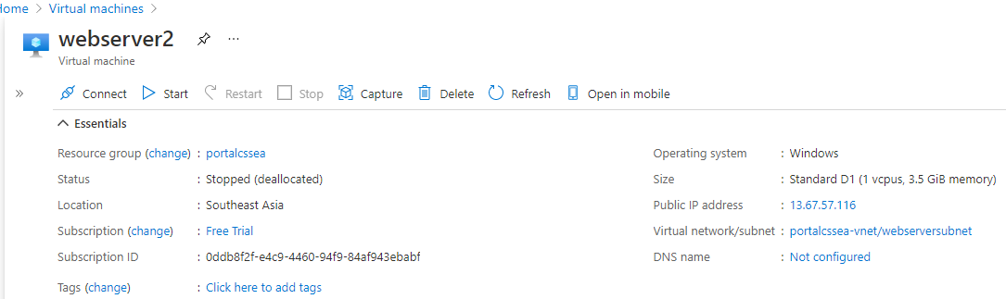

Creating backup for both the webservers

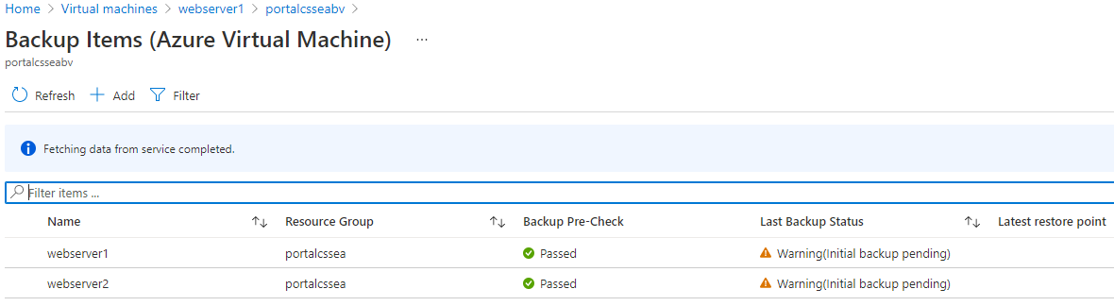

Creating alert rules for both the webservers

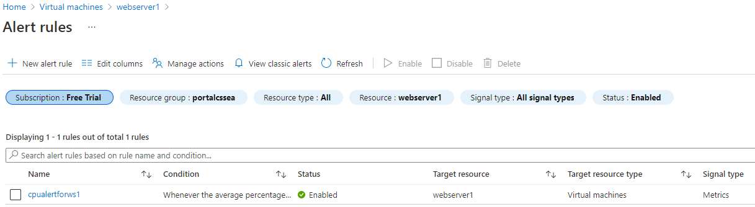

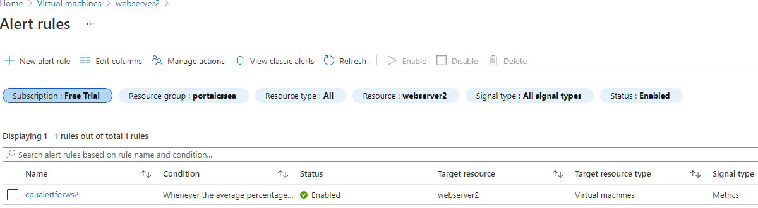

Configuring the load balancer

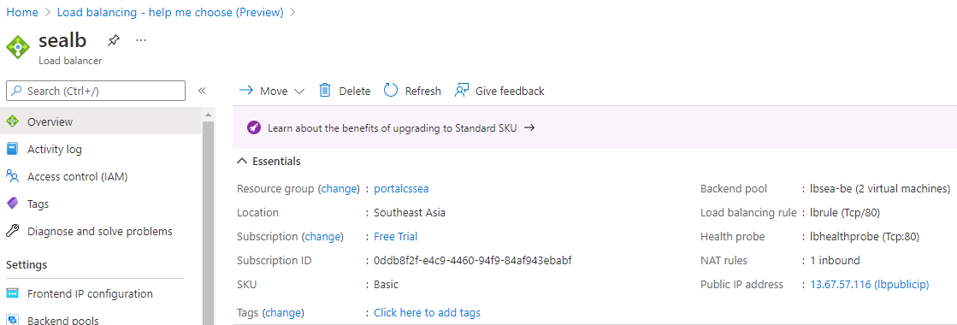

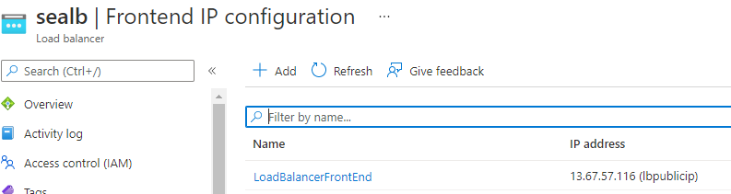

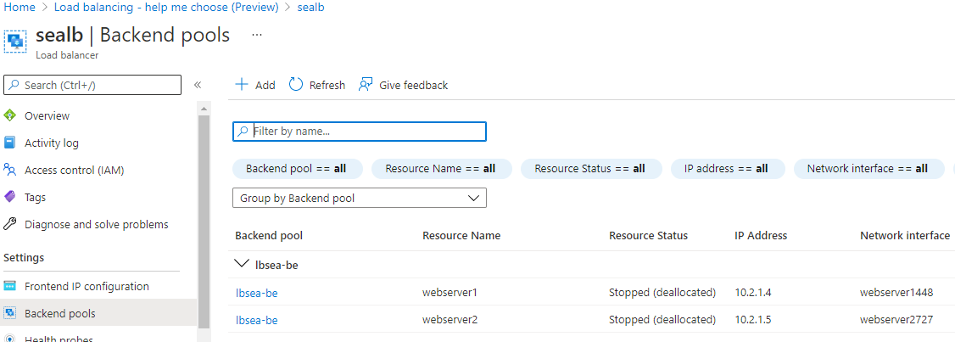

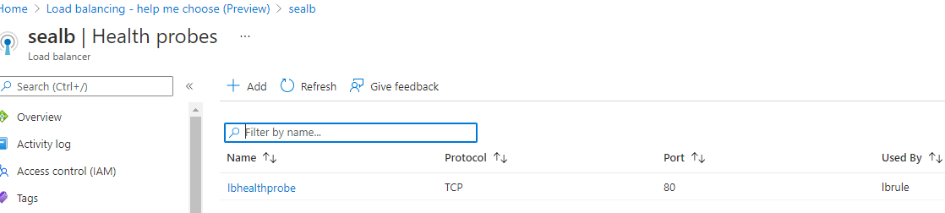

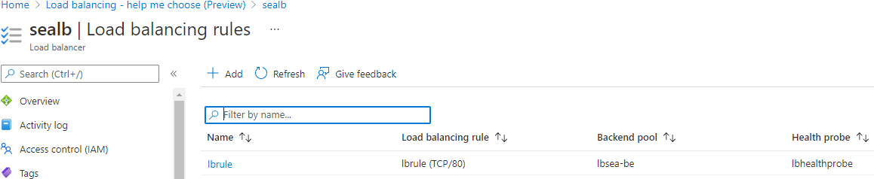

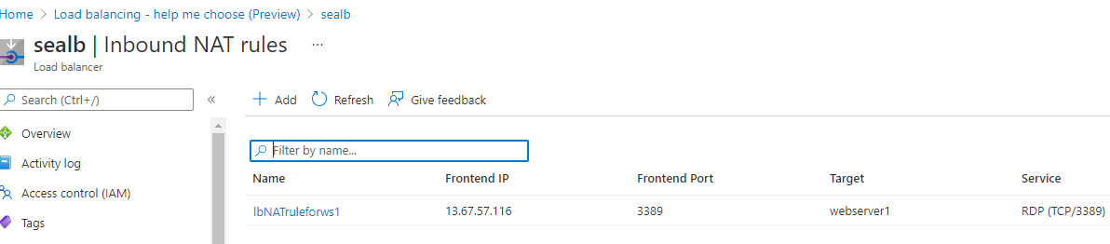

Creating jump port server

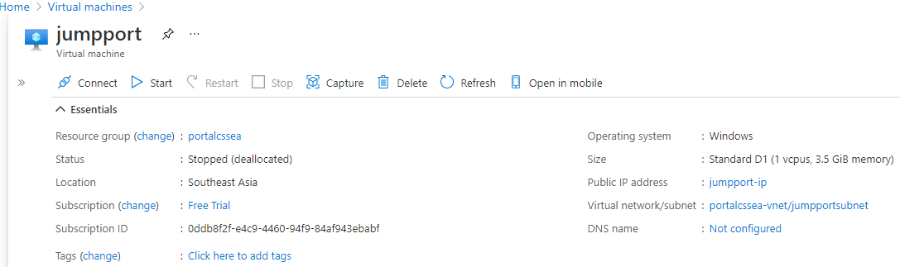

TOPOLOGY FOR SEA REGION

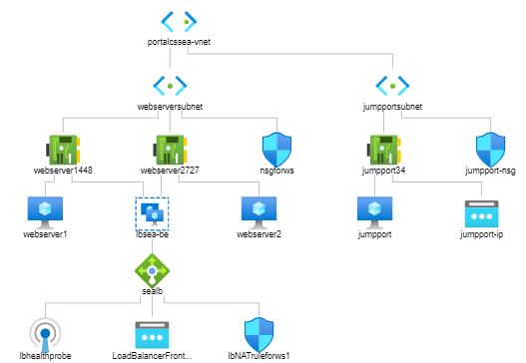

Creating resources in EUS region

Creating Virtual network and subnet

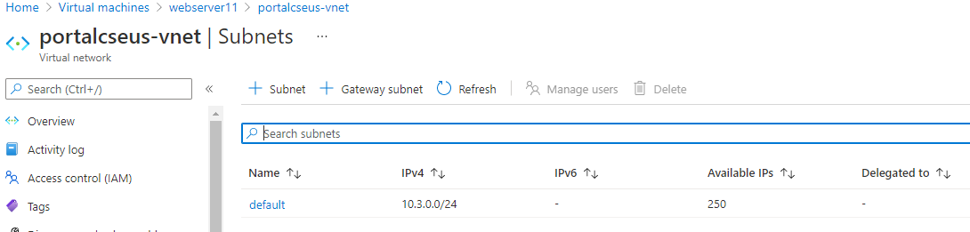

Creating an NSG rule for webserver11

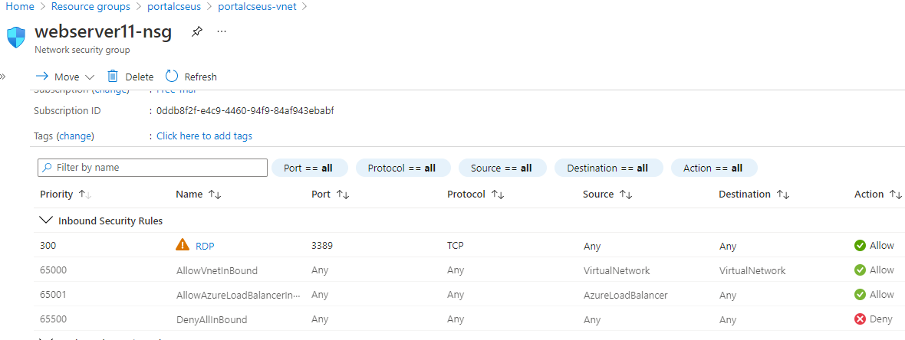

Creating webserver11

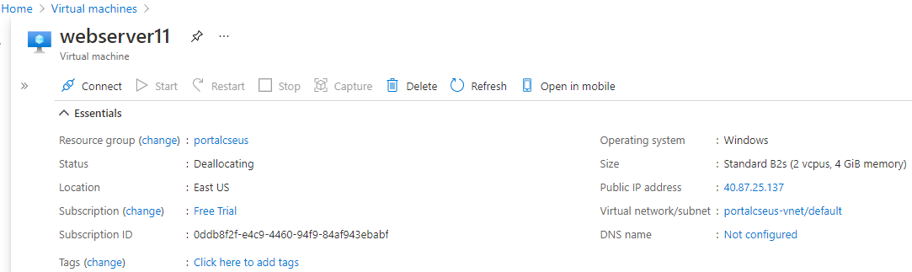

TOPOLOGY FOR EUS REGION

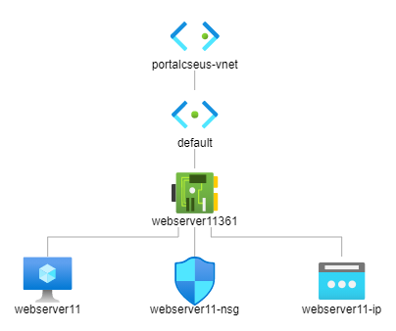

VNET PEERING

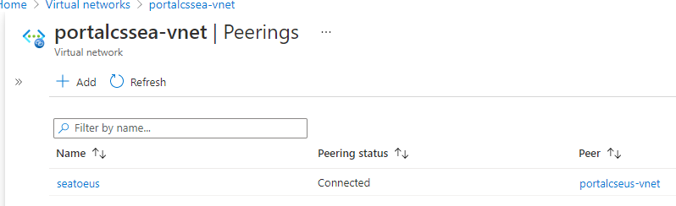

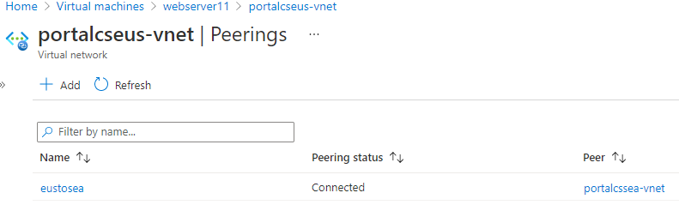

Creating storage account for SEA region with GRS replication

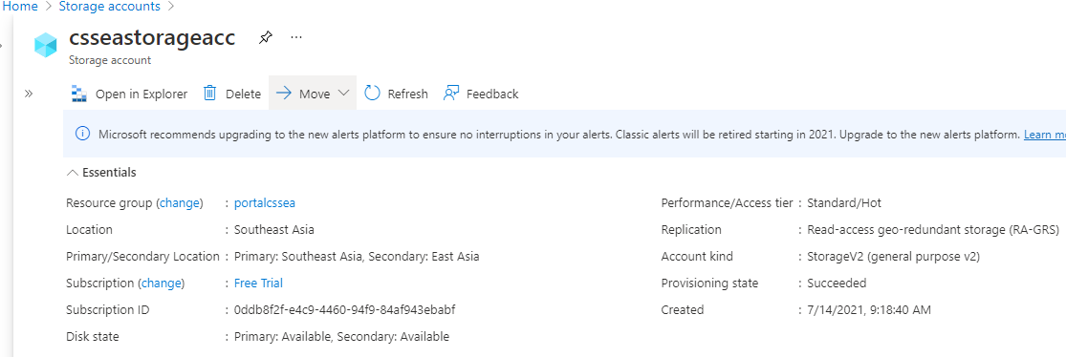

Creating storage account for EUS region with ZRS replication

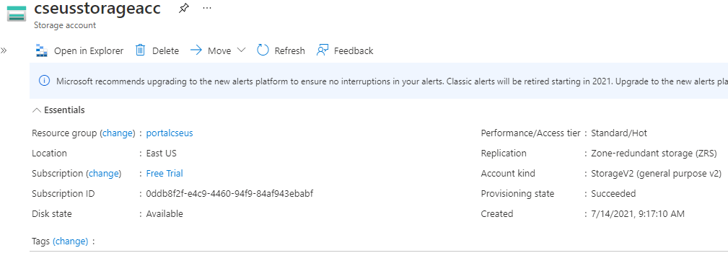

Storage access keys for EUS region

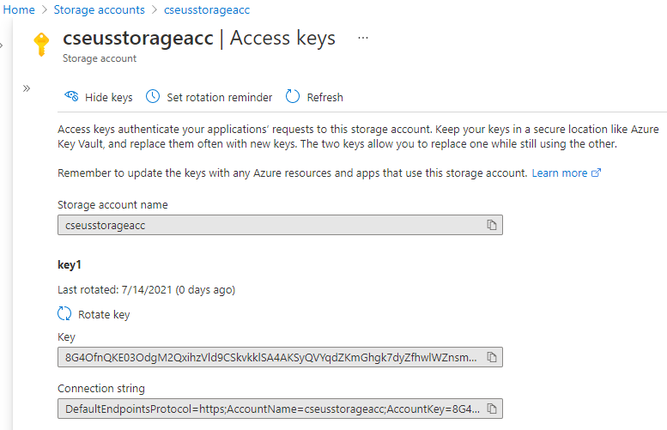

Storage explorer and uploading files from explorer

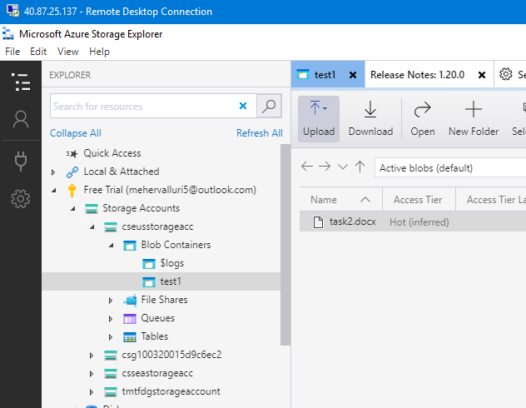

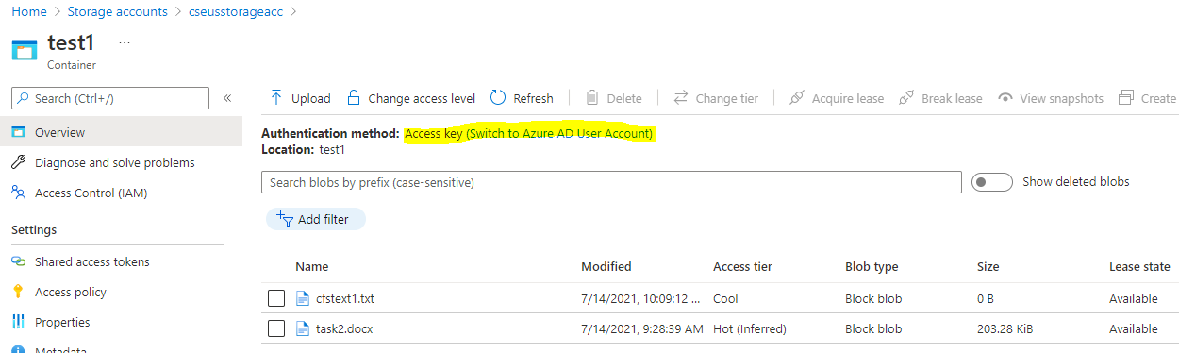

Creating users and giving role based access

