A Load balancer showing the details of the back end pool, load balancing rule and NAT rule

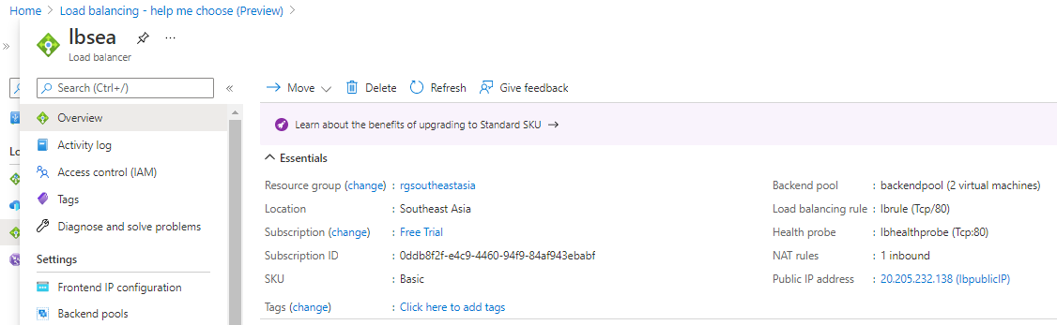

Webserver1, indicating the mapping of the load balancer IP

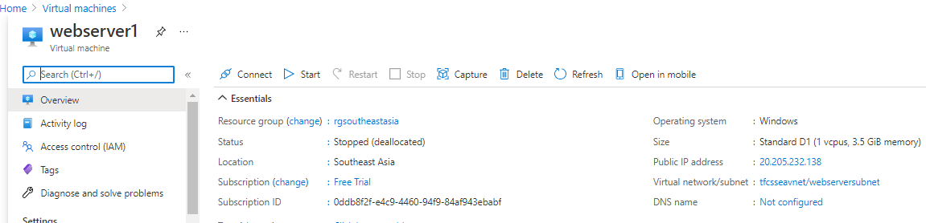

Webserver2, indicating the mapping of the load balancer IP

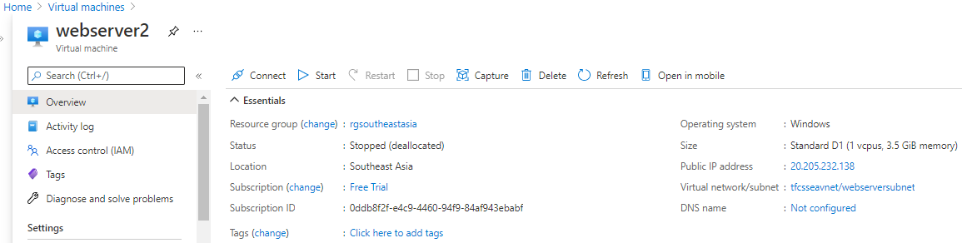

NSG rule applied for webservers

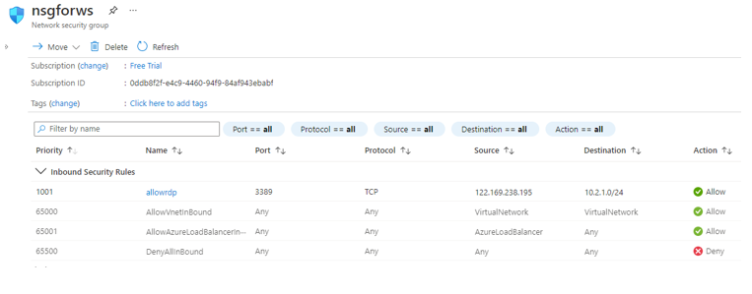

NSG rule applied for jump port server

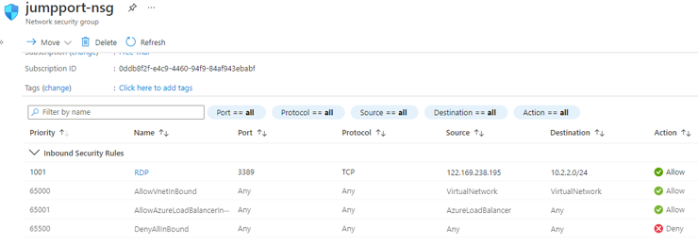

NSG rule applied for webserver11

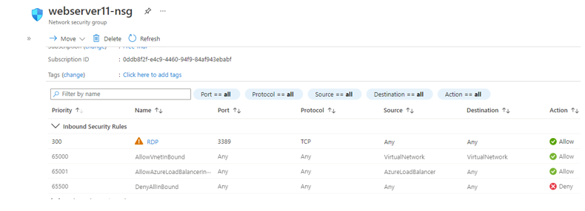

User 1 having Virtual Machine Contributor role at subscription level

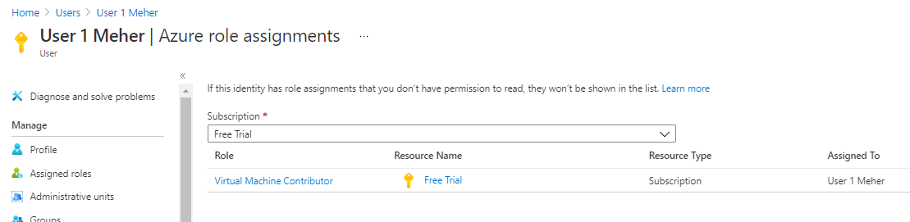

User 1 having backup contributor role at resource group level

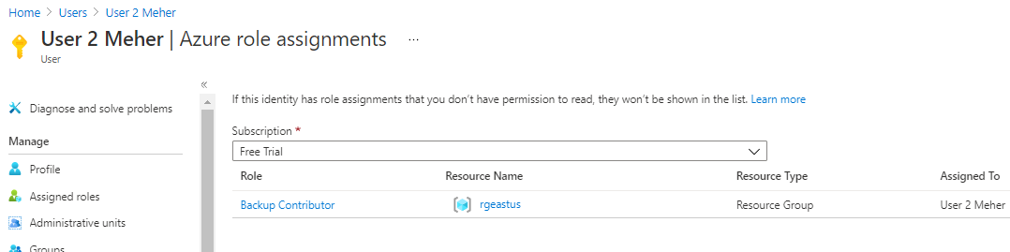

TOPOLOGY FOR SEA REGION

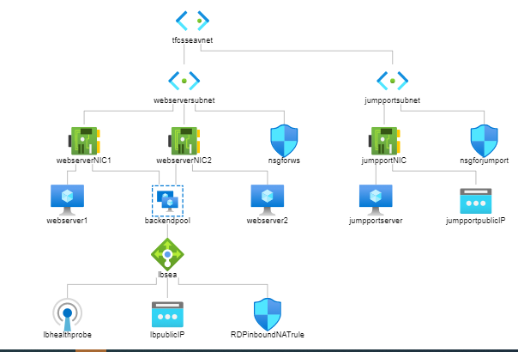

TOPOLOGY FOR EUS REGION

