Sharing page SETUP :

1. goto **developers.facebook.com** > **My Apps** **> Add a New App**

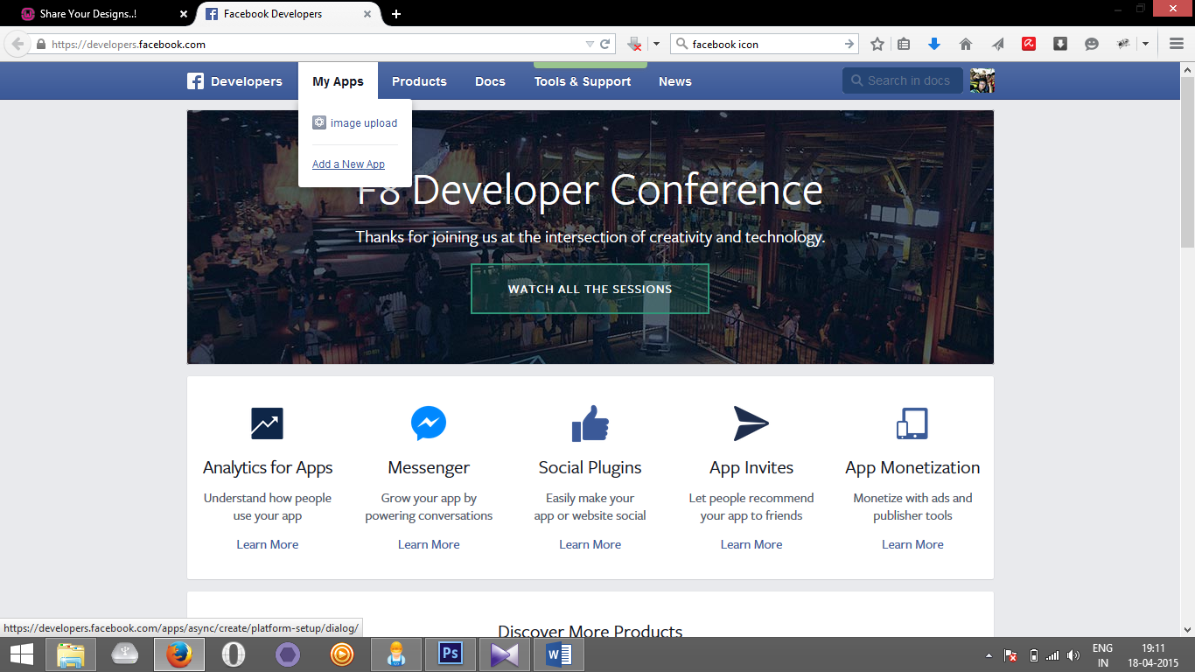

1. click on **Website**

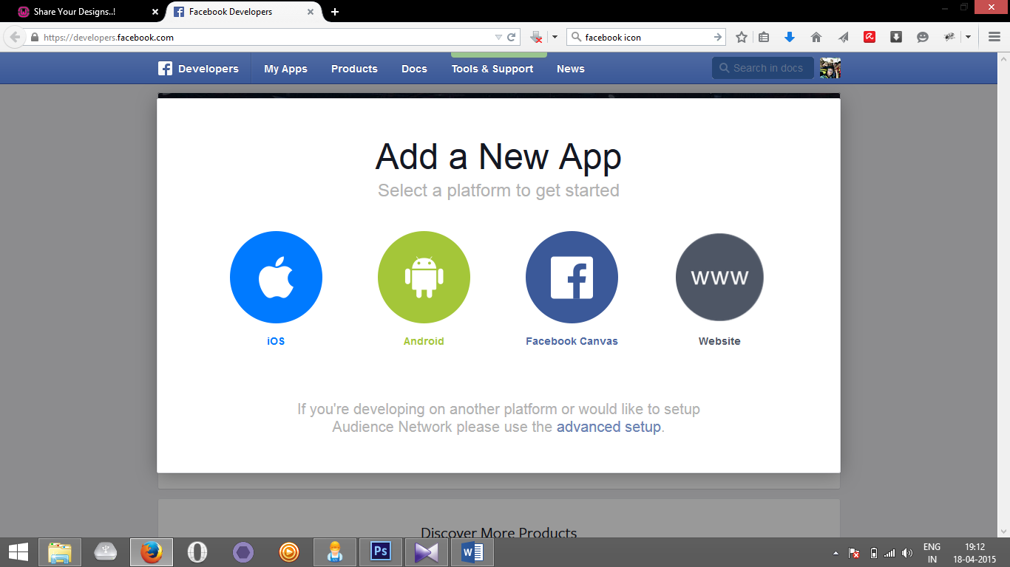

1. Enter the **APP name** in the given text area and click on the **Create New Facebook App ID** and choose the **category**.

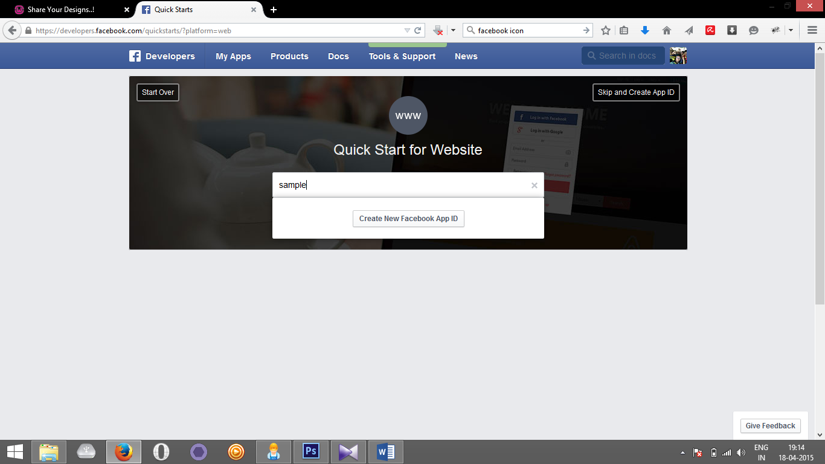

1. Enter the **URL** and **Mobile Site URL**  in this case both are **http://localhost/foldername**

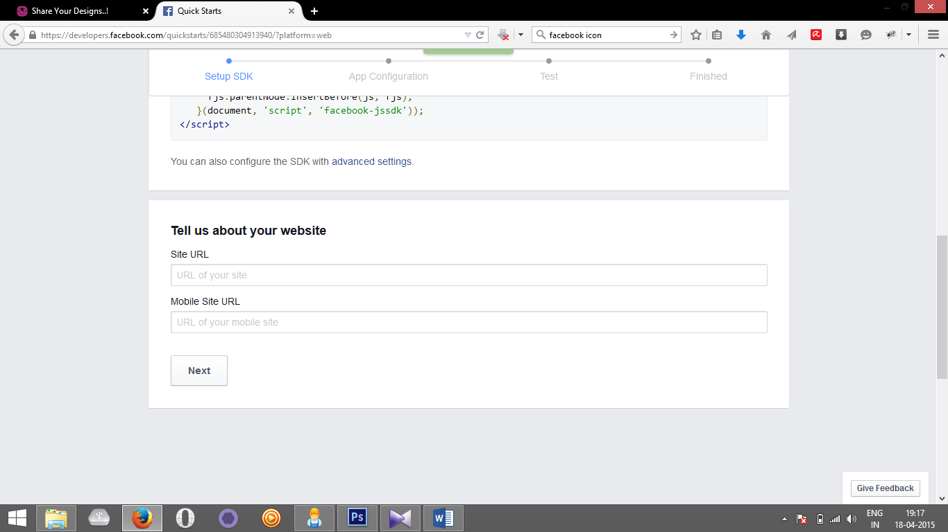

1. Then click on **Skip Quick Start.**

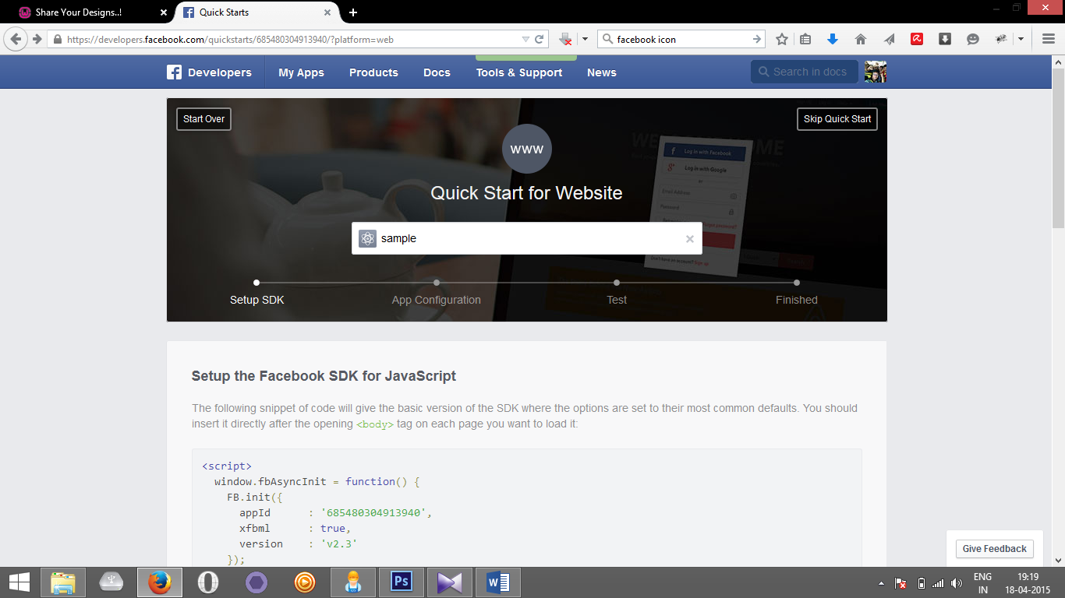

1. Note down **APP ID** and **App Secret** from the **dashboard Page**

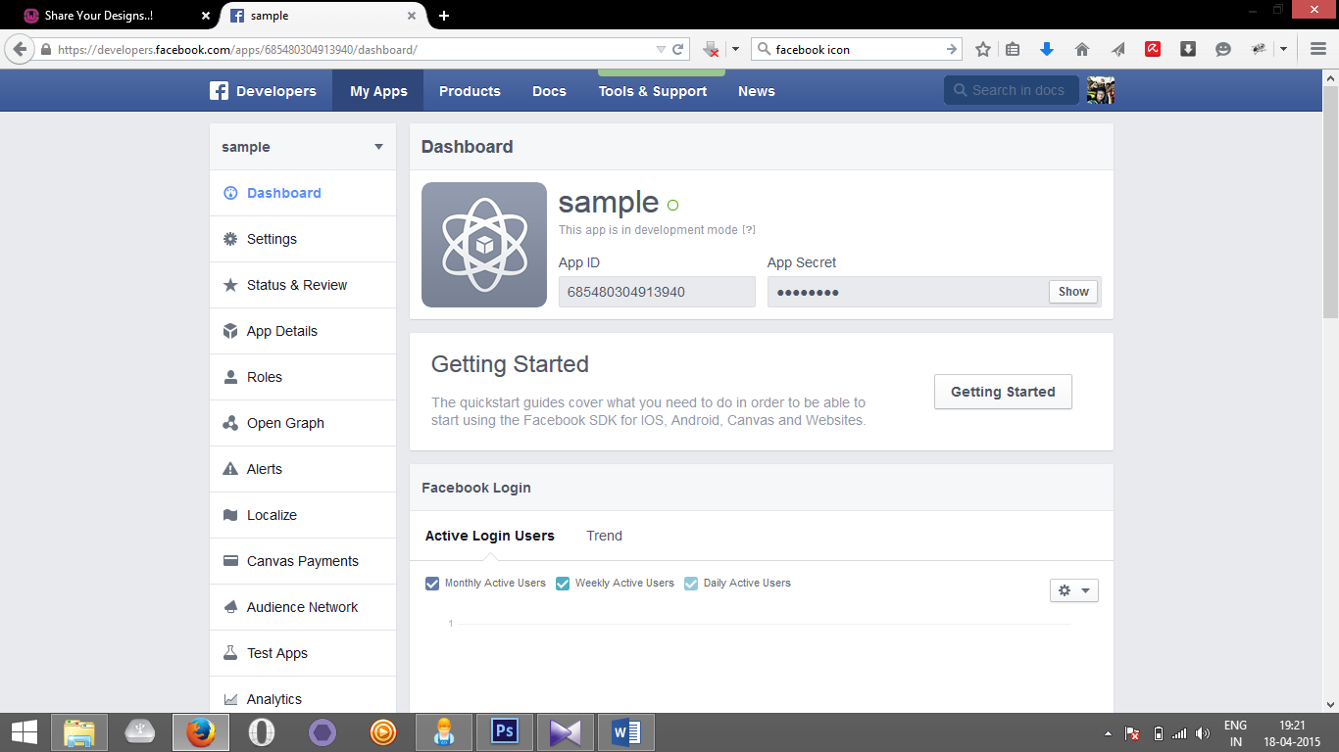

1. Then open **config.php**  from the source and replace the **$appId** and **$appSecret** with the values from the **dashboard** page.
2. And **$return_url** is [**http://localhost/**[root_folder]**/process.php**](http://localhost/%5broot_folder%5d/process.php)
3. And **$homeurl** is [**http://localhost/**[root_folder]**/fb.php**](http://localhost/%5broot_folder%5d/fb.php)**.**
4. **FOR Just click on the link given to post. Login will be asked later.**
5. **Screen shots**

