1. A screenshot of a computer

   Description automatically generated
2. A screenshot of a computer

   Description automatically generated
3. A screenshot of a computer

   Description automatically generated
4. A screenshot of a computer

   Description automatically generated
5. A screenshot of a computer

   Description automatically generated

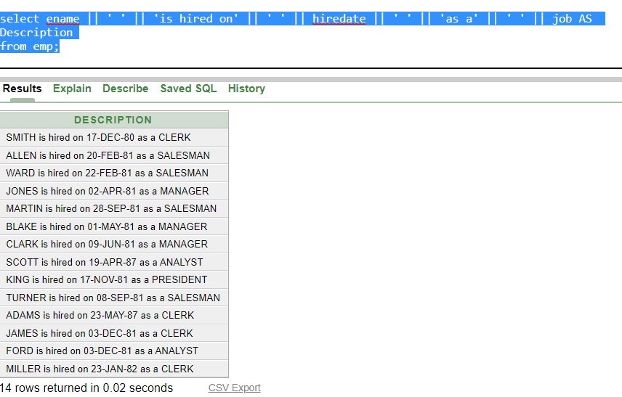

1. A screenshot of a computer

   Description automatically generatedA screenshot of a computer

   Description automatically generated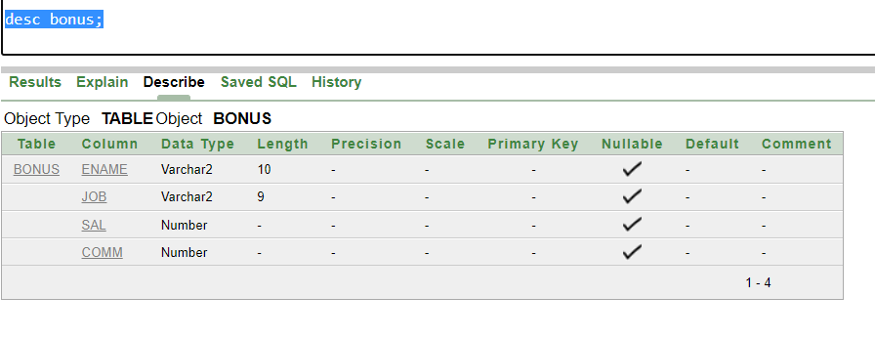

1. A screenshot of a computer

   Description automatically generated