**Creating a new table:**

CREATE TABLE Student (

student_id varchar(20),

student_name varchar(30),

marks number,

grade varchar (2));

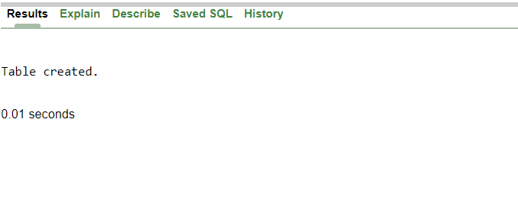

**Adding a new column:**

ALTER TABLE Student ADD (remarks varchar(4));

**Inserting data into the table:**

INSERT INTO Student (student_id, student_name, marks, grade, remarks)

VALUES ('GA-001', 'Jhon', 285, 'A', 'Pass');

INSERT INTO Student (student_id, student_name, marks, grade, remarks)

VALUES ('GA-002', 'Smith', 248, 'B', 'Pass');

INSERT INTO Student (student_id, student_name, marks, grade, remarks)

VALUES ('GA-003', 'Emma', 329, 'A+', 'Pass');

INSERT INTO Student (student_id, student_name, marks, grade, remarks)

VALUES ('GA-004', 'Sandy', 249, 'B', 'Pass');

INSERT INTO Student (student_id, student_name, marks, grade, remarks)

VALUES ('GA-005', 'Olivea', 150, 'F', 'Fail');

INSERT INTO Student (student_id, student_name, marks, grade, remarks)

VALUES ('GA-006', 'James', 187, 'D', 'Pass');

INSERT INTO Student (student_id, student_name, marks, grade, remarks)

VALUES ('GA-007', 'Eva', 352, 'A+', 'Pass');

INSERT INTO Student (student_id, student_name, marks, grade, remarks)

VALUES ('GA-008', 'Noah', 279, 'B', 'Pass');

INSERT INTO Student (student_id, student_name, marks, grade, remarks)

VALUES ('GA-009', 'Charlotte', 282, 'A', 'Pass');

INSERT INTO Student (student_id, student_name, marks, grade, remarks)

VALUES ('GA-010', 'Elijah', 301, 'A', 'Pass');

**Showing all data from the table:**

SELECT * FROM Student;

