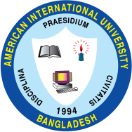

AMERICAN INTERNATIONAL UNIVERSITY–BANGLADESH (AIUB)
FACULTY OF SCIENCE & TECHNOLOGY

INTERNSHIP AFFILIATIONREPORT ON
Intern Engineer (AI) at Samsung R&D Institute Bangladesh Ltd. (SRBD)

An Internship Report Presented to the
OFFICE OF PLACEMENT and
DEPARTMENT OF COMPUTER SCIENCE
In Partial Fulfillment of the Requirements for the Degree
Bachelor of Computer Science and Engineering

Supervised By
Department of Computer Science

Submitted By
Meheraj Hasan, 22-49363-3

Spring 2025-2026
Date of Submission: May 06, 2026

LETTER OF SUBMITTAL

May 06, 2026
The Department Head [Undergraduate Program]
Faculty of Science and Technology
American International University-Bangladesh (AIUB)
Subject: Submission of Internship Affiliation Report

Dear Sir,
This Internship Affiliation Report is my honor to submit, as part of coursework in the undergraduate program in Computer Science and Engineering at American International University-Bangladesh (AIUB). This report summarizes the work done, things learned and work experiences during my term of internship at Samsung R&D Institute Bangladesh Ltd. (SRBD).
I worked as an Intern Engineer (AI) at SRBD. My work was focused on development, training and evaluation of deep learning models to analyse medical images systems with the implementation of object detection and segmentation pipelines and research into state-of-the art computer vision architectures that could be applied to medical imaging systems. I worked under the immediate guidance and supervision of Muhammad Rakeeb, an Assistant Principal Engineer with SRBD whose directives and supervision played a crucial role in helping me to develop my technical knowledge and professionalism.
This report is a narrative of the organization, my delegated tasks, the challenges I faced, the knowledge I gained and my recommendations on what the organization could do to improve. This report has been very much prepared by me with much sincerity, accuracy, and strict following of guidelines and template as stipulated by the Department of Computer Science, AIUB.
I have the honor to request that you would please accept this report and take it into consideration to evaluate. In case you need any more details about the internship, I will gladly be able to help you with this information at your convenience.


Sincerely yours,

Meheraj Hasan
ID: 22-49363-3
Bachelor of Science in Computer Science and Engineering
Date: May 06, 2026
LETTER OF ENDORSEMENT
The Internship Affiliation Report entitled “Intern Engineer (AI) at Samsung R&D Institute Bangladesh Ltd. (SRBD)”, has been submitted to the Office of Placement and Department of Computer Science in partial fulfillment of the requirements for the degree of Computer Science and Engineering by Meheraj Hasan & 22-49363-3. This report is presented to the Internship Defense Committee for evaluation and has been accepted.
(Any opinions, suggestions made in this report are entirely those of the author of the report. The University does not condone nor reject any of these opinions or suggestions.)

Muhammad Rakeeb
Internship Supervisor (Industry)
Assistant Principal Engineer
Samsung R&D Institute Bangladesh Ltd. (SRBD)

Dr. Muhammad Firoz Mridha
Professor, Head [Undergraduate Program]
Department of Computer Science
Faculty of Science & Technology

Dr. Md. Abdullah-Al-Jubair
Associate Professor, Director
Faculty of Science & Technology

ACKNOWLEDGEMENT
First of all, I would like to thank almighty Allah, for His grace in enabling me to complete this internship and prepare this report in timely manner.
I would also like to mention that I would like to express my heartfelt gratitude to the Faculty of Science & Technology for integrating the internship program into the graduation program which has given me the opportunity to acquire first hand experience in an industry based environment in tandem with my academic interests. I am also very thankful to the Faculty of Science & Technology and Office of Placement and Alumni of AIUB because they always kept students posted on the availability of internship opportunities in the industry which helped me to identify and secure my position in Samsung R&D Institute Bangladesh Ltd. (SRBD).

I wish to extend my utmost gratitude to my project lead and team lead, Muhammad Rakeeb, Assistant Principal Engineer, Samsung R&D Institute Bangladesh Ltd. (SRBD) who have been supportive, constructively supervising my work and personally guiding me through this internship. His guidance and leadership were very helpful in molding my professional practice and in helping me fulfill the duties of the position efficiently.

I am proud and privileged to have worked under the supervision of Imam Mohammad Bokhary, Senior Chief Engineer, SRBD, who supervised the project and assigned my tasks during the internship period. His technical skills, professionalism, and research were incredibly enriching the quality of my work and expanded my knowledge about the applied AI in the healthcare sphere.

I also would like to extend my sincere appreciation to Shafquat Mahbub, Lead Engineer, SRBD and B M Marjan Khan, Lead Engineer, SRBD, because of their support during the onboarding process and because of ensuring a smooth and well-structured internship experience on an organizational level.

At last, I would like to say my sincere gratitude to the whole team of Samsung R&D Institute Bangladesh Ltd. (SRBD) to cooperate, encourage and be willing to mentor me through the professional journey. Without their mutual support and cooperation, they would not have been able to prepare this report and the associated documentation.

TABLE OF CONTENTS

TOPICS | Page no.
- Title Page | 1
- Letter of Submittal | 2
- Letter of Endorsement | 3
- Acknowledgement | 4
- Table of Content | 5
- List of Tables &Figures | 6
- Introduction | 7
- Rationale | 7
- Background | 7
- Objectives | 9
- Activities | 10
- Workload | 10
- Organization Wide | 15
- Other Relevant Activities | 16
- Constraints/Challenges | 19
- Identified/Observed in the Organization | 19
- Academic Preparation | 19
- Personal/Professional Skills | 20
- Acquired Knowledge | 22
- Consequences to Organization | 22
- Implications to University’s Internship Program | 22
- Effects on Personal/Professional Skills | 23
- Concluding Statements | 25
- Summary | 25
- Recommendations/Suggestions for future strategic actions | 25
- Organization | 25
- University | 25
- Personal/Professional | 26
- Recommendation Letters | 27
- Industry Supervisor Evaluation | 28
- References | 30
- Appendices | 31

LIST OF TABLES & FIGURES
Tables
TITLES | Page no.
- SRBD At a Glance  - Samsung Research – Global R&D Network  2.1 Summary of Major Architectures Studied  2.2 Internship Activity Timeline | 8  8  14  17

Figures
TITLES | Page no.
- Samsung Research Logo  2.1 Daily Commute Route from Home to Office  2.2 Illustrative View of Jira Task Board  2.3 Evolution of YOLO Architecture Family  2.4 Evolution of U-Net Family  2.5 Transformer Architecture | 7  11  12  13  13  13
- INTRODUCTION
This report is a document of my internship experience as an Intern Engineer (AI) at Samsung R&D Institute Bangladesh Ltd. (SRBD) where I was stationed under the Medison AI team within the Medical Solution Group. I mostly was concentrated on computer vision solutions development for Samsung medical devices. This chapter gives the reason why I decided to undertake this internship, a background of the host organization and the objectives I wanted to attain.
  - Rational
The main reason why I have decided to do this internship and write this report is based on two interrelated factors. First, I am immensely interested in Artificial Intelligence and its practical implementation in the real world, especially in the highly influential fields of deep learning, computer vision, and medical imaging. Second, I personally decided to be an intern at SRBD due to the internationally recognized name of Samsung as a technological innovation leader.
As a student of Computer Science and Engineering, I have always tried to find a way to bridge the gap existing between theoretical concepts in academics and the needs of the practical world of the technology industry. SRBD was an unprecedented professional environment wherein state-of-the-art research in AI is implemented at a global scale to Samsung healthcare products. The significance of this report is that it would serve as a critical reflective report; the report would evaluate my personal and professional development, development of technical skills and adaptability in a fast-paced high-results research and development environment. It serves as an official document bridging my classroom experience and practices in the industry in the fast-developing field of AI in healthcare.
  - Background
Samsung R&D Institute Bangladesh Ltd. (SRBD) began its operations in February, 2011. Located in the heart of Dhaka, it is the first ever R&D hub set up by a multinational company in Bangladesh and is an integral part of a worldwide network of R&D centers set up by Samsung Electronics. The location of SRBD is West Tower, Abdul Momen Business District, 111 Bir Uttam C.R. Datta Road, Dhaka 1205, Bangladesh [1].
Figure 1.1: Samsung Research Logo
Samsung Research leads the development of future technologies with more than 10,000 researchers and developers worldwide, operating under the vision of "Shape the Future with Innovation and Intelligence." Core research themes include artificial intelligence, data intelligence, next-generation communications, robotics, life care, next-generation media, and security. The hub collaborates with 14 overseas R&D centers in 12 countries and 7 global AI centers to maximize technological innovation through open collaboration with universities, research institutes, and industry partners [2].
My internship was located in the Medison AI team within the Medical Solution Group that develops AI and computer vision solutions at Samsung Medison. Samsung Medison is a global leading medical device company specializing in diagnostic imaging devices, and became an affiliate of Samsung Electronics in 2011, integrating world-class IT, image processing, semiconductor and communication technologies into medical devices [3]. The work of the team contributes directly to the AI-powered clinical products of intelligent ultrasound analysis and automated X-ray screening tools used by medical professionals all over the world.
Table 1.1: Samsung R&D Institute Bangladesh Ltd. (SRBD) – At A Glance [1]
Category | Details
Full Name | Samsung R&D Institute Bangladesh Ltd. (SRBD)
Parent Organization | Samsung Electronics Co. Ltd.
Established | February 2011
Location | West Tower, Monem Business District, 111 Bir Uttam C.R. Dutta Road, Dhaka-1205, Bangladesh
Industry Type | Research & Development (Software, AI, Mobile, Wearables, Cloud)
Notable Distinction | First multinational R&D hub established in Bangladesh
Key Focus Areas | Artificial Intelligence, Computer Vision, Medical AI, Mult-Device Experience, Wearable & Cloud Solutions
Website | https://research.samsung.com/srbd
Table 1.2: Samsung Research – Global R&D Network [2]
Region | R&D Centers / AI Centers
America | Samsung Research America (SRA)
Europe / CIS / Middle East | UK, Poland, Ukraine, Russia, Israel, Jordan
SW & SE Asia | China-Beijing, China-Nanjing, Japan, India-Bangalore, Philippines, Indonesia, Bangladesh (SRBD)
Global AI Centers | Seoul, Mountain View, Toronto, Cambridge, Warsaw (7 centers total)

1.2.1 Vision
Samsung Research operates under the vision of Shape the Future with Innovation and Intelligence that drives research and development to create new values and make the lives of people better through the advanced technology [1].
1.2.2 Mission
Samsung Research is determined to find new future growth areas and acquire the latest technologies in AI, robotics, and healthcare.
  - Objectives
The main goals and intentions to be achieved in this report are as follows:
- To give a thorough description of SRBD, its global network and how the Medison AI team executes advanced R and D practices in the development of medical solutions.
- To elaborate the main tasks carried out during the internship, such as the development, training, and assessment of computer vision and deep learning models to analyze medical images.
- To determine how complex engineering problems and data problems are solved using the latest AI technologies and research methodologies in the organization.
- To determine the practical knowledge and technical competencies and professional behaviors at the workplace during the internship period.
- To make constructive recommendations to the organization, the internship program of the university, and my own future professional development basing on this practical experience.

- ACTIVITIES
In this chapter, a detailed description of the activities I have performed during my internship as an Intern Engineer (AI) at Samsung R&D Institute Bangladesh Ltd. (SRBD), in the Medison AI Team under the Medical Solution Group. The internship was centered around the development, training, and evaluation of deep learning models to a real-time medical imaging system. The activities are structured into three key areas namely work related tasks which are the core of the internship engagement, organization wide contributions which are the contextualization of how the work fit within the overall structure of SRBD and other relevant supporting activities such as literature reviews, documentation, communication, and coordination of activities with the headquarters (HQ).
2.1 Workload
The internship assignment was designed with a well-defined research and engineering goal, which is to design, explore, train, and evaluate deep learning-based models. The next is a step-by-step explanation of how I tackled this assignment over the last few months of the internship, how I was trained, and how I was assigned to work on the core system.
2.1.1 Daily Work Schedule, Time Management, and Travel
During the internship, I had a full schedule of professional work of nine hours per working day, including a one-hour lunch break, between 1:00 PM and 2:00 PM. This was equivalent to a net working time of eight hours in a day, five days in a week, which is in line with the official office hours of SRBD. Punctuality was enforced throughout the entire time; I never turned up late to work and I always made sure that I was at the office early enough to start working on what I was assigned to do.
My day to day transportation was between my home close to Le Merdien-Dhaka, Khilkhet and my office at SRBD, which is located in the Abdul Momen Business district, Bir Uttam C.R. Datta Road, Karwan Bazar, Dhaka 1205. The trip normally took one to one and a half hours in each direction depending on the traffic and transit conditions. The standard commuting route that I used started with a bus ride around Le Merdien-Dhaka to Mirpur-11, after which I took the Dhaka Metro Rail (MRT Line 6) bus ride which was around Karwan Bazar Station to SRBD office premises which was relatively nearby. The metro rail portion of the trip was remarkably efficient, and saved a significant amount of time in the commute than with the road-only travel. The overall commuting time was about two to three round trip hours per day.
Although the commute was somewhat demanding, I remained disciplined and time efficient during the internship period. At the end of every working day, a short self-assessment of progress in the work and updates to the project management system were made before leaving the office. This habit allowed me to have a steady flow of work and allowed me to make sure that no deliverable or deadline was forgotten during the entire internship period.
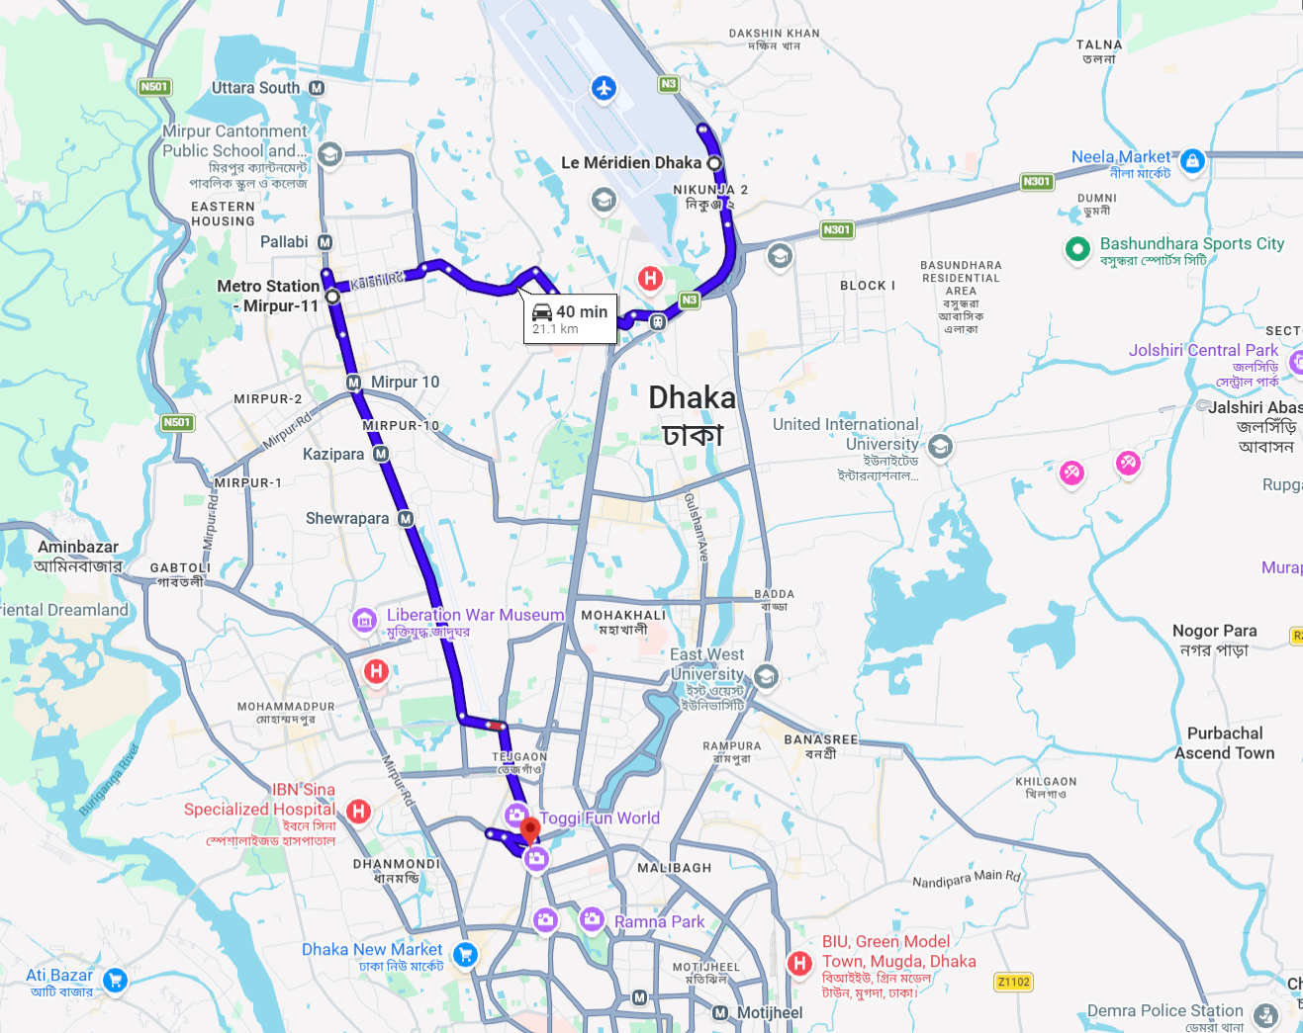
Figure 2.1: Daily Commute Route From Le Méridien to Mirpur-11 to Karwan Bazar [4]
2.1.2 Task Tracking and Daily Updates via Jira
One of the most prominent aspects of my work approach during the internship was that Atlassian Jira was used to manage the tasks and report on the progress of the work daily. Each working day, I had to write updates on the tasks assigned to me in the team in the project board of the Jira tool. This involved updating the status of work in progress (e.g. In Progress, Under Review, Completed) and adding detailed comments about the work done during that session and any blockers or problems encountered.
This reporting discipline that was done on daily basis had several purposes. It gave my immediate supervisors and the entire Medison AI Team real-time access to my progress report, as well as held everyone involved in the assigned deliverables accountable. It also assisted me to develop a systematic habit of self-documenting technical work, which was of value in compiling weekly summaries and formal reports to be sent to HQ. The Jira board was structured on the basis of sprint-based cycles and each task was assigned the specific level of priority and the approximate completion timeline, which allowed structuring the workload within the Jira board.
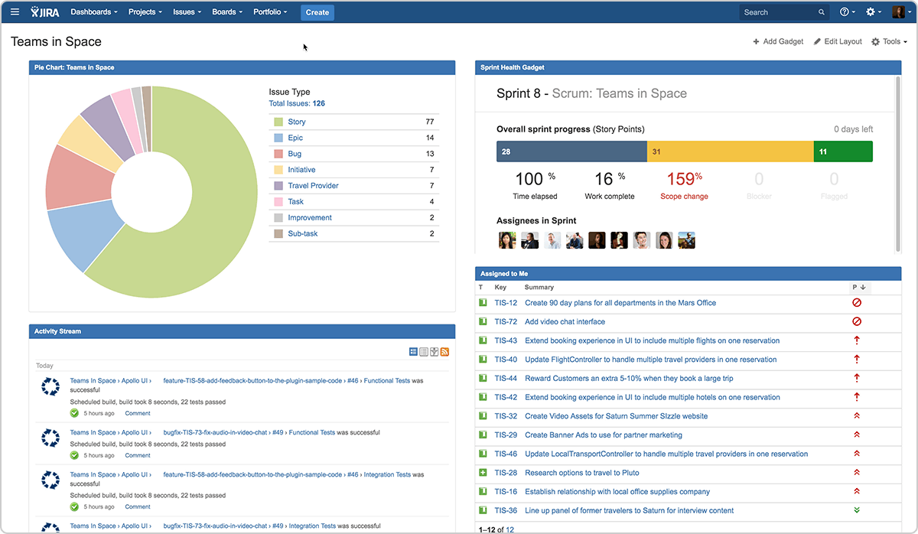
Figure 2.2: Illustrative View of Jira Task Board Used for Daily Progress Tracking [5]
2.1.3 Phase 1 – Training Period: Architecture Study (Weeks 1–2)
The initial two weeks of internship were set as a formal training. At this stage, I had not yet been assigned to active development tasks; rather, I was expected to build a comprehensive grasp of the deep learning architecture. This stage was to ascertain that I had the theoretical and conceptual background to be of value in the actual technical work that would follow.
My training included two general groups of architectures, namely, object detection and localization models, and image segmentation models. To detect, I trained a wide array of YOLO (You Only Look Once) variants, namely YOLOv5 through YOLOv26, YOLOX, RF-DETR (Region-Feature Detection Transformer), and D-FINE. To perform segmentation, I learned the UNet family of architectures - the original UNet, UNet++ and UNet3+.
Each architecture was analyzed with regards to its main design principles, problem that it was designed to solve, its core and neck/head design, the loss functions used, and its practical trade-offs in terms of speed (frames per second), memory footprint, and accuracy. This architectural literacy was directly applied to the project.
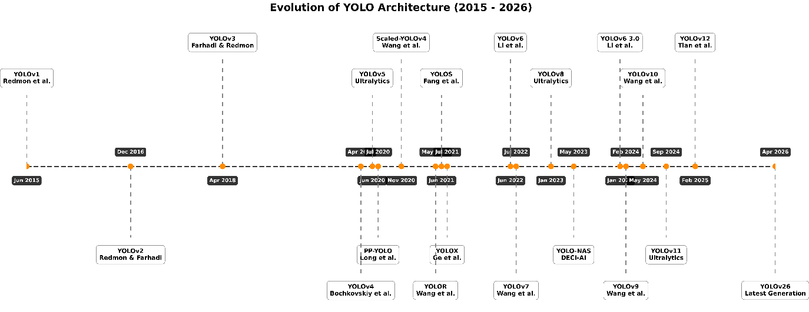
Figure 2.3: Evolution of YOLO Architecture Family - YOLOv1 to YOLOv26
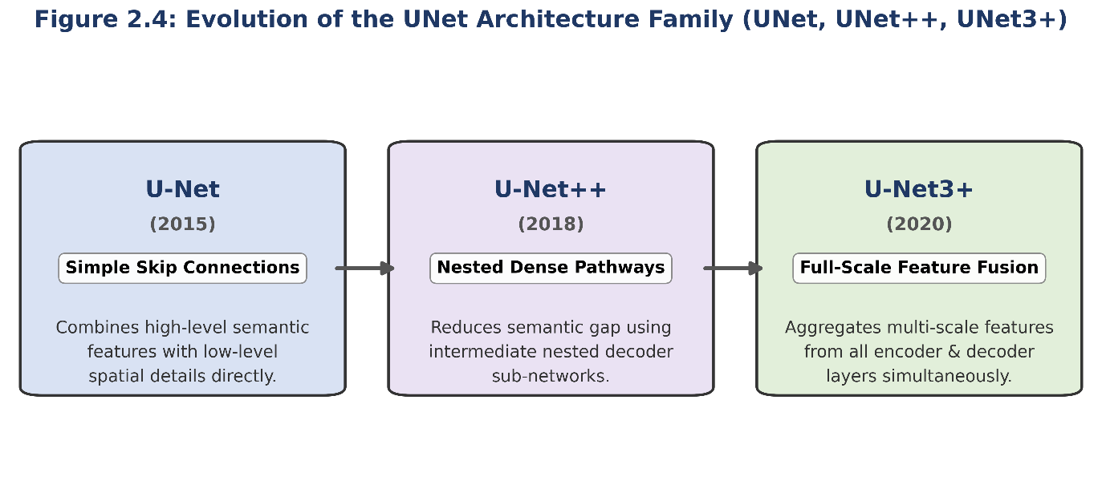
Figure 2.4: Evolution of U-Net Family – U-Net to U-Net3+
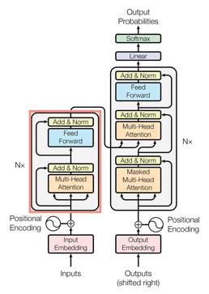
Figure 2.5: Transformer Architecture [6]
Table 2.1 Major architectures studied during the training phase, along with their primary application domain and the key design characteristic that distinguishes each.
Architecture | Category | Key Design Feature | Relevance to Project
YOLOv5 | Detection | CSP Backbone, PANNet | Real-time detection
YOLOv8–v12 | Detection | Anchor-free, decoupled head | Improved detection speed & accuracy
YOLOv26 | Detection | Latest YOLO variant | Benchmark comparison candidate
YOLOX | Detection | Decoupled head, SimOTA | Strong baseline for detection
RF-DETR | Detection | Region-Feature Transformer | Attention-based feature extraction
D-FINE | Detection | Fine-grained distribution prediction | Precise localization for clinical imaging
UNet | Segmentation | Encoder-Decoder with skip connections | Boundary segmentation
UNet++ | Segmentation | Nested dense skip connections | Improved multi-scale feature aggregation
UNet3+ | Segmentation | Full-scale skip connections | Enhanced global-local feature fusion
Transformer | Backbone (Universal) | Self-attention on image patches | Feature backbone for detection & seg.
Through the two-week training, I had gained a working knowledge of each of these architectures at a level of depth that I can assess their applicability to the my assigned project. This background played a vital role in the literature review and model exploration exercise that followed in further weeks.
2.1.4 Phase 2 – Project Requirements Review (Weeks 3–4)
The Weeks 3 and 4 were allocated to an in-depth review of the project requirements documentation.
I read these documents carefully, with notes of technical interest, and took part in the internal discussions with the team to clarify any ambiguities. The knowledge of the requirements was paramount to the fact that all the architectural decisions, training layout and the evaluation methodology adopted in the later stages of the project had to be traceable back to these requirements. This preparation review enabled me to proceed to the literature review stage with a clear and accurate picture of the scope of the problem.

2.1.5 Phase 3 – Literature Review (Weeks 5–6)
The weeks 5 and 6 were dedicated to the systematic and extensive literature review to survey the state of the art in clinical imaging applications related to our project. The literature search was conducted in the leading academic repositories such as IEEE Xplore, PubMed, Google Scholar, arXiv and Springer. To conduct the literature review, I made systematic notes to each article, such as the dataset used, the methodology followed and any information on the speed of inference or hardware specifications. The compilation of these notes was then translated into a literature review summary document which was then distributed to the project team.
2.1.6 Phase 4 – Core Development (Weeks 7–Present)
The internship started moving to the core development stage after Week 7 and which formed the bulk of the technical work done in the engagement. It involved preprocessing datasets and labeling, training and experimenting of model, performance evaluation based on the predetermined constraints and refining of the model.
2.2 Organization-Wide
My internship placement was in the Medison AI Team, a specialized research and engineering team, under the Medical Solution Group of Samsung R&D Institute Bangladesh Ltd. (SRBD). The realization of how my work was affected by the larger organizational context of SRBD was an important aspect of the internship experience, on the one hand in terms of understanding the magnitude and significance of the work and on the other hand in terms of gaining a sense of professional responsibility.
2.2.1 The Medison AI Team and the Medical Solution Group
The Medison AI Team works under the Medical Solution Group, which is among a few large technical groups within SRBD. The team will develop artificial intelligence and computer vision solutions that are implemented into medical imaging products. The AI solutions produced by the Medison AI Team are implemented in clinic settings at a global scale, and thus, the technical rigor and quality of the work produced by the team are directly related to patient outcomes.
The team operates in tight cooperation with Samsung international R&D network. Our project, specifically, was an international-level initiative, that is, the project requirements as well as the specifications of the deliverable, were defined on the international level and relayed to the SRBD team to be implemented and validated.
2.2.2 Collaboration with the Wider SRBD Research Ecosystem
One of the largest multinational R&D centres in Bangladesh, the SRBD, hosts several research teams working on a varied portfolio of projects in the mobile technology, wearables, cloud solutions and medical AI. Despite limited exposure to the overall culture of SRBD, I had an incidental exposure to the overall culture of the Medison AI Team (which is narrowly limited to a single technical team).
The team meetings which were a part of the working week gave a chance to see how the Medison AI Team aligned its activities with the goals of the Medical Solution Group and the entire research agenda of SRBD. Such meetings entailed project progress, technical presentation on model performance and model schedule on documentation and HQ reporting. I found my presence at those meetings to be a great eye opener as to how professional AI research and development is actually addressed on a corporate level where the deliverables must address not only the technical performance requirements but also the organizational and business needs.
2.3 Other Relevant Activities
Besides the simple technical work and organizational setting that was characterized in the earlier sections, there were also a number of other activities which were an inherent part of my internship experience. They included literature management, communication and reporting, documentation, and collaborative support and collectively enhanced the quality of the technical outputs, and my professional development.
2.3.1 Communication and Regular Updates
In case of any project, it is necessary to have a constant rhythm of communication and reporting. As a member of the team, I helped prepare progress updates, technical summaries and status reports. These were updates on the current situation in model training and evaluation exercises, initial results about model performance, any technical issues that occur and future action plan.
To prepare these updates, it was necessary to be able to sum up and synthesize complex technical work in a clear, concise, professionally structured manner, which was reviewable by senior engineers and project managers. This professional learning experience has been a valuable addition to the professional knowledge base in terms of the value of transparency, precision, and timeliness in cross-organizational technical collaboration.
2.3.2 Literature Management and Reference Maintenance
The literature review done in Weeks 5-6 was not a one-time event; instead, it was a continuous process during the internship. Since additional literature searches were conducted to find relevant prior work that could inform architectural decisions or provide context on observed results. I maintained my own organized library of reviewed papers that was kept up to date and shared with the team.

2.3.3 Documentation Practices
I kept a very detailed record of all technical operations like model training configurations, hyperparameter settings, evaluation results, data preprocessing decisions, and architectural comparison notes. This documentation was in structured internal documents and it was also a mandatory organizational practice of the Medison AI Team such that all the work done in the experiment could be replicated and the reasons that lead to the key decisions made in the technical work process would be recorded and would be referred upon in future.
This practice is indicative of global engineering standards of Samsung, and is compliant with the needs of software and system development in the medical device sector, where traceability of design decisions is a regulatory requirement.
2.3.4 Mentorship and Team Learning
During the internship, I had the opportunity to be guided by my immediate supervisors and seniors in the Medison AI Team. Frequent technical meetings, code inspection, and feedbacks were crucial towards my learning about how professional AI research is conducted in a corporate R&D setting. The team worked in a friendly and thought-provoking working environment where inquiries were welcomed and technical arguments were encouraged as part of the problem solving process.
Such interactions not only provided technical guidance but also other valuable professional lessons on how to deal with uncertainty in a research work - especially in cases where there are multiple model candidates that display similar performance and the selection decision needs to be carefully analysed on the trade-offs that exist in multiple dimensions at the same time.
Table 2.2: Week-by-Week Internship Activity Timeline
Period | Phase | Key Activities | Deliverables / Milestones
Weeks 1–2 | Training | Architecture study: YOLO family (v5–v26), YOLOX, RF-DETR, D-FINE, UNet, UNet++, UNet3+, Transformers | Architecture knowledge summary; Jira onboarding
Weeks 3–4 | Requirements Review | Review of project documentation; clarification discussions | Requirements comprehension notes; preliminary data schema
Weeks 5–6 | Literature Review | Systematic survey of literatures; reference database compilation | Literature review summary document; model shortlist rationale
Weeks 7–Present | Core Project Development | Training models, documenting and submitting reports | Reports and results
To conclude, these weeks of the internship at SRBD were marked by the systematic process of development of a young professional architect, starting with the introduction to the fundamental concepts of architecture and the review of the requirements, then the intensive study of literature, and finally the practical work of technical development with the use of the real medical imaging data. The work covered the entire range of a typical professional AI engineering engagement, including problem understanding, experiment design, and execution, findings documentation, and cross-organizational communication.

- CONSTRAINTS/CHALLENGES
The internship experience in Samsung R&D Institute Bangladesh Ltd. (SRBD) had been a totally rewarding experience, however, it has not come without its quota of issues and constraints. Being my first formal industry exposure, I was exposed to a number of challenges, which can be categorized as based on the organizational environment, the lack of alignment between academic training and practical work, and personal and professional skills shortfalls. All these, however, culminated in the fact that my growth and ultimately, my ability to effectively work in a professional research setting was developed.
3.1 Identified/Observed in the Organization
SRBD is a high-performance multinational research and development institute and with it a highly structure and fast-paced work environment. One of the initial differences that I observed was simply the difference in pace and anticipation between an academic setting and an industry R&D setting. Timeframes are relatively lenient and the work is supposed to be as an educational experience in a university environment. In SRBD, the deliverables are associated with the product level goals and actual engineering pipelines, which need higher level of consistency, responsibility and time sensitivity.
Among the most vivid challenges was to adjust to the working processes and patterns of communication of the organization inside. Being a new intern, it took some time to internalize the right channels of reporting progress, raising technical issues and seeking approvals. The institute follows organized engineering practices like code review standards, documentation standards and iterative review cycles - none of which I had direct experience with before joining.
Another factor which exposed me to a certain level of technical complexity with which I had not been exposed to in coursework is working in a research team which operates on deep learning pipelines to run medical imaging. The data sets, model structures and assessment measures that were used in the AI team of the Medical Solution Group were much more specialized as compared to what typical academic projects involve. It was very difficult to learn and match these requirements in the first few weeks of the internship.
That notwithstanding, my team lead Muhammad Rakeeb and project conductor Imam Mohammad Bokhary were very supportive in this adjustment period. Patience, their positive feedback and openness to explain the specifics of the industry approach made quite a difference in my readiness to adapt and be useful in the team.
3.2 Academic Preparation
I have a sound theoretical foundation in my academic experience in Computer Science and Engineering at AIUB - which includes concepts of data structures, algorithms, machine learning principles, and software engineering principles. But, as I started my employment at SRBD, I realized that there is a significant difference between the academic training and the expectations of an industry grade AI research facility.
The greatest discrepancy that I found was in the field of applied deep learning to healthcare imaging. Although my coursework had already exposed me to the principles of neural networks, supervised learning and basic computer vision, the practical work at SRBD demanded a much more granular understanding of specialized architectures. In most cases, these subjects are not taught in depth at the undergraduate level and I had to do a lot of self directed study in this regard.
Moreover, the scholarly focus on theoretical analysis - including passing exams and making assignments - fails to equip students to the iterative and immediate quality of research work in the industry. In SRBD, the progress is evaluated in terms of the results of the experimental work, its reproducibility, and its correspondence with the project milestones, which demanded a change in my attitude to the problem-solving process and self-evaluation.
The other area of mismatch was that of technical writing and documentation standards. Academic reports have a relatively loose format, whereas SRBD must comply with the standards of Samsung Research with respect to precise and detailed technical documentation.
In spite of these weaknesses, my scholarly training did not also lack its strengths. The mental quality of analytical thinking, programming skills in Python, and exposure to research methodologies that AIUB inculcated in me gave me a viable foundation upon which I could base my developments quickly. The keywords and conceptual frameworks provided by my coursework in machine learning and computer vision, specifically, allowed me to gain the vocabulary and the conceptual framework to understand the work of the team even when the specifics of the implementation were initially unknown.
3.3 Personal/Professional Skills
Personally and professionally, this internship had some of the most significant challenges of my academic life to date. Since it was the first industry experience, I had to overcome - and at times at the same time - the twin pressures of working in the industry and a rigorous academic semester.
I enrolled in 13 credits this semester, including the internship, which meant I had to attend the office five days per week, in addition to attending to the university coursework and class requirements one day per week. This workload was quite draining at some point especially when project due dates and school assignments overlapped. But due to my shear willness to learn, I was able to manage time for both.
In addition to coping with work overload, the process of leaving the role of a student and becoming a professional team member was a gradual and at times difficult one. In the academic setting, there exists a degree of leniency in the manner one goes about doing things and in seeking assistance. I needed to be more self-reliant, initiate and find a way out of ambiguous situations in a professional environment, where the way forward was not clearly defined, and had to be determined through independent research and experimentation.
Even the communication within the professional context had to be changed. The technical progress, articulation of blockers, and team discussions with senior engineers all required a degree of confidence and clarity that I had to consciously cultivate during the first few weeks. At the beginning, I had a problem with expressing my comprehension or posing questions without being nervous, especially in the presence of a senior engineer.
Nevertheless, I am happy to report that both of these issues - the academic-professional balance and the professional communication gap were dealt with successfully throughout the duration of the internship. The positive and cooperative atmosphere in SRBD and the encouragement provided by my teammates and supervisors, in particular, played a critical role in assisting me to develop confidence and learn to adapt successfully. By the second part of the internship period, I managed to participate in technical discussions, reporting on the results of the experiment, and handling my dual roles with much more comfort and confidence.
Not only have these experiences made me a better engineer, but it has also helped me become a better person, instilling in me a greater sense of responsibility and resilience which I believe will serve me well in my future career.
- ACQUIRED KNOWLEDGE
The internship experience at Samsung R&D Institute Bangladesh Ltd. (SRBD) as an Intern Engineer (AI) in the Medison AI Team, Medical Solution Group has been one of the most knowledge-intensive and formative experiences of my life. During this internship, I have obtained a significant scope of technical skills, research skills, and work practices that are far more extensive than what can be obtained through academic study alone. These knowledge and behavioral changes I have experienced over the course of this time have had a significant implication in the organization I worked, as well as in the internship program at the university, and most importantly, to my personal and professional growth.
4.1 Consequences to Organization
During the internship, I helped in the research and development activities of the AI Team, Medical Solution Group at SRBD. My assigned tasks comprised literature reviews about state-of-the-art deep learning architectures applicable in medical image analysis, helping in the development and testing of pipelines, and preparing technical documentation as per the Samsung Research standards. Although, the nature of my work as an intern is inherently constrained as compared to the work of full-time engineers, the work I was able to do was able to supplement the capacity of the team in conducting research in meaningful ways.
By seizing the bandwidth occupied by senior engineers to work on other higher-level levels of research and product integration decisions. My role as an active and engaged intern also led to a collaborative team environment, as I actively engaged in discussions, posing clarifying questions that occasionally triggered helpful re-evaluation of assumptions, and introduced new perspectives based on the recent literature in academic circles.
Also, in my efforts on deep learning architectures, I helped towards the accumulation of internal experimental data and documentation that can be useful reference material in the future research cycles of the group. The practice of extensive documentation - which I was taught to adhere to at SRBD - ensures that the work that is produced during my internship period can be traced, reproduced and made available to the team in future.
4.2 Implications to University's Internship Program
This internship has re-established the monumental importance of the internship program in AIUB as an institutionalized transition between academic and professional practice in the industry. The experience has illuminated the strengths of the program as well as several areas in which the program may be enhanced further to better prepare future interns to the realities of working in high-quality R&D environments.
On the side that is positive, the fact that the program requires a formal internship affiliation report has stimulated a rigorous reflection on all aspects of the experience - both daily tasks and larger professional observations - which has alone accelerated my learning and self-awareness. The institutional guidance of the Faculty of Science & Technology and the Office of Placement & Alumni at AIUB in keeping students informed of industry opportunities played a significant role in helping me to identify and secured my position at SRBD on my own.
Nevertheless, the experience has also brought to light the fact that undergraduate coursework, as it is, may not prepare students to the full extent of the applied technical work that they are likely to engage in once they graduate to the industry R&D position. In particular, there is a knowledge gap in exposure to production-grade deep learning workflows, industry documentation standards, version control practices of research codebases, and the iterative experimental methodology that drives AI development in the real world. It would go a long way to make students better prepared to take up such internships once advanced electives or practical project-based courses are introduced in these areas.
Also, formal pre-internship orientation sessions on professional communication standards, workplace etiquette and technical writing standards would help shorten the initial phase of adjustment of interns who are entering competitive industry environments. The existing program is a great starting point; with these specific improvements, it may become even more effective with students who may want to pursue a career in the field of research and technology.
4.3 Effects on Personal/Professional Skills
The greatest change brought about by this internship has been on my personal and professional growth. The experience of moving to SRBD with an entirely academic background and becoming someone who can work in a professional AI research environment has required - and has led to a colossal change on a variety of levels.
The most directly growing field has been applied deep learning and computer vision. I acquired applied skills in the design and analysis of deep learning models to analyze medical images, work with datasets, implement and benchmark architectures and conduct systematic literature reviews of state-of-the-art research.
The experience of working within a formal R&D team exposed me to how to approach problems with a research attitude - formulation of hypothesis, controlled experimentation, critical interpretation of results and iterative action based on empirical data. It is a radically different intellectual aspect of solving well-defined textbook problems, and acquisition of this ability has been one of the most substantially valuable intellectual products of the internship.
This necessitated an unprecedented degree of time management and personal discipline because it required one to do a 13-credit semester plus a five day per week industry internship. I have developed more habits around prioritization, timing of activities and able to maintain my productivity when I am under constant pressure. Being in a position to constantly deliver on both fronts - office work and academic demands - has objectively contributed to my capacity to withstand the laborious workloads.
I felt even more confident and clear in professional communication - written and verbal. This includes explaining technical innovations to the managers, discussing in a team with other senior engineers and writing professional-level reports.
Working within a field where problems tend to be open-ended, solutions are not guaranteed, and the way forward must be determined by independent research and experimentation has greatly enhanced my adaptability and instincts to solve problems. I am now more comfortable with ambiguity, more proactive in finding out the information, and more resilient to face technical setbacks.
Probably the most implicitly, yet more significantly, this internship has had an impact on my attitude towards work. My observations and internalization about the standards of punctuality, accountability, intellectual honesty, and collaborative respect that I observed and learned at SRBD has become a standard of how I intend to conduct myself in any future professional situation. This has been particularly powerful in this respect, by the example it sets to us, through the mentoring of Muhammad Rakeeb and Imam Mohammad Bokhary in this regard.
Combined, the experience and learning gained throughout this internship have greatly increased my preparedness to the professional world. Not only do I come out of this experience with a stronger technical portfolio but I am also able to better understand the concept of professional identity and how the discipline that meaningful research and engineering work requires is important.

- CONCLUDING STATEMENTS
5.1 Summary
This report has outlined my internship experience at Samsung R&D Institute Bangladesh Ltd. (SRBD), within the Medical Solution Group, as a part of the AI Team, in the Spring 2025-2026 semester internship program, at AIUB.
The type of work I did during the internship was a research-based work that involved deep learning to analyze medical images - the literature review section, the model development and evaluation section and pipeline implementation section and the technical documentation. As a student under the auspices of Muhammad Rakeeb and Imam Mohammad Bokhary, I got to experience the full gamut of applied AI research in a professional, product-oriented environment that is in marked contrast to the structured nature of academic learning.
It was difficult to balance between five workdays of the week and 13 academic credits, but in the end, it was possible to prove that long-term growth under pressure is possible, and it can even become a reality. All in all, this internship has been a career watershed experience - technically enriching, personally stretching, fundamentally clarifying in what a career in AI research would require.
5.2 Recommendations for Future Strategic Actions
5.2.1 Organization
SRBD is already a research environment of high quality but there are certain tweaks that might allow the intern experience to be more fruitful at the very beginning. A structured and formalized process of onboarding interns - regarding internal tools, codebases, documentation conventions, and workflows - would go a long way in helping to reduce ramp-up time, and help interns become productive much earlier. Lastly, defining the project scopes which are more quantifiable in terms of deliverables should be more specified at the onset of the internship which would result in a greater ownership of the project, motivation, and final quality of the output.
5.2.2 University
The internship program offered by AIUB is indeed a rather valuable entree into academic and professional life, and the structural framework - such as the affiliation report, supervisor evaluation, and defense - is well conceived. Nonetheless, there are a number of improvements that would help students to be better equipped to take competitive internships in R&D.
The most significant change would be the introduction of advanced applied electives in such areas as deep learning engineering, computer vision, medical AI, and MLOps. These areas are becoming more of a demand in the industry but they have a low coverage in the standard undergraduate programs. Even just a single course of hands-on projects which resembles the iterative, experiment-driven workflow of actual AI research would reduce the adjustment gap which students experience in their first weeks in an R&D institution by an order of magnitude.
It would also be of great help to have a preparatory professional communication, technical writing standards, workplace conduct, and version control practices of a research project are very important and should be prepared in advance. By having these skills in place, students going into their internships would spend less time getting adjusted to the working environment and more time contributing to the working environment.
Finally, the university might want to provide a knowledge-sharing session or series of sessions where students who have been on competitive internships share their experiences, tools and lessons with the upcoming batches. Such peer to peer knowledge transfer would help in setting out realistic expectations and offer practical guidance which cannot be duplicated by formal coursework.
5.2.3 Personal/Professional
The most intimate piece of advice that I can possibly give myself, and any student who is going to be involved in a similar internship is to put in advance in applied, self-directed learning before the internship. The gap between what course work is supposed to bear and what the industry needs perceived of me and their students is there, and the students who bridge it go proactively through their own projects, in the open-source realm or simply in education.
To further deepen my understanding of medical AI and computer vision, as well as generate research publications where I can transform the practical experience that I obtained at SRBD to research publications, in the future I intend to continue self-education, work on projects and expose myself to research publication opportunities where I will be able to convert the practical experience that I have received at SRBD to research publications. Creation of an enhanced technical portfolio: one that is representative of not only course performance, but now of the actual skills in solving a problem which can now be seen as a real world problem.
On a larger scale, this internship has reinstated in me the importance of being proactive, communicative and in fact curious within a working environment. The attitude that you take towards work and people is what determines how quickly and how far that learning will go.
RECOMMENDATION LETTER
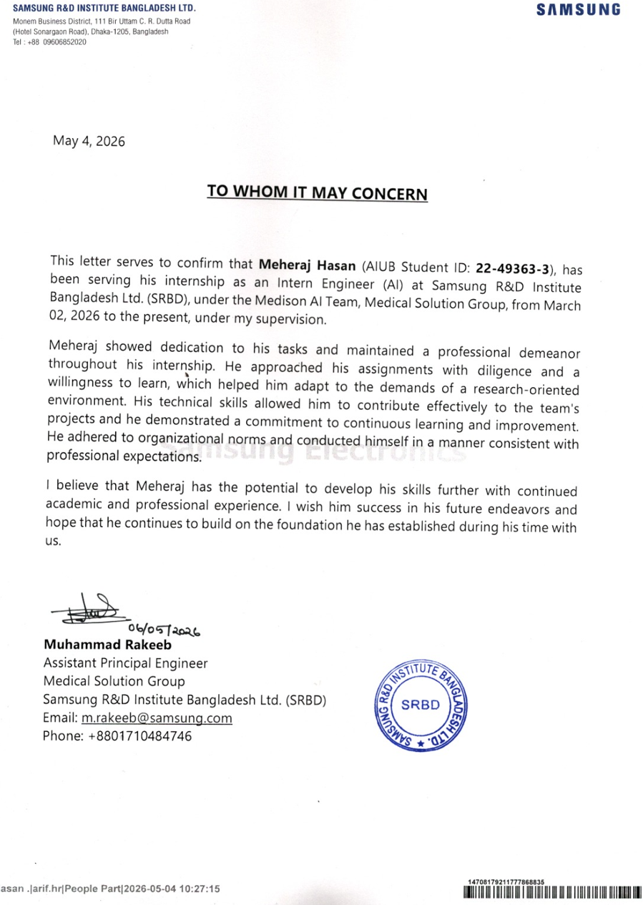
INDUSTRY SUPERVISOR EVALUATION
Assessment Attribute/Criteria |  | Missing/Absent (0); Inadequate (1);  Satisfactory (2); Excellent (3)
CO1: Perform as an effective individual in multi-disciplinary settings in solving computer science and engineering problems.
01 | Critical Thinking
02 | Focus on the Task (Self-directed)
03 | Reflection
04 | Quality of the Work
CO1 Total (out of 12)
CO2: Perform as an effective team member or leader in diverse team settings and solving multi-disciplinary problems in computer science and engineering domain.
05 | Taking responsibility
06 | Contributions
07 | Collaboration and Ability to Compromise
08 | Valuing other team members (Working with others)
CO2 Total (out of 12)
STUDENT NAME | Meheraj Hasan | ID: 22-49363-3 | SEMESTER:  Spring 2025-2026

Total Marks CO1+CO2 (out of 24)
Reference Guide for Industry Supervisor Evaluation
INTERN-CO1: Perform as an effective individual in multi-disciplinary settings in solving computer science and engineering problems.
Assessment  Attribute/Criteria | Missing/Absent  (0) | Inadequate  (1) | Satisfactory  (2) | Excellent  (3)
Critical Thinking | Recalls only functional or procedural knowledge of existing solutions | Explains the existing solutions and applies in multi-disciplinary case settings | Analyses and Evaluates  Conditional/  Declarative knowledge with elements in multi-disciplinary settings | Understands the concepts very well and creates new knowledge in multi-disciplinary settings
Focus on the Task (Self-directed) | Never stays focused on the task and what needs to be done | Sometime stays focused on the task and what needs to be done | Most of the time stays focused on the task and what needs to be done | Consistently stays focused on the task and what needs to be done
Reflection | Rarely acknowledges feedback and doesn’t apply strategies for making improvements | Acknowledges feedback but doesn’t apply strategies for making improvements | Acknowledges feedback and applies strategies for making improvements | Acknowledges and analyzes feedback and applies effective strategies for making improvements
Quality of the Work | Provides work that is not up to any quality standard and expectations. | Provides work that usually needs to be checked/redone by others to ensure quality | Provide high quality work. Some small errors that do not interfere with the meaning | Provides work of the highest quality. Work is checked and corrected for mistakes, and shows a high level of effort

INTERN-CO2: Perform as an effective team member or leader in diverse team settings and solving multi-disciplinary problems in computer science and engineering domain.
Assessment  Attribute/Criteria | Missing/Absent  (0) | Inadequate  (1) | Satisfactory  (2) | Excellent  (3)
Taking  responsibility | Does not perform assigned tasks; often misses meetings and, when present, does not have anything constructive to say; relies on others to do the work; | Partially performs all assigned tasks; attends meetings irregularly and occasionally participates and hence not reliable; | Performs all assigned tasks; attends meetings regularly and usually participates effectively.  generally reliable; | Performs all tasks very effectively; attends all meetings and participates enthusiastically; very reliable.
Contributions | Never provides useful ideas when participating in a group discussion | Rarely provides useful ideas when participating in a group discussion | Sometimes provides useful ideas when participating in a group discussion | Routinely provides useful ideas when participating in a group discussion
Collaboration and Ability to Compromise | Not cooperative, unable to compromise and disrupts the team process. | Sometimes cooperative, and rarely displays positive attitude. | Usually cooperative, able to compromise and generally displays positive attitude. | Always cooperative. Willingness to compromise. Always display positive attitude.
Valuing other  team members (Working with others) | Often argues with teammates; doesn't let anyone else talk; occasional personally attacks and "put‐downs"; wants to have things done his way and does not listen to alternate approaches; | Seldom listens to others' points of view; occasionally behaves in an oppressive manner; tries to force own ideologies on other; | Generally, listens to others' points of view; always uses appropriate and respectful language; tries to make a definite effort to understand others' ideas; | Always listens to others and their ideas; helps  them develop their ideas while giving them full credit; always helps the team reach a fair  decision.

------------------------------------------------
Muhammad Rakeeb
Assistant Principal Engineer
Samsung R&D Institute Bangladesh Ltd. (SRBD)
Monem Business District, 111 Bir Uttam CR Dutta Road, Dhaka-1205

REFERENCES
[1] Samsung Research, “Samsung Research | 삼성 리서치,” Samsung Research | 삼성 리서치, 2019.
https://research.samsung.com/
[2] SR, “SR Bangladesh | Samsung Research,” SR Bangladesh | Samsung Research, 2018.
https://research.samsung.com/srbd (accessed May 05, 2026).
[3] “SAMSUNG MEDISON,” Samsungmedison.com, 2015. https://samsungmedison.com/
sustainability/people
[4] Google Maps, “Google Maps,” Google Maps, 2025. https://www.google.com/maps
[5] idalko, “Jira Dashboards Made Simple: The Why, How & Best Practices – Idalko,” Idalko.com,
Mar. 19, 2019. https://idalko.com/blog/jira-dashboards
[6] A. Vaswani et al., “Attention Is All You Need,” Cornell University, Jun. 12, 2017.
https://arxiv.org/abs/1706.03762
‌

‌
APPENDICES
CV of Meheraj Hasan