The Evolution of Object Detection Backbones: From CNN to YOLOX

Part 1: Traditional Convolutional Neural Networks (CNNs) – The Foundation
Before the advent of modern object detection architectures, basic Convolutional Neural Networks (CNNs) like AlexNet and VGG established the modern standard for computer vision. At its core, a CNN is designed to approximate a complex mapping function:
$$f :X →Y$$
Where the raw input image array (X) is systematically transformed into a high-level semantic representation (Y) through a series of mathematical operations.
The Core Architecture
As illustrated in the CNN Architecture Components diagram, a traditional CNN relies on a sequential flow of specific layers to process visual data. Instead of looking at an image all at once, the network breaks it down through the following interconnected modules:
- Convolutional Layers (Feature Extraction): This is the heart of the network. A CNN slides a mathematical filter (kernel) across the image pixels to extract hierarchical features—starting with simple edges, progressing to textures, and eventually recognizing complex object parts. The core operation is a linear transformation:
$$y=W×x+b$$
(Where W is the filter weight matrix, x is the input pixel region, and b is the bias).
- Activation Layers (Non-Linearity): Linear math alone cannot solve complex real-world problems. Activation layers follow convolutions to introduce non-linearity, allowing the network to learn complex, curved boundaries. The most common is the ReLU (Rectified Linear Unit) function, which passes positive values and zeros out negative ones:
$$y=max⁡(0, W×x+b)$$

- Pooling Layers (Dimensionality Reduction): These layers compress the spatial dimensions of the feature maps (Max Pooling). This reduces the computational load and forces the network to preserve only the most dominant features, making the model more robust to slight shifts or distortions in the image.
- Fully Connected & Output Layers (Classification): At the end of the pipeline, the extracted spatial features are flattened and passed into dense, fully connected networks. These layers perform the final data conversion, calculating the probabilities to make the ultimate prediction (Output Layer).
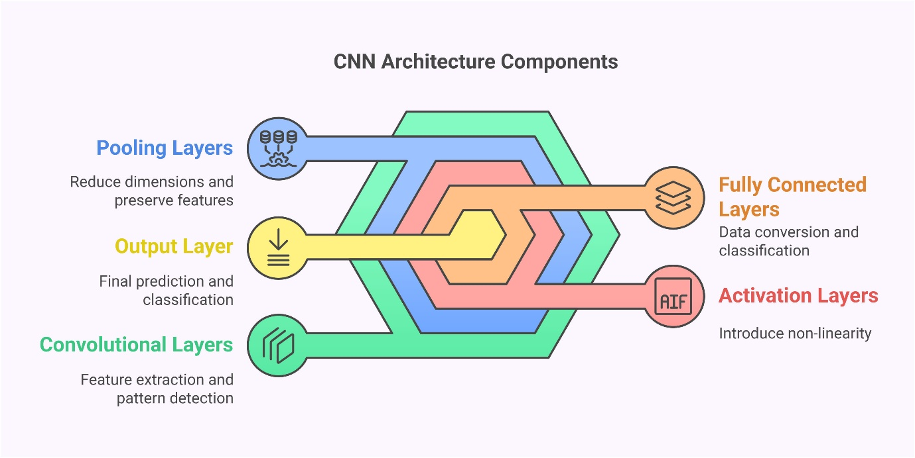
The Breakthrough: What CNNs Solved
The introduction of CNNs completely eliminated the need for "human feature engineering." Before CNNs, software engineers had to manually write complex, rigid algorithms (like HOG or SIFT) to teach a computer how to find a circle or an edge. CNNs automated this entirely. The machine could now learn the most optimal visual features directly from the raw pixels through iterative training.
The Fatal Limitation: Depth vs. Optimization
As researchers sought to identify increasingly complex objects, the logical next step was to make the networks "deeper" by stacking dozens of convolutional layers. Theoretically, a deeper network possesses a higher representation capacity and should approximate more complex functions.
However, in practice, engineers hit a massive wall: The Degradation Problem.
During the training phase (backpropagation), the network updates its weights by calculating error gradients using the chain rule of calculus. If you multiply fractions (gradients less than 1) across 30 or 40 sequential layers, the resulting number shrinks exponentially. Mathematically, as the number of layers (n) increases, the gradient of the loss function (L) with respect to the early inputs (x) approaches zero:
$$\lim_{n→∞}{\frac{∂L}{∂x} → 0}$$
This is known as the Vanishing Gradient Problem. The consequences were catastrophic for deep networks:
- Early Layers Stagnate: The foundational layers (responsible for detecting basic edges and shapes) receive update signals so infinitesimally small that they effectively stop learning.
- Optimization Fails: The optimization process becomes highly unstable.
- Accuracy Drops: Counterintuitively, stacking more layers actually caused the training error to increase.
The Key Insight: This failure revealed a crucial reality. The issue was not that the network lacked the capacity to learn complex representations; rather, the sequential architecture physically bottlenecked the propagation of gradients. The flow of information was broken.

Part 2: ResNet (Residual Networks) – The Gradient Highway
To address the severe optimization difficulties and the Vanishing Gradient Problem of deep CNNs, researchers introduced ResNet in 2015. ResNet fundamentally changed deep learning by introducing a structural reformulation known as the Residual Block.
The Mathematical Reformulation
In a traditional deep network, a sequence of layers attempts to directly learn an underlying mapping, which we can call H(x). However, as established in Part 1, directly approximating a highly complex H(x) across many layers is incredibly difficult due to gradient decay.
ResNet bypasses this by forcing the network to learn a residual mapping instead. If the desired final mapping is H(x), we let the stacked non-linear layers fit another function:
$$F\left(x\right)=H\left(x\right)-x$$
Where x is the original input. By rearranging this equation, the final output of the block becomes:
$$H\left(x\right)=F(\left(x\right)+x$$
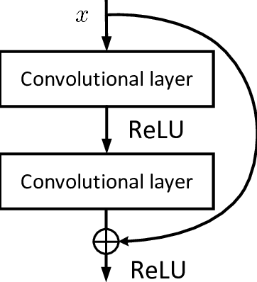
As seen in the figure above, the network passes the original input x around the computational layers via a "Skip Connection" (or identity shortcut) and adds it directly to the output of those layers F(x) before applying the final ReLU activation. The network no longer has to learn the entire transformation from scratch; it only has to learn the "residual" (the difference or the change) required to improve the feature map.
Architectural Variations: Handling Dimensionality
In a deep network, feature maps frequently change spatial dimensions (downsampling) or channel depths. How can you mathematically add x to F(x) if their matrix dimensions no longer match?
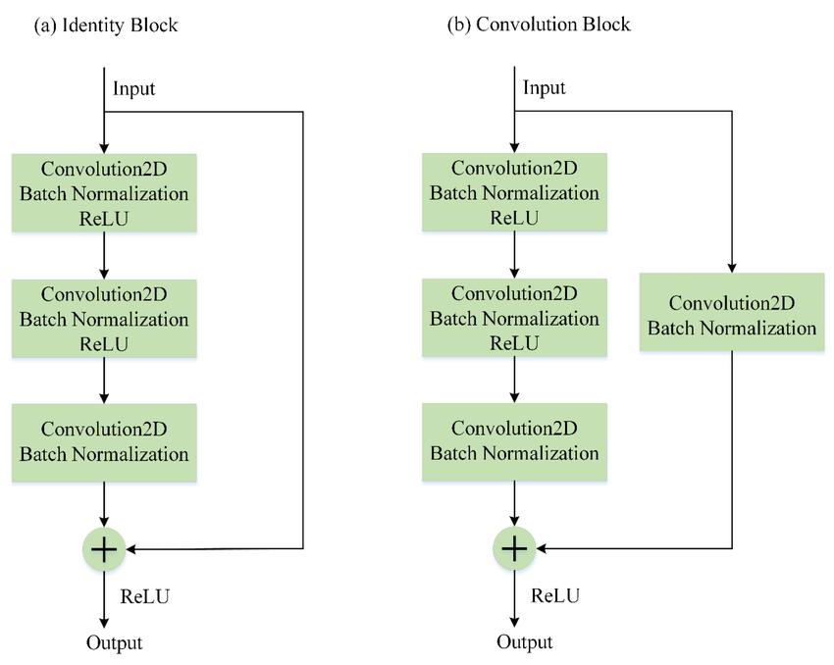
To solve this, ResNet utilizes two distinct variations of the residual block, as illustrated above:
- The Identity Block (a): Used when the input and output dimensions perfectly match. The input x flows directly through the shortcut and is added to the output of the convolutional layers without any modification.
- The Convolution Block (b): Used when the dimensions of the main path (F(x)) have changed (e.g., channels were doubled or spatial size was halved). To allow the matrix addition F(x) + x, the skip connection passes through a $1×1$Convolution layer (and Batch Normalization). This $1×1$convolution acts as a projection, adjusting the dimensions of x to perfectly match F(x) without altering its underlying identity data.
What it Solved: The Gradient Highway
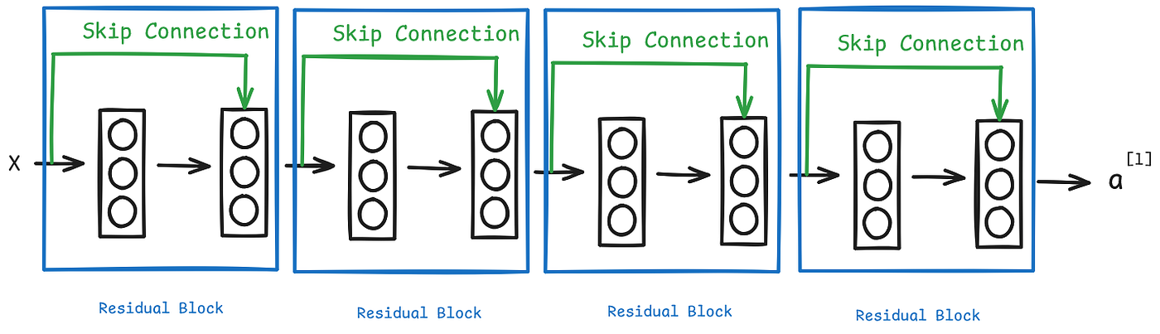
By stacking these blocks sequentially, ResNet creates an uninterrupted path for data and gradients to flow. The identity mapping x acts as a direct Gradient Highway.
We can prove why this solves the degradation problem using calculus. During backpropagation, the gradient of the loss (L) with respect to the input (x) is calculated as:
$$\frac{∂L}{∂x}= \frac{∂L}{∂y}∙(1+\frac{∂F}{∂x})$$
The Crucial Insight: Notice the 1 inside the parenthesis. Even if the layers are incredibly deep and the gradient of the residual layers $(\frac{∂F}{∂x})$ vanishes to absolutely 0, the equation becomes $\frac{∂L}{∂y}∙(1+0)$. The gradient is perfectly preserved and multiplied by 1, allowing it to flow backward freely through the network.
- It enables the training of networks up to 152 layers deep.
- It drastically stabilizes training.
- It eliminates the accuracy degradation problem.

The Fatal Limitation: Redundancy and Computational Inefficiency
While ResNet was a masterclass in optimization, it possessed hidden structural flaws that made it unsuitable for high-speed, real-time object detection.
- Massive Computational Cost (FLOPs): ResNet was designed for static image classification on powerful enterprise GPUs. Evaluating F(x) through dense $3×3$ convolutions across a 152-layer network requires an astronomical amount of Floating Point Operations (FLOPs), making it unacceptably slow for real-time video.
- Redundant Feature Propagation: The skip connections introduce parallel information flow. One path carries the transformed data F(x), while the other carries the unchanged data x. Because both paths merge (F(x) + x) and move to the next layer, they frequently carry highly similar, overlapping information. This results in duplicate gradient calculations during backpropagation and highly inefficient utilization of the network's parameters.
This specific memory bandwidth bottleneck and computational bloat forced researchers to rethink the architecture entirely, leading to the creation of Darknet.

Part 3: Darknet-19 to Darknet-53 (The YOLOv2 & YOLOv3 Engines)
While ResNet proved that deep networks could learn complex functions without degrading, it was engineered for static image classification on powerful enterprise hardware. PJ Reddie, the original creator of YOLO, needed an engine that possessed the deep intelligence of ResNet but operated with the blistering speed required for real-time video feeds.
This necessity birthed the Darknet architecture, which culminated in the highly successful Darknet-53 (the backbone of YOLOv3).
Design Philosophy & Micro-Architecture
The fundamental objective of Darknet is to perform feature extraction rapidly and efficiently:
$$Feature Extraction= f_{Darknet}(x)$$

To achieve high throughput (FPS), Darknet-53 is fully convolutional. It entirely strips away the bloated, memory-intensive "Fully Connected" (dense) layers found at the end of traditional networks.

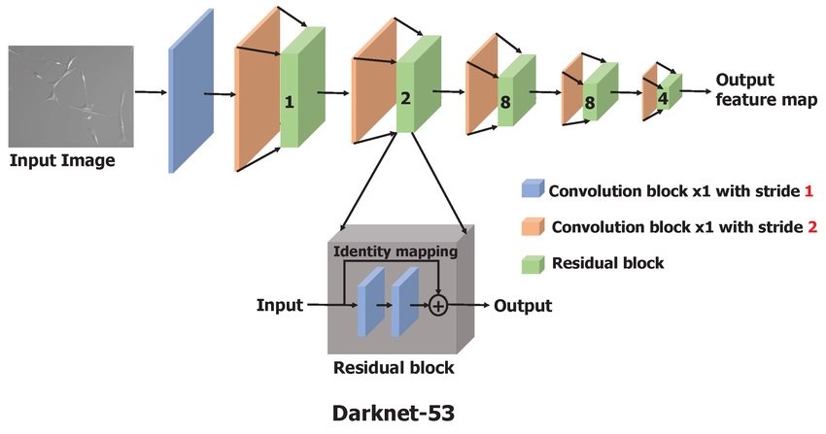
As seen in the zoomed-in section of the figure above, Darknet-53 integrates the "Skip Connections" from ResNet, but it optimizes the internal operations using a Bottleneck Architecture.
Inside each residual block, the network alternates between two specific filters:
- $1×1$Convolution: This acts as a mathematical "bottleneck." It drastically compresses the number of channels, which heavily reduces the memory footprint and computational requirements.
- $3×3$ Convolution: Following the compression, this larger filter performs the heavy spatial feature extraction.
Finally, the identity mapping adds the original input back to the output, preserving the gradient highway.
Macro-Architecture & Multi-Scale Output
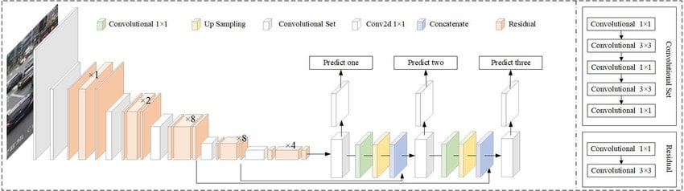
Looking at the broader architecture in the figure above, you can see how these residual blocks are stacked to process the image. The orange blocks indicate the residual sets, which are repeated in a very specific sequence: $×$1, $×$2, $×$8, $×$8, $×$4.
Between these sets, the network uses convolutional layers with a stride of 2 (shown in previous diagram) to downsample the spatial dimensions of the image.
Crucially, Darknet-53 does not just output one final feature map. It taps into the network at three different stages (after the first $×$8 block, the second $×$8 block, and the final $×$4 block) to send multi-scale features to the prediction heads. This allows the network to detect objects of vastly different sizes.
Achievements: What it Solved
Darknet-53 successfully bridged the gap between accuracy and latency. It achieved the exact same feature extraction accuracy as a massive ResNet-152, but it operated nearly 2x faster. By eliminating dense layers and utilizing 1 $×$1 bottleneck, it made real-time, high-FPS object detection a reality on standard consumer hardware.
The Fatal Limitation: Redundant Feature Propagation
Despite its speed, researchers eventually uncovered a severe mathematical and structural inefficiency within Darknet-53 (and ResNet by extension).
While the residual connections stabilized training, they introduced parallel information flow. Mathematically, during backpropagation, the gradient updates are calculated across both the transformed path and the identity path:
$$∇L= ∇L(F\left(x\right)+x)$$

The Underlying Inefficiency: Because F(x) and x often carry highly correlated, similar information, the network ends up processing the entire feature map repeatedly. This leads to:
- Duplicate Gradient Flow: The exact same gradient information is used to update weights across multiple different layers within the residual blocks.
- Massive Memory Access Cost (MAC): The hardware is forced to read and write redundant data to memory constantly.
- Inefficient Feature Utilization: A significant portion of the network's computational power is wasted doing the exact same math twice in different places.
The Insight: The network was learning correctly, but it was not learning efficiently. The theoretical capacity of the parameters was being bottlenecked by redundant data pathways.
This realization paved the way for a structural revolution: splitting the data flow entirely via CSPNet.
Part 4: CSPNet (Cross Stage Partial Network) – Selective Computation
By 2019, it was clear that while architectures like Darknet and ResNet were powerful, their overlapping gradient pathways resulted in massive computational bloat. To address this, researchers published a standalone architectural concept called CSPNet (Cross Stage Partial Network).
CSPNet was not originally a YOLO model; it was a pure computer vision research breakthrough designed to solve the underlying inefficiencies found in heavy feature extractors.
The Core Reformulation: Splitting the Flow
Instead of feeding an entire feature map x into a dense computational transformation (which causes duplicate gradient flow), CSPNet introduces a novel idea: Selective Computation.
When a feature map enters a CSP block, its channels are sliced perfectly in half:
$$x=[x_{1}, x_{2}]$$
From here, the data takes two completely separate paths:
- x₁ (The Learner): This half of the data is sent through the heavy Computational Blocks (like Residual or Dense layers) to actively learn complex, high-level semantic features. Let's call this transformation F(x₁).
- x₂ (The Bypass): This half completely bypasses the computational layers, acting as a vault that preserves the original, uncorrupted spatial information.
At the end of the stage, instead of adding them together (like ResNet), the two halves are concatenated (stitched back together side-by-side, denoted by $⊕$) before passing through a transition layer:
$$y=F\left(x_{1}\right)⊕x_{2}$$
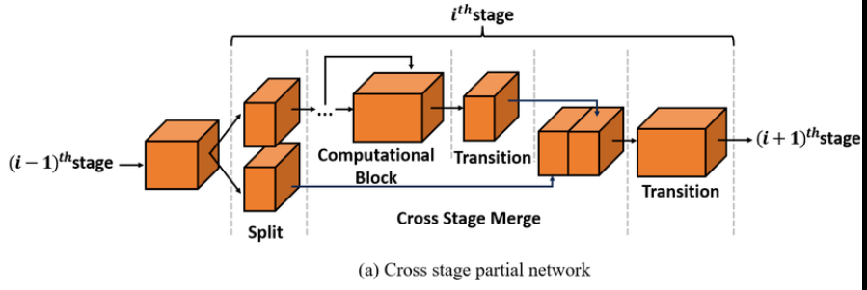
Looking at the top portion of the diagram above, you can visually trace this exact mathematical formulation. The input splits into two orange blocks. The top block goes through the "Computational Block" and a "Transition," while the bottom block bypasses the heavy lifting entirely. Finally, they meet at the "Cross Stage Merge" where they are concatenated back into a single tensor.
Gradient Analysis: Why it Works
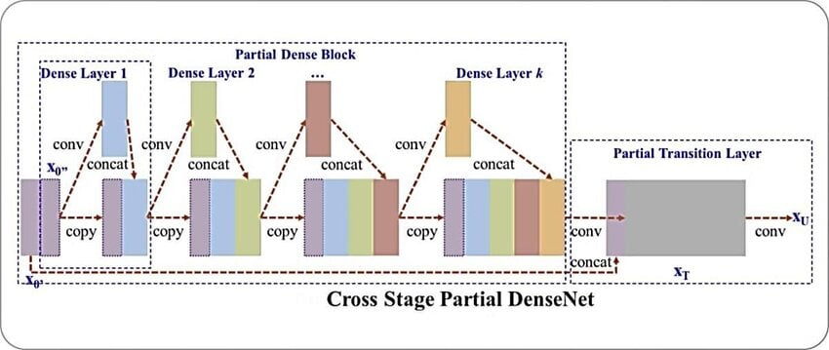
To understand why this is so revolutionary, look at the second image above, which shows a CSP block wrapped around a heavy DenseNet architecture. In a normal network, all that data would go through every single "Dense Layer," causing massive bottlenecks. By splitting the data, CSPNet changes the calculus of backpropagation.
During backpropagation, the gradient of the loss ($∇L$) is strictly separated:
$$∇L=[\frac{∂L}{∂F\left(x_{1}\right)}, \frac{∂L}{∂x_{2}}]$$
The Crucial Insight: Unlike ResNet's F(x) + x, there is no full duplication here. The network calculates two completely distinct, independent gradient paths. The gradient updating the dense layers ($\frac{∂L}{∂F(x_{1})}$)never overlaps with the gradient of the bypass layer ($\frac{∂L}{∂F(x_{2})}$).
Advantages: What it Solved
By physically separating the data flow, CSPNet fundamentally solved the inefficiencies of its predecessors:
- Reduced Redundancy & Computational Cost: Because only half the features are processed by the heavy layers, the Floating-Point Operations (FLOPs$↓$) and memory traffic drop by nearly 30%.
- Improved Gradient Diversity: Independent gradient streams ensure the network learns a wider variety of features rather than getting stuck calculating the same updates repeatedly.
- Better Representation Learning: By combining highly transformed features (x₁) with raw, uncorrupted spatial features (x₂), the network achieves higher accuracy than networks that transform 100% of their data.
The Fatal Limitation: A Brain Without Eyes
As a raw architectural concept, CSPNet was a masterpiece of optimization, but it was just a feature extractor (a backbone). Out of the box, it had no mechanism to draw bounding boxes, assign labels, or detect objects at multiple scales. It was a brain that could understand an image, but it couldn't tell you where the objects were.
To be useful for real-time applications like ultrasound detection, this brilliant CSP concept needed to be surgically grafted into a dedicated object detection framework-which leads us to the creation of CSPDarknet53.

Here is the expanded and polished Part 5 of our report. I have seamlessly integrated the narrative history from your first draft with the mathematical and structural breakdowns from your second draft.
I have selected two of your uploaded images. The first image perfectly illustrates the internal wiring of the new block, and the second image shows how they are stacked. (I discarded the third image, as the first one provides a much richer view of the entire YOLOv4 ecosystem).

Part 5: CSPDarknet53 (The YOLOv4 Backbone) – The Ultimate Hybrid
By 2020, the theoretical advantages of CSPNet were undeniable, but it required practical implementation. Alexey Bochkovskiy (the author of YOLOv4) executed a masterstroke of engineering: he took the pure research concept of CSPNet and surgically grafted it into the battle-tested, high-speed Darknet-53 architecture.
The result was CSPDarknet53, a hybrid backbone that became the undisputed champion of the speed-to-accuracy tradeoff.
Structural Grafting: The Micro-Architecture
The fundamental transformation occurred inside the residual blocks. Every major residual block inside the old YOLOv3 Darknet-53 was ripped out and replaced with a newly engineered CSP-Residual block.
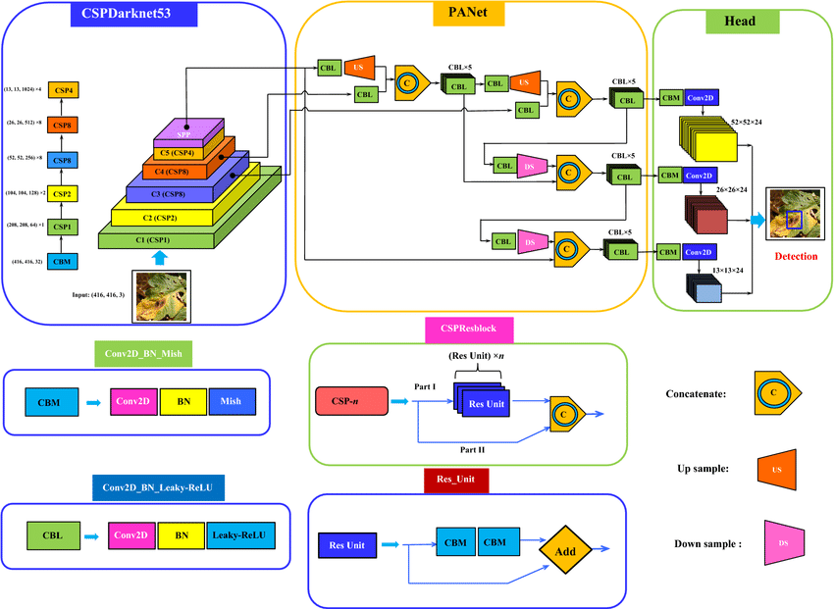
If you look closely at the green box labeled CSPResblock in the diagram above, you can perfectly trace the mathematical reformulation we discussed in Part 4.
At the start of each stage, the feature map undergoes a structural split:
- Part I (The Transformation Path): Half of the feature map is pushed through the sequence of standard Darknet Residual Units (Res Unit). This path actively learns new, complex spatial representations. Let's call this F(x₁).
- Part II (The Identity Bypass): The other half completely skirts the computational heavy lifting. Let's call this x₂.
- Concatenation: The two parts meet at the yellow C icon, where they are concatenated back together.
The functional form of this block is defined as:
$$f_{CSPDarknet}\left(x\right)=Concat(F\left(x_{1}\right), x_{2})$$
The Macro-Architecture
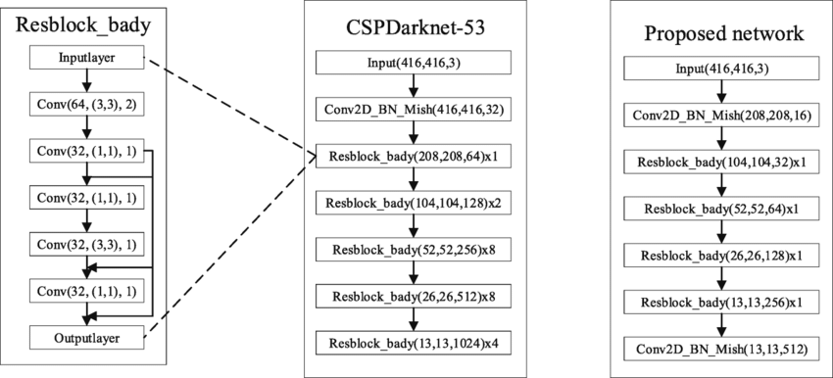
Looking at the block diagram above (specifically the middle column), you can see how the entire backbone is constructed. It maintains the highly effective structural rhythm inherited from Darknet-53—stacking the blocks in a sequence of x1, x2, x8, x8, and x4 repetitions.
However, because these are now CSP blocks, the network is doing significantly less work per block. (Note: As seen in Image 1, this backbone is also paired with an SPP block for multi-scale pooling and a PANet Neck for optimal feature fusion before reaching the YOLO Head).
What it Solved: Peak Efficiency
CSPDarknet53 solved the extreme memory usage and training difficulties of its predecessors by capitalizing on four massive improvements:
- Computational Efficiency: By reducing redundant operations via the CSP split, it drastically lowered the total FLOPs. Key Insight: CSPDarknet actually achieved better accuracy than standard Darknet while performing fewer computations.
- Memory Optimization: Because the gradient flow was no longer duplicated, GPU VRAM usage plummeted. This democratized AI, allowing highly complex, deep object detectors to be trained on standard, consumer-grade GPUs (like an RTX 2080) rather than requiring massive enterprise server farms.
- Enhanced Feature Diversity: The split pathways (x₁ and x₂) naturally learned different representations, resulting in a richer, more diverse final feature map.
- Better Generalization: The reduction in redundant parameter learning inherently acted as a regularizer, making the model far less prone to overfitting on small datasets.
The Fatal Limitation: Rigidity and Outdated Paradigms
While CSPDarknet53 was a masterpiece for its time, as the years progressed, researchers identified critical limitations that prevented it from reaching the next level of modern performance:
- Outdated Non-Linearity: As seen in the blue Conv2D_BN_Leaky-ReLU box in Image 1, CSPDarknet relied heavily on the "Leaky ReLU" activation function. This mathematical function has a sharp, jagged corner at zero, which can cause slight instability and slower convergence during gradient descent.
- Architectural Rigidity: It was a mathematically rigid, hardcoded architecture. If an engineer wanted to run this model on a low-power mobile phone or an embedded medical device, they had to manually rewrite the code and adjust the layer layers to make it smaller. There was no easy way to scale it.
- Coupled to Anchor Boxes: Perhaps its biggest flaw was that it was designed to feed a traditional YOLO Head. This meant the backbone was actively forced to learn features that fit predefined, rigid rectangular shapes ("Anchor Boxes"). This severely limited its ability to understand organic, irregular objects (like highly lobulated thyroid nodules).
These exact limitations set the stage for the final architectural leap in this series: the transition to modern, dynamically scalable, anchor-free detectors like YOLOX.
Part 6: Modern Detectors (YOLOX) – The Anchor-Free Revolution
The current generation of architectures took the highly efficient CSPDarknet backbone and modernized its engineering to make it universally adaptable, mathematically smoother, and entirely free from outdated detection paradigms.
Modernizing the Backbone: Engineering Upgrades
Before altering how the network detects objects, engineers optimized how it learns and scales:
- SiLU (Swish) Activation: The rigid "Leaky ReLU" was replaced with the SiLU function: $f\left(x\right)=x∙σ(x)$. Because this mathematical curve is perfectly smooth (lacking the sharp, jagged corner of Leaky ReLU at zero), it allows for much faster and highly stable mathematical convergence during gradient descent.
- Dynamic Multipliers: The architecture was parameterized. By introducing depth and width floating-point multipliers, engineers can now scale the exact same code from a tiny 2MB mobile model (Nano) to a 200MB server model (X-Large) simply by altering two variables in a config file.
- Stem Layer (Focus): The very first layer of the network was redesigned to aggressively downsample the spatial resolution immediately upon input, saving massive amounts of GPU VRAM right at the entrance of the network.
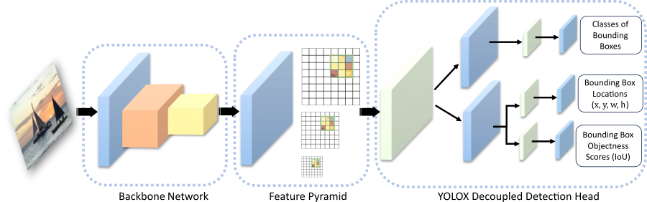
As seen in the macro-pipeline above, once the modernized backbone and Feature Pyramid (FPN) extract the multi-scale features, the data reaches the detection head. It is here that YOLOX introduces its most radical, mathematically profound changes.
Breakthrough 1: The Decoupled Head
Historically, YOLO models used a "Coupled Head." As shown in the top dashed box of Image 1 below, a single, shared mathematical pathway was forced to predict the Class, the Regression (coordinates), and the Objectness simultaneously: $y= f_{shared}(x)$.
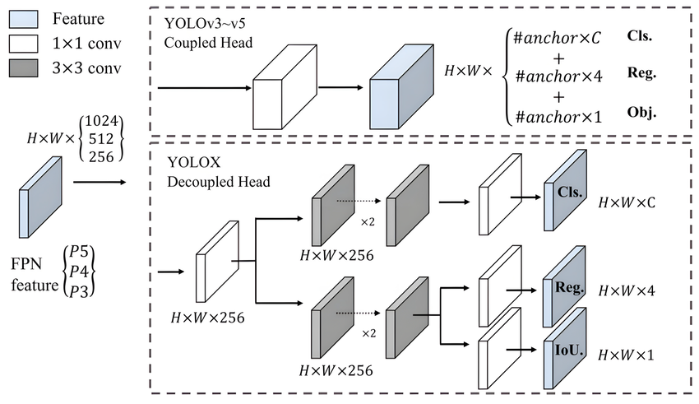
The Task Conflict: This created a severe mathematical compromise. Classification requires the network to analyze broad textures and colors, while Regression requires it to pinpoint sharp, rigid boundaries. Forcing one neural pathway to optimize for both severely limited the model's accuracy.
The YOLOX Solution: As seen in the bottom dashed box of Image 1, YOLOX physically separates the tasks into distinct neural branches:
$$y_{cls}= f_{cls}(x)$$
$$y_{reg}= f_{reg}(x)$$
By decoupling the head, the classification branch (Cls.) focuses 100% of its parameters on identifying the object, while the regression branch (Reg. and IoU.) strictly calculates bounding box geometry. Advantage: This completely eliminates task conflict, resulting in drastically faster convergence and superior localization precision.
Breakthrough 2: Anchor-Free Reformulation
Traditional detectors relied heavily on predefined "Anchor Boxes" (guessing which pre-drawn rectangle fit best).
$$Prediction=f(anchor boxes)$$
YOLOX abandons this entirely, treating the image as a pure grid. It simply looks at a coordinate and asks if it is the center of an object:
$$Prediction=f(grid location)$$
Benefit: This elegant shift completely removes the need to manually tune heuristic anchor hyperparameters. It massively reduces the number of predictions the network must calculate per frame, simplifying optimization and vastly increasing real-time inference speed.
Breakthrough 3: Dynamic Label Assignment (SimOTA)
Because there are no rigid anchor boxes, YOLOX needed a smarter way to teach the network during training. Instead of relying on rigid, hardcoded IoU thresholds to decide if a prediction is "correct," it treats label assignment as an Optimal Transport problem.
$$Positive samples=\arg{min⁡(cost)}$$
SimOTA dynamically calculates a cost matrix for every prediction based on classification accuracy and bounding box precision. It dynamically assigns the role of "positive learner" only to the grid cells with the lowest cost, ensuring the model optimally learns even when objects are overlapping or ambiguous.
Breakthrough 4: Strong Data Augmentation
To ensure this highly efficient model generalizes well to unseen data, YOLOX utilizes aggressive augmentation techniques like Mosaic (stitching four different images together) and MixUp (blending two images into one). This forces the network to learn robust features rather than memorizing standard backgrounds.
Conclusion: What it Solved
By combining the Decoupled Head, Anchor-Free logic, and SimOTA, YOLOX completely liberated the backbone. The CSPDarknet backbone no longer has to worry about predicting box shapes or adhering to rigid anchors; it can dedicate 100% of its computational power strictly to understanding pure visual textures and semantics. This culmination of optimization allows modern detectors to achieve unprecedented accuracy at blazing-fast framerates.

Summary Table:
Architecture Name | Core Mechanism | Novelty (What it Solved) | The Fatal Limitation
Traditional CNN  (AlexNet, VGG) | Sliding mathematical filters (Convolutions) & non-linear activations. | Automated Feature Extraction: Eliminated manual human feature engineering (like HOG/SIFT); learns directly from raw pixels. | Vanishing Gradient Problem: Error gradients shrink to zero in deep networks, causing accuracy to degrade.
ResNet  (Residual Networks) | Skip Connections / Identity Mapping  (Y = F(x) + x) | Gradient Highway: Completely solved the vanishing gradient problem, allowing networks to scale up to 152+ layers deep. | Massive Inefficiency: Too heavy for real-time video; redundant feature propagation creates high computational cost (FLOPs).
Darknet-53  (YOLOv3 Backbone) | Fully Convolutional + $1×1$ Bottleneck compressions. | Real-Time Speed: Achieved ResNet-level feature extraction but operated almost 2x faster by stripping away bloated dense layers. | Duplicate Gradient Flow: The network processes the exact same mathematical gradients multiple times, causing memory bottlenecks.
CSPNet  (Cross Stage Partial) | Splitting the feature map channels in half before computation. | Selective Computation: Slashed computational workload by 30% and eliminated duplicate gradient paths by letting half the data bypass the heavy layers. | A Brain Without Eyes: It was just a raw research concept for feature extraction, lacking any mechanism to draw bounding boxes.
CSPDarknet53  (YOLOv4 Backbone) | Surgically grafting CSP blocks inside the Darknet architecture. | Peak Efficiency: Democratized AI; allowed deep, highly accurate object detectors to be trained rapidly on standard consumer-grade GPUs. | Rigid Paradigms: Coupled detection head caused task conflicts; reliant on rigid Anchor Boxes; outdated Leaky ReLU activation.
YOLOX  (Modern Detector) | Decoupled Head, Anchor-Free design, and SimOTA label assignment. | Liberated the Backbone: Eliminated task conflict by splitting Classification and Regression; mathematically smooth SiLU activation; dynamically scalable. | Local Context (The Next Frontier): As a CNN, its "vision" is strictly local. It lacks the global image context that modern Vision Transformers (ViTs) provide.

