Methodology – COMPANY A

* 1. Detail your proposed methodology for research and data collection, the analysis of which will underpin your proposal.



Company A has always employed Scrum, a pragmatic and highly collaborative Agile framework, to which user centred design and Drupal development is perfectly suited. Our entire team are Certified Scrum Masters demonstrating our commitment and belief that it is the best approach for delivering successful projects.

## Discovery

The objective of the Discovery phase is to understand the whole, creating a deeper understanding of the Business requirements and the user needs. Starting with a series of stakeholder interviews and followed by user research. The user research will be focussed on the 5 groups identified and outlined in Part 1 of the tender documents.

Depending on the current knowledge within the CDU team about these 5 target audiences research activities like; interviews and observations will be able to fill any knowledge gaps on the role of the website in the context of each audience.

Company A work closely with our clients to help prioritise feature and functionality requirements, and then optimise the implementation to best suit budgets and timelines. Smart planning up front, and collaborative project management throughout, saves time and money, and always delivers more value for the available budget.

While the deliverables for the Discovery phase will vary depending on the required research, the Project Backlog with design challenges, User stories and Tasks will always be included. The Project Backlog will guide the following design sprints and eventually development as well.

## Design Sprints

The objective of each design sprint is to define, explore, and validate solutions to design challenges ready for detailed design and development. Working closely with the CDU team, each design sprint consists of the following;

* Strategy
  + Sprint planning; all team planning session for all design activities in coming sprints, including the success metrics for each.
  + Co-creation; ideation for selected design challenges with selected team members. Aimed to gather a wider range of ideas and solutions.
  + Design exploration: Company A’s Experience Designer will explore the ideas further through best practises within the outside the industry.
* Validation
  + Sketches; with more details on how the ideas can be implemented in the context of CDU.
  + Prototype; when required to validate the designs prior detailed design or development. Company A has the in house capability to test designs with the target audiences. This is not included in the presented cost.
* Creation
  + Detailed design (UI Design); for the creation of designs which can be handed over to the development team for implementation.
  + Style guides; All modules, labels, button styles and other commonly used elements will be documented which allows the design and development team to re use these elements during this project and in any further projects.

The final design sprint will be focussed on a overall polish and the launch of the website without the exploration of new journeys or features. Where necessary, design sprints will occur in tandem with development sprints.

## Development & Delivery Sprints

Scrum promotes a higher level of knowledge transfer between team members and clients. We utilise a suite of web-based tools to collaborate and manage all types of project communication and deliverables, meaning we can easily manage distributed development teams and clients in disparate locations.

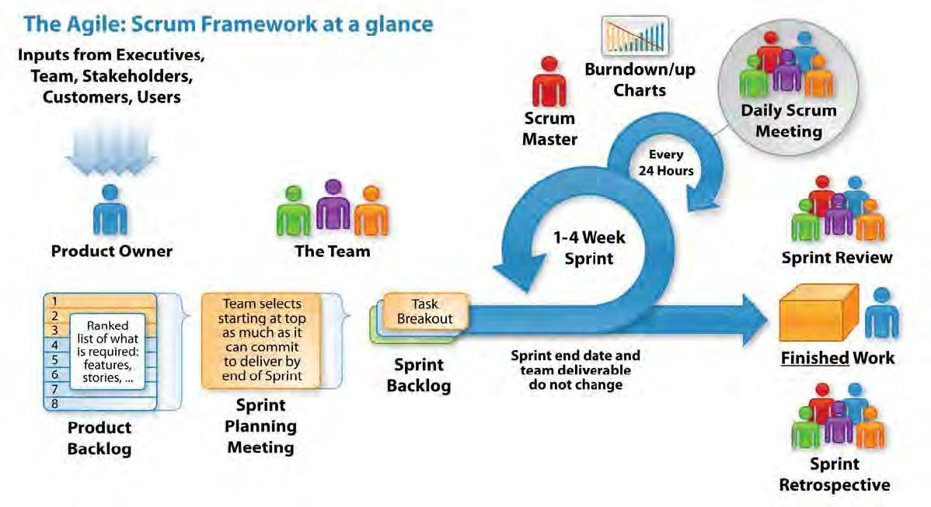

We ensure our client contact (the 'Product Owner') is embedded as part of the development team, promoting transparency and better understanding of processes and deliverables. We break up large projects into 2 week iterative release cycles (Sprints) where small groups of features and functions are built, tested and released to a development server in a completed state for client acceptance testing.

Scrum is focused on prioritisation of feature and functional requirements to achieve the highest business value. This means that projects can go live with core functionality in a faster time frame, with less urgent features added over time in subsequent iterative releases where the budget and timeline allow.

Requirements changes will always occur mid-stream on large projects, and Scrum enables the development team to respond quickly to these changes by re-prioritising features for release without cumbersome change-request processes.

Testing is integrated into each iterative release, resulting in a shorter period of final testing at the end of the project cycle. As part of our Scrum development methodology, Quality Assurance (QA) tasks are built into every iteration cycle, so User Acceptance Testing (UAT) is a basic component of our solution building process. Access for sight-impaired and other special users has become a key requirement for many websites, particularly in the government and non-profit sector, and Company A is a leader in WCAG 2.0 accessibility compliance for Australian Government websites.

## RELATIONSHIP MANAGEMENT & COMMUNICATION

All our client engagements commence with a Project Charter workshop to clearly establish roles, responsibilities and communication channels.

Day to day contact is managed by a dedicated Client Service Manager, with our Client Service Director overseeing issue escalation as required. Company A’s founders are always available for involvement in key discussions and decisions.

Company A uses the Agile development framework, Scrum, for managing our projects, whilst ensuring that the team is working towards clear milestones in well defined phases. This enables Company A to focus on delivering the highest business value for a project by prioritising requirements in collaboration with the client’s Product Owner.

Our communication approach and tools include:

* Daily 'Scrum' Meetings: Quick 15 minute team updates on the project status with the Product Owner.
* Weekly Status Reports: Summary of the project's status - current task status, hours tally and task burn-down.
* Regular Executive Reviews with the Client Service Director or company Founders.
* Text chat and online video conferencing to ensure efficient communications, using tools such as Slack, Google Hangouts and GoToMeeting.
* Project Tracking: All project task tracking, documentation and file sharing is done via our online tool, Redmine. Documentation transcripts can be exported as spreadsheet files from Redmine for reference and archiving purposes. If additional documentation is required, Company A can provide this as needed, costed accordingly.

## Program of works



Provide a Program of Works (preferably in the form of a Gantt Chart or similar) that is to include at a minimum project work disciplines, relevant milestone progress dates, and a project completion date.

We expect to commence the project in the last week of February and to spend March and April gathering requirements and developing the user experience and design approach. The Development Sprints will then commence in May, with an expected 12 week cycle for the main site, and a 6 week cycle for the subsites, which can be run in parallel by a separate team from June to late July.

The Delivery Sprints would then commence in late July and run to mid August, with an indicative launch date in late August or early September. Company A would then supply support services for the following 6 months or beyond based on CDU’s requirements.

Please refer to the pricing schedule for a detailed breakdown of all deliverables for each phase of work.

The program of works will be refined during the Discovery Phase in consultation with CDU.

**Project Kickoff:** Feb**​** 27 - Mar 3 (1 week)

**Discovery:​**Mar 6 - 31 (4 weeks)

**Design Sprints 1-2** (4**​** weeks)

|  |  |
| --- | --- |
| - Sprint 1 | Apr 3 - 14 |
| - Sprint 2 | Apr 17 - 28 |

**Main Site Development Sprints​**(12 weeks)

|  |  |  |
| --- | --- | --- |
| - Sprint 1 | May 1 - 12 | |
| - Sprint 2 | May 15 - 26 | |
| - Sprint 3 | May 29 - Jun 9 | |
| - Sprint 4 | Jun 12 | - 23 |
| - Sprint 5 | Jun 26 | - Jul 7 |
| - Sprint 6 | Jul 10 - 21 | |

**Design Sprints 3-6​**(8 weeks in parallel with Main Site Development Sprints)

|  |  |  |
| --- | --- | --- |
| - Sprint 3 | May 1 - 12 | |
| - Sprint 4 | May 15 | - 26 |
| - Sprint 5 | May 29 | - Jun 9 |
| - Sprint 6 | Jun 12 - 23 | |

**Sub Site Development Sprints** (6**​** weeks in parallel with Main Site Development Sprints)

|  |  |  |
| --- | --- | --- |
| - Sprint 1 | Jun12 - 23 |  |
| - Sprint 2 | Jun 26 - Jul 7 |  |
| - Sprint 3 | Jul 10 - 21 |  |
|  | |  |
| **Delivery Sprints** (4**​** weeks)  - Sprint 7 Jul 24 - Aug 4  - Sprint 8 Aug 7 - 18 | |  |

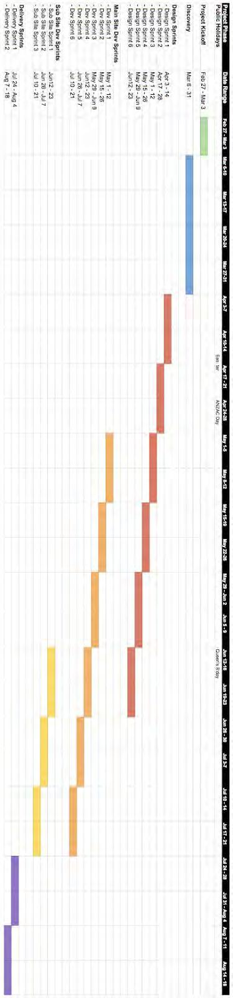

The following provides a chart detailing the proposed project schedule, to be refined and finalised during the Discovery Phase.