Company B

Methodology



Company B

Methodology

Detail your proposed methodology for research and data collection, the analysis of which will underpin your proposal.

Data collection

Competitor audit

External audience engagement

Internal stakeholder engagement

Brand workshop

Content strategy.

Functional specifications

Outcomes

Data collection

Company B will collect data from Google Analytics from the current CDU website and analyse the data to determine user’s activity on the site. Data to be collected from Google Analytics includes:

- Landing pages

- Pages visited

- User demographics

- Navigation path

- Time spent on pages/site

- Source used to arrive at site

This data will be used to determine patterns in user behaviour and allow us to recognise any unused or low volume pages, identify where people are leaving the site and provide insight into areas that are obsolete or need to be easier to find.

Competitor audit

Through a comprehensive competitor audit we will create benchmarks to guide the development and design process. A detailed examination of key pages on competitors' websites will be undertaken and usability testing with current and prospective students to measure the performance of the CDU website site against competitor sites.

.com.au

External audience engagement

We would conduct surveys, interviews and focus groups between iinternal and external stakeholders. We plan to implement a competition in conjunction with the survey, with feedback gaining participants entry into a prize draw.

This will allow us to gain qualitative data to identify what is most important to each key stakeholder or end user group. The purpose of the prize draw is to encourage participation and ensure our data pool is significant enough to ensure we can gain viable insights. into user behaviours.

Internal stakeholder engagement

As the website represents all faculties and business units across the university, it is important that internal and external stakeholders are engaged and informed across the duration of the project. Each stakeholder has their own business objectives and requirements from the CDU website and it is important that their insight is recorded and factored into the project plan. We will facilitate workshops with key team members to gather their thoughts and ideas.

Internal stakeholders will be involved in the process throughout the project and will be apprised of development progress with regular meetings, demonstrations and opportunities to provide feedback. Their continued involvement will be essential to the success of the project.


39

Brand workshop

Company B will collate CDU brand information and documentation, discussing the brand with key groups to ensure in depth specifications and requirements are captured and recommendations for knowledge translation into the online space in line with CDU branding.

Content strategy

Auditing existing content and developing new content will be the largest piece of the project, requiring the most considerable resources from commencement to completed of the project. The content strategy for the new website will need to be worked upon throughout the entirety of the proposed schedule and is critical for the success and timely delivery of the project.

Considerable efforts will be directed to workshops to discuss content with key stakeholders to identify key content requirements. These workshops will identify key navigation paths and group together the website structure in a way that correlates with how users will potentially engage with CDU online.

Outcomes

The research methodologies above will feed into stage two of the project and allow for:

- User Group Analysis Report (each group’s aims and frustrations)

- User journey/user persona mapping

- Brand Persona - documents tone of voice of the site and whether it has multiple personalities for various users

- Sitemaps

- Content strategy

- Hierarchy of content wireframes

- Recording outcomes of consultations

- Integration of consultation outcomes

- Proposed consultation locations and schedules

- Functional specifications report

- Strategy document detailing all of the above

Functional specifications

Our Drupal experts and system architects will review the outcomes of the research phases above to determine functional requirements for development of the site. A detailed document will be produced outlining:

• Technology stack and topology • Contrib modules required

• Content types and entities • Custom module requirements

• Workflow diagrams • 3rd party system integrations

• User roles and permissions • Implementation strategy

• Security requirements • Development strategy

• Accessibility requirements


41




Program of works

Provide a Program of Works (preferably in the form of a Gantt Chart or similar) that is to include at a minimum project work disciplines, relevant milestone progress dates, and a project completion date.

Proposed timeline
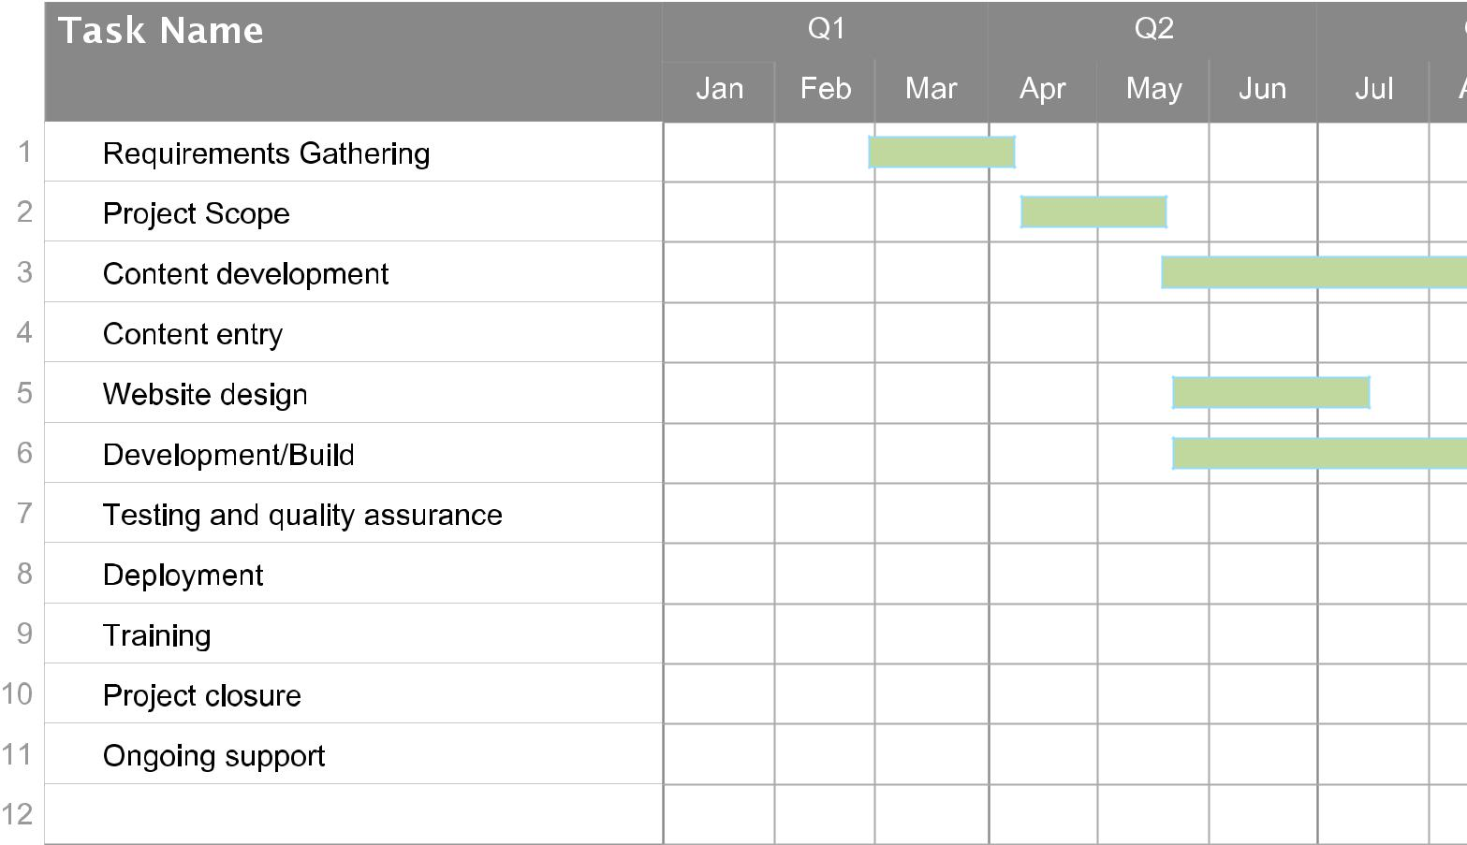
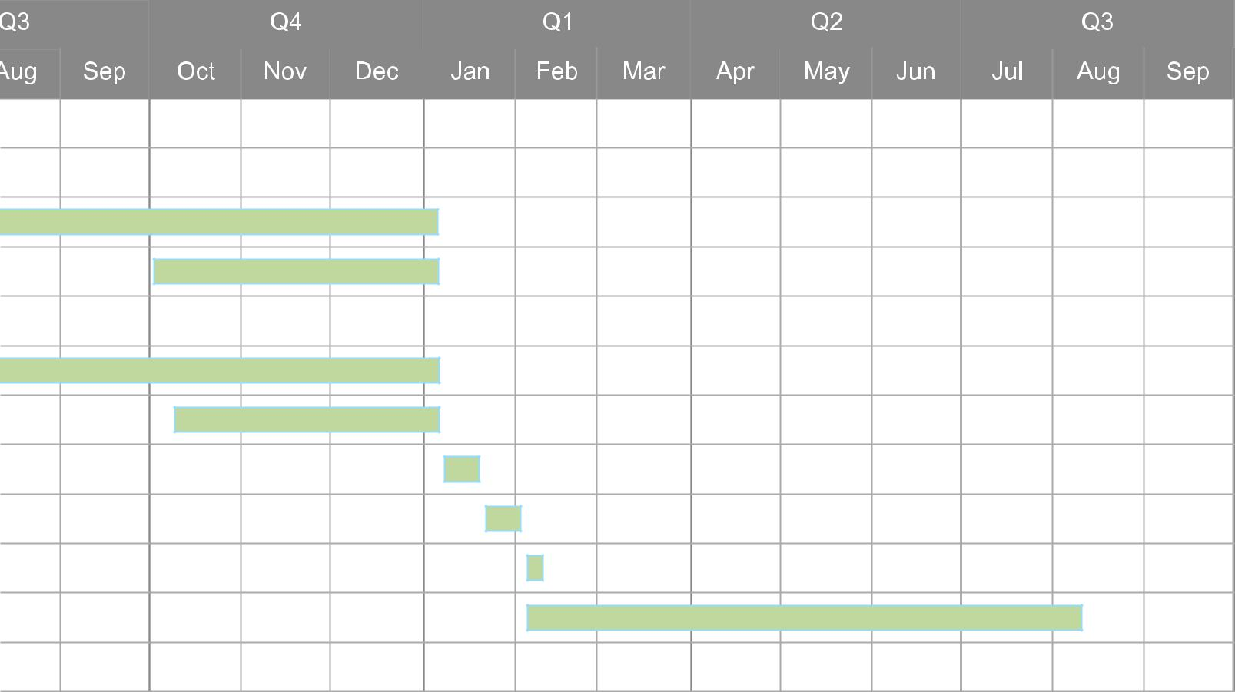
Companhy B

57

