AI Assisted Data Center Infrastructure Monitoring and Predictive Maintenance System
Capstone Technical Report Chapters 4 5 and 6
Zakir H.
University of the People
Master of Science in Information Technology
MSIT 5910 Capstone Project
Submitted to the MSIT 5910 Course Instructor
October 12, 2026

Contents
Chapter 4 Results
4.1 Implementation Overview
4.2 Output and Screenshots
4.3 Evaluation Metrics
Chapter 5 Discussion
5.1 Interpretation of Results
5.2 Comparison with Literature Findings
5.3 Implications and Limitations
5.4 Future Work
Chapter 6 Conclusion
6.1 Main Findings and Contributions
6.2 Lessons Learned and Challenges
6.3 Next Improvements and Final Implications

Chapter 4 Results

4.1 Implementation Overview

Introduction and Project Scope
This chapter reports implementation outcomes for the AI Assisted Data Center Infrastructure Monitoring and Predictive Maintenance System across Units 4, 5, and 6. The project converts infrastructure readings into understandable evidence for technician investigation. Its research question asks how effectively transparent thresholds and Isolation Forest identify abnormal telemetry and how an integrated interface can support review. Unit 4 established the delivery rationale and demonstrated the initial analytical design. Unit 5 strengthened validation, standardized the detector comparison, and documented 43 passing tests. Unit 6 connects that core to authentication, browser interaction, API orchestration, persistent observations, and review records. The application demonstrates a local decision-support workflow. It does not establish actual equipment-failure prediction, reduced downtime, or production readiness. The implemented workflow retains the original scope while leaving operational validation for subsequent work with representative telemetry. Consistent with the engineering orientation of Summers (2020), the report links requirements to executable behavior and inspectable evidence. The accompanying figures expose architecture, source, outputs, setup, and evaluation so that the findings can be examined rather than accepted solely from verbal descriptions.

Core Algorithm and Data Preparation
The generator produces 12,000 labeled synthetic observations with seed 5910 through a local random-number generator. The six features are CPU utilization, memory utilization, storage utilization, network throughput, device temperature, and environmental temperature. Approximately eight percent of observations receive an injected anomaly in one of five indicators. Environmental temperature supplies context but has no independent threshold rule. The first 9,600 records form the development partition and the final 2,400 form the holdout. Although this is a positional split, the records are independent synthetic samples rather than chronological asset histories. Consequently, the partition does not demonstrate generalization to later equipment behavior. Validation converts approved fields to numeric values, rejects missing or nonfinite readings, and enforces the documented synthetic ranges. CPU, memory, and storage span zero to 100 percent; network spans zero to 1,000 Mbps; device temperature spans zero to 100°C; environmental temperature spans zero to 45°C. These envelopes describe the experiment, not universal safe operating limits. Full validation precedes threshold decisions, preserving the Unit 5 correction that prevents an early breach from concealing a later invalid field. Fixed seeds and explicit boundaries make failures reproducible and simplify comparison between versions.

Detectors and Evaluation Logic
The threshold baseline flags an observation when at least one of five measurements equals or exceeds its configured limit. Configuration contains CPU 92%, memory 94%, storage 95%, network 940 Mbps, and device temperature 82°C. The baseline is transparent because the interface can display the particular measurement and limit responsible for investigation. Isolation Forest provides a contrasting unsupervised approach using 200 trees, contamination 0.08, and random state 5910. StandardScaler and the model are fitted exclusively to development observations. The holdout is transformed using that fitted scaler; it does not contribute to fitting or threshold selection. Model output minus one maps to anomaly label one, while output one maps to normal label zero. The evaluator applies both detectors to identical holdout observations and calculates the same confusion-based measures. It rejects empty, mismatched, or nonbinary metric vectors instead of silently truncating them. This preserves the corrected Unit 5 comparison. Ruff et al. (2021) explain the importance of assumptions about normality in anomaly detection. Here, statistical unusualness is presented as an experimental observation, whereas configured threshold breaches drive the main review workflow.

Integrated Architecture and Data Flow
Figure 1 presents the implemented architecture and its trust boundary. A browser interface exchanges same-origin JSON with Flask. Authentication and CSRF checks precede state-changing requests. The application factory loads configuration, initializes SQLite, and constructs a reusable detection service. The service retains the existing validation and baseline modules, fits the experimental forest once during startup, and makes both predictions available to the API. Request data never retrains the model. After analysis, the storage module commits an observation before the API returns a successful creation response. The browser then renders the explanation and refreshes the latest-record table. This ordering makes saved status meaningful: the interface does not announce successful persistence before the transaction completes. API routes also expose held-out metrics and review acknowledgements. The design separates presentation, orchestration, analysis, and persistence, allowing each responsibility to be examined independently. A malformed request fails at the API boundary; a schema violation fails during validation; a storage error becomes an explicit service-unavailable response. This separation supports fault localization and preserves technician authority by excluding endpoints that reboot equipment, alter infrastructure settings, or close maintenance tickets automatically.

Persistence and Review Semantics
SQLite stores observations with an identifier, UTC creation time, serialized analysis payload, baseline anomaly flag, and review status. The payload retains validated telemetry, both predictions, threshold reasons, and configuration and model identifiers. A separate audit table records acknowledgement actor, action, observation identifier, and timestamp. Parameterized statements prevent input values from being interpreted as SQL syntax. The acknowledgement transaction updates only a record whose status is open and inserts its corresponding audit entry within the same transaction. A repeated acknowledgement therefore returns a conflict response rather than creating another review event. Normal observations remain visible for comparison but do not require acknowledgement. The retrieval endpoint returns the latest 50 records, ordered by descending identifier. This bounds the response while acknowledging a usability limitation: older records need a future paginated view. Reopening storage through another Store instance preserves observation and review state in the integration test. Persistence is therefore demonstrated beyond transient in-memory output. However, local SQLite files are not encrypted by this implementation, and audit rows are not cryptographically tamper-resistant. These limitations matter before introducing organizational telemetry or claiming enterprise-grade governance.

Authentication and Prototype Boundaries
Authentication uses one configured technician account and a Werkzeug-generated password hash. Required environment settings supply the password hash and session secret; application startup fails when either is absent. Successful login clears previous session contents and creates a new CSRF token. Protected API routes require an authenticated session, and protected POST requests require the matching token. Cookies use HttpOnly and strict SameSite settings, with a 30-minute permanent-session lifetime. Secure cookies are configurable for HTTPS staging; loopback demonstration uses ordinary HTTP. A content-security policy permits same-origin scripts and styles, rejects framing, and restricts external resources. Other headers disable caching and content-type sniffing. Request bodies are limited to 16 KiB. The login route rejects a conflicting Origin header, and the browser displays generic credential errors. These controls provide an inspectable boundary for the research prototype. They do not implement organizational identity federation, multiple roles, password recovery, multifactor authentication, login throttling, or account lockout. Therefore, the application should remain restricted to controlled demonstration until stronger identity and transport controls are validated. Security completion is evaluated separately from detection quality.

4.2 Output and Screenshots

Two Demonstrated Functionalities
The first demonstrated functionality is authenticated telemetry analysis. The normal fixture contains CPU 50%, memory 60%, storage 70%, network 400 Mbps, device temperature 55°C, and environmental temperature 24°C. After login, submitting these values creates observation one with HTTP 201, a baseline anomaly value of zero, and a normal status. The second fixture changes only device temperature to 90°C. It creates observation two with baseline anomaly one, open status, and the explanation “temperature_c: 90 >= 82.” The forest calls this particular hot fixture typical. Figure 4 shows that disagreement explicitly rather than hiding it behind a single reassuring classification. The second functionality is persistent alert review. Selecting Acknowledge for observation two changes its status to acknowledged and creates an audit event naming the configured technician. Figure 5 shows the resulting table, and the database evidence confirms the matching row and audit action. The interface explains that acknowledgement means reviewed for investigation, not repaired or safe. Together, these workflows demonstrate telemetry analysis and recorded human review without changing the condition of the equipment.

Source and Output Traceability
Figures 2 and 3 pair actual source excerpts with captured execution evidence. The generator, validator, baseline, forest preparation, evaluator, service, API handler, SQL operations, and browser fetch linkage are represented. The API handler calls the detector and storage modules rather than reproducing their logic in the interface. The browser sends numerical JSON, checks unsuccessful responses, renders text safely, and refreshes saved records after successful creation. Negative testing submits a CPU value below the declared minimum and obtains HTTP 400 with the message identifying the violated range. Automated checks confirm invalid requests do not create records. Authentication tests separately verify HTTP 401 for unauthenticated access and HTTP 403 for missing CSRF tokens. A simulated SQLite failure yields HTTP 503 and a neutral retry message rather than exposing database details. Archived execution reports no JavaScript errors for the captured normal, hot, and acknowledgement sequence. Screenshots are records of the working local application; source captures display executable files and logs. They provide visual evidence of implementation, but do not replace tests of correctness, security, or usability.
Figure 1
Implemented system architecture
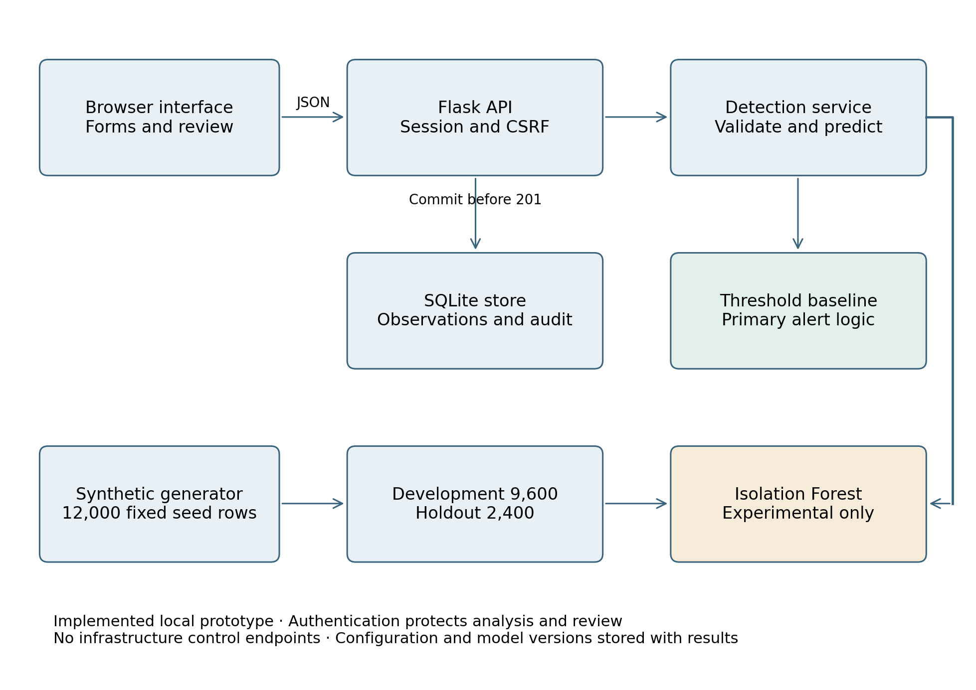
Note. The detection service fits the model on development data before requests are accepted. Analysis precedes storage; review updates the stored observation and audit.
Figure 2
Core module implementation
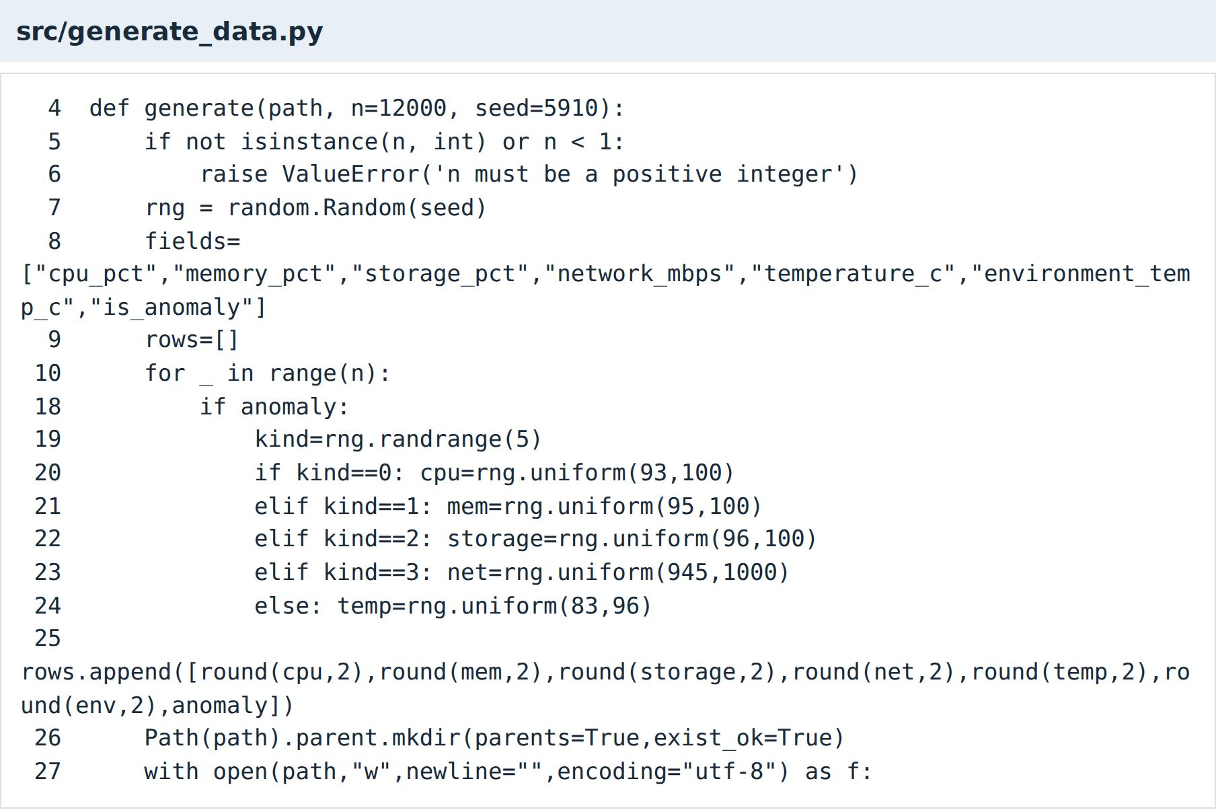
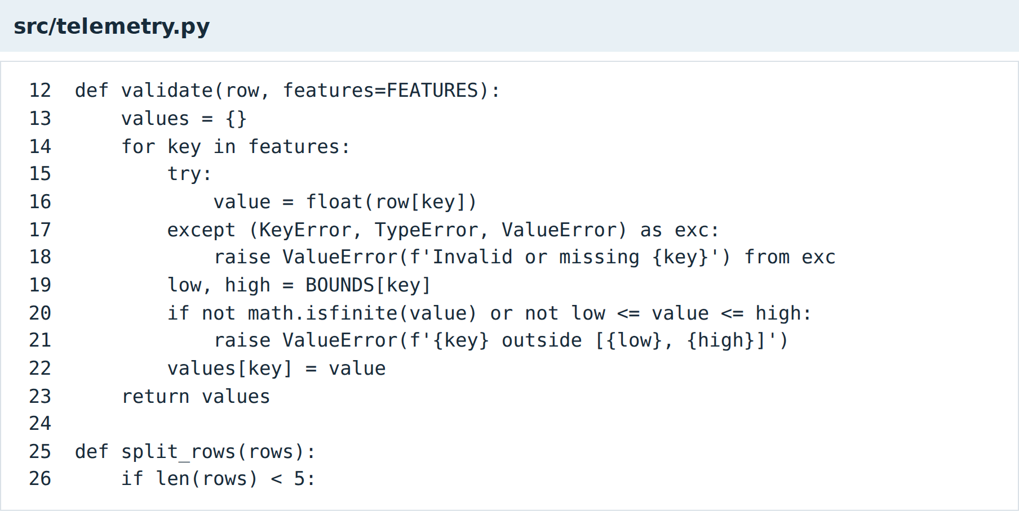
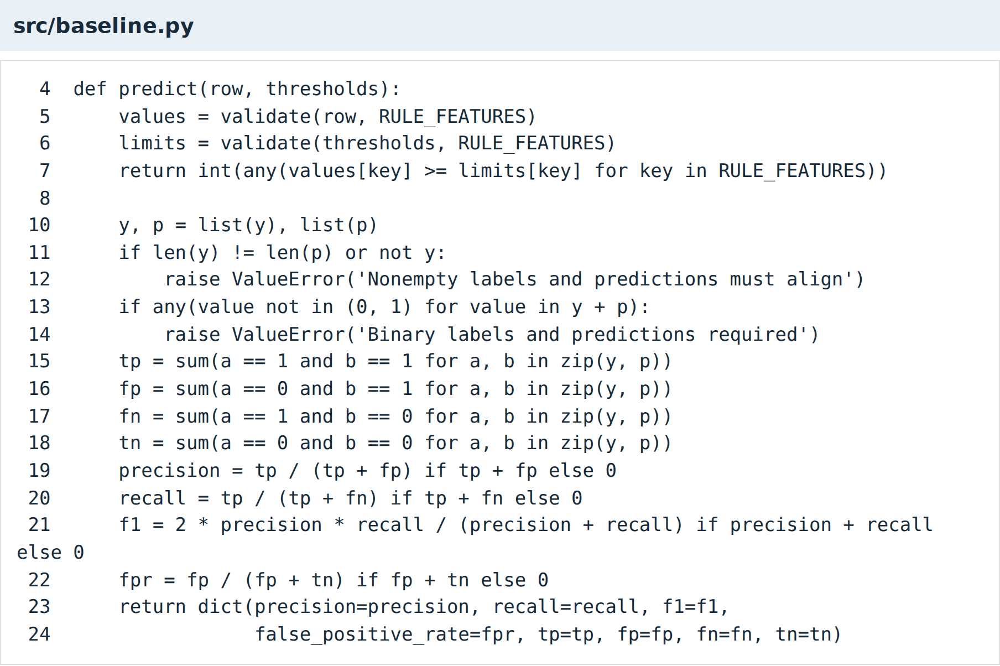
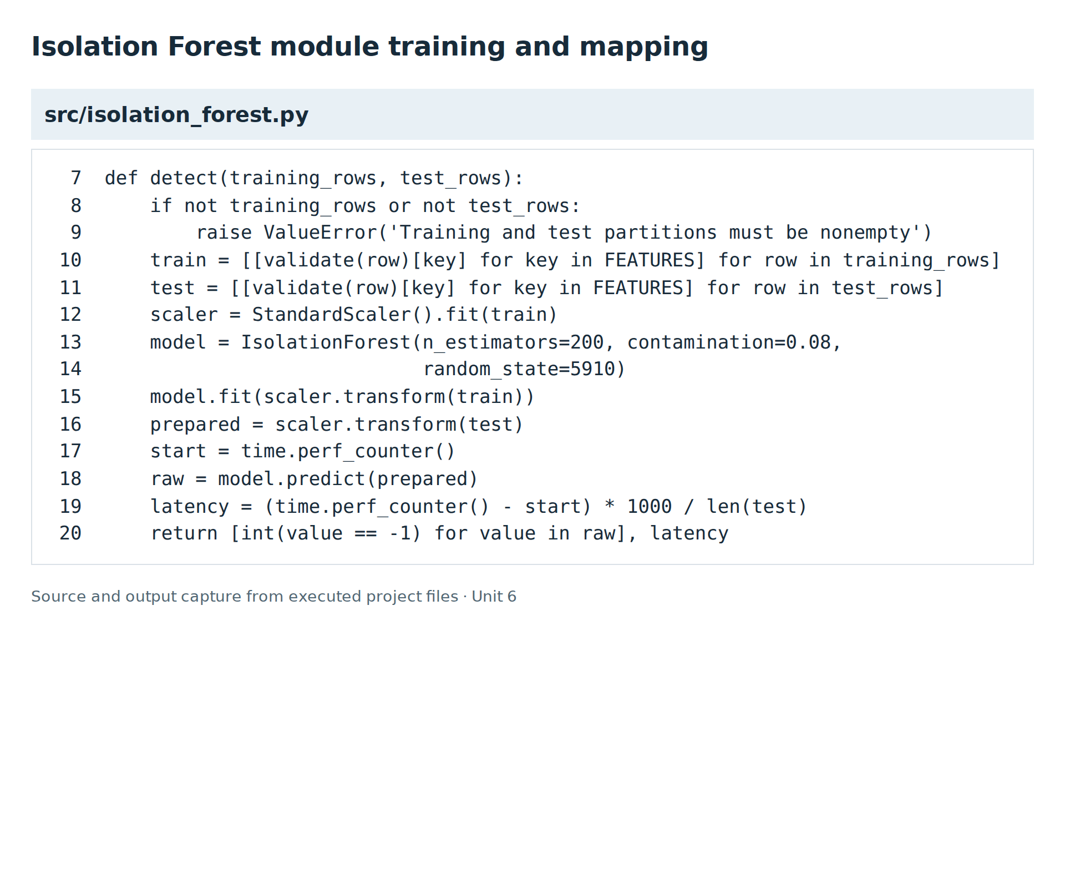
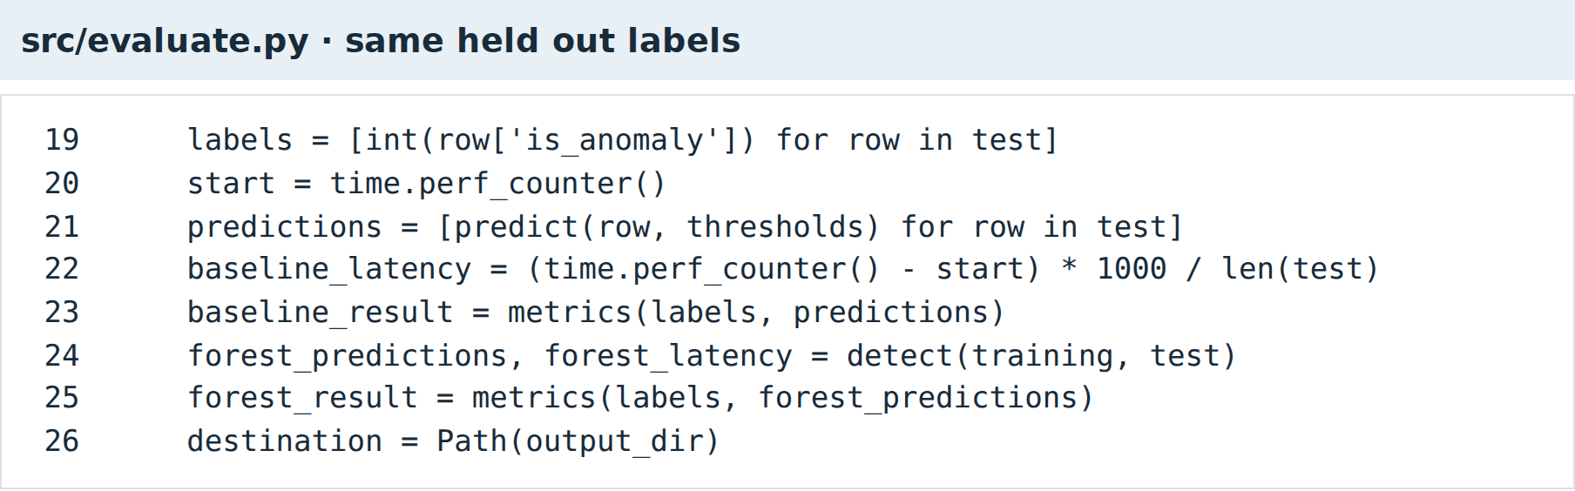
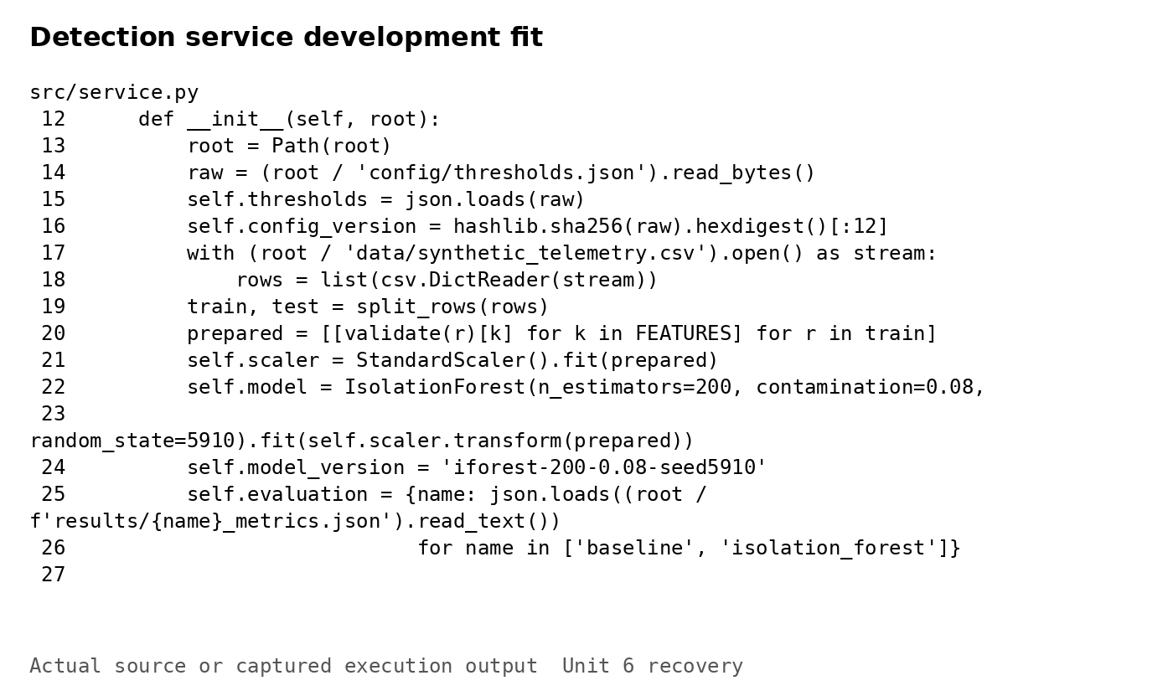
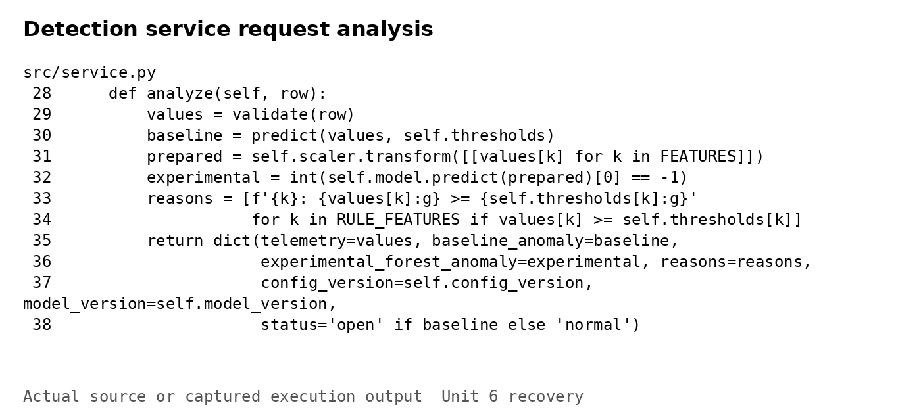
Note. Source excerpts show data generation, validation, the baseline, forest fitting and label mapping, comparable evaluation, and the reusable detection service. All model fitting uses the development partition.
Figure 3
API communication storage and detector outputs
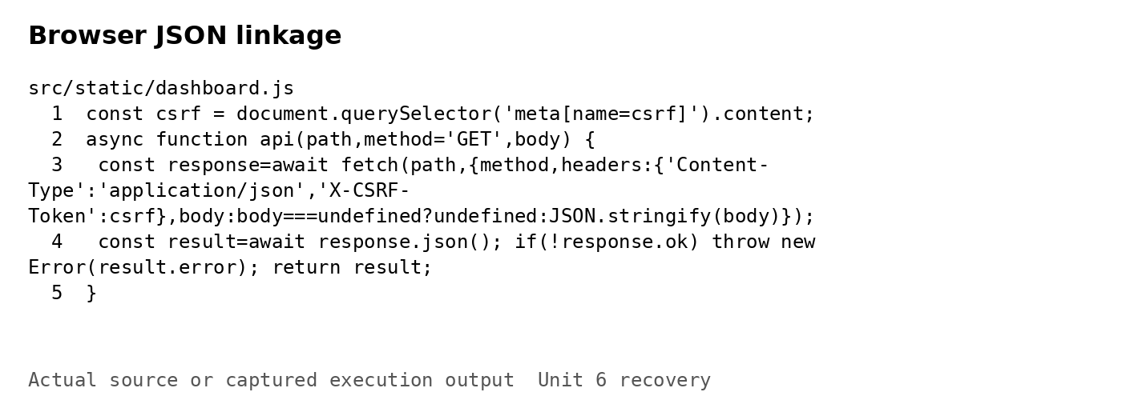
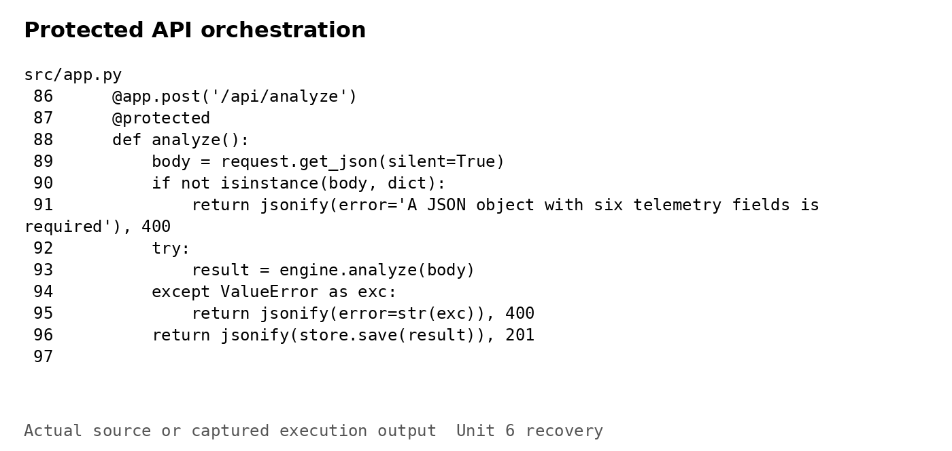
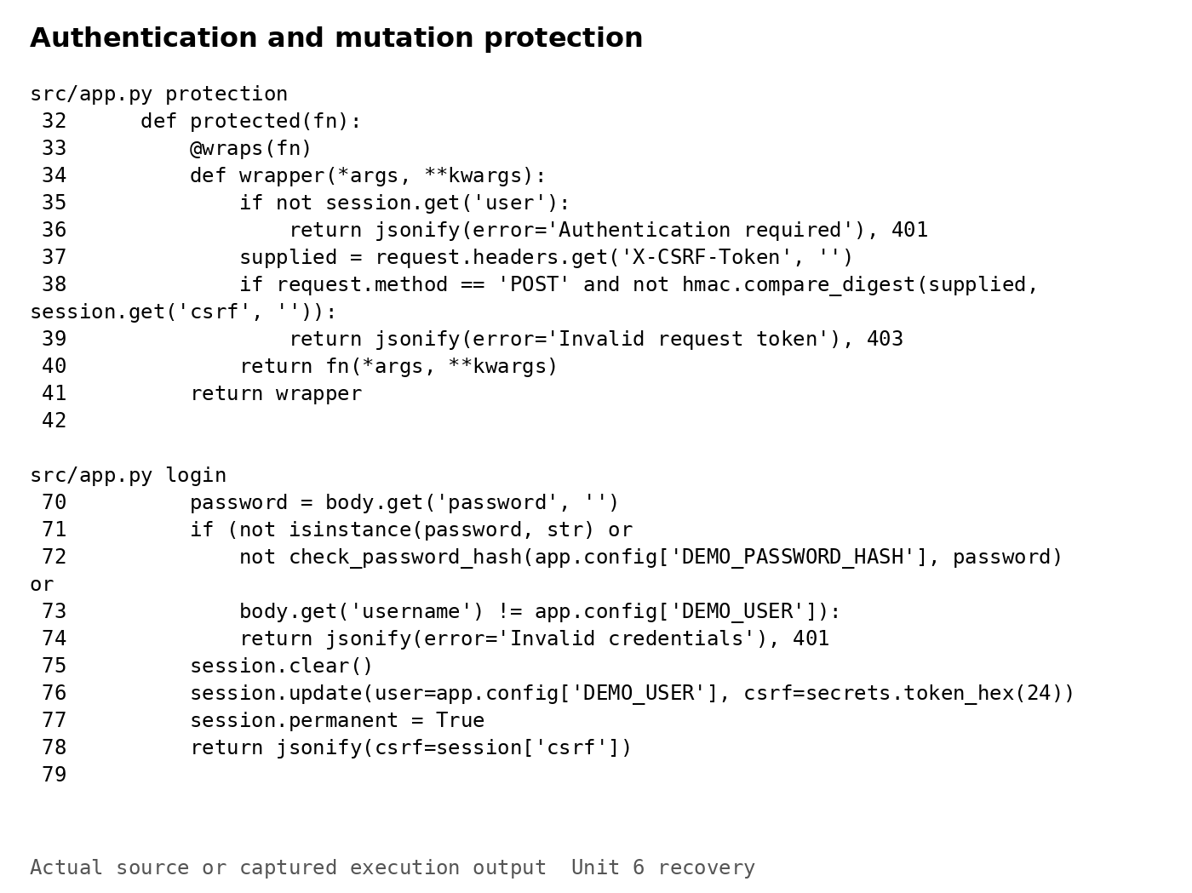
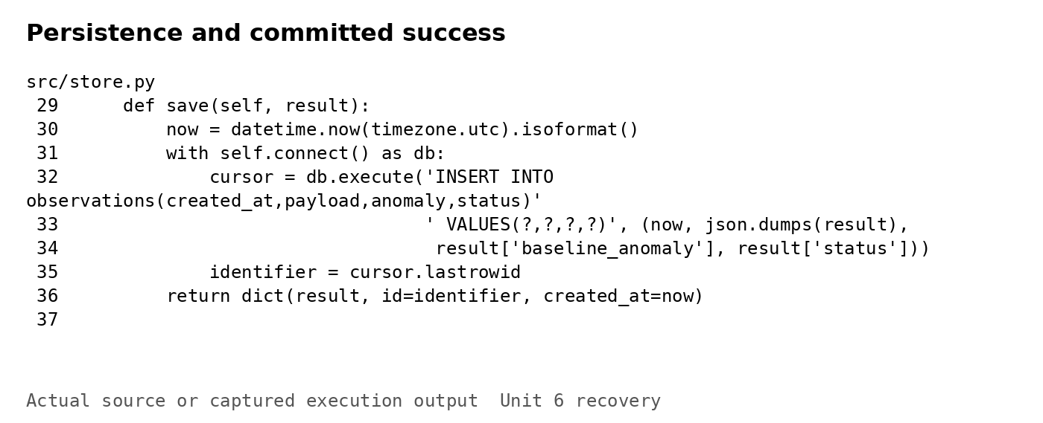
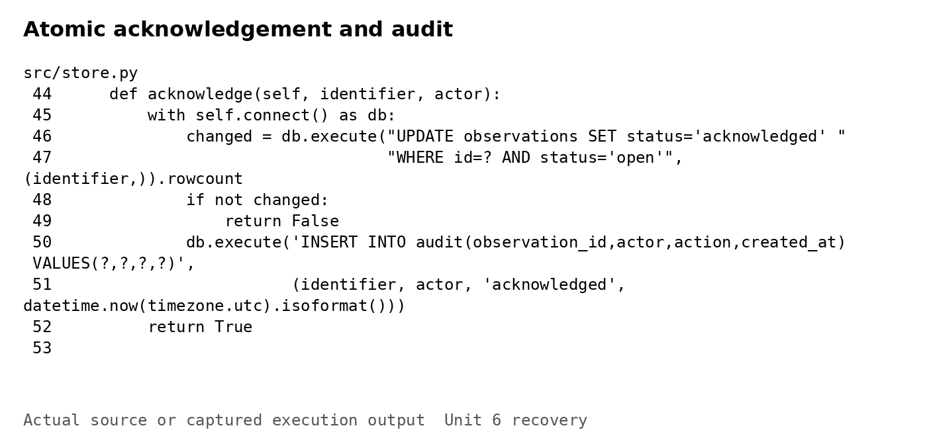
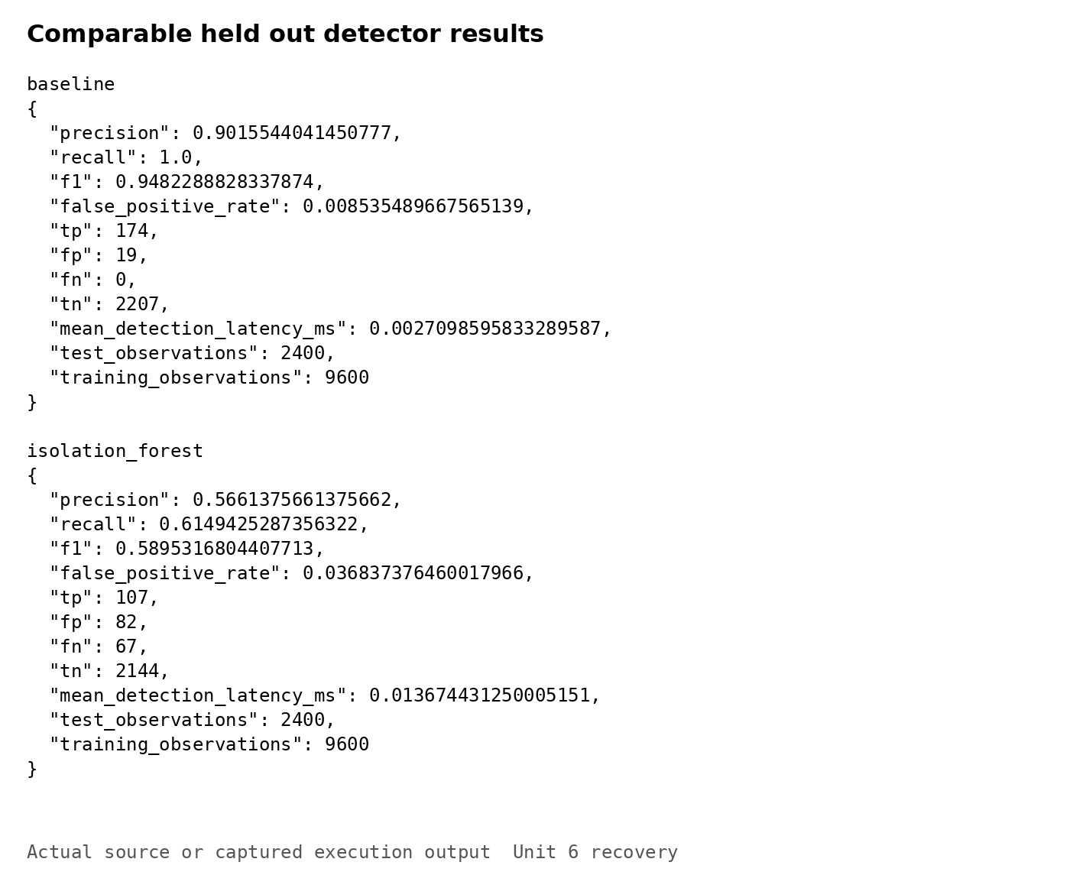
Note. The browser sends JSON to protected API routes. Analysis results are committed before HTTP 201 is returned. Acknowledgement updates status and inserts the audit entry in one transaction.
Figure 4
Normal and hot telemetry submissions
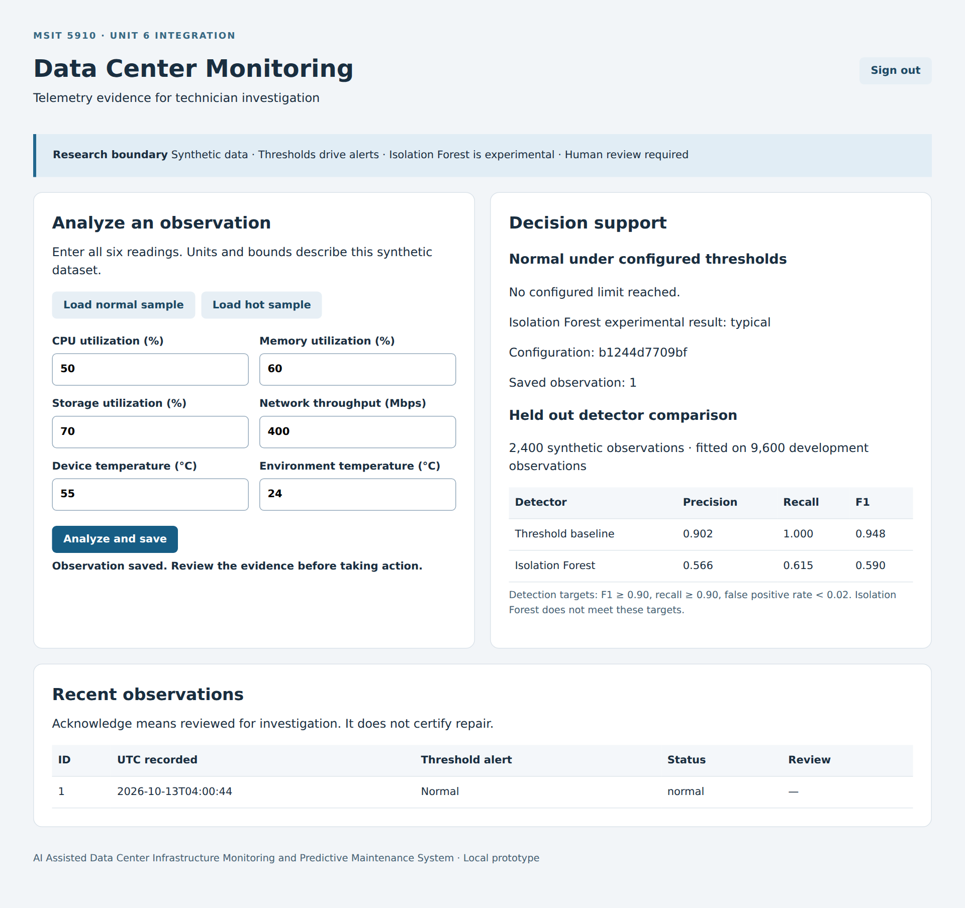
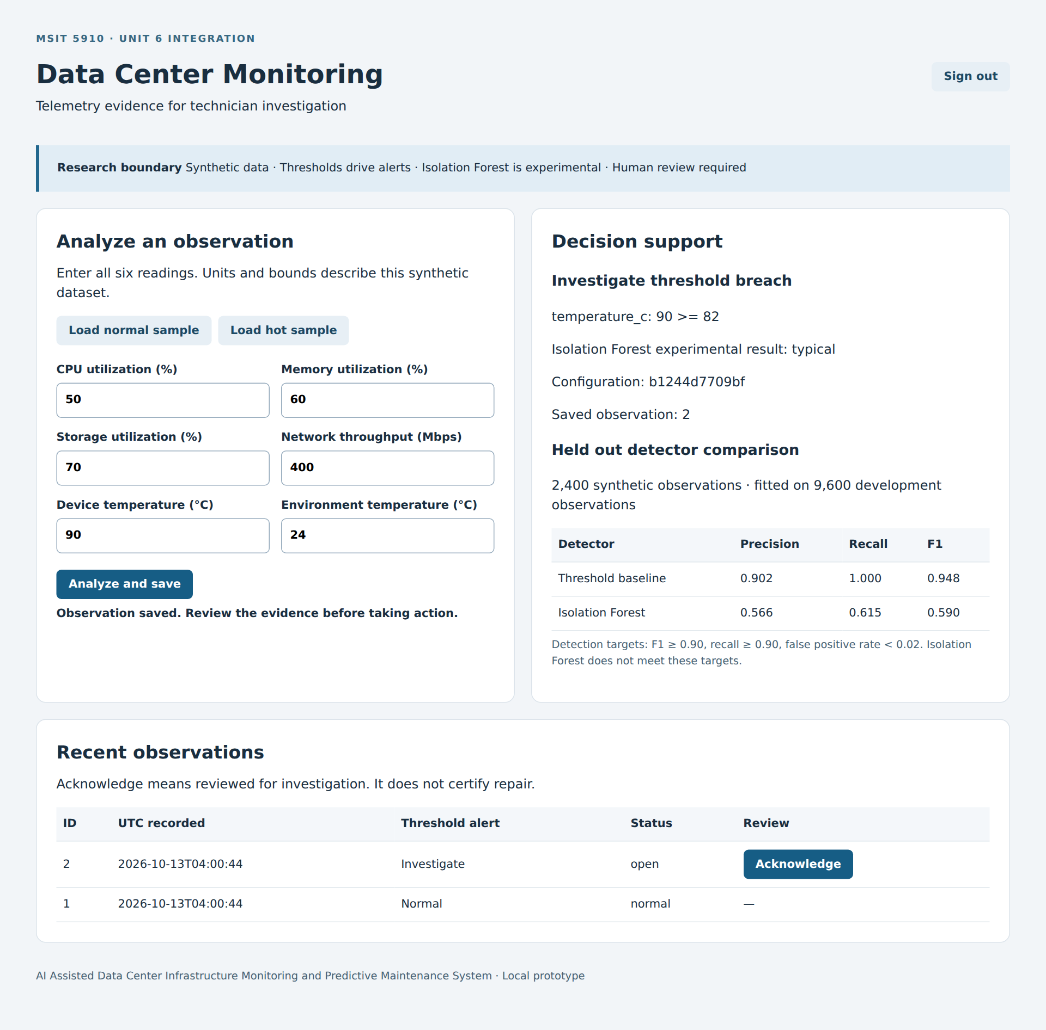
Note. Archived browser captures of authenticated submissions. The hot fixture breaches the threshold despite a typical forest classification. Current API behavior is recorded in Figure 8; browser rendering was not repeated.
Figure 5
Persistent alert acknowledgement
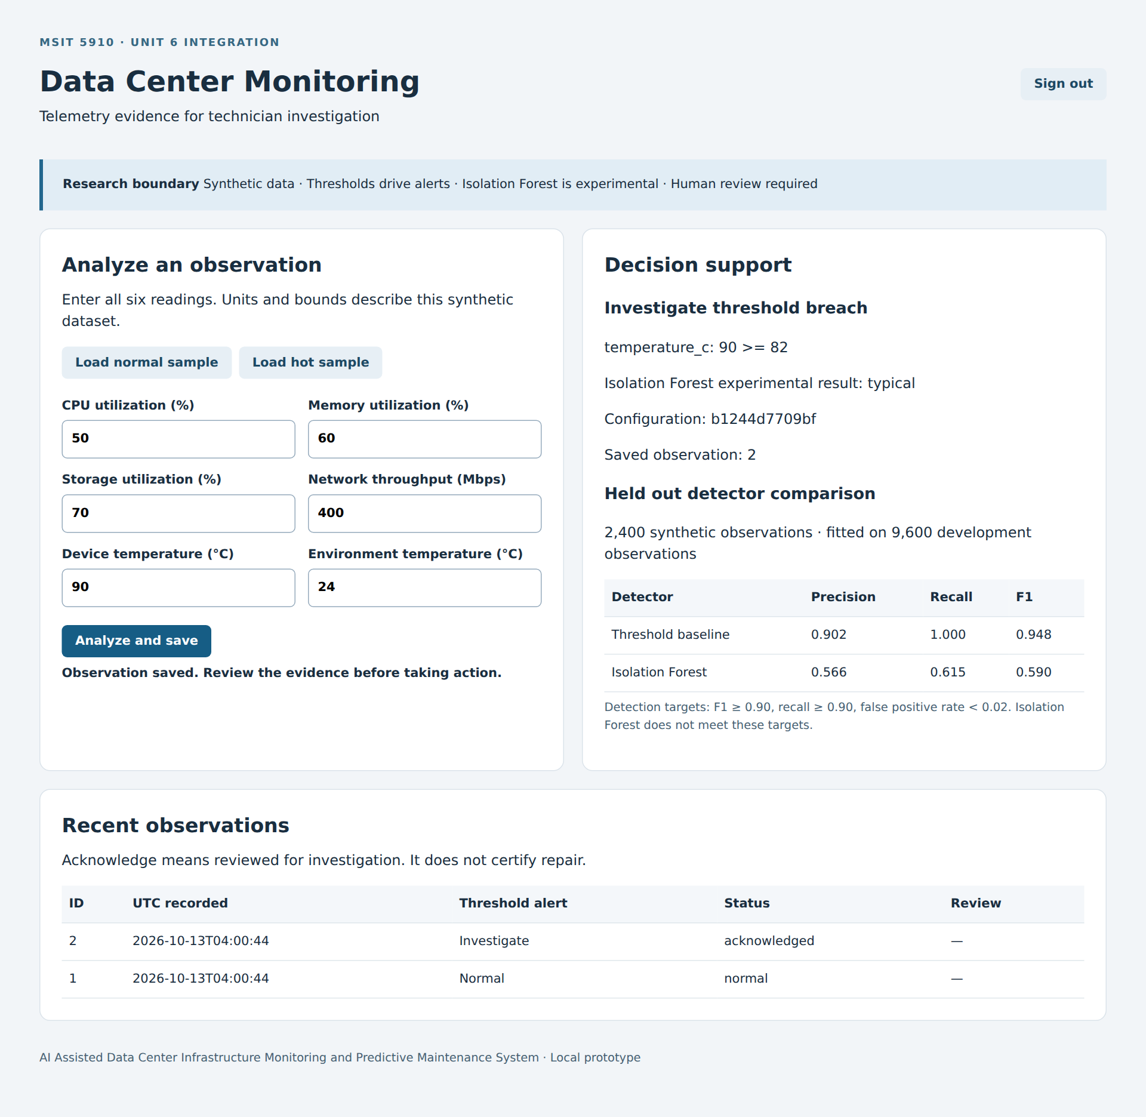
Note. Archived browser capture after acknowledgement. The stored review status changes while the original alert remains traceable; acknowledgement does not indicate repair.

4.3 Evaluation Metrics

Comparative Detection Results
The holdout contains 174 injected anomalies and 2,226 normal observations. The baseline records 174 true positives, 19 false positives, zero false negatives, and 2,207 true negatives. Precision is 174 divided by 193, or 0.9016; recall is 174 divided by 174, or 1.0000; F1 is 0.9482; false-positive rate is 19 divided by 2,226, or 0.0085. Isolation Forest records 107 true positives, 82 false positives, 67 false negatives, and 2,144 true negatives. Its precision is 0.5661, recall 0.6149, F1 0.5895, and false-positive rate 0.0368. Table 1 retains these counts and derived measures, and Figure 7 visualizes the comparison. Accuracy can also be calculated as 99.21% for the baseline and 93.79% for the forest. However, classifying every record as normal would already achieve 92.75% accuracy because anomalies are uncommon. That reference makes clear why accuracy alone cannot support the research conclusion. The more relevant error tradeoff is that the forest misses 67 injected anomalies while generating 82 false alerts. The reported confusion counts are more informative than a general statement that both models perform well.

Request Performance and Measurement Scope
The integrated service was benchmarked using authenticated loopback HTTP requests to POST /api/analyze under one synchronous Gunicorn worker. Ten warmup requests preceded three sequential batches of 100 requests. Each measured response included request processing, schema validation, the baseline, prediction through the cached forest, SQLite insertion and commit, and JSON return. Login, initial model fitting, browser rendering, and any remote network path were excluded. Median latency was 14.60, 14.85, and 14.70 milliseconds across the three batches. The corresponding nearest-rank p95 values were 20.04, 18.57, and 22.80 milliseconds. Throughput was 66.00, 65.40, and 63.27 successful requests per second, calculated from batch completion time. All 300 measured requests returned the expected creation response and threshold alert. These are serial experimental measurements, not concurrent capacity or a service-level guarantee. Figure 8 preserves the benchmark output. Repository evaluation files record approximately 0.0019 milliseconds per record for the baseline and 0.0120 for the forest in a separate measurement run. Those averages describe a different execution path and should not be compared directly with single-request HTTP latency.

Test Outcomes and Coverage Definitions
The expanded pytest suite passes 59 tests, comprising the earlier 43 core cases and 16 additional integration cases, including parameterized invalid inputs. Coverage records 278 executed statements out of 283, or 98.23%, and 55 covered branch destinations out of 58, or 94.83%. The combined denominator is 341 statement and branch opportunities; 333 are covered, producing 97.65%, rounded to 98% in the terminal report. The earlier Unit 5 result used 118 of 123 statements and 33 of 36 branches, producing 151/159, or 94.97%, displayed as 95%. It was therefore neither precisely 95% statement coverage nor 95% branch coverage. Coverage.py documentation distinguishes execution opportunities from simple line totals (Coverage.py, n.d.). Figure 6 includes the current passing log and module breakdown. Uncovered paths include command-line entry sections and three executable branches. Separate successful command-line runs demonstrate the normal startup path but are outside the coverage run. Their consequences include incomplete evidence for executable launch conditions and failure handling, even where imported functions pass. Coverage quantifies tested structure; it does not demonstrate predictive validity or the absence of defects.
Table 1
Detection results on the shared holdout
Metric | Threshold baseline | Isolation Forest | Interpretation
Precision | 0.9016 | 0.5661 | Baseline stronger on these fixtures
Recall | 1.0000 | 0.6149 | Forest misses 67/174 injected anomalies
F1 | 0.9482 | 0.5895 | Target ≥ 0.90; forest fails
False positive rate | 0.0085 | 0.0368 | Target < 0.02; forest fails
TP / FP / FN / TN | 174 / 19 / 0 / 2,207 | 107 / 82 / 67 / 2,144 | Same 2,400 held-out records

Table 1 continued
Serial HTTP request performance
Run | Median latency | p95 latency | Throughput
Batch 1 | 14.60 ms | 20.04 ms | 66.00/s
Batch 2 | 14.85 ms | 18.57 ms | 65.40/s
Batch 3 | 14.70 ms | 22.80 ms | 63.27/s
The holdout contains 2,400 observations. HTTP results use ten warmups and three serial batches of 100 authenticated requests under one Gunicorn worker; all measured requests returned HTTP 201.
Table 2
Qualitative interface clarity inspection
Task or criterion | Observed evidence | Limitation or next check
Normal submission | Units and a saved identifier are visible; record status is normal. | Participant interpretation remains unmeasured.
Hot alert interpretation | Explicit 90 ≥ 82 breach and forest disagreement are shown. | Internal feature names need clearer language.
Alert acknowledgement | Table changes to acknowledged; SQL audit persists. | Acknowledgement does not mean repaired.
History and navigation | Latest 50 records are available. | Add filters, pagination, equipment context, and trends.

Figure 6
Automated tests and coverage
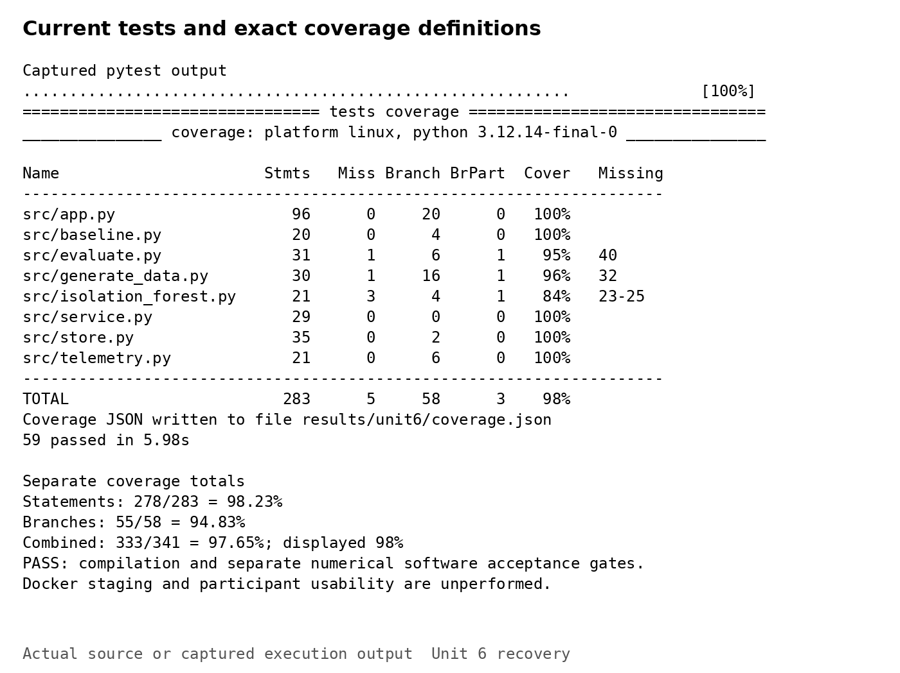
Note. Recorded pytest results: 59 tests pass, with 98.23% statement coverage and 94.83% branch coverage. The terminal combines both measures and rounds to 98%.
Figure 7
Detection comparison and request latency
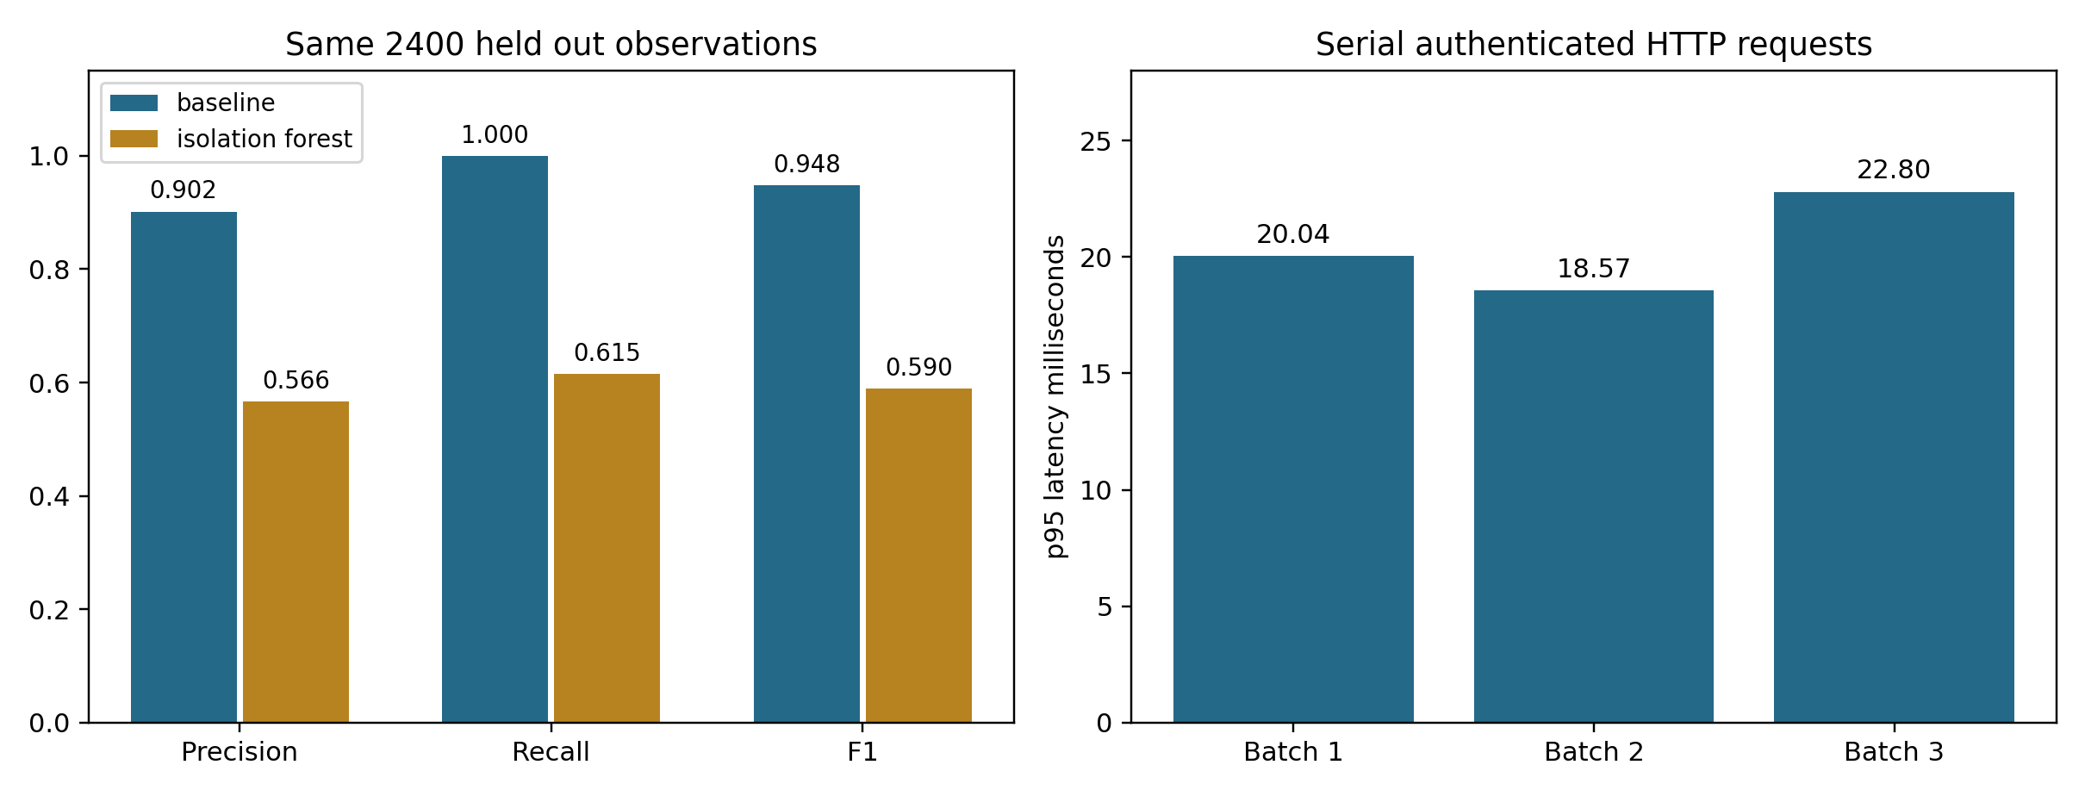
Note. Threshold-aligned synthetic labels favor the baseline. The latency chart reports batch p95 for the complete authenticated analysis and save request.
Figure 8
HTTP performance and workflow results
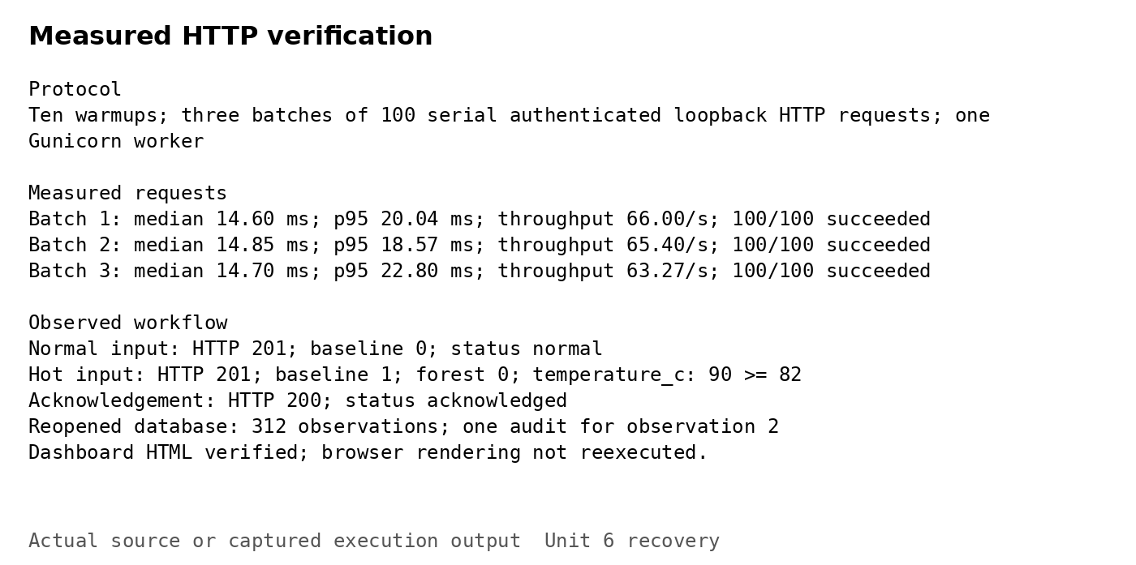
Note. Recorded outputs for normal submission, the hot threshold breach, acknowledgement, and three request batches. Dashboard HTML was checked; browser JavaScript was not reexecuted.

Chapter 5 Discussion

5.1 Interpretation of Results

Detection Acceptance and Baseline Bias
The quantitative findings answer the detector-comparison portion of the research question under controlled synthetic conditions. The threshold baseline meets the stricter Unit 5 targets: recall and F1 of at least 0.90 and false-positive rate below 0.02. Isolation Forest does not meet any of those three targets. This result should not be softened by emphasizing its high overall accuracy. Its recall indicates substantial missed injected events, and its false-positive rate exceeds the selected limit. Nevertheless, the baseline's success is partly designed into the experiment. Injected anomalies cross the same kinds of feature limits that the rules enforce. This favors a detector whose definition of abnormality resembles the labeling mechanism. Naturally occurring normal samples can also cross a threshold, accounting for the 19 false positives. The finding therefore supports correct implementation on the declared fixtures and a defensible choice of primary prototype alert logic. It does not demonstrate that rules outperform learned methods in general, or that the configured values are appropriate for production hardware. The forest remains visible as an experimental comparison because its disagreement can guide future dataset and modeling work without silently driving operational decisions.

Integration Success and Operational Meaning
The integration findings answer a different question: whether telemetry can move through a coherent, inspectable workflow. The observed route from login to analysis, persistence, rendered explanation, acknowledgement, and audit confirms that the main components communicate successfully. The measured request path includes the database commit, making latency relevant to a user-facing save operation rather than only an isolated algorithm call. All 300 benchmark requests succeed, but this sample cannot establish long-term availability, sustained load tolerance, or resilience to power loss. The one-worker configuration and serial request protocol deliberately constrain the interpretation. An operator could reasonably use this prototype to demonstrate how six readings produce investigation evidence. The same operator could not infer that the service has been validated for an entire data center or that acknowledgement changes physical equipment condition. This distinction shapes both interface terminology and conclusions. Successful software integration is an achievement in architecture and reliability; maintenance effectiveness would require independently labeled incidents, evidence of earlier actionable warnings, and comparison with existing operational procedures. The local milestone supplies a foundation for that evaluation rather than its outcome.

Qualitative Clarity and Remaining Friction
A structured interface inspection examined three tasks: submit a normal observation, interpret a hot observation, and acknowledge the corresponding alert. The screenshots support descriptive findings about visibility, terminology, feedback, and control. Labels identify units and required fields. Successful submission produces a saved identifier and a clear status message. The hot fixture exposes the measured temperature, configured threshold, and experimental forest disagreement. Acknowledgement updates the visible table and remains present in storage. These features make the state transition understandable and preserve human control. However, explanations retain internal field names such as temperature_c, which may require extra interpretation. The table supplies only recent observations, without filtering, search, or pagination. The interface also lacks equipment history, trend charts, and clear prioritization when many simultaneous alerts appear. These are inspection findings rather than participant opinions. No representative technicians completed a recruited usability study, and no satisfaction ratings or SUS scores were collected. The original five-user pilot remains necessary. Its planned criteria are at least 80% successful completion of predefined review tasks and an average SUS score of at least 70, supplemented by explanations of misunderstandings and workload concerns.

5.2 Comparison with Literature Findings

Scholarly Evidence and Methodological Fit
Ruff et al. (2021), Han et al. (2022), and Zhao et al. (2019) provide complementary foundations for the evaluation. Ruff et al. review deep and shallow anomaly detection and explain how assumptions about normality shape the interpretation of unusual observations. This distinction matters here because an unusual feature vector does not establish a developing equipment failure. Han et al.'s ADBench examines detector performance across varied datasets and anomaly scenarios. Its breadth highlights the weakness of evaluating this prototype only with labels generated by crossing familiar feature limits. Zhao et al. describe PyOD, an open-source toolbox for comparative outlier detection. Although this implementation uses scikit-learn rather than PyOD, their work illustrates how inspectable implementations and consistent evaluation procedures support comparison. Together, these studies support the project's shared holdout, explicit error measures, and cautious interpretation of detector disagreement. They do not validate the selected temperature threshold or demonstrate the capstone's usefulness in an operating data center. That evidence must come from authorized telemetry and observed maintenance outcomes. The present experiment therefore contributes a reproducible implementation comparison within a deliberately restricted dataset.

Professional Sources and Evidence Quality
The professional readings address the engineering work surrounding detection. Brereton (2023) distinguishes numerical measurements from qualitative observations; this supports reporting request latency separately from interface clarity. Wells (2025) and GeeksforGeeks (2025) describe several dimensions of software quality, which explains why passing tests alone cannot establish usability or operational reliability. Brown (2026) emphasizes documentation for different audiences and maintenance alongside software changes. For this application, technicians need an explanation of alert and acknowledgement status, while maintainers need prerequisites, configuration settings, and recovery procedures. Bennett (2024) addresses configuration baselines and controlled changes. Versioning thresholds with source and recorded results follows that principle and helps explain a changed classification. Sumo Logic (n.d.) treats deployment as a process involving preparation and delivery, supporting the separation of local execution from staging promotion. These practical publications are relevant to implementation planning, but their commercial and instructional purposes limit their authority for scientific claims about anomaly detection. The report uses them for process guidance and relies on the project's measured outputs for empirical findings. Peer-reviewed studies supply the methodological comparison, while neither source category substitutes for representative operational evaluation.

5.3 Implications and Limitations

Validity and Predictive Maintenance Claims
The largest limitation is external validity. Independent synthetic observations omit timestamps, asset identities, lifecycle information, workload seasonality, firmware changes, repeated incidents, and repair outcomes. They cannot establish lead time before failure or distinguish a harmless workload spike from a harmful developing fault. The project title retains predictive maintenance as its intended application, but the achieved function is anomaly-oriented decision support. A model can identify an unusual reading while lacking evidence that a component will fail. Likewise, a normal model classification cannot guarantee safety. The hot fixture illustrates this point particularly well: the explicit temperature breach is important to the threshold workflow even though the experimental forest calls the feature vector typical. Future studies must define an operational event, forecast horizon, and outcome label before claiming prediction. They must also prevent leakage between the same asset's development and evaluation histories. A defensible evaluation would reserve later periods or distinct devices, compare against current monitoring practice, and record uncertainty. These changes would address the research question more closely than merely increasing the number of generated samples or adding a more complex algorithm.

Privacy Governance and Stakeholder Validation
Synthetic data avoids customer information, production identifiers, and operational credentials in this milestone. Introducing real telemetry would change the governance requirements. Collection should begin only with organizational authorization, a documented purpose, minimal fields, and an agreed retention period. Asset identifiers can be pseudonymized, but reidentification risk remains when detailed operational patterns are retained. Access should reflect separate technician, reviewer, and administrator responsibilities, with auditable identity and protected storage. Encryption at rest and in transit must be verified rather than inferred from the presence of a database or container. The current audit table provides traceability for acknowledgement but does not prevent privileged modification. A technician, an operations lead, and a security reviewer should validate threshold interpretation, escalation wording, and data handling before a pilot. They should also assess whether the interface adds unnecessary alerts or encourages overconfidence in experimental outputs. This validation cannot be replaced by developer inspection. Human review is retained because evidence quality and operational consequences differ across environments, and the system lacks authority or validated logic for autonomous maintenance actions.

Reliability Security and Scaling Limits
The integration suite exercises normal workflows, invalid inputs, authentication boundaries, missing CSRF tokens, repeated acknowledgement, persistence, and simulated storage failure. Those cases provide useful evidence, yet several conditions remain unexplored: expired sessions during submission, simultaneous writers, interrupted transactions, full storage, invalid startup files, and repeated failed logins. The uncovered coverage paths reinforce these gaps. A one-worker process avoids concurrency complexity during demonstration but limits capacity and introduces one service instance as a failure point. SQLite is appropriate for bounded local evidence, whereas multiple replicas or sustained write-heavy use would require a carefully evaluated storage strategy. Model fitting at startup also delays readiness and repeats after each restart. Cached prediction reduces per-request work but does not solve model-version management or drift. Secret rotation invalidates existing sessions and therefore needs an intentional rollout procedure. Prototype authentication lacks throttling and account lifecycle controls. These limitations do not negate the demonstrated functionality; they identify what the evidence can support. Before staging, reliability review should treat configuration, identity, storage, model loading, and recovery as connected responsibilities rather than assuming high test coverage guarantees deployability.

5.4 Future Work

Deployment Method Selection
The selected next deployment approach is Docker on a controlled Linux staging host. A local virtual environment remains the simplest teaching and demonstration option, while a directly managed on-premises server offers control at the cost of manual patching and configuration drift. A managed cloud platform can simplify hosting, but introduces costs, service limits, data-location decisions, and organizational approval for telemetry handling. Docker packages the runtime, dependencies, configuration files, and application consistently while keeping persistent records outside the replaceable container layer. Docker documentation explains the independent lifecycle of volumes (Docker, n.d.). The prepared Dockerfile uses Python 3.12, installs the pinned direct dependencies, generates synthetic data during image creation, creates a non-root account, and launches one Gunicorn worker. Flask documentation supports the application-factory command syntax and distinguishes Gunicorn from the development server (Pallets Projects, n.d.). The image includes a readiness-oriented health check. However, Docker is not available in the measured environment, so no successful image build or container execution is claimed. The proposed commands form a reviewable staging plan that still requires execution and evidence.

Environment Setup and Configuration Management
Figure 9 documents the working environment and setup sequence. Linux x86_64 and Python 3.12.14 were used with scikit-learn 1.8.0, Flask 3.1.2, Gunicorn 23.0.0, pytest 9.1.1, pytest-cov 7.1.0, and SQLite 3.53.1. The IDE should open the repository root and select the project's virtual-environment interpreter. Dependencies are installed from requirements.txt; Python's standard library supplies SQLite and JSON support. APP_SECRET_KEY and DEMO_PASSWORD_HASH are required secrets. DEMO_USER identifies the local account, DATABASE_PATH selects writable persistent storage, and COOKIE_SECURE controls HTTPS-only cookies. Thresholds reside in config/thresholds.json, and their SHA-256-derived identifier is included in analysis outputs. The model identifier records the fixed configuration but is not a cryptographic hash of a serialized model. Source, settings, dependencies, and test evidence therefore need to remain associated with the same commit. Table 3 lists installation, data generation, testing, evaluation, compilation, and server commands, together with proposed Docker commands. Configuration control reduces ambiguity when reproducing a result or diagnosing a regression. Secret values and generated databases must remain outside Git; an example file documents names and nonsecret defaults.
Figure 9
Environment setup and persistent storage
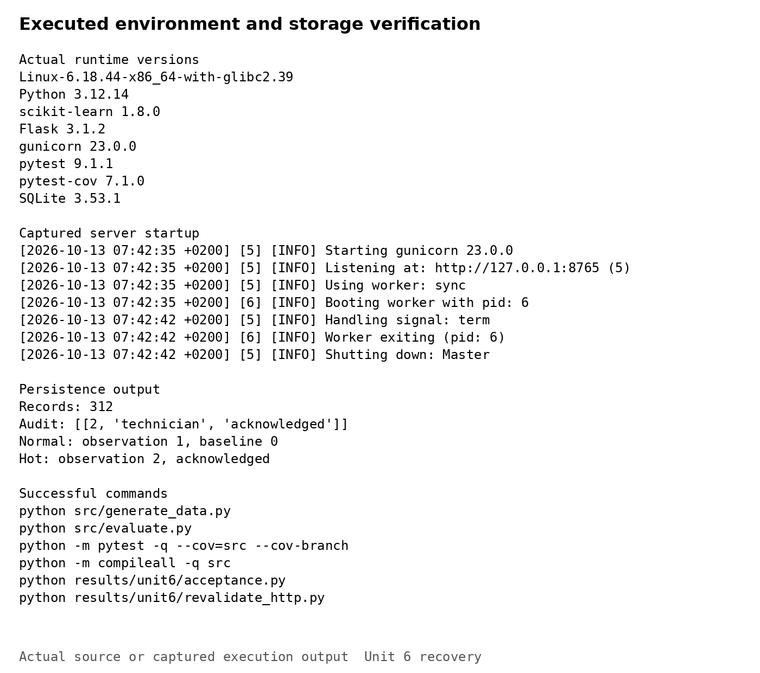
Note. Recorded interpreter, dependency, server, and database outputs. The database contains 312 observations and one acknowledgement audit entry. Appendix A gives the setup and proposed deployment sequence.

Merge and Staging Acceptance Criteria
The integration workflow defines separate acceptance criteria for software review and staging promotion. A pull request must pass the complete pytest suite, preserve existing regression assertions, achieve at least 90% statement coverage and at least 90% branch coverage separately, compile successfully, and reproduce the seeded baseline confusion counts of 174, 19, zero, and 2,207. The baseline must also meet its recall, F1, and false-positive-rate targets. The acceptance script checks these numerical conditions. GitHub Actions installs dependencies, generates data, runs tests, evaluates both detectors, and invokes the gate; the recorded workflow run passed. Review must also examine configuration and security changes for embedded credentials or undocumented data collection. These criteria permit review of the software while leaving the forest experimental. Staging promotion requires additional evidence: a successful image build, healthy startup, persistence after restart, backup restoration, secure secret injection, HTTPS and secure-cookie checks, dependency review, and serial p95 below the project-specific 100-millisecond target. Failure blocks promotion. Protected-branch enforcement and staging execution remain unverified, so a passing workflow alone does not establish deployment readiness.

Branches Tags Releases and Recovery
The repository separates feature development from milestone publication. Core validation entered development through pull request 2 and reached main through pull request 3. Tags v0.1.0 and v0.2.0 retain the initial prototype and tested core, with v0.2.0 identifying commit e7ff128. The main baseline used for integration is cf9b069. Unit 6 source and reproducible evidence are available on feature/unit6-integration-recovery in pull request 4. The intended sequence is review into development, validation, and integration into main. A subsequent v0.3.0 prerelease should identify the accepted integration commit and record its configuration, evaluation scope, and outstanding limitations. Earlier tags should remain unchanged. Rollback should restore a known application image and compatible settings while preserving observations. Because the prototype lacks a migration framework, any schema change needs a backup and a tested restoration procedure before promotion. The staging runbook should associate the image digest with its source commit, dependency lock, threshold identifier, secret revision, backup, and smoke-test outcomes. This makes the deployed combination identifiable and supports investigation when code, configuration, or stored state changes. Versions identify snapshots.

Research and Usability Improvements
Future research should first improve the dataset rather than promote model complexity prematurely. Additional scenarios should include contextual anomalies that stay below individual limits, correlated feature changes, missing readings, sensor faults, and changing workload patterns. Labeled operational histories, obtained with permission, should separate development and test periods and include verified maintenance outcomes. Thresholds and model parameters should be selected using development or validation data, with the final holdout reserved for unbiased assessment. Repeated seeds and uncertainty estimates would clarify how stable the comparative results are. In parallel, the five-technician pilot should measure completion of alert interpretation, saved-record retrieval, and acknowledgement tasks. Participants should explain their decisions aloud, identify confusing terms, and describe whether experimental disagreement changes their confidence. A requirements traceability matrix should connect these observations to interface revisions, including clearer field names, history filtering, and trend views. Finally, container and recovery tests should precede any organizational demonstration. These improvements would extend the current evidence in three distinct directions: predictive relevance, human usefulness, and deployment reliability. Each direction needs its own acceptance criteria and limitations.

Requirements Traceability and Recovery Tests
Table 4 connects the original functional requirements to the implemented modules and evidence. FR-01 and FR-02 are represented by approved-field ingestion and range validation. FR-03 is demonstrated through SQLite persistence, FR-04 through threshold predictions, and FR-05 through the held-out forest comparison. FR-06 is represented by readable investigation evidence, FR-07 by stored configuration and model identifiers, and FR-08 by the absence of infrastructure-control operations. The nonfunctional requirements have mixed completion status. Local latency, regression reliability, reproducibility, and modularity have direct evidence. Scalability, independent usability, enterprise security, and production privacy remain incomplete. The matrix distinguishes demonstrated local behavior from requirements that still need staging or stakeholder evaluation.

Recovery Verification
Recovery testing should extend beyond a green health response. A staging rehearsal should create an alert, acknowledge it, restart the process, and confirm that both observation and audit survive. It should restore a database backup into a separate test location and verify identifiers and statuses without overwriting the active store. An intentionally unavailable database should produce an explicit failure instead of a success message. Session-expiry testing should confirm that a stale browser cannot mutate review state. Concurrent acknowledgement attempts should preserve one audit action for one transition. These checks target meaningful failure consequences rather than repeating the implementation line by line.

Benchmark Record Reconciliation
The benchmark database contains 312 records: two HTTP examples, ten warmups, and 300 measured requests. Matching that total to the protocol provides a useful persistence check. These repeated synthetic submissions are neither a participant sample nor independent incidents. The single audit entry belongs to acknowledgement of the hot demonstration. A separate query of the reopened database confirms that relationship. Future performance runs should retain a distinct database or run identifier so that measurement traffic cannot be confused with genuine technician work. This separation would also make deletion and retention rules easier to apply.

Chapter 6 Conclusion

6.1 Main Findings and Contributions

Integrated System and Research Answer
The capstone now combines its tested analytical core with a functioning local application that supports authentication, telemetry submission, comparative detection, persistent results, and technician acknowledgement. The research question receives a bounded answer. Transparent thresholds identify the injected holdout anomalies more effectively than the configured Isolation Forest, and the interface presents concrete evidence for investigation. The baseline's precision of 0.902, recall of 1.000, F1 of 0.948, and false-positive rate of 0.0085 satisfy the declared fixture-level criteria. The forest's lower recall and F1 justify retaining it as experimental. The integrated request path also exhibits low latency under the documented serial protocol, with no failed measured requests. These findings demonstrate local implementation and repeatability; they do not establish failure forecasts or production effectiveness. The project's contribution is a technician-centered reference workflow that connects transparent rules, an experimental learning method, secure interaction boundaries, persistent review semantics, and evidence-based evaluation. Its value lies partly in making disagreement and limitations visible instead of presenting AI output as authoritative maintenance advice.

6.2 Lessons Learned and Challenges

Engineering Evidence and Evaluation Discipline
The central lesson is that correctness, detection usefulness, usability, and deployability require different evidence. Unit tests can establish validation behavior and module contracts, but cannot prove that synthetic labels represent real failure conditions. High coverage measures exercised structure, while screenshots demonstrate observable workflows. Neither replaces representative usability testing. Similarly, fast batch prediction does not describe the complete HTTP request path, and a Dockerfile does not demonstrate a successful deployment. The earlier unequal evaluation partitions and silent metric truncation showed how apparently plausible results can arise from flawed implementation. The corrected holdout and regression tests now prevent those specific errors. The forest's disappointing results are therefore useful: they reveal the need for independent data and appropriate labeling rather than supporting a predetermined success narrative. Integrating storage and acknowledgement introduced further lessons about transaction ordering, status meaning, and audit consistency. Authentication and configuration requirements also exposed that operational boundaries must be designed explicitly. These challenges strengthened the project by converting assumptions into tests, visible outputs, and documented limitations.

6.3 Next Improvements and Final Implications

Prioritized Development and Conclusion
The next milestone should validate container startup and persistence, exercise uncovered executable and command-line paths, and strengthen authentication before expanding access. It should then obtain independent telemetry or substantially richer synthetic scenarios, evaluate temporal generalization, and conduct the planned technician pilot. Model promotion should depend on improved comparative evidence and operational relevance, not the mere presence of a learning algorithm. Configuration and release records should remain tied to immutable versions, with restore procedures tested before deployment. The main implication is practical: an understandable, reproducible monitoring workflow can support technician investigation even when its experimental AI component fails acceptance criteria. The capstone provides that workflow and a clear account of what has been demonstrated. It also preserves the distinction between observed anomaly evidence and maintenance outcomes that future research must establish. Continued development should prioritize trustworthy evidence, clear human review, and reliable configuration over unsupported claims of autonomous intelligence or enterprise readiness.

References
Bennett, L. (2024, August 13). Software configuration management in software engineering. Guru99. https://www.guru99.com/software-configuration-management-tutorial.html
Brereton, J. (2023, November 27). Qualitative vs quantitative metrics: A comprehensive comparison. LaunchNotes. https://www.launchnotes.com/blog/qualitative-vs-quantitative-metrics-a-comprehensive-comparison
Brown, J. (2026, September 13). Software documentation guide: Definition, examples, downloadable templates + how to write. Helpjuice. https://helpjuice.com/blog/software-documentation
Coverage.py. (n.d.). Branch coverage measurement. https://coverage.readthedocs.io/en/latest/branch.html
Docker. (n.d.). Volumes. https://docs.docker.com/engine/storage/volumes/
GeeksforGeeks. (2025, July 15). Measuring software quality using quality metrics. https://www.geeksforgeeks.org/software-engineering/measuring-software-quality-using-quality-metrics/
Han, S., Hu, X., Huang, H., Jiang, M., & Zhao, Y. (2022). ADBench: Anomaly detection benchmark. Advances in Neural Information Processing Systems, 35, 32142–32159. https://proceedings.neurips.cc/paper_files/paper/2022/hash/cf93972b116ca5268827d575f2cc226b-Abstract-Datasets_and_Benchmarks.html
Pallets Projects. (n.d.). Gunicorn. Flask documentation. https://flask.palletsprojects.com/en/stable/deploying/gunicorn/
Ruff, L., Kauffmann, J. R., Vandermeulen, R. A., Montavon, G., Samek, W., Kloft, M., Dietterich, T. G., & Müller, K.-R. (2021). A unifying review of deep and shallow anomaly detection. Proceedings of the IEEE, 109(5), 756–795. https://doi.org/10.1109/JPROC.2021.3052449
Sumo Logic. (n.d.). What is software deployment? https://www.sumologic.com/glossary/software-development/
Summers, B. L. (2020). Effective methods for software engineering. Auerbach Publications. https://doi.org/10.1201/9781003025665
Wells, J. (2025, April 16). Top 12 software quality metrics to measure and why. LinearB. https://linearb.io/blog/software-quality-metrics
Zhao, Y., Nasrullah, Z., & Li, Z. (2019). PyOD: A Python toolbox for scalable outlier detection. Journal of Machine Learning Research, 20(96), 1–7. https://www.jmlr.org/papers/v20/19-011.html

Appendix A Configuration and Setup
Table 3
Prerequisites and configuration settings
Item | Requirement or setting
Runtime | Linux x86_64; Python 3.12.14; scikit-learn 1.8.0; Flask 3.1.2; Gunicorn 23.0.0
Tests and storage | pytest 9.1.1; pytest-cov 7.1.0; SQLite 3.53.1; writable database parent directory
APP_SECRET_KEY | Required random session-signing secret; injected externally; never committed
DEMO_PASSWORD_HASH | Required Werkzeug password hash; never store the password in source
DEMO_USER | Default technician; one prototype account
DATABASE_PATH | Default data/monitor.db; staging /app/state/monitor.db on a persistent volume
COOKIE_SECURE | 0 only for loopback HTTP; 1 behind staging HTTPS
Threshold configuration | config/thresholds.json; SHA-256 prefix b1244d7709bf; restart after changes
Model configuration | 200 trees; contamination 0.08; seed 5910; fit at startup on development partition

Local Setup
python -m venv .venv
. .venv/bin/activate
python -m pip install -r requirements.txt
python src/generate_data.py
python src/evaluate.py
python -m pytest -q --cov=src --cov-branch --cov-report=json:results/unit6/coverage.json
python -m compileall -q src
python results/unit6/acceptance.py
Prepare the session secret and password hash before starting Gunicorn. These commands prompt for the password without echoing it; secret values must remain outside Git.
export APP_SECRET_KEY="$(python -c 'import secrets; print(secrets.token_hex(32))')"
export DEMO_PASSWORD_HASH="$(python -c 'from getpass import getpass; from werkzeug.security import generate_password_hash; print(generate_password_hash(getpass("Demo password: ")))')"
python -m gunicorn --chdir src --bind 127.0.0.1:8000 --workers 1 'app:create_app()'

Proposed Docker Deployment
The Docker sequence is planned and has not been executed. Supply the external secrets in a protected .env file. HTTPS is required when COOKIE_SECURE=1. Verify volume permissions, persistence after restart, and backup restoration before staging promotion.
docker build -t msit5910:unit6 .
docker volume create msit5910-state
docker run --rm --env-file .env -p 127.0.0.1:8000:8000 \
--mount type=volume,src=msit5910-state,dst=/app/state msit5910:unit6

Appendix B Requirements Traceability
Table 4
Functional requirements and demonstrated behavior
Requirement | Implementation and evidence | Status
FR-01 approved ingestion | Six-field browser input and JSON API | Demonstrated locally
FR-02 validation | Finite numeric bounds; invalid requests rejected | Tested
FR-03 storage | Parameterized SQLite inserts; reopened state | Tested
FR-04 baseline detection | Five versioned limits; visible breach reasons | Fixture targets met
FR-05 learned comparison | Isolation Forest; shared 2,400-row holdout | Experimental; detection targets failed
FR-06 technician evidence | Units, reasons, saved IDs, review status | Inspected; participant study pending
FR-07 versions and results | Config identifier, model label, Git snapshots, logs | Recorded; staging release pending
FR-08 human authority | Acknowledgement only; no hardware controls | Preserved

Table 4 continued
Nonfunctional requirements and remaining validation
Attribute | Observed evidence | Remaining validation
Performance | Serial p95 18.57–22.80 ms | Concurrent and sustained load
Reliability | 59 passing tests; explicit storage failure | Restart, backup restore, disk exhaustion
Usability | Three-task clarity inspection | Five-user pilot; ≥80% tasks; SUS ≥70
Security and privacy | Session, CSRF, hashing; synthetic inputs | Identity roles, HTTPS, throttling, encryption
Reproducibility | Fixed seed; versioned code and configuration | Transitive lock and image digest
Scalability | One local worker; bounded record retrieval | Multi-user and storage redesign

Table B1
Acceptance decisions
Decision | Required evidence | Current status
Software merge | All tests pass; statements ≥90%; branches ≥90%; compilation succeeds; seed baseline counts preserved | Local and GitHub Actions checks pass; branch protection unverified
Staging promotion | Built image; healthy startup; persisted restart; restore; HTTPS cookies; secret handling; dependency review; serial p95 <100 ms | Planned; Docker not executed
Forest as primary detector | Independent evaluation; recall/F1 ≥0.90 and false-positive rate <0.02; stakeholder review | Not accepted
Operational release | Authorized telemetry, representative user study, operational reliability and privacy validation | Outside completed milestone

Implementation and recorded results: https://github.com/Meherzaad/MSIT-5910/tree/211add31d02730a4c31c9063e09d9f78723c7d81. Integration review: https://github.com/Meherzaad/MSIT-5910/pull/4. Browser captures are archived from the earlier local demonstration; quantitative results correspond to the recorded Unit 6 execution.

