AI Assisted Data Center Infrastructure Monitoring and Predictive Maintenance System
System Integration Performance Evaluation and Deployment Planning
Zakir H.
University of the People
Master of Science in Information Technology
MSIT 5910 Capstone Project
Submitted to the MSIT 5910 Course Instructor
October 12, 2026

Introduction

Purpose and Research Question
The AI Assisted Data Center Infrastructure Monitoring and Predictive Maintenance System now integrates a browser interface, authenticated API, reusable detection service, and SQLite persistence. Building on Units 4 and 5, it asks how effectively transparent thresholds and Isolation Forest identify abnormal synthetic telemetry while supporting technician investigation. The integrated workflow operates locally; failure forecasting and operational effectiveness remain unproven. Engineering evidence connects implementation, testing, and configuration control (Summers, 2020).

Part A: System Integration & Feature Completion

Architecture and Module Responsibilities
Figure 1 maps the implemented architecture. The generator creates 12,000 observations using seed 5910. Validation checks six finite numeric readings against declared bounds. The baseline compares five readings with versioned thresholds. Isolation Forest uses six features, 200 trees, contamination 0.08, and the same seed. Training and scaling use only 9,600 development observations; evaluation uses the remaining 2,400. The service fits once at startup, exposes both predictions, and keeps the forest experimental. Anomaly identification does not establish impending failure (Ruff et al., 2021).

Demonstrated Inputs and Outputs
Figures 2-5 show source captures and actual browser outputs. The normal input contains CPU 50%, memory 60%, storage 70%, network 400 Mbps, device temperature 55°C, and environment temperature 24°C. It returns HTTP 201 and baseline label zero. Changing device temperature to 90°C returns label one and the explanation “temperature_c: 90 >= 82.” The forest labels this hot example typical, visibly demonstrating disagreement. A negative CPU reading returns HTTP 400 and is not saved. Acknowledging the hot observation changes its stored status and creates an audit record; acknowledgement does not certify repair.

Communication and Security
The browser submits JSON through fetch to POST /api/analyze. The API checks authentication and the session CSRF token before validation and detection. Store.save uses parameterized SQL and commits before returning the observation identifier. GET /api/observations retrieves recent records; the acknowledgement endpoint updates only open alerts and records the actor atomically. Figure 3 documents these connections and checks. Password hashing, HttpOnly cookies, strict SameSite settings, request-size limits, and restrictive response headers support the local prototype. Single-user authentication, absent login throttling, and unencrypted SQLite constrain deployment.
Figure 1
Implemented system architecture
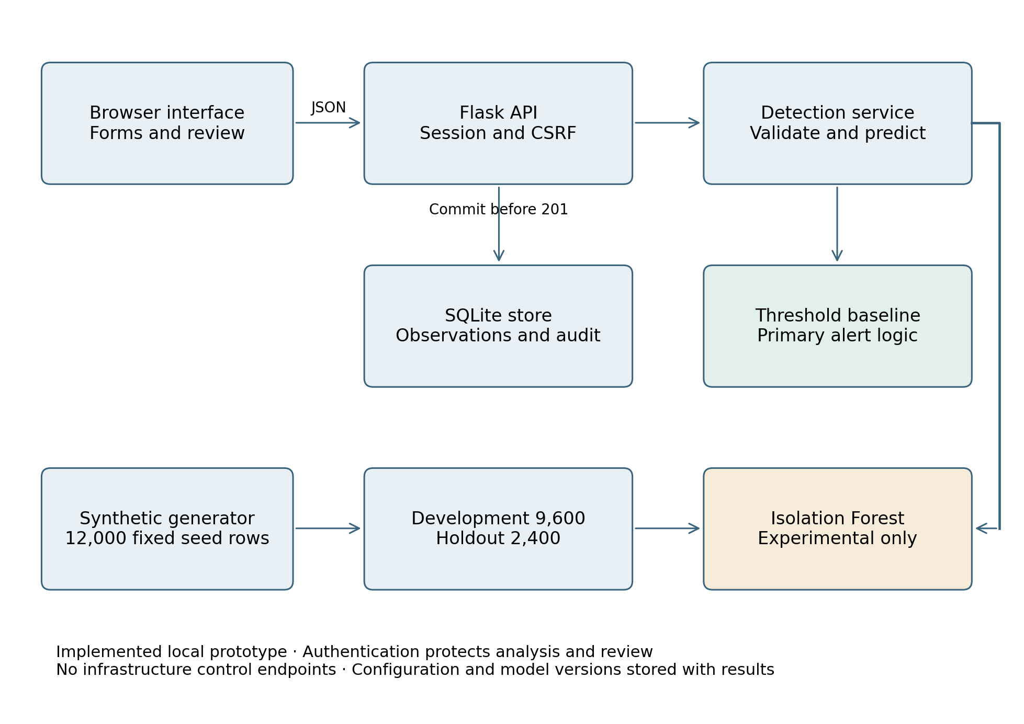
Note. The detection service fits the model on development data before requests are accepted. Analysis precedes storage; review updates the stored observation and audit.
Figure 2
Core module implementation
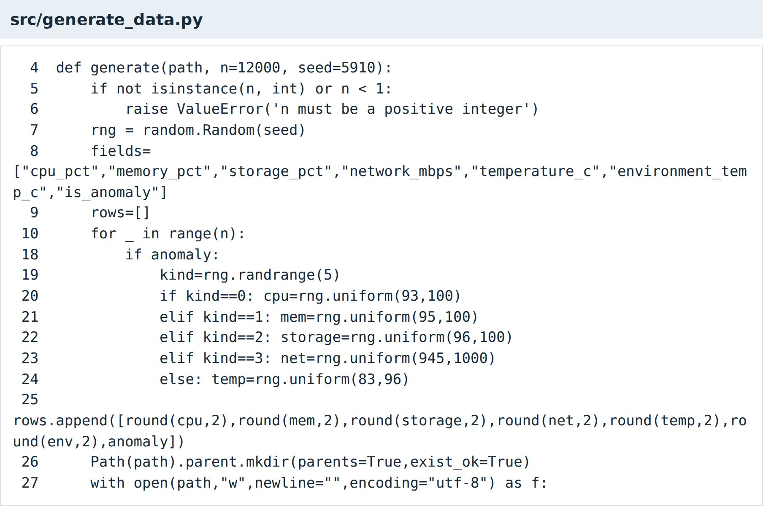
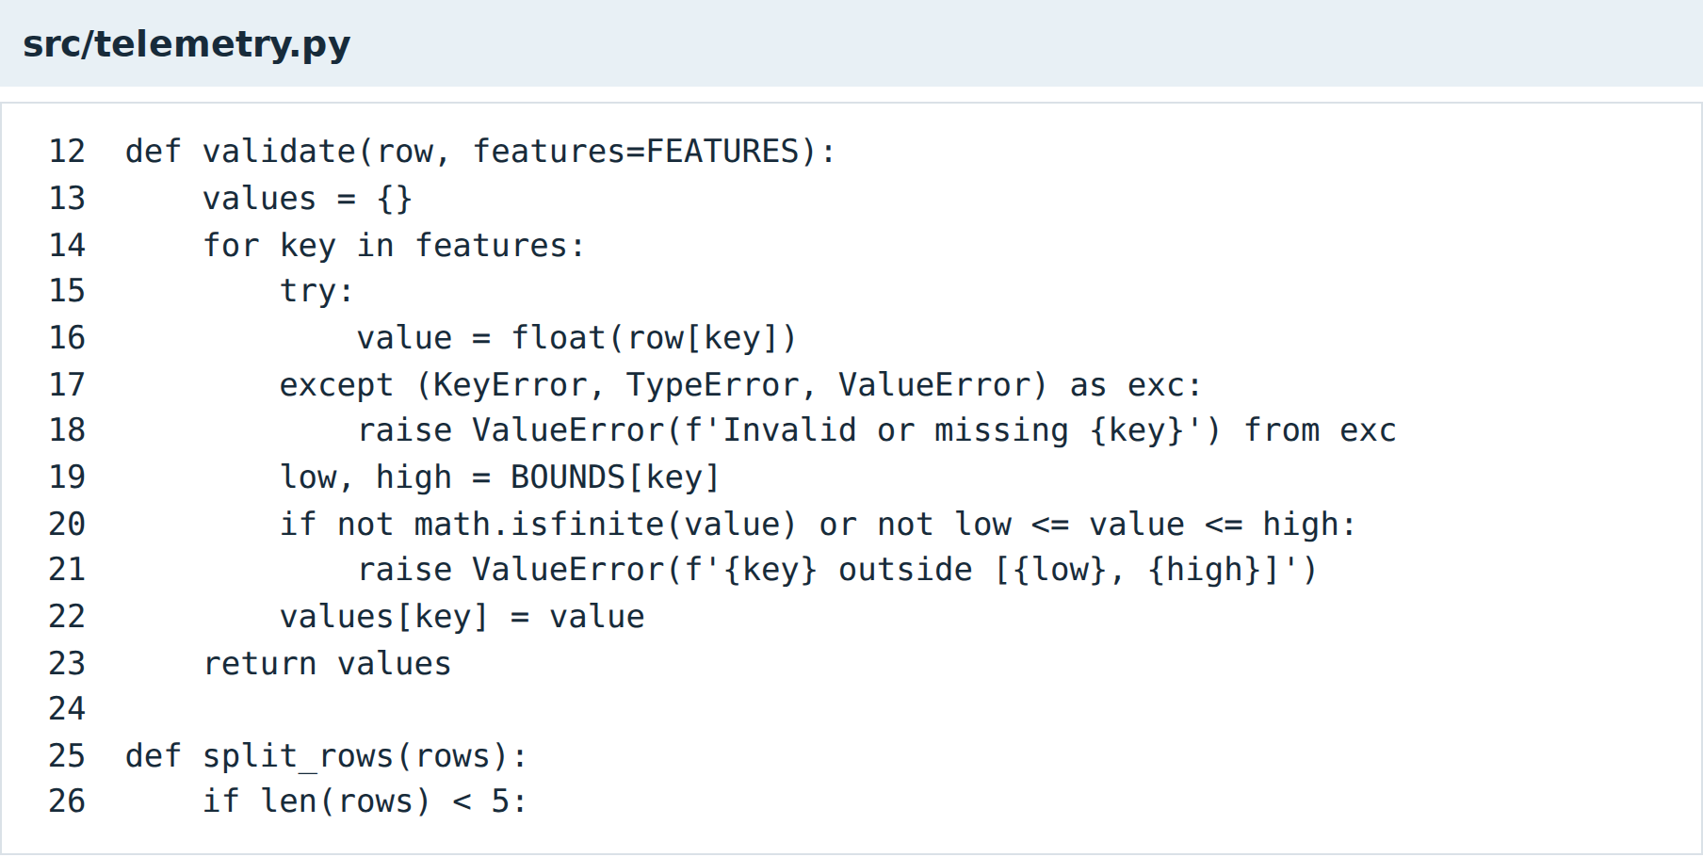
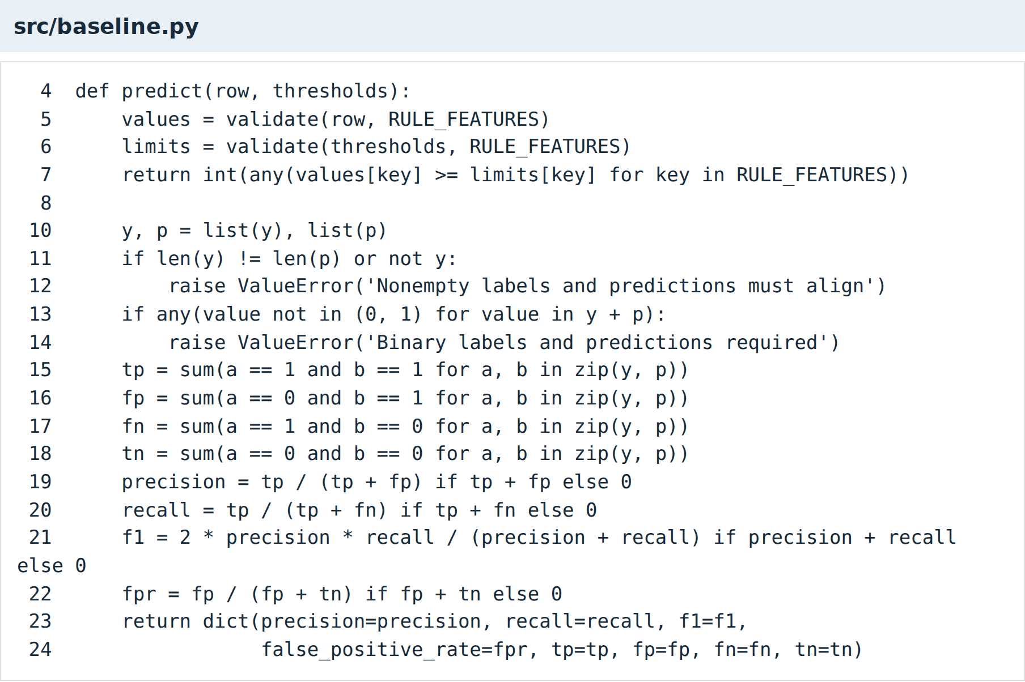
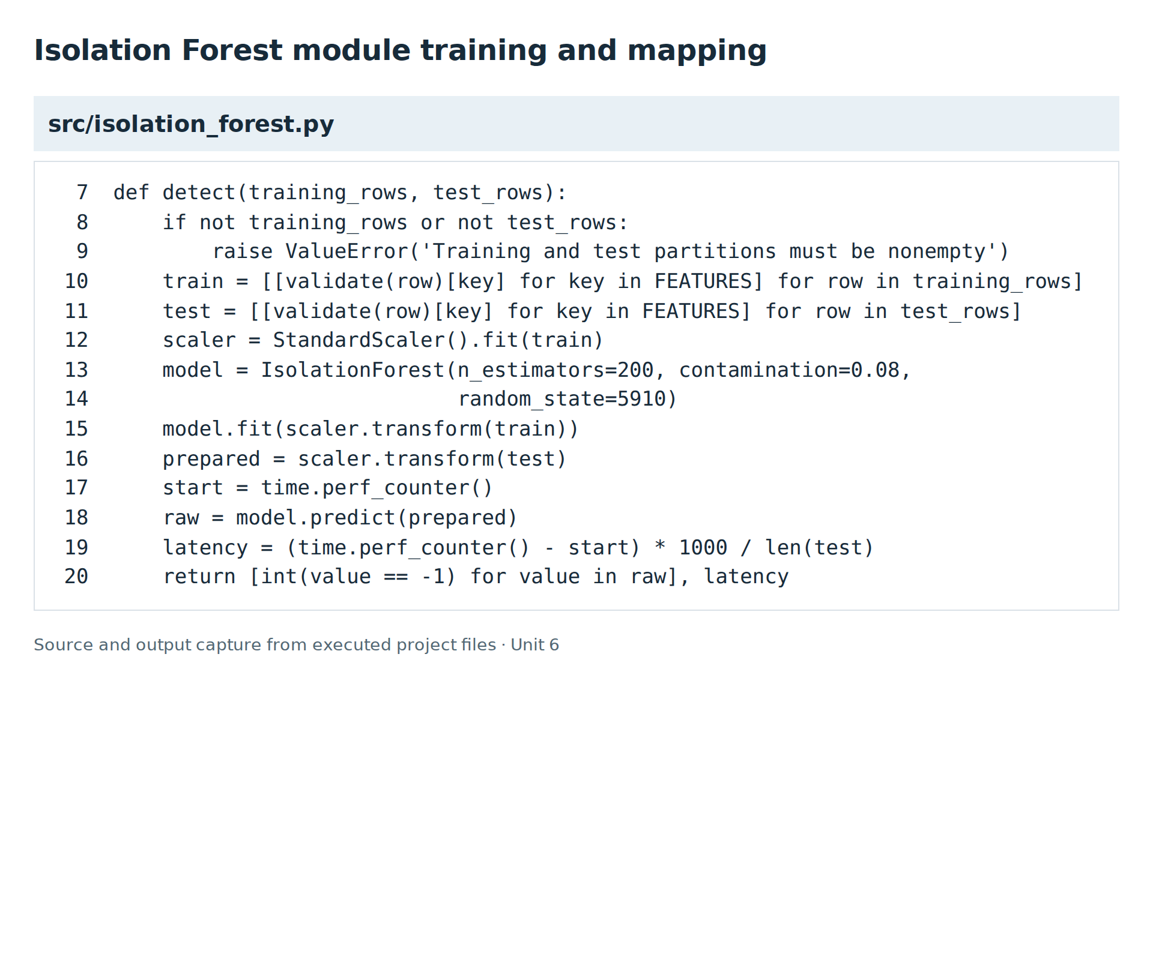
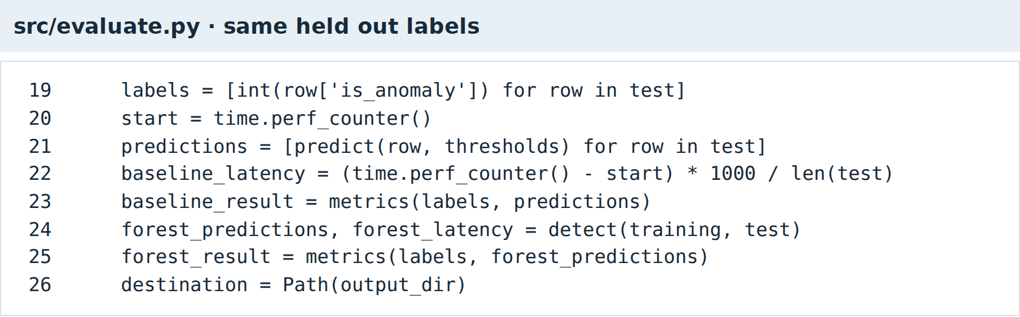
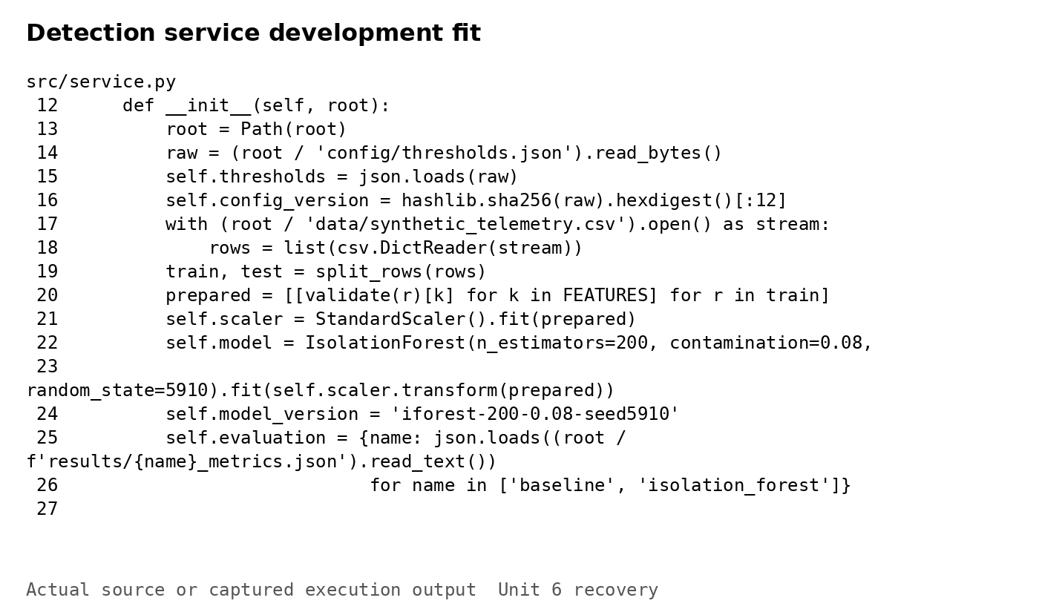
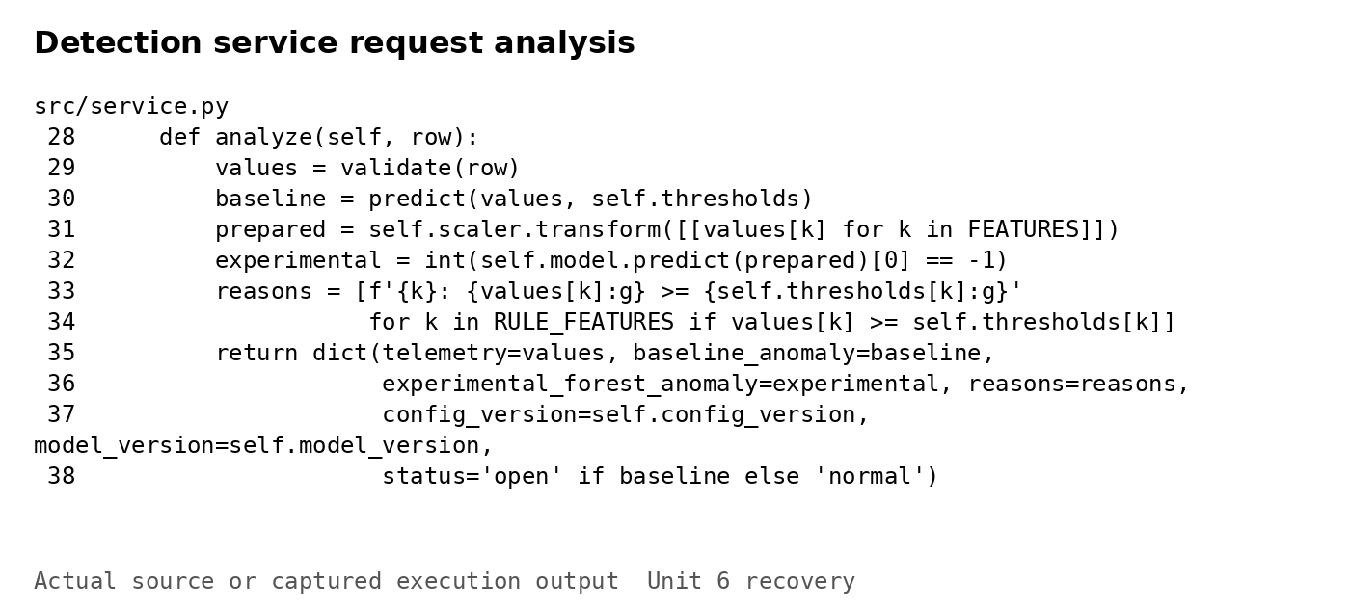
Note. Source excerpts show data generation, validation, the baseline, forest fitting and label mapping, comparable evaluation, and the reusable detection service. All model fitting uses the development partition.
Figure 3
API communication storage and detector outputs
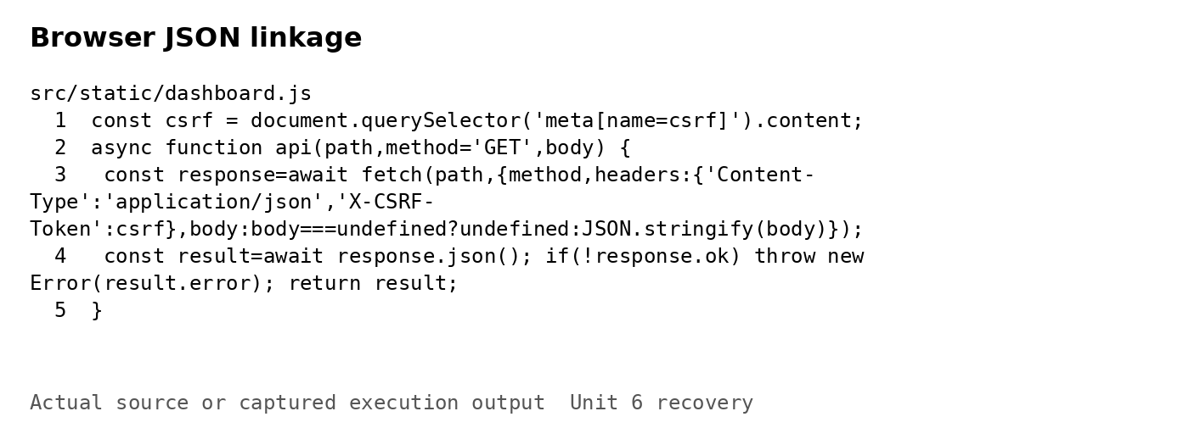
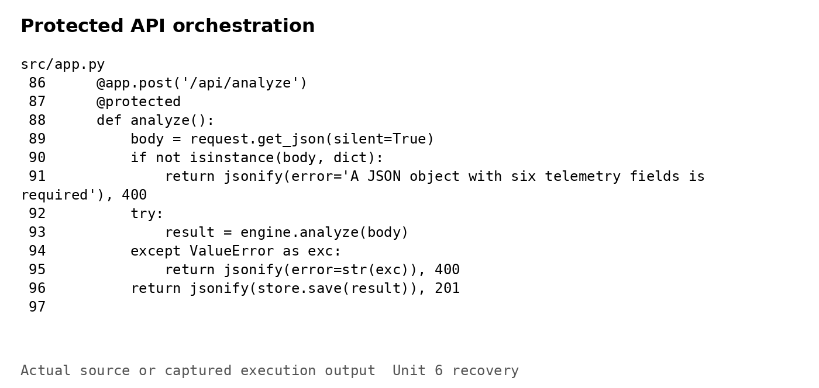
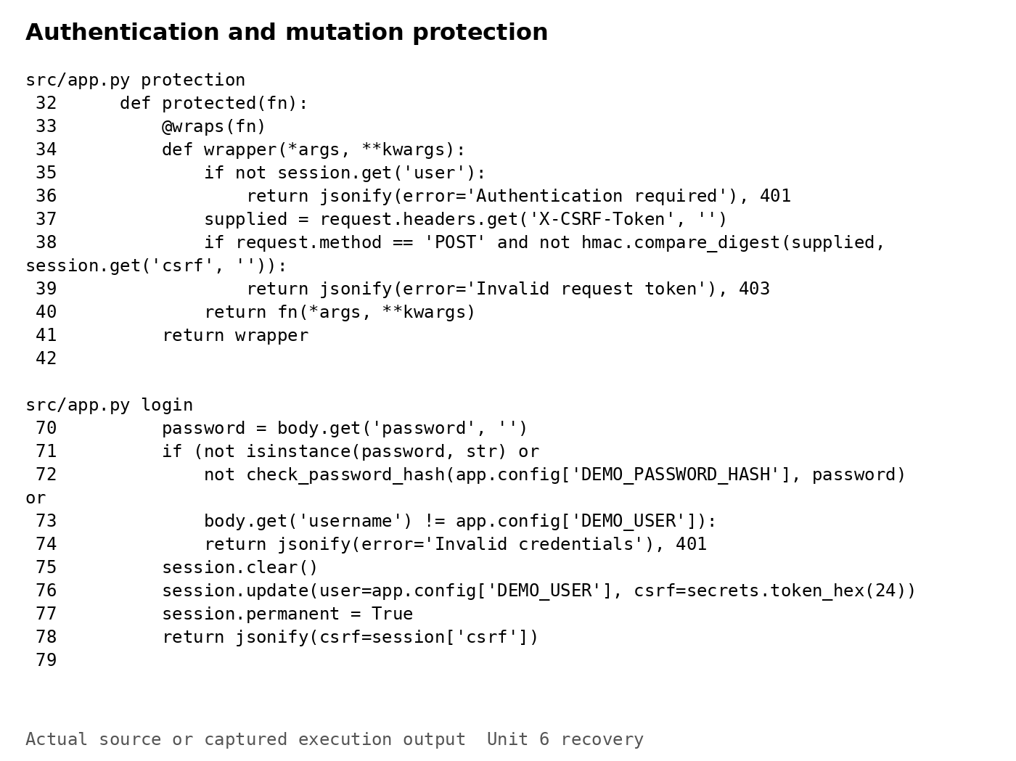
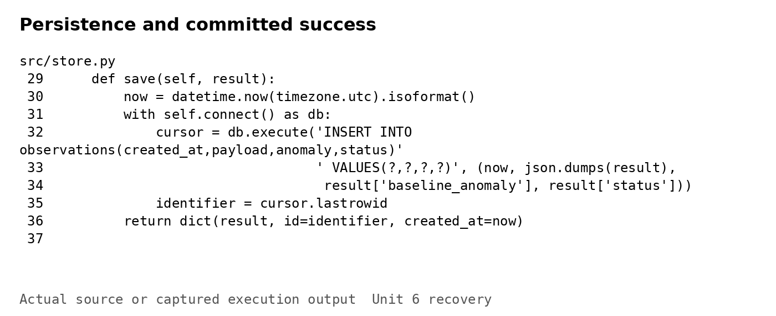
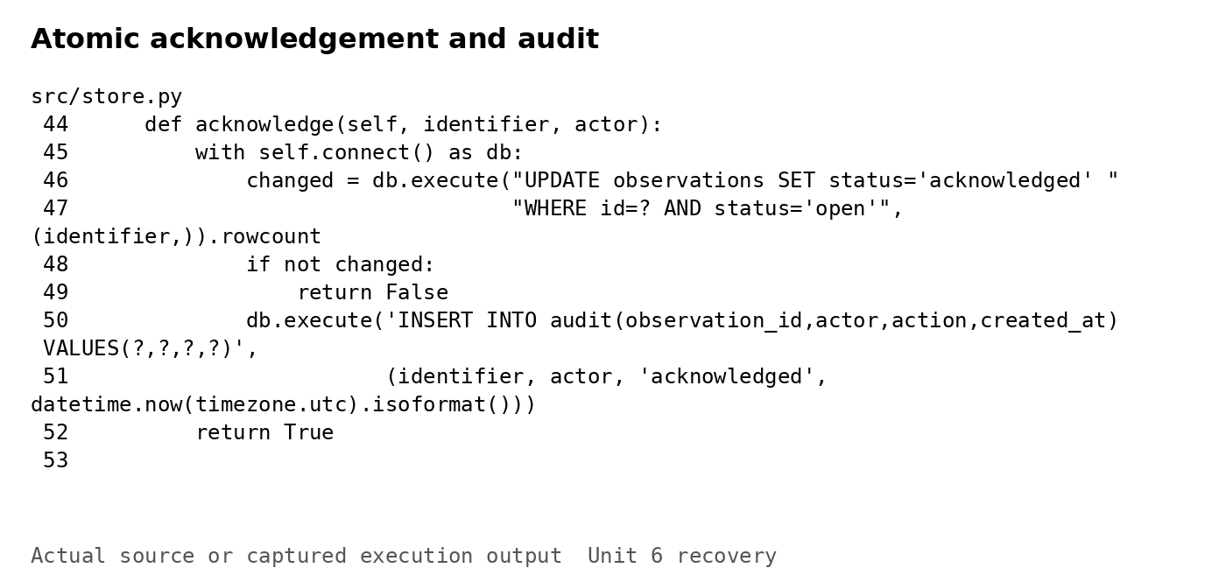
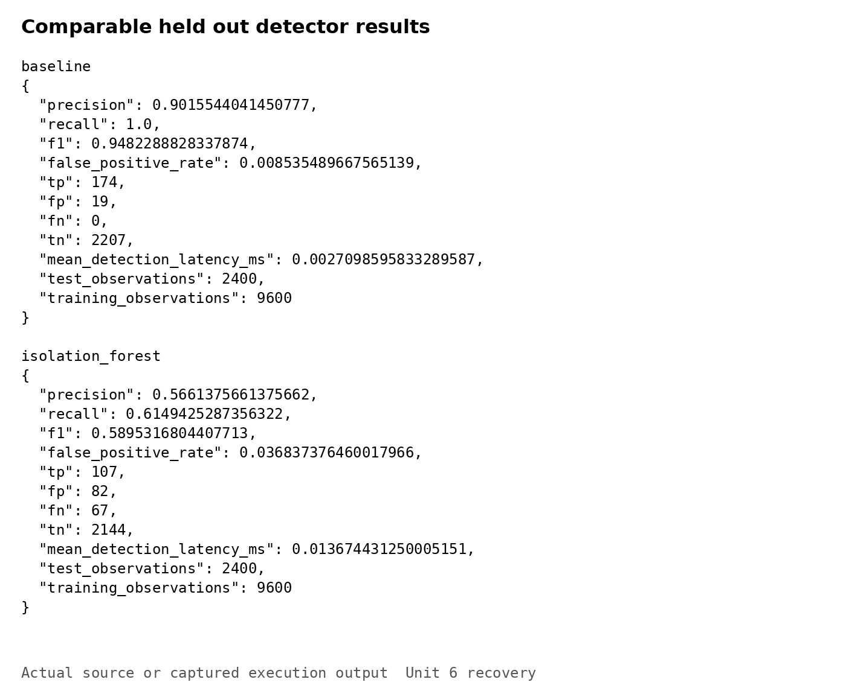
Note. The browser sends JSON to protected API routes. Analysis results are committed before HTTP 201 is returned. Acknowledgement updates status and inserts the audit entry in one transaction.
Figure 4
Normal telemetry submission
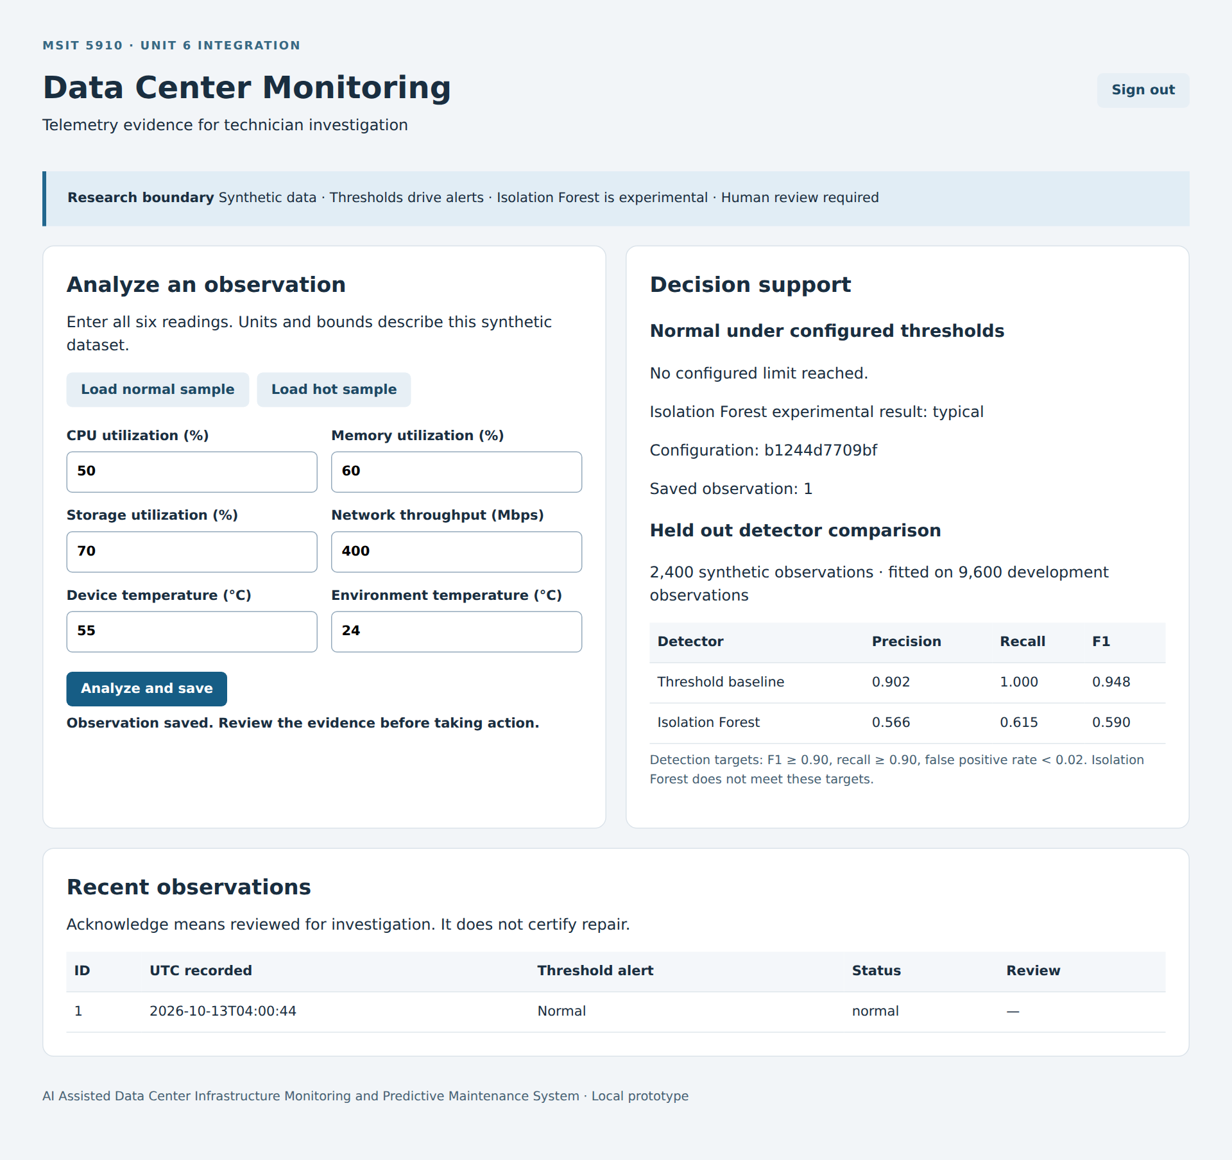
Note. Archived browser capture of the authenticated normal fixture. The saved observation has normal status. Current API and persistence results are recorded in Figure 8; browser rendering was not repeated.
Figure 5
Hot telemetry and acknowledgement
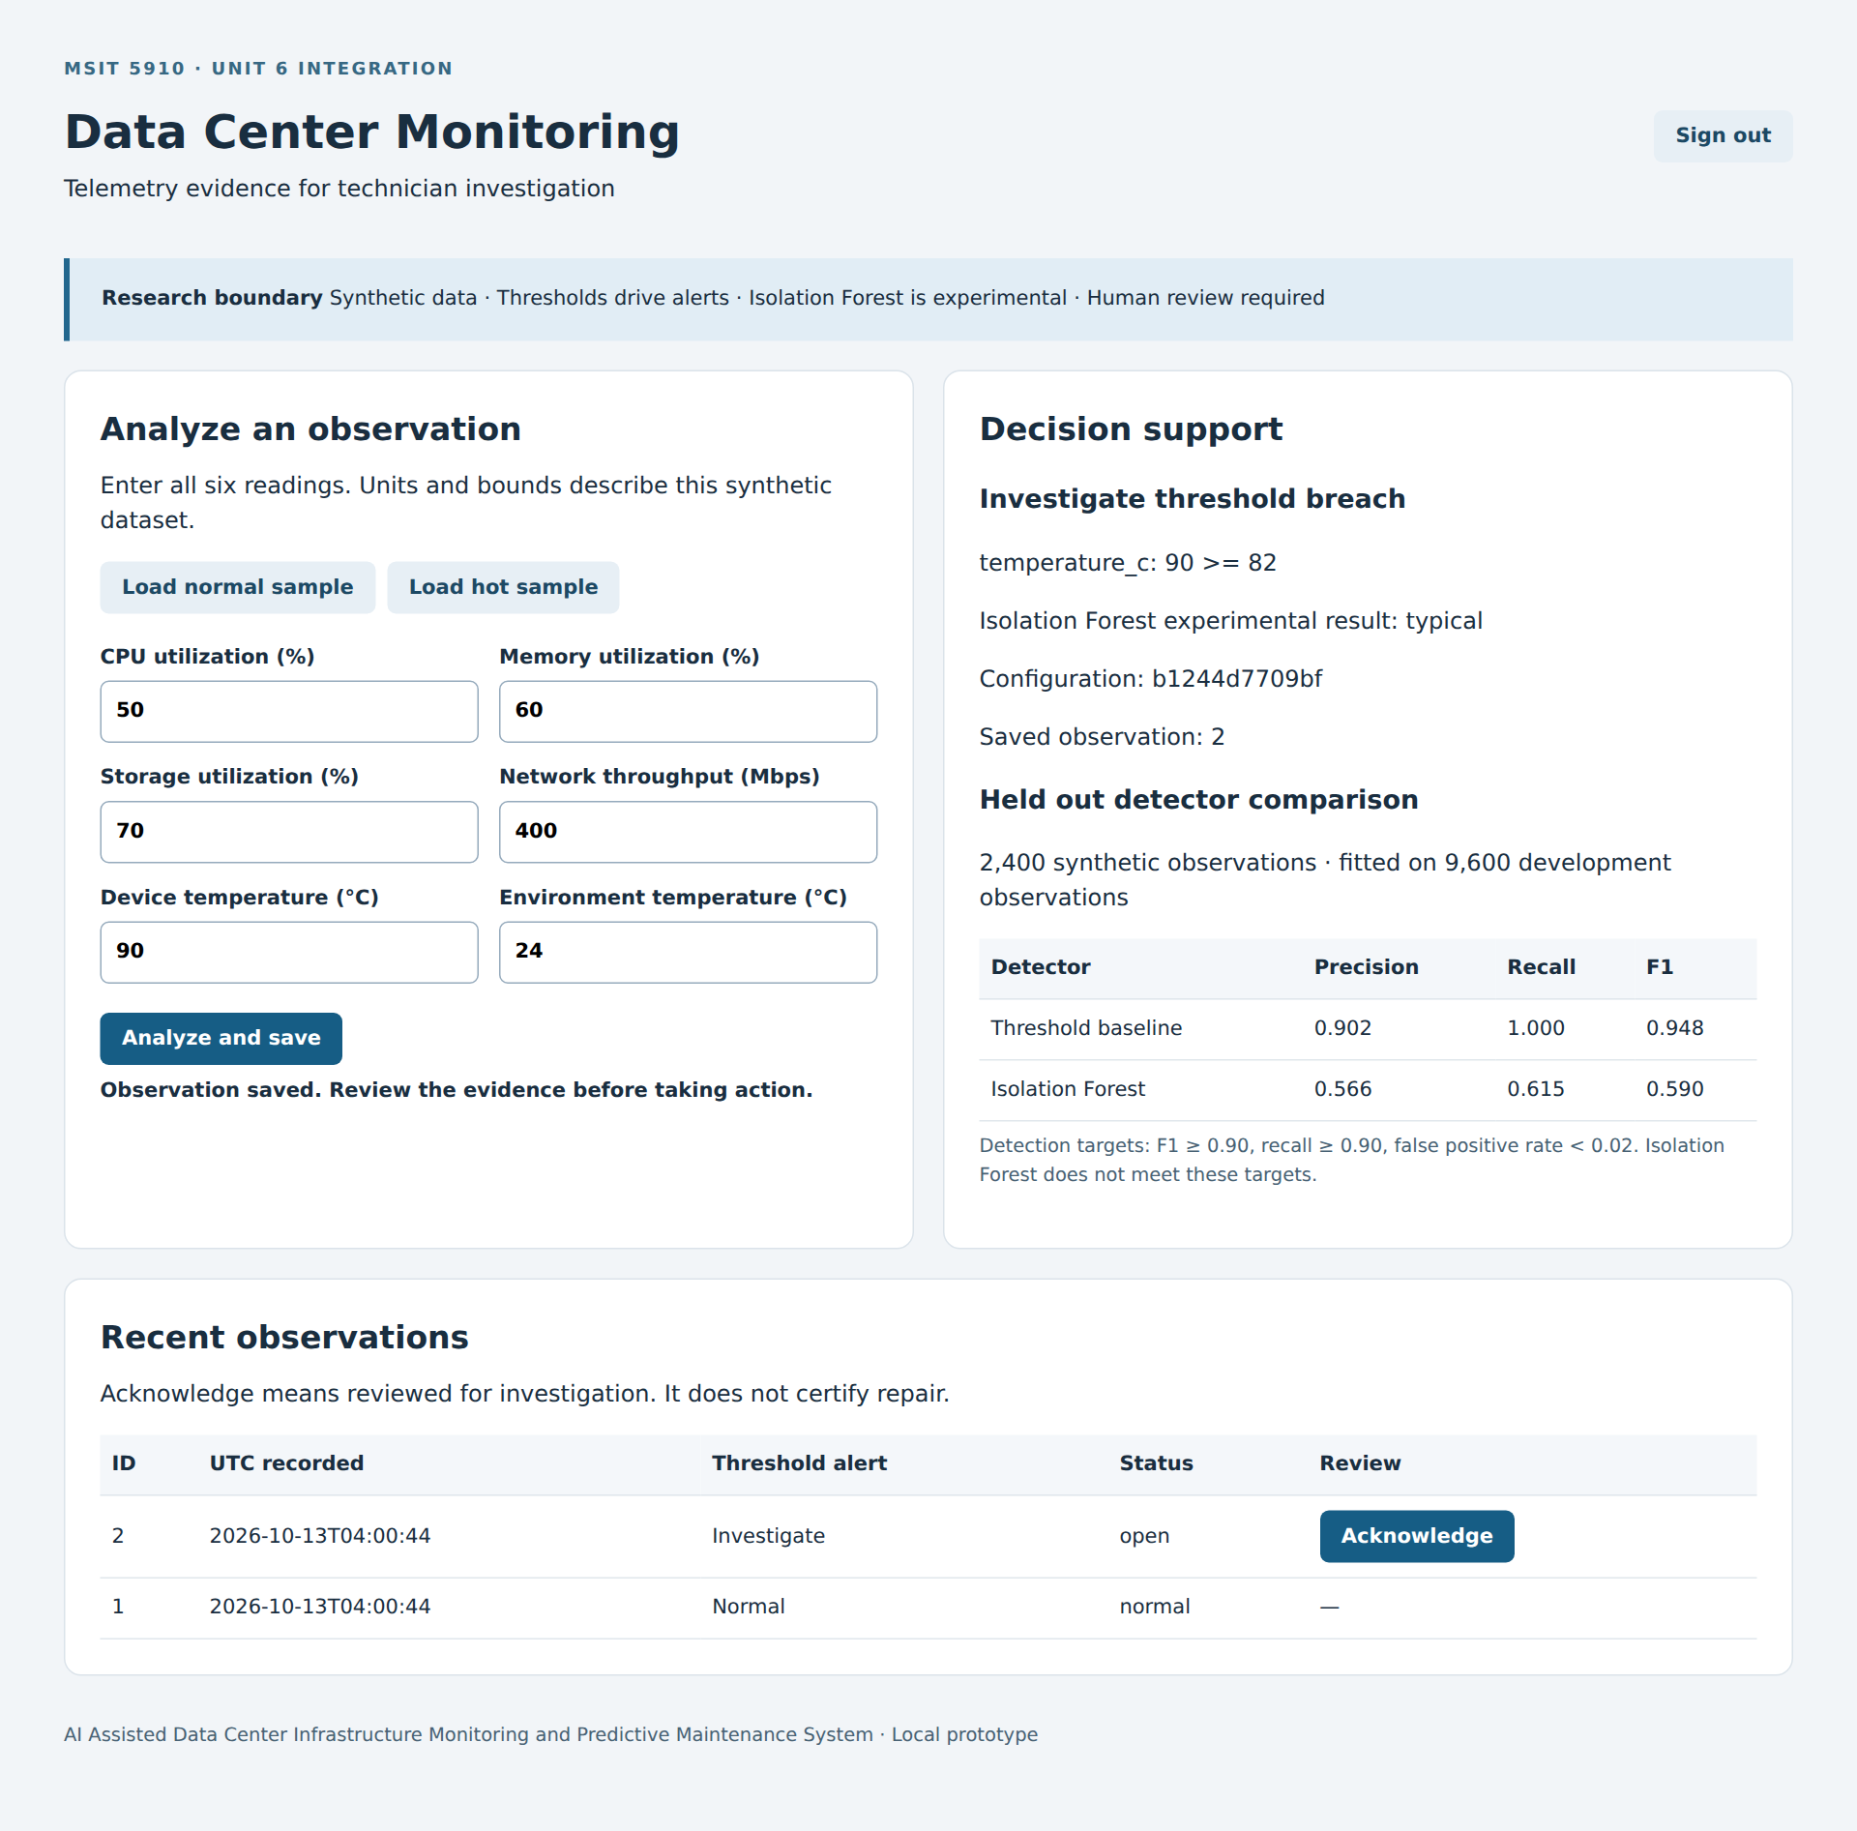
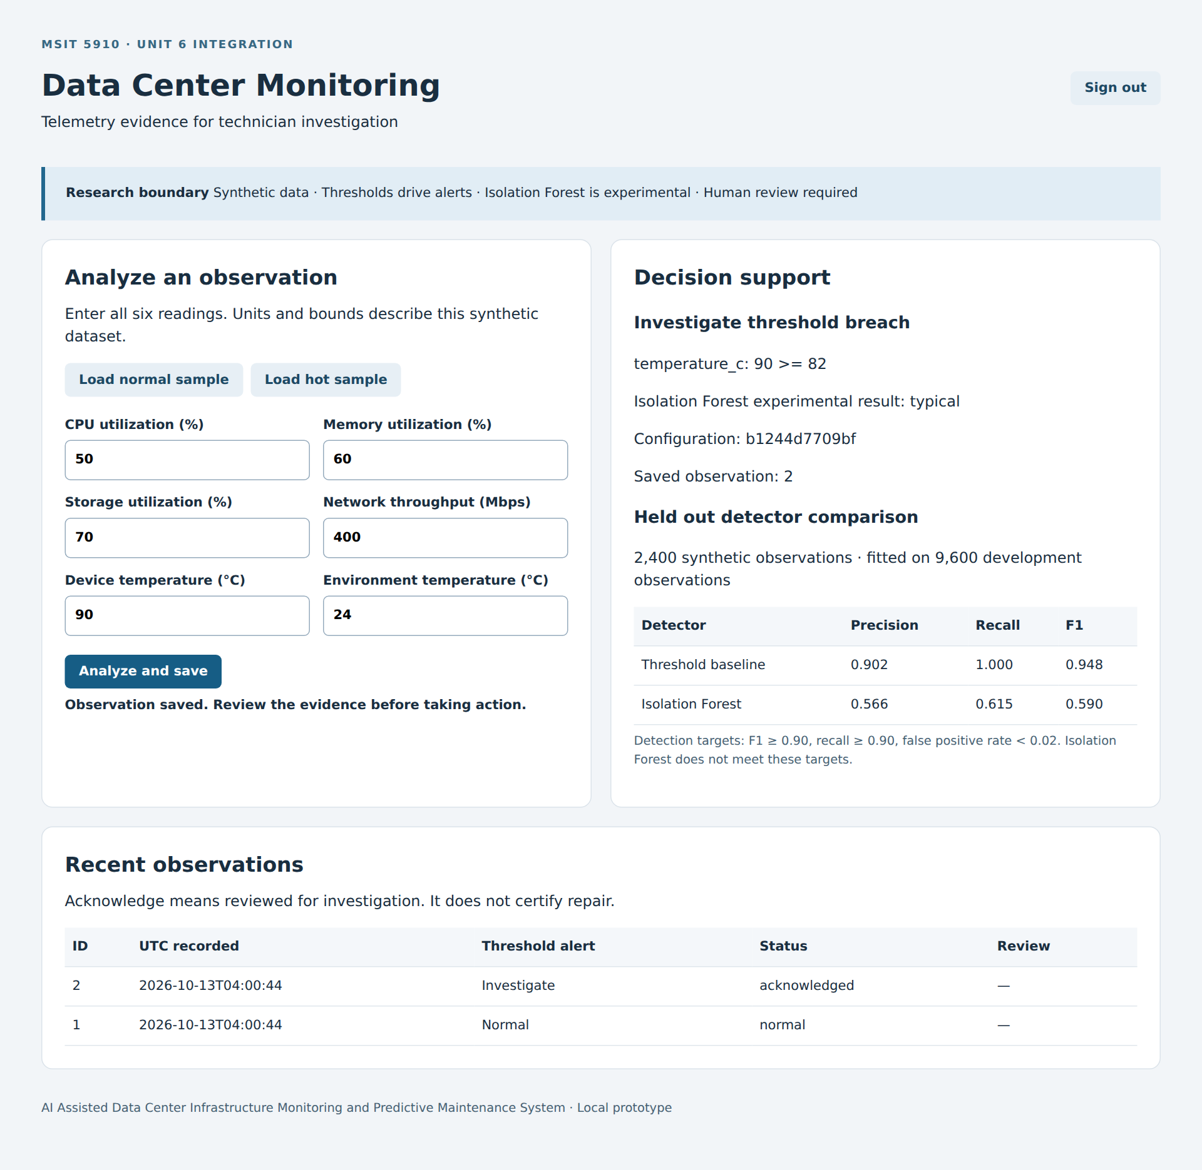
Note. Archived browser captures before and after acknowledgement. Temperature 90°C exceeds the 82°C threshold while the forest calls the input typical. Acknowledgement records review for investigation.
Figure 6
Authentication screen
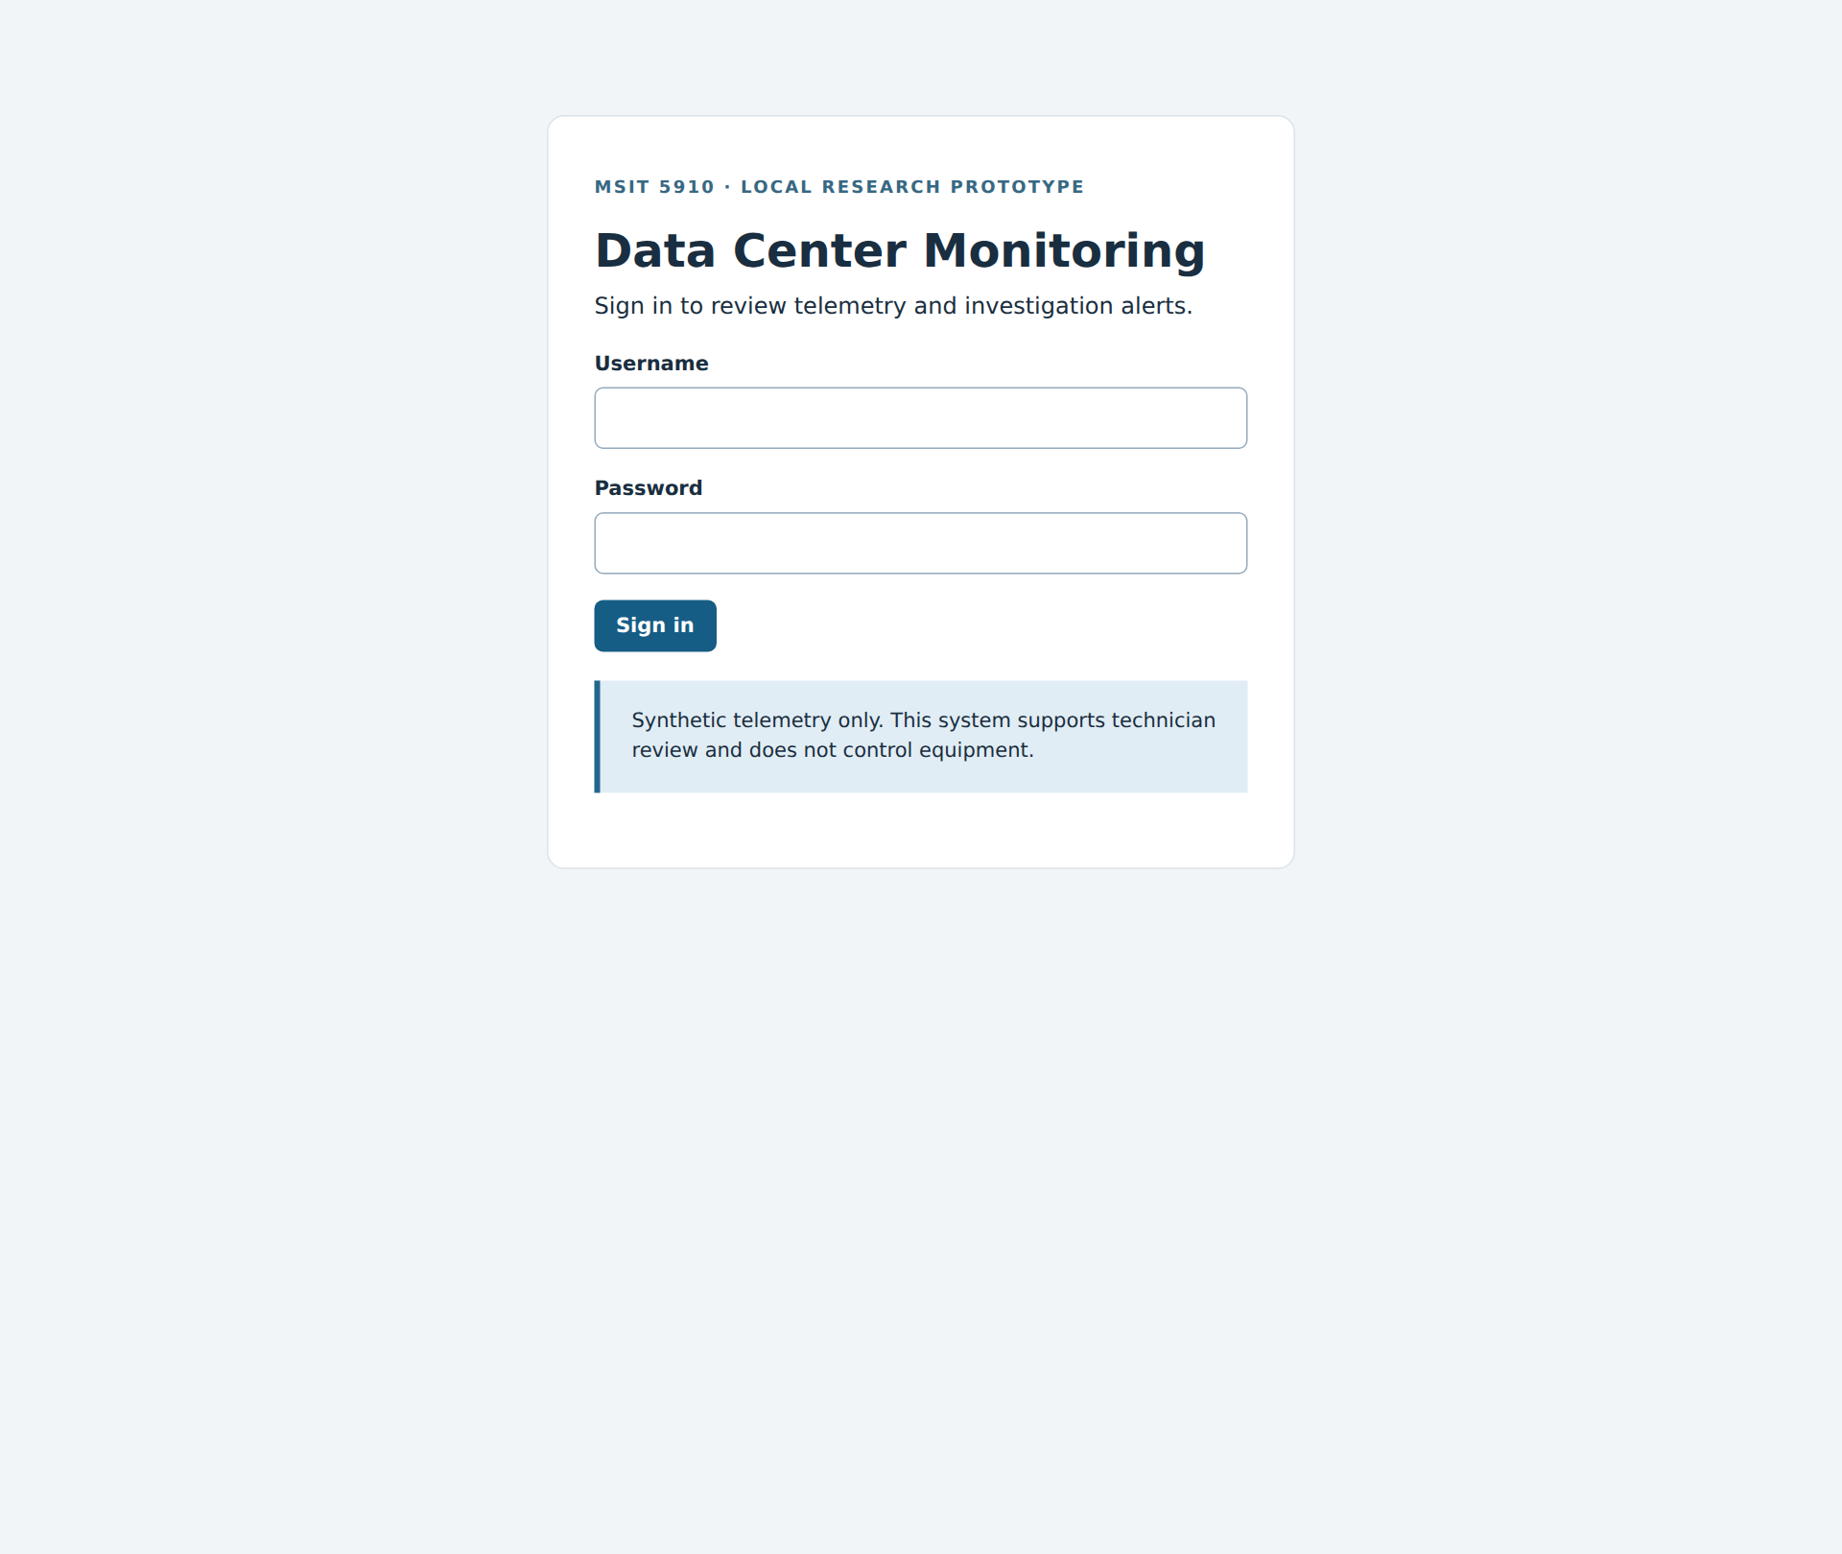
Note. Archived login screen for the local prototype. Figure 3 shows the implemented authentication and CSRF checks; no secret values are included.

Part B: System Evaluation & Metrics Reporting

Quantitative Protocol and Findings
Table 1 and Figure 7 report measured outcomes. Both detectors evaluate 174 injected anomalies and 2,226 normal records. The baseline produces 174 true positives, 19 false positives, zero false negatives, and 2,207 true negatives. Its precision is 0.902, recall 1.000, F1 0.948, and false-positive rate 0.0085. Isolation Forest produces 107, 82, 67, and 2,144 respectively: precision 0.566, recall 0.615, F1 0.590, and false-positive rate 0.0368. The baseline satisfies Unit 5 targets of F1 and recall at least 0.90 and false-positive rate below 0.02; the forest fails. Threshold-aligned synthetic labels favor the baseline, preventing claims of operational superiority. Benchmark diversity matters when assessing anomaly detectors (Han et al., 2022).

Latency Throughput and Reliability
Three serial batches of 100 authenticated loopback requests followed ten warmups under one Gunicorn worker. Measurements include validation, both predictions, and SQLite commit, excluding login, startup, and browser rendering. Median latency ranged 14.60–14.85 milliseconds, batch p95 ranged 18.57–22.80 milliseconds, and throughput ranged 63.27–66.00 requests per second; all 300 requests succeeded. Figures 8 and 9 show the recorded outputs. The suite passes 59 tests. Statement coverage is 278/283, or 98.23%; branch coverage is 55/58, or 94.83%. The combined score is 333/341, or 97.65%, displayed as 98%. Unit 5 combined 118/123 statements and 33/36 branches to obtain 151/159, or 94.97%, displayed as 95%. Uncovered command-line entry paths leave launch behavior and associated failure conditions incompletely tested. Successful smoke runs provide separate evidence but do not change the coverage denominator.

Qualitative Interface Assessment
A structured implementation walkthrough assessed clarity, feedback, and review semantics using normal submission, hot submission, and acknowledgement tasks. Screenshots show explicit units, readable breach reasons, visible experimental-model disagreement, saved identifiers, and persistent status changes. Terminology such as cpu_pct remains technical, and the latest-record table lacks pagination and filtering. These observations support formative interface assessment, not participant satisfaction or a System Usability Scale score. Numerical and descriptive evidence answer different evaluation questions (Brereton, 2023; Wells, 2025). GeeksforGeeks (2025) identifies usability alongside reliability and performance. Five-technician testing remains planned, with at least 80% task completion and SUS at least 70 as targets. Zhao et al. (2019) provide a scholarly open-source comparison framework; PyOD is not a dependency here.
Table 1
Detection results on the shared holdout
Metric | Threshold baseline | Isolation Forest | Interpretation
Precision | 0.9016 | 0.5661 | Baseline stronger on these fixtures
Recall | 1.0000 | 0.6149 | Forest misses 67/174 injected anomalies
F1 | 0.9482 | 0.5895 | Target ≥ 0.90; forest fails
False positive rate | 0.0085 | 0.0368 | Target < 0.02; forest fails
TP / FP / FN / TN | 174 / 19 / 0 / 2,207 | 107 / 82 / 67 / 2,144 | Same 2,400 held-out records

Table 1 continued
Serial HTTP request performance
Run | Median latency | p95 latency | Throughput
Batch 1 | 14.60 ms | 20.04 ms | 66.00/s
Batch 2 | 14.85 ms | 18.57 ms | 65.40/s
Batch 3 | 14.70 ms | 22.80 ms | 63.27/s
The holdout contains 2,400 observations. HTTP results use ten warmups and three serial batches of 100 authenticated requests under one Gunicorn worker; all measured requests returned HTTP 201.
Table Q1
Qualitative interface clarity inspection
Task or criterion | Observed evidence | Limitation or next check
Normal submission | Units and a saved identifier are visible; record status is normal. | Participant interpretation remains unmeasured.
Hot alert interpretation | Explicit 90 ≥ 82 breach and forest disagreement are shown. | Internal feature names need clearer language.
Alert acknowledgement | Table changes to acknowledged; SQL audit persists. | Acknowledgement does not mean repaired.
History and navigation | Latest 50 records are available. | Add filters, pagination, equipment context, and trends.

Figure 7
Detection comparison and request latency
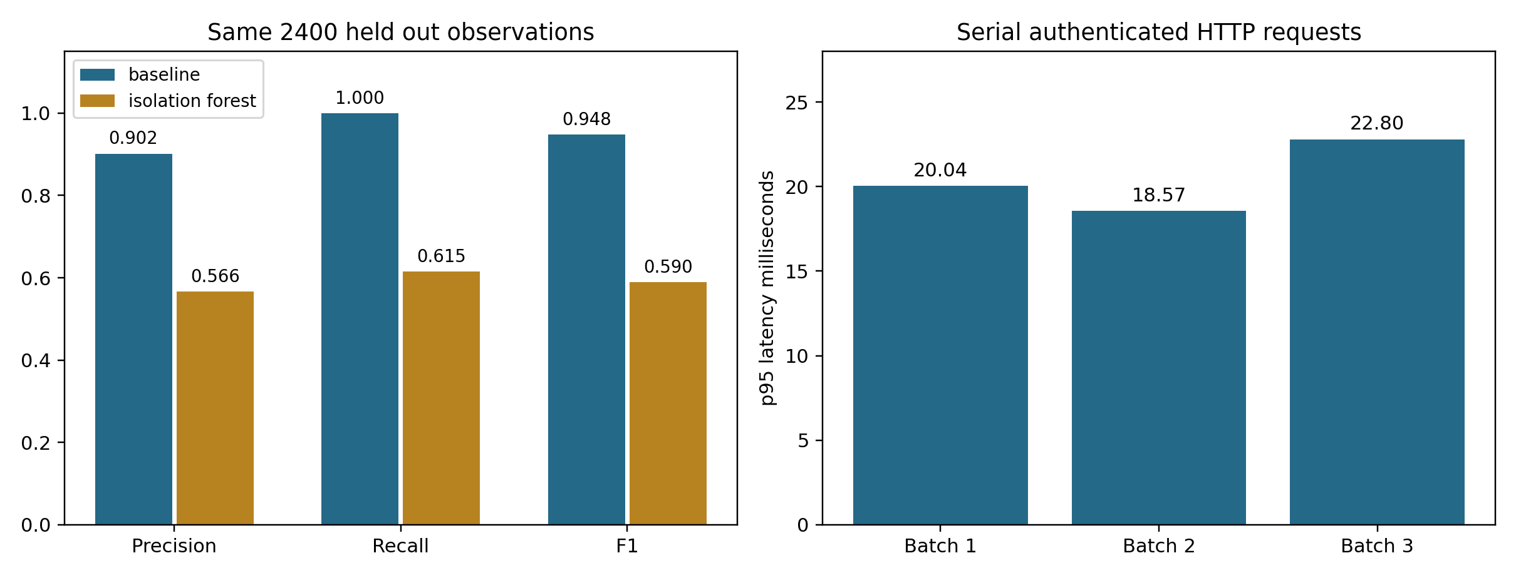
Note. Threshold-aligned synthetic labels favor the baseline. The latency chart reports batch p95 for the complete authenticated analysis and save request.
Figure 8
HTTP performance and workflow results
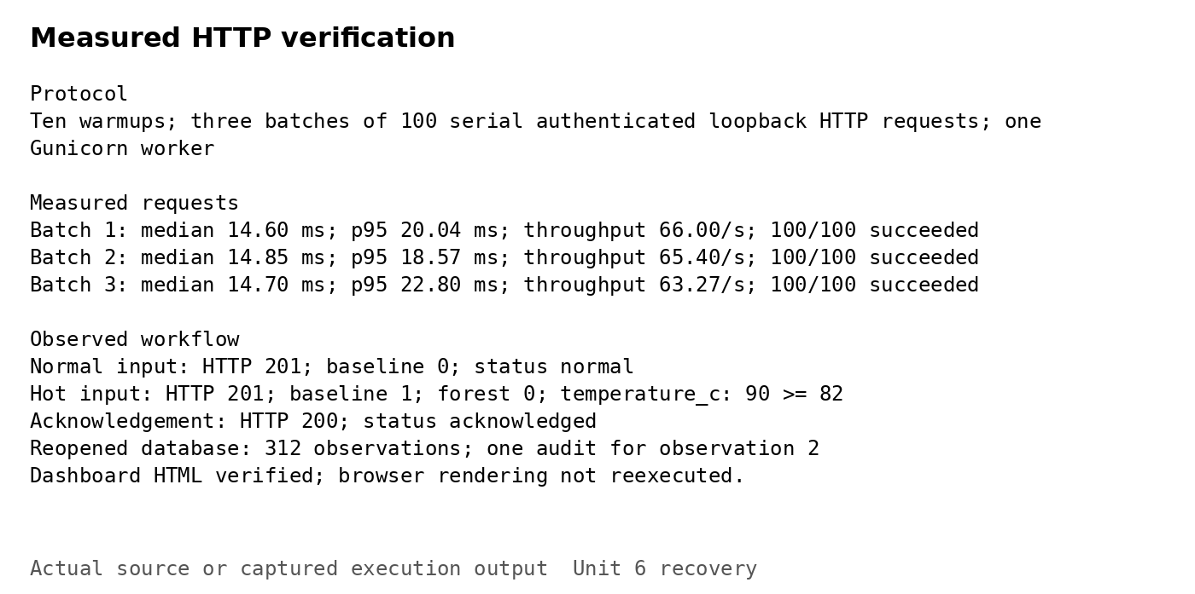
Note. Recorded outputs for normal submission, the hot threshold breach, acknowledgement, and three request batches. Dashboard HTML was checked; browser JavaScript was not reexecuted.
Figure 9
Automated tests and coverage
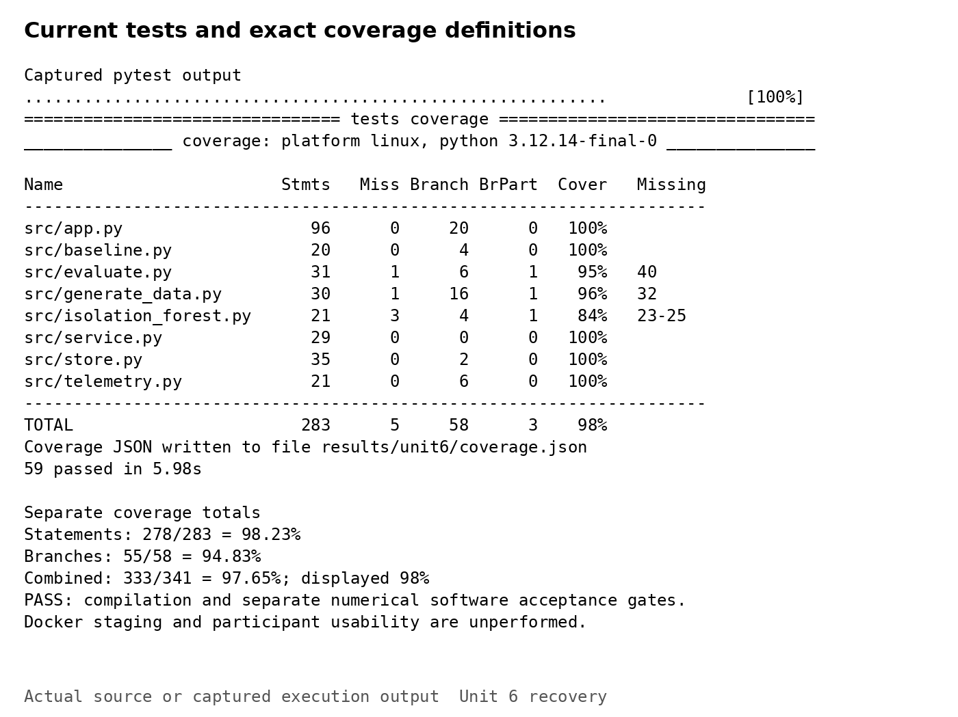
Note. Recorded pytest results: 59 tests pass, with 98.23% statement coverage and 94.83% branch coverage. The combined terminal score rounds to 98%.

Part C: Deployment & Configuration Planning

Selected Deployment and Alternatives
Docker on a controlled Linux staging host is selected for repeatable packaging and isolation. A local virtual environment suits demonstrations; a managed cloud host offers convenience but introduces costs and organizational data controls. An on-premises server provides locality but requires patching and backup ownership. The prepared Dockerfile uses a non-root account, one Gunicorn worker, and a health check. A persistent volume preserves SQLite records (Docker, n.d.). Docker execution and staging promotion have not been performed; the measured environment is local Gunicorn. Deployment includes packaging and configuration, rather than simply copying source files (Sumo Logic, n.d.). Staging must also confirm that the service account can write to its mounted volume.

Prerequisites Environment and Commands
Table 2 and Figure 10 document setup. Validated prerequisites are Linux x86_64, Python 3.12.14, scikit-learn 1.8.0, Flask 3.1.2, Gunicorn 23.0.0, pytest 9.1.1, pytest-cov 7.1.0, and SQLite 3.53.1. An IDE opens the repository root and selects its virtual-environment interpreter. Required settings are APP_SECRET_KEY and DEMO_PASSWORD_HASH; DEMO_USER defaults to technician, DATABASE_PATH identifies writable storage, and COOKIE_SECURE becomes one behind staging HTTPS. Secrets remain outside Git. Commands create the environment, install dependencies, generate data, run evaluation and tests, compile Python, and start the server. Docker build/run commands are proposed. Flask documentation specifies Gunicorn’s application-factory syntax (Pallets Projects, n.d.).

Configuration and Acceptance Criteria
Configuration management versions source, thresholds, dependencies, and evidence together (Bennett, 2024). The feature/unit6-integration-recovery branch preserves the integration work separately from main. Verified earlier tags v0.1.0 and v0.2.0 retain prototype and tested-core milestones; a future v0.3.0 prerelease should identify reviewed integration. Merge criteria require all tests passing, separate statement and branch coverage at least 90%, successful compilation, unchanged seeded baseline confusion counts, and review of configuration and security changes. Staging additionally requires a built image, restart/persistence checks, HTTPS, secret injection, backup restoration, dependency review, and p95 below 100 milliseconds under the documented serial protocol. Passing software gates does not promote the forest to operational use. Documentation must remain synchronized with implementation (Brown, 2026).

Reproduction and Configuration Evidence
Setup depends on the order of initialization. Generate the dataset and evaluation files before server startup because the detection service reads both during construction. Supply the session secret and password hash before creating the application; missing secrets deliberately stop startup. The database parent directory must be writable. Restart after changing thresholds because the service loads its configuration and fits the detector once. The recorded database contains 312 observations: two demonstrations, ten warmups, and 300 benchmark requests. Its single acknowledgement belongs to the hot demonstration. Reopening SQLite confirms the saved review status. These records establish persistence without representing participant activity or operational incidents. Reproduction should compare classification counts rather than require identical timings, since scheduling and storage conditions vary. Appendix A provides the ordered commands, including secret preparation before Gunicorn startup. The staging plan adds restart and backup restoration checks before wider access.

Conclusion

Findings and Next Steps
The project now demonstrates connected decision support with reproducible evidence. Detection results favor the baseline under biased synthetic conditions, while latency and integration tests establish local functionality. The next priorities are independent telemetry, representative usability testing, stronger access controls, and verified container deployment with documented acceptance criteria.
Figure 10
Environment setup and persistent storage
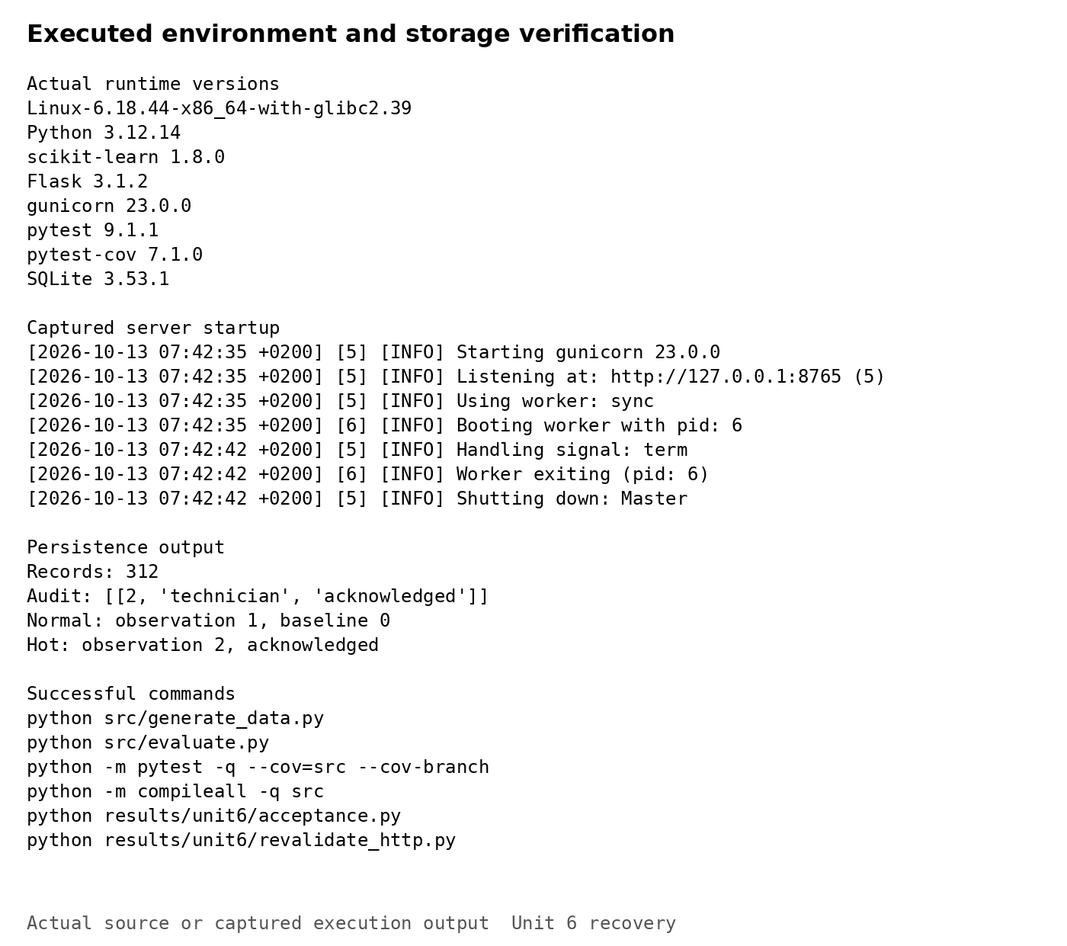
Note. Recorded interpreter, dependency, server, and database outputs. The database contains 312 observations and one acknowledgement audit entry. Docker execution remains planned.

References
Bennett, L. (2024, August 13). Software configuration management in software engineering. Guru99. https://www.guru99.com/software-configuration-management-tutorial.html
Brereton, J. (2023, November 27). Qualitative vs quantitative metrics: A comprehensive comparison. LaunchNotes. https://www.launchnotes.com/blog/qualitative-vs-quantitative-metrics-a-comprehensive-comparison
Brown, J. (2026, September 13). Software documentation guide: Definition, examples, downloadable templates + how to write. Helpjuice. https://helpjuice.com/blog/software-documentation
Docker. (n.d.). Volumes. https://docs.docker.com/engine/storage/volumes/
GeeksforGeeks. (2025, July 15). Measuring software quality using quality metrics. https://www.geeksforgeeks.org/software-engineering/measuring-software-quality-using-quality-metrics/
Han, S., Hu, X., Huang, H., Jiang, M., & Zhao, Y. (2022). ADBench: Anomaly detection benchmark. Advances in Neural Information Processing Systems, 35, 32142–32159. https://proceedings.neurips.cc/paper_files/paper/2022/hash/cf93972b116ca5268827d575f2cc226b-Abstract-Datasets_and_Benchmarks.html
Pallets Projects. (n.d.). Gunicorn. Flask documentation. https://flask.palletsprojects.com/en/stable/deploying/gunicorn/
Ruff, L., Kauffmann, J. R., Vandermeulen, R. A., Montavon, G., Samek, W., Kloft, M., Dietterich, T. G., & Müller, K.-R. (2021). A unifying review of deep and shallow anomaly detection. Proceedings of the IEEE, 109(5), 756–795. https://doi.org/10.1109/JPROC.2021.3052449
Sumo Logic. (n.d.). What is software deployment? https://www.sumologic.com/glossary/software-development/
Summers, B. L. (2020). Effective methods for software engineering. Auerbach Publications. https://doi.org/10.1201/9781003025665
Wells, J. (2025, April 16). Top 12 software quality metrics to measure and why. LinearB. https://linearb.io/blog/software-quality-metrics
Zhao, Y., Nasrullah, Z., & Li, Z. (2019). PyOD: A Python toolbox for scalable outlier detection. Journal of Machine Learning Research, 20(96), 1–7. https://www.jmlr.org/papers/v20/19-011.html

Appendix A Configuration and Setup
Table 2
Prerequisites and configuration settings
Item | Requirement or setting
Runtime | Linux x86_64; Python 3.12.14; scikit-learn 1.8.0; Flask 3.1.2; Gunicorn 23.0.0
Tests and storage | pytest 9.1.1; pytest-cov 7.1.0; SQLite 3.53.1; writable database parent directory
APP_SECRET_KEY | Required random session-signing secret; injected externally; never committed
DEMO_PASSWORD_HASH | Required Werkzeug password hash; never store the password in source
DEMO_USER | Default technician; one prototype account
DATABASE_PATH | Default data/monitor.db; staging /app/state/monitor.db on a persistent volume
COOKIE_SECURE | 0 only for loopback HTTP; 1 behind staging HTTPS
Threshold configuration | config/thresholds.json; SHA-256 prefix b1244d7709bf; restart after changes
Model configuration | 200 trees; contamination 0.08; seed 5910; fit at startup on development partition

Local Setup
python -m venv .venv
. .venv/bin/activate
python -m pip install -r requirements.txt
python src/generate_data.py
python src/evaluate.py
python -m pytest -q --cov=src --cov-branch --cov-report=json:results/unit6/coverage.json
python -m compileall -q src
python results/unit6/acceptance.py
Prepare the session secret and password hash before starting Gunicorn. These commands prompt for the password without echoing it; secret values must remain outside Git.
export APP_SECRET_KEY="$(python -c 'import secrets; print(secrets.token_hex(32))')"
export DEMO_PASSWORD_HASH="$(python -c 'from getpass import getpass; from werkzeug.security import generate_password_hash; print(generate_password_hash(getpass("Demo password: ")))')"
python -m gunicorn --chdir src --bind 127.0.0.1:8000 --workers 1 'app:create_app()'

Proposed Docker Deployment
The Docker sequence is planned and has not been executed. Supply the external secrets in a protected .env file. HTTPS is required when COOKIE_SECURE=1. Verify volume permissions, persistence after restart, and backup restoration before staging promotion.
docker build -t msit5910:unit6 .
docker volume create msit5910-state
docker run --rm --env-file .env -p 127.0.0.1:8000:8000 \
--mount type=volume,src=msit5910-state,dst=/app/state msit5910:unit6
Implementation and recorded results: https://github.com/Meherzaad/MSIT-5910/tree/211add31d02730a4c31c9063e09d9f78723c7d81. Integration review: https://github.com/Meherzaad/MSIT-5910/pull/4. Browser captures are archived from the earlier local demonstration; quantitative results correspond to the recorded Unit 6 execution.

