Mehfooz-ur-Rehman

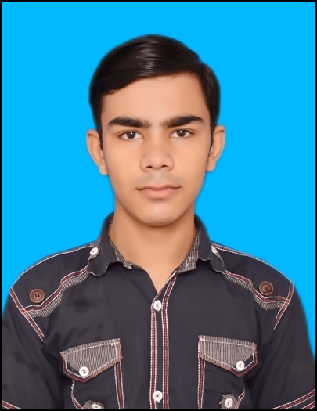

**Address**: House No. P-42, Near Liaqat Karyana Store, Mohallah Islamabad

Main Street No. 3, Tehsil Samundri Faisalabad

**Cell** # 0313-7178074 **NIC** # 33105-6846560-9

**Objective**

To seek a progressive career that enhances my abilities & hidden skills in a competitive environment.

**Personal Information**

**Father’s Name** Muhammad Ijaz Ahmad

**Marital Status**  Unmarried

**Date of Birth**  09-12-2000

**Domicile (Province)** Faisalabad (Punjab)

**Nationality**  Pakistani

**Religion** Islam

**Languages** Urdu, English, Punjabi

**Home**  0333-8535217

**Email**  [mehfoozijaz786@gmail.com](mailto:mehfoozijaz786@gmail.com)

**Website** <https://mehfooz-ur-rehman.firebaseapp.com>

**Academic Qualifications**

|  |  |  |  |
| --- | --- | --- | --- |
| **Certificate / Degree** | **Board / University** | **Session** | **M**arks |
| Metric with computer science | Board of intermediate and secondary education Faisalabad | 2014-16 | 1100/700 |
| Intermediate with computer science | Board of intermediate and secondary education Faisalabad | 2016-18 | 1100/540 |
| Bachelors in computer science | Virtual university of Pakistan | 2019-23 | 4.00/3.78 |

**Professional Qualifications**

|  |  |  |
| --- | --- | --- |
| **Certificate / Degree** | **Board / University** | **Session** |
| Diploma Certificate in Computer Application | Trade Testing Board TEVTA Lahore | 2015 |
| Diploma Computer Operator | Punjab Board of Technical Education TEVTA Lahore | 2016 |
| Diploma Auto Cad | Punjab Board of Technical Education TEVTA Lahore | 2017 |
| Diploma Civil Surveyor | Trade Testing Board TEVTA Lahore | 2018 |
| Diploma Electrician | Trade Testing Board TEVTA Lahore | 2019 |

**Experience**

* 06 months as Computer Lab Attendant at Govt. Technical Training Center near General Bus Stand Samundri.
* 06 months as AutoCAD instructor at Govt. Technical Training Center near General Bus Stand Samundri.
* as an architecture at a Waqar-ul-Afreen architect.

**Skills**

**Office Automations** MS Word, MS Excel and MS Power Point, In page

**Programming Languages** C++, HTML, CSS, JavaScript, Bootstrap, Ionic

**Graphics**  Corel Draw, Photo Shop, Adobe XD, AutoCad

**Type Speed**  Have a 35 to 40 Words/Min

**Reference**

Documents will be furnished on demand.