NAME- MEHIR SAXENA
BATCH NO- 01 ( DATA SCIENCE) SAP ID- 500123380
SUBMITTED TO- DR.MUTHU KUMAR SIR

DATA NETWROKING AND COMMUNICATION LAB REPORT -1
TOPIC- FAMILIARIZATION OF NETWORKING DEVICES

OBJECTIVE-

This report outlines the steps to familiarize oneself with network devices using Cisco Packet Tracer, as outlined in the uploaded exercise. Each step has been summarized for clarity.
STEP-1

Step 1: Open Cisco Packet Tracer
Launch Cisco Packet Tracer on your computer.
Create a new workspace by navigating to File → New.
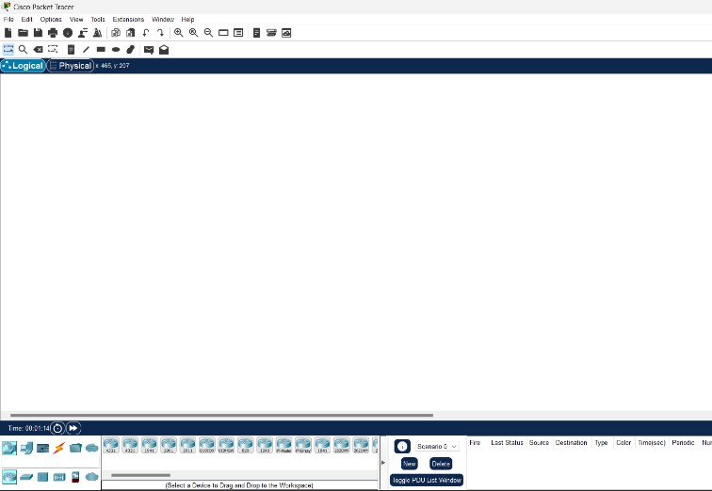

STEP 2-:

Add Network Devices to the Workspace
Access Devices Panel: Locate categories like routers, switches, hubs, end devices, and connections on the left panel.
Drag and Drop Devices: Add the following devices to the workspace:

- Router (e.g., 1841).: Directs traffic between networks and facilitates communication.
- Switch: (e.g., 2960). Connects devices within a network and handles traffic based on MAC addresses.
- End Devices (PCs, Laptops): Represent users or endpoints in the network.
- Adding devices visually demonstrates their positions and connections in a network

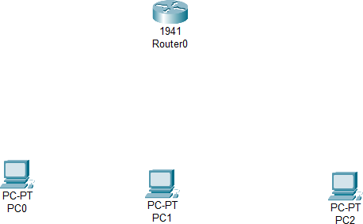

STEP 3-

Connect Devices
Select the Connections Tool: Use the lightning bolt icon on the left panel.

Connect Devices:
Router to Switch (Crossover Cable): Used for similar device types or to establish trunk links.
Switch to PC (Straight-through Cable): Connects end devices to networking equipment.
Proper connections ensure data can flow between devices in the simulation.

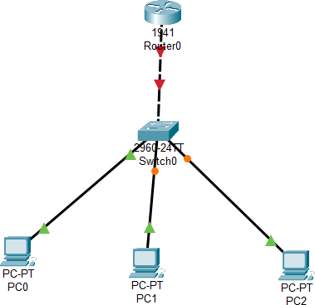

STEP 4-
Power On Devices
Networking devices like routers and switches need manual power-on checks, while PCs are powered by default.
Ensuring devices are powered prevents connectivity issues during configuration.

Step 5: Explore Device Interfaces Explanation:
Router/Switch CLI: Enables advanced network configuration through command-line commands.
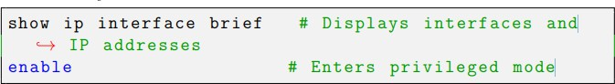
Example commands:
show ip interface brief: Displays active interfaces and IP addresses. enable: Enters privileged mode for higher access.
PC Interfaces: Tools like IP Configuration and Command Prompt simulate real-world PC networking tasks.
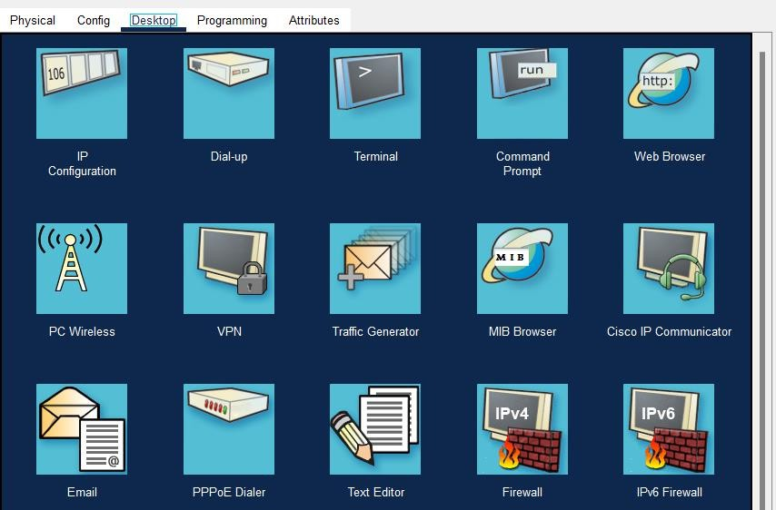

STEP 6-

Set IP Addresses:
Assign an IP address to a PC: – Click on the PC → Desktop → IP Configuration. – Enter an IP address (e.g., 192.168.1.2) and a
subnet mask (e.g., 255.255.255.0). 2. Configure Router Interface: In the CLI, enable and assign IP to an interface

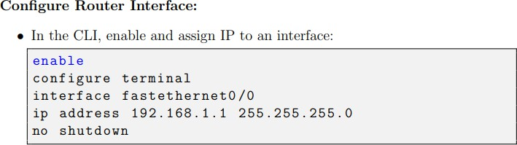

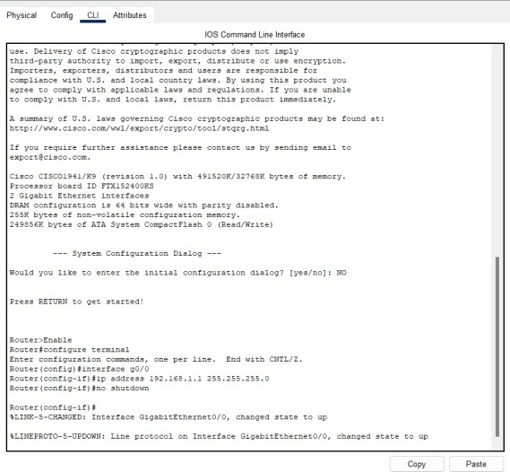
CLI INTERFACE-

PC configuration
Setting an IP , Subnet Mask for PC0,PC1 and PC2

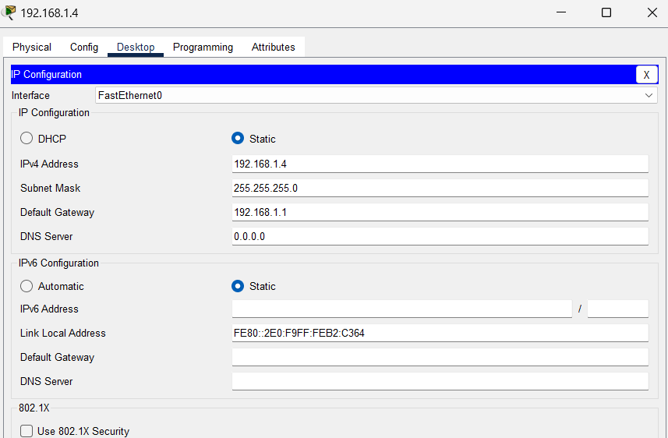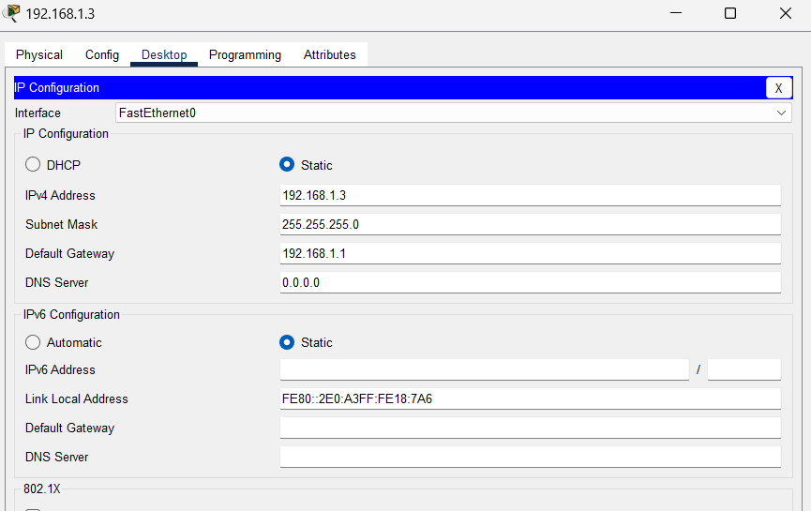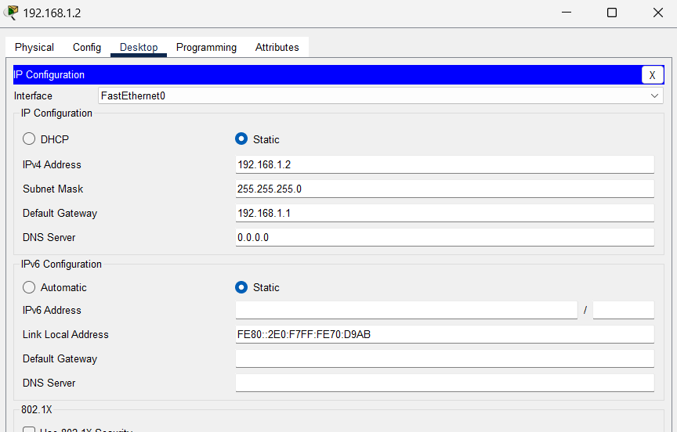
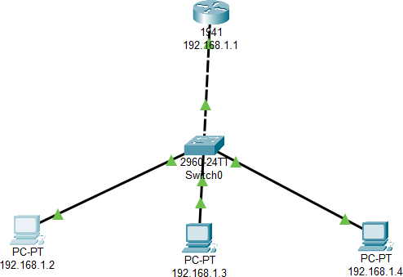

STEP 7-

Verify Connectivity Explanation:
- The ping command sends ICMP packets to test reachability.
- A successful ping verifies that IP addresses, cabling, and configurations are correct.
- 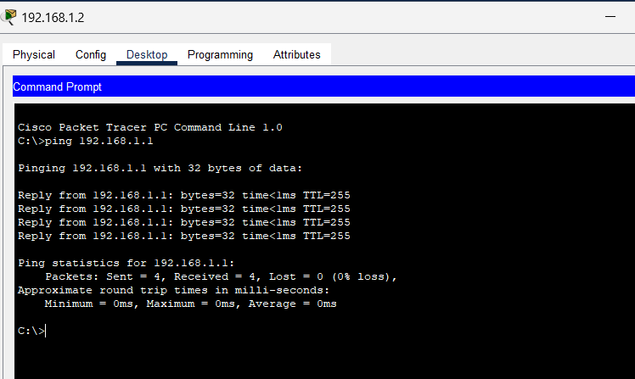
- SAVE THE FILE with the given Nomenclature.
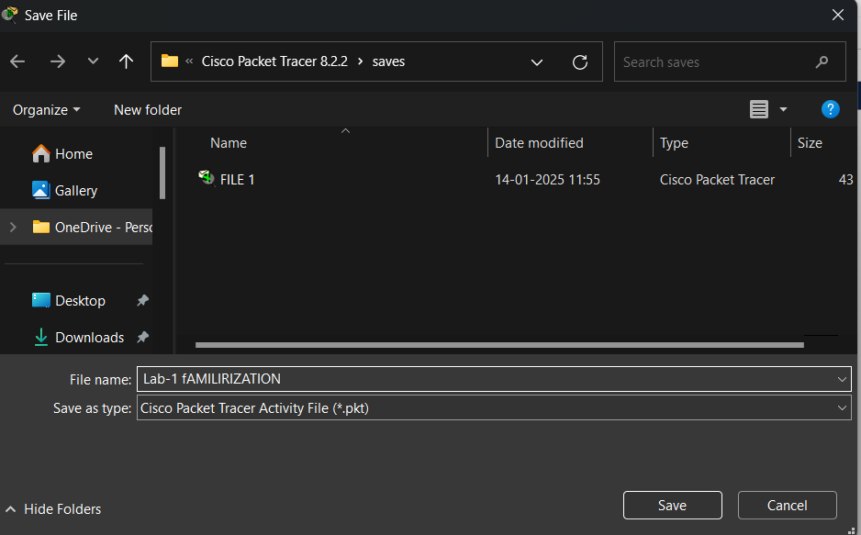

CONCLUSION:-

This exercise provides a hands-on introduction to networking fundamentals using Cisco Packet Tracer, allowing users to understand and explore the functionality of various network devices such as routers, switches, and end devices. By learning to connect devices with appropriate cabling, configure basic settings like IP addresses and interfaces, and utilize the command-line interface for device management, users gain practical skills essential for network design and configuration. The exercise also emphasizes the importance of verification and troubleshooting using tools like the ping command to ensure proper connectivity. Overall, this activity serves as a foundational step in building confidence and competence in networking, preparing users for more advanced tasks in the field.

