Class activity A — empty app (10 min)
- Scaffold with Vite (shopkit or your own name)
- Clear App.jsx until it only returns <h1>ShopKit</h1>
- Create the folder src/components/
- Open React DevTools → Components — you should see App
Done when: localhost shows only your heading, and npm run build works with no errors.

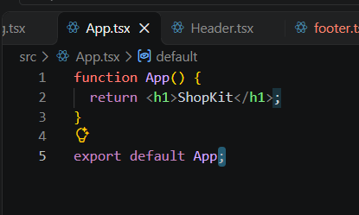
Output
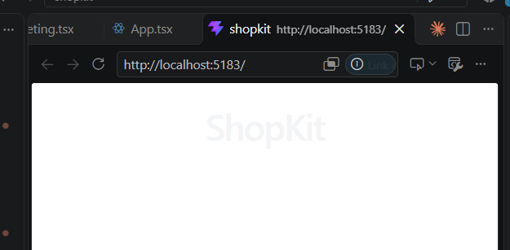
Class activity B — Header + Footer (12 min)
- Create src/components/Header.jsx — site name + a small <nav> (links can be href="#")
- Create src/components/Footer.jsx — one copyright line
- Import both in App.jsx and render: Header → temporary <main> → Footer
- Filenames match component names; each file has export default
Done when: DevTools shows App → Header, Footer — not one giant App only.

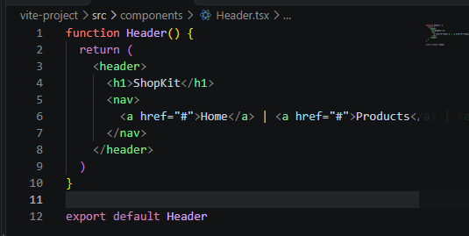
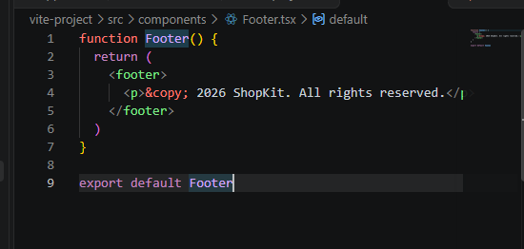
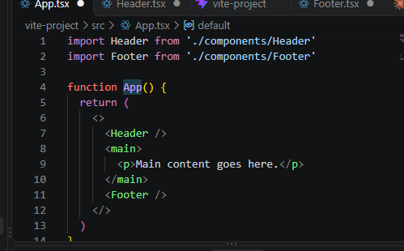
Output:
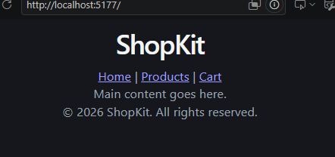

Class activity C — JSX in a Hero (10 min)
Create src/components/Hero.jsx that uses at least:
- A variable for the headline
- className (not class)
Render <Hero /> inside <main> in App.
Done when: changing the variables at the top of Hero and saving updates the page.

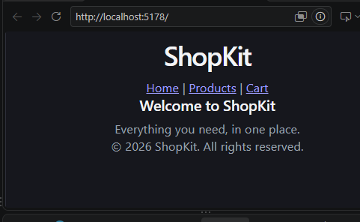
Class activity D — three product cards (15 min)
- Build ProductCard with a CSS Module (change the product details if you like)
- Add a simple .grid in index.css (Flexbox or Grid — Week 04 skills)
- Render ProductCard three times under “Featured”
- Optional: a small Badge or Button component — still static data
Done when: the page shows Header + Hero + three cards + Footer, and DevTools lists ProductCard three times.
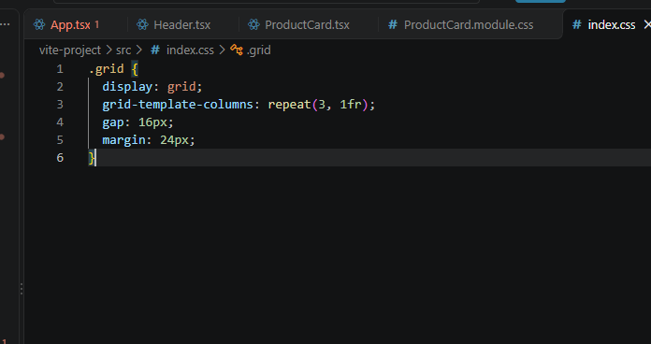

Task 1 — Homepage with a React UI library (main task)
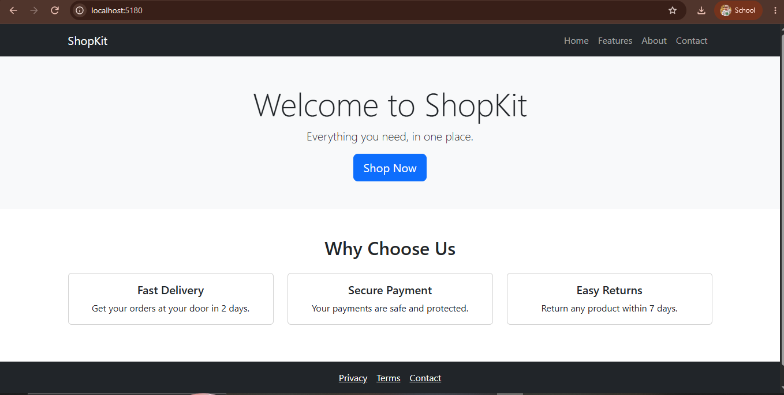

Readme
# My Homepage

Library used: React Bootstrap.

Installed with: `npm install react-bootstrap bootstrap`

Project is built with Vite + React. The homepage has 4 components:
Navbar, Hero, Features and Footer inside `src/components/`.

React Bootstrap saved me from writing the navbar layout, responsive grid
and card styling by hand using plain CSS.



