**Diet Plan App**

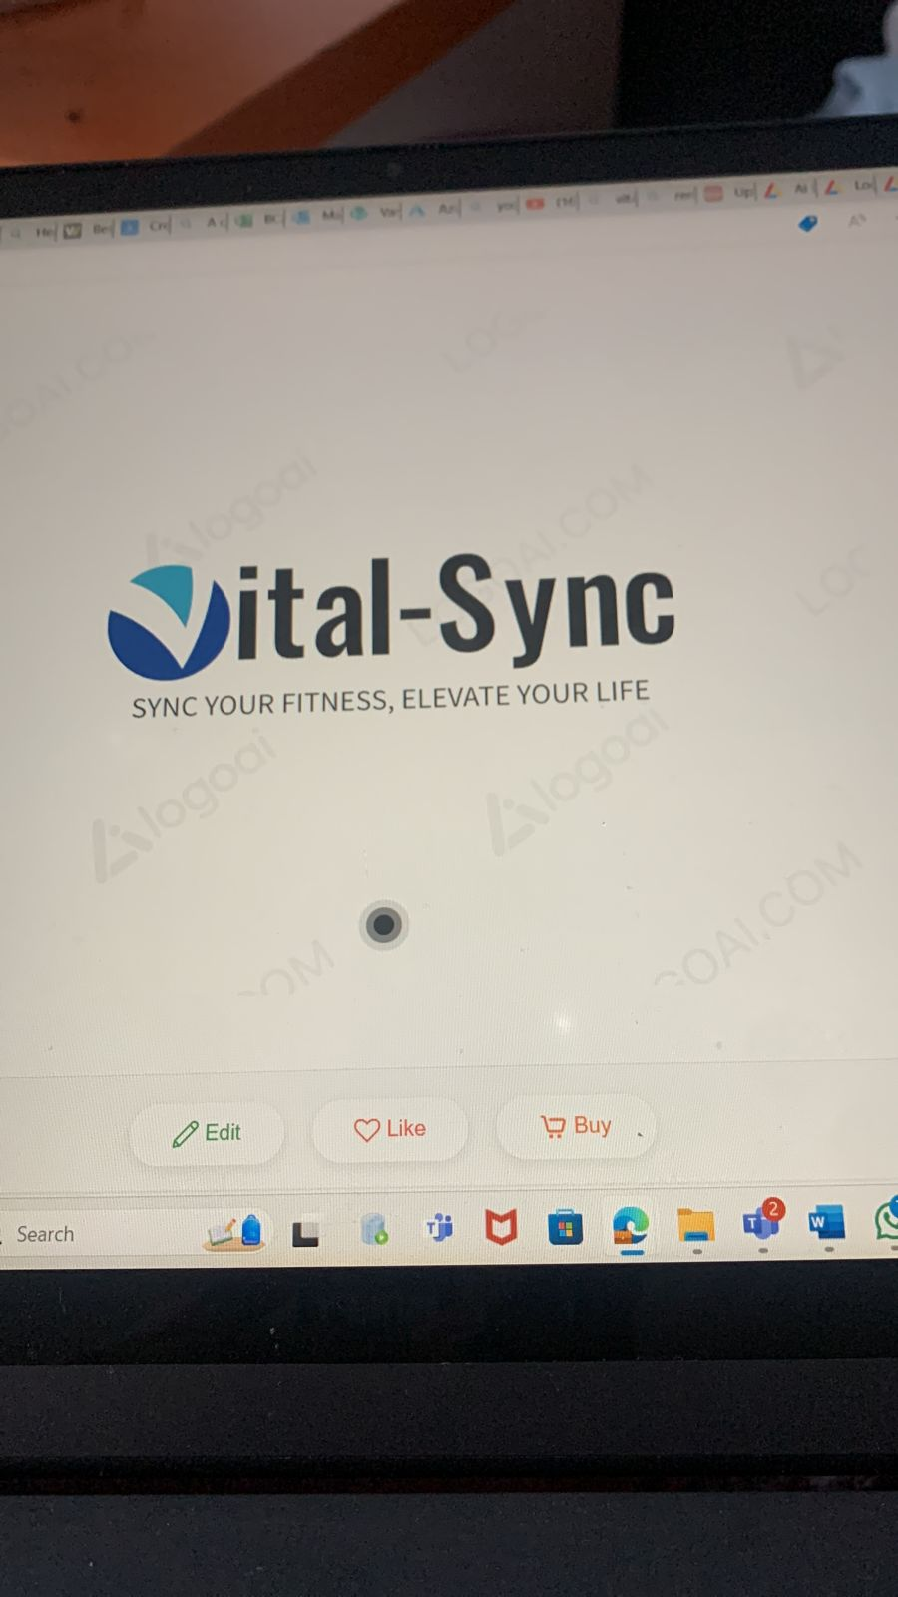

Core Features

1. **User Authentication and Profiles**

* **Login/Register**: Secure user authentication using email, social media, or phone number.
* **Biometrics login api**
* **Profile Management**: Users can create and update their profiles with personal details, dietary preferences, and health goals.

1. **Diet Tracker**
   * **Meal Logging**: Users can log their meals with detailed nutritional information.
   * **Activity Tracking**: Integrates with Google Fit/Samsung Health to track steps, physical activity, and calories burned.
   * **Goal Setting**: Users can set dietary goals (e.g., calorie intake, macronutrient ratios) and track their progress.
   * **Progress Reports**: Provides data visualization (charts, graphs) of user progress over time.
   * **Offline Mode**: Users can log meals and track progress even without an internet connection, with data syncing once online.
2. **Data Integration and API**
   * **Database Integration**: API to fetch and store user data securely.
   * **Third-Party Integration**: Connect with external databases for comprehensive nutritional information and user activity data.
   * **Period Data Analysis**: Generate reports for user activity and dietary habits over specific periods (weekly, monthly).
3. **Notifications and Reminders**
   * **Goal Notifications**: Timely reminders to help users stay on track with their dietary goals.
   * **Bedtime Mode**: Users can set a bedtime, and the app will provide notifications to wind down and prepare for sleep.
   * **Rest/Break Mode**: Users can set rest periods, during which the app will monitor and suggest ideal rest activities.
4. **Content and Community**
   * **Articles and Tips**: Online mode provides access to articles, diet tips, and expert advice.
   * **Community Features**: Users can join groups, participate in challenges, and share their progress.
   * **Recipe Suggestions**: Personalized meal and recipe suggestions based on dietary preferences and goals.

**Additional Features**

* + - **Customizable Dashboard**: Users can customize their dashboard to display the most relevant information for them.\
    - **Changes in colours** like dark mode / light mode
    - A **button that takes user to their target** or goals like weight gain or weight less where the app ask user questions on their goals**.**  
       multi-language (English and etc. Afrikaans)
    - **Barcode Scanner**: Easily log meals by scanning barcodes of food items.
    - **Recipe Import**: Import recipes from the web or upload manually.
    - **Feedback and Support**: In-app support and feedback system for user queries and issues.

Colour palette:

* Dark colours (blue / green) as main colours
* secondary colours grey / sliver / white/blue

Fonts

* title (Poppins fronts type)
* body
* sub text

Logos sizes

* Large welcome page
* Med dashboard
* Small for icons

**Register page:**

* + Username
  + Emali
  + Password
  + Confirmation password*
  + Phone number*

**Login page:**

-username

-Password

-Are sign-in

**Home page:**

Q-A od the user details like (height ,age, Weight sex /Gender )

Toal calorie progress bar

A+W+H/100*3

Age ,Weight ,Height progress bar in different colour grey % bar

Daily goals progress bar

Number of steps

Date

BMR method (Women 18-29 years: 14.8 x weight in kg + 487 = BMR  
Men 18-29 years: 15.1 x weight in kg + 692 = BMR  
Women 30-59 years: 8.3 x weight in kg + 846 = BMR  
Men 30-58 years: 11.5 x weight in kg + 873 = BMR

Once you've calculated your BMR, you can then take this figure and apply it to your level of training (or 'activity'):

Inactive men and women: 1.4 x BMR  
Moderately active women: 1.6 x BMR  
Moderately active men: 1.7 x BMR  
Very active women: 1.8 x BMR  
Very active men: 1.9 x BMR

 )

Calories method the suggest calorie intake()

**My health page**

* + Informing user about food groups
  + Recipe
  + Exercises

**Setting page**

notification bell icon on every page*

* + What it does

language chance

biometrics

dash customize options

sleep mode*

profile customization

* + Name
  + Email
  + Username
  + Phone*
  + BMR details
    1. Weight
    2. height

Fonts Scales*

Google sign*

Calories tracker*

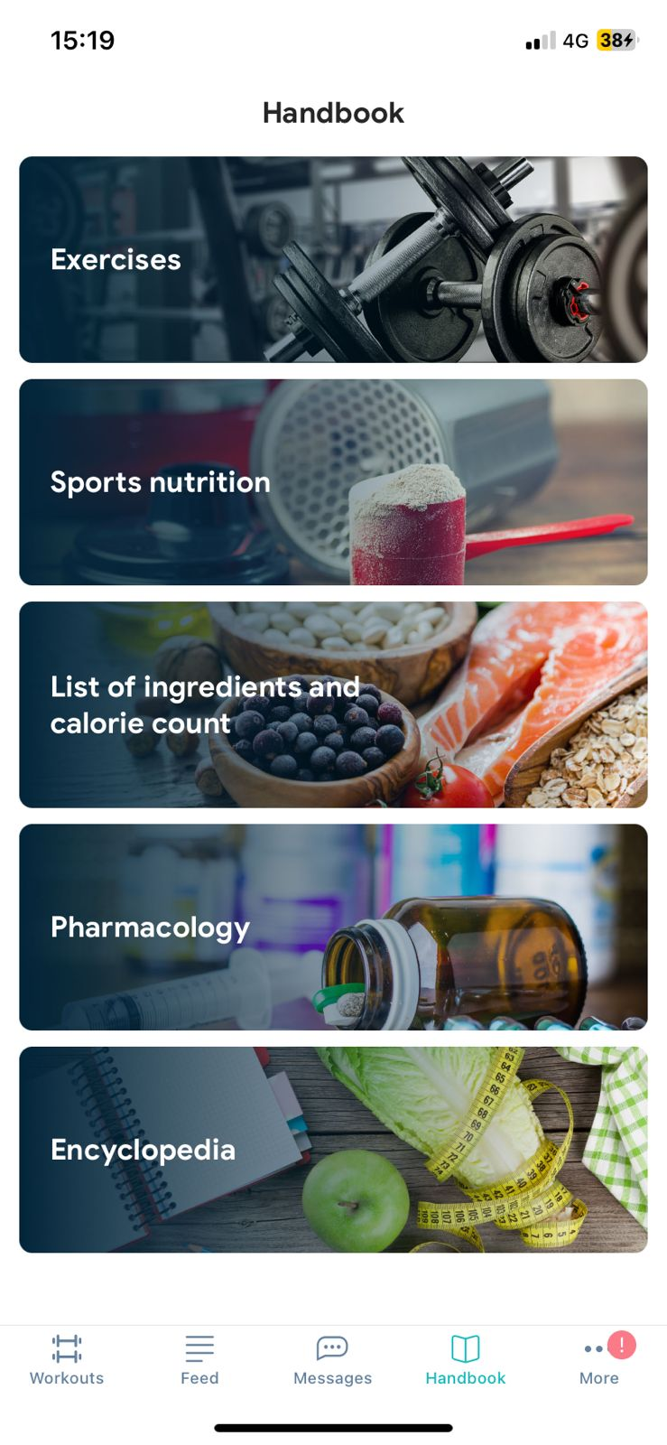



Example Use Case: **Bedtime Mode**

* **Set Bedtime**: User selects a bedtime (e.g., 10 PM).
* **Notifications**: The app sends notifications 30 minutes before bedtime to start winding down.
* **Activity Tracking**: During bedtime mode, the app tracks user activity to ensure they are resting and provides suggestions for better sleep.
* **Sleep Report**: In the morning, users receive a sleep report summarizing their rest quality and providing tips for improvement.

Example Use Case: **Rest Mode**

* **Set Rest Period**: User sets a rest period during the day (e.g., 1 PM - 2 PM).
* **Idle Mode Monitoring**: The app tracks user activity to ensure they are taking a break.
* **Suggestions**: Provides suggestions for ideal rest activities, such as meditation or light stretching.
* **Rest Report**: After the rest period, users receive a summary of their rest quality and activity during the break.