OPEN-SOURCE CODING 7311

Milani Figlan and Mehluli Booi

Table of Contents

Introduction 3

Research on Each time Tracking Applications: 4

Overview of the **Everhour** time tracking application: 4

Strengths and Weaknesses of the Everhour time tracking application: 5

Innovative Features of the Everhour application: 6

Overview of the **Toggl** time tracking application: 6

Strengths and Weaknesses of the Everhour time tracking application: 8

Innovative Features of the Toggl application: 9

Overview of the **Clockify** time tracking application: 9

Strengths and Weaknesses of the Clockify time tracking application: 10

Innovative Features of the Clockify application: 11

Visual Infographic comparing Everhour, Toggl and Clockify: 12

References: 14

# Introduction

Effective time management is a cornerstone of successful project execution and business operation (monday.com, 2021). Time tracking applications have emerged as valuable tools to address this need by providing functionalities such as individual task tracking, team collaboration features, and comprehensive project oversight. This study will analyse three prominent time tracking applications, evaluating their strengths and weaknesses. We will provide an overview of each application, including illustrative screenshots to enhance clarity. A comparative infographic will be presented to visually analyse the core functionalities of these applications. Subsequently, we will identify the most advantageous features from each application that could be incorporated into the development of a novel time tracking tool. Finally, the discussion will explore innovative features present within the analysed applications that hold promise for future advancements in time tracking technology.

# Research on Each time Tracking Applications:

To develop a robust time tracking application, it's essential to analyse existing solutions in the market.

## Overview of the **Everhour** time tracking application:

Everhour is a time tracking application designed to streamline project management. It allows users to track time spent on individual tasks and projects, set project budgets, and generate detailed reports to analyse team productivity and resource allocation (Everhour, N/A).

**Budget Monitoring**:

Consolidate project budgets into a single, easily accessible view. Monitor progress with ease and prevent budget overruns


Consolidate project budgets into a single, easily accessible view. Monitor progress with ease and prevent budget overruns (Everhour, N/A).

**Timesheet Compilation:**

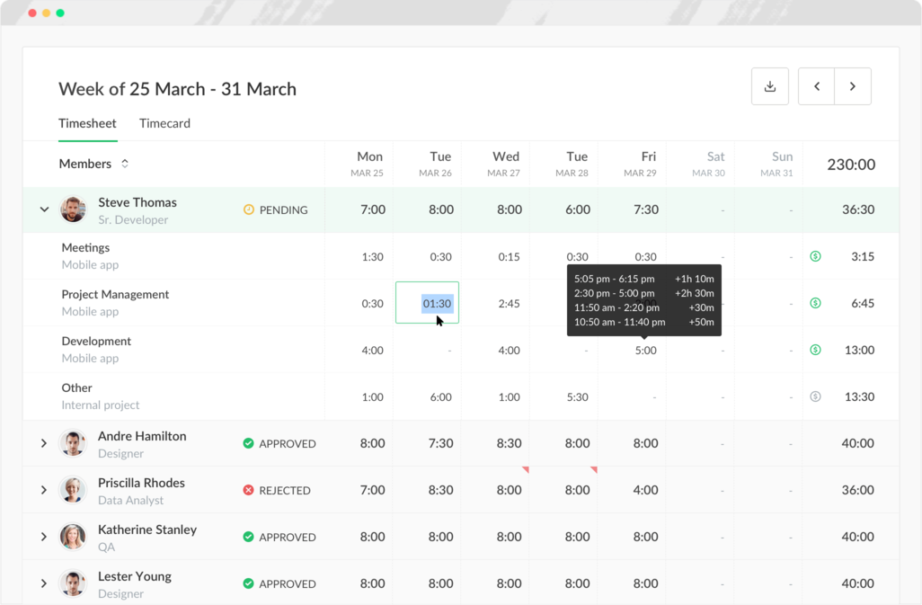

Effortlessly access a comprehensive breakdown of individual time expenditures, streamlining the timesheet approval workflow.

### Strengths and Weaknesses of the Everhour time tracking application:

Strengths:

* Ease of Use: Everhour boasts a clean and intuitive interface, making it easy for users to learn and navigate.
* Detailed Time Tracking: Users can track time down to individual tasks within projects, providing granular insights into time allocation.
* Reporting and Analytics: Everhour offers comprehensive reports that analyse team productivity, project timelines, and billable hours.
* Project Management Integration: Integrates with popular project management tools like Asana, Trello, and Jira streamlining workflow for teams.
* Team Collaboration: Features like team timesheet overview and project budgeting aid in collaborative project management.
* Mobile App Availability: Offers a mobile app for on-the-go time tracking, increasing flexibility for remote teams.

Weaknesses:

* Limited Free Plan: The free plan has restricted features, and paid plans can become expensive for larger teams.
* Customization Limitations: While reports offer insights, some users find them lacking in customization options.
* Advanced Features: May lack some advanced features compared to competitors, such as automatic time tracking or employee monitoring tools.
* Focus on Project Tracking: While great for project-based teams, may not be ideal for freelancers or solopreneurs with simpler needs.

Everhour is a reliable time-tracking program with an easy-to-use UI and robust reporting features. Teams working on collaborative projects will find it especially useful due to its connection with project management. However, some users may find the limited free plan and absence of advanced features to be disadvantageous.

### Innovative Features of the Everhour application:

* Resource Allocation Optimization**:** Everhour integrates with project management tools, allowing it to potentially analyse team member skills and workload alongside time tracking data. This could pave the way for suggesting optimal resource allocation for projects, ensuring the right people are assigned to tasks based on their expertise and availability.
* Project Budget Alerts: Everhour can be configured to send automated alerts when project costs approach pre-defined thresholds. These timely notifications allow project managers to intervene and take corrective actions before budget overruns become significant issues. This proactive approach helps maintain financial control and client satisfaction throughout project lifecycles.

## Overview of the **Toggl** time tracking application:

Toggl Track is a user-friendly time tracking app known for its generous free plan. It allows you to track time for unlimited projects and clients, generate reports, and even set up automatic timers. The free tier also includes an idle time detection feature to ensure accuracy. Toggl offers paid plans with additional features like billable rates and team reminders (Toggl, N/A).

**Time Tracking**: 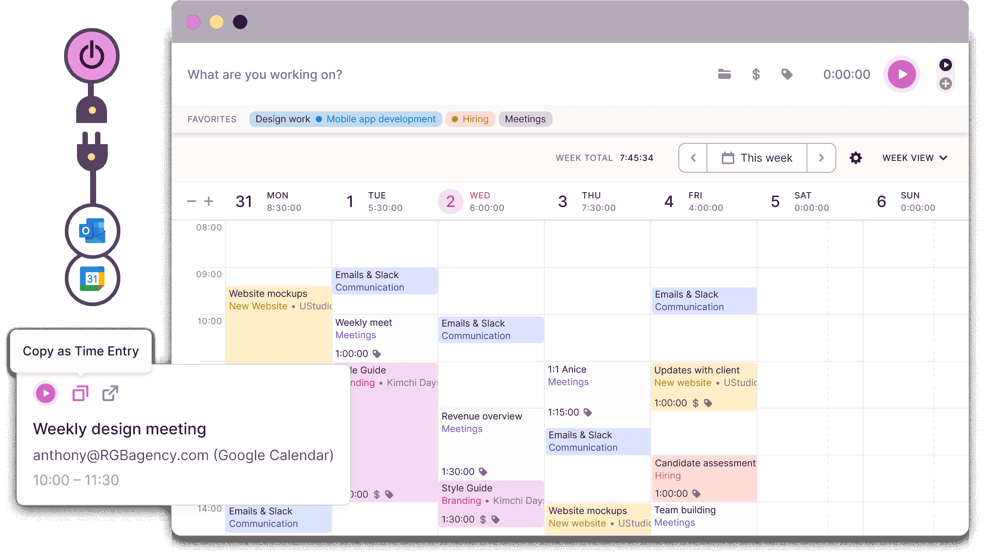This screenshot captures the heart of Toggl Track - effortless time tracking. The prominent "Start Timer" button allows users to begin tracking their work immediately. Simply select the project or client you're working on from the dropdown menu, and Toggl Track starts recording the elapsed time. A clear timer view displays the duration of your current activity. You can pause or stop the timer as needed, and even add notes to provide context for your work session. This flexibility ensures accurate and detailed time tracking for all your tasks, using Toggl Calendar view.

**Integration:**

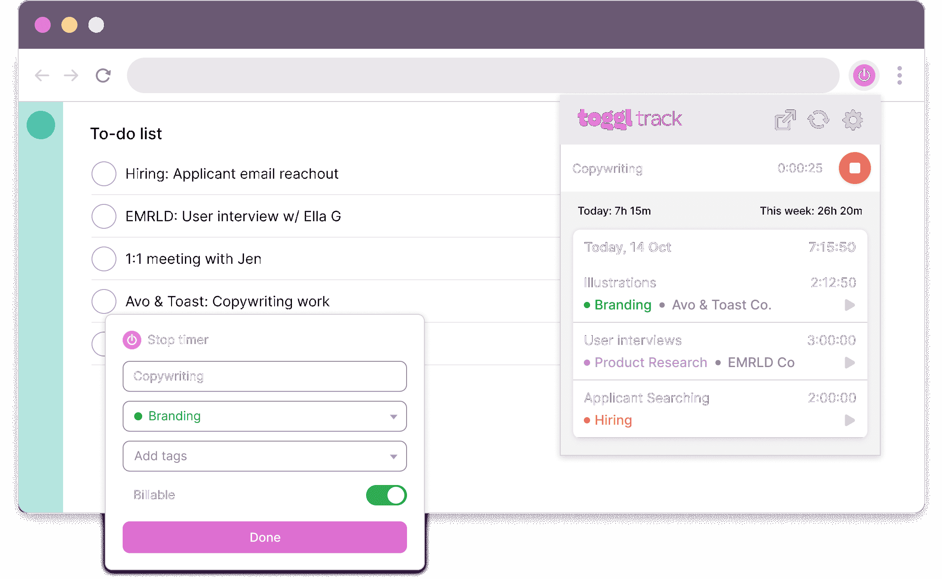

Toggl Track eliminates the hassle of switching applications with its browser extension integration. This handy feature embeds a timer directly into your web browser toolbar, allowing you to start tracking time and select the relevant project within popular web apps like Gmail or Trello – all with just a click. This seamless integration streamlines your workflow and ensures accurate time allocation for all your tasks.

### Strengths and Weaknesses of the Everhour time tracking application:

Strengths:

* Simplicity and Ease of Use: Toggl Track boasts a clean and intuitive interface, making it easy for users to learn and navigate. Starting and stopping timers, selecting projects, and accessing reports are all effortless actions.
* Background Tracking: Users can keep the timer running in the background while working in other applications, improving workflow efficiency.
* Pomodoro Timer Integration: Integrates with popular Pomodoro timer tools, catering to users who prefer this time management technique.
* Free Plan with Generous Features: The free plan offers unlimited time tracking, projects, and clients, making it a great choice for freelancers and small teams.

Weaknesses:

* Limited Features in Free Plan: The free plan lacks advanced features like billable rates, project budgeting, and team collaboration tools. These require upgrading to a paid plan.
* Limited Customization Options: While reports offer some customization, they might not be as flexible as some competitors for in-depth analysis needs.
* Focus on Freelancers: While suitable for teams, Toggl Track may not offer the robust project management features needed for more complex team workflows.
* Limited Reporting Features: Compared to some competitors, reporting functionalities might be considered less comprehensive, potentially lacking advanced filtering or data export options.

### Innovative Features of the Toggl application:

* Background Tracking with Pomodoro Timer Integration: Toggl Track allows users to keep the timer running in the background while working in other applications. This eliminates the need to constantly switch back and forth, improving workflow efficiency. Additionally, the integration with Pomodoro timers caters to users who prefer this time management technique, allowing seamless integration with their time tracking process.
* Idle Time Detection: This feature automatically detects periods of inactivity and prompts users to either resume tracking their time or log the idle time as a break. This helps maintain the accuracy of time tracking data and avoids inflated entries due to forgetfulness.

## Overview of the **Clockify** time tracking application:

Clockify offers a user-friendly and feature-rich time tracking experience, all wrapped up in a completely free plan. It allows you to track time for unlimited projects and clients, generate reports, and even utilize a built-in Pomodoro timer to boost your productivity. With desktop, mobile app, and browser extension options, Clockify ensures you can track your time seamlessly, no matter where you work (Clockify, N/A).

**Timekeeping Kiosk:**

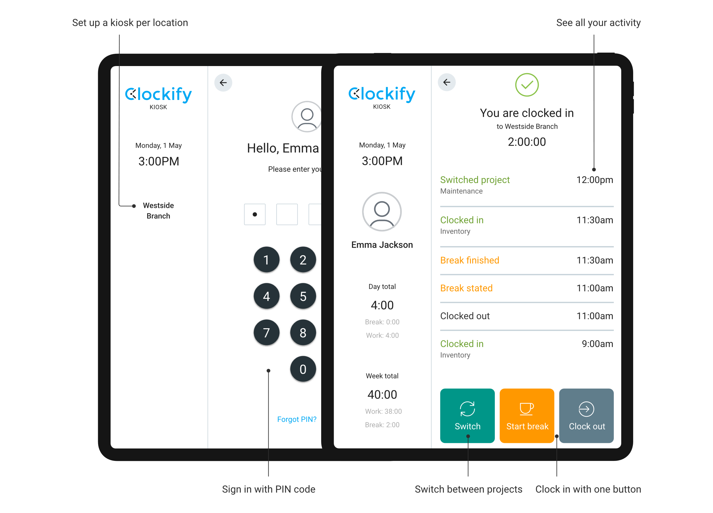

Clockify's Kiosk feature turns any device into a shared time clock. Employees simply enter a PIN or choose their name for effortless clock-in and out. With optional break tracking, project selection, and 24/7 availability, the Kiosk offers a secure and convenient way to streamline employee time tracking for your business.

**Reporting Location:**

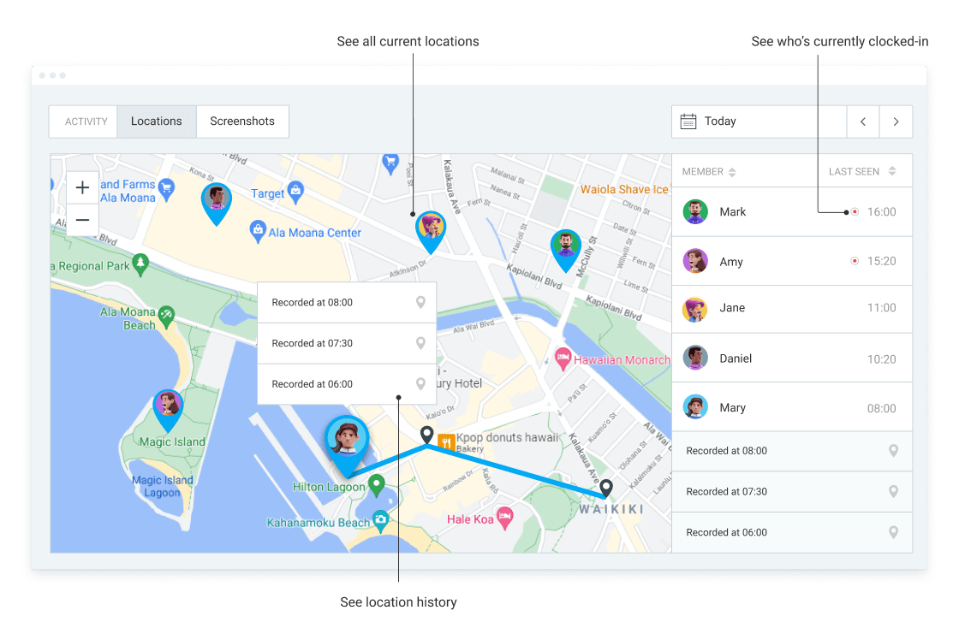

Clockify's location tracking goes beyond time. When you clock in or out, it automatically captures your work location, boosting verification for remote or field teams. This streamlines project management by giving managers insights into team member locations and simplifies tracking by eliminating manual location entries.

### Strengths and Weaknesses of the Clockify time tracking application:

Strength:

* Free Plan with Generous Features: The free plan offers unlimited projects, clients, and time tracking, making it a great choice for freelancers and small teams.
* User-Friendly Interface: Clean and intuitive design allows for easy navigation and quick time tracking.
* Cross-Platform Availability: Available on desktop, mobile app, and web browser, ensuring accessibility no matter your device.
* Location Tracking: (For Paid Plans) Automatically captures work location when clocking in and out, enhancing verification and streamlining project management for remote or field teams. (Not available in the free plan)
* Reporting and Analytics: Generate reports to analyse team productivity, project timelines, and track billable hours. (Limited features in the free plan)
* Kiosk Mode: (For Paid Plans) Transform any device into a shared time clock for effortless employee time tracking.
* Integrations: Integrates with popular project management and communication tools.

Weaknesses:

* Limited Features in Free Plan: Advanced features like location tracking, project budgeting, and detailed reporting require upgrading to a paid plan.
* Limited Customization Options: While reports offer some customization, they might be less flexible compared to some competitors for in-depth analysis.
* Focus on Freelancers: While suitable for teams, Clockify may not offer the robust project management features needed for highly complex workflows.

### Innovative Features of the Clockify application:

* Customizable Dashboards: Clockify allows users to personalize their dashboards with the most relevant metrics and visualizations. This provides a quick and clear overview of key data points like team productivity, project progress, and billable hours, tailored to your specific needs.
* Goal Setting and Tracking: Clockify allows you to set goals for individual team members or projects. You can track progress towards these goals in real-time, keeping teams motivated and focused on achieving objectives.

# Visual Infographic comparing Everhour, Toggl and Clockify:

## List of best features from the three apps discussed:

# References:

* CAKE.com Inc (no date) *Clockify - FREE time tracking software*, *Clockify*. Available at: https://clockify.me/ (Accessed: March 17, 2024).
* Petrova, S. (2023) *15 best time tracking apps & software (work hours & personal)*, *Crm.org*. Available at: https://crm.org/news/best-time-tracking-app (Accessed: March 17, 2024).
* *Time tracker for budgeting, client invoicing & painless payroll –* (no date) *Everhour*. Available at: https://everhour.com/ (Accessed: March 17, 2024).
* *Toggl track: Time tracking software for any workflow* (no date) *Toggl.com*. Available at: https://toggl.com/ (Accessed: March 17, 2024).
* *What is time tracking?* (2021) *monday.com Blog*. Available at: https://monday.com/blog/productivity/time-tracking/ (Accessed: March 17, 2024).