**EE 464**

**STATIC POWER CONVERSION-I**

**Spring 2022-2023**

**Homework 2**

**Complete Simulation Report**

**Autobots**

Mehmet Emre Doğan – 2374825

Metehan Küçükler – 2305068

Table of Contents

Introduction 3

Topology Selection 3

UPDATE MAGENTIC DESIGN 4

Component Selection 15

Switching Device 15

Secondary Diode: 15

Output Capacitor: 15

Controller IC: 15

UPDATE TRANSFORMER: 16

Tests 18

PCB Design 18

Conclusion 18

References 19

# Introduction

This report explains the design decisions for the hardware project. Furthermore, it presents the details of the Magnetic Design of the Isolated Power Supply and the simulation results for the selected topology.

# Topology Selection

The converter needs to be isolated. Therefore, the alternatives are listed below:

* Flyback converter
* Forward converter
* Push-Pull converter

Among these converter topologies, the flyback converter is chosen as an appropriate converter for given requirements. When compared with other topologies, it is easier to increase the output voltage with Flyback due to its input-output voltage relation. Thus, it requires fewer turns ratio with the same duty cycle or, it requires less duty cycle with the same turns ratio. This may decrease the losses on copper or conduction losses of switching devices. Additionally, the Flyback converter requires fewer components than the other converter topologies, so its control is less complex.

diyagram içeren bir resim

Açıklama otomatik olarak oluşturuldu

Figure 1: TI Webench design

# UPDATE MAGENTIC DESIGN

1. The duty range of the converter is selected as [0.278 – 0.336] to match the design by the Ti Webench. According to the duty range determination, the turn ratio is calculated via the MATLAB code below.

clearvars

syms d turnsRatio

v_o = 48

d_min = 0.278; v_d_minduty = 18;

d_max = 0.366; v_d_maxduty = 12

turnsRatio_minduty = ( (d_min/(1-d_min)) * (v_d_minduty/v_o) )^-1

turnsRatio_maxduty = ( (d_max/(1-d_max)) * (v_d_maxduty/v_o) )^-1

According to the code above, the transformer turns ratio (Ns/Np) is calculated as 6.93.

2. The available cores and coil formers are investigated. Firstly, due to its available stock number is high, PCB5530-FA is selected as the coil former. Therefore, the compatible core 0P45530EC is selected as the transformer core. However, after calculations, it is seen that this core is overkill. Afterward, **79440A7 toroidal core is selected** due to its high stock number and wide window area. A wide window area makes the wounding procedure easier.
3. Using the MATLAB code below, the primary turn number is 13, while the secondary turn number is 87. The magnetizing inductance is 8 uH.

U_o = v_o;

v_t = d_max;

f_sw = 100e3;

i_out = 1;

i_avgSec = i_out/(1-v_t);

xformerCurrRipple = 0.5; % percent

L_sec = (U_o*(1-v_t))/(xformerCurrRipple*i_avgSec*f_sw)

L_pri = L_sec/(turnsRatio_maxduty^2)

% (turnsRatio_maxduty^2)*2.814e-6

syms priTurns secTurns

AL = 51e-9 % nH/T^2; minimal

priTurns = double(solve(L_pri == AL*priTurns^2))

secTurns = double(solve(L_sec == AL*secTurns^2))

% make sure core is not saturated

ampTurns = i_out*secTurns

1. According to the AWG table, the secondary should be wounded using 5 parallel 28 AWG wires. The primary, on the other hand, 18 parallel 28 AWG wires will be used.
2. According to the code below, the fill factor is 12.53%, which is reasonable.

windowArea_mm2 = 427;

priTurns = ceil(priTurns(priTurns>0))

secTurns = ceil(secTurns(secTurns>0))

num_of_paralles_pri = ceil(num_of_paralles_pri)

num_of_paralles_sec = ceil(num_of_paralles_sec)

cableArea_mm2 = 0.080;

primaryArea_mm2 = priTurns*num_of_paralles_pri*cableArea_mm2

secondaryArea_mm2 = secTurns*num_of_paralles_sec*cableArea_mm2

totalCableArea_mm2 = primaryArea_mm2 + secondaryArea_mm2

fillFactor_perc = 100*totalCableArea_mm2/windowArea_mm2

1. Cable resistance calculation is done by the code below:

windingLengthPerTurn_mm = 68.2

ohms_per_meter = 212.872 / 1e3

primaryLength_m = windingLengthPerTurn_mm * priTurns * 1e-3

secondaryLength_m = windingLengthPerTurn_mm * secTurns * 1e-3

primary_DC_resistance_ohm = ohms_per_meter * primaryLength_m / num_of_paralles_pri

secondary_DC_resistance_ohm = ohms_per_meter * secondaryLength_m / num_of_paralles_sec

The DC and AC resistances of the transformer are assumed equal thanks to the skin depth being greater than the radius.

**Primary Resistance: 10.5 mOhm**

**Secondary Resistance: 252 mOhm**

1. Copper losses are calculated by the code below:

diameter_mm = vpa(0.32004*u.mm)

radius_mm = diameter_mm/2

skinDepth_cm = vpa(7.5/sqrt(f_sw)*u.cm)

skinDepth_mm = unitConvert(skinDepth_cm, u.mm)

% skin depth is greater than radius.

% Therefore, AC reistance equals DC resistance

DC_to_AC_ratio = 1

primary_AC_resistance_ohm = primary_DC_resistance_ohm*DC_to_AC_ratio

secondary_AC_resistance_ohm = secondary_DC_resistance_ohm*DC_to_AC_ratio

resistancePri_ohm = vpa(primary_AC_resistance_ohm * u.Ohm)

resistanceSec_ohm = vpa(secondary_AC_resistance_ohm * u.Ohm)

copperLossPri = vpa(unitConvert((i_in_max*u.A)^2 * resistancePri_ohm, u.W))

copperLossSec = vpa(unitConvert((i_out*u.A)^2 * resistanceSec_ohm, u.W))

copperLoss_W = copperLossPri + copperLossSec

**Total Copper Losses: 0.42 W**

1. Core losses are calculated by the code below:

permeability = 26;

mu_zero = 1.25663706212e-6;

pathLength_m = 107e-3;

fluxDensity_Tesla = mu_zero * permeability * ampTurns / pathLength_m

% using graph above, 0.03 Tesla @ 100 kHz corresponds to

wattLoss_mW_cm3 = 60*u.mW/u.cm^3

volume_mm3 = 21300;

volume_cm3 = vpa(unitConvert(volume_mm3*u.mm^3, u.cm^3))

coreLoss_w = vpa(unitConvert(wattLoss_mW_cm3 * volume_cm3, u.W))

**Core Loss: 1.27 W**

The core loss is comparable with the copper loss. Hence, the design is good. No need to iterate more.

1. The open-loop flyback design is simulated on Simulink as shown in Figure 2. The circuit is simulated at its edges, namely, 12V input voltage and 0.366 duty and 18V input voltage and 0.278 duty. The simulation results are shown in Figures 3-6 for 0.278 duty and Figures 7-10 for 0.366 duty.

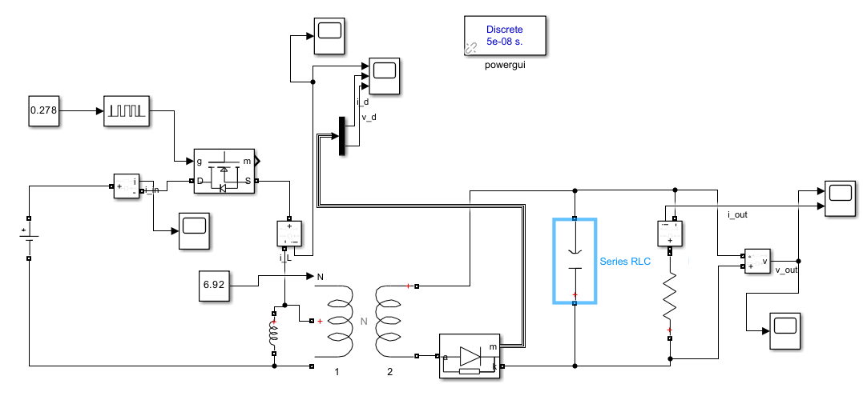

Figure 2: The Flyback converter in Simulink

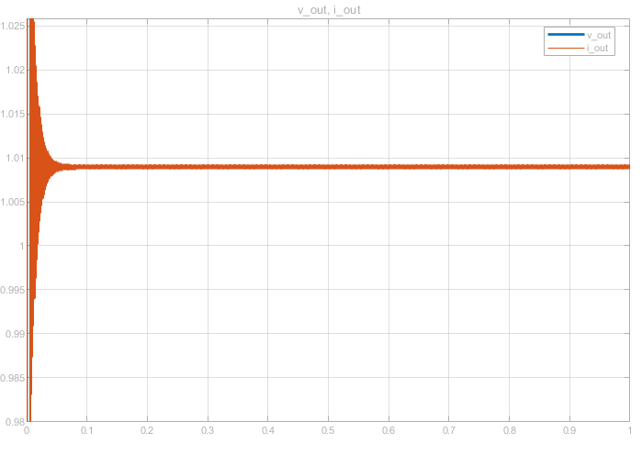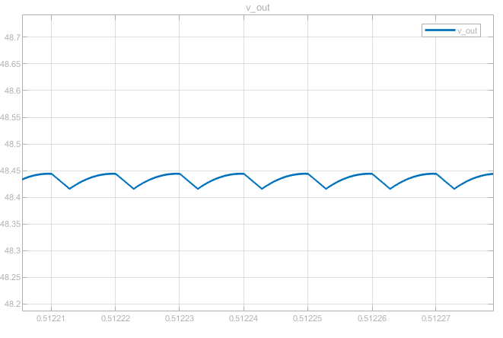

Figure 3: Output voltage ripple for 0.278 duty

Figure 4: Output current waveform for 0.278 duty

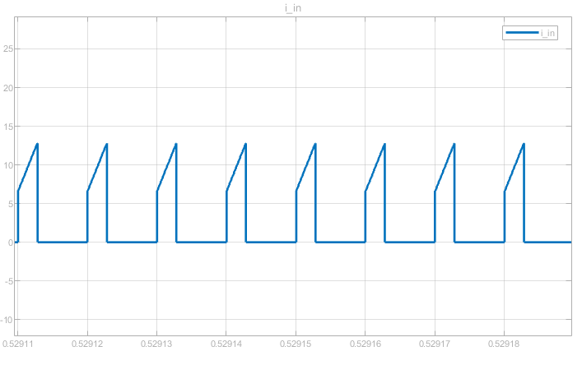

Figure 5: Input current waveform for 0.278 duty

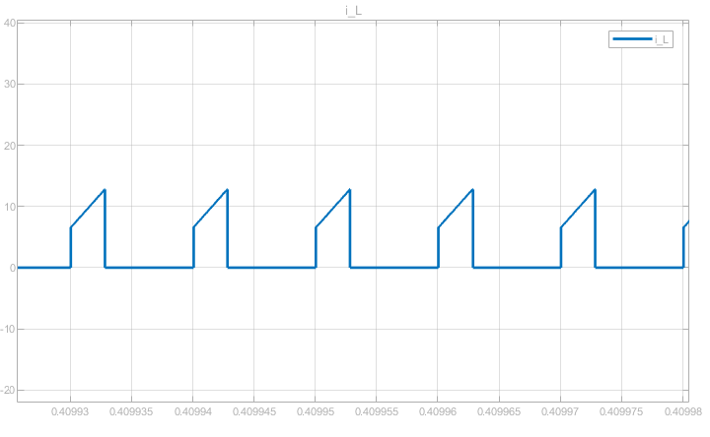

Figure 6: Transformer primary current waveform for 0.278 duty

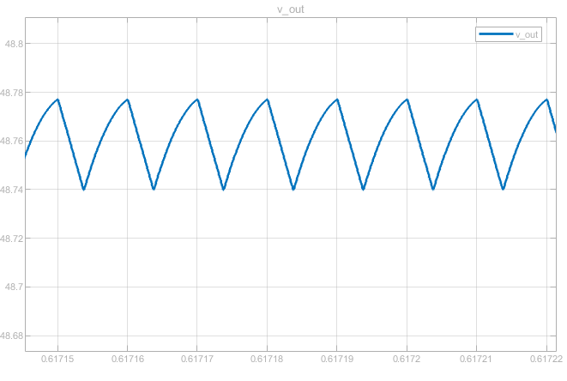

Figure 7: Output voltage ripple for 0.366 duty

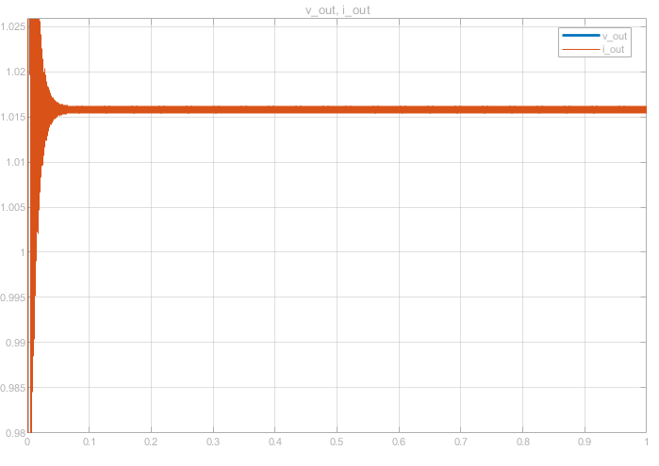

Figure 8: Output current waveform for 0.366 duty

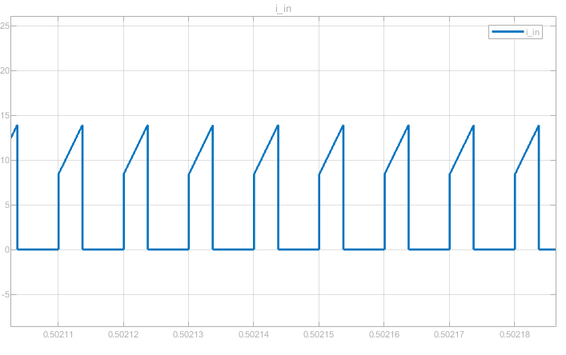

Figure 9: Input current waveform for 0.366 duty

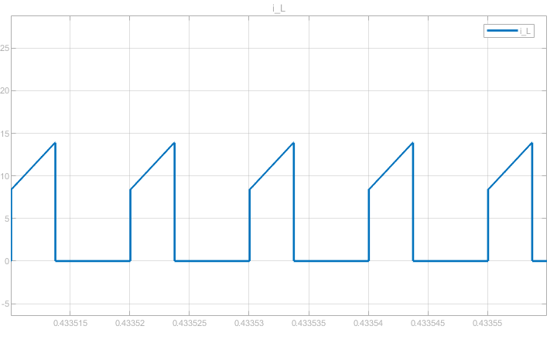

Figure 10: Transformer primary current waveform for 0.366 duty

1. The minimum load current to avoid DCM is calculated with the code below:

Lm = 8*10^-6; f_sw = 100*10^3;

% DCM

% for Vs = 12V

Vs = 12; D = 0.366;

deltaI_lm = Vs*D/(Lm*f_sw);

P_min = Vs^2 * D^2 / (2*Lm*f_sw);

I_load_min = P_min / 48

% for Vs = 18V

Vs = 18; D = 0.278;

deltaI_lm = Vs*D/(Lm*f_sw);

P_min = Vs^2 * D^2 / (2*Lm*f_sw);

I_load_min = P_min / 48

Minimum load current to operate in CCM when input is 12V = 0.251mA

Minimum load current to operate in CCM when input is 18V = 0.326mA

The maximum current that can flow through the transformer is calculated with the code below:

% max I_Lm current occurs when input voltage is 12V and at 100% load

Vs = 12; D = 0.366;

turnsRatio = 6.92; R = 48;

deltaI_lm = Vs*D/(Lm*f_sw);

P_out = Vs^2 * D^2 * turnsRatio^2 / ((1-D)^2 * R);

I_Lm_max = deltaI_lm/2 + P_out/(Vs*D)

Current can rise up to the 13.645A while converter is working with 100% load and 12V input voltage.

diyagram, şematik içeren bir resim

Açıklama otomatik olarak oluşturuldu

Figure : Simulation of the converter with parasitic elements of transformer and switching device.

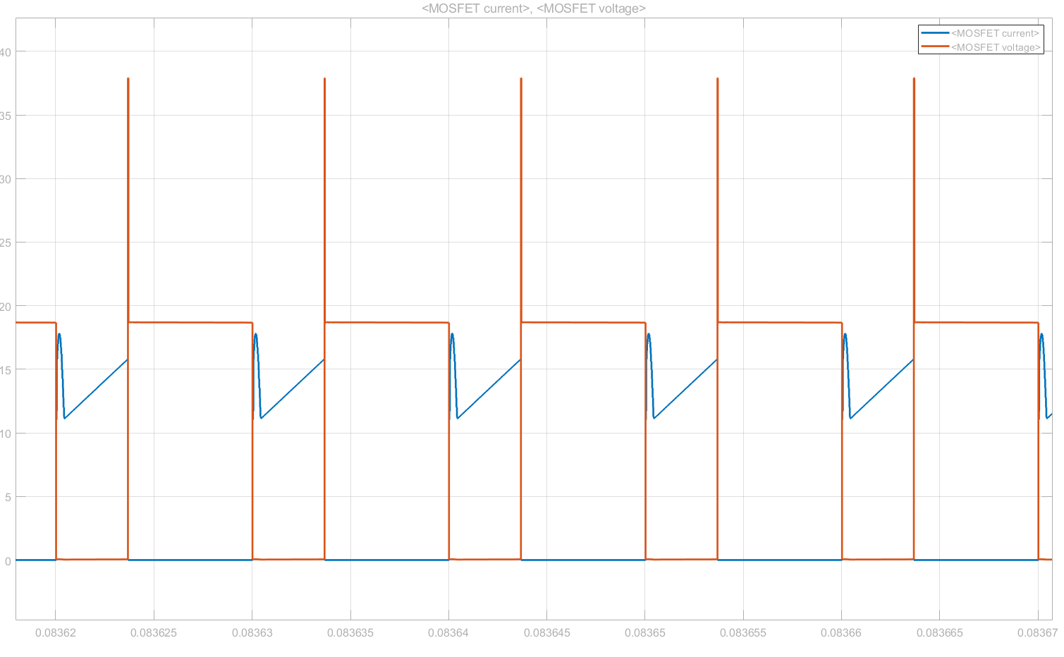

Figure : Voltage and current waveforms of MOSFET with parasitic elements.

In Figure 12, it can be seen that, due to parasitic inductances, there are voltage spikes on MOSFET while switching. Because of leakage inductance, a snubber must be used to discharge the leakage inductance. Snubber design is taken from the recommended design of Webench.

The flyback converter is simulated with parasitic elements and non-ideal switching devices as shown in Figure 13.

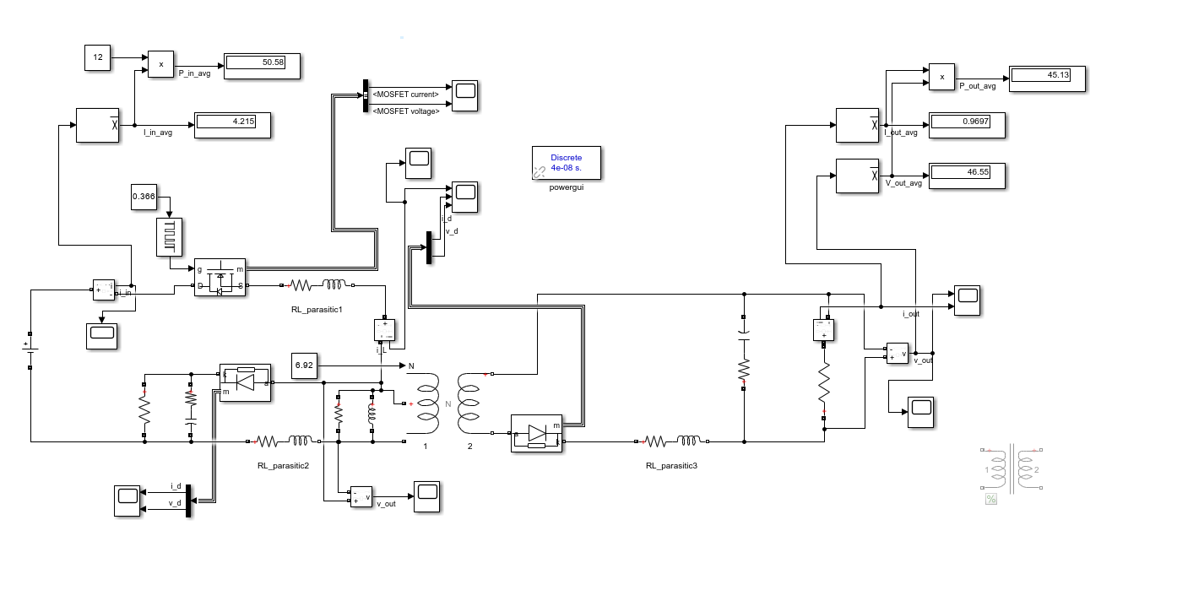

Figure : Simulation design for efficiency test.

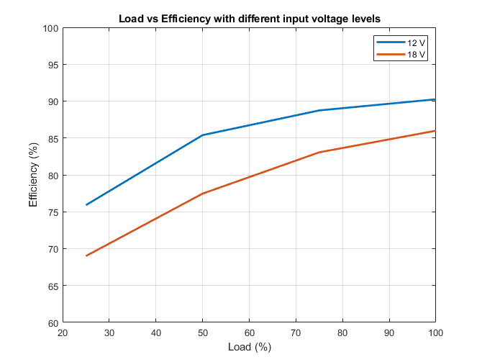

Figure : Efficiency vs Load curves for different voltage input levels.

Table : Simulation result of efficiency values for different

input voltage and load conditions.

|  |  |  |
| --- | --- | --- |
| Load (%) | Efficiency (%) | |
| 12V | 18V |
| 25 | 75.9 | 69 |
| 50 | 85.39 | 77.46 |
| 75 | 88.74 | 83.06 |
| 100 | 90.25 | 85.99 |

Table : Calculated efficiency values without snubber losses.

|  |  |  |
| --- | --- | --- |
| Load (%) | Efficiency (%) | |
| 12V | 18V |
| 25 | 87.7 | 87.89 |
| 50 | 92.78 | 93.03 |
| 75 | 94.3 | 94.62 |
| 100 | 94.94 | 95.33 |

The efficiency of the flyback converter decreases with less load since core loss and snubber losses become dominant. Also, when the input voltage increases, the losses on the switching device increase quadratically; thus, the converter becomes less efficient with a higher input voltage. Lastly, how inefficient is snubber can be seen by comparing two results.

# Component Selection

### Switching Device

Peak switching current and voltage can be calculated equations below:

V_sw = Vs + 1/turnsRatio*48

I_sw = 1./(1-duty).*turnsRatio.*I_out_avg + 1/turnsRatio.*

(1-duty)./2./L_pri./f_sw*48

Switching voltages are calculated as 18.94V and 24.94V, respectively with 12V and 18V input voltage, and the maximum switching current is calculated as 13.65A. However, due to leakage inductances and parasitic elements, there are voltage spikes while switching. Thus, also it can be seen in Webench design, a Mosfet with 80V rated voltage and 100A rated current is selected [1]. For less rated voltages it is easy and cheap to find high current rated Mosfets which also results in fewer losses on Mosfet due to less Rds value.

### Secondary Diode:

V_d_max = Vs*turnsRatio + 48

I_d_max = I_sw./turnsRatio

By using the above equations, the maximum voltage on the diode is found as 131.04V and 172.56V, respectively with 12V and 18V input voltage, and the maximum current is calculated as 1.976A. The voltage rating of the diode should be selected higher because the effect of voltage spikes increases with the turns ratio at the secondary side. Thus, the diode is selected with a 600V rated voltage and 3A rated current with a forward voltage drop of 1.0V [2].

### Output Capacitor:

The maximum allowed voltage ripple at the output is 3%.

C_min = duty/f_sw/R/ripple

The minimum capacitance value of the output capacitor is found as 2.54µF with the equation above. However, the output voltage is 48V and to be safe rated voltage of the capacitor should be higher. A high voltage-rated capacitor is found as an aluminum capacitor which has high ESR values compared with other types. Found capacitors in the market have high voltage ratings, so they have also high ESR values. Because ESR values become dominant on output ripple, a capacitor with high capacitances is selected. The selected capacitor has 47µF capacitance and 2Ω ESR. The effect of ESR can be calculated equation below:

V_ESR = ESR * I_out_avg

The ripple due to ESR can be around 2V when a single capacitor is used. Thus, four of the selected capacitors [3] must be connected in parallel.

### Controller IC:

UCC2813DTR-1 is selected which is appropriate for Webench’s design. It is a current-mode PWM controller that can drive the gate of the Mosfet with respect to sensed current and output voltage [4].

### UPDATE TRANSFORMER:

The detailed calculation of the transformer’s turn ratio, cable parameters, core, magnetizing inductance, etc. is given in the magnetic design section.

#### Experimental results of transformer on first try:

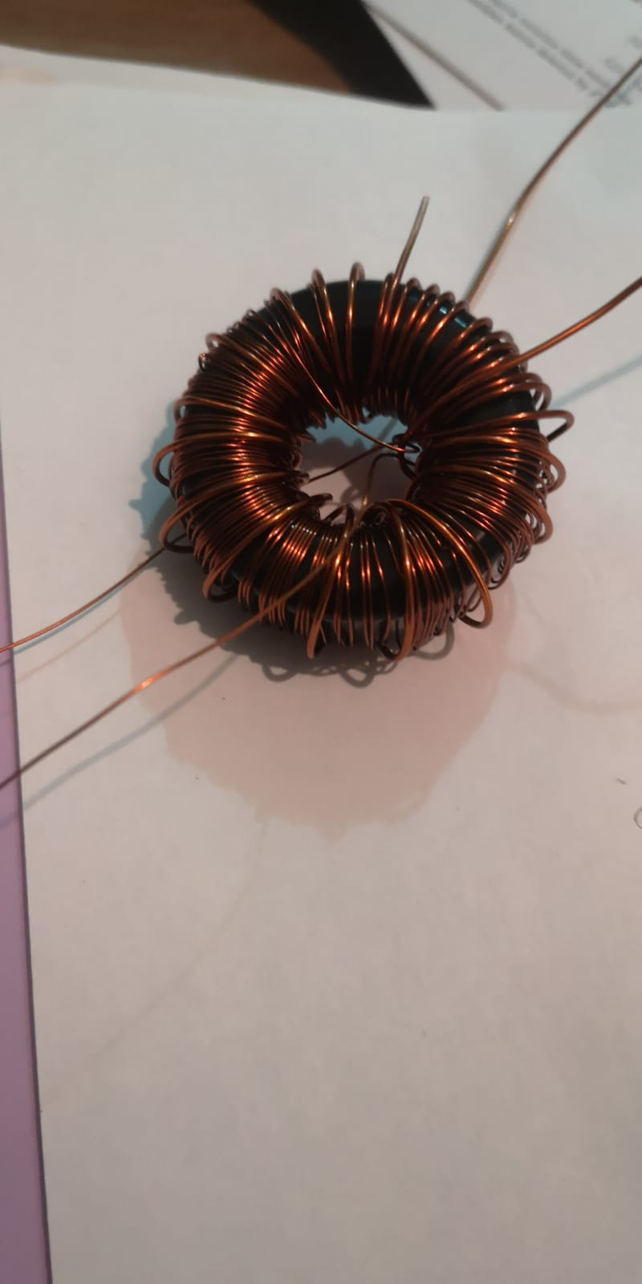

Figure : Wound transformer for initial experiments.

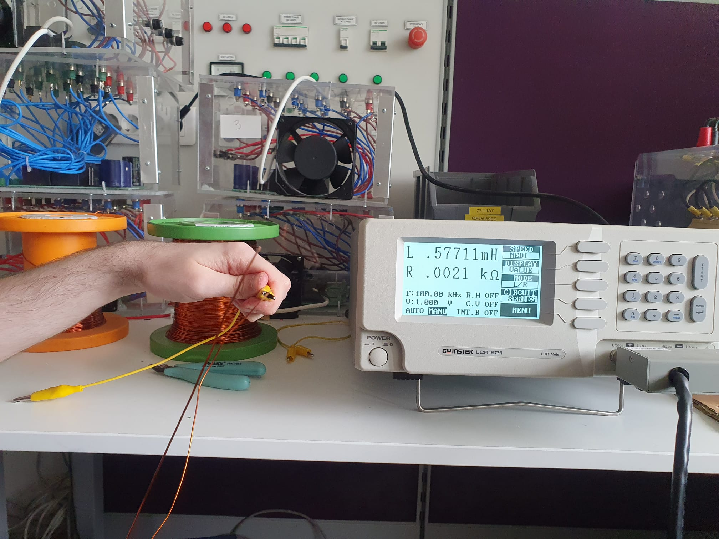

Figure : Primary is open circuited to measure leakage + magnetizing inductance at secondary.

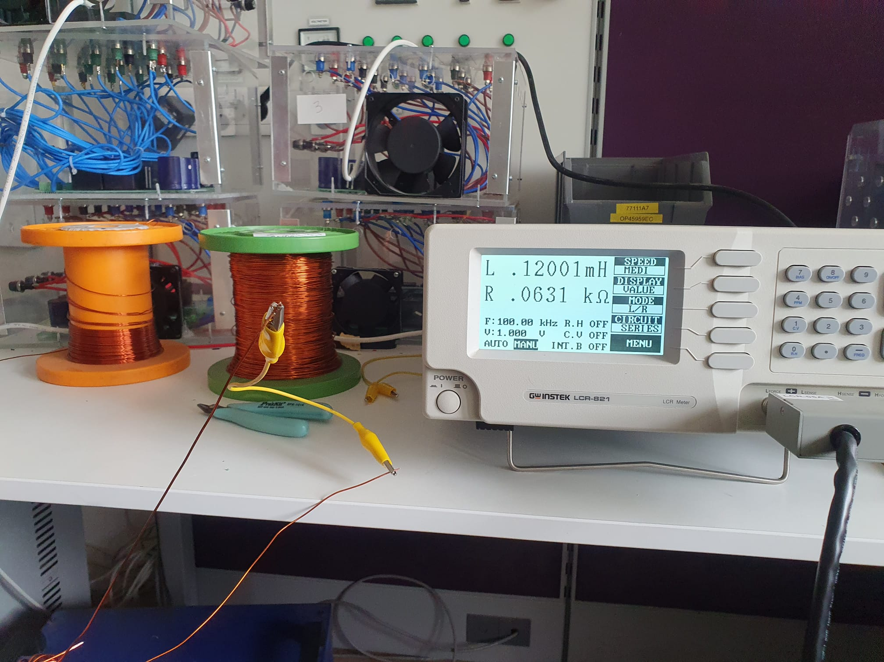

Figure : Primary is short circuited to measure leakge inductance at secondary.

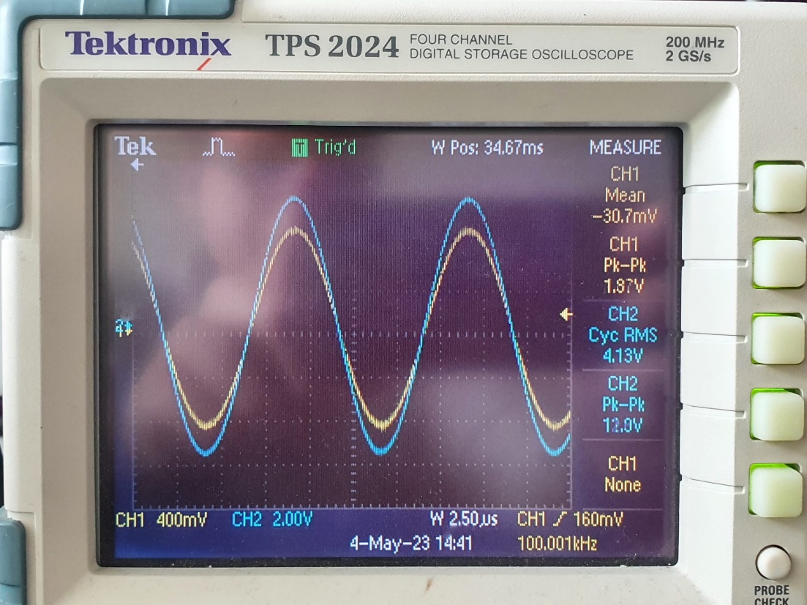

Figure : Input and output voltage ratio to observe turns ratio.

The leakage inductance at the secondary is measured as 120μH and by subtracting this value from the total inductance measured as 577μH, magnetizing inductance is measured as 457μH. Also, the turns ratio, which is the ratio of output and input voltage, is measured as 6. It can be seen that the leakage inductance is too high than the expected values. This may be caused by the toroid core because winding around a toroid core is difficult and results in high leakage which can be seen also Figure 15.

Some additional plots are given on Page 4 of Appendix – 2.

# Tests

Efficiency figures, start-up, ripple content, step-load response, low-voltage operation and discussions

# PCB Design

# Conclusion

In conclusion, this report has effectively demonstrated the design process, computer simulations, and component selection for the flyback converter project. Through meticulous analysis and optimization, the design decisions were made with the primary goal of maximizing efficiency and reliability. Moreover, preliminary experimental results have shown promising outcomes, with measured magnetizing inductance and leakage inductance falling within acceptable ranges. The transformer, capacitor, and semiconductor components were carefully chosen to complement the overall design and meet performance requirements. This comprehensive approach to the flyback converter design ensures that the final product is robust, efficient, and suitable for the required range of voltage and current.

# References

|  |  |
| --- | --- |
| [1] | Ozdisan, "STB100N10F7 - MOSFET DIS.80A 100V N-CH TO263(D2PAK) SMT," [Online]. Available: https://ozdisan.com/guc-yari-iletkenleri/mosfetler/discrete-mosfetler/STB100N10F7/585449. [Accessed 05 05 2023]. |
| [2] | Ozdisan, "STTH3R06S - DIODE U.FAST Single 3A 600V SMT DO214AB (SMC)," [Online]. Available: https://ozdisan.com/guc-yari-iletkenleri/diyotlar-modul-diyotlar-ve-dogrultucular/genel-amacli-diyotlar/STTH3R06S/497200. [Accessed 05 05 2023]. |
| [3] | Ozdisan, "PKLH-400V470MJ200 - CAP.EL.47UF 400V 16X20 7.5MM 105C L.ESR 5000H," [Online]. Available: https://ozdisan.com/pasif-komponentler/kondansatorler/aluminyum-kondansatorler/PKLH-400V470MJ200/487365. [Accessed 05 05 2023]. |
| [4] | Digikey, "UCC2813DTR-1," [Online]. Available: https://www.digikey.com/en/products/detail/texas-instruments/UCC2813DTR-1/1911585. [Accessed 05 05 2023]. |