**EE 464**

**STATIC POWER CONVERSION-I**

**Spring 2022-2023**

**Homework 2**

**Complete Simulation Report**

Mehmet Emre Doğan – 2374825

Metehan Küçükler –

Table of Contents

Introduction 3

Topology Selection 3

Magnetic Design 4

Complete Simulations 11

Conclusion 11

# Introduction

This report explains the design decisions for the hardware project. Furthermore, it presents the details of the Magnetic Design of the Isolated Power Supply and the simulation results for the selected topology.

# Topology Selection

The converter needs to be isolated. Therefore, the alternatives are listed below:

* Flyback converter
* Forward converter
* Push-Pull converter

diyagram içeren bir resim

Açıklama otomatik olarak oluşturuldu

Figure : TI Webench design

# Magnetic Design

1. The duty range of the converter is selected as [0.278 – 0.336] to match the design by the Ti Webench. According to the duty range determination, the turn ratio is calculated via the MATLAB code below.

clearvars

syms d turnsRatio

v_o = 48

d_min = 0.278; v_d_minduty = 18;

d_max = 0.366; v_d_maxduty = 12

turnsRatio_minduty = ( (d_min/(1-d_min)) * (v_d_minduty/v_o) )^-1

turnsRatio_maxduty = ( (d_max/(1-d_max)) * (v_d_maxduty/v_o) )^-1

According to the code above, the transformer turns ratio (Ns/Np) is calculated as 6.93.

2. The available cores and coil formers are investigated. Firstly, due to its available stock number is high, PCB5530-FA is selected as the coil former. Therefore, the compatible core 0P45530EC is selected as the transformer core. However, after calculations, it is seen that this core is overkill. Afterward, **79440A7 toroidal core is selected** due to its high stock number and wide window area. A wide window area makes the wounding procedure easier.
3. Using the MATLAB code below, the primary turn number is 13, while the secondary turn number is 87. The magnetizing inductance is 8 uH.

U_o = v_o;

v_t = d_max;

f_sw = 100e3;

i_out = 1;

i_avgSec = i_out/(1-v_t);

xformerCurrRipple = 0.5; % percent

L_sec = (U_o*(1-v_t))/(xformerCurrRipple*i_avgSec*f_sw)

L_pri = L_sec/(turnsRatio_maxduty^2)

% (turnsRatio_maxduty^2)*2.814e-6

syms priTurns secTurns

AL = 51e-9 % nH/T^2; minimal

priTurns = double(solve(L_pri == AL*priTurns^2))

secTurns = double(solve(L_sec == AL*secTurns^2))

% make sure core is not saturated

ampTurns = i_out*secTurns

1. According to the AWG table, the secondary should be wounded using 5 parallel 28 AWG wires. The primary, on the other hand, 18 parallel 28 AWG wires will be used.
2. According to the code below, the fill factor is 12.53%, which is reasonable.

windowArea_mm2 = 427;

priTurns = ceil(priTurns(priTurns>0))

secTurns = ceil(secTurns(secTurns>0))

num_of_paralles_pri = ceil(num_of_paralles_pri)

num_of_paralles_sec = ceil(num_of_paralles_sec)

cableArea_mm2 = 0.080;

primaryArea_mm2 = priTurns*num_of_paralles_pri*cableArea_mm2

secondaryArea_mm2 = secTurns*num_of_paralles_sec*cableArea_mm2

totalCableArea_mm2 = primaryArea_mm2 + secondaryArea_mm2

fillFactor_perc = 100*totalCableArea_mm2/windowArea_mm2

1. Cable resistance calculation is done by the code below:

windingLengthPerTurn_mm = 68.2

ohms_per_meter = 212.872 / 1e3

primaryLength_m = windingLengthPerTurn_mm * priTurns * 1e-3

secondaryLength_m = windingLengthPerTurn_mm * secTurns * 1e-3

primary_DC_resistance_ohm = ohms_per_meter * primaryLength_m / num_of_paralles_pri

secondary_DC_resistance_ohm = ohms_per_meter * secondaryLength_m / num_of_paralles_sec

The DC and AC resistances of the transformer are assumed equal thanks to the skin depth being greater than the radius.

**Primary Resistance: 10.5 mOhm**

**Secondary Resistance: 252 mOhm**

1. Copper losses are calculated by the code below:

diameter_mm = vpa(0.32004*u.mm)

radius_mm = diameter_mm/2

skinDepth_cm = vpa(7.5/sqrt(f_sw)*u.cm)

skinDepth_mm = unitConvert(skinDepth_cm, u.mm)

% skin depth is greater than radius.

% Therefore, AC reistance equals DC resistance

DC_to_AC_ratio = 1

primary_AC_resistance_ohm = primary_DC_resistance_ohm*DC_to_AC_ratio

secondary_AC_resistance_ohm = secondary_DC_resistance_ohm*DC_to_AC_ratio

resistancePri_ohm = vpa(primary_AC_resistance_ohm * u.Ohm)

resistanceSec_ohm = vpa(secondary_AC_resistance_ohm * u.Ohm)

copperLossPri = vpa(unitConvert((i_in_max*u.A)^2 * resistancePri_ohm, u.W))

copperLossSec = vpa(unitConvert((i_out*u.A)^2 * resistanceSec_ohm, u.W))

copperLoss_W = copperLossPri + copperLossSec

**Total Copper Losses: 0.42 W**

1. Core losses are calculated by the code below:

permeability = 26;

mu_zero = 1.25663706212e-6;

pathLength_m = 107e-3;

fluxDensity_Tesla = mu_zero * permeability * ampTurns / pathLength_m

% using graph above, 0.03 Tesla @ 100 kHz corresponds to

wattLoss_mW_cm3 = 60*u.mW/u.cm^3

volume_mm3 = 21300;

volume_cm3 = vpa(unitConvert(volume_mm3*u.mm^3, u.cm^3))

coreLoss_w = vpa(unitConvert(wattLoss_mW_cm3 * volume_cm3, u.W))

**Core Loss: 1.27 W**

The core loss is comparable with the copper loss. Hence, the design is good. No need to iterate more.

c. The open-loop flyback design is simulated on Simulink as shown in Figure 2. The circuit is simulated at its edges, namely, 12V input voltage and 0.366 duty and 18V input voltage and 0.278 duty. The simulation results are shown in Figures 3-6 for 0.278 duty and Figures 7-10 for 0.366 duty.

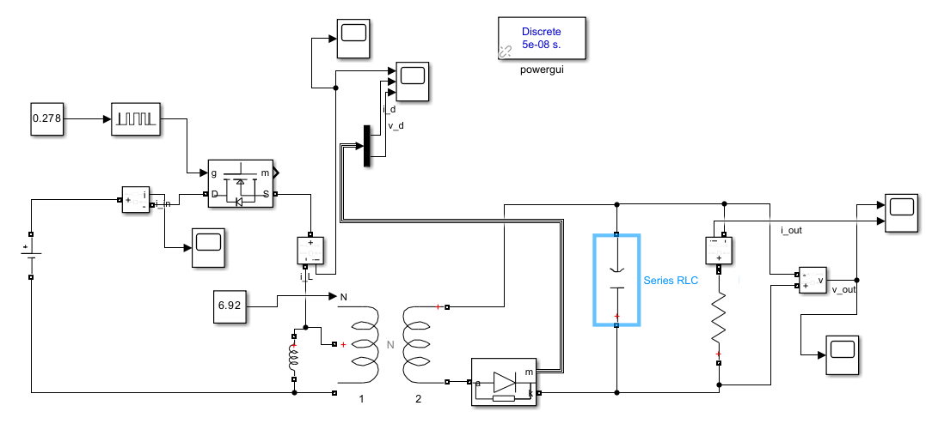

Figure : The Flyback converter in Simulink

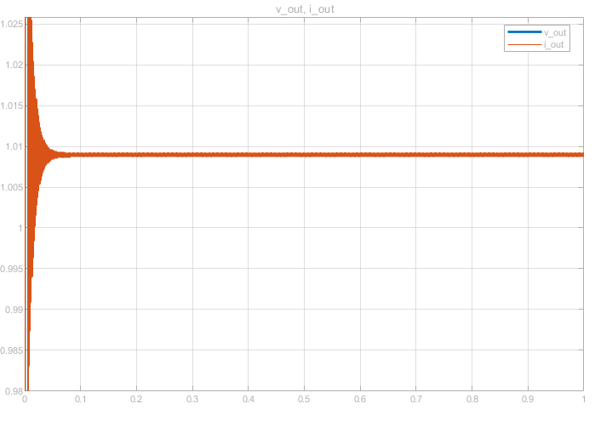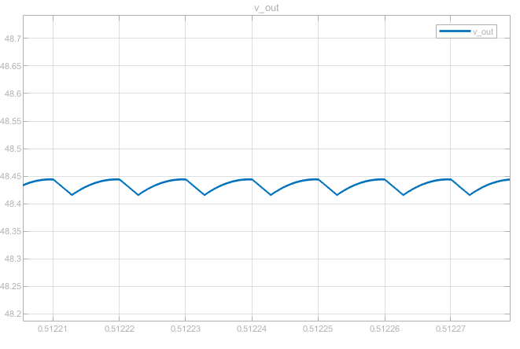

Figure : Output voltage ripple for 0.278 duty

Figure 4: Output current waveform for 0.278 duty

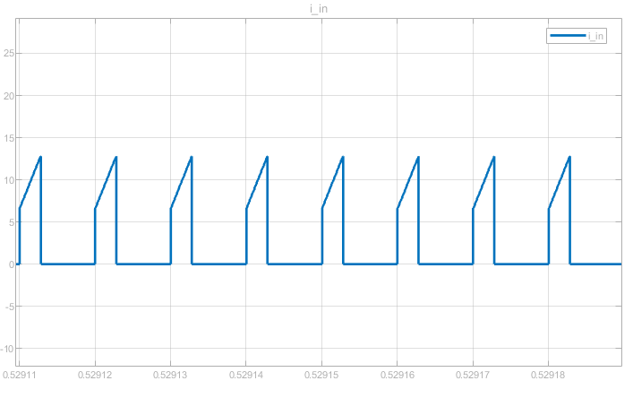

Figure 5: Input current waveform for 0.278 duty

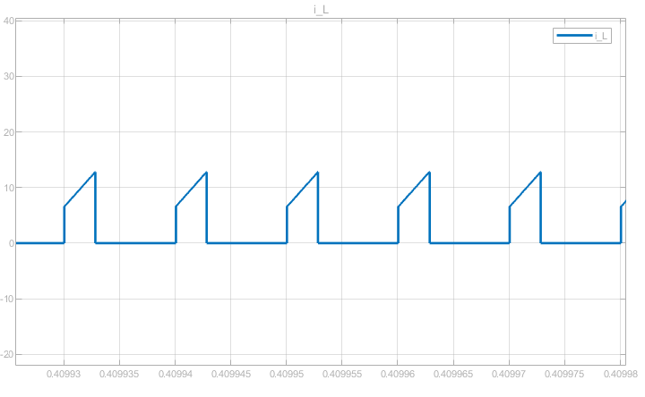

Figure 6: Transformer primary current waveform for 0.278 duty

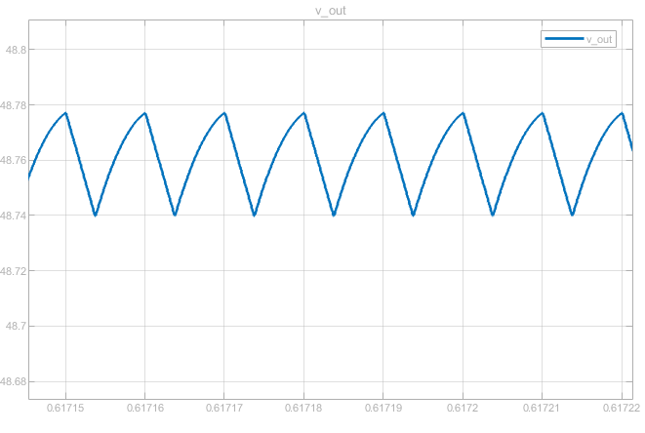

Figure 7: Output voltage ripple for 0.366 duty

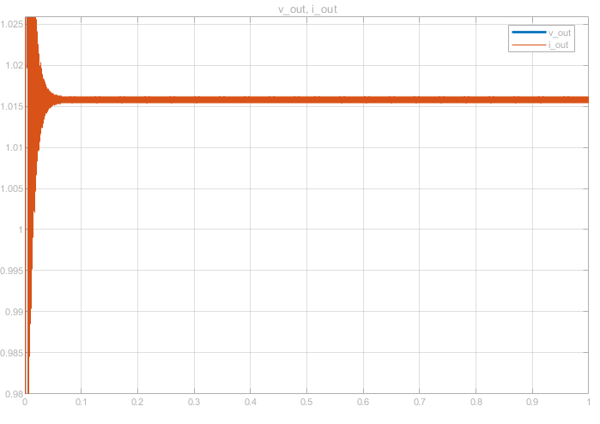

Figure 8: Output current waveform for 0.366 duty

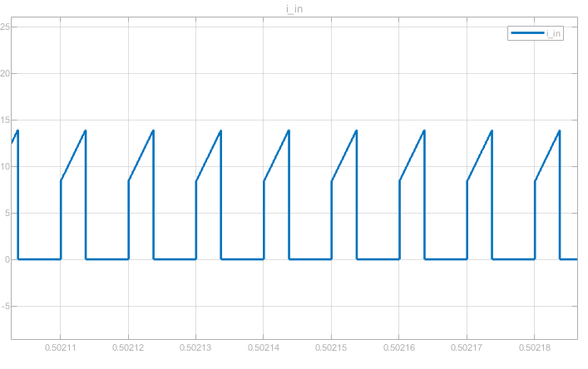

Figure 9: Input current waveform for 0.366 duty

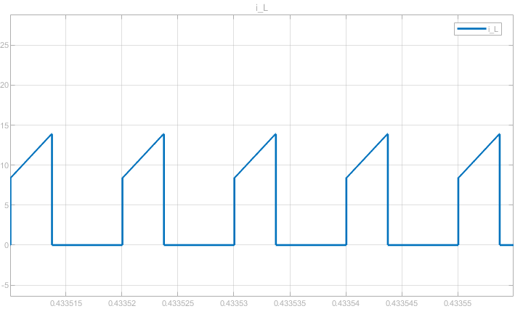

Figure 10: Transformer primary current waveform for 0.366 duty

# Complete Simulations

# Conclusion