

**Ankara Yıldırım Beyazit University**

**Business School**

**Esenboğa, Ankara**

-------------------------------

**2020-2021**

**------------------------**

**Mehmet Sait Altıntaş**

**17030411048**

**Management Information System**

**Problem Identification;**

Our lifestyles and conditions have changed due to Covid-19, which has been an epidemic disease for a while. Indirectly, the other factors most affected by this situation were our education and working conditions.

For example; students had to continue their education process online, and many students were not equipped to support this process in the early days. (Computer, internet etc.)

At the same time, in addition to the measures taken by the states against this extraordinary situation, private companies tried to take their own precautions.

As a result, many people's education, career and future plans had to change, along with the labor demand, working conditions, and hybrid working solutions in the market.

In this project, we will examine the change in the conditions of new graduate internship and employment, the change experienced by existing employees, unemployment and new job conditions.

**Introductory Part;**

We have been trying to fight Covid-19, an epidemic disease, for about 2 years. This extraordinary situation, which many people were caught unprepared for, has caused a radical change in our lifestyles and working conditions. Indirectly, the other factors most affected by this situation were our education and working conditions.

Education and training channels have developed hybrid education forms and online exam platforms within the framework of various measures. Digital education platforms were in high demand. Students became able to access all kinds of information through a computer and the internet, but this also started to cause problems in the field of applied education.

Students who are graduates of the years 2020-2021, who have great difficulties in finding internships and beginner jobs, have started to look for many ways to find jobs in different fields.

At the same time, existing employees had to be fired, found another job or changed their current working conditions.

Governments and companies alike are applying for layoffs in some positions, but have difficulty finding experienced staff to work in some areas.

**Step – B: About Data;**

Data collection;

The datasets I think I need are;

Turkey Student Population

<https://sgb.meb.gov.tr/www/icerik_goruntule.php?KNO=396>

Turkey Student Population

<https://istatistik.yok.gov.tr/>

Internet usage in Turkey by years

Reasons for internet use.

<https://www.dogrulukpayi.com/bulten/turkiye-de-internet-erisimi-ve-kullanimi-ne-durumda?gclid=CjwKCAjwiLGGBhAqEiwAgq3q_poWhotEJKW73NovpK7AnYTcWqX-hdaUff1dcpeV6eF56dzgsTnldhoCLf0QAvD_BwE>

<https://data.tuik.gov.tr/Bulten/Index?p=Hanehalki-Bilisim-Teknolojileri-(BT)-Kullanim-Arastirmasi-2020-33679>

Internet Usage by Occupational Groups

<https://www.oecd.org/education/Turkey-coronavirus-education-country-note.pdf>

Turkey unemployment data

<https://www.sbb.gov.tr/ocak-2021-istihdam-verileri/>

**Since the datasets I found were very comprehensive and detailed, the data I needed was parsed and re-visualized.**

Visualization Tools;

I prefer to use Data Wrapper for visualization, ease of use, clean and simple structure are important factors for me to choose compatibility in terms of optimization.

I visualized the excel files I created with the Data wrapper that serves over the web.

**Graphs:**

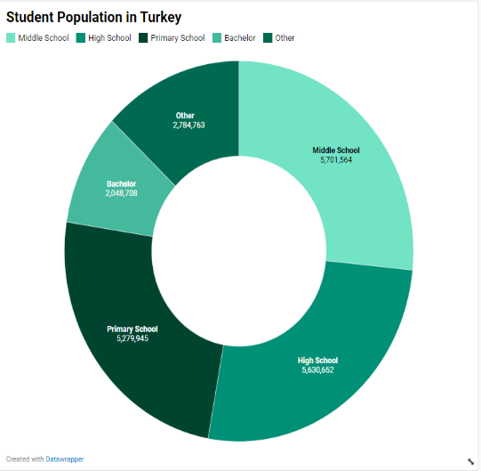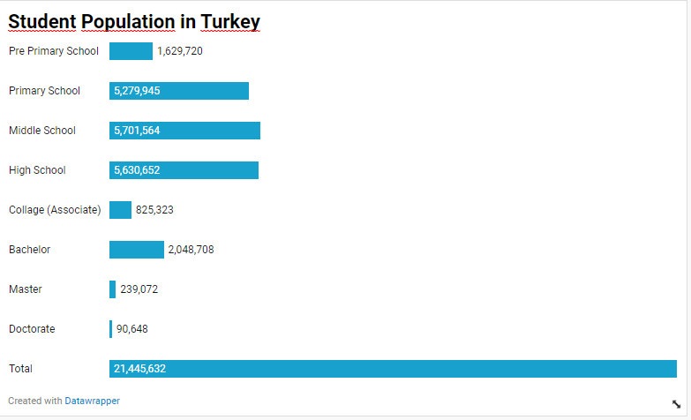

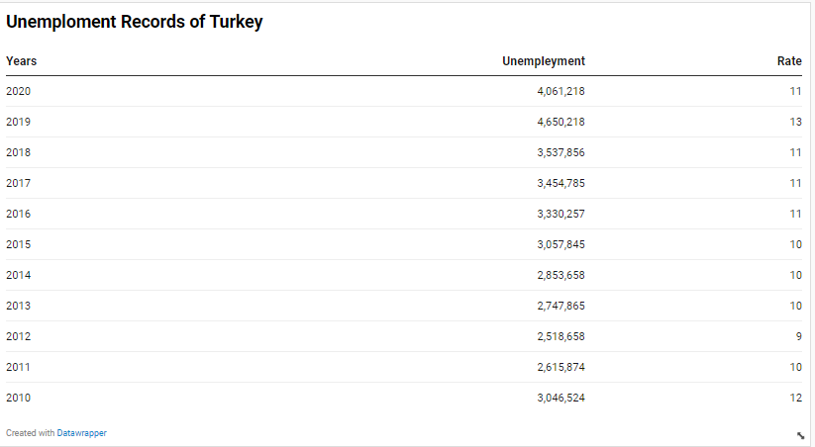

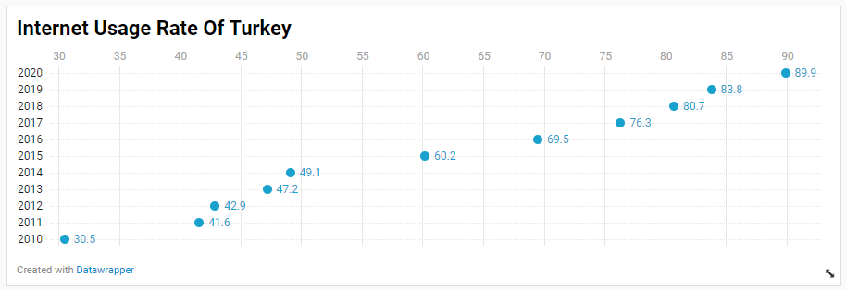

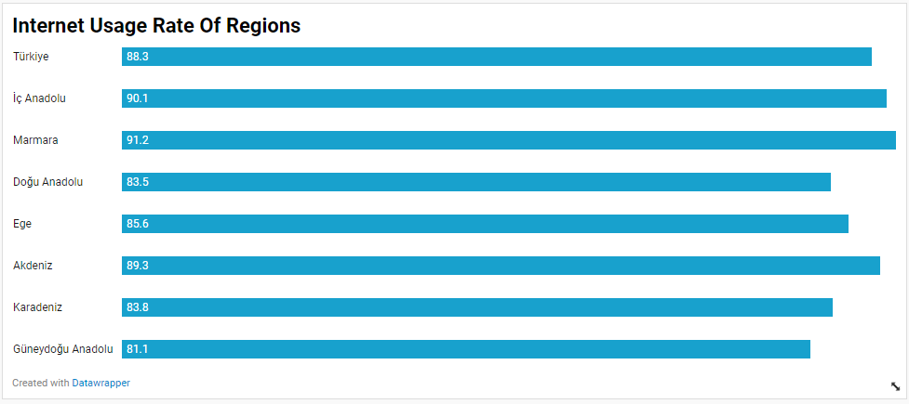

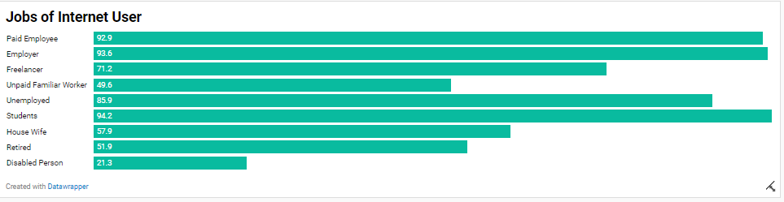

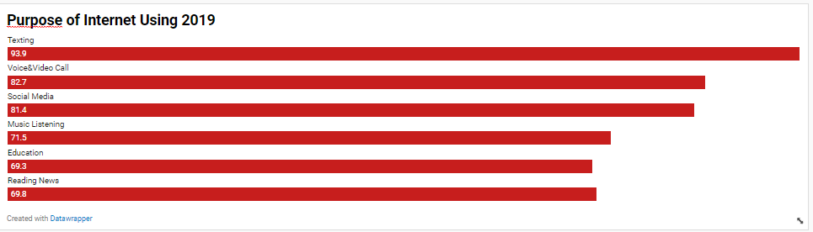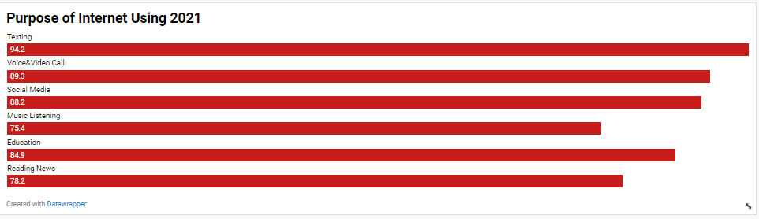

**Results :**

As a result of my investigations, it has been seen that there has been a great increase in inter, video interviews and home education & working with the Pandemic in Turkey.

Compared to the last 10 years, there have been very visible changes in 2020.

The factors affecting internet usage are as follows;

- Age

- Gender

-Income rate

-Profession

- Geography

At the same time, people experiencing loss of income also decline in internet use.

It has been observed that 5% of the students in Turkey do not have access to the internet.

At the same time, while unemployment rates should have increased, there was a decrease in 2020. It could not be confirmed whether there was a change in the calculation method.