1)

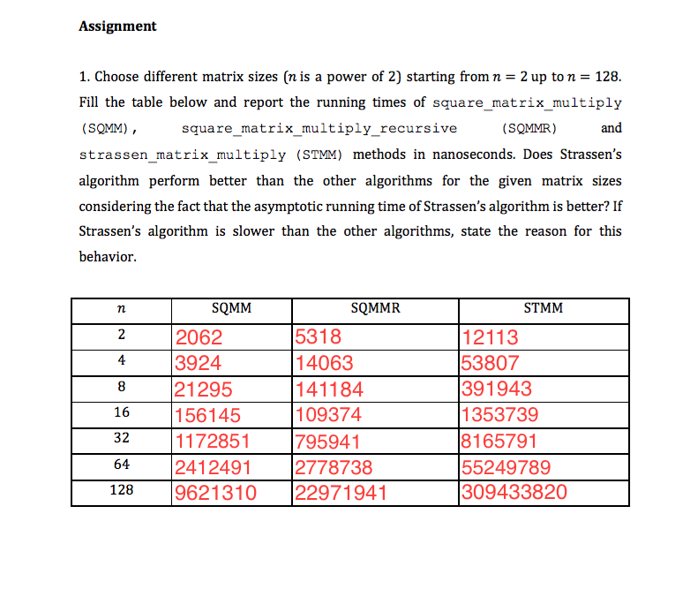

Strassen matrix multiplication is slower than other two algorithm because the coefficient c in Strassen multiplication, $STMM(n)=O(n^{\log_{2}{7}})$ and from here we have STMM(n) $≤{c×n}^{\log_{2}{7}}$ this c coefficent is larger than the coefficient in SQMMR. İn order to get a better result with Strassen matrix multiplication, we must choose a very large n value but, in that case, we cannot compute that matrix in a regular Office computer. As a result, in order to get a better result with Strassen matrix multiplication, we must choose a n value which is very large. But in most of the case, Strassen is theoretically better but in real life, we got slower results due to our computers are not able to calculate very big matrix multiplication.

2)

b)

The result that I get after modification of Strassen method is:

----Strassen Result----

6 6 6

12 12 12

18 18 18